Data Science – Term Project

Cricket World Cup Matches Prediction

201835528 조병근 | 201835538 최지원 | 201931889 정다희

[Full Code]

#  Data Science

#  Term project - Cricket World Cup Matches Prediction

#  Name            :  Jo Byeong Geun, Choi Ji Won, Jeong Da Hee

#  Student Number  :  201835528, 201835538, 201931889

#  Class           :  Mon 5678

#  Date            :  2021.05.26

#  Update          :  2021.06.11

import pandas as pd

import numpy as np

import matplotlib.pyplot as plt

from sklearn.preprocessing import LabelEncoder

from sklearn.preprocessing import MinMaxScaler, StandardScaler, RobustScaler

from sklearn.model_selection import train_test_split

from sklearn.linear_model import LinearRegression, LogisticRegression

from sklearn.neighbors import KNeighborsClassifier

from sklearn.metrics import confusion_matrix, plot_confusion_matrix, classification_report

from sklearn.model_selection import KFold

from sklearn.ensemble import RandomForestClassifier

from sklearn import metrics

from sklearn import svm, datasets

from warnings import simplefilter

import warnings

with warnings.catch_warnings():

    warnings.filterwarnings("ignore")

simplefilter(action='ignore', category=FutureWarning)

# Make Confusion Matirx

def make_cf_matrix(y_test, y_pred):

    # Compare y testing sets with predicted y values

    cf_matrix = confusion_matrix(y_test, y_pred)

    # Show the confusion Matrix

    print("\n***************Confusion Matrix******************")

    print(cf_matrix)

# Make Classification Report

def make_cf_report(y_test, y_pred):

    # Evaluate the precision and reproducibility

    cf_report = classification_report(y_test, y_pred)

    # Show the Classificatin Report

    print("\n***************Classification Report******************")

    print(cf_report)

# Scaling data from wicketts, runs

def scaler_team(df_team, df, scaler):

    value = []

    for i in df_team.index:

        # Importing data in the 'Margin' column

        value.append(df.loc[i]['Margin'])

    # Change dimension and shape

    value = np.array(value).reshape(-1, 1)

    scaled = scaler.transform(value)

    # Scaling to mean values

    return np.mean(scaled)

# Scaling using scaler

def scaling(scaler):

    wickets_np = df_wickets['Margin'].to_numpy().reshape(-1, 1)

    scaler.fit(wickets_np)

    # Declaring a list to insert values for scaling

    wicket_scaler = []

    wicket_scaler.append(scaler_team(df_England_wicket, df_wickets, scaler))

    wicket_scaler.append(scaler_team(df_SouthAfrica_wicket, df_wickets, scaler))

    wicket_scaler.append(scaler_team(df_WestIndies_wicket, df_wickets, scaler))

    wicket_scaler.append(scaler_team(df_Pakistan_wicket, df_wickets, scaler))

    wicket_scaler.append(scaler_team(df_NewZealand_wicket, df_wickets, scaler))

    wicket_scaler.append(scaler_team(df_SriLanka_wicket, df_wickets, scaler))

    wicket_scaler.append(scaler_team(df_Afghanistan_wicket, df_wickets, scaler))

    wicket_scaler.append(scaler_team(df_Australia_wicket, df_wickets, scaler))

    wicket_scaler.append(scaler_team(df_Bangladesh_wicket, df_wickets, scaler))

    wicket_scaler.append(scaler_team(df_India_wicket, df_wickets, scaler))

    runs_np = df_runs['Margin'].to_numpy().reshape(-1, 1)

    scaler.fit(runs_np)

    # Declaring a list to insert values for scaling

    runs_scaler = []

    runs_scaler.append(scaler_team(df_England_runs, df_runs, scaler))

    runs_scaler.append(scaler_team(df_SouthAfrica_runs, df_runs, scaler))

    runs_scaler.append(scaler_team(df_WestIndies_runs, df_runs, scaler))

    runs_scaler.append(scaler_team(df_Pakistan_runs, df_runs, scaler))

    runs_scaler.append(scaler_team(df_NewZealand_runs, df_runs, scaler))

    runs_scaler.append(scaler_team(df_SriLanka_runs, df_runs, scaler))

    runs_scaler.append(scaler_team(df_Afghanistan_runs, df_runs, scaler))

    runs_scaler.append(scaler_team(df_Australia_runs, df_runs, scaler))

    runs_scaler.append(scaler_team(df_Bangladesh_runs, df_runs, scaler))

    runs_scaler.append(scaler_team(df_India_runs, df_runs, scaler))

    # Outputs scaling results for worldcup_team in bar form

    plt.bar(worldcup_teams, wicket_scaler)

    # X axis name

    plt.xlabel('Teams')

    # Y axis name

    plt.ylabel('Scaled Wicket')

    # Show plotting result

    plt.show()

    # Outputs scaling results for worldcup_team in bar form

    plt.bar(worldcup_teams, runs_scaler)

    # X axis name

    plt.xlabel('Teams')

    # Y axis name

    plt.ylabel('Scaled Runs')

    # Show plotting result

    plt.show()

    return wicket_scaler, runs_scaler

# Kfold- Linear Regression

def kfold_lin(kfold, df_teams):

    sum_training = 0

    sum_testing = 0

    count = 0

    for train_index, test_index in kfold.split(df_teams):

        # Data for training

        df_train = df_teams.iloc[train_index]

        # Data for testing

        df_test = df_teams.iloc[test_index]

        model = LinearRegression()

        # Change the training set and testing set to the correct structure and store them.

        train = pd.get_dummies(df_train, prefix=['Team_1', 'Team_2'], columns=['Team_1', 'Team_2'])

        test = pd.get_dummies(df_test, prefix=['Team_1', 'Team_2'], columns=['Team_1', 'Team_2'])

        # Drop 'Winner' column of training set and put it in the X training set.

        X_train = train.drop(['Winner'], axis=1)

        # Insert the 'Winner' column of training set into the y training set.

        y_train = train["Winner"]

        # Drop 'Winner' column of testing set and put it in the X testing set.

        X_test = test.drop(['Winner'], axis=1)

        # Insert the 'Winner' column of testing set into the y testing set.

        y_test = test["Winner"]

        model.fit(X_train, y_train)

        # Derives the value of learning the training set to Linear Regression

        score = model.score(X_train, y_train)

        # Derives the value of learning the testing set to Linear Regression

        score2 = model.score(X_test, y_test)

        count = count + 1

        sum_training = sum_training + score

        sum_testing = sum_testing + score2

        # Accuracy output each K-fold data

        print("Training set accuracy: ", '%.3f' % (score))

        print("Test set accuracy: ", '%.3f' % (score2))

    print("Training set accuracy average: ", '%.3f' % (sum_training / count))

    print("Test set accuracy average: ", '%.3f' % (sum_testing / count))

    return sum_testing/count

# Kfold - Logistic Regression

def kfold_log(kfold,df_teams):

    sum_training = 0

    sum_testing = 0

    count = 0

    for train_index, test_index in kfold.split(df_teams):

        # Data for training

        df_train = df_teams.iloc[train_index]

        # Data for testing

        df_test = df_teams.iloc[test_index]

        model = LogisticRegression()

        # Change the training set and testing set to the correct structure and store them.

        train = pd.get_dummies(df_train, prefix=['Team_1', 'Team_2'], columns=['Team_1', 'Team_2'])

        test = pd.get_dummies(df_test, prefix=['Team_1', 'Team_2'], columns=['Team_1', 'Team_2'])

        # Drop 'Winner' column of training set and put it in the X training set.

        X_train = train.drop(['Winner'], axis=1)

        # Insert the 'Winner' column of training set into the y training set.

        y_train = train["Winner"]

        # Drop 'Winner' column of testing set and put it in the X testing set.

        X_test = test.drop(['Winner'], axis=1)

        # Insert the 'Winner' column of testing set into the y testing set.

        y_test = test["Winner"]

        model.fit(X_train, y_train)

        # Derives the value of learning the training set to Logistic Regression

        score = model.score(X_train, y_train)

        # Derives the value of learning the testing set to Logistic Regression

        score2 = model.score(X_test, y_test)

        count = count + 1

        sum_training = sum_training + score

        sum_testing = sum_testing + score2

        # Accuracy output each K-fold data

        print("Training set accuracy: ", '%.3f' % (score))

        print("Test set accuracy: ", '%.3f' % (score2))

    print("Training set accuracy average: ", '%.3f' % (sum_training / count))

    print("Test set accuracy average: ", '%.3f' % (sum_testing / count))

    return sum_testing/count

# Kfold - Random Forest

def kfold_ran(kfold, best_score, df_teams):

    sum_training=0

    sum_testing=0

    count=0

    for train_index, test_index in kfold.split(df_teams):

        # Data for training

        df_train = df_teams.iloc[train_index]

        # Data for testing

        df_test = df_teams.iloc[test_index]

        # Change the training set and testing set to the correct structure and store them.

        train = pd.get_dummies(df_train, prefix=['Team_1', 'Team_2'], columns=['Team_1', 'Team_2'])

        test = pd.get_dummies(df_test, prefix=['Team_1', 'Team_2'], columns=['Team_1', 'Team_2'])

        # Drop 'Winner' column of training set and put it in the X training set.

        X_train = train.drop(['Winner'], axis=1)

        # Insert the 'Winner' column of training set into the y training set.

        y_train = train["Winner"]

        # Drop 'Winner' column of testing set and put it in the X testing set.

        X_test = test.drop(['Winner'], axis=1)

        # Insert the 'Winner' column of testing set into the y testing set.

        y_test = test["Winner"]

        # Random Forest

        rf = RandomForestClassifier(n_estimators=100, max_depth=20, random_state=0)

        # Learning X training set by y training

        rf.fit(X_train, y_train)

        # Derives the value of learning the training set to Random Forest

        score = rf.score(X_train, y_train)

        # Derives the value of learning the testing set to Random Forest

        score2 = rf.score(X_test, y_test)

        count=count+1

        sum_training=sum_training+score

        sum_testing=sum_testing+score2

        # Store the Random Forest of the best test value that have learned

        if best_score < score2:

            best_score = score2

            best_rf = rf

        # Accuracy output each K-fold data

        print("Training set accuracy: ", '%.3f' % (score))

        print("Test set accuracy: ", '%.3f' % (score2))

    print("Training set accuracy average: ", '%.3f' % (sum_training/count))

    print("Test set accuracy average: ", '%.3f' % (sum_testing/count))

    return sum_testing/count, best_rf

# Label Encoding

def labelEncoding(df_teams):

        df_teams = df_teams.apply(LabelEncoder().fit_transform)

        return df_teams

# Best accuracy of K-Fold & algorithm (Linear, Logistic and RandomForest)

def best_kfold_reg(df_teams):

    #K-fold Linear Regression

    print("\n*************Kfold of Linear Regression***************")

    scores = []

    kfold = KFold(n_splits=3, shuffle=True)

    scaled_kfold_lin = kfold_lin(kfold, df_teams)

    #K-fold Logistic Regression

    print("\n*************Kfold of Logistic Regression***************")

    scores = []

    kfold = KFold(n_splits=3, shuffle=True)

    df_teams['Winner']=df_teams['Winner'].astype(int)

    scaled_kfold_log = kfold_log(kfold,df_teams)

    # Kfold random forest

    # Split data into three

    print("\n*************Kfold of Random Forest ***************")

    kfold = KFold(n_splits=3, shuffle=True)

    # Declaring a variable to put the best value in

    best_score = 0

    scaled_kfold_ran, best_rf = kfold_ran(kfold, best_score, df_teams)

    best_acc = bestAcc(scaled_kfold_lin, scaled_kfold_log, scaled_kfold_ran)

    #print("\nthe best acc = ", '%0.3f' % best_acc)

    return best_acc

# Calculate best accuracy

def bestAcc(lin, log, ran):

    return max(lin, max(log, ran))

# Best combination

def best_combi(df_teams_minmax, df_teams_standard, df_teams_robust):

    return max(best_kfold_reg(df_teams_minmax), max(best_kfold_reg(df_teams_standard), best_kfold_reg(df_teams_robust)))

# Read the csv file

results = pd.read_csv('dataset/results.csv')

# dataset statistical data

print("\n***********statistical data***************")

print(results.describe())

# Feature names

print("\n***********feature names***************")

print(results.columns.values)

# data types

print("\n***********feature data types***************")

print(results.dtypes)

# data shape

print("\n***********data shape***************")

print(results.shape)

# data index

print("\n***********data index***************")

print(results.index)

# dataset columns

print("\n***********dataset columns***************")

print(results.columns)

# Top 5 data in dataset

print("\n***********dataset***************")

print(results.head())

# data preprocessing

# Drop missing null or ground information that is not needed

results.dropna(axis=0, inplace=True)

results.drop(['Ground'], axis=1, inplace=True)

# Limited to 10 teams participating in the World Cup

worldcup_teams = ['England', 'South Africa', 'West Indies',

                  'Pakistan', 'New Zealand', 'Sri Lanka', 'Afghanistan',

                  'Australia', 'Bangladesh', 'India']

# Include only countries corresponding to worldcup_teams in results dataset of column 'Team_1'

df_teams_1 = results[results['Team_1'].isin(worldcup_teams)]

# Include only countries corresponding to worldcup_teams in results dataset of column 'Team_2'

df_teams = df_teams_1[df_teams_1['Team_2'].isin(worldcup_teams)]

# deduplication

df_teams = df_teams.drop_duplicates()

# Clean up index

df_teams = df_teams.sort_index(ascending=True)

# Show df_teams dataset

print("\n***********df_teams dataset***************")

print(df_teams.head())

# data shape

print("\n***********df_teams data shape***************")

print(df_teams.shape)

# If the defense team wins

# data with a value of 'Wicket' in the 'Margin' column will be separately saved.

df_wickets = df_teams.loc[df_teams['Margin'].str.contains('wickets')].copy()

# To omit the word 'wickets' from the value and only insert numbers (int types)

df_wickets['Margin'] = df_wickets.Margin.str.extract('(\d+)')

# Create time series data using the 'data' value

df_wickets['year'] = pd.DatetimeIndex(df_wickets['date']).year

df_England_wicket = df_wickets[df_wickets['Winner'] == worldcup_teams[0]]

df_SouthAfrica_wicket = df_wickets[df_wickets['Winner'] == worldcup_teams[1]]

df_WestIndies_wicket = df_wickets[df_wickets['Winner'] == worldcup_teams[2]]

df_Pakistan_wicket = df_wickets[df_wickets['Winner'] == worldcup_teams[3]]

df_NewZealand_wicket = df_wickets[df_wickets['Winner'] == worldcup_teams[4]]

df_SriLanka_wicket = df_wickets[df_wickets['Winner'] == worldcup_teams[5]]

df_Afghanistan_wicket = df_wickets[df_wickets['Winner'] == worldcup_teams[6]]

df_Australia_wicket = df_wickets[df_wickets['Winner'] == worldcup_teams[7]]

df_Bangladesh_wicket = df_wickets[df_wickets['Winner'] == worldcup_teams[8]]

df_India_wicket = df_wickets[df_wickets['Winner'] == worldcup_teams[9]]

# If the offense team wins

# data with a value of 'runs' in the 'Margin' column will be separately saved.

df_runs = df_teams.loc[df_teams['Margin'].str.contains('runs')].copy()

# To omit the word 'runs' from the value and only insert numbers (int types)

df_runs['Margin'] = df_runs.Margin.str.extract('(\d+)')

# Create time series data using the 'data' value

df_runs['year'] = pd.DatetimeIndex(df_runs['date']).year

df_England_runs = df_runs[df_runs['Winner'] == worldcup_teams[0]]

df_SouthAfrica_runs = df_runs[df_runs['Winner'] == worldcup_teams[1]]

df_WestIndies_runs = df_runs[df_runs['Winner'] == worldcup_teams[2]]

df_Pakistan_runs = df_runs[df_runs['Winner'] == worldcup_teams[3]]

df_NewZealand_runs = df_runs[df_runs['Winner'] == worldcup_teams[4]]

df_SriLanka_runs = df_runs[df_runs['Winner'] == worldcup_teams[5]]

df_Afghanistan_runs = df_runs[df_runs['Winner'] == worldcup_teams[6]]

df_Australia_runs = df_runs[df_runs['Winner'] == worldcup_teams[7]]

df_Bangladesh_runs = df_runs[df_runs['Winner'] == worldcup_teams[8]]

df_India_runs = df_runs[df_runs['Winner'] == worldcup_teams[9]]

########### Scaling ###########

# MinMax Scaling

minmax_scaler = MinMaxScaler()

minmax_wicket_scaler, minmax_runs_scaler = scaling(minmax_scaler)

# Standard Scaling

standard_scaler = StandardScaler()

standard_wicket_scaler, standard_runs_scaler = scaling(standard_scaler)

# Robust Scaling

robust_scaler = RobustScaler()

robust_wicket_scaler, robust_runs_scaler = scaling(robust_scaler)

# Drop columns of 'Margin' and 'date' that has nothing to do with winning or losing.

df_teams = df_teams.drop(['date', 'Margin'], axis=1)

# reorder index

df_teams = df_teams.reset_index(drop=True)

########## Encoding ###########

# LabelEncoding to change team name to number

df_teams = labelEncoding(df_teams)

# Divide the categorical properties for Team_1 and Team_2.

final = pd.get_dummies(df_teams, prefix=['Team_1', 'Team_2'], columns=['Team_1', 'Team_2'])

# Drop 'Winner' column from final dataset and put it in X

X = final.drop(['Winner'], axis=1)

# Store only 'Winner' column in y in final dataset

y = final["Winner"]

# Divide training and testing set by 7:3 each.

X_train, X_test, y_train, y_test = train_test_split(X, y, test_size=0.30, random_state=42)

# Random Forest

rf = RandomForestClassifier(n_estimators=100, max_depth=20, random_state=0)

# Learning X training set by y training

rf.fit(X_train, y_train)

# Predicting an X testing set with learning results

y_pred = rf.predict(X_test)

# Derives the value of learning the training set to Random Forest

score = rf.score(X_train, y_train)

# Derives the value of learning the testing set to Random Forest

score2 = rf.score(X_test, y_test)

# Show Random Forest

print("\n***************Random Forest******************")

print('Mean Absolute Error:', metrics.mean_absolute_error(y_test, y_pred))

print('Mean Squared Error:', metrics.mean_squared_error(y_test, y_pred))

print('Root Mean Squared Error:', np.sqrt(metrics.mean_squared_error(y_test, y_pred)))

# Accuracy output

print("Training set accuracy: ", '%.3f' % (score))

print("Test set accuracy: ", '%.3f' % (score2))

# K neareast neighbor

k_list = range(1,10)

training_accuracy = []

test_accuracy = []

for k in k_list:

  classifier = KNeighborsClassifier(n_neighbors = k)

  # Learning X training set by y training

  classifier.fit(X_train, y_train)

  # Store accuracy of training set

  training_accuracy.append(classifier.score(X_train, y_train))

  # Store accuracy of testing set

  test_accuracy.append(classifier.score(X_test, y_test))

# Outputs K neareast neighbor result

plt.plot(k_list, training_accuracy)

# X axis name

plt.xlabel("n_neighbors")

# Y axis name

plt.ylabel("Accuracy")

# Show plotting result

plt.show()

# Prediction of testing set

clf = KNeighborsClassifier(n_neighbors = 7)

# Learning X training set by y training

clf.fit(X_train, y_train)

# Show the prediction and accuracy of testing set

print("\n*********************KNN***********************")

print("Test Prediction: {}".format(clf.predict(X_test)))

print("Test Accuracy: {:.2f}".format(clf.score(X_test, y_test)))

# Linear Regression

linreg = LinearRegression()

# Learning X training set by y training

linreg.fit(X_train, y_train)

# Predicting an X testing set with learning results

y_pred = linreg.predict(X_test)

# Derives the value of learning the training set to Linear regression

score = linreg.score(X_train, y_train)

# Derives the value of learning the testing set to Linear regression

score2 = linreg.score(X_test, y_test)

# Show Linear Regression

print("\n***************Linear Regression******************")

print('Mean Absolute Error:', metrics.mean_absolute_error(y_test, y_pred))

print('Mean Squared Error:', metrics.mean_squared_error(y_test, y_pred))

print('Root Mean Squared Error:', np.sqrt(metrics.mean_squared_error(y_test, y_pred)))

# Accuracy output

print("Training set accuracy: ", '%.3f' % (score))

print("Test set accuracy: ", '%.3f' % (score2))

# Logistic Regression

logreg = LogisticRegression()

# Learning X training set by y training

logreg.fit(X_train, y_train)

# Predicting an X testing set with learning results

y_pred = logreg.predict(X_test)

# Derives the value of learning the training set to Logistic regression

score = logreg.score(X_train, y_train)

# Derives the value of learning the testing set to Logistic regression

score2 = logreg.score(X_test, y_test)

# Show Logistic Regression

print("\n******************Logistic Regression*********************")

print('Mean Absolute Error:', metrics.mean_absolute_error(y_test, y_pred))

print('Mean Squared Error:', metrics.mean_squared_error(y_test, y_pred))

print('Root Mean Squared Error:', np.sqrt(metrics.mean_squared_error(y_test, y_pred)))

# Accuracy output

print("Training set accuracy: ", '%.3f' % (score))

print("Test set accuracy: ", '%.3f' % (score2))

# Show Confusion Matrix and Classification Report

make_cf_matrix(y_test, y_pred)

make_cf_report( y_test, y_pred)

# Confusion matrix Visualization

cf_matrix = confusion_matrix(y_test, y_pred)

# Support Vector classifier

clf = svm.SVC(random_state=0)

# Learning X training set by y training

clf.fit(X_train, y_train)

svm.SVC(random_state=0)

# Decide how to show the matrix

matrix = plot_confusion_matrix(clf, X_test, y_test, cmap=plt.cm.Blues, normalize='true')

# Title of matrix table

plt.title('Confusion matrix for our classifier')

# Show the matrix table

plt.show()

Scaler = MinMaxScaler()

df_teams_minmax = pd.DataFrame(Scaler.fit_transform(df_teams), columns=['Team_1', 'Team_2', 'Winner'])

print(df_teams_minmax)

Scaler = StandardScaler()

df_teams_standard = pd.DataFrame(Scaler.fit_transform(df_teams), columns=['Team_1', 'Team_2', 'Winner'])

print(df_teams_standard)

Scaler = RobustScaler()

df_teams_robust = pd.DataFrame(Scaler.fit_transform(df_teams), columns=['Team_1', 'Team_2', 'Winner'])

print(df_teams_robust)

best_combi_acc = best_combi(df_teams_minmax, df_teams_standard, df_teams_robust)

print("\nbest combination accuracy : ", best_combi_acc)

# Expected qualifier rank

# Read the csv file

ranking = pd.read_csv('dataset/icc_rankings.csv')

fixtures = pd.read_csv('dataset/fixtures.csv')

# Show Top 5 data of fixtures dataset

print("\n***************icc_rankings dataset******************")

print(ranking.head())

# Show last 5 data of fixtures dataset

print("\n***************Fixtures dataset******************")

print(fixtures.tail())

# Ranked using icc_ranking dataset

fixtures.insert(1, 'first_position', fixtures['Team_1'].map(ranking.set_index('Team')['Position']))

fixtures.insert(2, 'second_position', fixtures['Team_2'].map(ranking.set_index('Team')['Position']))

# Find the value through the integral position

fixtures = fixtures.iloc[:45, :]

# Show last 5 data of fixtures dataset with ranking

print("\n***************fixtures dataset with ranking******************")

print(fixtures.tail())

# Declaring a variable to put the predicted value

pred_ranking_set = []

# The first variable is indexed, and the second variable is accessed one by one in the row in the column.

for idx, row in fixtures.iterrows():

    # Change the value of team_1 or team_2 according to rank

    if row['first_position'] < row['second_position']:

        pred_ranking_set.append({'Team_1': row['Team_1'], 'Team_2': row['Team_2'], 'Winner': None})

    else:

        pred_ranking_set.append({'Team_1': row['Team_2'], 'Team_2': row['Team_1'], 'Winner': None})

# Convert DataFrame type

pred_ranking_set = pd.DataFrame(pred_ranking_set)

# Top 5 data in dataset

print("\n***************Predicted dataset******************")

print(pred_ranking_set.head())

# Declares variables for backing up data in 'df_teams'

backup_df_teams = df_teams

# Divide the categorical properties for Team_1 and Team_2.

backup_final = pd.get_dummies(backup_df_teams, prefix=['Team_1', 'Team_2'], columns=['Team_1', 'Team_2'])

# Declares variables for backing up data in 'pred_set'

backup_pred_set = pred_ranking_set

# Divide the categorical properties for Team_1 and Team_2.

pred_ranking_set = pd.get_dummies(pred_ranking_set, prefix=['Team_1', 'Team_2'], columns=['Team_1', 'Team_2'])

# Store the differences between existing dataset and predicted dataset

missing_cols = set(backup_final.columns) - set(pred_ranking_set.columns)

# Store missing value as 0 in predicted dataset

for c in missing_cols:

    pred_ranking_set[c] = 0

# Insert data of the column in 'backup_final' into the predicted dataset

pred_ranking_set = pred_ranking_set[backup_final.columns]

# Drop the 'Winner' column

pred_ranking_set = pred_ranking_set.drop(['Winner'], axis=1)

# Put the dataset to experiment into the random forest to derive the result value

best_rf = RandomForestClassifier(n_estimators=100, max_depth=20, random_state=0)

best_rf.fit(X_train, y_train)

predict_result = best_rf.predict(pred_ranking_set)

# Show expected qualifier rank

print("\n*************Qualifier***************")

for i in range(fixtures.shape[0]):

    # Show the country to compete with

    print(backup_pred_set.iloc[i, 1] + " and " + backup_pred_set.iloc[i, 0])

    if predict_result[i] == 1:

        # The second written country wins

        print("Winner: " + backup_pred_set.iloc[i, 1])

    else:

        # The first written country wins

        print("Winner: " + backup_pred_set.iloc[i, 0])

    print("")

[result]

<Describe ‘results’ dataset>

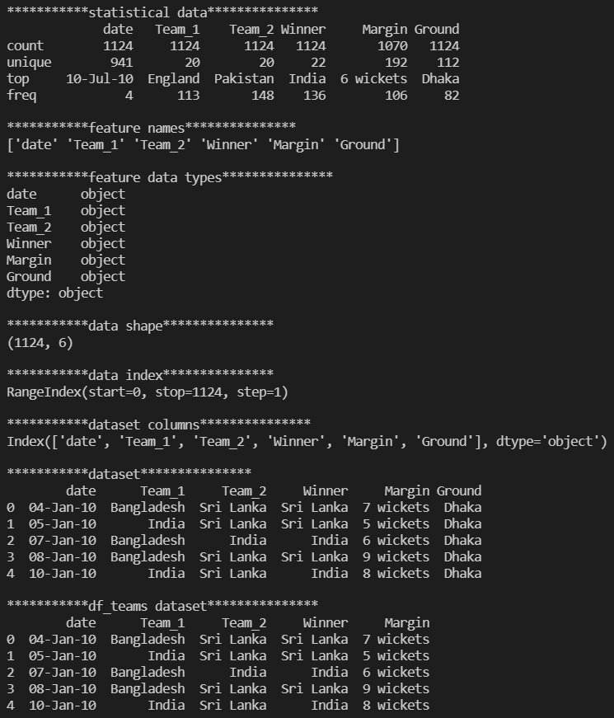



<Standard Scaling – Wicket and Runs>

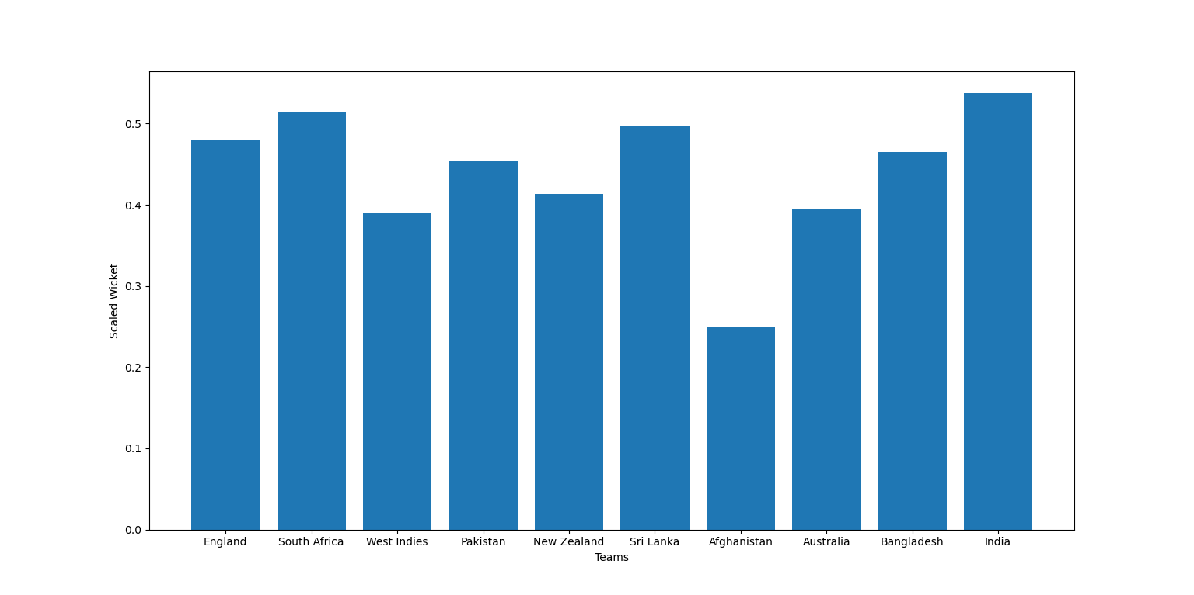

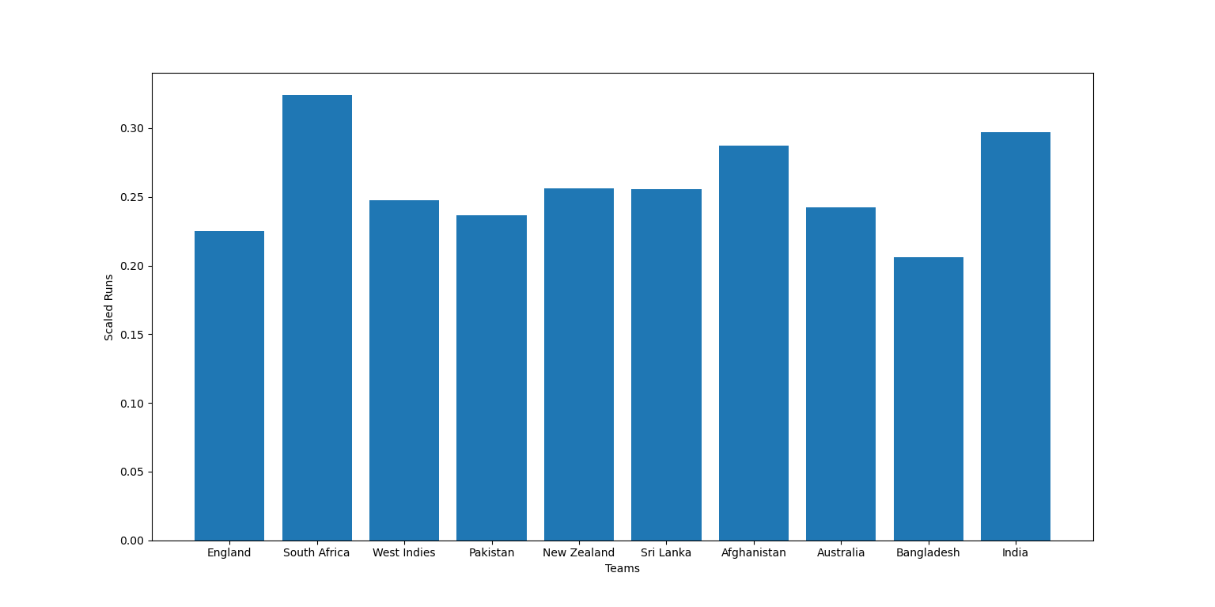

<MinMax Scaling – Wicket and Runs>

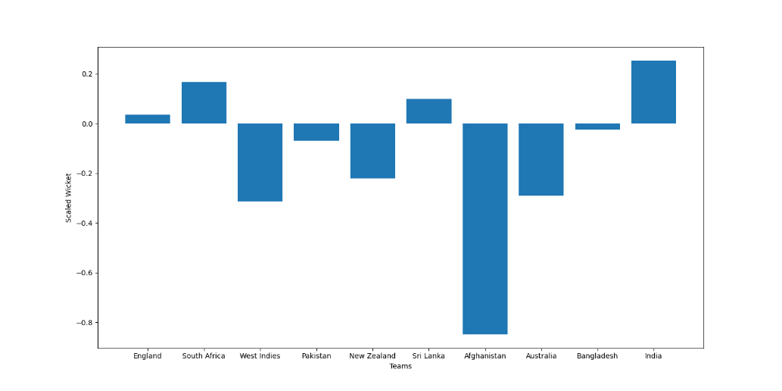

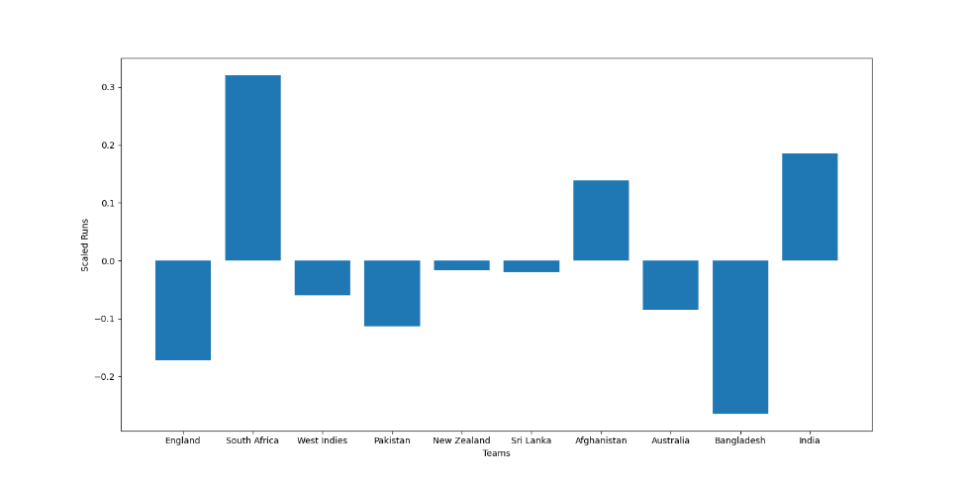

<Robust Scaling – Wicket and Runs>

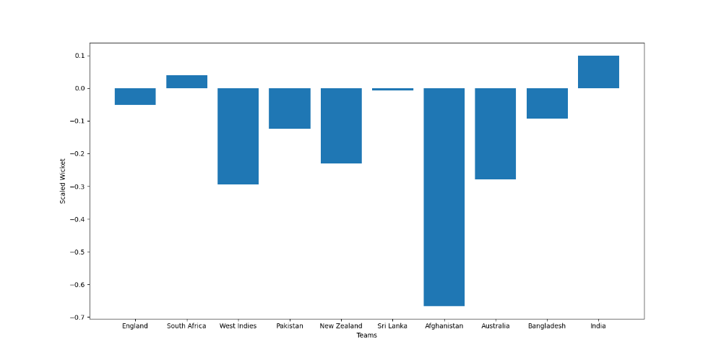

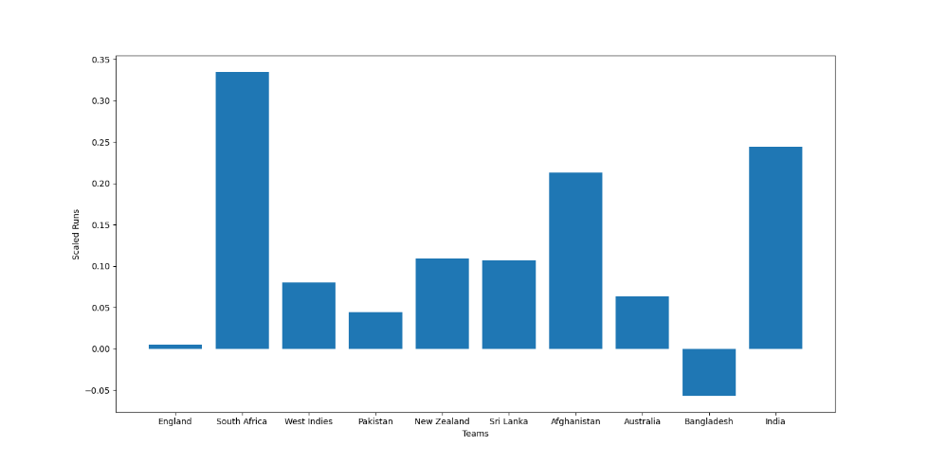

<Linear Regression>

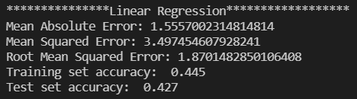

<Logistic Regression>

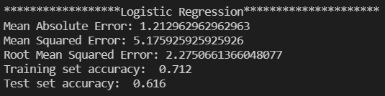

<Random Forest>

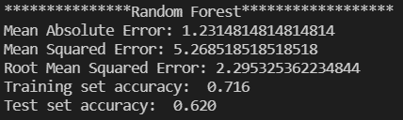

<KNN plot according to k value>

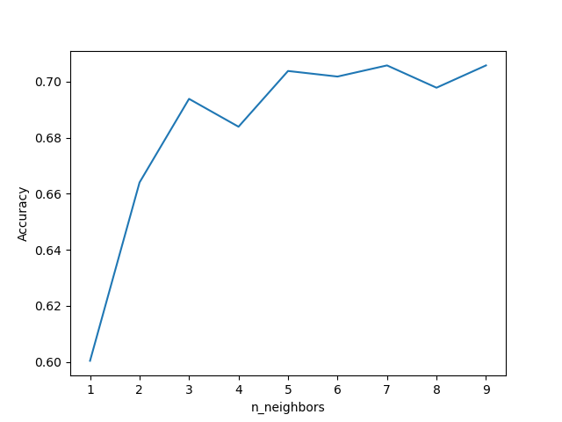

<Prediction and Accuracy of KNN (k = 7)>

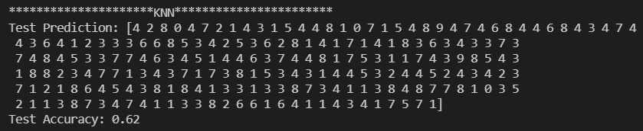

<Confusion Matrix – Logistic Regression>

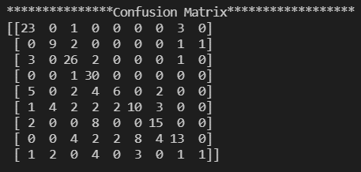

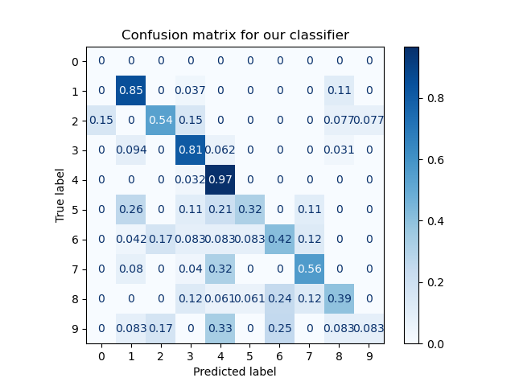

<Classification Report – Logistic Regression>

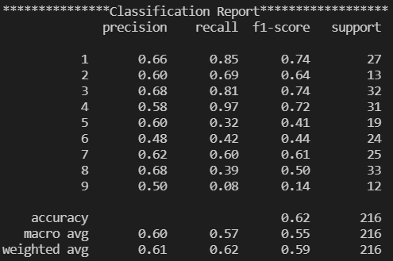

<MinMaxScaler result – df_teams>

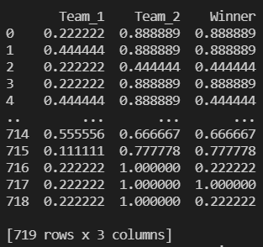

<StandardScaler result – df_teams>

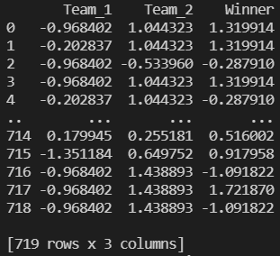

<RobustScaler result – df_teams>

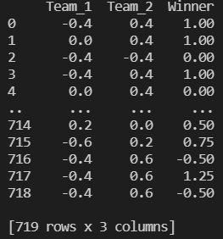

<MinMaxScaler & Kfold (Linear regression, Logistic Regression, Random Forest>

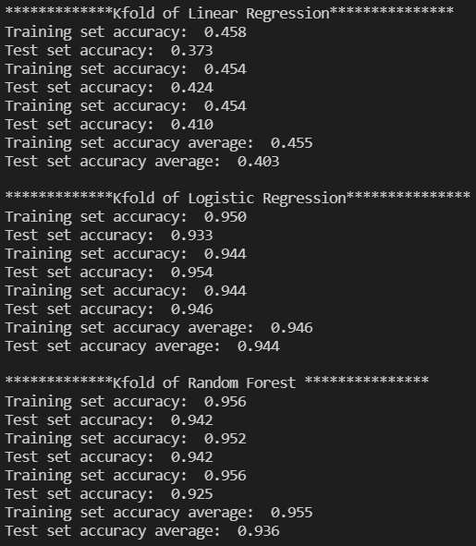

< StandardScaler & Kfold (Linear regression, Logistic Regression, Random Forest >

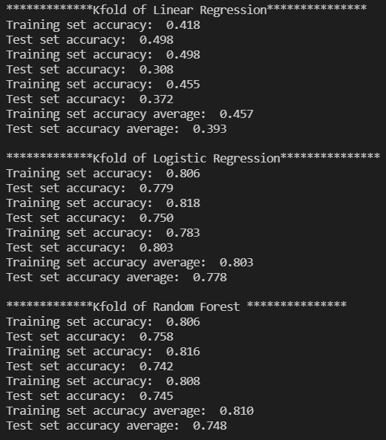

< RobustScaler & Kfold (Linear regression, Logistic Regression, Random Forest >

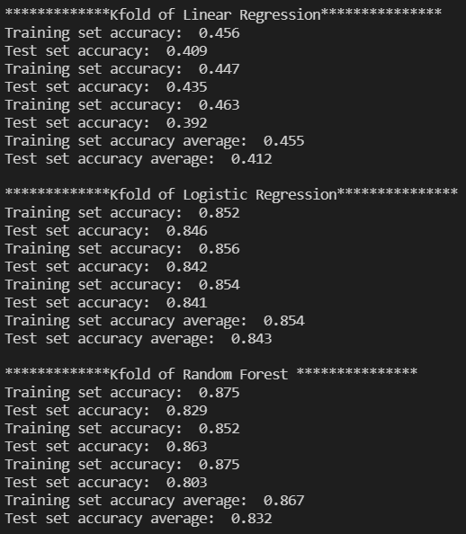

<Best Combination Accuracy>



<Describe ‘icc_rankings’ and ‘Fixtures’ dataset>

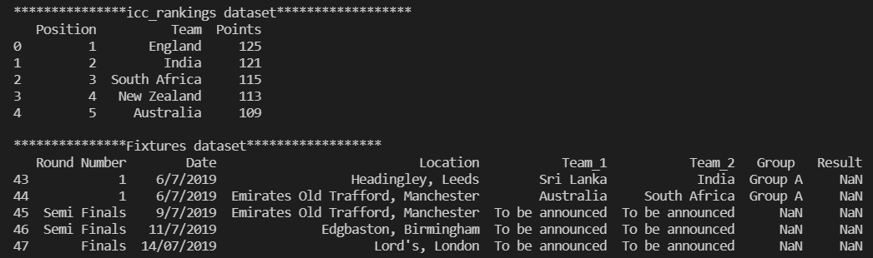

<Ranked using ‘icc_rankings’ dataset>

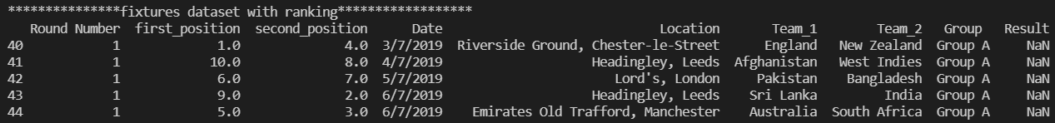

<Top 5 of team to predict the match>

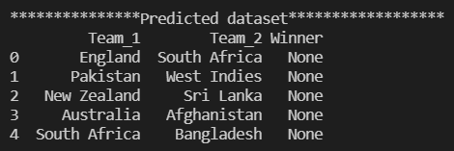

<Predicted result>

