Restaurant Tips Analytics Dashboard
with AI-Generated Business Insights
IBM SkillsBuild – Data Analytics with AI Internship
Project Report
Submitted by: Jiya Attar
Date: October 2026

1. Introduction
Restaurants generate large amounts of billing data every day, but owners often lack the time to turn it into decisions. This project builds a small analytics solution in Python that summarizes restaurant billing data in a one-page dashboard and uses generative AI to explain the results in plain language.

2. Problem Statement
A restaurant owner wants to know which days earn the most revenue, and which customers (by time of day and party size) tip best. Build a dashboard and use AI to generate business insights and recommendations.

3. Objectives
- Analyze revenue by day of the week.
- Compare tipping behaviour by time of day (lunch/dinner) and by party size.
- Present the results in a single-page interactive dashboard.
- Integrate a generative AI model to produce insights and a recommendation.

4. Dataset
The project uses the Tips dataset (seaborn-data), which contains 244 restaurant bills. It is available at https://github.com/mwaskom/seaborn-data/blob/master/tips.csv and is loaded in code with sns.load_dataset("tips"). The dataset has no missing values.
Column | Description
total_bill | Total bill amount in dollars
tip | Tip amount in dollars
sex | Gender of the bill payer
smoker | Whether the party included smokers
day | Day of the week (Thu, Fri, Sat, Sun)
time | Lunch or Dinner
size | Party size (number of people)
tip_pct (added) | Tip as a percentage of the total bill

5. Tools and Technologies
Tool | Purpose
Python 3 | Programming language
pandas | Data grouping and aggregation
seaborn | Loading the dataset
Plotly | Interactive one-page dashboard
Google Gemini API (google-genai) | Generating AI insights and recommendation
Google Colab | Development and execution environment

6. Methodology
The project follows four steps: Data → Analysis → AI Insights → Dashboard.
- Data preparation: the dataset is loaded and checked for missing values. A tip percentage column is calculated for every bill.
- Analysis: data is grouped to compute total revenue by day, average tip percentage by time, and average tip percentage by party size.
- AI integration: the grouped results are converted into a short text summary and sent to the Gemini model with a prompt asking for three insights and one recommendation. Only the summary is sent, not the raw data, which is faster, cheaper and more private.
- Dashboard: four Plotly charts (Revenue by Day, Avg Tip % by Time, Avg Tip % by Party Size, Bill vs Tip) are placed on one page, followed by the AI insights.

7. Analysis Results
Metric | Value
Total revenue | $4,828
Average tip percentage | 16.1%
Revenue – Saturday | $1,778
Revenue – Sunday | $1,627
Revenue – Thursday | $1,096
Revenue – Friday | $326
Avg tip % – Lunch | 16.4%
Avg tip % – Dinner | 16.0%
Avg tip % – party of 1 | 21.7%
Avg tip % – party of 2 | 16.6%
Avg tip % – party of 4 | 14.6%
Avg tip % – party of 6 | 15.6%

8. One-Page Dashboard

Figure 1: Restaurant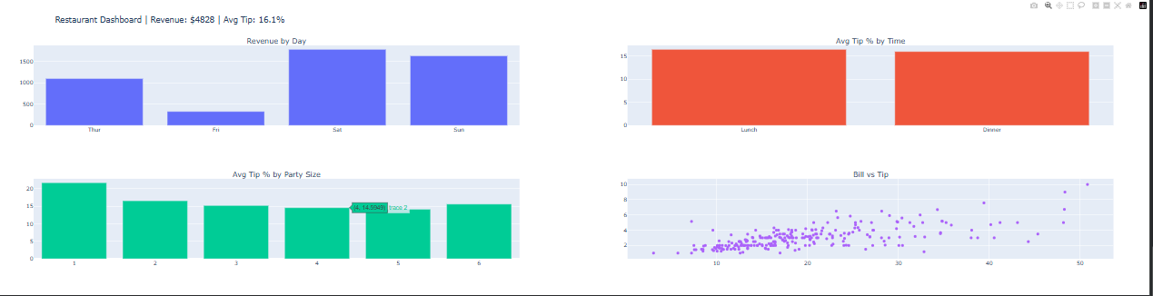 dashboard (static preview of the interactive Plotly dashboard)

9. AI Integration and Insights
The Gemini model receives the data summary and acts as a business analyst. To make the integration reliable, the code retries each model up to three times and falls back to other Gemini models if one is unavailable. If every attempt fails, a placeholder message is shown so the dashboard still renders.
AI-generated insights :
Total revenue: 4828, average tip %: 16.1
Revenue by day: {'Thur': 1096.0, 'Fri': 326.0, 'Sat': 1778.0, 'Sun': 1627.0}
Avg tip % by time: {'Lunch': 16.4, 'Dinner': 16.0}
Avg tip % by party size: {1: 21.7, 2: 16.6, 3: 15.2, 4: 14.6, 5: 14.1, 6: 15.6}

10. Key Findings
- Saturday and Sunday are the highest revenue days; Friday is the lowest.
- Small parties (especially single diners) tip the highest percentage; tip percentage falls as party size grows.
- Lunch and dinner customers tip almost equally (about 16%).

11. Business Recommendations
- Staff more servers on Saturday and Sunday to handle the highest demand.
- Run promotions on Friday to lift the weakest revenue day.
- Prioritize service quality for small parties, which tip the most.

12. Challenges and Solutions
Challenge | Solution
google.generativeai package is deprecated | Switched to the newer google-genai package
Model gemini-2.0-flash returned 404 (retired) | Updated the model name and added a list of fallback models
503 error: model overloaded | Added retry logic with waits and a final placeholder message

13. Conclusion
The project shows how a small Python workflow can turn raw billing data into decisions. The dashboard gives a quick view of revenue and tipping patterns, and the AI layer explains them in simple language with an actionable recommendation for the owner.

14. Future Scope
- Add filters for smoker/non-smoker and gender.
- Use a larger, real restaurant dataset with dates to study trends over time.
- Deploy the dashboard as a web app using Streamlit.
- Add a chat box so the owner can ask the AI questions about the data.

15. References
- Tips dataset: https://github.com/mwaskom/seaborn-data/blob/master/tips.csv
- Google AI Studio and Gemini API documentation: https://ai.google.dev
- Plotly documentation: https://plotly.com/python

