Assignment

- OSI layer Explanations

- Layer 1 – Physical

The physical layer deals with the actual movement of bits which is 0s and 1s across the medium. At this layer no meaning is attached to the data it only ensures that raw bits travel from one device to another.
Examples include Ethernet cables (like Cat 6), fibre-optic lines, hubs and physical standards such as USB or Bluetooth radio frequencies. A real-world analogy is a road or railway track i.e.; this layer provides the path on which everything else travels but does not worry about traffic rules or what is being transported.

- Layer 2- Data Link Layer
The data link layer is the second layer of the OSI model, responsible for reliable data transfer between two directly connected nodes on a network. It handles MAC addressing, error detection, and controlling who gets to send data at what time. A good analogy is a local delivery service inside a neighbourhood, it knows each houses MAC addresses.

C. Layer 3- Network Layer
The network layer is responsible for routing data packets across different networks by handling logical addressing, path determination and forwarding. Protocols include IPv4, IPv6, ICMP and routing protocols such as OSPF or BGP. A real-world analogy is a nationwide postal system, it looks at full addresses, determines the best route through many cities and forward mail toward the destination even if it requires multiple hops

D. Layer 4 – Transport Layer
Transport layer is responsible for end-to-end communication and providing transparent data transfer between applications running on different hosts. It breaks data into segments, tracks what has been sent, retransmits missing pieces and control flow to avoid congestion. protocols like TCP ensure reliability, UDP focuses on speed without guaranteeing delivery.
A real-world analogy is a courier service that keeps track of each parcel, confirms delivery and replaces lost items (TCP), or a fast newspaper delivery where speed matters more than confirmation (UDP).

E. Layer 5- Session Layer
This layer is responsible for establishing, managing and terminating communication sessions between applications on different devices. The analogy is a moderator controlling a meeting, deciding when the conversion starts, ensuring participants stay connected, and officially closing the meeting when finished.

F. Layer 6- Presentation Layer
It is responsible for translating and formatting data to ensure compatibility between systems. A real-world analogy is a translator which converts a message into a language where both the users understand or encrypts it in a secret code when privacy is needed.

G. Layer 7- Application Layer
The Application Layer is where the user interacts with the network. It provides services such as email, file transfer, web browsing, and remote login. Protocols include HTTP/HTTPS, FTP, SMTP, DNS, etc...
The real-world analogy is the actual service counter customers interact with, a bank teller or restaurant waiter providing the service directly to the user while relying on all the lower layers to support the communication behind the scenes.

- OSI Mnemonic
“Please do not touch Sandy’s pet Anaconda”
Please Physical
Do Data link
Not Network
Touch Transport
Sandys Session
Pet Presentation
Anaconda Application

- OSI vs TCP/IP Model Comparison

The OSI model is a detailed reference with seven layers. Each layer describes a specific stage of data communication. It is mainly used to teach, design, and understand network functions in a structured way. In contrast, the TCP/IP model is a practical framework used by the internet. It has four layers that group similar OSI functions based on how actual protocols work. While OSI separates concepts like presentation, session, and application into three layers, TCP/IP combines them into a single Application layer. This makes the model simpler and more focused on implementation.
Another difference is perspective. OSI emphasizes how communication should occur step-by-step as a guideline. On the other hand, TCP/IP defines what protocols actually operate as a functioning standard. Even though both models differ in structure, they complement each other. TCP/IP protocols can be explained using OSI’s more detailed layered concepts.

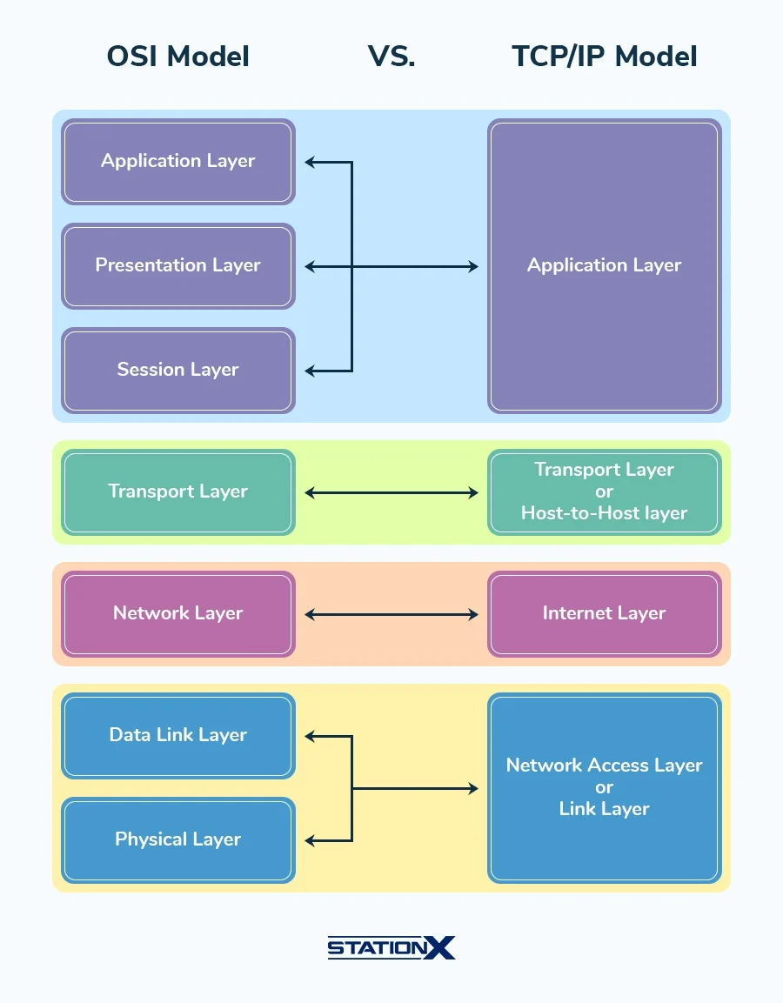

- Protocol Data Units (PDUs)
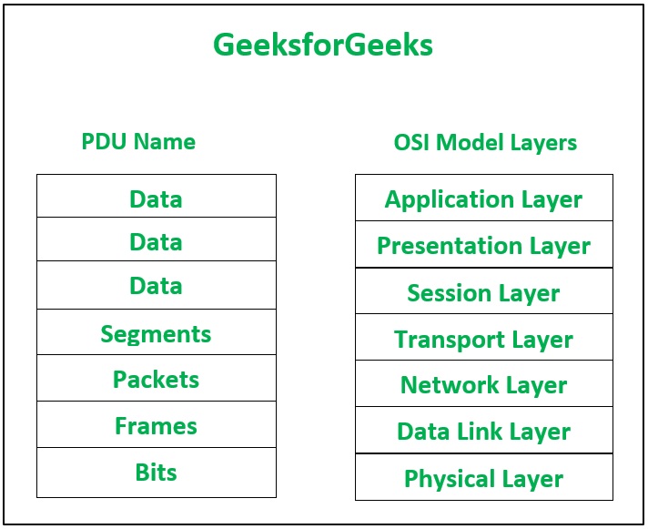

- Addressing Concepts
- MAC address used at Layer 2 (Data Link)
A MAC address is a physical address associated with a network interface card. It identifies a device on a local network. At the Data Link Layer, MAC addresses facilitate the delivery of frames within the same LAN segment. Switches use MAC addresses to determine where to send frames. Since MAC addresses only work within local networks, they do not pass through routers.

- IP Address – used at Layer 3 (Network)
IP address is a logical address used to identify devices across different networks. At the network layer, IP addresses are used for routing, finding the best path from the source network to the destination network.

- Port Number – used at Layer 4 (Transport)
A port number identifies a specific application or service running on a device. At the transport layer, port numbers help the system deliver data to the correct program.

PART B
1. HTTP Traffic (Application over TCP)
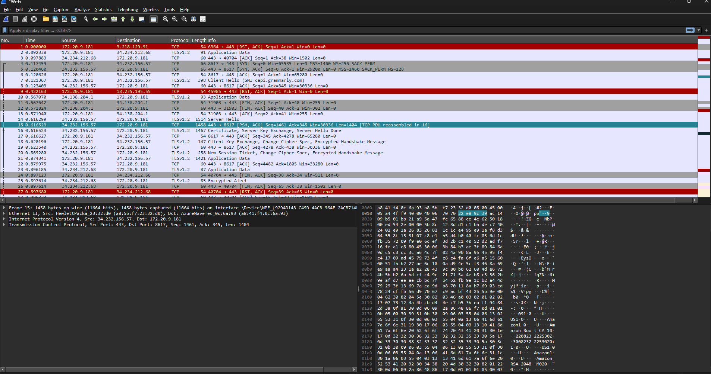
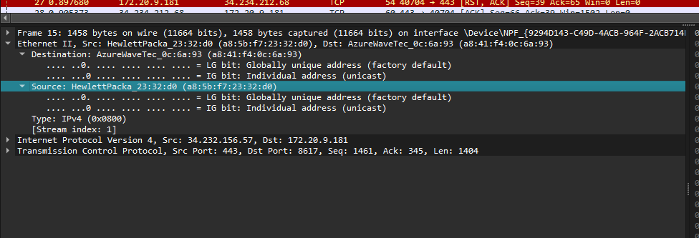

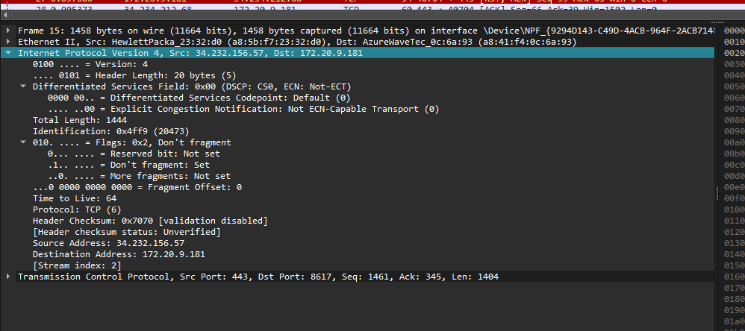

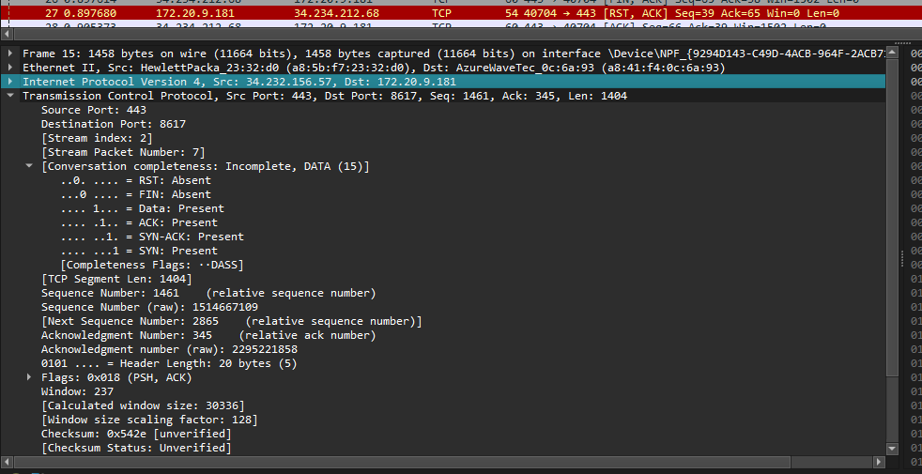

2. TCP Packets
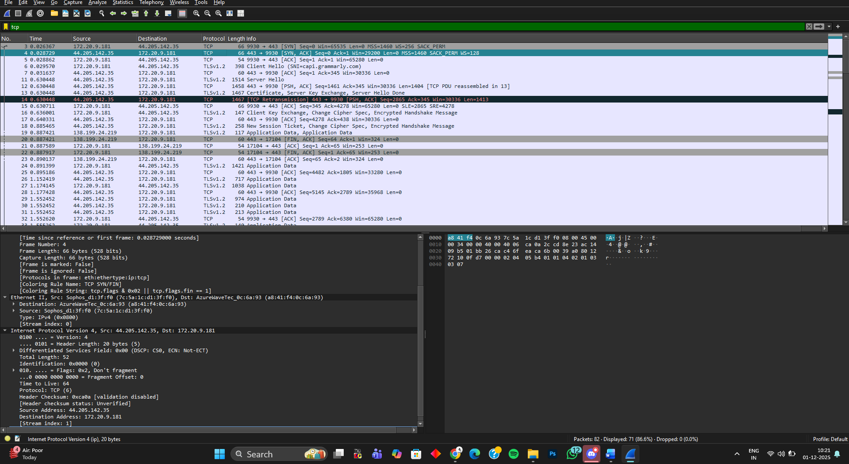

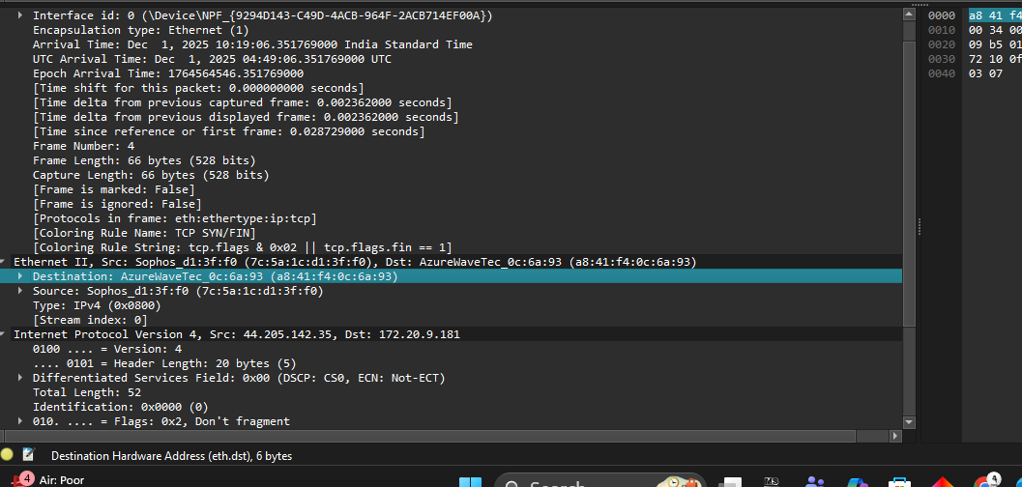

3. UDP Packets
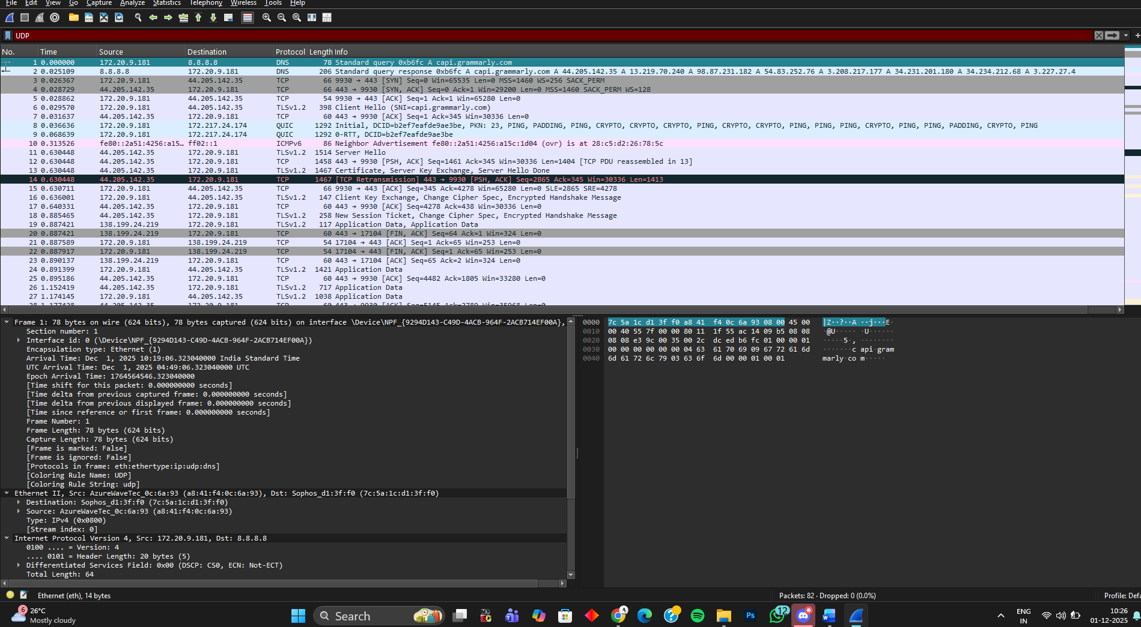

4. ICMP Packets (Ping)
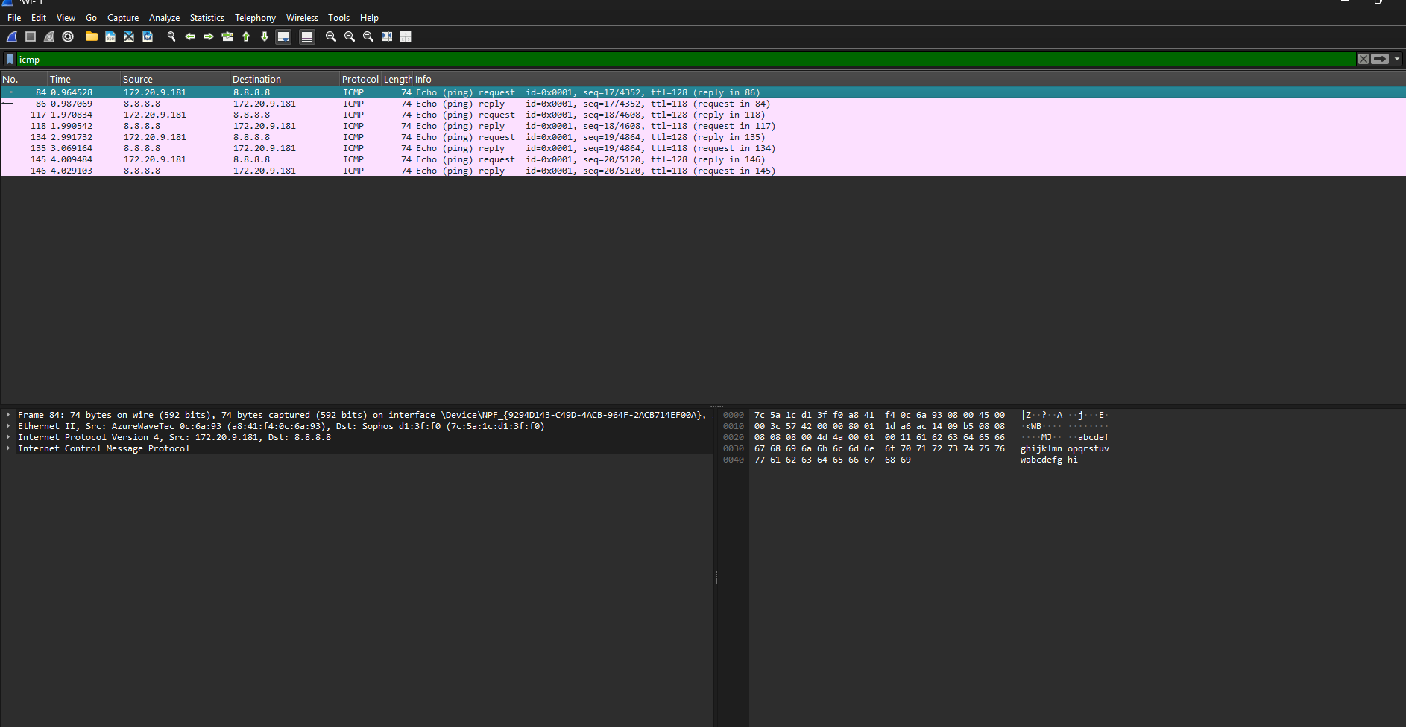
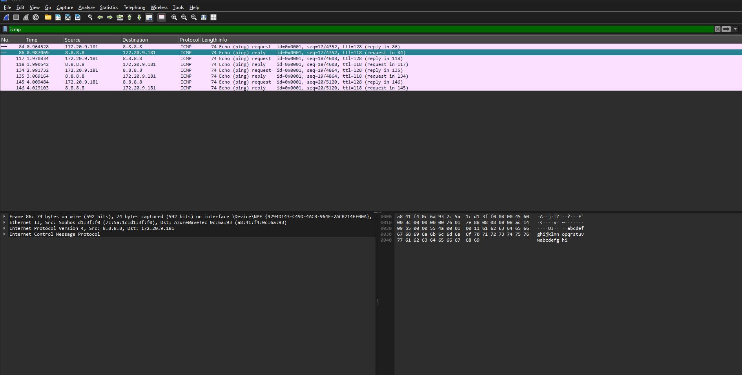

OUTCOME
From this activity I learned how the OSI Model organizes network communication into seven layers, each with a specific role in moving data from one device to another. I also understood how important addressing concepts work at different layers MAC addresses at the Data Link Layer, IP addresses at the Network Layer, and port numbers at the Transport Layer. By comparing the OSI and TCP/IP models, I learned how theory and real-world networking fit together, and how protocols are grouped in practical implementations. Overall, this activity helped me build a structured understanding of how networks function from the physical signals all the way up to user-level applications. Also, in filtering out the packets using Wireshark

