AUTONOMOUS
CONTEXT-AWARE FOOD WASTE
OPTIMIZATION SYSTEM
End-to-End Build, Synthetic Data, Agentic Workflow, Evaluation and Deployment Blueprint

Prepared for the project team
Jiya Mishra — 24BCE0779
Hasini Kanneganti — 24BCE0697
Mehul Jain — 24BCT0024

Primary implementation principle: every generated record and every simulated outcome must be explicitly labelled synthetic.

How to use this document
This is a build specification intended to be given to another AI coding assistant or used by the team as an implementation contract. It converts the submitted presentation and notes into an ordered engineering workflow. The presentation’s central contribution is retained: the system must move beyond prediction into diagnosis, intervention, observation and learning.
- Build the smallest complete vertical slice first: one meal, synthetic historical data, forecast, batch recommendation, dashboard, feedback and evaluation.
- Then add the remaining contextual signals and agent roles incrementally. Do not create many empty agents just to claim a multi-agent architecture.
- Use deterministic, testable Python tools for calculations and constraints. Use an LLM for explanations, structured diagnosis and planning where it adds value—not for arithmetic or unconstrained food-safety decisions.
- Treat the attached August 2026 R Mess menu as a menu template/source for menu names and meal structure, not as evidence of actual attendance, consumption or waste.
Scope boundary
The first release is a synthetic-data prototype. It must not claim that it is connected to VIT systems, real attendance feeds, real weather APIs, kitchen equipment or live student identities unless those integrations are actually built and authorized.

Contents
- 1. Project definition and acceptance criteria
- 2. Source materials reviewed and what they establish
- 3. Product scope and user roles
- 4. End-to-end architecture
- 5. Synthetic data design and generation plan
- 6. R Mess menu ingestion and menu catalogue
- 7. Database schema
- 8. Feature engineering and availability engine
- 9. Forecasting, preference modelling and rush prediction
- 10. Waste diagnosis and agent architecture
- 11. Decision optimizer and kitchen batch policy
- 12. Real-time simulation and closed-loop learning
- 13. Frontend pages and dashboard behaviour
- 14. API contract
- 15. Testing, evaluation and reporting
- 16. Security, privacy, safety and honesty controls
- 17. Deployment architecture and step-by-step release
- 18. Suggested repository structure and development order
- 19. Definition of done and marking-oriented evidence
- 20. Master prompt for another AI to implement the complete project
- Appendix A. Attached source images and menu references

1. Project definition and acceptance criteria
Project title: Autonomous Context-Aware Food Waste Optimization System.
Problem: institutional cafeterias often prepare quantities using capacity or fixed schedules even though actual demand changes with availability, academic schedules, menu, weather, events, day of week and arrival patterns. Predicting demand alone does not prevent waste unless the system converts the forecast into safe, operationally feasible actions and then learns from the result.
Goal: implement a context-aware closed loop that predicts demand and arrival timing, identifies likely waste causes, recommends initial batches and conditional replenishment, records the simulated outcome, and evaluates waste and shortage trade-offs.

Must-have acceptance criteria
- A reproducible synthetic-data generator creates related data across meals, dates, menus, timetables, exams, events, weather, attendance, prepared quantities, consumption and waste.
- Every synthetic table and generated chart is labelled as simulated/demo data.
- A menu catalogue covers the meal items found in the attached vegetarian August 2026 R Mess menu; non-vegetarian menu images are reference material only and are not required for the vegetarian prototype.
- A student availability engine accounts for class/lab/exam overlap, estimated travel time, hostel/mess mapping and attendance history at aggregate or pseudonymous level.
- The system predicts total meal demand and demand by time interval; it exposes uncertainty or a range instead of pretending a synthetic estimate is exact.
- A baseline model is compared with at least one improved context-aware model using a chronological holdout split.
- A waste diagnosis module returns ranked possible causes with evidence and confidence/uncertainty.
- A constrained optimizer creates an initial batch, reserve/replenishment quantity, trigger rule and rationale.
- A simulation endpoint or dashboard control can run a meal forward in time and compare the recommended policy with a baseline policy.
- The dashboard shows forecasts, rush curves, food-by-food recommendations, waste, shortage risk, interventions and evaluation metrics.
- The application has automated tests, seeded data generation, documented environment variables and deployment instructions.
- No synthetic results are described as real cafeteria results; no automatic live kitchen control is claimed.

2. Source materials reviewed and what they establish

2.1 Presentation: 16 slides
The presentation names the project “Context-Aware AI Agent for Autonomous Food Waste Reduction in Institutional Cafeterias.” Its main argument is that fixed preparation causes avoidable waste when demand changes. The slides establish the proposed system’s main modules and metrics.
Presentation location | Source-derived content | Implementation consequence
Slides 2–6 | Problem, context dependence and research gap; monitoring or prediction alone is insufficient. | Show the full predict → diagnose → decide → act → observe → learn loop.
Slides 7, 10 | Closed-loop agent and six-stage pipeline: collection, processing, context, prediction, intervention, feedback. | Implement these as traceable backend stages with persisted outputs.
Slide 8 | Preference is context-dependent, e.g. food preference varies by weather and context; displayed values are illustrative. | Train/test preference model on synthetic survey and meal outcomes; label sample scores illustrative.
Slide 9 | Variables include demand, preference, waste, prepared quantity, consumption, attendance and context; objective balances waste and preparation cost with constraints and split batches. | Encode a transparent objective and hard constraints in a deterministic optimizer.
Slides 11–12 | Orchestrator, demand/preference/waste/context agents, diagnosis, intervention, action, outcome monitoring and learning; intervention categories include preparation, serving, menu and surplus. | Implement specialized modules and an orchestrator; use tools for calculations.
Slide 13 | Rainy-day example is explicitly illustrative, not experimental. | Do not reuse its numbers as results. Generate a new reproducible simulation.
Slides 14–15 | Stack: React/Streamlit, Python/FastAPI, PostgreSQL, scikit-learn/XGBoost, Pandas/NumPy, optional LLM/tool calling, weather API, Plotly, Docker; metrics include MAE, RMSE, R², waste reduction, shortages and response time. | Use React + FastAPI + PostgreSQL + scikit-learn first; add optional integrations only if they work.
Slide 16 | Expected contribution: context-aware preferences, weather-conditioned consumption, cause-oriented diagnosis, closed-loop intervention and feedback adaptation. | Map evaluation and final report directly to these five contributions.

2.2 Detailed project notes
The notes expand the context features: class timetable and rush distribution, evening theory/class conflict during snacks, exams, labs, campus events, sports, day of week, menu repetition/fatigue, hostel-specific patterns, previous meal attendance, portion/serving behaviour and cross-item substitution. They also outline a student availability engine and a proposed Google Form for collecting preference and meal behaviour.
The prototype should model these features as separate data entities and engineered features. Where a real timetable or real survey is unavailable, create synthetic equivalents with a documented generation process.

2.3 Attached technology-stack screenshot
The screenshot suggests React + Vite + Tailwind CSS; Python + FastAPI; OpenAI Agents SDK; an OpenAI model; scikit-learn/XGBoost; a custom spaced-repetition learning engine; OR-Tools; PostgreSQL; pgvector; WebSockets/Socket.IO; Redis Streams/Pub/Sub; Celery + Redis; RAG with LlamaIndex/LangChain or custom retrieval; JWT/OAuth; Docker + AWS/Render/Railway. Not every technology is necessary for a credible prototype. The implementation plan below distinguishes required components from optional scale-up components.
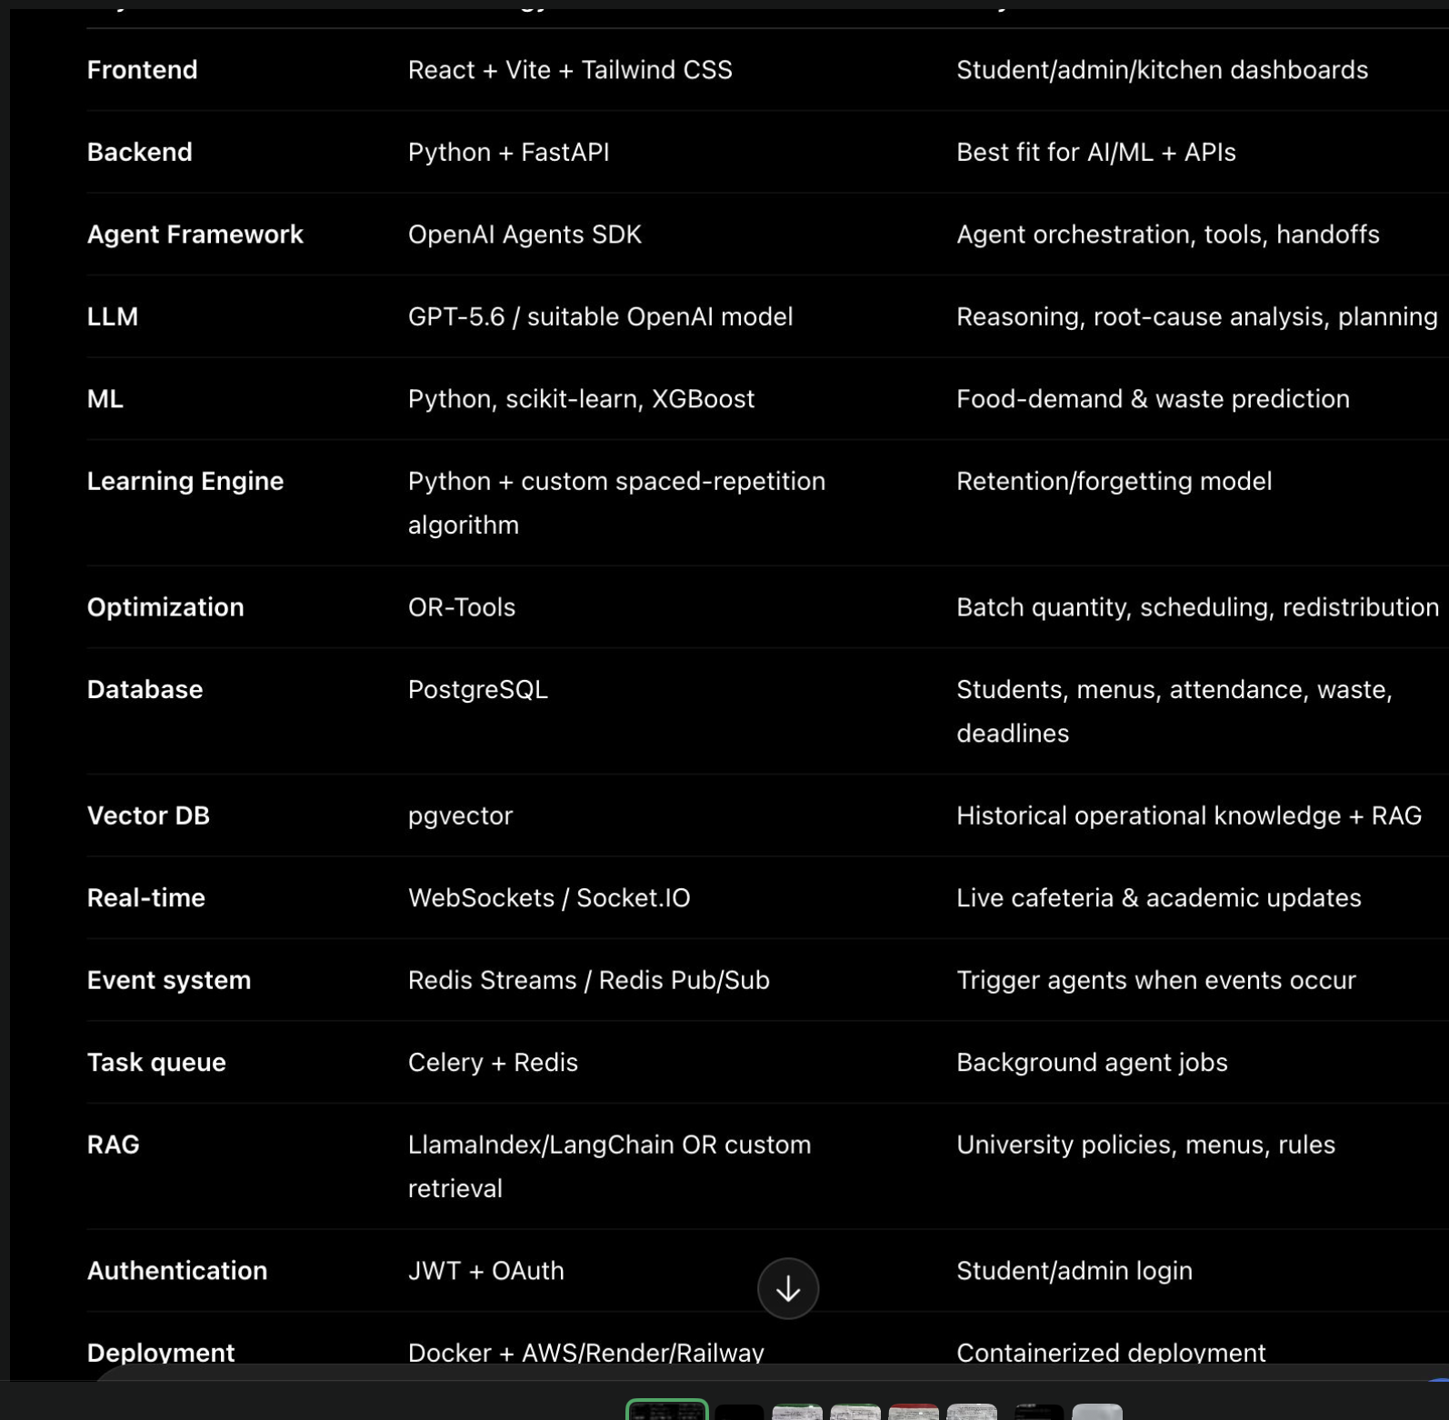
Attached technology-stack reference screenshot supplied by the team.

2.4 R Mess menu photos
The attached menu photos show the Ladies Hostel, VIT Vellore, vegetarian and non-vegetarian August 2026 menus, including breakfast, lunch, snacks and dinner. The prototype should use the vegetarian menu as the default demonstration menu because the project notes and user context describe a vegetarian mess workflow. Menu names can be seeded from the photographed menu, but the image does not provide portion counts, recipes, actual consumption or measured waste.

3. Product scope and user roles
Role | Primary tasks | Permissions
Admin / project evaluator | Manage synthetic scenarios, meal windows, menu catalogue, model version, demo resets and evaluation runs. | Full demo access; no real personal data.
Mess manager | Review demand forecast, expected rush, initial batch, reserve batch, shortage risk and reasons. | Approve/reject simulated operational recommendations.
Kitchen operator | View batch plan, current service state, replenish/hold instructions and remaining quantity. | Record simulated batch start, portions served and remaining stock.
Analyst / evaluator | Compare baseline and agent policy, inspect prediction errors, waste, shortages and intervention logs. | Read-only reports and reproducible runs.
Student feedback respondent (synthetic) | Contribute anonymized preference and typical attendance responses. | Only synthetic/pseudonymous sample records in the prototype.

Out of scope for the first prototype
- Direct integration with real VIT attendance, timetable, hostel or mess billing systems without authorization.
- Automatic operation of real kitchen equipment or automatic changes to actual food production.
- Personalized decisions about identifiable students; use group-level aggregates or pseudonymous synthetic profiles.
- Automated donation/redistribution without human approval and verified food-safety, time-temperature and institutional policies.
- Claims of actual waste reduction based only on synthetic experiments.

4. End-to-end architecture
Synthetic Data Generator / Admin Imports
|
v
Data Validation + ETL
|
v
PostgreSQL <----> Feature Builder / Context Snapshot Service
| |
| v
| Student Availability Engine
| |
| v
| Demand + Rush Forecasting
| |
| v
| Waste Risk Estimator
| |
| v
| Root-Cause Diagnosis
| |
| v
| Decision Planner / Optimizer
| |
| v
| Batch & Action Plan
| |
| v
| Meal-Service Simulator
| |
| v
+<--- Outcome Log / Metrics / Model Feedback
|
v
FastAPI REST + WebSocket
|
v
React + Vite + Tailwind + Plotly

Design rule: the LLM/agent layer orchestrates tools and explains decisions. Numerical forecasts, data joins, constraints, batch calculations and metrics must be implemented in deterministic or trained Python modules and covered by tests.

Recommended first-release stack
Layer | Required choice | Why | Optional later
Frontend | React + Vite + Tailwind CSS + Plotly | Role-based dashboard and interactive plots. | Streamlit only for a fast internal prototype; do not build both frontends initially.
Backend | Python + FastAPI + Pydantic | Typed API contracts, model-serving endpoints and docs. | WebSockets for live demo updates.
Data | PostgreSQL | Relational operational records, experiment logs and model metadata. | pgvector only if RAG is implemented.
Data science | Pandas, NumPy, scikit-learn; XGBoost optional | Reliable tabular feature engineering and demand prediction. | MLflow for experiment tracking.
Optimization | OR-Tools or transparent custom constrained optimizer | Batch planning under capacity, minimum availability and replenishment constraints. | OR-Tools if scheduling constraints become complex.
Agent orchestration | Explicit Python orchestrator with typed tools; optional OpenAI Agents SDK | Auditable multi-step coordination. | LLM tool calling for diagnosis/explanation; never required for every numerical step.
Background jobs | In-process task for demo; Celery + Redis only if needed | Avoid unnecessary infrastructure before core workflow works. | Scheduled retraining and long simulations.
Deployment | Docker Compose locally; frontend/backend/database hosted with secrets | Reproducible build and simpler evaluation. | AWS or another cloud when the app is stable.

5. Synthetic data design and generation plan
Synthetic data must be internally consistent: every meal’s prepared quantity, served/consumed quantity, leftover and plate-waste quantities must obey defined accounting rules. Do not generate independent random columns that contradict one another.

5.1 Dataset grain and time span
- Prototype horizon: 6–12 months of synthetic meal records, across breakfast, lunch, snacks and dinner, with multiple food items per meal.
- Generate at least 3 synthetic hostel/mess groups and 500–2,000 pseudonymous synthetic residents for variation; the number is a design setting, not a claim about actual VIT population.
- Use 30-minute service intervals, configurable by meal. The menu photos list mess time windows; use the times visible in the menu reference as defaults only if they match the demo scenario.
- Use a fixed random seed (for example, 42) so the same dataset and demo can be reproduced.
- Store `is_synthetic=true`, `generation_seed`, `generated_at` and `scenario_id` for every generated dataset/run.

5.2 Synthetic source tables to generate
Dataset | Key columns | Generation logic
residents_synthetic | resident_key, hostel_id, mess_id, cohort, active_dates | Random pseudonymous IDs; no real names, registration numbers or phone numbers.
hostel_daily_state | date, hostel_id, occupied_count, occupancy_rate | Vary by weekday, holiday and scenario; enforce occupied_count ≤ capacity.
academic_slots | date, cohort_id, activity_type, start_time, end_time, location_id | Generate theory/lab blocks, exams and free periods; enforce valid times.
campus_events | event_id, date, start/end, type, location, affected_cohorts, expected_participants | Create event overlap and attendance-shift scenarios.
weather_daily | date, rain_mm, temperature_c, weather_label, source_type | Synthetic weather regimes; no live weather claim.
menu_calendar | date, meal_type, dish_id, dish_name, category, vegetarian_flag, repetition_count | Seed dishes from attached vegetarian menu and rotate plausible menu cycles.
preference_survey_synthetic | respondent_key, dish/category ratings, weather preference, timing habits, dietary flags | Simulate survey response distributions; do not present as actual survey results.
meal_attendance | meal_id, interval_start, arrivals, cumulative_attendance, hostel_id | Generate arrivals using availability and context, not just total capacity.
food_operations | meal_id, dish_id, prepared_qty, served_qty, consumed_qty, untouched_leftover, plate_waste, unit | Generate linked quantities with accounting constraints.
batch_events | meal_id, dish_id, timestamp, batch_type, quantity, trigger_reason, approved_by | Record initial and replenishment batches.
predictions | meal_id, dish_id, model_version, predicted_demand, lower_bound, upper_bound, predicted_rush_curve | Persist every prediction for later evaluation.
interventions | meal_id, action_type, proposed_value, applied_value, reason_codes, status | Capture recommendation, approval and simulated execution.
outcomes | meal_id, dish_id, actual_consumption, leftover, waste, shortage, intervention_result | Created after simulation; linked to prediction and policy run.

5.3 Accounting definitions (must be consistent)
prepared_qty = sum of all batches cooked for the dish
served_qty = quantity placed in serving line / made available
consumed_qty = estimated quantity actually eaten
untouched_leftover = safe, unserved or recoverable leftover measured separately
plate_waste = food taken/served but not eaten
shortage_qty = max(0, demand_qty - available_servings)

For a simplified portion-count simulation:
consumed_portions <= served_portions <= prepared_portions
leftover_portions = prepared_portions - served_portions
plate_waste_portions is tracked separately from unserved leftovers.
Do not add plate waste to unserved leftovers if both are already in total waste.

For the first demo, select one clear unit per dish (portions or kilograms). Do not mix kilograms and portions in a single arithmetic expression. If kilogram-based waste is shown, maintain a conversion factor per dish and state it is synthetic.

5.4 Synthetic scenario library
Scenario | Context | Expected system behaviour to test
Normal weekday | Typical timetable, moderate weather, usual menu. | Baseline forecast and normal batch plan.
Early-class rush | Many classes begin at 8:00 AM during breakfast. | Higher demand in the earlier interval; lower later batch.
Exam morning | Exam overlaps or precedes breakfast for a subset of students. | Availability and attendance adjusted according to learned synthetic patterns, not a universal fixed reduction.
Evening theory conflict | Many cohorts have class during snacks. | Snack demand reduced or shifted; initial batch reflects available population.
Heavy rain | Synthetic rainfall regime and context-dependent preference response. | Use learned association; do not hard-code ‘rain always reduces demand’.
Campus fest / sports | Event overlaps with snacks or dinner for a known synthetic group. | Estimate affected share and potential demand shift.
Menu fatigue | Dish or combination repeated within a short interval. | Model repetition feature and test whether it predicts lower acceptance in the generated data.
Surprise surge | Actual arrivals exceed forecast during service. | Trigger replenishment if capacity, lead time and safety constraints allow.
Demand collapse | Actual arrivals are below forecast. | Hold/cancel subsequent batch where feasible and log why.

Synthetic-data honesty
The generator may intentionally encode patterns to test whether the pipeline can recover them. Report this as a controlled simulation. Do not claim it proves that the same relationships exist among actual VIT students.

6. R Mess menu ingestion and menu catalogue
Use the vegetarian menu photos to create a manually verified menu catalogue for the demo. OCR can assist, but the source images are photographed, angled and partially reflective; manually verify dish names before inserting them. Keep the source date and image filename in a provenance field.
Meal | Examples visible in the attached vegetarian menu photos | How to use in prototype
Breakfast | Aloo paratha, idli, vada, kichadi, pongal, thin masala dosa, poori, upma, semiya, chutney, sambar, curd, tea/coffee/milk. | Seed dish catalogue and meal-combination features.
Lunch | Phulka/chapathi, dal varieties, white rice, rasam, sambar, poriyal, curd, vegetable biryani, paneer dishes and listed sweets. | Model dish-level demand and correlated staple/curry consumption.
Snacks | Samosa, veg puffs, raw banana bajji, black channa, dahi papdi chat, masala peanuts, pizza, cake and beverages. | Model snack availability conflicts and interval rush.
Dinner | Phulka/chapathi, dal, white rice, rasam, sambar, curd, vegetable dishes, veg fried rice, and listed fruits. | Model late-day demand and meal attendance.

The photos show different menu variants and the non-vegetarian menu separately. For a clear initial scope, build the vegetarian menu first; optionally add a separate non-vegetarian catalogue only if the project scope explicitly requires it. The photographed menu provides dish names and scheduled meal windows, not recipe quantities or nutrition data.

Dish catalogue fields
dish_id, dish_name, category, meal_type, vegetarian_flag,
default_unit, typical_portion_size, prep_lead_minutes,
batch_min, batch_max, kitchen_capacity_per_interval,
shelf_life_minutes, menu_source, source_date, is_synthetic

Menu fatigue and substitution
- Calculate `days_since_last_served`, `count_last_7_days`, and recent combination frequency for each dish.
- Represent dish combinations and substitution links, e.g. a preferred curry may increase rice demand; one filling item may reduce demand for other items.
- Use preference ratings as one feature, not as a direct command to change the menu.
- Menu changes are recommendations for the manager, not automatic menu edits in the first prototype.

7. Database schema
Use PostgreSQL for structured operational records. Use migrations (for example Alembic) and foreign keys. Store model predictions and intervention decisions as immutable run records so that results can be reproduced.
Table | Purpose / important fields
users | id, email, password_hash, role, created_at; only if authentication is implemented.
hostels | id, name_or_code, capacity, linked_mess_id.
meal_windows | id, meal_type, start_time, end_time, interval_minutes.
dishes | id, name, category, vegetarian_flag, unit, prep_lead_minutes, batch limits, source provenance.
menu_items | date, meal_type, dish_id, planned availability, repetition features.
synthetic_context | scenario_id, date, weather, exam/event/day flags, occupancy and synthetic marker.
academic_slots | date, cohort_id, activity type, start/end, location; no real personal identifiers.
availability_snapshots | meal_id, interval, available_population, expected_arrivals, uncertainty bounds.
meal_runs | id, date, meal_type, scenario_id, policy, status, random_seed, created_at.
meal_item_actuals | meal_run_id, dish_id, prepared, served, consumed, leftover, plate_waste, shortage.
predictions | meal_run_id, dish_id, model_version, predicted_demand, bounds, prediction timestamp.
batch_plans | meal_run_id, dish_id, initial_qty, reserve_qty, trigger_threshold, lead time, rationale.
agent_traces | meal_run_id, stage, agent/module, input summary, tool calls, output JSON, duration, status.
diagnoses | meal_run_id, dish_id, ranked causes, evidence, confidence, caveats.
interventions | meal_run_id, action, proposed/applied value, approval status, reason and result.
evaluation_runs | id, dataset version, train/test dates, model/policy version, metrics, seed.
feedback_events | meal_run_id, actual outcome, prediction error, policy effect, model-update status.

Data integrity constraints
- Foreign keys connect predictions, batches, outcomes and evaluations to their meal run and dish.
- Quantities must be non-negative; prepared quantity cannot exceed declared kitchen capacity.
- Time intervals must have start < end; events and classes must use a consistent timezone.
- Every synthetic row has a synthetic provenance flag and scenario/run ID.
- Store both raw contextual inputs and engineered feature snapshots used for each prediction.
- Do not overwrite past predictions after outcomes arrive; create a new model version or prediction run.

8. Feature engineering and student availability engine

8.1 Availability calculation
The availability engine estimates the population that can realistically attend each meal and each time interval. The system must not assume all hostel residents will eat every meal. Start with cohort/hostel aggregates and pseudonymous synthetic profiles.
available_population(t) =
occupied_population
- unavailable_due_to_class_or_lab(t)
- unavailable_due_to_exam(t)
- unavailable_due_to_event(t)
+ expected_returning_or_delayed_population(t)

expected_attendance(t) =
sum_over_groups(available_population[group,t]
* attendance_probability[group, meal, context])

Apply overlap handling so one student/group is not subtracted multiple times
for simultaneous class, exam and event records. Model time windows rather
than using a single binary "has class" flag.

Do not simply sum independent absence counts. A student in an exam and a class overlap should not be counted as two unavailable students. If using aggregate groups, resolve overlaps by cohort/time interval before estimating availability.

8.2 Core features
Feature family | Examples
Calendar | day_of_week, weekend, holiday, semester week, meal type, time interval.
Academic availability | available_share, class_overlap_share, lab_overlap_share, exam_overlap_share, expected travel delay, early-class share.
Events | event_overlap_share, event_type, participant share, expected return-time shift.
Weather | rain_mm, temperature, weather category, source type; all synthetic for prototype.
Menu | dish ID/category, meal combination, preference score, recent repetition, days since last served.
History | attendance lag 1/7/14 days, dish consumption lag, waste rate lag, same weekday/meal average.
Operations | initial batch, replenishment lead time, batch capacity, available ingredients, serving interval.
Live simulation | actual arrivals so far, cumulative served portions, remaining stock, current queue proxy.

8.3 Feature leakage prevention
- Only use data that would have been known at forecast time. Actual consumption and waste from the target meal must never be model inputs for that same meal’s forecast.
- Split by date chronologically, not by random row, to simulate forecasting the future.
- Use training-only preprocessing and encoders; persist the pipeline and model version.
- Keep an explicit feature timestamp or forecast cutoff for each prediction.
- Do not infer that weather causes preference shifts just because synthetic generator logic uses both; evaluate only what the experiment supports.

9. Forecasting, preference modelling and rush prediction

9.1 Baseline first
- Baseline A: historical mean for same meal type and weekday.
- Baseline B: recent rolling mean, such as the last 7 comparable meals.
- Context model: scikit-learn model (for example HistGradientBoostingRegressor, RandomForestRegressor or GradientBoostingRegressor) using contextual and historical features. Compare with XGBoost only if installed and useful.
- Optional quantile/range estimate: create prediction intervals from residual quantiles or a quantile model. Label the method and do not claim calibrated uncertainty unless tested.

9.2 Targets
- Meal-level demand: total expected portions or attendees per meal.
- Dish-level demand: expected portions by dish, because dish consumption differs within one meal.
- Interval-level arrivals: expected arrivals in each 15- or 30-minute interval.
- Waste risk: probability or category of ending with waste above a defined threshold.
- Shortage risk: probability or expected quantity of demand exceeding available servings.

9.3 Context-aware preference model
The presentation proposes preference as a function of food, context, attendance and history. For a feasible synthetic prototype, begin with preference survey scores and observed simulated consumption, then estimate dish acceptance by dish/category and context. Do not claim an individual’s real preferences.
preference_score(dish, context) =
model(dish/category, weather, meal, weekday, repetition,
menu_combination, aggregate survey preferences)

dish_demand = meal_attendance_forecast
* expected_share_selecting_dish
* expected_portion_factor

The model must account for cross-item substitution: consumption of rice can change with curry popularity; one filling dish can reduce demand for other dishes. A simple first version can use dish-level share models and synthetic pairwise interaction features.

9.4 Rush prediction
Divide each meal window into intervals. Estimate arrivals in each interval from timetable end times, class starts, travel delays, historical arrival curves and current simulated attendance. Produce both a chart and a batch plan. Example intervals below are illustrative format only, not expected VIT values.
Interval | Predicted arrivals | Rush class | Operational implication
07:00–07:30 | Model output | Low / normal / high | Initial stock and serving-line readiness.
07:30–08:00 | Model output | Low / normal / high | Potential main rush; prepare enough safe capacity.
08:00–08:30 | Model output | Low / normal / high | Recalculate based on observed arrivals.
08:30–09:00 | Model output | Low / normal / high | Avoid unnecessary final batch unless threshold is reached.

10. Waste diagnosis and agent architecture
The presentation’s architecture uses an orchestrator with demand, preference, waste and context agents, followed by diagnosis, intervention, action, outcome monitoring and learning. Implement the modules as specialized services/functions with typed input/output contracts. A separate LLM call is optional for each role; it is not required to create one LLM per box.
Agent/module | Inputs | Outputs / tools | What must remain deterministic
1. Campus Observation / Context Agent | Calendar, synthetic weather, timetable, occupancy, menu, events, prior meal records. | Validated context snapshot; missing-data warnings; tool: fetch_context(). | Database queries, time overlap and aggregation.
2. Availability Agent | Context snapshot, meal windows, cohort mapping, travel-time assumptions, historical attendance. | Available population and arrival profile by interval; tool: calculate_availability(). | Overlap resolution and population bounds.
3. Demand & Preference Agent | Feature snapshot, trained model, menu and survey features. | Meal/dish forecast, intervals, bounds, model version. | Model inference, encoders and metric calculations.
4. Waste Investigation Agent | Predicted vs actual outcomes, dish-level waste, context, history. | Ranked candidate causes with evidence and uncertainty. | Cause statistics, comparisons and correlations; LLM may phrase/explain, not fabricate evidence.
5. Master Orchestrator / Planner | Forecast, diagnosis, constraints, policy settings. | Action plan and reason codes; selects tools and checks preconditions. | Hard constraints, safe bounds and approval requirements.
6. Kitchen Operations Agent | Batch plan, lead times, capacity, actual arrivals and remaining stock. | Initial batch, reserve batch, replenish/hold recommendation. | Quantity calculations and trigger thresholds.
7. Surplus / Redistribution Agent | Surplus estimate, destination capacity, time/temperature and policy constraints. | Flag surplus for human review or recommend safe approved route. | Never authorize unsafe redistribution; human approval required.
8. Outcome / Learning Agent | Actual simulated outcome, predictions, interventions and baseline run. | Evaluation record, error analysis, model retraining candidate. | Metrics, dataset split and model versioning.

10.1 Required orchestration sequence
- Start a MealRun with a scenario ID, forecast cutoff and fixed random seed.
- Observation module loads the menu, meal window, synthetic context and latest available history.
- Availability module calculates available population and arrival distribution, resolving overlapping class/exam/event effects.
- Demand module predicts meal and dish quantities and demand by interval.
- Waste module estimates risk and identifies likely drivers using evidence available before the meal; after service, it performs retrospective diagnosis.
- Planner calls the deterministic optimizer and returns a structured plan plus rationale.
- For the simulation, apply the plan to a simulated kitchen; in a real deployment, require human approval and integration permissions.
- Monitor arrivals and remaining stock at each interval; recalculate only the remaining demand, not the already consumed quantity.
- At meal close, calculate outcomes, compare with baseline policy and save the full trace.
- Learning module updates evaluation records and may retrain a model on a scheduled, versioned process; never silently overwrite the production model.

10.2 Structured agent output contract
{
"meal_run_id": "synthetic-run-id",
"stage": "planning",
"status": "success",
"summary": "Short plain-language explanation",
"evidence": [
{"feature": "class_overlap_share", "value": 0.42, "source": "synthetic_context"}
],
"recommended_actions": [
{
"action_type": "split_batch",
"dish_id": "dish-id",
"initial_quantity": 180,
"reserve_quantity": 50,
"trigger": "remaining_stock < projected_demand_until_next_batch",
"requires_human_approval": true
}
],
"uncertainties": ["Synthetic scenario; no live attendance feed"],
"model_version": "context-demand-v1"
}

Validate outputs with Pydantic. Reject invalid JSON, quantities outside constraints, missing evidence, unrecognized actions or unapproved live-execution requests. The LLM must not invent data sources or assert that an action was executed unless the execution layer confirms it.

11. Decision optimizer and kitchen batch policy
The decision layer converts forecasts into a feasible plan. It should balance waste cost against shortage/stockout cost and preparation cost, while respecting kitchen capacity, minimum availability, batch sizes, lead time and service close time.

11.1 Objective
Minimize:
waste_penalty * expected_leftover
+ shortage_penalty * expected_shortage
+ preparation_cost * prepared_quantity
+ batch_change_cost * number_of_batches

Subject to:
minimum_service_level <= planned_available_quantity <= kitchen_capacity
initial_batch >= minimum_batch
reserve_batch <= remaining_capacity
batch_time + prep_lead_time <= service_end
no replenishment after the safe/operational cutoff
all quantities are non-negative and in the same unit

Use a larger shortage penalty than waste penalty where maintaining food availability is the priority. Report the chosen weights and perform a sensitivity analysis rather than selecting weights invisibly. A simple deterministic grid search is acceptable for the first version; OR-Tools is useful if the formulation becomes multi-period and constrained.

11.2 Initial batch and replenishment
Inputs:
demand_forecast, uncertainty range, arrivals by interval,
current stock, batch size limits, preparation lead time,
kitchen capacity, service end time, minimum availability target

Plan:
initial_batch = feasible quantity covering early expected demand
plus a documented safety buffer
reserve_quantity = feasible remaining quantity, not cooked yet
trigger = observed demand / remaining-stock threshold that indicates
stock may run out before the next batch is ready
replan = recompute remaining demand using arrivals observed so far

Never:
cook above capacity;
replenish after the cutoff;
treat forecast demand as a guaranteed count;
cancel safe food availability purely to optimize a metric.

11.3 Illustrative worked example
The presentation contains an illustrative example of predicted consumption 720 and a split plan of 600 initial + 150 conditional replenishment. Use it only as a design example, not a project result. In the actual demo, compute quantities from the generated forecast and constraints and show the input values so an evaluator can reproduce the decision.

11.4 Surplus handling
- Distinguish unprepared reserve, cooked but unserved surplus, safe untouched leftovers and plate waste.
- Prioritize holding/cancelling a future batch before producing surplus, when feasible.
- Any redistribution/donation suggestion must be a proposal only unless the institution’s food-safety policy, time-temperature records, recipient capacity and authorization are verified.
- Do not assume a dish can be reused, stored or redistributed merely because the model predicts surplus.

12. Real-time simulation and closed-loop learning
Since the initial dataset is synthetic, build a deterministic meal-service simulator. It should play through the serving window in intervals and compare two policies on the same scenario: (A) fixed/capacity-based preparation baseline, and (B) context-aware split-batch policy. Use the same synthetic demand realization for both policies to make the comparison fair.

12.1 Simulation loop
for each meal interval:
reveal arrivals and simulated demand for this interval
update cumulative attendance and remaining stock
calculate projected demand until the next feasible replenishment
if stockout risk crosses threshold and replenishment is feasible:
trigger reserve batch and record reason
else:
hold/cancel the next batch when permitted
record stock, arrivals, served portions and action timestamp

at meal close:
compute served, consumed, untouched leftover, plate waste, shortage
compare baseline and agent policy
store the outcome and prediction error
add the outcome to the learning/evaluation queue

12.2 Learning protocol
- First: log outcomes and calculate errors; do not immediately retrain after every simulated meal.
- Second: periodically retrain using only historical data before the evaluation period.
- Third: compare the candidate model against the current model on a time-based validation set.
- Fourth: promote only if the candidate meets forecast and operational acceptance criteria.
- Fifth: keep model version, training cutoff, features and metrics for every model.
For a class project, ‘learning’ can initially mean feedback-driven evaluation and versioned retraining rather than a complex online-learning system. This is more explainable and safer than changing the model after every observation.

13. Frontend pages and dashboard behaviour
Page | Components | Expected interaction
Overview | Today’s synthetic meal, expected attendance, predicted waste risk, current run status, recent interventions. | Select scenario/date/meal and start a simulation.
Meal Planner | Menu items, total and dish demand forecasts, uncertainty bands, initial/reserve quantities, capacity and lead time. | Edit constraints in demo mode; recompute plan.
Rush Timeline | Interval arrival curve, class/exam/event overlays, low/normal/high demand labels. | Select an interval and inspect the rationale.
Context & Availability | Occupancy, class/lab/exam conflicts, events, weather, available-population calculation. | Show the contribution of each factor and any missing data.
Waste Diagnosis | Ranked causes, evidence, before/after comparisons, confidence caveat. | Expand cause evidence; avoid unsupported causal language.
Kitchen Live Simulation | Arrivals so far, stock remaining, batch status, trigger, projected end-of-service stock. | Advance one interval, trigger a batch, hold next batch, end meal.
Menu Analytics | Dish acceptance, repetition, estimated portions, waste rate, substitution effects. | Compare a dish across similar contexts.
Evaluation | MAE, RMSE, R² where appropriate, waste reduction, shortage rate, excess preparation, intervention success and response time. | Choose baseline/model/policy/scenario and export results.
Agent Trace | Stage-by-stage input summary, tool calls, output JSON, duration, errors and approval state. | Inspect why an action was recommended.
Settings / Data | Synthetic-data generation, seed, scenario library, model version, meal windows, batch constraints. | Regenerate reproducible demo data and reset run.

UI requirements
- Display a persistent “SYNTHETIC DEMO DATA” banner wherever generated data or simulation results appear.
- Every recommendation must show the top reasons, forecast version, uncertainty, capacity check and whether approval is required.
- Use charts that have labelled axes and units; do not show a metric without explaining its denominator.
- Include loading, empty, validation-error and failed-model states.
- Use accessible contrast, responsive layout, and readable tables.
- A simulation must be visibly distinct from a live cafeteria feed.

14. API contract
Method / route | Purpose | Key response
GET /health | Deployment health check. | status, database connectivity.
GET /api/v1/menus?date=&meal_type= | Retrieve menu for a meal. | menu items and source/provenance.
POST /api/v1/synthetic/generate | Generate seeded synthetic data. | dataset version, seed, row counts.
GET /api/v1/context/{meal_run_id} | Return context snapshot. | weather/calendar/academic/event features and missing data.
POST /api/v1/availability/estimate | Estimate availability and interval arrivals. | population estimate and interval profile.
POST /api/v1/forecast | Forecast meal and dish demand. | predictions, bounds, model version and features timestamp.
POST /api/v1/plan | Create batch plan. | initial/reserve quantity, triggers, constraints and rationale.
POST /api/v1/simulation/start | Start meal-service simulation. | run ID and scenario metadata.
POST /api/v1/simulation/{run_id}/step | Advance one interval. | arrivals, stock, action and next state.
POST /api/v1/simulation/{run_id}/finish | Close the meal and calculate outcomes. | waste, shortage and policy results.
GET /api/v1/evaluation/{run_id} | Fetch evaluation metrics. | forecast and operational metrics.
GET /api/v1/agent-trace/{run_id} | Inspect agent/tool sequence. | stage outputs, tool names, durations and status.

API rules
- Use Pydantic request/response models, clear error codes and OpenAPI docs.
- Validate quantities and time ranges on the backend; frontend validation is not sufficient.
- Version routes and model outputs. Record the model version with each forecast.
- Do not expose stack traces, secrets, prompts containing private data or database credentials in API errors.
- If using WebSockets, treat them as a demo live-update channel; keep REST endpoints available for reproducibility.

15. Testing, evaluation and reporting

15.1 Prediction metrics
Metric | Definition / use | Caveat
MAE | Mean absolute error between predicted and actual demand. | Report in portions or the chosen unit.
RMSE | Penalizes larger prediction errors. | Sensitive to outliers; compare on same holdout.
R² | Variance explained by regression model. | Can be negative on holdout; do not use alone.
Interval coverage | Share of actual outcomes inside forecast interval. | Only meaningful if interval method is defined.

15.2 Operational metrics
Waste reduction (%) =
(baseline_waste - agent_policy_waste) / baseline_waste * 100

Shortage rate (%) =
meals or dish-runs with shortage / total evaluated meal-item runs * 100

Excess preparation =
max(0, prepared_quantity - actual_demand_or_consumption_definition)

Replenishment efficiency =
triggered batches that prevented shortage / all triggered batches

Intervention success =
interventions meeting pre-defined outcome rule / evaluated interventions

Define waste consistently before computing the metric. If `baseline_waste` is zero, report the percentage as undefined and show the absolute difference instead. Clarify whether ‘actual demand’ means consumed portions, portions requested, or attendance; do not swap definitions across charts.

15.3 Fair experimental comparison
- Use a chronological train/validation/test split, e.g. early dates for training, later dates for validation and the latest dates for test.
- Evaluate the fixed-preparation baseline and context-aware policy on identical held-out scenario seeds/demand realizations.
- Report results overall and by meal type, weekday/weekend, exam/non-exam, weather regime and rush category where sample size permits.
- Include ablation tests: remove timetable features; remove weather; remove menu preference; remove event/exam features; compare the change.
- Run multiple random seeds and report mean and spread where feasible.
- Keep a table of failed or negative results as well as improvements.
- Do not tune model or optimizer weights on the final test set.

15.4 Required evaluation outputs
- Prediction metrics table by model and meal type.
- Baseline versus agent policy: total prepared, consumed, leftovers, plate waste, shortage, and estimated cost.
- Demand curve versus actual arrivals for at least one illustrative scenario.
- A case study showing context → diagnosis → plan → observed simulated outcome.
- Ablation study showing which context features helped within the synthetic experiment.
- Failure analysis: demand surge, missing timetable, wrong preference pattern, insufficient lead time, and model uncertainty.
- Exportable CSV/JSON evaluation report and screenshot-ready dashboard.
Avoid metric gaming
Do not optimize only for lower waste. A policy that avoids all waste by preparing too little is a failure. Evaluate waste and shortage together, and define a minimum service-level target.

16. Security, privacy, safety and honesty controls
- Synthetic-only by default: use pseudonymous resident keys and generated schedules. Do not include actual student IDs, names or personal attendance histories.
- If a real survey is later used, collect only necessary data, obtain appropriate consent/approval, aggregate results and document retention.
- Use environment variables for API keys and database credentials; never commit `.env` or secrets.
- Hash passwords using a suitable password-hashing function if authentication is implemented; use role-based authorization for manager/admin features.
- Validate LLM output against schemas; treat retrieved notes and model-generated text as untrusted input, not instructions.
- Human approval is required for real production changes, menu changes, surplus transfer and redistribution.
- Do not make medical, allergy or dietary-safety decisions from inferred preference. Dietary and food-safety constraints are hard rules, not LLM guesses.
- Display confidence/uncertainty and missing data; fail safely if context or model output is invalid.
- Keep an audit trail of proposed, approved, rejected and simulated actions.
- Clearly label every simulated outcome; distinguish expected, predicted, observed-simulated and real-measured values.

17. Deployment architecture and step-by-step release

17.1 Local development
- Create a repository with separate `frontend/`, `backend/`, `ml/`, `data/`, `infra/`, `tests/` and `docs/` folders.
- Create a Python virtual environment; install FastAPI, Uvicorn, Pydantic, SQLAlchemy, Alembic, Pandas, NumPy, scikit-learn, joblib, pytest and database driver. Add optional LLM/OR-Tools/XGBoost packages only when used.
- Create the React Vite app and install Tailwind CSS and Plotly.
- Create PostgreSQL via Docker Compose and configure database URL through `.env`.
- Implement schema migrations and a health endpoint before model code.
- Implement the seeded synthetic-data generator; test constraints and row relationships.
- Implement menu import/catalogue and verify dish names against the attached images.
- Implement availability and feature generation, then baseline forecasts and chronological evaluation.
- Implement context-aware model, rush curve, waste diagnosis, optimizer and batch plan.
- Implement meal-service simulator and persist every state transition.
- Connect dashboard pages to real backend endpoints; avoid hardcoded demo numbers in the frontend.
- Add tests, seed/reset controls, trace inspection and CSV/JSON export.

17.2 Local Docker Compose
services:
db:
image: postgres:16
environment:
POSTGRES_DB: foodwaste
POSTGRES_USER: appuser
POSTGRES_PASSWORD: ${POSTGRES_PASSWORD}
volumes:
- postgres_data:/var/lib/postgresql/data
healthcheck:
test: ["CMD-SHELL", "pg_isready -U appuser -d foodwaste"]
interval: 5s
timeout: 3s
retries: 10

backend:
build: ./backend
environment:
DATABASE_URL: ${DATABASE_URL}
APP_ENV: ${APP_ENV}
SYNTHETIC_ONLY: "true"
depends_on:
db:
condition: service_healthy
ports:
- "8000:8000"

frontend:
build: ./frontend
environment:
VITE_API_BASE_URL: ${VITE_API_BASE_URL}
depends_on:
- backend
ports:
- "5173:80"

volumes:
postgres_data:

This is a reference template, not a complete drop-in file until matching Dockerfiles, environment values, database driver and startup commands are created. Do not use a weak or hardcoded database password in a public deployment.

17.3 Production deployment checklist
- Choose one frontend host and one backend/container host; choose a managed PostgreSQL database with backups.
- Configure production environment variables and allowed frontend origins; do not put backend secrets in Vite variables.
- Run migrations as a controlled release step, not on every web request.
- Build frontend assets and run the backend with a production ASGI server configuration.
- Add `/health` and readiness checks; verify database connectivity and model-file loading.
- Persist trained model artifacts and version metadata; do not depend on ephemeral local filesystem state.
- Add request timeouts, structured logs, error monitoring and basic rate limits.
- Use HTTPS, least-privilege database credentials and restricted CORS origins.
- Generate demo data through an explicit admin action or controlled seed command, not on every app startup.
- Run smoke tests against the deployed URL: login (if present), generate data, forecast, plan, simulate, finish, view evaluation and export.
- Verify the synthetic banner, no real data claims and no exposed secrets.
- Record deployment URL, commit hash, model version, database migration version and a short demo script.

17.4 Production limitations to state honestly
A public demo deployment proves that the application is hosted and its software workflow operates. It does not prove real operational impact. Actual cafeteria deployment would require authorized integrations, real measured food and attendance data, validation across seasons, food-safety procedures, kitchen staff training, human approvals and a controlled pilot.

18. Suggested repository structure and development order
food-waste-optimizer/
├── README.md
├── .env.example
├── docker-compose.yml
├── frontend/
│ ├── src/
│ │ ├── api/
│ │ ├── components/
│ │ ├── pages/
│ │ ├── charts/
│ │ └── types/
│ └── Dockerfile
├── backend/
│ ├── app/
│ │ ├── main.py
│ │ ├── api/v1/
│ │ ├── core/config.py
│ │ ├── db/models.py
│ │ ├── schemas/
│ │ ├── services/
│ │ │ ├── synthetic_data.py
│ │ │ ├── menu_service.py
│ │ │ ├── availability.py
│ │ │ ├── features.py
│ │ │ ├── forecasting.py
│ │ │ ├── waste_diagnosis.py
│ │ │ ├── optimizer.py
│ │ │ ├── simulator.py
│ │ │ └── evaluation.py
│ │ ├── agents/
│ │ │ ├── orchestrator.py
│ │ │ ├── context_agent.py
│ │ │ ├── demand_agent.py
│ │ │ ├── diagnosis_agent.py
│ │ │ ├── kitchen_agent.py
│ │ │ └── learning_agent.py
│ │ └── tests/
│ ├── alembic/
│ └── Dockerfile
├── ml/
│ ├── train.py
│ ├── evaluate.py
│ └── artifacts/
├── data/
│ ├── generated/
│ └── menu_seed/
├── tests/
├── infra/
└── docs/
├── architecture.md
├── data_dictionary.md
└── evaluation_protocol.md

18.1 Recommended team split
Workstream | Primary owner suggestion | Deliverables
Data & ML | Jiya Mishra | Synthetic generator, feature engineering, availability/demand/rush models, evaluation notebook/report.
Backend & agents | Hasini Kanneganti | FastAPI, PostgreSQL schema, orchestrator, diagnosis/optimizer services, trace logs.
Frontend & deployment | Mehul Jain | React dashboard, charts, simulation controls, Docker/hosting and smoke tests.
Shared | All members | Menu verification, test scenarios, evaluation interpretation, report, slides and demo rehearsal.

This is only a suggested division; all team members should understand the end-to-end flow, data definitions and evaluation results.

19. Definition of done and marking-oriented evidence
Area | Evidence to show evaluator | Pass condition
Problem alignment | Architecture diagram and workflow matching context → forecast → diagnosis → action → observe → learn. | Every stage is implemented and linked to stored records.
Data | Synthetic data dictionary, generator seed, sample CSVs and menu catalogue provenance. | Reproducible, consistent and visibly labelled synthetic data.
ML | Baseline vs context model metrics on chronological holdout. | No target leakage; clear metric definitions and model version.
Agentic behaviour | Agent trace for a scenario with tool calls, evidence, constraints and action plan. | Specialized modules coordinate; agent cannot bypass constraints.
Optimization | Batch plan with capacity, lead time, reserve and trigger rationale. | Plan is feasible and shortage is evaluated alongside waste.
Closed loop | Same scenario run through baseline and agent policy with outcome logs. | Observed-simulated outcomes update evaluation and future training queue.
Dashboard | Forecast, rush curve, context, diagnosis, batch plan, simulation and metrics screens. | Data comes from API/database rather than hardcoded UI constants.
Deployment | Working URL, health check, environment configuration and smoke-test checklist. | A new evaluator can access and run the demo.
Research integrity | Report labels and limitations. | No synthetic metrics presented as real-world proof.

Final demo sequence (5–7 minutes)
- Open the overview and point out the synthetic-data label.
- Select the “early-class rush” or “exam morning” scenario.
- Show context snapshot and the availability calculation.
- Show total demand forecast plus interval-level rush curve.
- Open waste diagnosis and inspect the evidence behind the ranked causes.
- Generate a batch plan and show the capacity, lead-time and shortage safeguards.
- Advance the meal simulator through at least two intervals; show a replenishment or hold action.
- Finish the meal and compare baseline versus agent policy on the same scenario.
- Open the evaluation page and explain MAE/RMSE plus waste and shortage metrics.
- Close with limitations: synthetic prototype now; real data and human-approved pilot required later.

20. Master prompt for another AI to implement the complete project
Copy the following prompt into the coding AI together with this document and the original attachments. Ask it to work in phases, run the code, and verify each phase before moving on.
You are a senior full-stack engineer, applied ML engineer, optimization engineer, and technical project mentor. Implement the project “Autonomous Context-Aware Food Waste Optimization System” end to end, using the attached implementation blueprint as the source of truth.

NON-NEGOTIABLE REQUIREMENTS
1. Read the full blueprint and original presentation/notes/menu images before coding. Preserve the project’s stated goal: context-aware forecasting plus root-cause diagnosis, constrained operational intervention, simulation, outcome observation and feedback-based learning.
2. All initial data and experiments must be SYNTHETIC. Clearly label every generated record, chart, prediction and result as synthetic/demo data. Do not claim real VIT integration, real student behaviour or measured real-world waste reduction.
3. Use React + Vite + Tailwind CSS for the frontend; Python + FastAPI + Pydantic for the API; PostgreSQL for persisted data; Pandas/NumPy/scikit-learn for data and forecasting; Plotly for charts; Docker for reproducible local deployment. Add optional tools such as XGBoost, OR-Tools, Redis, pgvector or an LLM agent SDK only when implemented and justified. Do not add unused technology just to enlarge the stack.
4. Create a reproducible seeded synthetic-data generator with coherent relational records for hostels/occupancy, timetable/labs/exams, events, weather, menus, preferences, meal arrivals, quantities prepared/served/consumed, leftover, plate waste, predictions, batch events, interventions and outcomes. Enforce quantity accounting and valid ranges.
5. Use the attached vegetarian August 2026 R Mess menu images as a menu seed. Verify dish names manually; menu photos do not supply actual quantities, preferences, attendance or waste. Keep source provenance in the menu catalogue.
6. Implement an availability engine that maps class/lab/exam/event overlaps to each meal and interval, avoids double-counting unavailable populations, includes travel/delay assumptions and estimates attendance probabilistically using aggregate or pseudonymous synthetic groups.
7. Forecast both meal/dish demand and arrival-by-interval rush patterns. Compare a simple baseline against a context-aware scikit-learn model using a chronological holdout split. Prevent target leakage. Persist model version and forecast cutoff. Report MAE, RMSE, R² where appropriate and uncertainty only if methodologically supported.
8. Implement specialized, testable modules for context observation, availability, demand/preference, waste diagnosis, planning/orchestration, kitchen batch operations, outcome monitoring and learning. These may be Python services/functions; do not make a separate LLM call for every role unless useful. Use typed tools and structured JSON outputs. The LLM must not perform arithmetic that should be deterministic, invent evidence or bypass constraints.
9. Implement a deterministic constrained batch optimizer that balances waste, shortage, preparation cost and batch changes, with hard limits for kitchen capacity, minimum service availability, batch size, preparation lead time and service close. Recommend initial and reserve batches with a trigger threshold and rationale. Keep human approval required for real actions.
10. Build a deterministic meal-service simulator that compares baseline policy and agent policy on the same synthetic demand realization. At each interval reveal arrivals, update stock, trigger replenishment/hold only when feasible, and persist every event. At meal close calculate outcomes and evaluate both policies. Keep plate waste distinct from unserved leftovers.
11. Build dashboard pages: Overview, Meal Planner, Rush Timeline, Context & Availability, Waste Diagnosis, Kitchen Live Simulation, Menu Analytics, Evaluation, Agent Trace, and Settings/Data. All values must come from backend APIs/database, not hardcoded dashboard constants. Show a persistent synthetic-data banner and expose reasons, uncertainty, model version, constraints and approval state.
12. Add REST endpoints for health, menu, synthetic data generation, context, availability, forecast, plan, simulation start/step/finish, evaluation and agent traces. Add database migrations, request validation, error handling, tests and CSV/JSON export.
13. Provide Docker Compose for frontend, backend and PostgreSQL, `.env.example` with placeholders only, and complete instructions to run locally and deploy. Never commit secrets. Include health/readiness checks, CORS configuration, migrations, model artifact persistence and a deployed smoke-test checklist.
14. Add automated tests for quantity consistency, overlap/double-count prevention, feature leakage safeguards, model train/test split, optimizer capacity/lead-time constraints, invalid agent outputs, simulation transitions and metric edge cases (including zero baseline waste).
15. Produce the final deliverables: working source tree, README, architecture diagram, data dictionary, API docs, synthetic dataset generation script, training/evaluation scripts, test suite, Docker files, screenshots, sample evaluation report, limitations and a short demo script.

WORK METHOD
- First inspect the workspace and list existing files; do not overwrite useful user work without checking.
- Then provide a short implementation plan and create the repository structure.
- Implement in vertical slices: (A) schema + seed data + health API; (B) availability/features; (C) baseline and context forecast; (D) optimizer and batch plan; (E) simulation + outcome logs; (F) dashboard; (G) agents/trace; (H) evaluation; (I) deployment and documentation.
- After each slice, run tests and fix errors before proceeding. Do not merely output code snippets: create the actual files in the workspace, run the application where possible, and report what was tested.
- Do not mark a feature complete unless the code path works. If a deployment credential or external service is unavailable, provide the exact remaining manual step and a local fallback.
- Keep the implementation understandable for a university project defense. Explain the algorithm, inputs, outputs, limitations and why each technology is used.
- Use synthetic values for demos but never hardcode outcome claims. Derive all displayed metrics from persisted simulation/evaluation runs.
- End with a requirements checklist mapping each blueprint requirement to files, tests and demo evidence, plus the exact commands to run locally and deploy.

Appendix A. Attached source images and menu references
The following are the original images supplied with the request. They are included here as implementation references. The original presentation and project-notes PDFs should be supplied to the coding AI alongside this blueprint for complete context.

A1. Technology-stack screenshot
Original stack screenshot.

A2. Vegetarian R Mess menu — photo 1
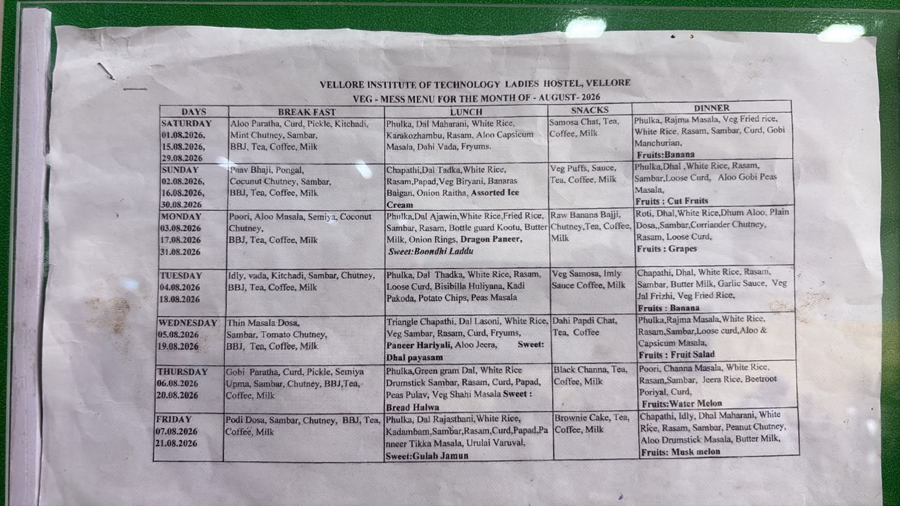
Original uploaded vegetarian menu photo.

A3. Vegetarian R Mess menu — photo 2
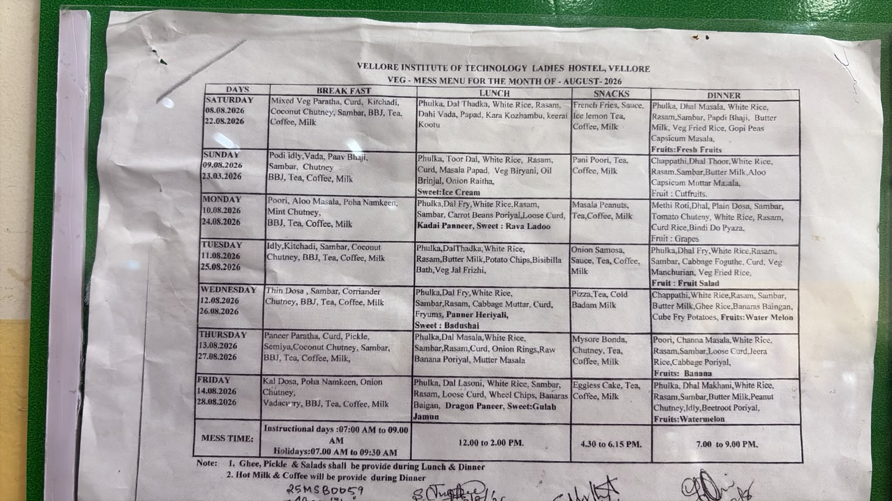
Original uploaded vegetarian menu photo.

A4. Non-vegetarian menu reference — photo 1
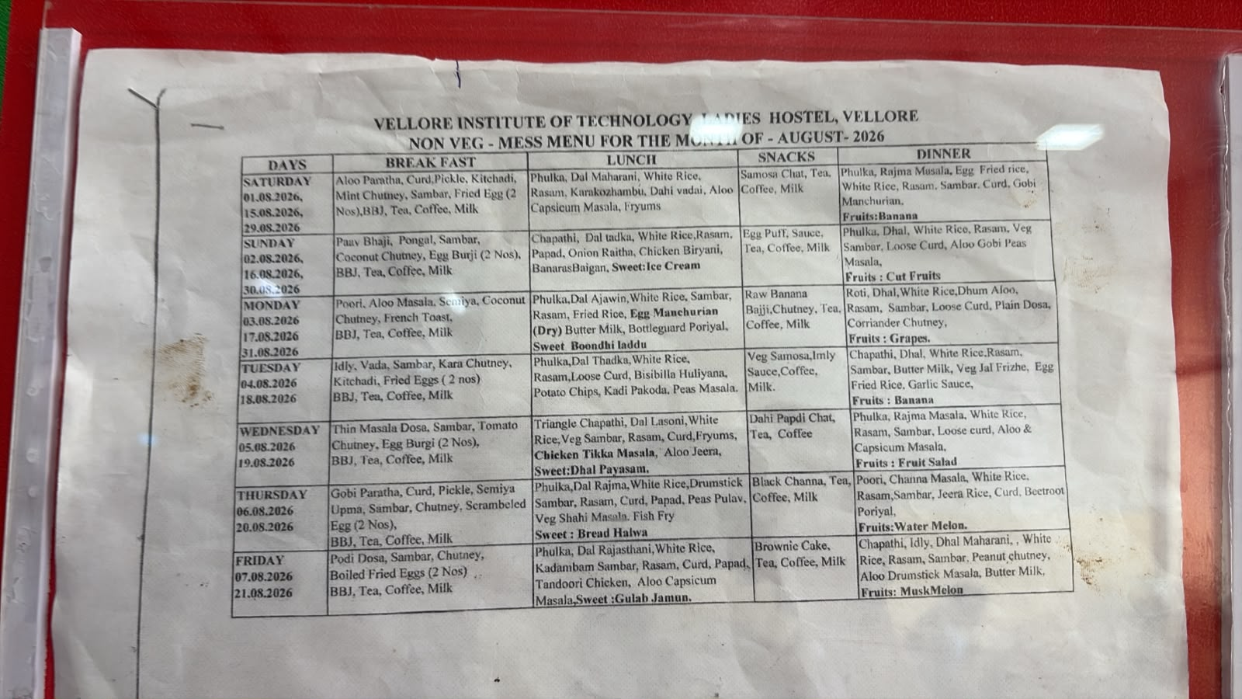
Original uploaded non-vegetarian menu photo; optional scope only.

A5. Non-vegetarian menu reference — photo 2
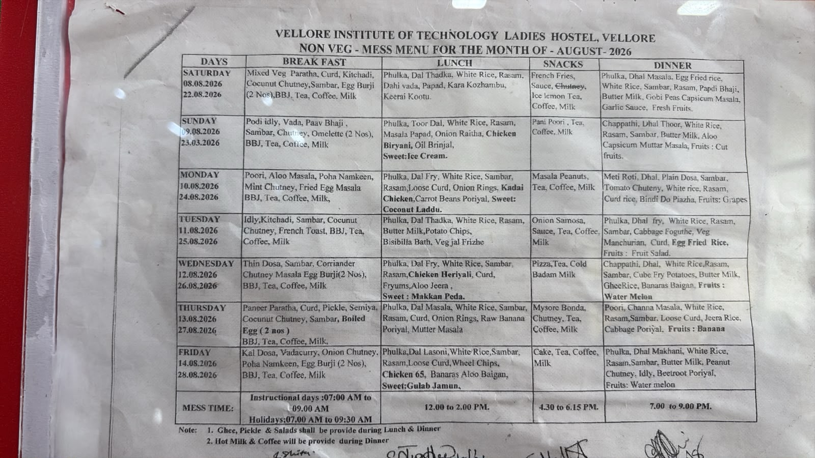
Original uploaded non-vegetarian menu photo; optional scope only.

Appendix B. Important source equations and terms
The presentation’s mathematical slide defines the following core variables and relations. The implementation should retain their intent while ensuring consistent units and measurable definitions.
Term | Meaning for implementation
Dᵢ,ₜ | Predicted demand for dish i at time interval t.
Pᵢ,ₜ | Contextual preference/selection score for dish i.
Wᵢ,ₜ | Waste estimate; use a clear definition and distinguish leftovers from plate waste.
Qᵢ,ₜ | Prepared quantity for dish i at interval t.
Cᵢ,ₜ | Consumption or cumulative consumed quantity; specify which one in each function.
Aₜ | Available or expected-attending population at time t.
Xₜ | Contextual features: weather, schedule, day, events, menu and operational conditions.
Hᵢ,ₜ | Historical dish/meal behaviour available at forecast time.
Bᵢ / Lᵢ | Preparation cost and waste penalty, respectively; use documented units/weights.

Presentation equations include a waste function `Wᵢ,ₜ = max(0, Qᵢ,ₜ − Dᵢ,ₜ)`, an optimization objective that balances waste penalty and preparation cost, constraints for minimum availability and kitchen capacity, and split-batch preparation with replenishment triggered by observed consumption. In the code, refine these definitions to prevent confusing prepared quantity, available stock, demand, consumption and leftovers.

Appendix C. Source materials to pass to the coding AI
- This implementation blueprint DOCX.
- Original presentation PDF: AI presentation(1).pdf.
- Detailed notes PDF: ai project.pdf.
- Technology-stack screenshot.
- Four R Mess menu images (two vegetarian, two non-vegetarian).
The detailed notes PDF includes a proposed Google Form and module mappings on its later pages. If the team collects actual survey responses in a later phase, replace synthetic preference inputs only after appropriate approval and document the source and collection date.

