Assignment: Feature Engineering Using Snowflake and Feature Stores
Name: Jiya Anand Moolya
- Introduction to Feature Engineering
- Define feature engineering and explain its importance in machine learning.
Feature engineering means changing raw data into useful pieces of information (called features) that help a machine learning model make better predictions. It includes cleaning data, choosing the right columns, and creating new ones that show important patterns.
It is important because it:
- Makes the model more accurate and reliable.
- Removes unnecessary or confusing data.
- Helps the model perform well on new, unseen data.
- Gives the model meaningful inputs that represent real-world behavior.

- Describe different types of feature engineering techniques (e.g., normalization, encoding, time-based aggregations).
Common techniques include:
- Normalization / Standardization – scales numeric values to a common range.
- Encoding – converts categorical data into numeric form (Label or One-Hot encoding).
- Aggregation – summarizes data (e.g., average sales per month).
- Feature Extraction – derives new features from existing ones (e.g., date differences, text length).
- Feature Selection – removes irrelevant or highly correlated features.
- Time-based Features – builds rolling averages, lag values, or time-window counts.

- Using Snowflake for Data Storage & Processing
- Explain how Snowflake is used for storing structured and semi-structured data.
Snowflake is a cloud-based data warehouse that stores both structured data (like tables and CSV files) and semi-structured data (like JSON, Avro, and Parquet) in one place. It keeps storage and computing separate, so you can scale each independently based on need. Snowflake also supports SQL for querying all types of data and automatically improves performance through column-based compression and smart data organization.

- Provide an example of SQL queries that extract and preprocess data in Snowflake.
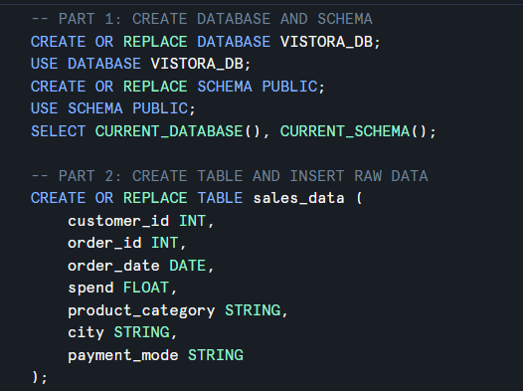

- Discuss how Snowflake integrates with ML pipelines.
Snowflake integrates with ML workflows through:
- Snowpark API – lets you build feature pipelines using Python, Scala, or Java inside Snowflake.
- Connectors – exports data directly to ML environments like AWS SageMaker or Databricks.
- Feature Store (Native / Partner) – stores engineered features for consistent training & inference.
- External Functions – calls remote ML models from inside SQL queries.

- Feature Store Concepts
- What is a Feature Store, and why is it needed?
A Feature Store is a centralized system that stores curated and versioned ML features for reuse in both training and real-time inference.
It is needed to:
- Maintain consistent feature definitions between training and serving.
- Prevent duplication of feature logic across teams.
- Enable feature sharing and governance.
- Simplify monitoring and version control of features.

Feature Store | Cloud Provider | Key Features | Best Use Case
AWS SageMaker FS | AWS | Real-time and batch retrieval | Enterprise-scale ML
Databricks FS | Azure / AWS | Integrated with Delta Lake and MLflow | Unified data and ML pipelines
Snowflake FS | Snowflake | SQL and Snowpark integration | In-database ML features
- Compare different feature stores (e.g., AWS Sage Maker Feature Store, Snowflake Feature Store,Databricks Feature Store).

- Implementing Feature Engineering with Snowflake & Feature Store
- Extract: Use Snowflake SQL to fetch raw data.
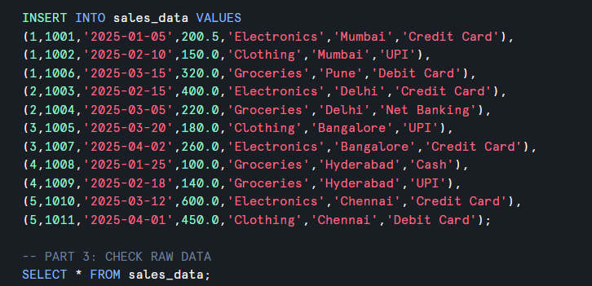
- Transform: Perform feature engineering (aggregations, encoding, etc.).
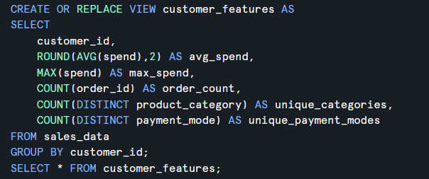
- Load into Feature Store: Explain how features can be stored in a Feature Store

- Access for ML: How can ML models retrieve features from the store?


