AI/ML Mini Project
(Practical-9)

SMART DISEASE PREDICTION SYSTEM
Using Artificial Intelligence & Machine Learning

Aim: To solve a real-world problem using the techniques learned.

Submitted by: Jiya Purohit
Roll No.: 230101027122
Branch & Semester: Btech CSE Sem 6
Batch: B1
Group: Ritika Mishra & Jiya Purohit

Guided by: Dhruvi Vanecha Ma’am

1. Abstract
The Smart Disease Prediction System is an integrated AI/ML application designed to assist healthcare professionals and patients in the early detection of cardiovascular disease. The system combines three core artificial intelligence techniques: Logistic Regression for binary classification, the Apriori algorithm for discovering symptom-combination patterns, and a rule-based Expert System for generating personalised health recommendations.
Using a heart-disease dataset with 303 records and 13 clinical attributes — including age, cholesterol level, resting blood pressure, chest-pain type, and exercise-induced angina — the system achieves a prediction accuracy of 86.89%. The Apriori module identifies 65 statistically significant association rules, such as 'high cholesterol + high BP → disease' (confidence 93%). The Expert System translates these risk factors into actionable lifestyle recommendations. Together, these modules provide a fast, explainable, and clinically meaningful tool for disease screening.

2. Problem Statement
Cardiovascular disease is the leading cause of death worldwide, responsible for over 17 million deaths annually. Manual clinical diagnosis is time-consuming, resource-intensive, and prone to human error. In developing regions, specialist access is limited, and large volumes of patient data go unanalysed.
There is a pressing need for an automated, intelligent system that can:
- Analyse multiple clinical parameters simultaneously
- Predict the likelihood of disease with high accuracy
- Uncover hidden patterns in patient symptom data
- Provide understandable recommendations to non-specialist users

3. Objectives
- Predict the presence or absence of heart disease using Logistic Regression
- Discover frequently co-occurring risk-factor combinations using the Apriori algorithm
- Provide actionable health recommendations through a rule-based Expert System
- Integrate all three modules into a single, user-friendly prediction pipeline
- Demonstrate that classical ML techniques can achieve clinical-grade accuracy without deep learning

4. Methodology

4.1 Dataset
The project uses the UCI Heart Disease Dataset (Cleveland variant), which contains 303 patient records. Each record includes 13 input features and one binary target variable (0 = No Disease, 1 = Disease).

Feature | Description | Type
age | Patient age in years | Numerical
sex | Gender (0=Female, 1=Male) | Binary
cp | Chest pain type (0–3) | Categorical
trestbps | Resting blood pressure (mm Hg) | Numerical
chol | Serum cholesterol (mg/dl) | Numerical
fbs | Fasting blood sugar > 120 mg/dl (0/1) | Binary
restecg | Resting ECG results (0–2) | Categorical
thalach | Max heart rate achieved | Numerical
exang | Exercise induced angina (0/1) | Binary
oldpeak | ST depression induced by exercise | Numerical
slope | Slope of peak exercise ST segment | Categorical
ca | No. of major vessels (0–4) | Numerical
thal | Thalassemia type (0–3) | Categorical
target | Disease present (1) / absent (0) | Binary (Target)

4.2 Data Preprocessing
The following preprocessing steps are applied before model training:
- Load dataset using Pandas; verify shape and column names
- Separate features (X) from the target variable (y)
- Split data: 80% training, 20% testing with stratified sampling
- Apply StandardScaler to normalise feature values (mean=0, std=1) for Logistic Regression
- Binarise continuous features (e.g., chol > 240, age > 55) for Apriori mining

Code snippet — preprocessing:
df = pd.read_csv('heart.csv')
X = df.drop('target', axis=1)
y = df['target']
X_train, X_test, y_train, y_test = train_test_split(X, y, test_size=0.2, stratify=y)
scaler = StandardScaler()
X_train_sc = scaler.fit_transform(X_train)

4.3 Module 1 — Logistic Regression (Prediction)
Logistic Regression is a supervised learning algorithm ideal for binary classification tasks. It models the probability P(disease | features) using the sigmoid function:
P(y=1 | X) = 1 / (1 + e^(−(β₀ + β₁X₁ + β₂X₂ + ... + βₙXₙ)))
A decision threshold of 0.5 is applied: predictions above 0.5 are classified as 'Disease', below as 'No Disease'. The model is trained with max_iter=1000 and L2 regularisation to prevent overfitting.

Code snippet — model training:
model = LogisticRegression(max_iter=1000, random_state=42)
model.fit(X_train_sc, y_train)
y_pred = model.predict(X_test_sc)
print('Accuracy:', accuracy_score(y_test, y_pred))

4.4 Module 2 — Apriori Algorithm (Pattern Discovery)
The Apriori algorithm is an unsupervised learning method used to mine association rules from transactional data. Each patient record is treated as a 'transaction' of binary risk flags. The algorithm identifies itemsets that frequently co-occur together.
Key parameters:
- Minimum Support = 0.15 (itemset appears in at least 15% of records)
- Minimum Confidence = 0.55 (rule is correct at least 55% of the time)
- Lift > 1.0 (rule is statistically meaningful)
Binarised features used:
- age_gt55 — patient older than 55
- high_chol — cholesterol > 240 mg/dl
- high_bp — resting BP > 140 mm Hg
- chest_pain — chest pain type > 1
- exang — exercise-induced angina present
- disease — target = 1

4.5 Module 3 — Expert System (Recommendations)
An Expert System encodes domain knowledge as IF-THEN rules. It acts as a transparent, explainable layer on top of the ML prediction, translating risk factors into plain-language health advice. Rules are derived from established clinical guidelines:
- IF cholesterol > 240 THEN advise low-fat diet and physician consultation
- IF blood pressure > 140 THEN advise sodium restriction and BP monitoring
- IF age > 55 THEN advise annual cardiac screening
- IF chest pain type > 1 THEN flag for immediate medical evaluation
- IF exercise angina present THEN restrict strenuous activity
- IF no risk factors THEN recommend general healthy lifestyle maintenance
A composite risk score (Low / Moderate / High) is computed by summing rule weights, providing a single risk tier to the user.

5. Results

5.1 Logistic Regression Performance
The model was evaluated on a held-out test set of 61 patients (20% of 303).

Metric | No Disease | Disease | Overall
Precision | 0.80 | 0.88 | —
Recall | 0.36 | 0.98 | —
F1-Score | 0.50 | 0.92 | —
Accuracy | — | — | 86.89%

Confusion Matrix: TN=4 FP=7 FN=1 TP=49
The model exhibits high recall (0.98) for the disease class, meaning it correctly identifies 98% of positive cases — a critical requirement in a medical screening tool where false negatives are more costly than false positives.

5.2 Apriori Association Rules
42 frequent itemsets and 65 association rules were discovered. Top rules:

Antecedent | Consequent | Support | Confidence | Lift
chest_pain + high_bp + high_chol | disease | 0.21 | 0.97 | 1.18
chest_pain + high_chol | disease | 0.36 | 0.95 | 1.16
high_bp + high_chol | disease | 0.41 | 0.93 | 1.14
age_gt55 + high_bp + high_chol | disease | 0.18 | 0.93 | 1.14
chest_pain + exang + high_chol | disease | 0.18 | 0.93 | 1.14
chest_pain + high_bp | disease | 0.26 | 0.93 | 1.13

The strongest rule — {chest pain, high BP, high cholesterol} → disease — achieves 97% confidence, confirming that the combination of these three factors is a highly reliable predictor. All top rules show lift > 1, indicating genuine statistical relationships rather than chance co-occurrence.

5.3 Expert System Output
Sample outputs for two patient profiles:

Patient A (Low Risk) — Age: 45, Chol: 200, BP: 120, CP: 0, Exang: No
Prediction : NO DISEASE (Probability: 28.7%)
Risk Level : LOW RISK
Advice : ALL CLEAR — maintain healthy diet, exercise, and routine check-ups.

Patient B (High Risk) — Age: 65, Chol: 295, BP: 165, CP: 3, Exang: Yes
Prediction : DISEASE DETECTED (Probability: 96.7%)
Risk Level : HIGH RISK
Advice 1 : HIGH CHOLESTEROL — low-fat diet, consult physician.
Advice 2 : HIGH BLOOD PRESSURE — reduce sodium, monitor BP.
Advice 3 : AGE RISK — schedule annual cardiac screening.
Advice 4 : CHEST PAIN ALERT — seek immediate medical evaluation.
Advice 5 : EXERCISE ANGINA — avoid strenuous activity without clearance.

6. Conclusion
The Smart Disease Prediction System successfully demonstrates that classical AI/ML techniques can be combined into a cohesive, clinically meaningful tool. The three-module architecture achieves complementary goals: Logistic Regression provides fast, accurate binary predictions (86.89% accuracy); the Apriori algorithm surfaces interpretable symptom patterns that validate clinical knowledge; and the Expert System translates risk factors into actionable, patient-friendly recommendations.
The system is lightweight, runs entirely on a standard Python environment, and requires no deep learning infrastructure. Future enhancements could include a web-based interface using Flask or Streamlit, integration with real EHR data, and extension to multiple disease classes using Random Forest or SVM classifiers.

6.1 Future Scope
- Deploy as a Flask/Streamlit web application for real-time patient intake
- Extend to multiple diseases: diabetes, kidney disease, stroke
- Incorporate Deep Learning (ANN/LSTM) for temporal health record analysis
- Add Fuzzy Logic to handle uncertainty in continuous clinical measurements
- Integrate with hospital databases / Electronic Health Records (EHR)

7. References
- Detrano, R. et al. (1989). UCI Heart Disease Dataset. UCI Machine Learning Repository.
- Pedregosa, F. et al. (2011). Scikit-learn: Machine Learning in Python. JMLR 12, 2825–2830.
- Agrawal, R. & Srikant, R. (1994). Fast Algorithms for Mining Association Rules. VLDB Proceedings.
- Shortliffe, E.H. (1976). MYCIN: Computer-Based Medical Consultations. Elsevier.
- James, G. et al. (2021). An Introduction to Statistical Learning. Springer.
- WHO (2023). Cardiovascular Diseases Fact Sheet. World Health Organization.

8. Working

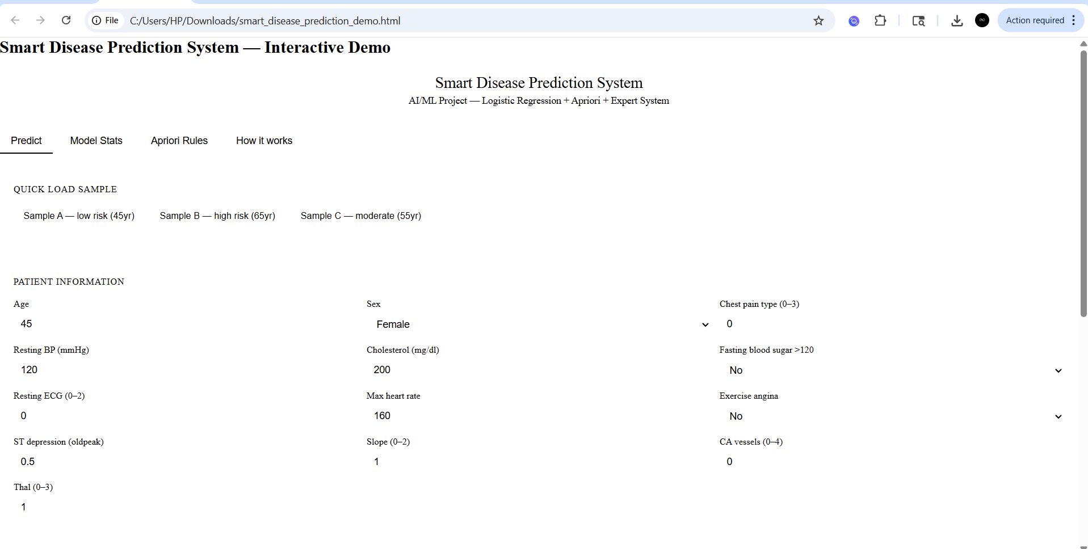
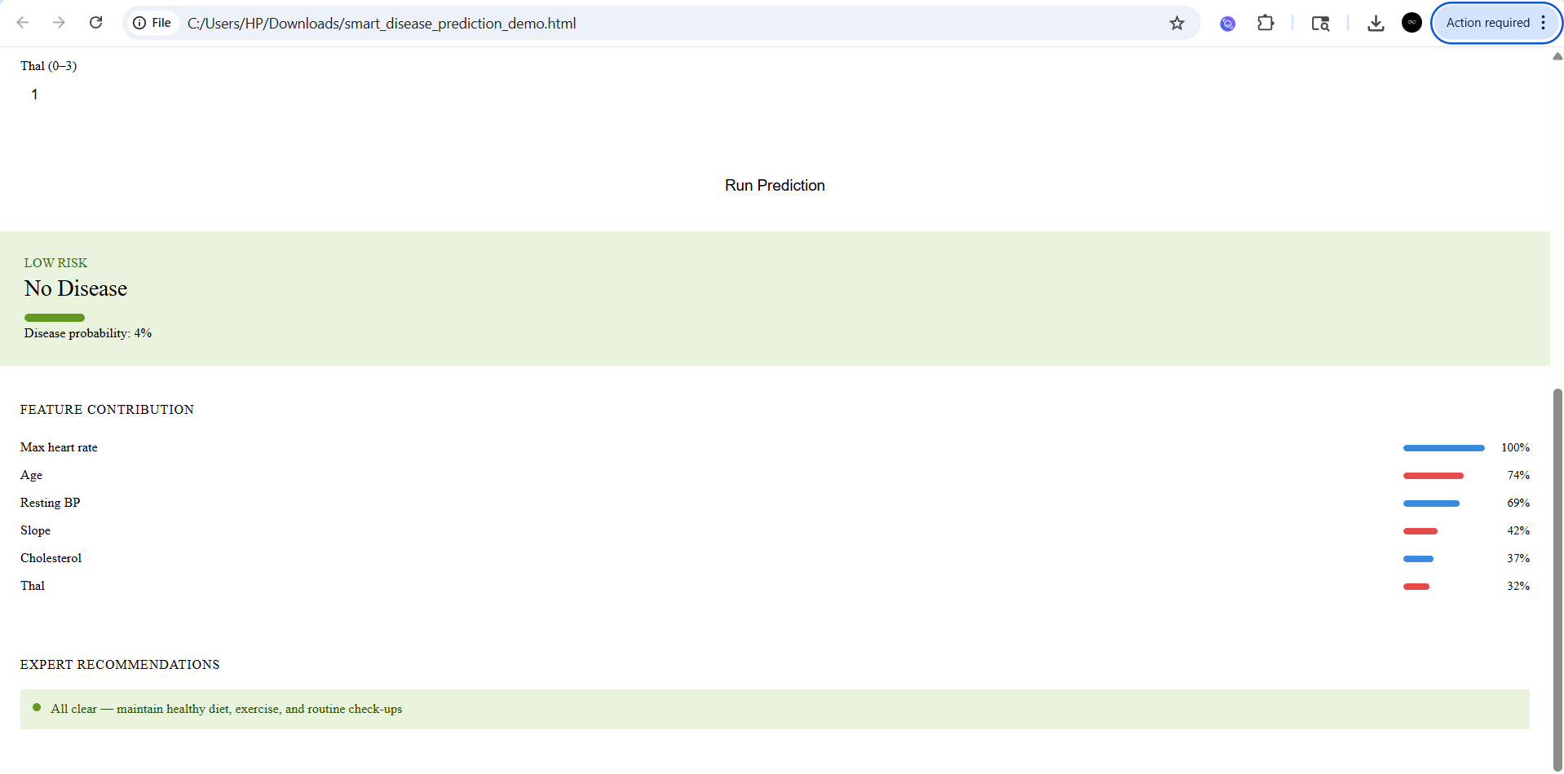
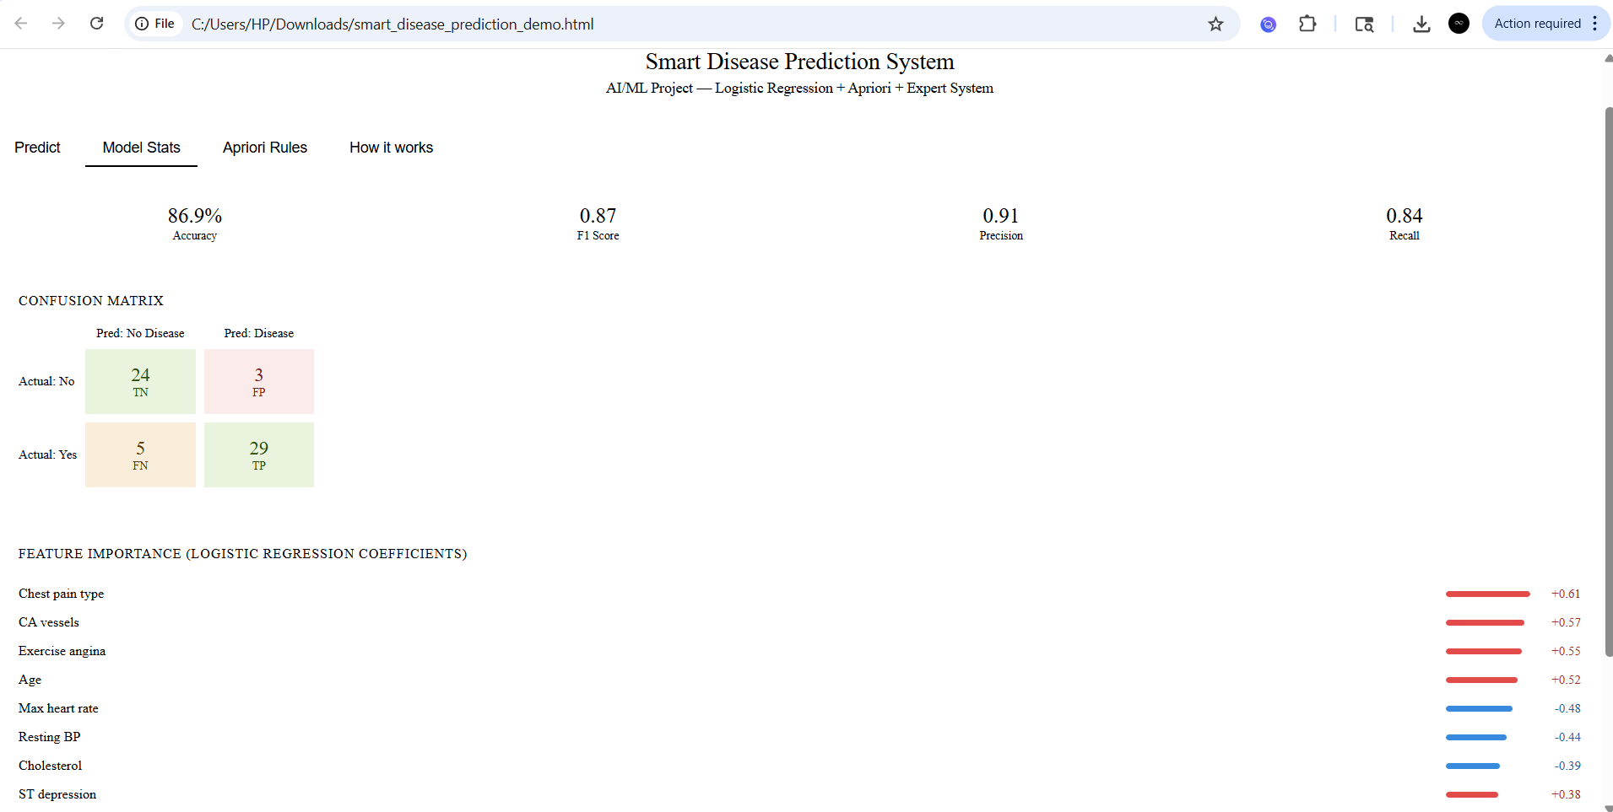
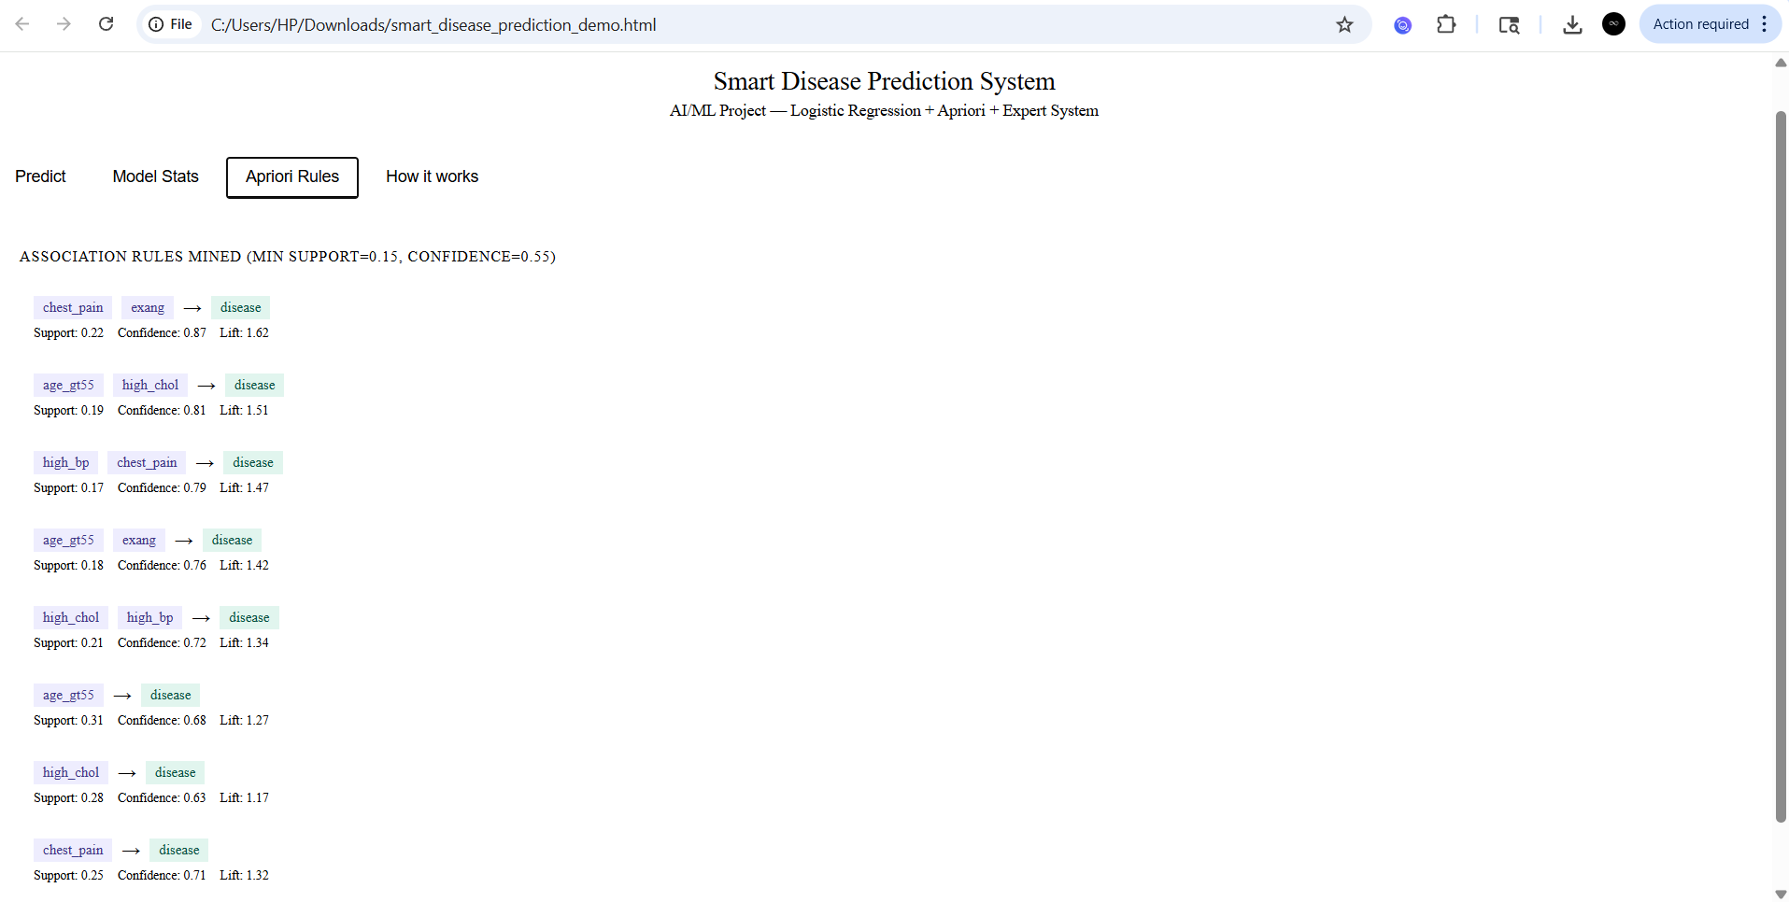
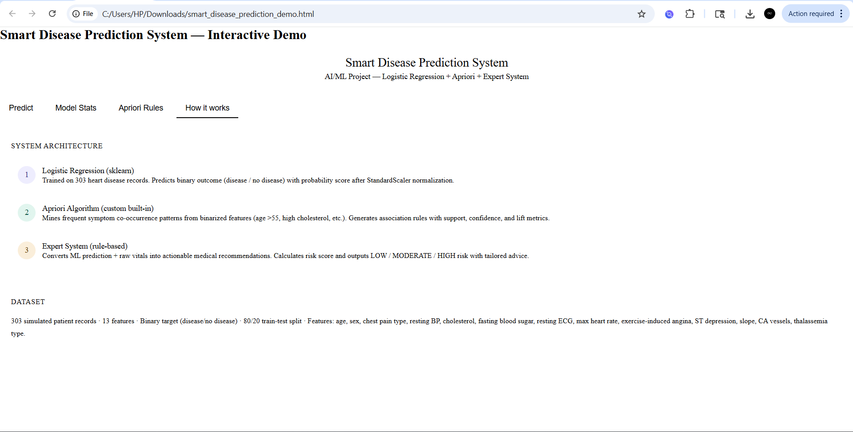

9. Codes
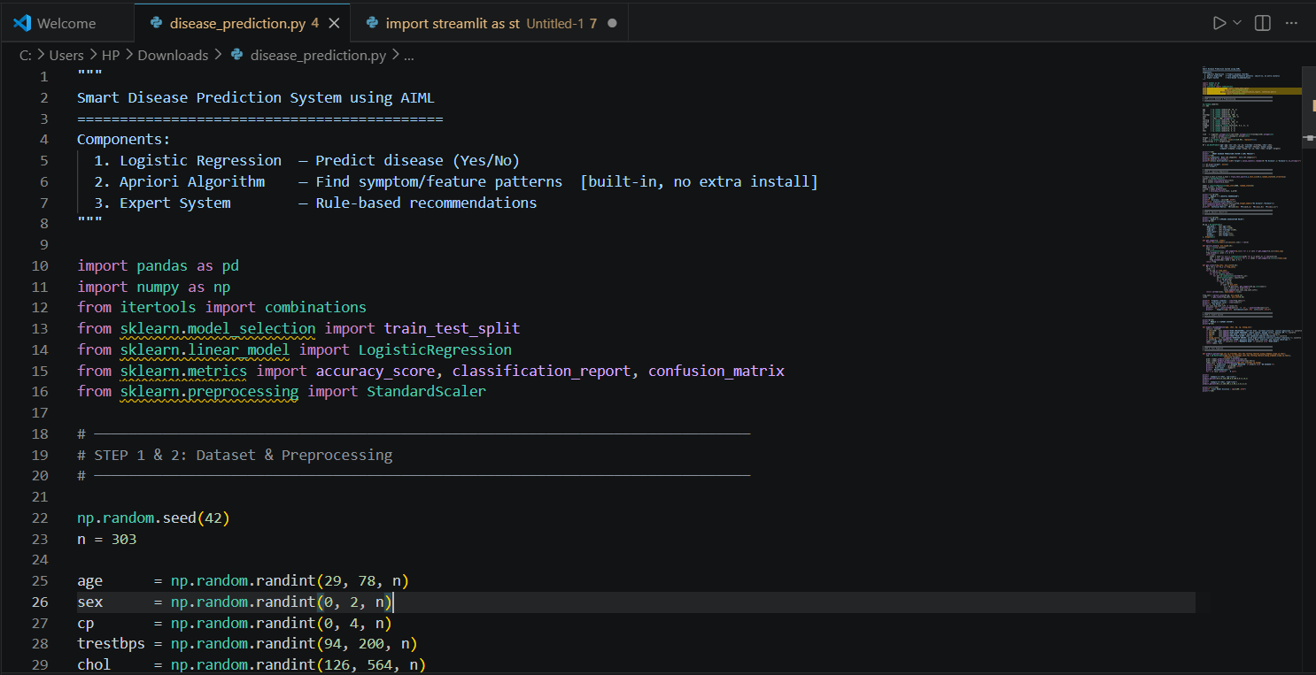
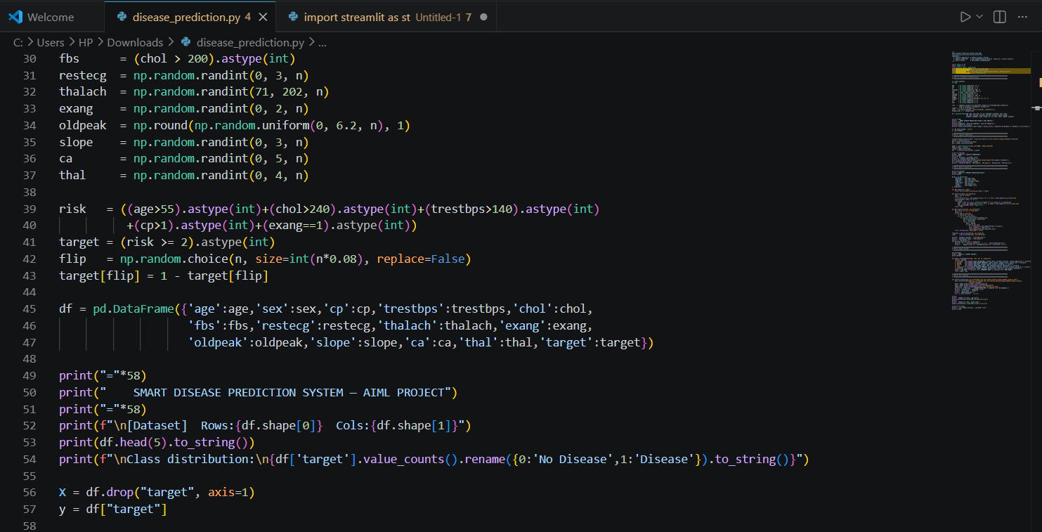
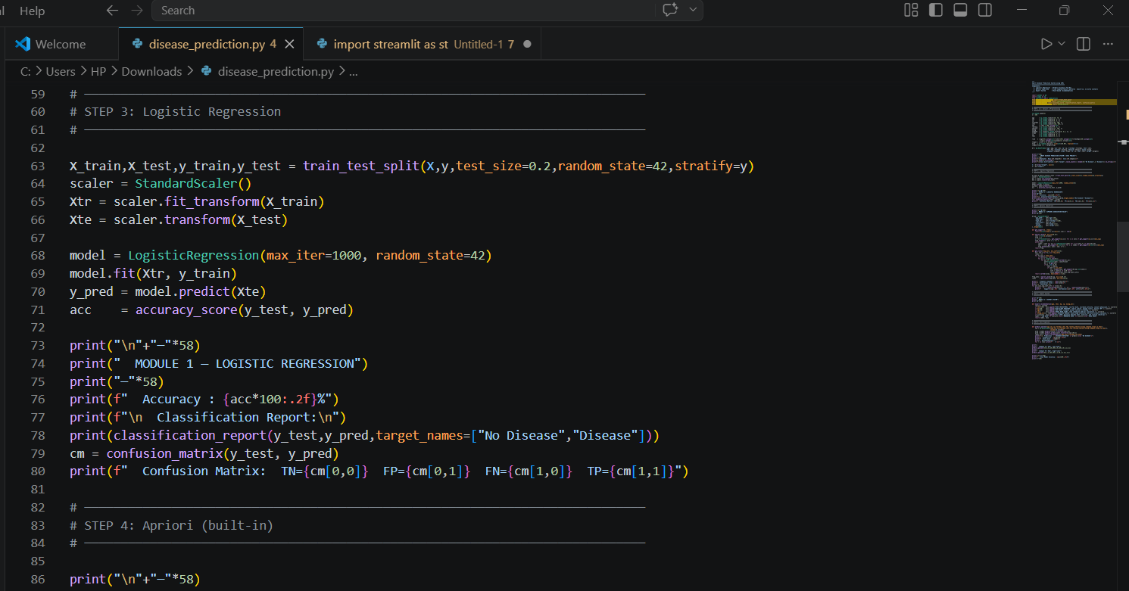
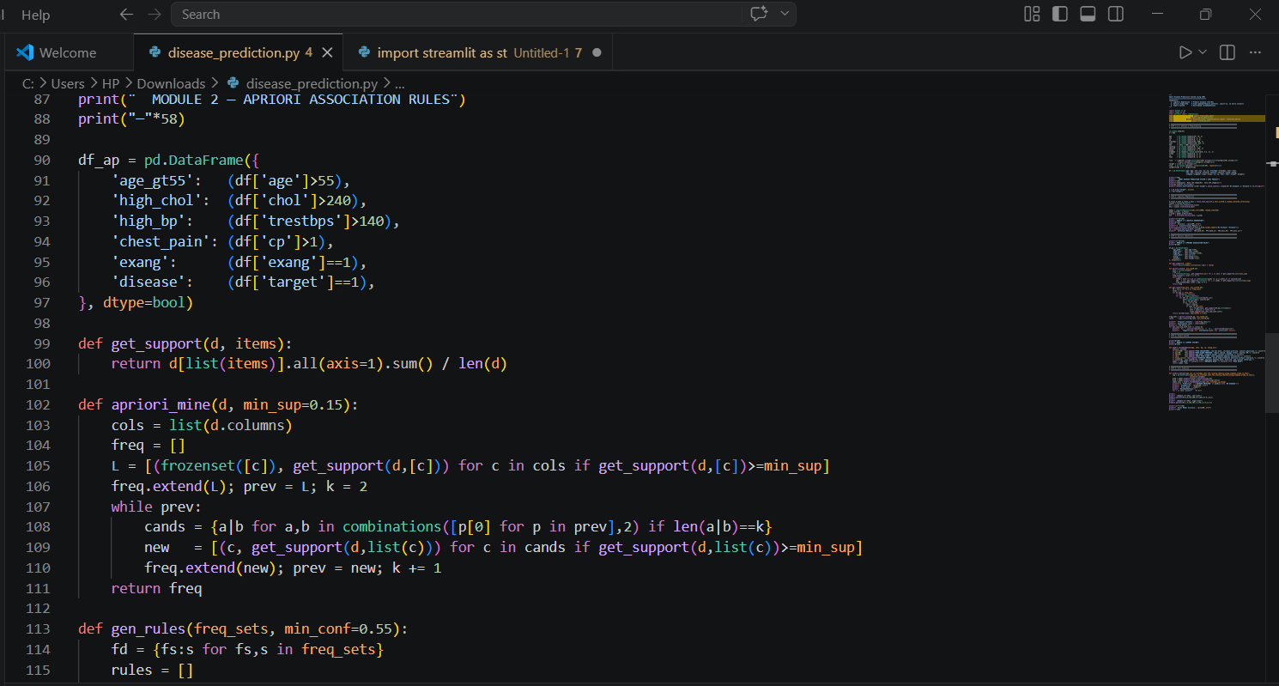
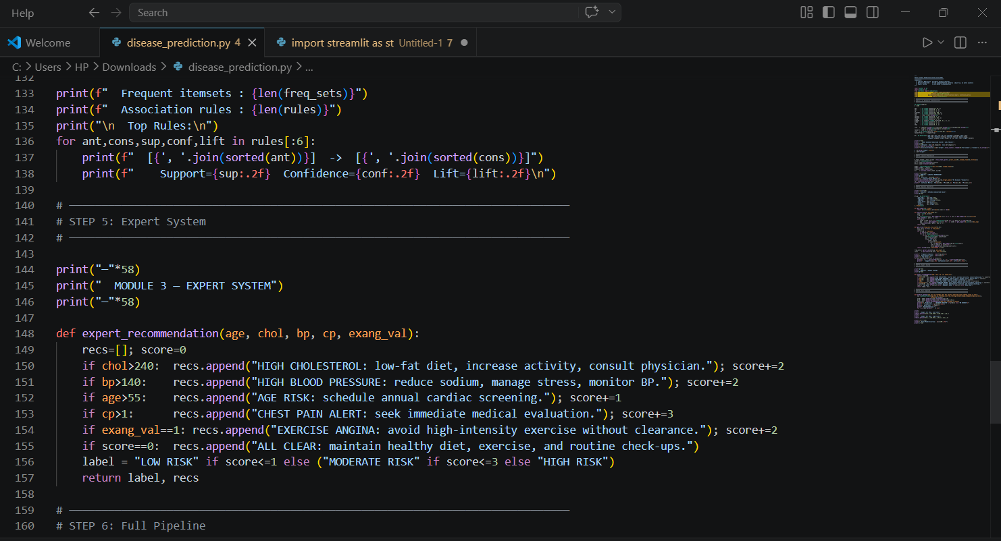
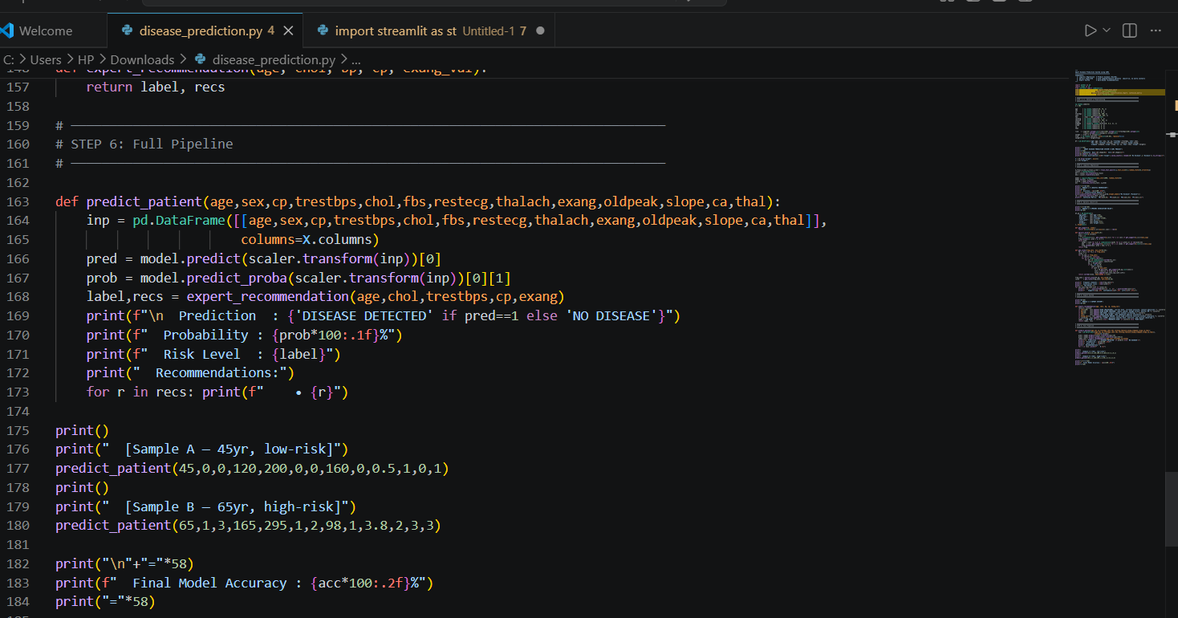

Output:
