Technical Formative Assessment 3
Making It Editable Forms Validation and File Upload
Ledgerline Refill CodeIgniter POS Integration

Student | Jian Edward A. Acob
Program and Section | BSITBA - TW32
Course | IT0049 - Web System Technologies
Instructor | Mr. Von Erick Magbitang
Assessment | Technical Formative Assessment 3
Date | September 27, 2026

Project Overview

Purpose and scope
I continued my TSA1 Ledgerline Refill project and its refill-shop design. I added validated customer and staff forms, profile picture uploads, and task creation, editing, and deletion. I also made a bottle-and-return logo image for the header.

Application structure
I connected each route to a controller. My controllers validate form submissions and use Models to save permitted fields. My Views escape displayed values and keep entered text when validation fails. I kept the Today, All tasks, Profile, and About pages.

Database separation
I kept five original customers and five staff users in the TFA3 POS database. I placed nine tasks across four dates and one demo profile user in a separate TFA3 task database. I left my original TSA1 project and databases untouched.

Required route | Implemented behavior
/ | Today-only task list and live customer/staff counts
/tasks | All task records in date order with edit actions
/tasks/new and /tasks/{id}/edit | Validated task creation and prefilled editing
/tasks/{id}/delete | CSRF-protected task deletion with a browser confirmation
/profile | One task-system demo user
/about | Refill shop and TFA3 developer details
/customers and /customers/new | Customer listing and validated creation
/customers/{id}/edit | Prefilled customer update
/users and /users/new | Staff listing with avatars and unique-username creation
/users/{id}/edit | Prefilled staff update and optional image upload

Application Page Evidence

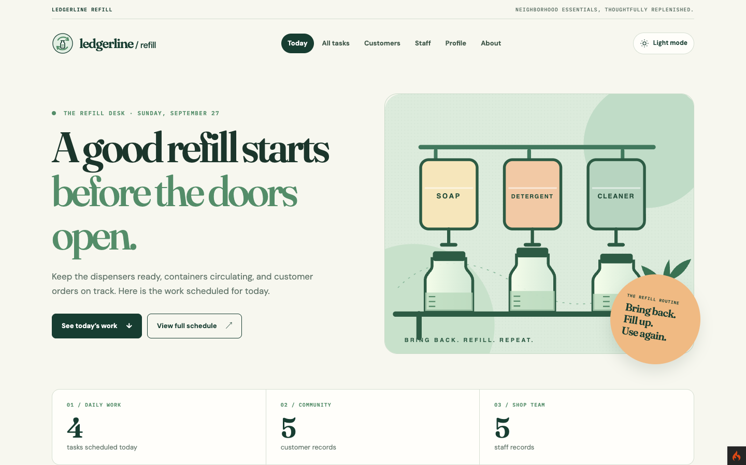
Figure 1. My Today page keeps the TSA1 refill shop design and shows current work and record totals.

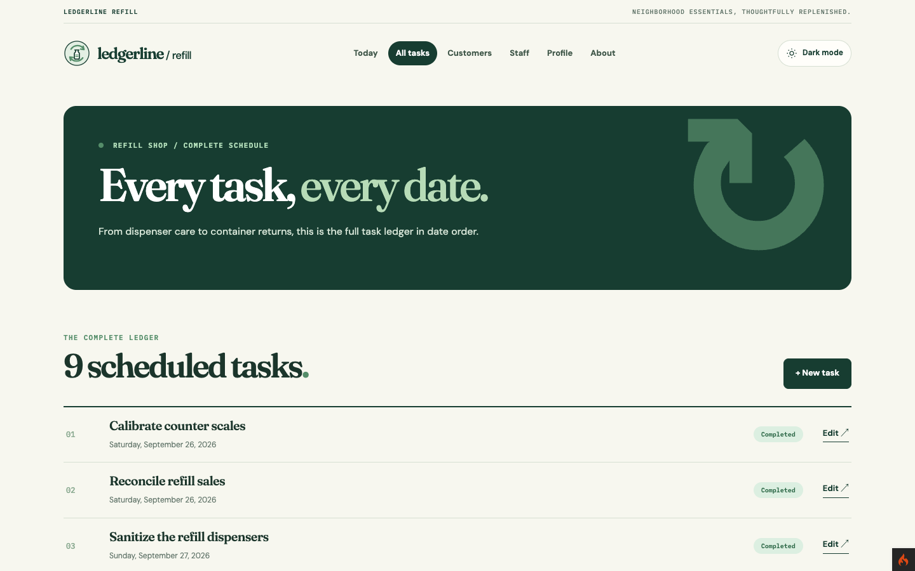
Figure 2. I added New task and Edit actions to my complete task list.

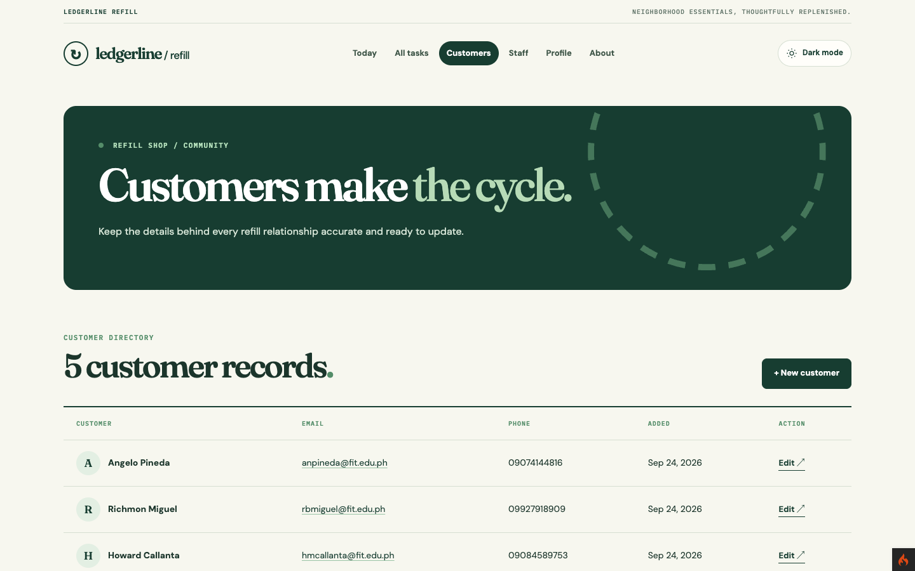
Figure 3. I kept the original customer records and added New customer and Edit actions.

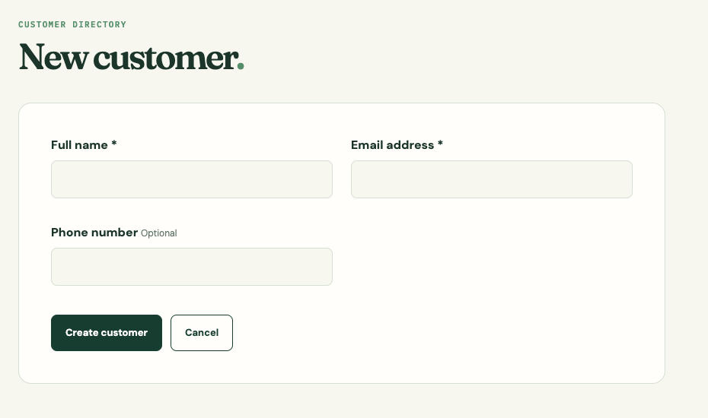
Figure 4. My new customer form asks for a full name and valid email.

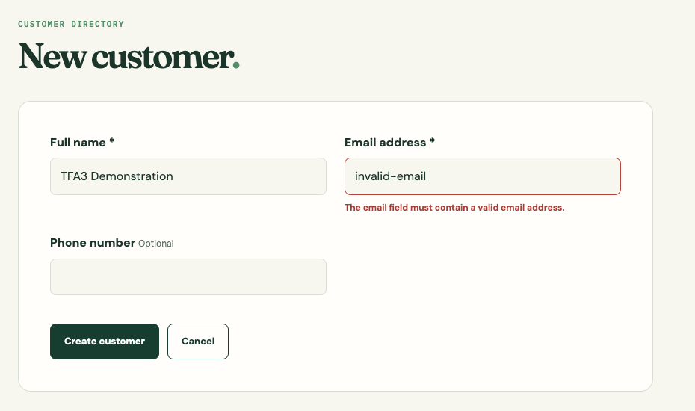
Figure 5. I show an invalid email error while keeping the full name I entered.

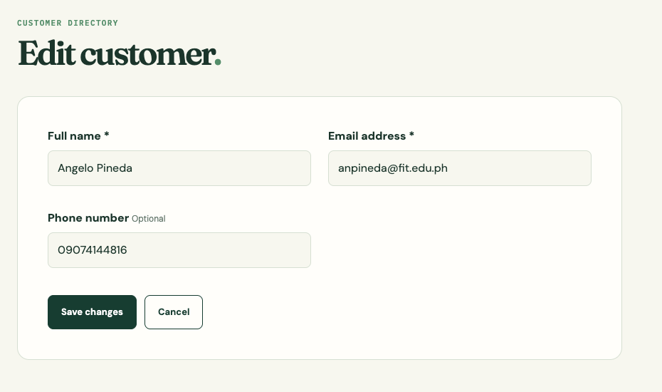
Figure 6. My customer edit form loads the selected record before I update it.

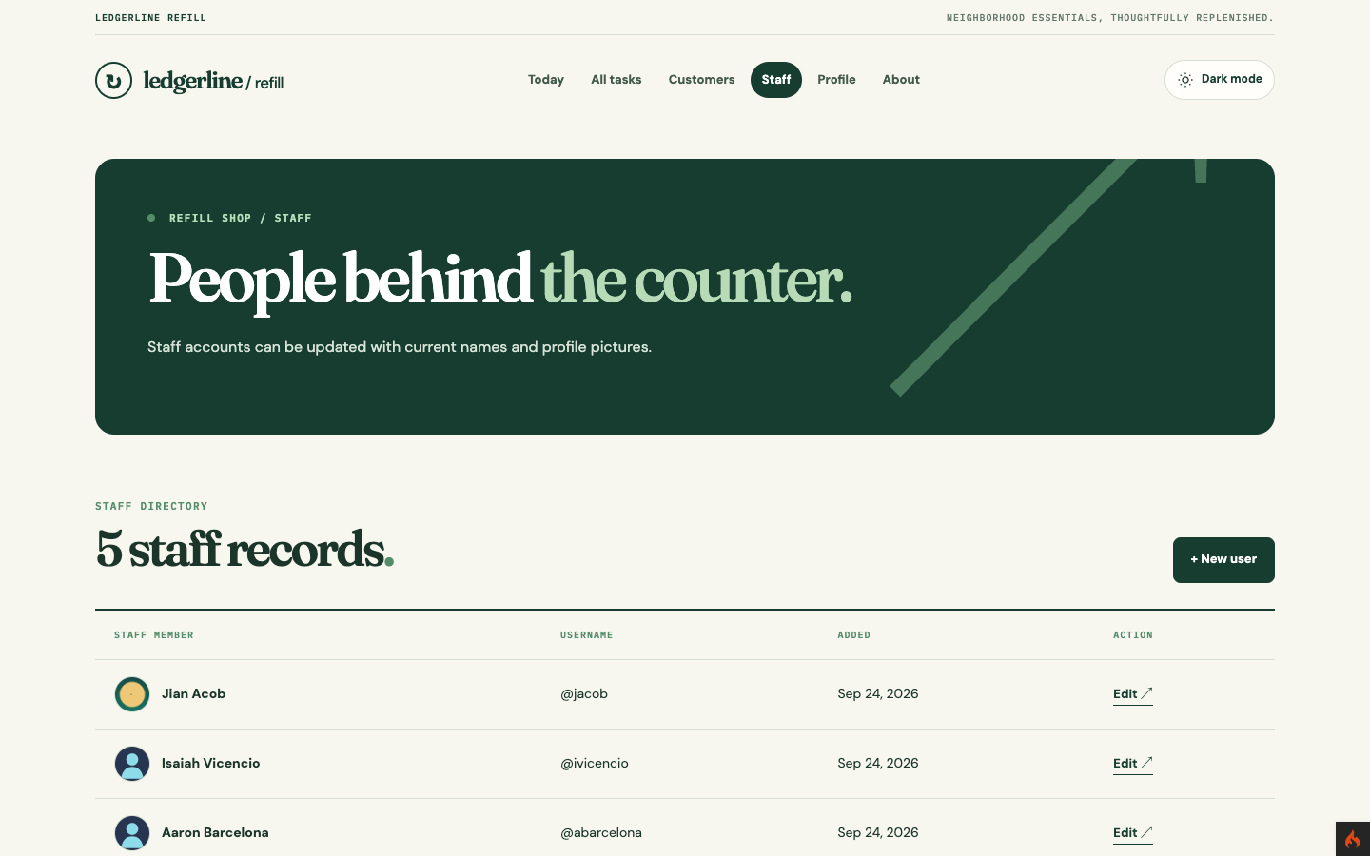
Figure 7. My staff directory shows avatars or placeholders, with creation and editing actions.

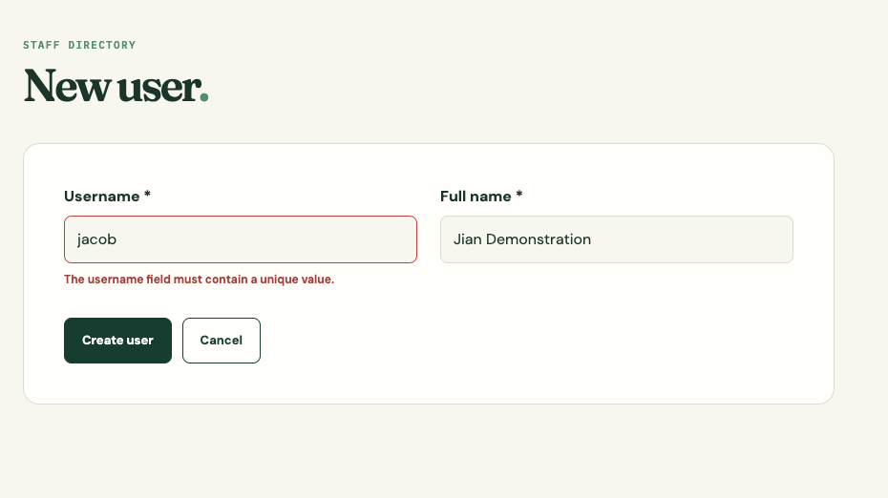
Figure 8. I reject a duplicate username without discarding the full name I typed.

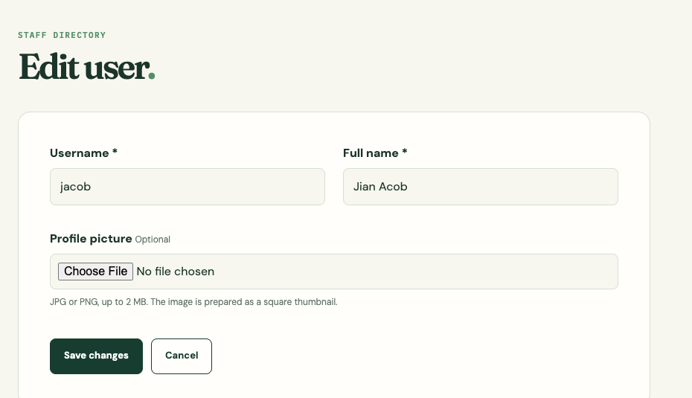
Figure 9. My staff edit form is prefilled and accepts an optional JPG or PNG up to 2 MB.

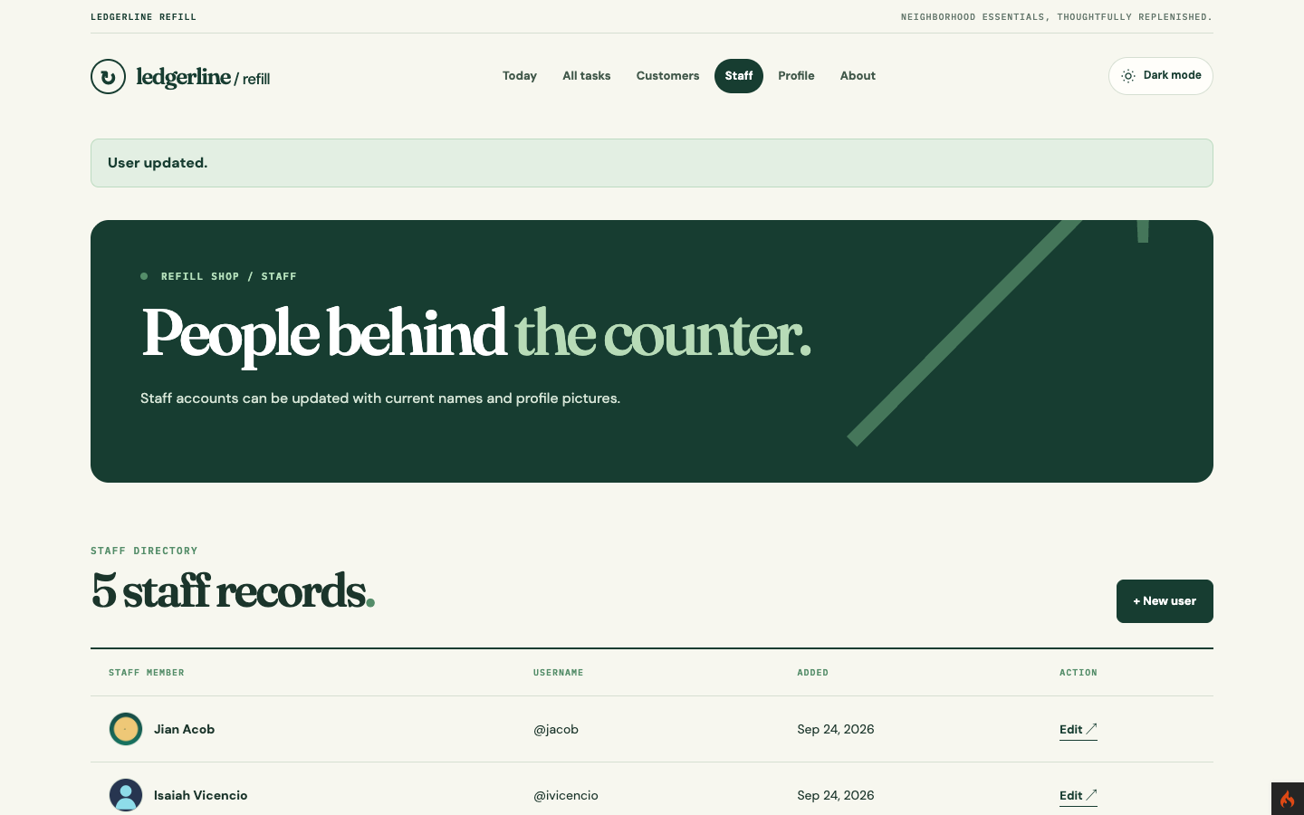
Figure 10. I uploaded a sample initials PNG, which appears as a prepared JPEG avatar on my staff listing.

Responsive and Existing Record Evidence

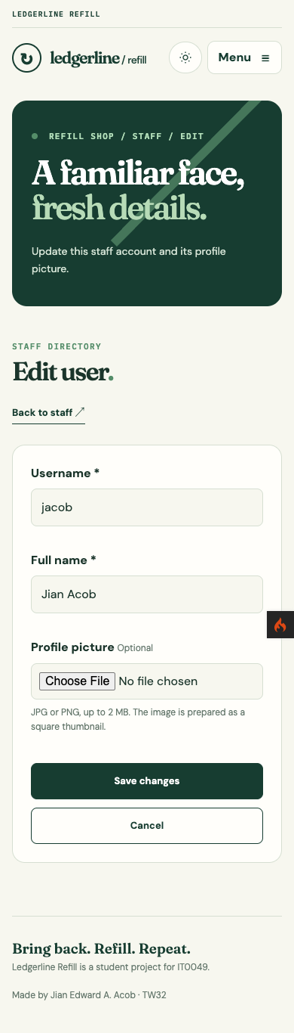
Figure 11. My staff edit form becomes one column at 390 pixels without horizontal overflow.

Task Management Extension

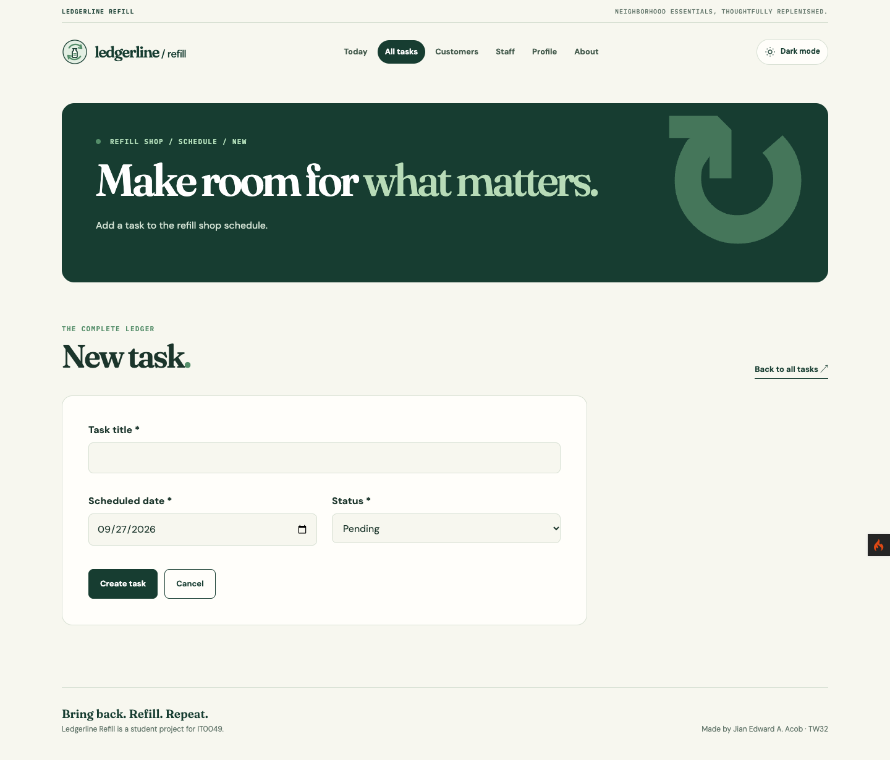
Figure 12. I can enter a title, scheduled date, and status in my new task form.

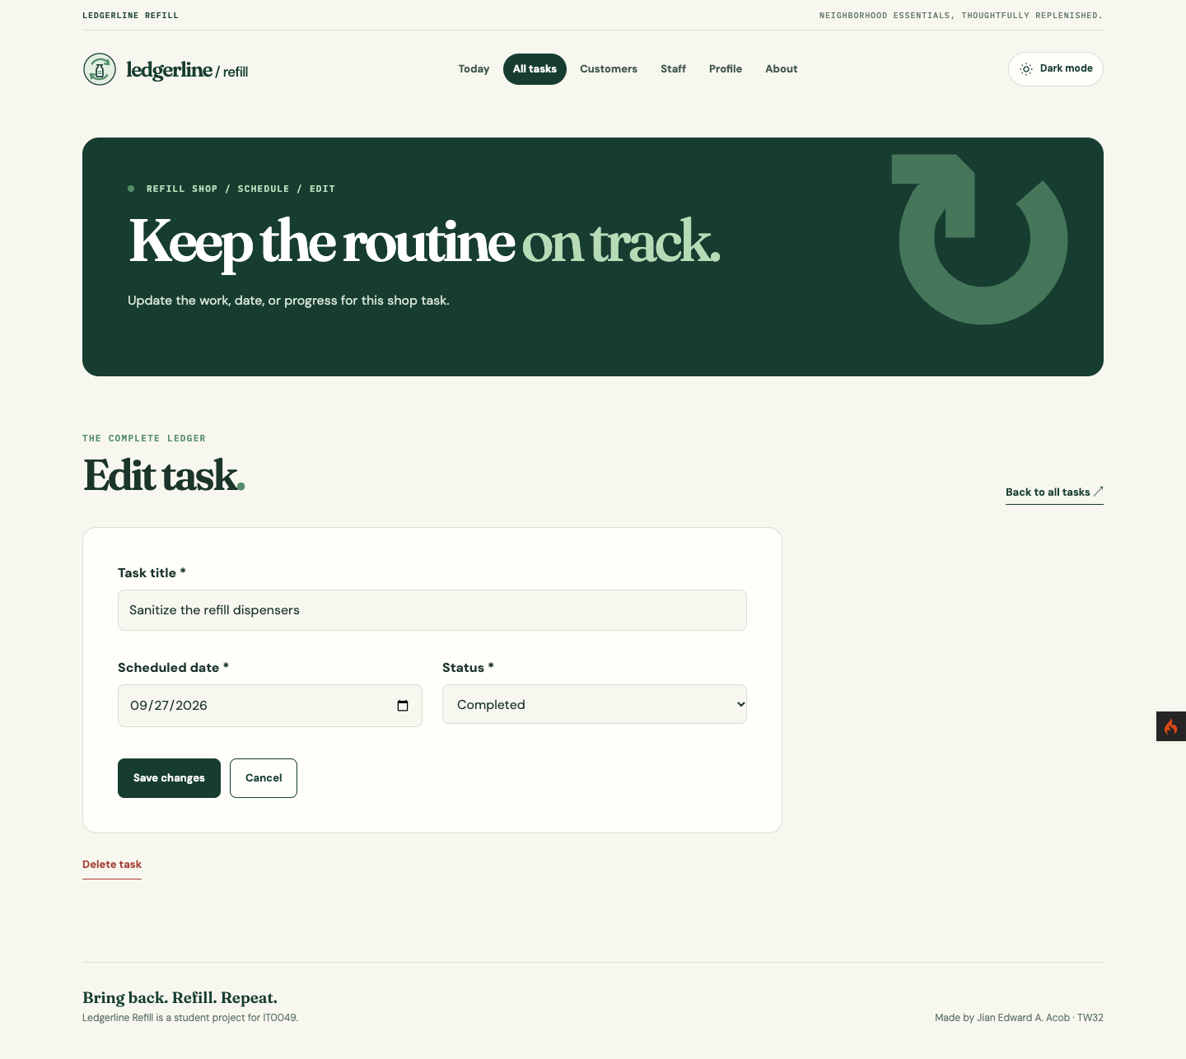
Figure 13. My task edit form loads an existing record and offers Save changes and Delete task.

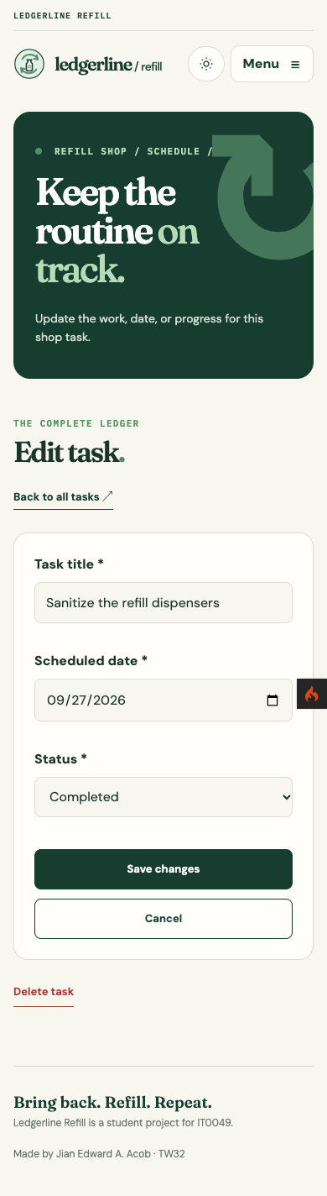
Figure 14. My task edit form remains usable at 390 pixels without horizontal overflow.

Task write flow
I validate each task title, date, and status in my Tasks controller before saving to the separate task database. I use a CSRF-protected POST route and a confirmation for deletion. My Today page reads the current task rows.

Preserved directories and data
I checked five POS customer rows, five POS staff rows, nine task rows across four dates, four tasks dated today, and one task-system demo user. I used a generated initials graphic for the sample avatar.

Database Structure and Model Evidence

Table | Required columns and constraints
customers | id primary key; full_name and email required; phone optional; created_at
POS users | id primary key; username unique; full_name required; avatar nullable filename; created_at
tasks | id primary key; title, status, task_date, and created_at
task-system users | id primary key; username unique; full_name, email, and created_at

Component | Implementation evidence
AddUserAvatar migration | I added the nullable users.avatar filename column to my POS database.
CustomerModel and UserModel | I limited saved columns and queried my POS database through these Models.
TaskModel and TaskUserModel | I read and save tasks, and read the demo profile, from my separate taskStore database.
Avatar preparation | I reject non-JPG/PNG files and files over 2 MB. I use CodeIgniter to crop images to 320 by 320 pixels, convert them to JPEG, and store a random filename.

Controller View and Testing Evidence

Validation and redisplay
I require a full name and valid email for customers, and a full name and unique username for staff. My forms show field errors and keep entered values when validation fails. I prefill edit forms from existing records and protect POST routes with CSRF tokens.

Upload and listing
I accept JPG or PNG files up to 2 MB in the staff edit controller. I prepare a real 320 by 320 JPEG in public/uploads/avatars and save only its filename in users.avatar. I show a placeholder when no avatar is saved.

Local verification
I checked all twelve GET pages and received HTTP 200. I created, edited, and deleted a temporary task. I confirmed that invalid email, duplicate username, invalid image, and an image over 2 MB were rejected. I also tested valid customer and staff inserts and updates. My PNG upload produced a real JPEG. PHPUnit passed five tests and seven assertions. My task and staff forms had no horizontal overflow at 390 pixels.

Submission Links and References

Submission item | Verified status
GitHub repository | https://github.com/Jiyaannnn/TFA3_ACOB_IT0049
POS database export | database/ledgerline_pos_tfa3.sql
Task database export | database/ledgerline_refill_tfa3.sql

Publication verification
I published my CodeIgniter source, README, both SQL exports, report, and captured evidence in the GitHub repository. GitHub publication is the submission requirement for this activity; hosting is reserved for the final project.

