Technical Formative Assessment 4
WHO'S ALLOWED IN? SESSIONS AND AUTHENTICATION
Ledgerline Refill CodeIgniter POS Integration
Student | Jian Edward A. Acob
Program and Section | BSITBA - TW32
Course | IT0049 - Web System Technologies
Instructor | Mr. Von Erick Magbitang
Assessment | Technical Formative Assessment 4
Date | October 4, 2026

Project Overview

I continued my TFA3 Ledgerline Refill POS in a separate TFA4 project. I kept its refill shop branding, Today and task pages, customer and staff forms, validation, avatar uploads, and responsive layout. I added staff sign in so only an authenticated staff member can manage customer and staff accounts.
I kept the TFA3 project and its databases untouched. My TFA4 copy uses ledgerline_pos_tfa4 and ledgerline_refill_tfa4. The POS database retains five original customer records and five staff records.
Required Routes and Behavior

Route | My implementation
GET and POST /login | Public sign in; the POST checks password_verify() and starts a session.
GET /customers, /customers/new, /customers/{id}/edit | The auth filter requires a staff session for listing and forms.
GET /users, /users/new, /users/{id}/edit | The same filter protects the staff directory and forms.
POST /customers and /users routes | Auth and CSRF filters protect creation and updates.
POST /logout | Destroys session data and redirects to login.

Authentication and Database Design

I added a nullable password column through a CodeIgniter migration so existing TFA3 rows could be upgraded. I then assigned each existing TFA4 staff record its own private password hash. My export contains the hashes, not plaintext passwords. The local credentials file is excluded from Git.
At sign in, my Auth controller finds the username and calls password_verify() on the stored hash. A successful check regenerates the session ID and stores the staff ID and name. My AuthFilter checks for that ID before protected routes run. Logout destroys the session. New staff passwords must be at least 12 characters; leaving the password blank when editing keeps the existing hash.
Component | What I can explain
AddUserPassword migration | Adds users.password without changing customer or task tables.
UserModel and Users controller | Allows password writes and hashes only a newly entered password.
Auth controller and AuthFilter | Verifies credentials, manages session state, and redirects guests.
Routes and CSRF | Applies auth to customer and staff GET and POST paths; forms retain CSRF tokens.

Verification I Performed

Test | Result
Guest access to customer and staff pages and edit forms | Redirected to login.
Wrong password and correct password | Wrong password showed a generic error; correct password opened customers.
Logout then revisit staff edit | Returned to login.
Public and protected GET pages | All 12 checked pages returned HTTP 200 when appropriate.
Invalid customer email and duplicate staff username | Rejected while retaining entered values.
Customer and staff create and update | Saved to TFA4 database; temporary records later removed.
Invalid file, file above 2 MB, valid JPEG avatar | Invalid files rejected; valid avatar accepted.
Staff password hash | password_verify() succeeded; plaintext absent in database.
390 pixel staff edit form | No horizontal overflow after header adjustment.

Application Page Evidence

The following figures are real screenshots captured from my locally running TFA4 application. I cropped page images consistently for readability; the original full captures are in docs/evidence.
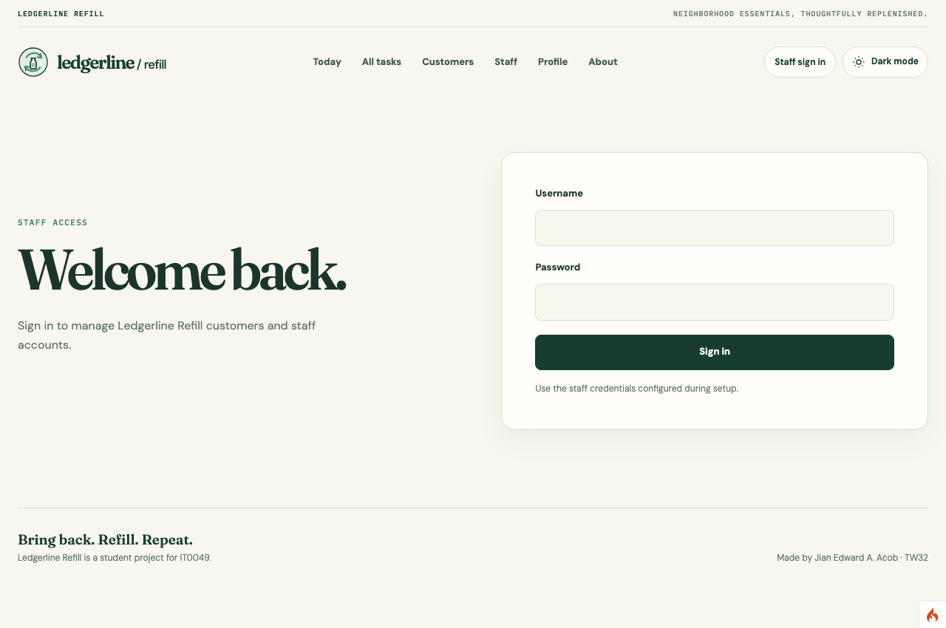
Figure 1. My Ledgerline Refill staff sign in page.
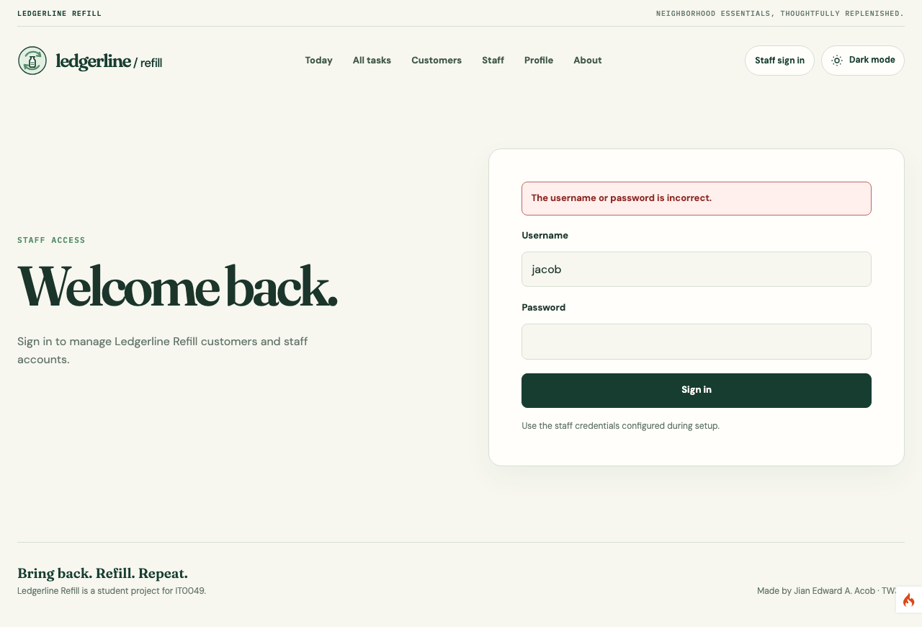
Figure 2. My invalid login displays a generic error.
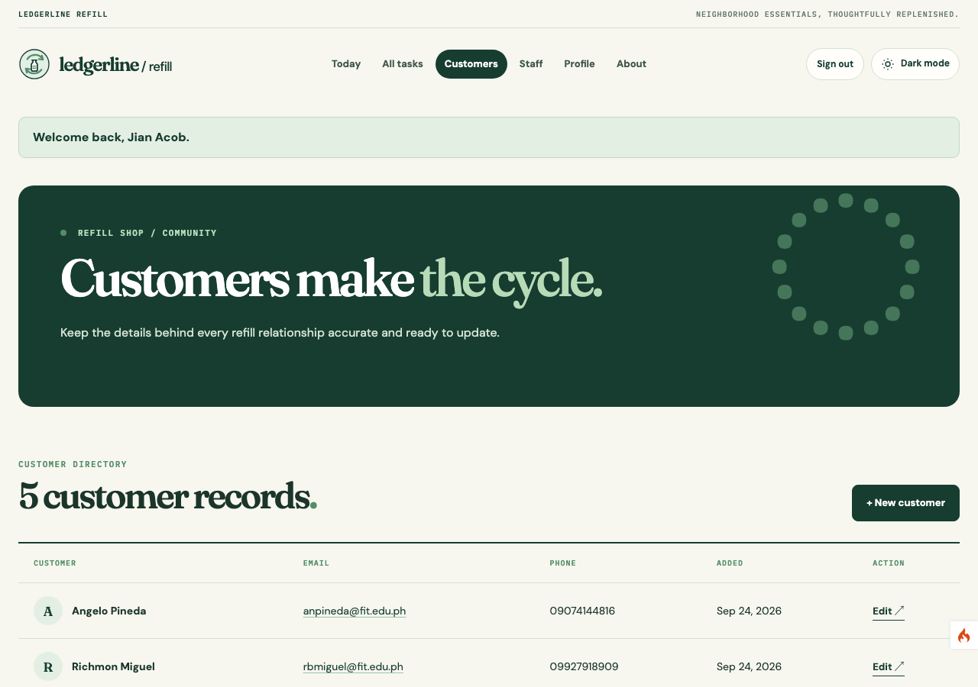
Figure 3. My customer directory opens after successful sign in.
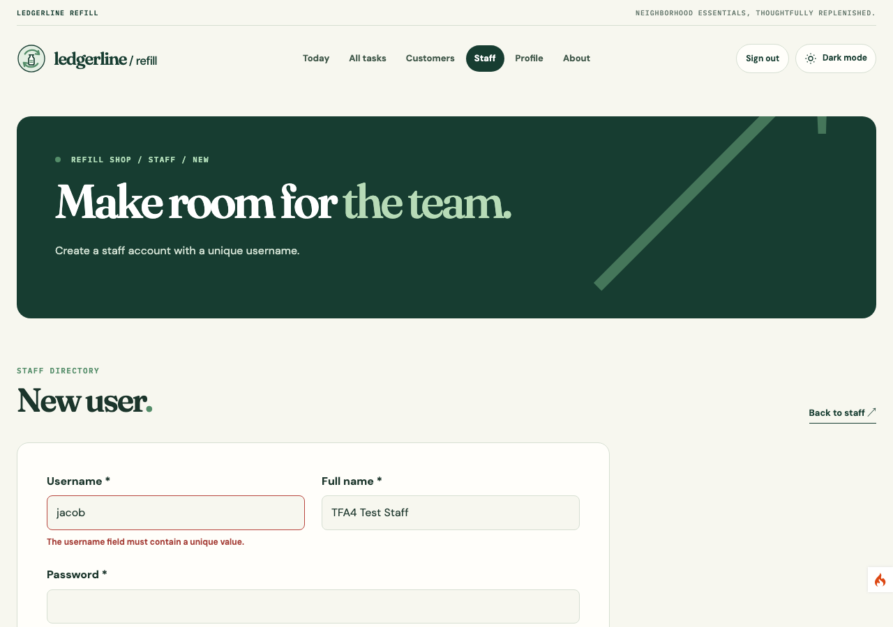
Figure 5. My new staff form rejects a duplicate username.
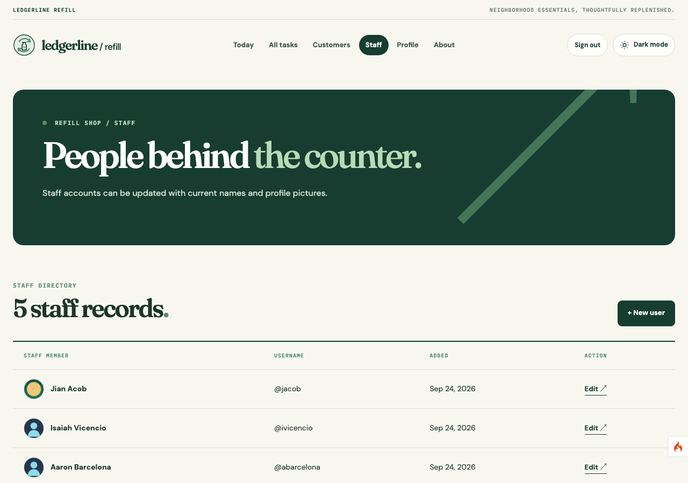
Figure 6. My staff directory retains its original design.
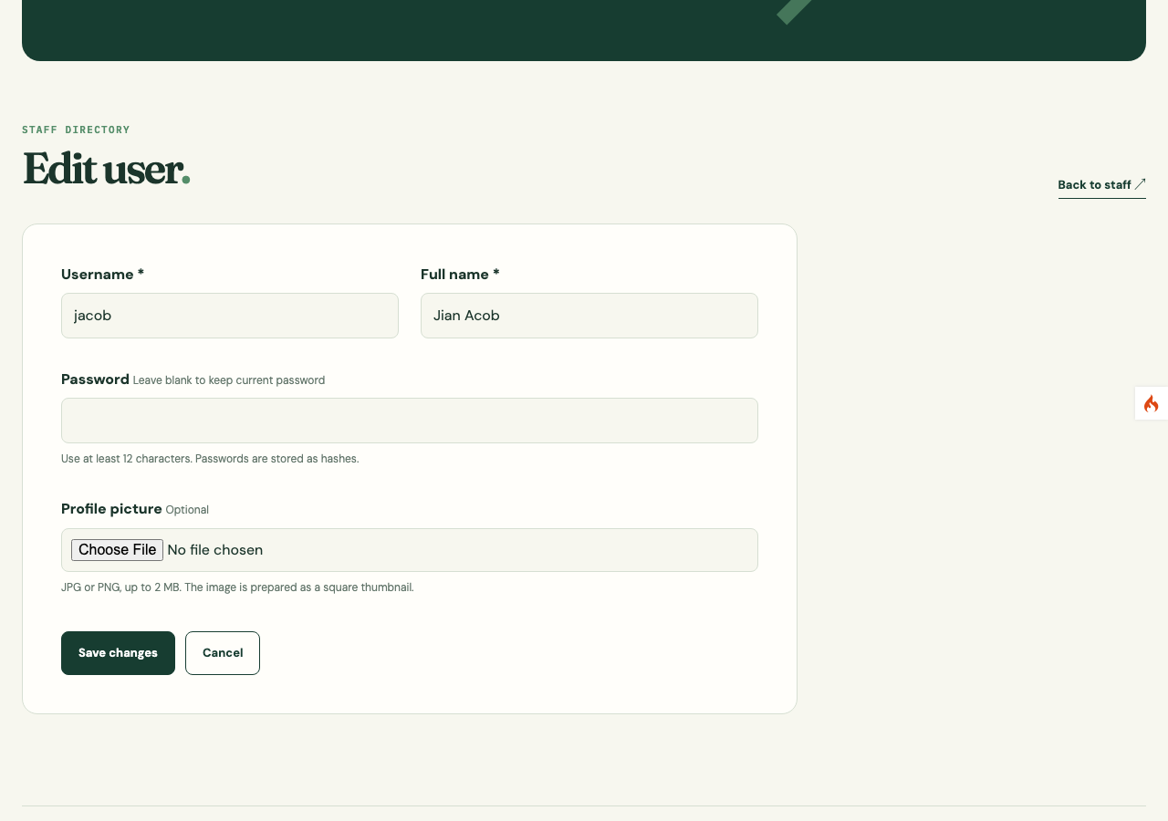
Figure 7. My staff edit form offers an optional password change.
Figure 10. My logout sends a protected edit request back to sign in.
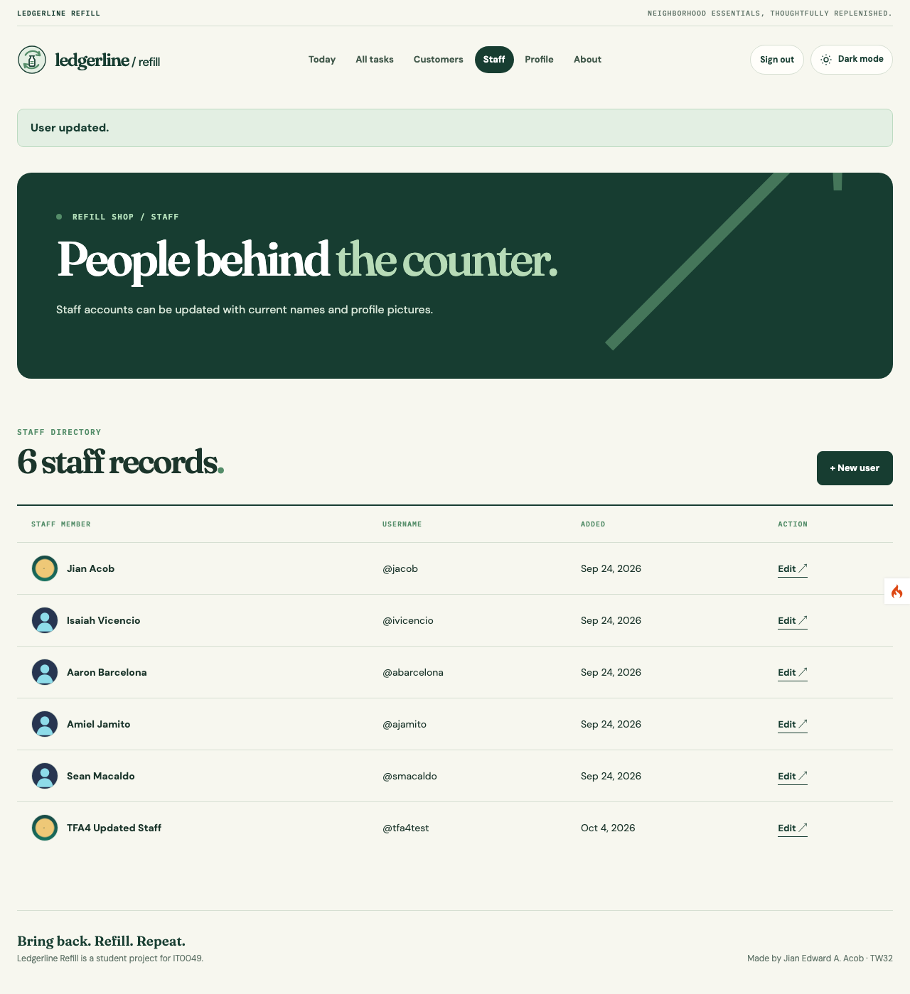
Figure 13. My valid avatar upload appears on the staff listing.
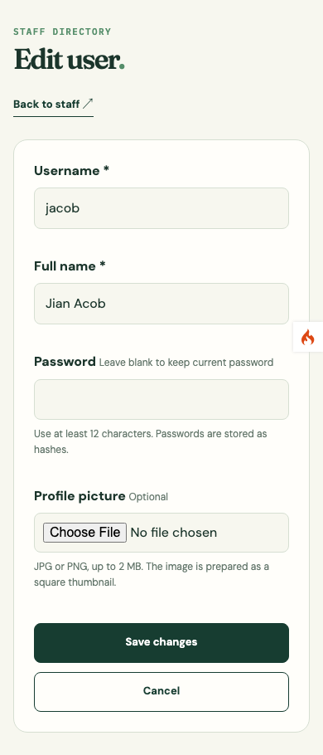 | Figure 8. My staff edit form fits a 390 pixel screen. Its single-column fields and upload remain usable without horizontal scrolling.
Submission

My GitHub repository contains the CodeIgniter source, TFA4 database exports, migration, seeder, README, report, and captured evidence. I excluded .env, local credentials, vendor dependencies, sessions, logs, and temporary uploads. The activity is published on GitHub only; a live hosted site is reserved for the final project.
Repository: https://github.com/Jiyaannnn/TFA4_ACOB_IT0049
My Presentation Walkthrough

I will first open a customer URL while signed out and show the redirect. I will enter a wrong password and point out the generic error, then sign in and show the customer and staff pages. I will open a new staff form to explain the password requirement and show the users.password hash in the TFA4 database without revealing a password. Finally, I will sign out and retry a protected edit URL to show that the session has ended.

