Technical Formative Assessment 5
FROM ZERO TO FOUR PAGES, AGAIN: YOUR FIRST LARAVEL APPLICATION
Soluna Solar Supply & Installation
Student | Jian Edward A. Acob
Program and Section | BSITBA - TW32
Course | IT0049 - Web System Technologies
Professor | Mr. Von Erick Magbitang
Date | October 19, 2026
Project Overview

I built Soluna Solar Supply & Installation as a new Laravel 13 application for Technical Formative Assessment 5. It presents a Philippine solar installation concept through four public pages: Overview, About, Customer Accounts, and User Accounts. I used the earlier CodeIgniter project as a reference for the account names, while the new project is in a separate folder.
The two account pages use static PHP arrays with five records each. This matches the activity focus on routes, controllers, and Blade views before database-driven records are introduced. The interface adds useful reading controls: directory search, stage and team filters, a rooftop explainer, and a simple solar-system explainer.
Activity Requirements and Result

Required item | My implementation
New Laravel project | Laravel Framework 13.37.0; runs with the Artisan server on port 8080.
Four pages and navigation | GET /, /about, /customers, and /users; every page links to the others.
Controllers and Blade views | PageController, CustomerController, and UserController render four Blade views.
Static account data | Each account controller holds five records; the views render them with @foreach.
Submission source | The repository includes Laravel source, migration and seeder files, README, and evidence.

Project Identity

I changed the shop concept to a solar supply and installation workspace in the Philippines. The visual design uses solar photography, deep blue, warm sunlight, and a fine drafting grid. The photograph is an AI-generated illustrative site asset; all screenshots in this report are real captures of the running application.

Laravel Structure

The route chooses a controller action. The controller prepares the page data. Blade renders the HTML that a visitor sees. This is the same division of responsibility I learned in CodeIgniter, expressed in Laravel files.
File | Responsibility
routes/web.php | Names and connects the four public GET routes.
PageController.php | Supplies page titles and my profile information.
CustomerController.php | Defines five solar customer records and counts project stages.
UserController.php | Defines five user records carried from the earlier project and counts teams.
resources/views/pages | Contains the four Blade pages; both account views use @foreach.
public/assets | Contains the styles, interaction script, and illustrative rooftop image.

Data and Interaction

The customer array contains a code, name, location, project type, sample system capacity, and stage. The user array contains a code, username, name, role, team, location, and status. Blade escapes the displayed values. The search and banner controls filter only the already rendered rows, so they do not alter the arrays or write to a database.
Small Code Examples

The routes below connect URLs to controller methods. The Blade loop then renders every record supplied by the controller.
Route::get('/customers', [CustomerController::class, 'index']);
Route::get('/users', [UserController::class, 'index']);
@foreach($customers as $customer) ... @endforeach
Verification I Performed

Check | Observed result
Routes | All four pages returned HTTP 200 on the local Artisan server at 127.0.0.1:8080.
Static records | The customer page displayed five records; the user page displayed the five earlier names.
Search and filters | Matching search returned one row; a nonmatching search showed an empty message; stage and team buttons changed the visible rows.
Explainers | Rooftop markers and the About page buttons changed the text and selected state.
Mobile and keyboard | At 390 px, pages had no horizontal overflow; the menu opened; Enter activated a selected control.
Framework checks | Artisan listed the four expected routes; the existing PHPUnit suite passed 2 tests.

This activity does not require a working form, upload, or database write. The Laravel scaffold still includes migration and seeder files for later development.

Application Page Evidence

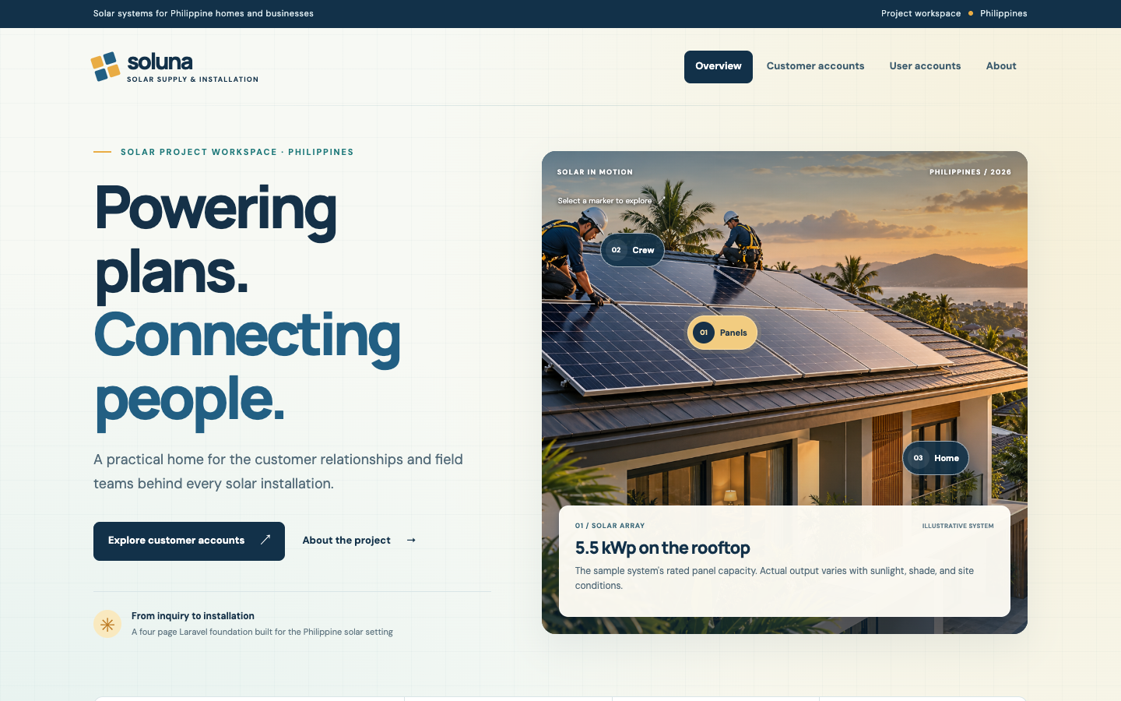
Figure 1. Overview page.
The landing route introduces the solar concept and links to the customer directory.
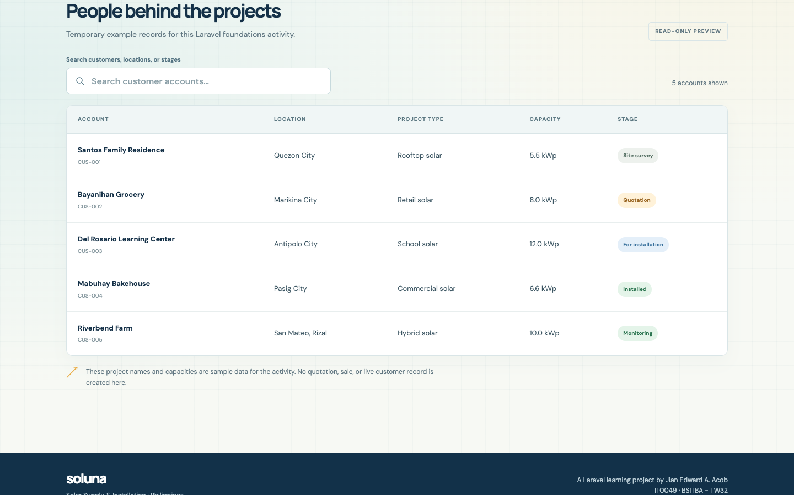
Figure 2. Customer accounts directory.
The customer route displays five static records rendered by Blade.

Account and About Evidence

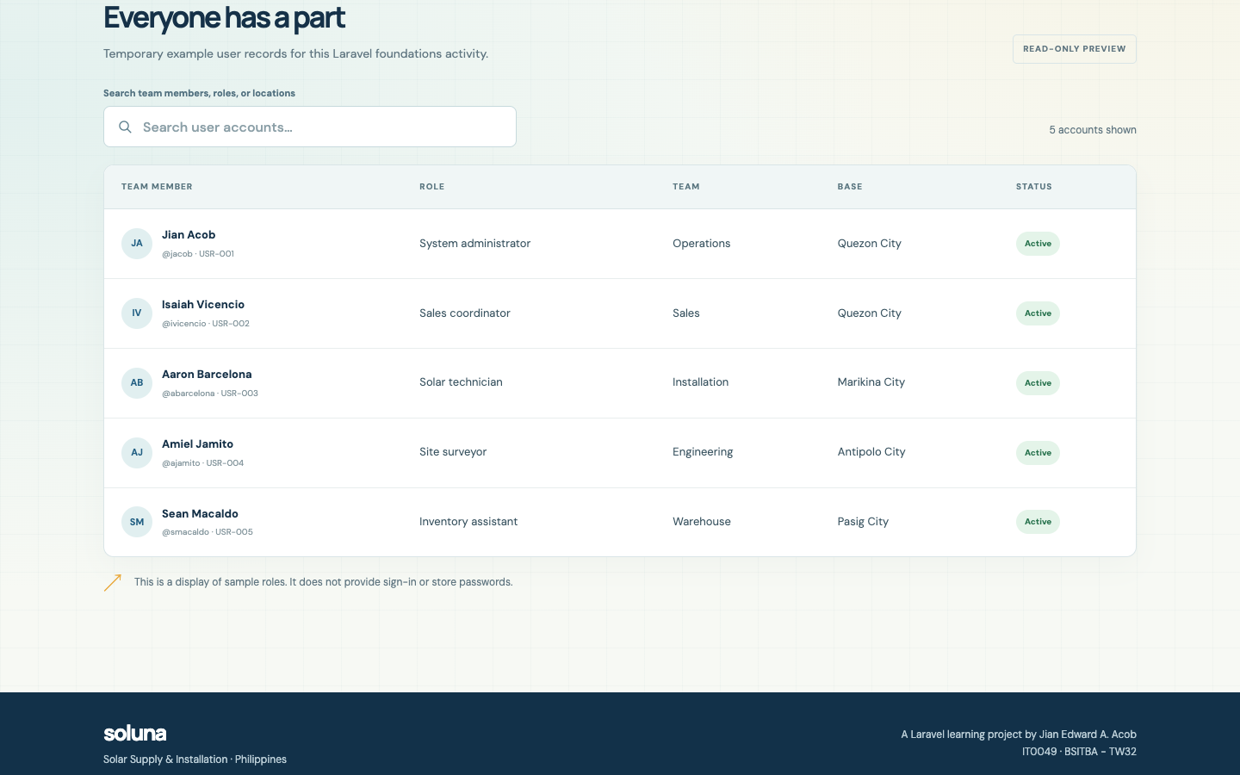
Figure 3. User accounts directory.
The directory uses the five user names and usernames from my earlier CodeIgniter project.
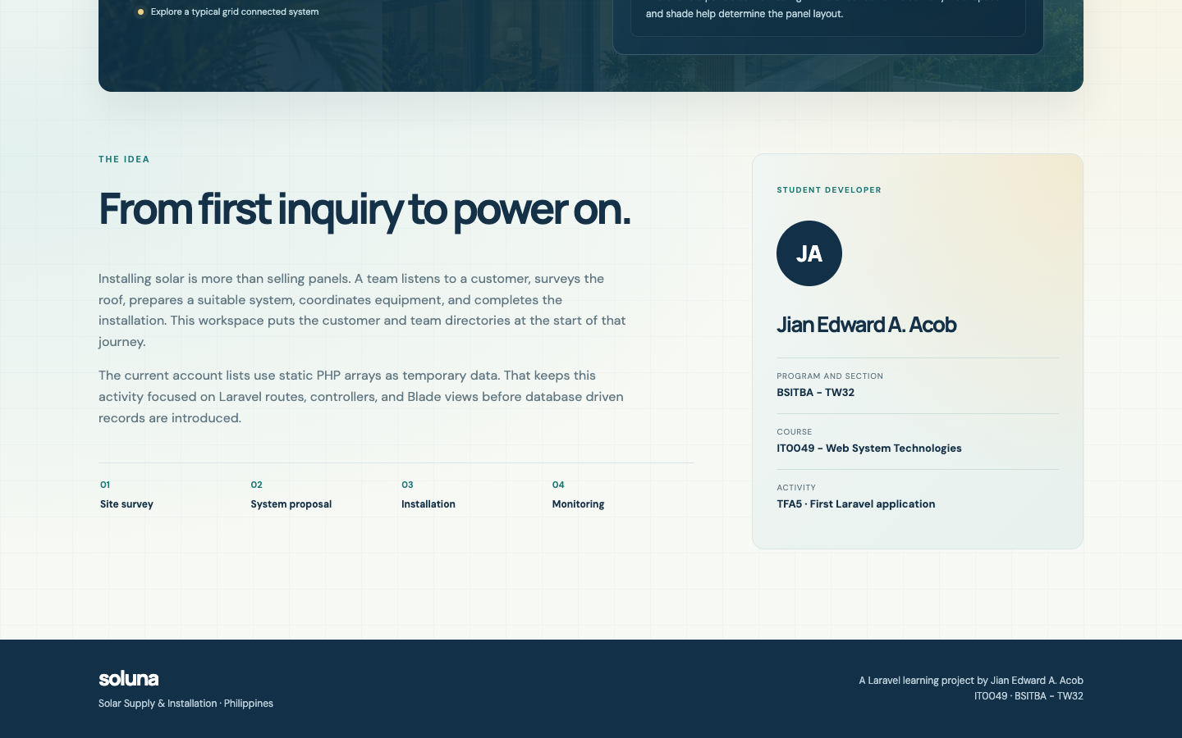
Figure 4. About page and student profile.
The About page shows my name, section, and course beside the project story.

Interaction Evidence

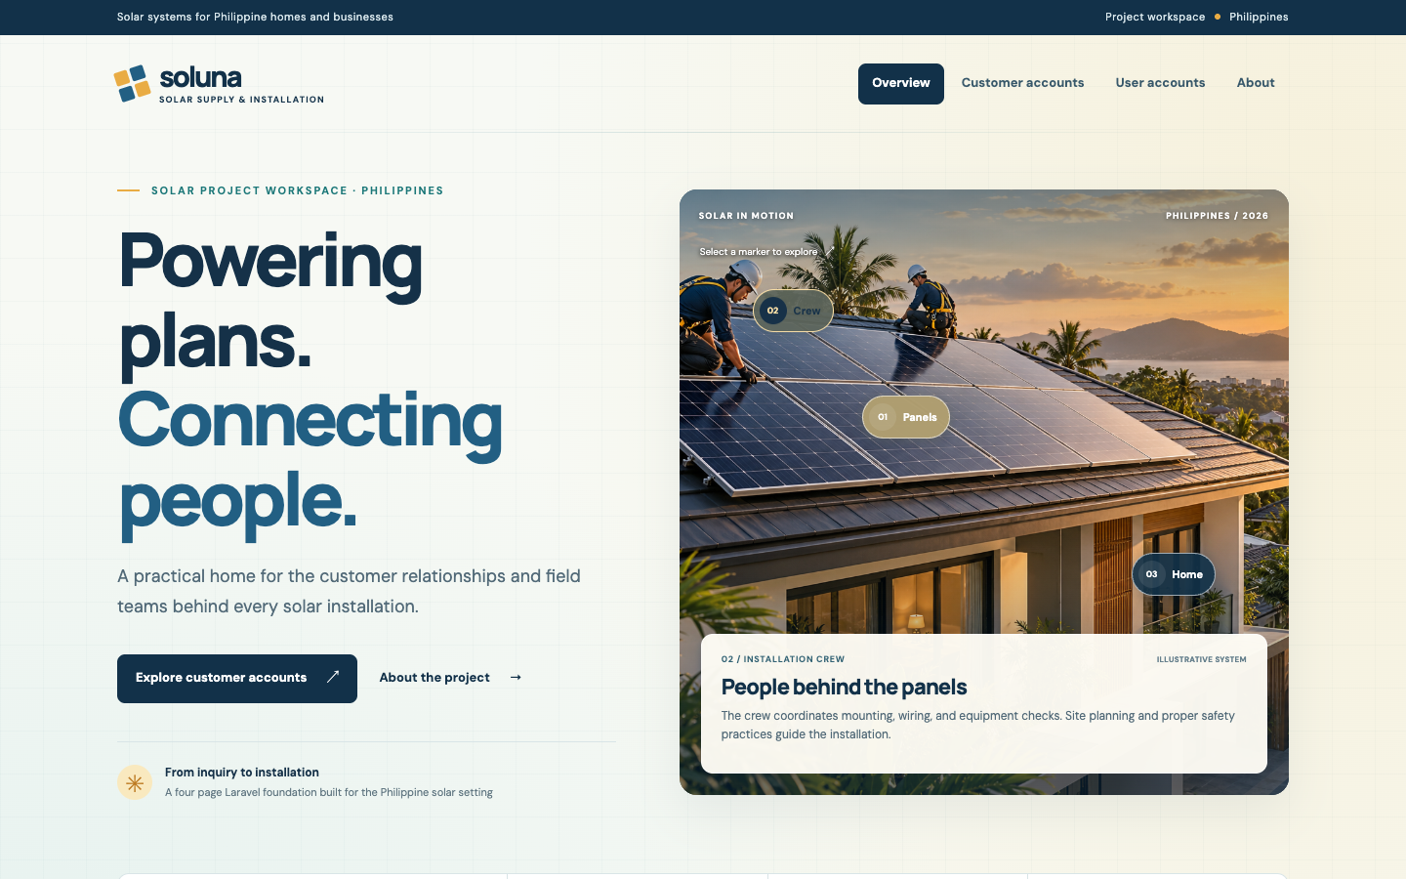
Figure 5. Rooftop marker interaction.
Selecting Crew changes the information card in the home hero.
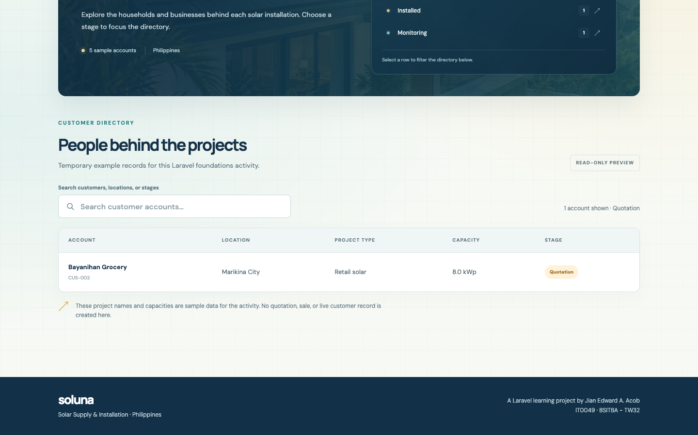
Figure 6. Customer stage filter.
Selecting Quotation leaves the one matching sample record visible.

Mobile and Submission

I checked the responsive layout at a 390-pixel browser width. The navigation collapses into a Menu button, and the site keeps the links to all four pages.
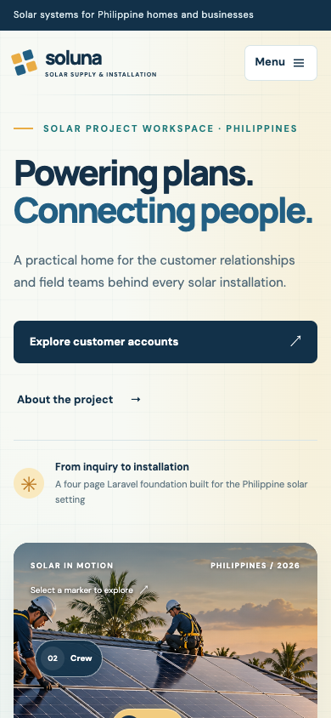 | 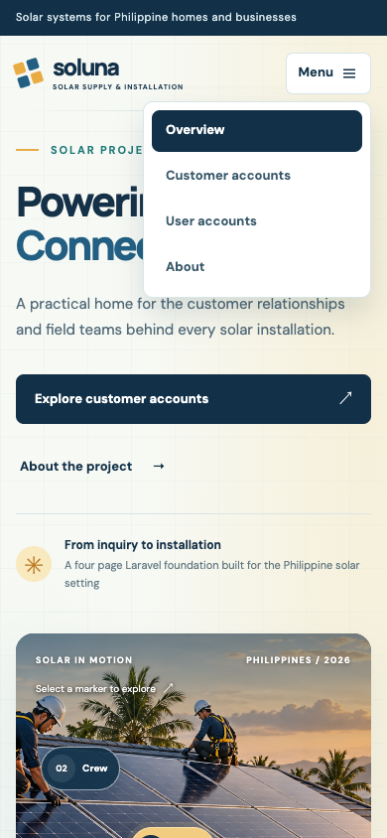
Figure 7. Mobile overview (left). Figure 8. Open mobile navigation (right).
Repository and Presentation

Repository: https://github.com/Jiyaannnn/TFA5_ACOB_IT0049
To present the program, I will open the four routes, explain that each route calls a controller, show one static array and its @foreach Blade loop, then demonstrate search and a banner filter. I will finish by opening the mobile menu and explaining that the current account records are samples.
Local setup: composer install; copy .env.example to .env; run php artisan key:generate; then run php artisan serve --host=127.0.0.1 --port=8080.

