Technical Formative Assessment 6
FROM ARRAYS TO ELOQUENT
Soluna Solar Supply & Installation
Student | Jian Edward A. Acob
Program and Section | BSITBA - TW32
Course | IT0049 - Web System Technologies
Professor | Mr. Von Erick Magbitang
Date | October 26, 2026

Project Overview

I continued my TFA5 Soluna Solar Supply & Installation application in a separate TFA6 project. I kept the four public pages, solar branding, colors, layout, and interactions while replacing the account controller arrays with database records.
I created migrations, a seeder, and Customer and User Eloquent models. Each table contains five sample records. Both account controllers now retrieve ordered database records, and Blade displays them through the existing directories.

Activity Requirements and Result

Required item | My implementation
Migrations and schema | TFA2 core columns and unique username, plus Soluna display fields.
Seeded sample records | DatabaseSeeder supplies five customers and five users.
Eloquent models and controllers | Customer and User models retrieve records with orderBy and get.
Blade views and four pages | Existing navigation, directories, search, and filters are retained.
Submission source | GitHub contains source, migrations, seeder, README, report, and evidence.

Project Identity

I retained the Philippine solar workspace from TFA5. The rooftop photograph is an AI-generated illustrative asset already used in the project. Every screenshot in this report is a real capture of the running TFA6 application.

Laravel Structure

I use migrations to describe the database, a seeder to populate examples, and Eloquent models to retrieve records. Routes call controllers, and controllers pass collections to Blade views. The customer and user pages no longer contain static controller arrays.
File | Responsibility
database/migrations | Create customers and users; down reverses the schema.
database/seeders/DatabaseSeeder.php | Populate five records in each table with stable keys.
app/Models/Customer.php and User.php | Map database records to Eloquent objects.
CustomerController and UserController | Retrieve ordered collections and calculate filter counts.
resources/views/pages | Render database records with escaped Blade expressions.
public/assets | Preserve the Soluna styles, interactions, and rooftop image.

Data and Interaction

I matched TFA2's core fields: customers have full_name, email, nullable phone, and created_at; users have a unique username, full_name, and created_at. I retained extra Soluna project and team fields to preserve the existing filters. Both models disable updated_at to match the earlier schema.

Small Code Examples

I retrieve database records in ID order and display their escaped values in Blade. The seeder uses stable keys so running it again updates the samples without duplicating them.
$customers = Customer::orderBy('id')->get();
$users = User::orderBy('id')->get();
@foreach($customers as $customer) {{ $customer->full_name }} @endforeach

Verification I Performed

Check | Observed result
Routes and records | Four pages passed; each directory displayed five seeded records.
Database lifecycle | Seeding, reseeding, insert/update/delete, and rollback/rebuild passed.
Invalid data and output | Duplicate usernames and missing names rejected; HTML escaped; null phone handled.
Browser interactions | Search, empty results, stage/team filters, and both explainers worked.
Responsive navigation | All pages fit 390, 768, and 1440 px; mobile Menu and Escape worked.
Automated checks | 8 tests passed with 33 assertions; Pint formatting passed.
I tested database changes through Eloquent in an isolated test database. This activity has no editing forms, uploads, checkout, or login. SQLite does not enforce VARCHAR lengths; the migration definitions retain the TFA2 lengths.

Application Page Evidence

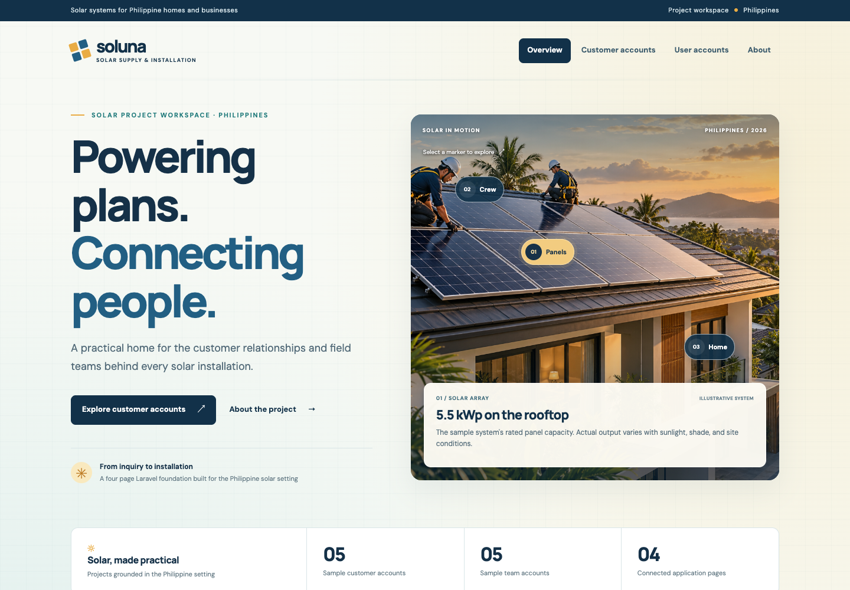
Figure 1. Overview page.
I retained the Soluna landing page and navigation from TFA5.
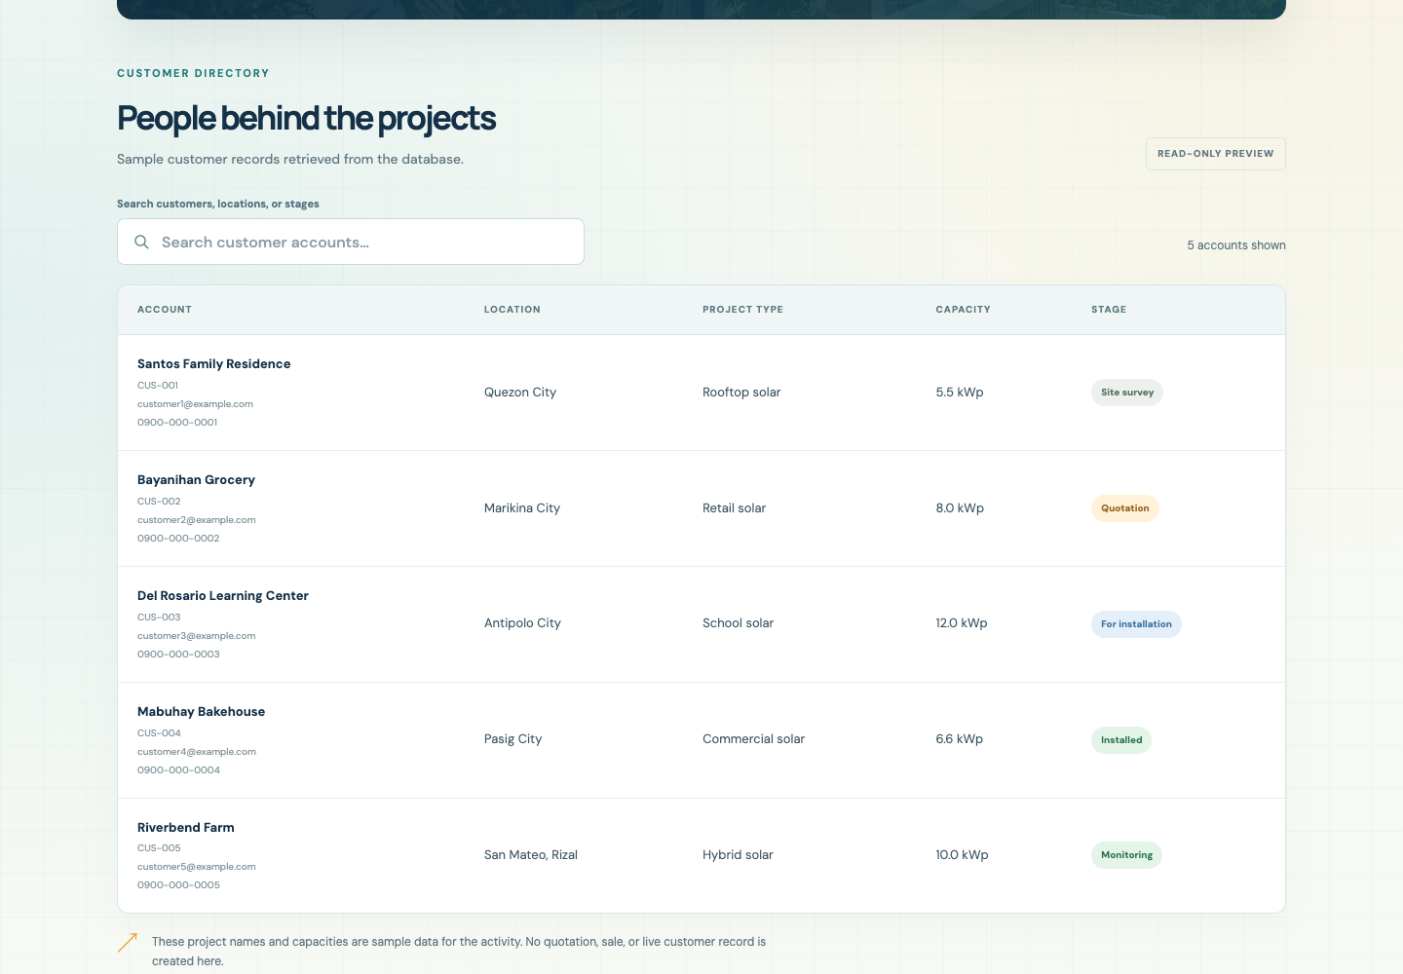
Figure 2. Customer accounts from Eloquent.
I display five seeded customer records with contact and project details.

Account and About Evidence

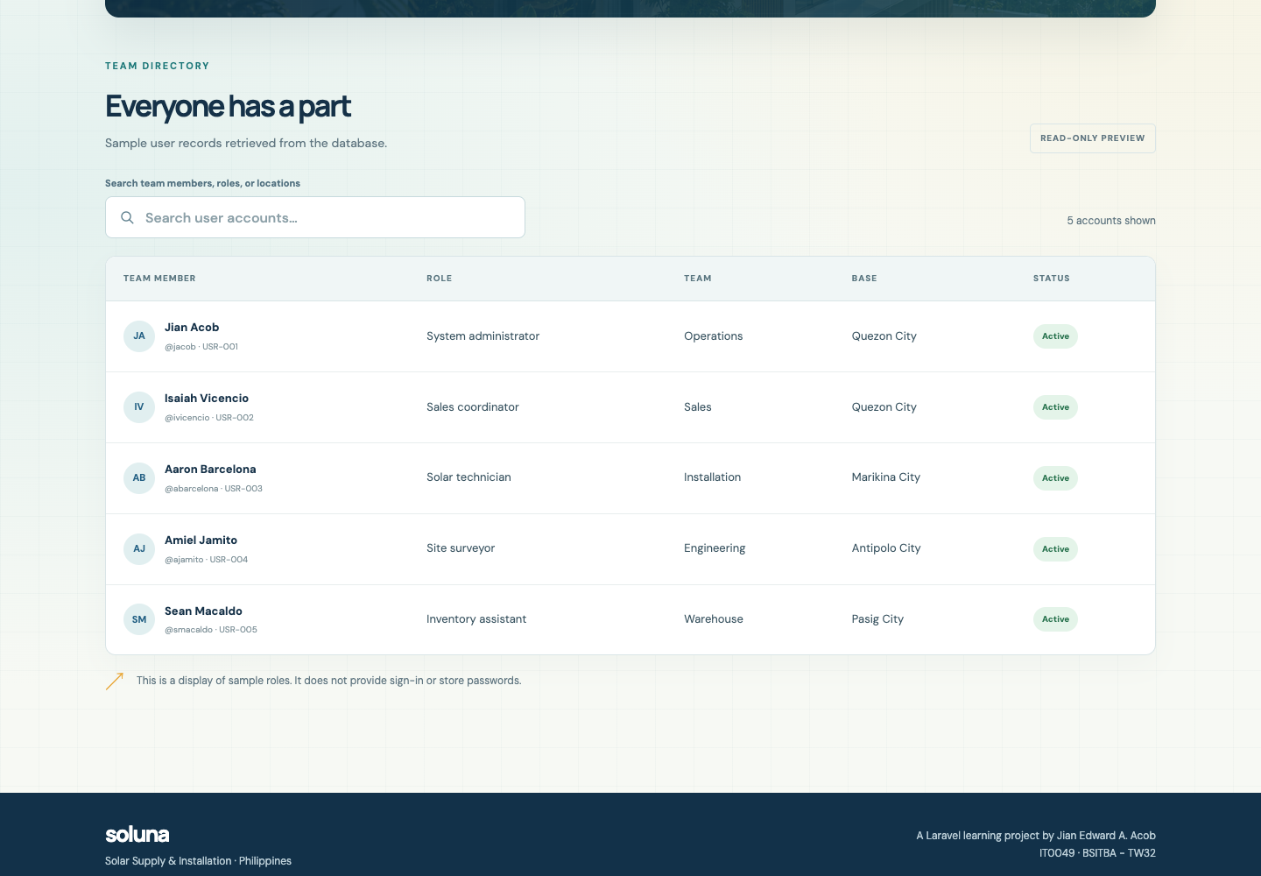
Figure 3. User accounts from Eloquent.
I retrieve the five earlier team names and unique usernames from the database.
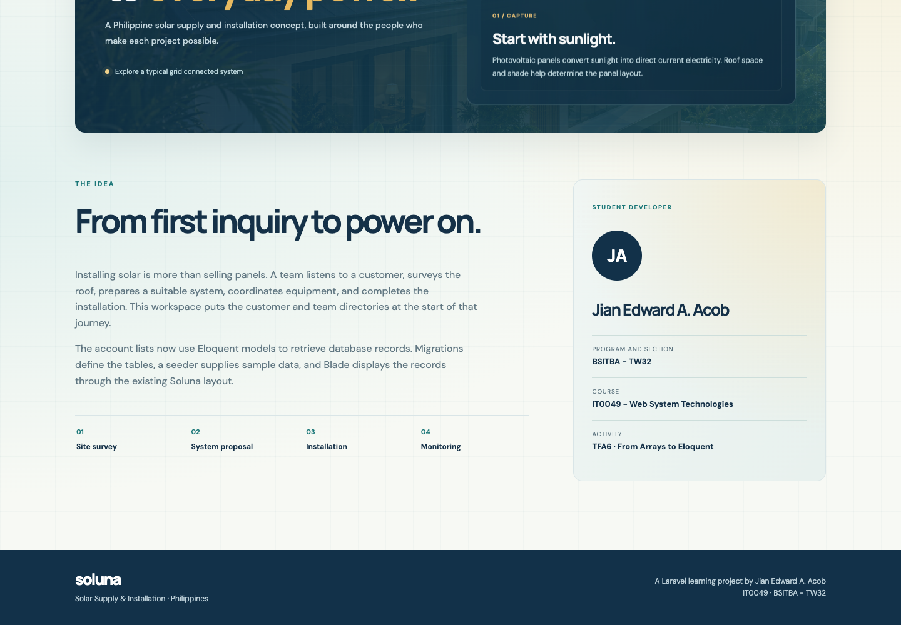
Figure 4. About page and student profile.
I explain the database-backed application beside my updated TFA6 profile.

Interaction Evidence

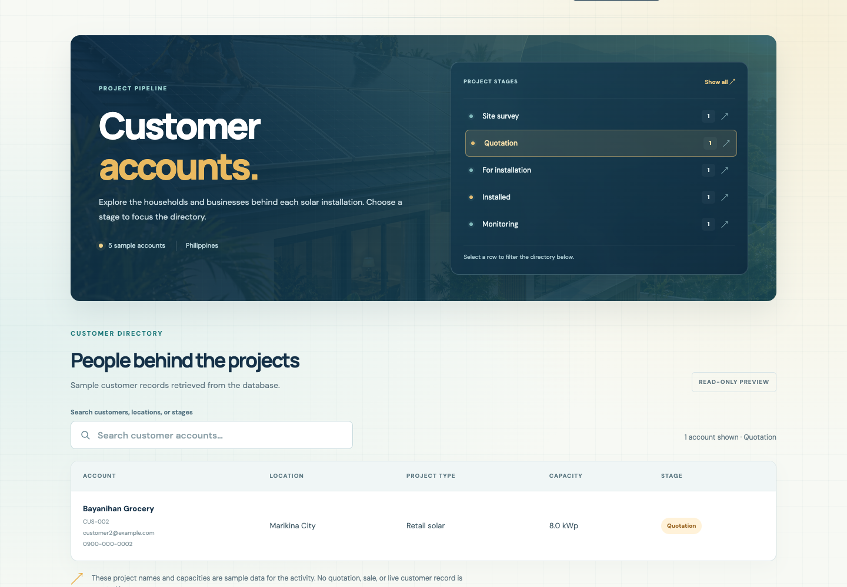
Figure 5. Customer stage filter.
Selecting Quotation leaves the matching customer visible without changing stored data.
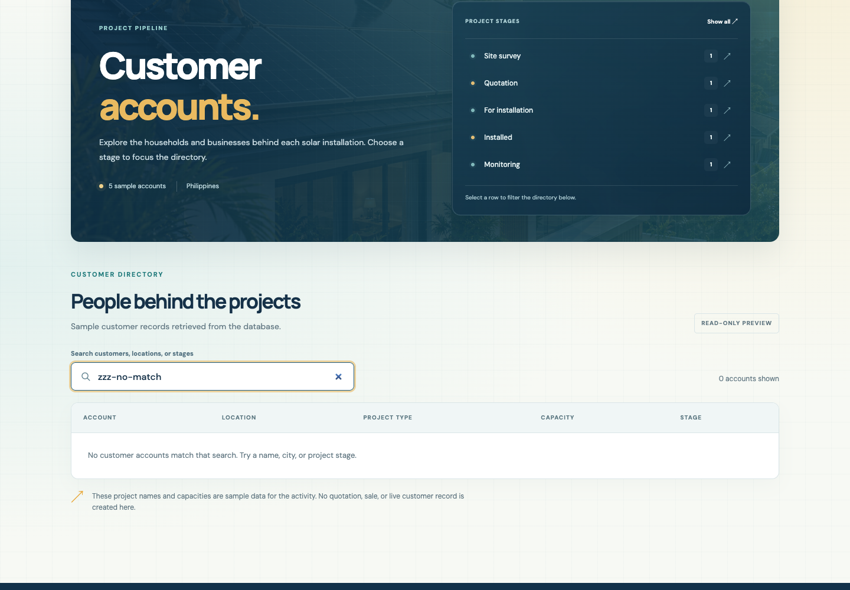
Figure 6. Search with no matching accounts.
A nonmatching search shows zero results and a helpful empty message.

Mobile and Submission

I checked all four pages at 390, 768, and 1440 pixels with no horizontal overflow. The mobile Menu opens the navigation and Escape closes it.
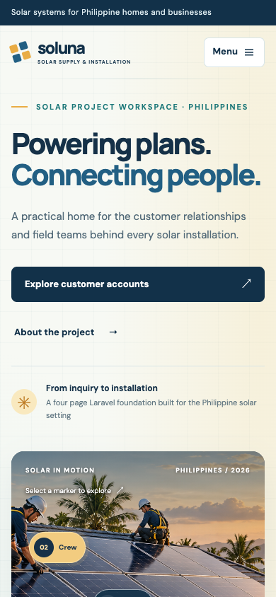 | 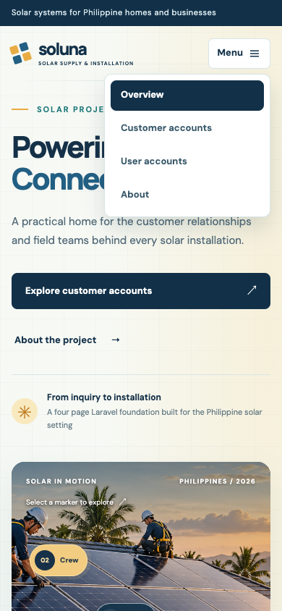
Figure 7. Mobile overview (left). Figure 8. Open mobile navigation (right).

Repository

Repository: https://github.com/Jiyaannnn/TFA6_ACOB_IT0049
I prepared a GitHub-only submission. The handout also requests a hosted link; no public application was deployed for this submission.

