Technical Summative Assessment 2
TASKS FOR TODAY MANAGEMENT SYSTEM: FULL CRUD AND AUTHENTICATION
Ledgerline Print & Supply
Student | Jian Edward A. Acob
Program and Section | BSITBA - TW32
Course | IT0049 - Web System Technologies
Professor | Mr. Von Erick Magbitang
Date | October 9, 2026

Project Overview

I extended my CodeIgniter project in a separate TSA2 folder, leaving the original TFA4 project unchanged. The new concept is Ledgerline Print & Supply, a neighborhood print counter and stationery shop. Its daily task list covers realistic work such as preparing print pickups, checking paper stock, testing the color printer, receiving ink cartridges, and confirming binding orders. This context gives the task records a clear purpose while keeping the assessment focused on CRUD and authentication.
Visitors can open Today, Task Board, Profile, and About without an account. Staff sign-in unlocks the management controls and the existing customer and staff sections. I kept the established navy, mint, and warm orange palette, then replaced the earlier oversized letters in the inner-page heroes with paper, task sheet, pencil, and shop card illustrations.
What TSA2 Added After TFA4

Earlier TFA4 work | Additional TSA2 work
Sessions and staff sign-in for POS records | A hashed password for the task-system demo user and task management access.
Protected customer and staff pages | Public task reading with protected task creation, editing, and archiving.
Existing customer and staff forms | A dedicated new-task form and edit form with required-field validation.
Permanent task rows from TSA1 | An is_archived flag that hides deleted tasks without removing their database rows.

The assessment title says “full CRUD.” In my application, the delete part is intentionally a soft delete: clicking Archive changes a flag instead of running a SQL DELETE. That follows the activity instructions and preserves a record that can still be inspected in the database.

Application Structure and Routes

I kept the CodeIgniter MVC structure. Routes decide which controller action receives a request. Controllers handle input and redirects. Models query the correct database group. Views show public pages, task cards, and forms. This separation also makes the task flow easier for me to explain and debug.
File or component | Responsibility
Routes.php | Keeps public GET pages open and applies auth plus CSRF filters to task-changing POST routes.
Auth.php and AuthFilter.php | Verify sign-in, manage the session, preserve a safe return path, and redirect guests.
Tasks.php | Show lists and forms; validate fields; create, update, and archive tasks.
TaskModel.php | Query the taskStore database and exclude archived rows before rendering lists.
Task views and task-board.js | Render accessible forms and filters, then enhance the board without removing its normal URL-based behavior.

Required Route Behavior

Route or action | Access and behavior
GET / and GET /tasks | Public; list only active tasks. The board supports search, status, and Today filters.
GET /profile and GET /about | Public; explain the creator and shop concept.
GET /login and POST /login | Public; accept staff credentials and verify the stored password hash.
GET /tasks/new; POST /tasks | Signed in; show and submit a validated new-task form.
GET /tasks/{id}/edit; POST /tasks/{id} | Signed in; show existing values and save valid changes.
POST /tasks/{id}/delete; POST /logout | Signed in; archive a task or end the session.

Database Changes

The TSA2 migration adds users.password to the task database and tasks.is_archived with a false default. The demo password seeder reads a private setup value, hashes it, and writes only the hash. I did not place a reusable password in the repository. The project still uses separate POS and task database groups, so task queries do not accidentally read a same-named table in the POS database.
Field or rule | Why it matters
users.password | Stores a one-way hash used by password_verify() at sign-in.
tasks.title and tasks.task_date | Identify the work and its scheduled day; both are required by the form.
tasks.status | Limits progress to Pending, In progress, or Completed.
tasks.is_archived | Defaults to false. Archive sets it to true; lists query only false rows.

Task Workflow and Security

When I create a task, the new form starts with today’s date and Pending status. The save action trims the submitted text, validates the title, date, and allowed status, and redisplays the submitted values when a rule fails. A successful create sets created_at once, inserts the task, and returns to the board with a confirmation message. Editing follows the same validation path but updates the existing ID and keeps its original creation timestamp.
Archiving first checks that the requested ID exists. It then changes is_archived to 1 and redirects to the board. TaskModel includes is_archived = 0 in its list queries, so the archived record disappears from both Today and Task Board while remaining in MySQL. Unknown IDs return a 404 instead of pretending that a change succeeded.
Sign In and Protected Actions

The login action finds the task user by username and calls password_verify() against the stored hash. On success, it regenerates the session ID and stores the user ID and name. The route filter checks that session before showing new or edit forms and before accepting create, update, or archive requests. The login page can return a signed-in user to the protected page they originally requested, but only when that path matches an allowed local route.
Every task-changing form posts a CodeIgniter CSRF token. This helps reject submissions that did not originate from the application. The task routes use separate auth and csrf filter aliases; while testing, I found and corrected an earlier combined-alias declaration that made POST requests fail. The corrected routes now appear with both filters in the CodeIgniter route list.
Validation and Error States

Input or state | Application response
Missing or whitespace-only title | The controller rejects it and redisplays the title error.
Missing or invalid task date | The date rule rejects it before any database write.
Unrecognized status | The allowed-value rule rejects it.
Unknown edit or archive ID | The request returns a 404.
Guest management request | The filter sends the visitor to sign-in; public reading remains available.

Design and Interaction Decisions

The print-studio interface uses large readable headings, clear status controls, and illustrated paper objects that match the shop rather than generic page initials. The task board has search, status chips, and a Today filter; JavaScript improves their response while the ordinary links and form URLs still work. On narrow screens, the navigation becomes a menu, the hero content stacks, and form fields remain usable in one column. I kept motion subtle and respected reduced-motion settings.
Reproducibility and Project Files

I prepared the repository so the activity can be installed from source without copying my local databases or password. The README lists PHP, Composer, and MySQL requirements, the two database names, migration and seeder commands, and the local server command. The task demo password is supplied privately during setup; the task database stores its hash. Keeping the setup steps with the source makes the submitted project easier to review on another device.

Verification I Performed

I tested the application on the local CodeIgniter server. The table records observed results, not planned tests. For database behavior, I created one test task, edited it, archived it, and inspected the saved row. I left that archived row in the local database as evidence of soft deletion.
Check | Observed result
Guest new/edit/archive access | Protected requests redirected to the sign-in page.
Wrong and correct passwords | A wrong password stayed on sign-in; the correct password opened protected pages.
Missing title; invalid date or status | The form rejected each invalid value and did not create a new task.
Valid create and update | The new task appeared on the board; edited title, date, and status persisted.
Archive and public lists | The task disappeared from Task Board and Today; its row remained with is_archived = 1.
Search, status, and Today filters | The board returned the expected visible subset for each filter.
Logout | The session ended; a later protected request returned to sign-in.
390-pixel public pages | Today, Task Board, Profile, About, and Login rendered at phone width; Menu opened and closed with Escape.

I also opened the existing customer and staff pages after sign-in and confirmed that both responded successfully. The browser captures below come from the running application at localhost:8088. They show actual UI states; I used consistent crops only to fit the report pages.
Application Page Evidence

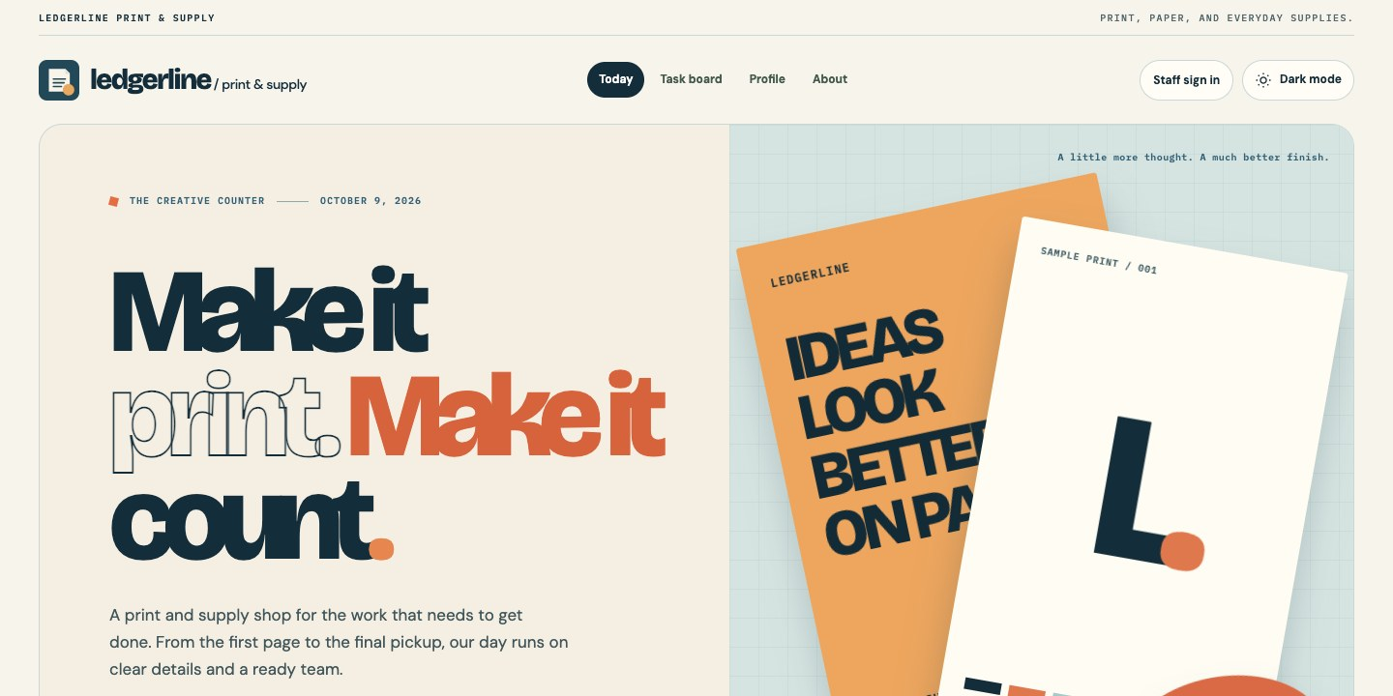
Figure 1. Public Today page.
The landing page introduces the shop and the type of work on its daily schedule.
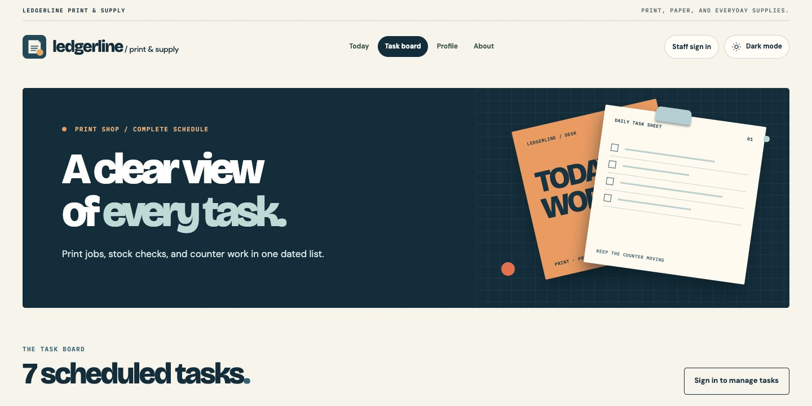
Figure 2. Public task board.
Visitors can browse scheduled tasks while management controls remain behind sign-in.
Authentication Evidence

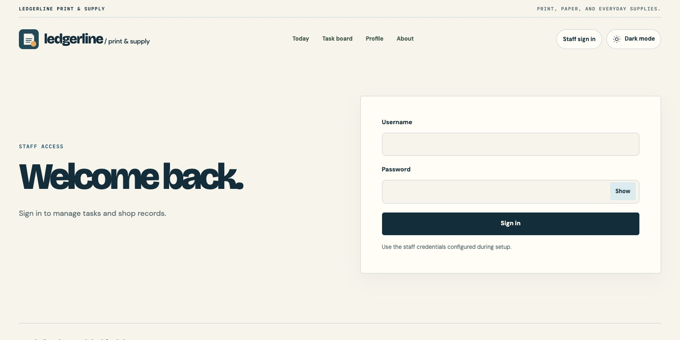
Figure 3. Staff sign-in page.
The public form accepts a username and password without exposing the stored hash.
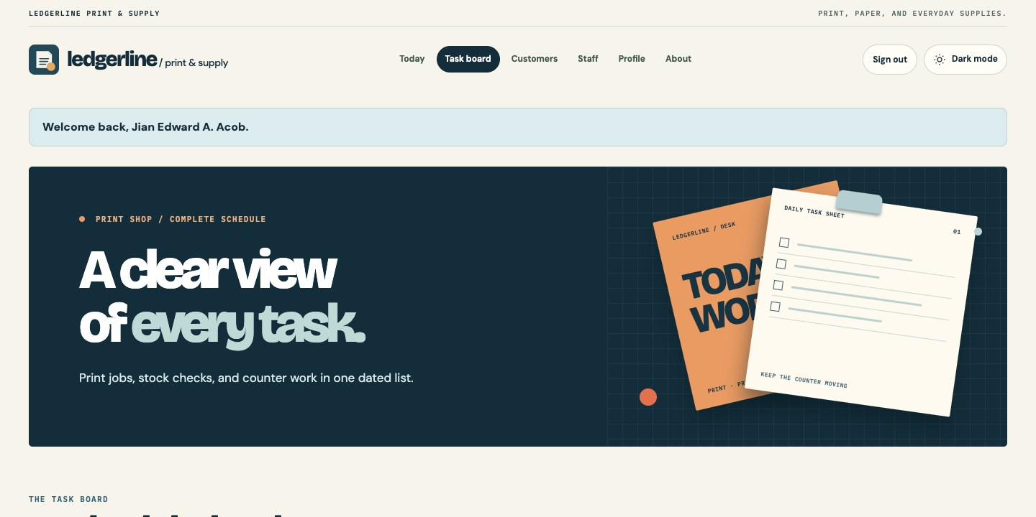
Figure 4. Authenticated task board.
The signed-in header and welcome message show that a staff session is active.
Management Form and Personalized Pages

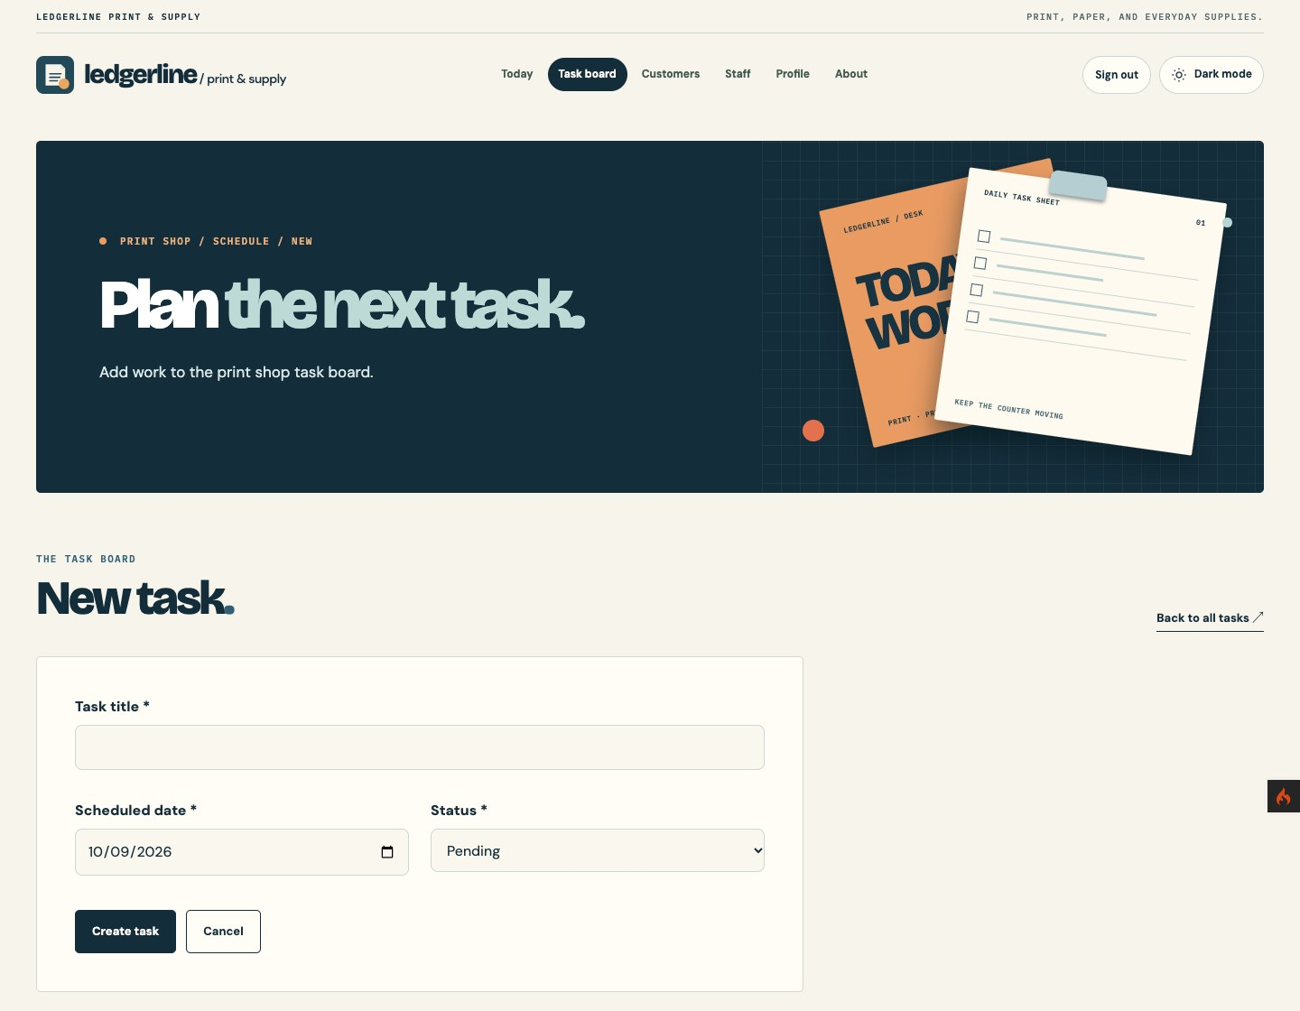
Figure 5. New-task form.
The title, scheduled date, status, and Create task action are visible.
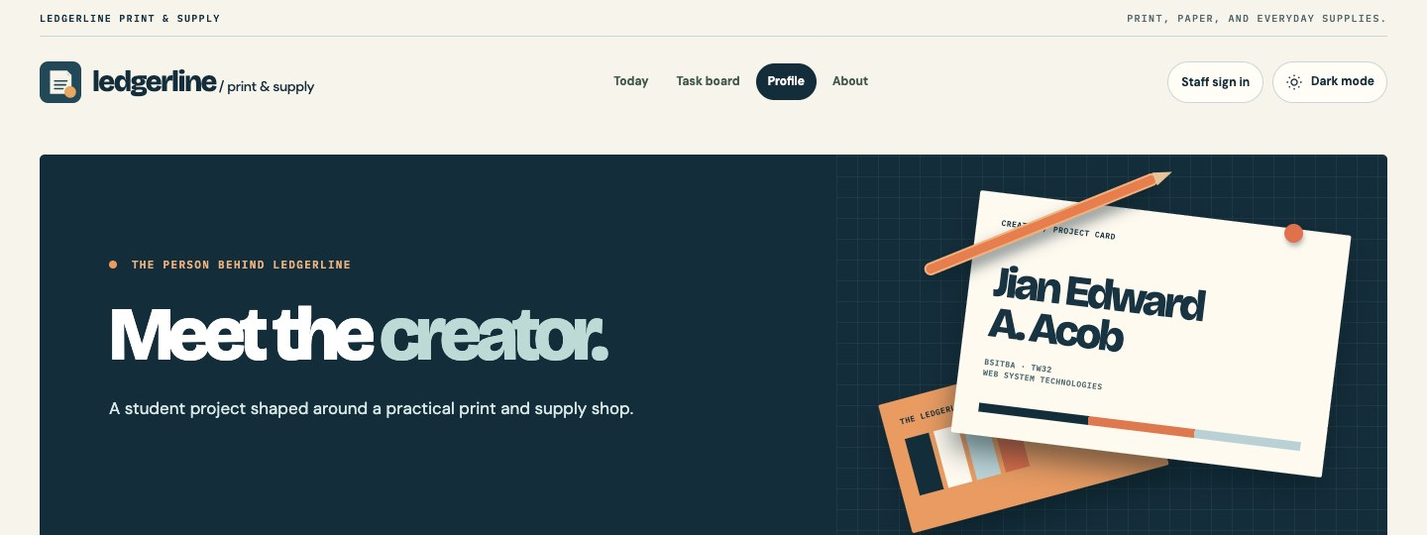
Figure 6. Creator profile.
The public profile shows my name, section, and course.

Figure 7. About the shop.
The About page explains the print and stationery shop concept.
Submission and Presentation

My GitHub repository contains the CodeIgniter source, migrations and seeders, README setup instructions, this report, and the screenshot evidence. I excluded .env, local credentials, vendor dependencies, and runtime files. The repository can be opened using the link below; for my current submission I am providing the GitHub project link only.
Repository: https://github.com/Jiyaannnn/TSA2_ACOB_IT0049
For a demonstration, I would first show that guests can read Today and Task Board. I would open New task to show the sign-in redirect, then log in, create a task, edit its status and date, and archive it. I would finish by explaining that the archived task is hidden from public lists but still exists in the database. This sequence demonstrates the main difference between TFA4 and TSA2.

Signed-In Staff Views

I captured the following views while signed in to the local application as the task demo user. These are browser screenshots of the running pages. The complete, uncropped files are saved in docs/evidence/staff; the crops here keep the controls and records readable on the report page. No password or private setup value appears in the images.
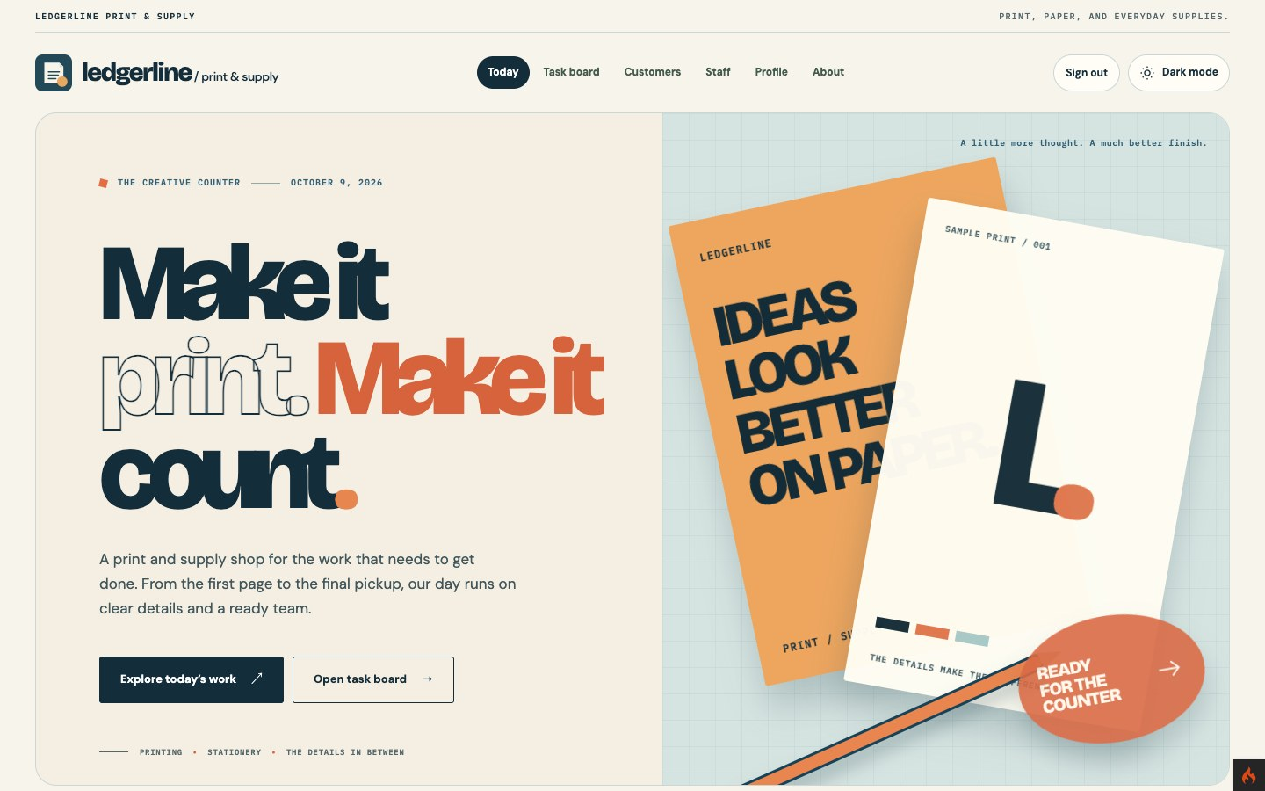
Figure 8. Today page with staff navigation.
The signed-in header includes Customers, Staff, and Sign out while the public landing page remains available.
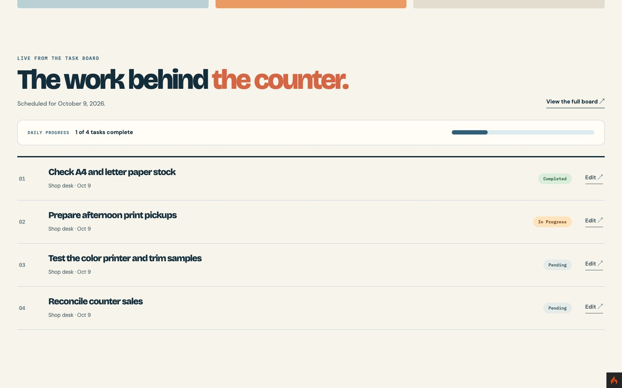
Figure 9. Today work list with Edit actions.
This scrolled capture shows the daily progress, four scheduled tasks, statuses, and staff edit links.
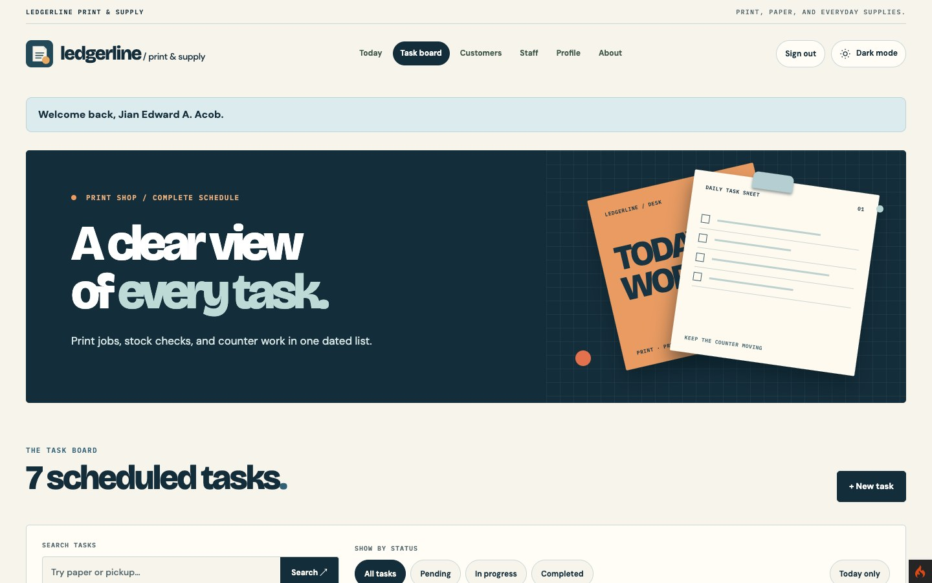
Figure 10. Signed-in task board overview.
The welcome message, task count, New task button, and filters appear on the same board.
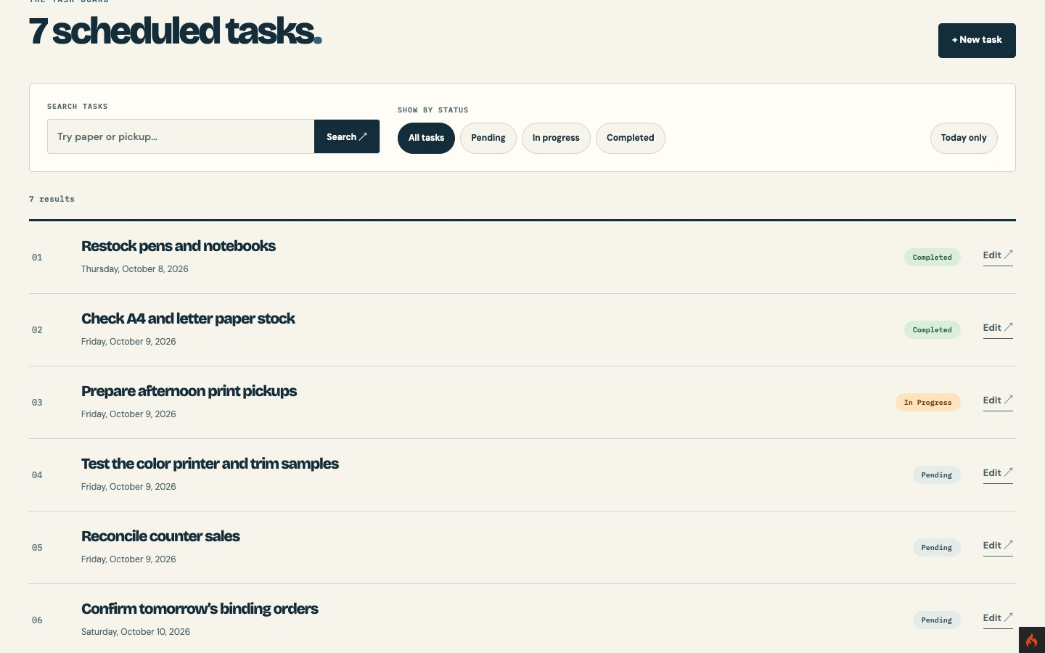
Figure 11. Task board controls and records.
This view shows search, status filters, the Today filter, task rows, and Edit links.
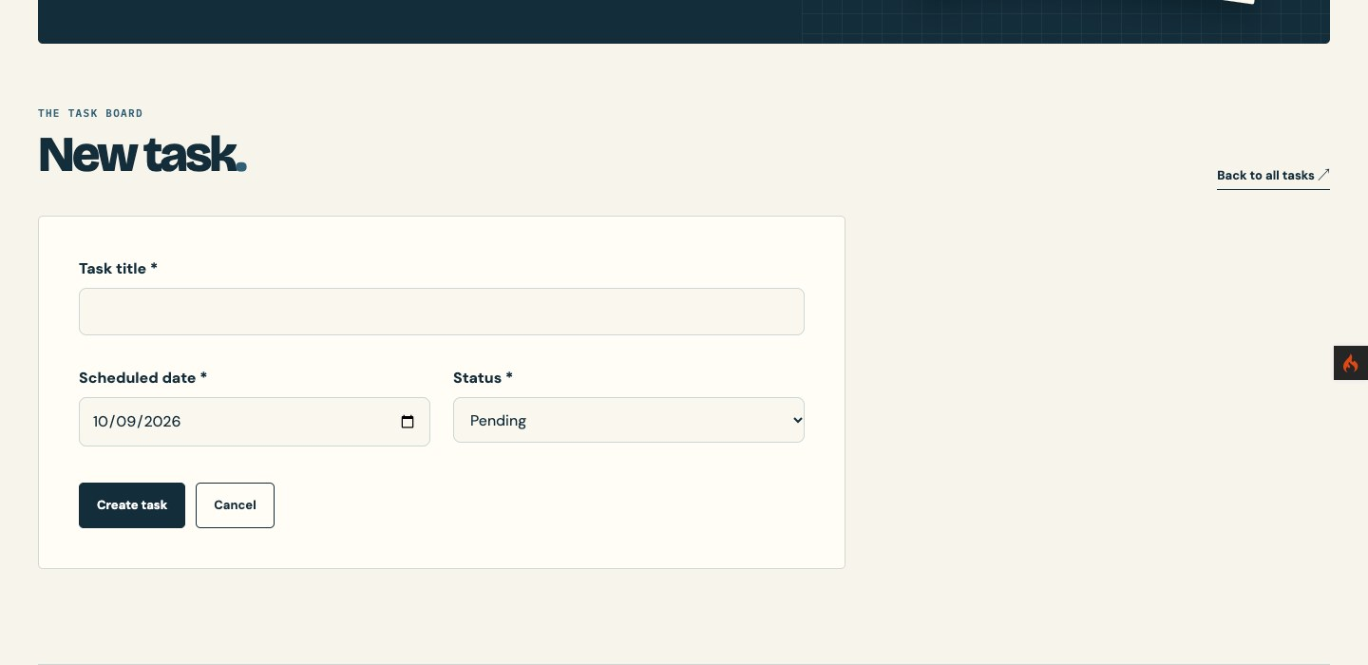
Figure 12. New-task form after sign-in.
Staff can enter a title, date, and status before creating a task.
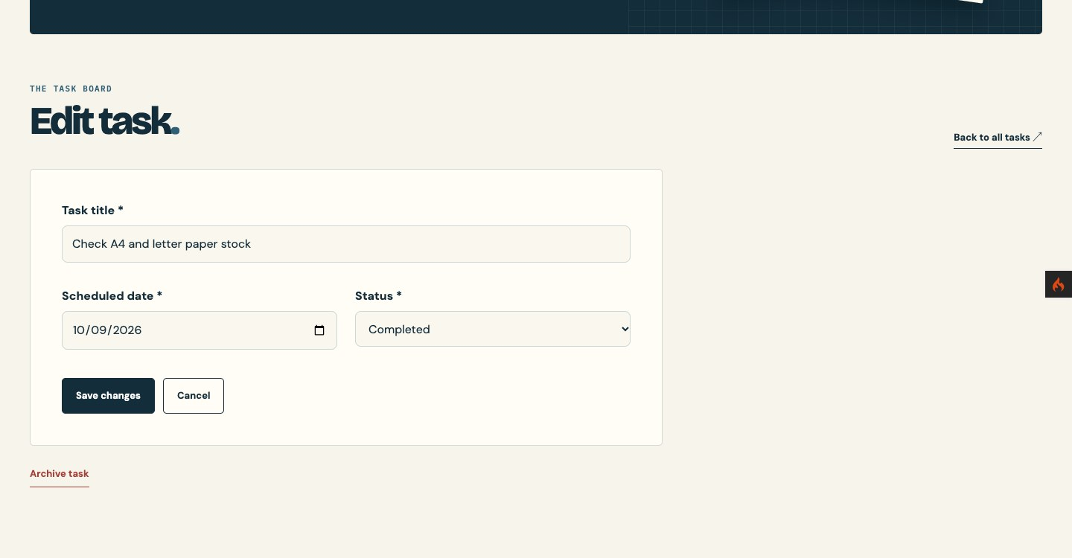
Figure 13. Edit-task form and Archive action.
The existing title, date, and status are filled in, with Save changes and Archive task available.
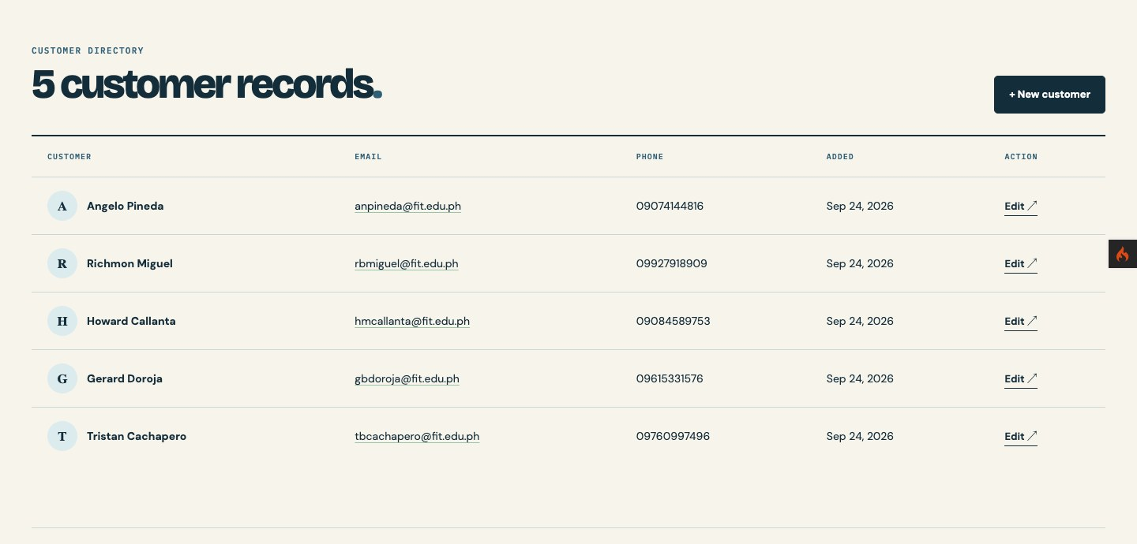
Figure 14. Customer directory after sign-in.
The preserved customer records and staff management actions remain available.
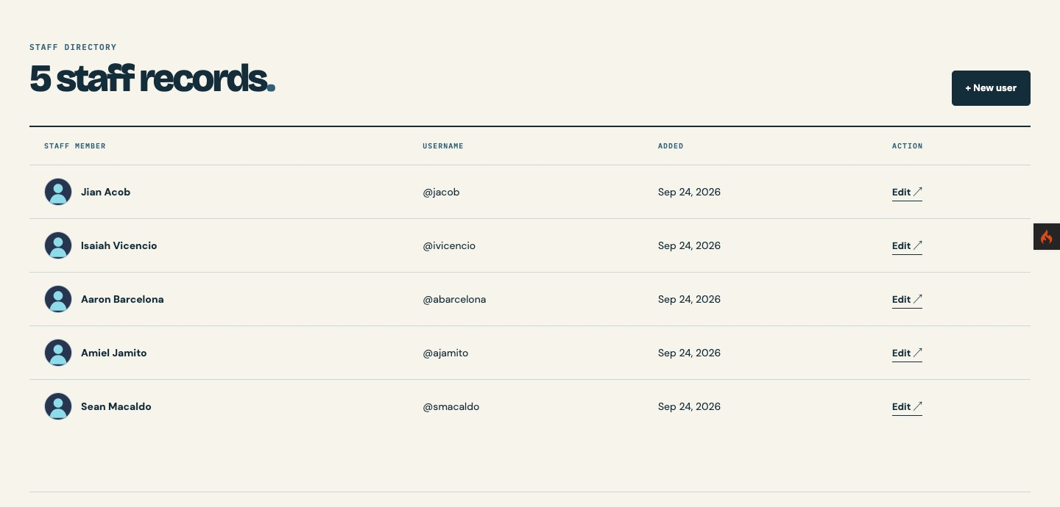
Figure 15. Staff directory after sign-in.
The existing staff records and edit actions remain visible in the TSA2 project.
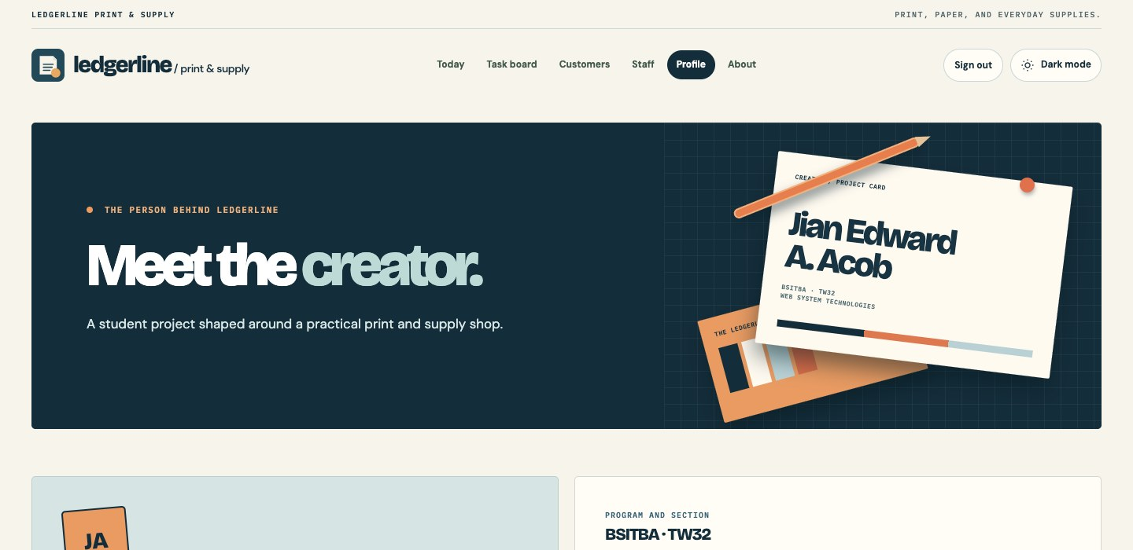
Figure 16. Creator profile with staff navigation.
My name and course details remain public, while the signed-in header is visible.
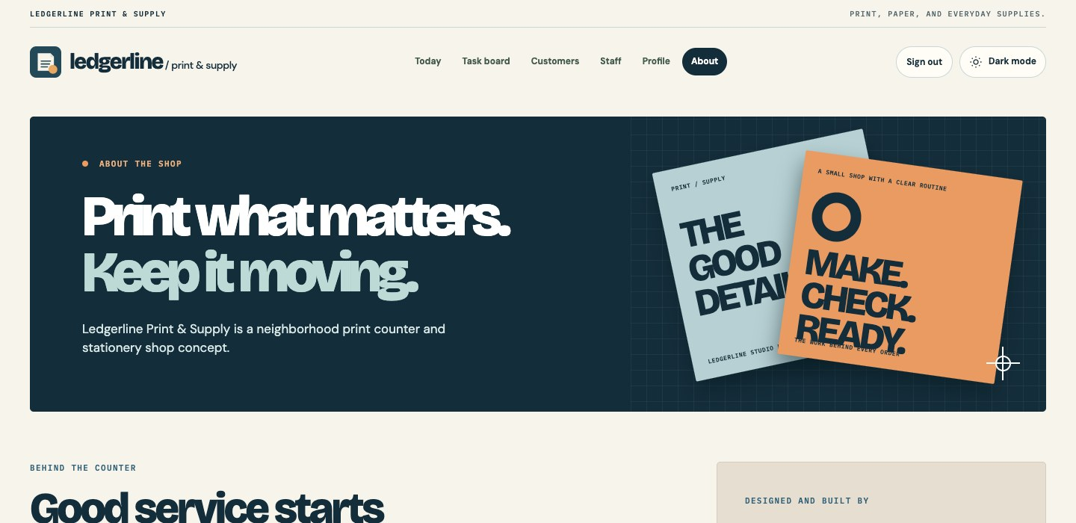
Figure 17. About page with staff navigation.
The print-shop concept page retains its design and signed-in navigation.

