Technical Summative Assessment 2
TASKS FOR TODAY MANAGEMENT SYSTEM: FULL CRUD AND AUTHENTICATION
Ledgerline Print & Supply
Student | Jian Edward A. Acob
Program and Section | BSITBA - TW32
Course | IT0049 - Web System Technologies
Professor | Mr. Von Erick Magbitang
Date | October 9, 2026

Project Overview

I continued my CodeIgniter project in a separate TSA2 folder and reframed the shop as Ledgerline Print & Supply. The original TFA4 folder remains untouched. The public pages show the daily work, complete task board, creator profile, and shop concept. Staff sign-in unlocks task management and the existing customer and staff records.
The visual design uses a dark navy and mint palette, orange print accents, paper-inspired illustrations, clear task status controls, and responsive navigation. I kept the task workflow practical for a neighborhood print and stationery shop: print pickups, stock checks, binding orders, and counter work.
Required Routes and Behavior

Route or action | My implementation
Welcome, /tasks, /profile, /about | Public read-only pages; archived records are excluded from task lists.
/login and /logout | Hashed password verification, session regeneration, and sign-out.
/tasks/new and POST /tasks | Protected task creation with required title and date validation.
/tasks/{id}/edit and POST /tasks/{id} | Protected editing of title, scheduled date, and status.
POST /tasks/{id}/delete | Protected soft delete that sets is_archived to 1.

Authentication and Database Design

My task users table stores a password hash rather than a readable password. The Auth controller verifies it with password_verify(), rotates the session ID after a successful login, and stores the staff ID and name. Route filters keep create, edit, and archive actions private; each POST form also carries a CSRF token. The tasks migration adds is_archived with a false default. TaskModel applies the archive filter in SQL, so both the Today and Task Board pages omit archived rows.

Verification I Performed

Check | Observed result
Guest access to /tasks/new | Redirected to /login.
Wrong and correct passwords | Wrong password stayed on sign-in; correct password opened the protected form.
Blank task title | Rejected; no new task row was created.
Create and update | New task appeared on the board; changing its title, date, and status persisted.
Archive | Task disappeared from the board; database row remained with is_archived = 1.

I also opened the public pages and the protected new-task form in a browser. The screenshots below were captured from the locally running application at localhost:8088. The automated task checks used a local test record that is now archived.
Application Page Evidence

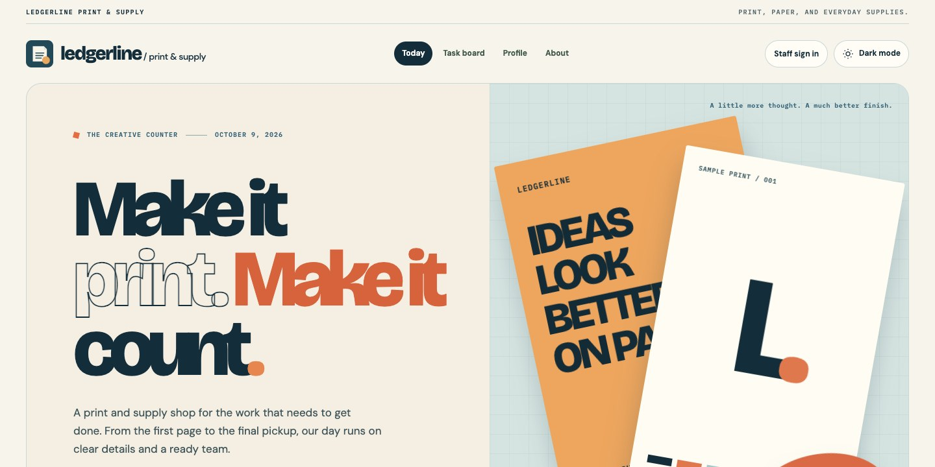
Figure 1. Public Today page.
The landing page introduces the shop and its daily work.
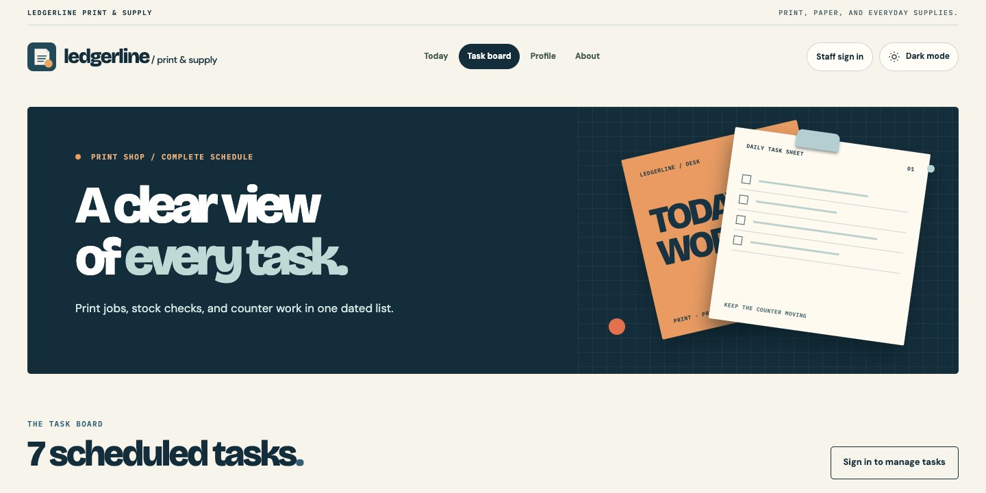
Figure 2. Public task board.
Visitors can browse tasks without a staff session.
Sign In and Task Management

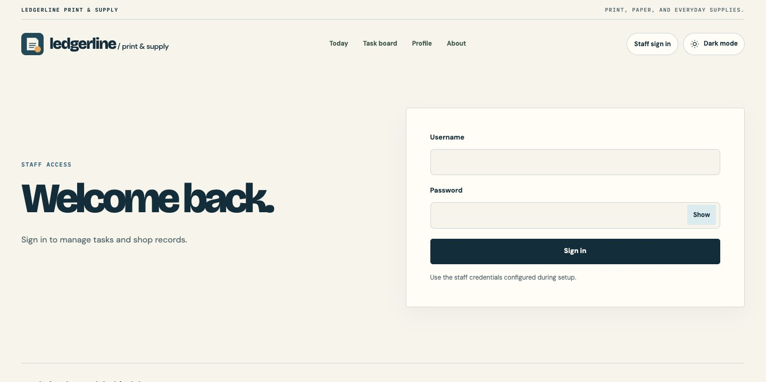
Figure 3. Staff sign-in page.
This form is the entry point for protected management actions.
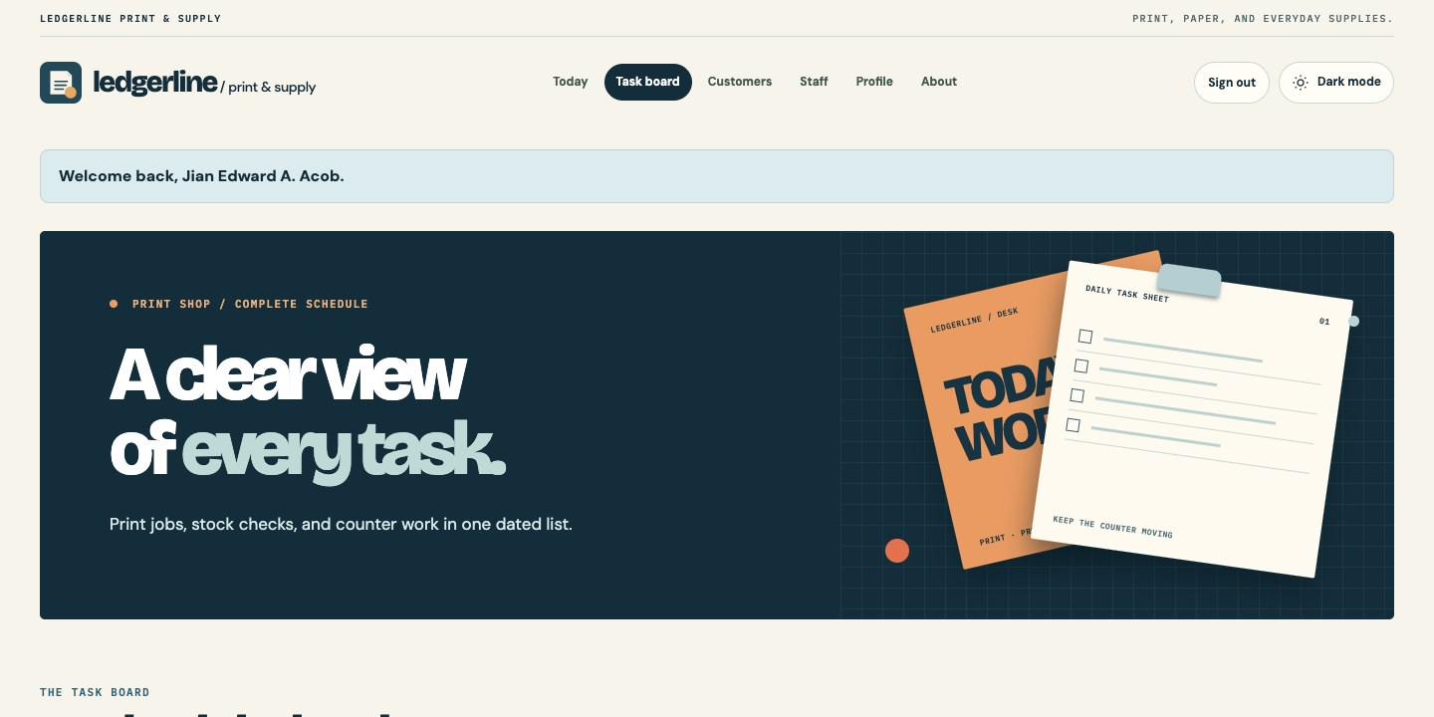
Figure 4. Authenticated task board.
The signed-in header and welcome message appear after login.
Task Form and Creator Profile

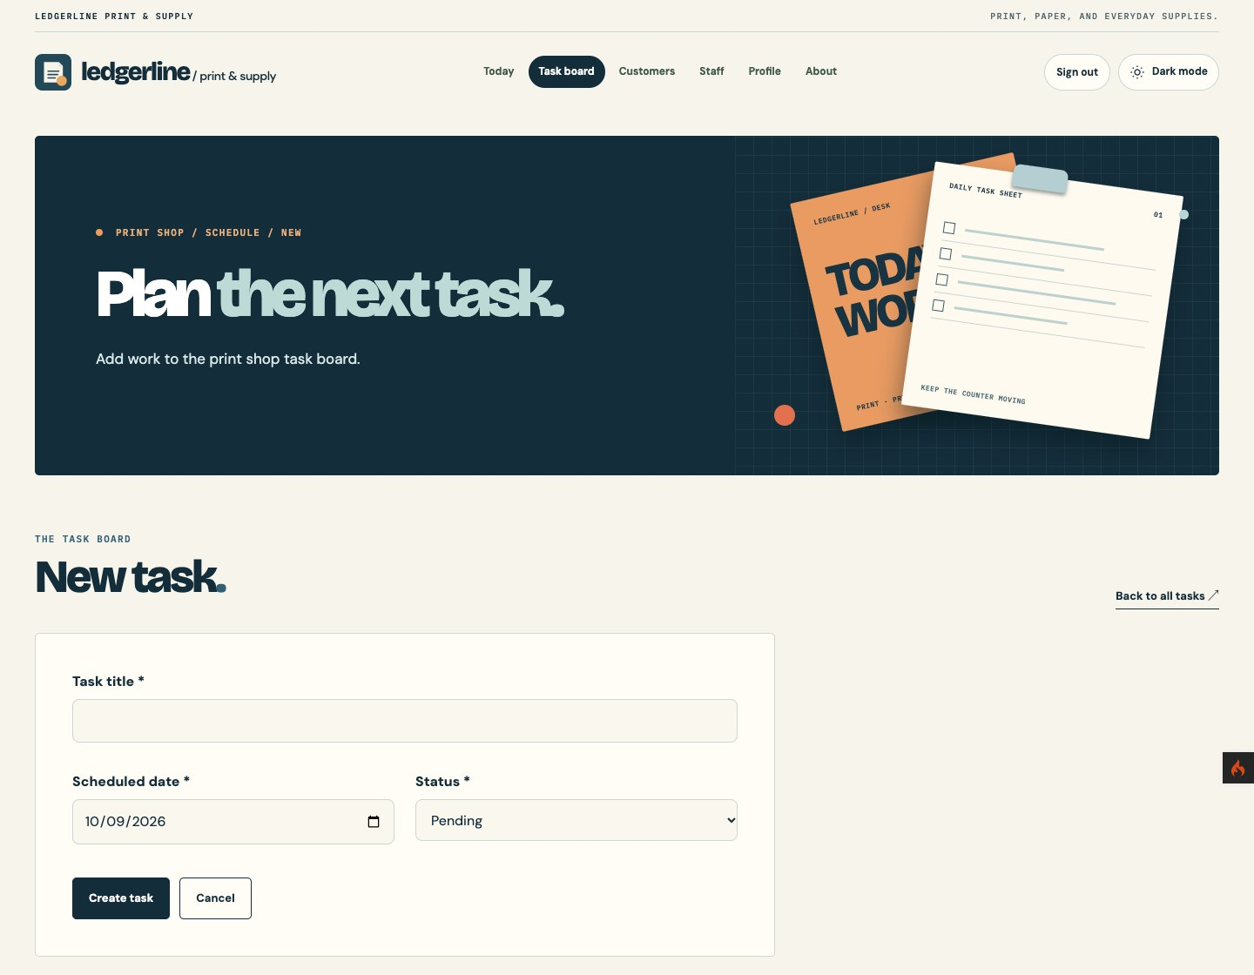
Figure 5. New-task form.
The form collects the title, scheduled date, and status.
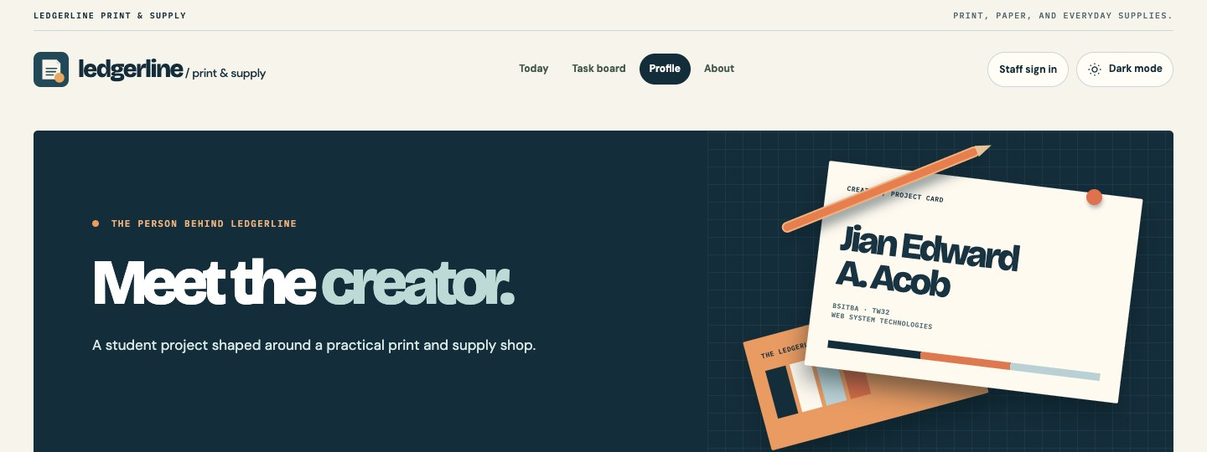
Figure 6. Creator profile.
The public profile shows my name and course information.
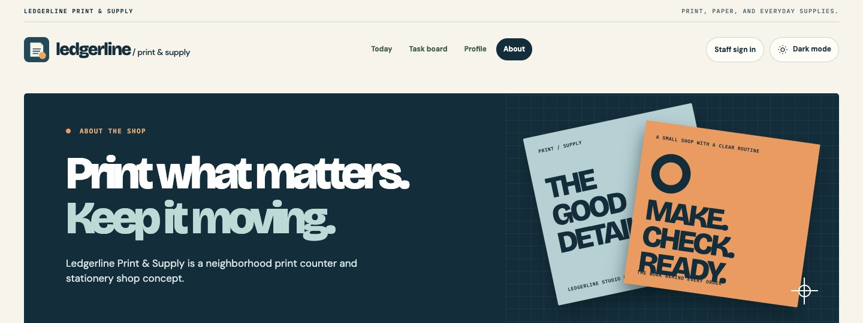
Figure 7. About the shop.
The About page explains the print and stationery shop concept.
Submission

The GitHub repository contains the CodeIgniter application, task migration and seeder, README, report, and screenshot evidence. I keep .env, local credentials, dependencies, and runtime files out of the repository. For my current submission, I am providing the GitHub project link only.
Repository: https://github.com/Jiyaannnn/TSA2_ACOB_IT0049

