Technical Summative Assessment 3
TASKS FOR TODAY MANAGEMENT SYSTEM IN LARAVEL
Soluna Solar Supply & Installation
Student | Jian Edward A. Acob
Program and Section | BSITBA - TW32
Course | IT0049 - Web System Technologies
Professor | Mr. Von Erick Magbitang
Date | October 30, 2026

Project Overview

I continued my TFA6 Laravel project in a separate TSA3 folder. I retained the Soluna branding, colors, navigation, and solar interactions and kept both account directories active. I added the Tasks for Today Management System from TSA1.
I created a tasks migration, adapted the users schema, and seeded nine tasks across four dates with exactly one sample user. Eloquent supplies the added task section, Task List, and Task Profile.

Activity Requirements and Result

Required item | My implementation
Migrations and schema | Tasks and users follow TSA1; tasks include timestamps.
Seeded sample records | Nine tasks across four dates; exactly one sample user.
Eloquent models and controllers | Task and User models supply the required data.
Blade views and six pages | Original account pages plus Task List and Task Profile.
Submission source | Source, migrations, seeder, README, report, and evidence.

Project Identity

I retained Soluna’s visual identity and the original TSA1 refill-task dataset. The rooftop illustration is an existing AI-generated asset. Every evidence screenshot is a real capture of my running TSA3 application.

Laravel Structure

I use migrations to define the database, a seeder to supply sample records, and Eloquent models to retrieve them. Routes call controllers, which pass data to Blade. Overview’s task section and Task List reuse the same task-table partial.
File | Responsibility
database/migrations | Define tasks and users; down reverses each schema.
database/seeders/DatabaseSeeder.php | Seed nine relative-date tasks and one user.
app/Models/Task.php and User.php | Map database rows to Eloquent objects.
TaskController and UserController | Filter today, order every task, and retrieve the profile.
resources/views/pages | Render escaped records and a shared task table.
public/assets | Retain Soluna styles, interactions, and rooftop image.

Data and Interaction

The tasks table has a title of up to 150 characters, status defaulting to pending, task_date, and timestamps. Users have a unique username, full_name, email, and created_at. I retained TSA1’s field lengths and added updated_at to tasks as required by TSA3.

Small Code Examples

I filter by today in the controller, using Asia/Manila as the application timezone. The full list orders every record by date and then ID. The seeder uses relative dates and stable keys so reseeding does not duplicate sample records.
Task::whereDate('task_date', today())->orderBy('id')->get();
Task::orderBy('task_date')->orderBy('id')->get();
User::orderBy('id')->first();

Verification I Performed

Check | Observed result
Routes and records | Six routes passed; existing accounts and new task data retained.
Database lifecycle | Reseeding, insert/update/delete, and rollback/rebuild passed.
Invalid data and output | Duplicate username and missing title rejected; HTML escaped.
Browser interactions | Matching and empty search, rooftop Crew, and Inverter worked.
Responsive navigation | Six pages fit three widths; Menu and Escape worked.
Automated checks | 9 tests passed with 53 assertions; Pint formatting passed.
I tested database changes in isolated in-memory SQLite. This activity is read-only: it has no editing forms, uploads, or login. SQLite does not enforce VARCHAR lengths; the migration retains the specified lengths.

Application Page Evidence

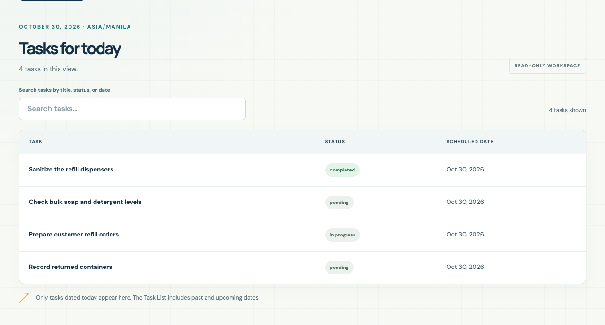
Figure 1. Today’s tasks added below the original Overview.
I display four tasks dated October 30, 2026. Tasks from other dates are excluded by Eloquent.
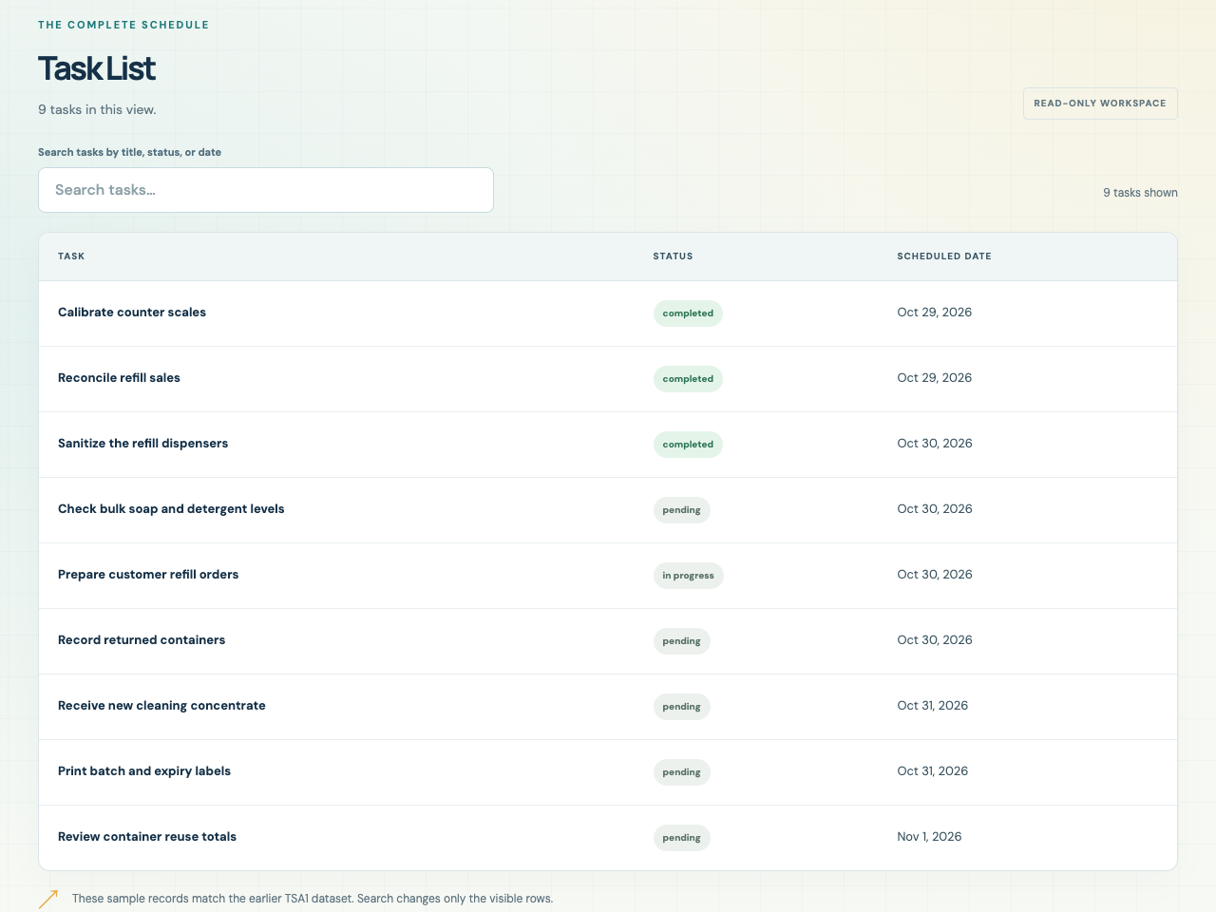
Figure 2. Complete Task List in date order.
I display all nine tasks, spanning October 29 through November 1, 2026.

Profile and About Evidence

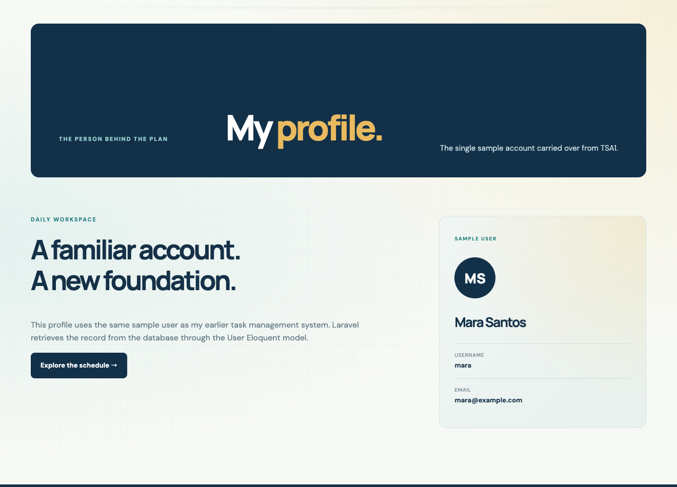
Figure 3. Single sample user profile.
I retrieve Mara Santos from the users table, preserving the original TSA1 sample account.
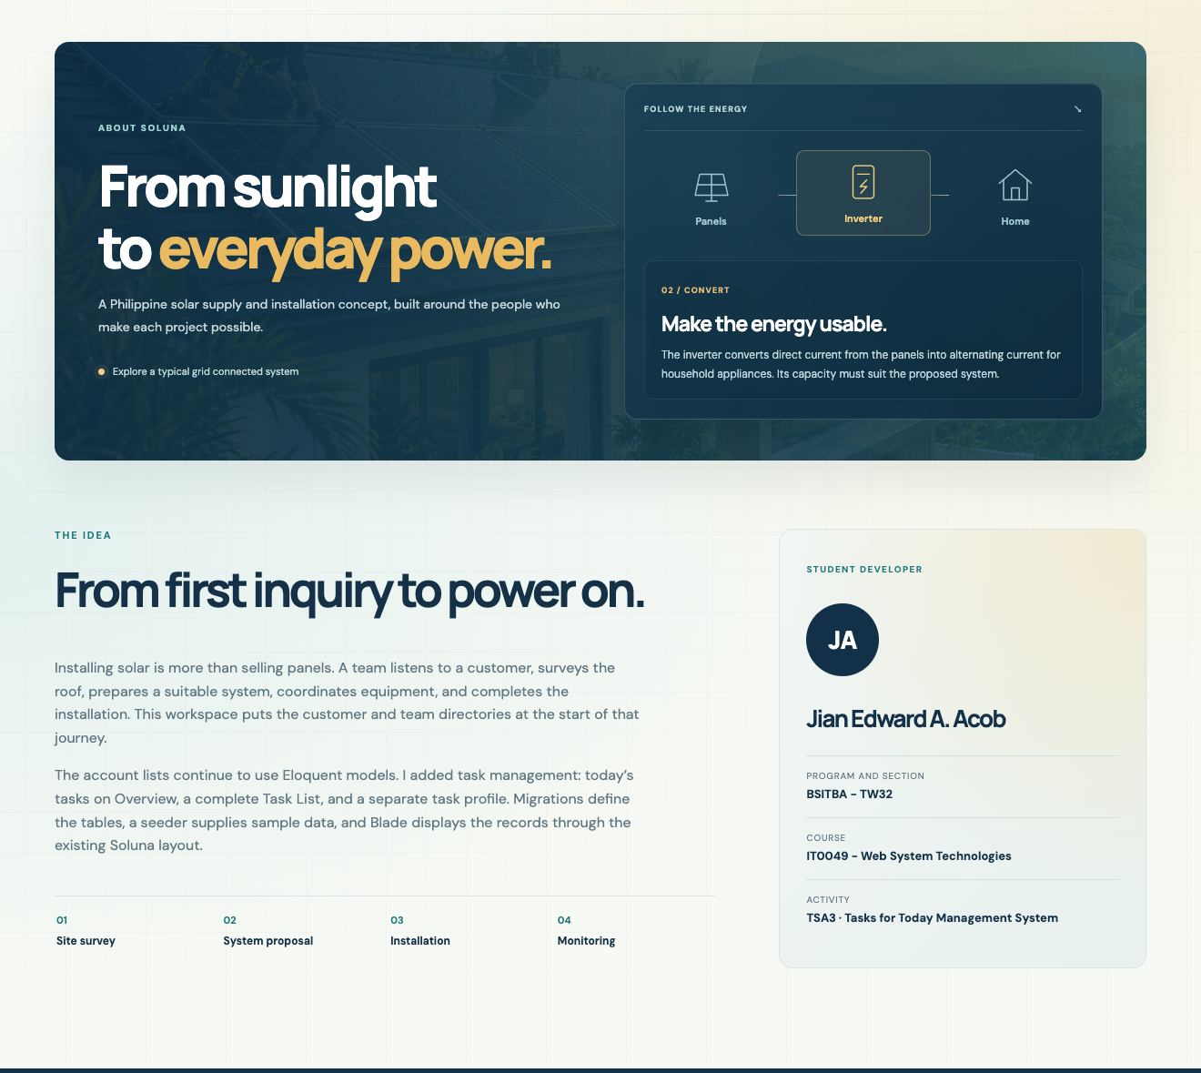
Figure 4. About page identifying me as the developer.
I explain the Laravel task system beside my name, section, course, and TSA3 activity title.

Interaction Evidence

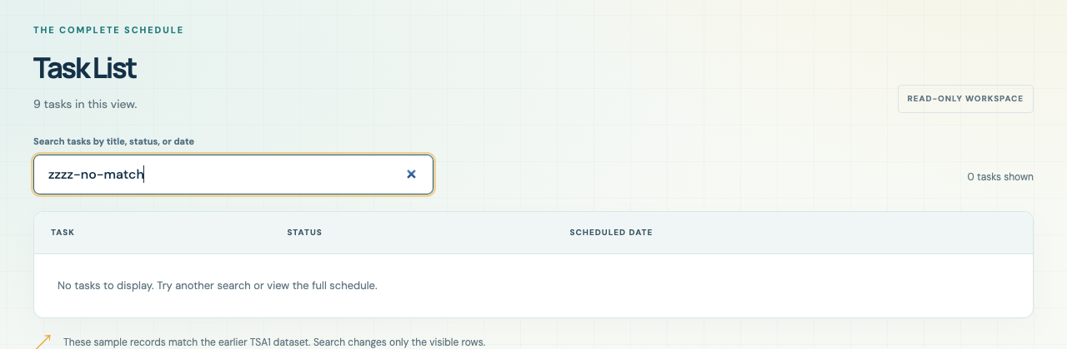
Figure 5. Search with no matching tasks.
I entered a nonmatching query and verified the zero count and helpful empty message.
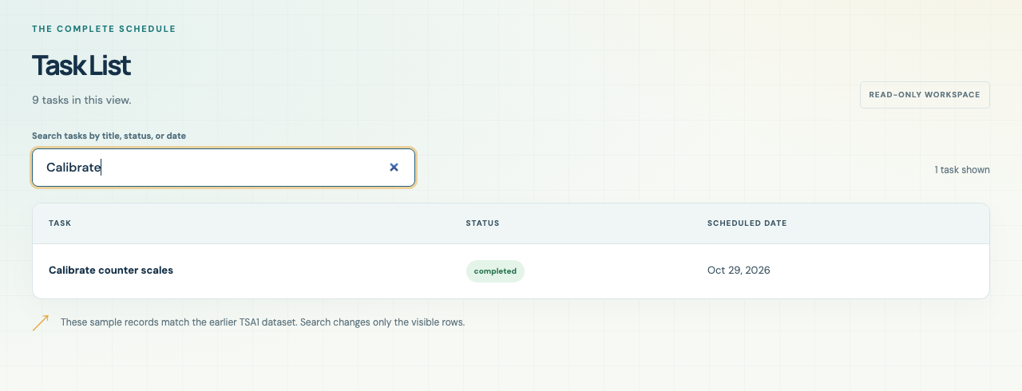
Figure 6. Search with one matching task.
Searching for Calibrate leaves one task visible without changing stored records.

Mobile and Submission

I checked all six pages at 390, 768, and 1440 pixels with no horizontal overflow. The mobile Menu opens the navigation, and Escape closes it.
 | 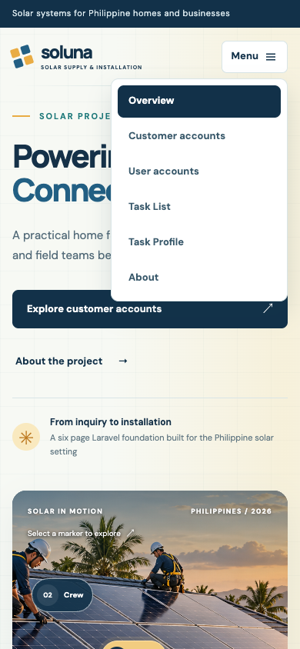
Figure 7. Mobile Overview (left). Figure 8. Open mobile navigation (right).

Repository

Repository: https://github.com/Jiyaannnn/TSA3_ACOB_IT0049

Preserved TFA6 Features
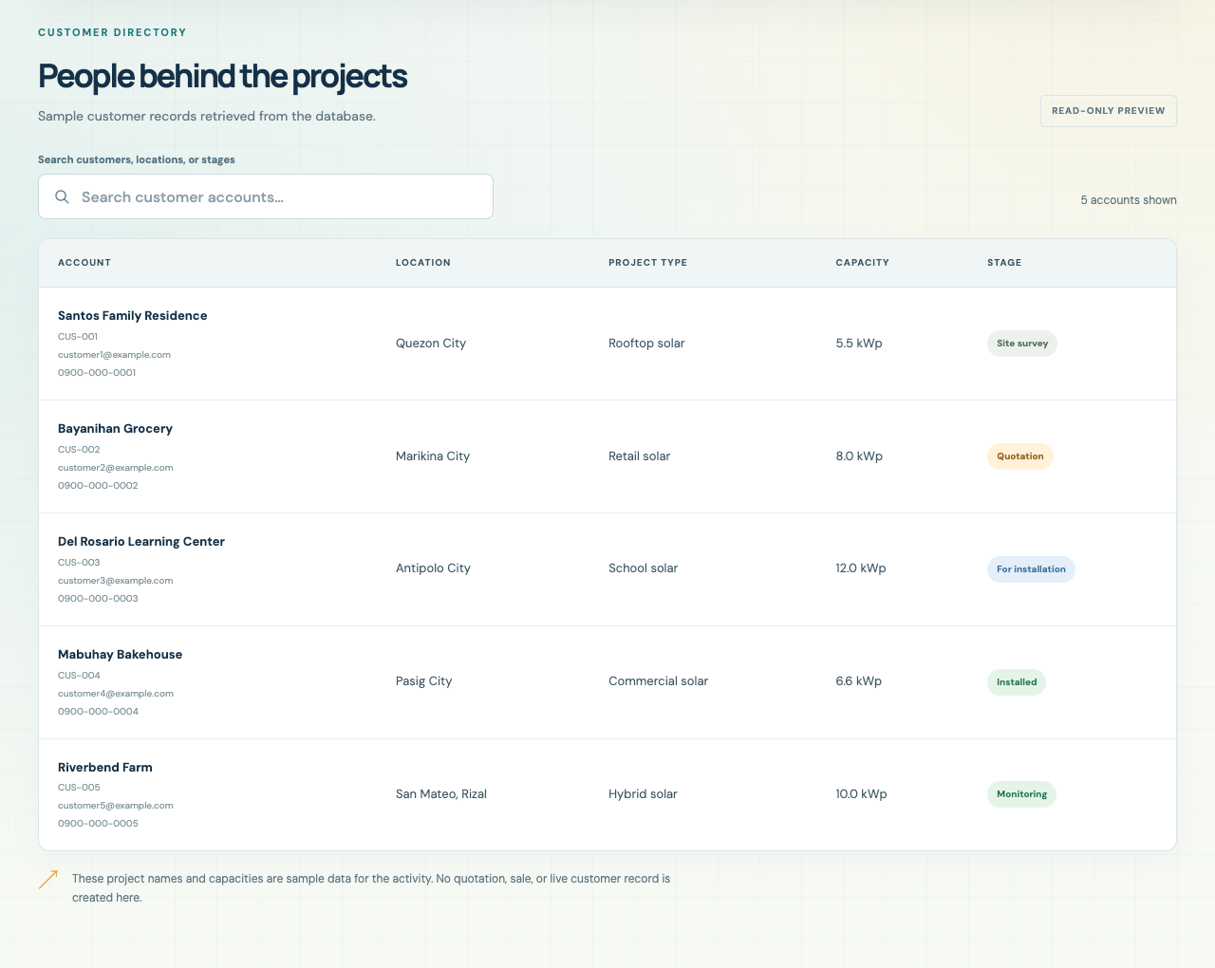
Figure 9. Preserved customer account directory.
I retained all five customer accounts, stage filters, search, and the original directory layout.
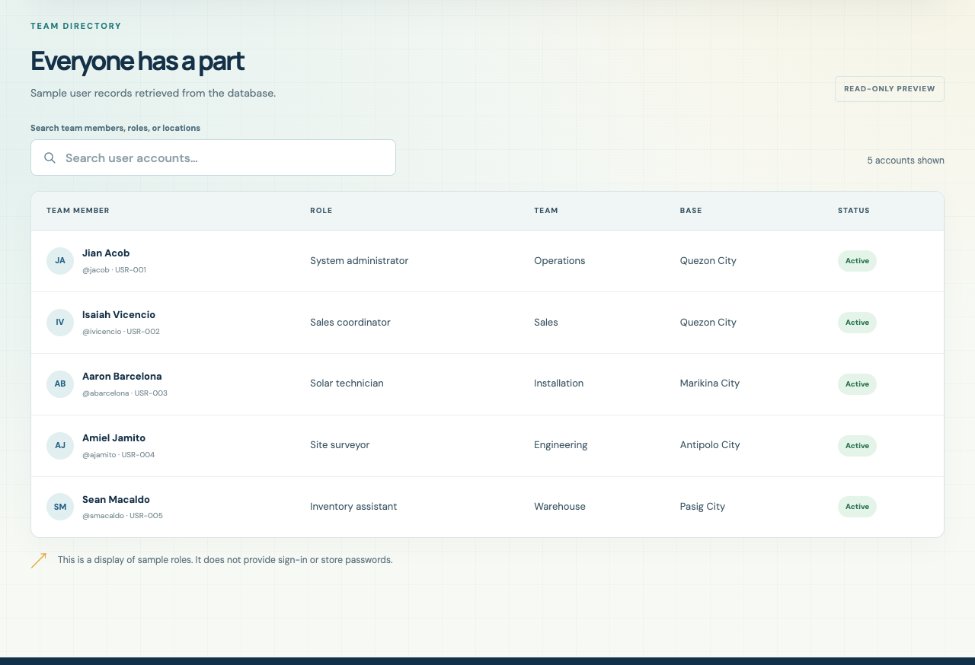
Figure 10. Preserved user account directory.
I retained all five original team accounts in team_members. The separate users table holds the single TSA3 task-profile record.

