**Introduction to the Twin Support Vector Machine (TWSVM)**

**Jiyang Liu 4731134**

**1. Project summary**

In Lecture 9, we learned about a learning algorithm for analyzing data, SVM. SVM divides two classes of data samples by determining a hyperplane in the input space that maximizes the separation between the two classes of data samples. SVM also uses kernel function theory to effectively classify nonlinear classification data samples.

Twin support vector machine (TWSVM) is a new machine learning algorithm developed based on traditional support vector machine (SVM). In order to solve the binary classification problem, TWSVM constructs a hyperplane for each type of sample, so that each type of sample is as close as possible to the hyperplane of this class and as far away as possible from the hyperplane of another class. The two hyperplanes of TWSVM are obtained by solving two quadratic programming problems (QPPs), and the constraints of each QPP are Only related to one type of sample. TWSVM not only maintains the advantages of SVM, but also has a training speed 4 times faster than traditional SVM.

In real-life problems, multi-classification problems are more common. Based on TWSVM, I will introduce a one-versus-one twin support vector machine (OVO TWSVM) method, which can effectively perform multi-classification. It is also one of the commonly used multi-classification methods.

In this project, I’m going to introduce the basic concepts, mathematical derivation, pros and cons, and practical implementation of TWSVM and OVO strategies.

**2. Detailed project description**

Twin support vector machine (TWSVM) is a new machine learning algorithm developed based on traditional support vector machine (SVM). It was originally proposed by JAYADEVA, KHEMCHANDNI R, SURESH C in May 2007. Similar to SVM, TWSVM constructs a hyperplane for each type of sample, so that each type of sample is as close as possible to the hyperplane of this class and as far away as possible from the hyperplane of another class. TWSVM solves a pair of smaller size QPPs instead of one complex QPP as in the conventional SVM.

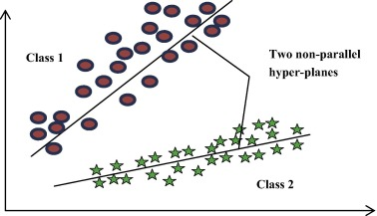

As shown in the figure above, there are two classes - Class 1 and Class 2. They are divided by two non-parallel planes. Each plane is closer to the data samples of one class and farther from the data samples of the other class.

The project goal is to read the following paper, understand and derive the linear and non-linear TWSVM algorithm.

(The paper needs to be read: JAYADEVA, KHEMCHANDNI R, SURESH C.Twin support vector machines for pattern classification[J].IEEE Transactions on Pattern Analysis and Machine Intelligence,2007,29(5):905-910.)

TWSVM was originally proposed to solve two classification problems and cannot be directly used for multi-classification problems. In real-life problems, multi-classification problems are more common. Therefore, the research on multi-classification twin support vector machines (MTWSVMs) has practical significance.

The "one-to-one (OVO)" combination strategy was originally proposed by Knerr for multi-classification SVM. The principle is to construct a binary SVM between any two classes. If the sample belongs to K categories, design K(K-1)/2 binary SVM. This strategy generally uses a "voting method" to determine which category a sample belongs to. When deciding which class a given sample belongs to, the voting method is passed through all binary classifiers of OVO TWSVM.

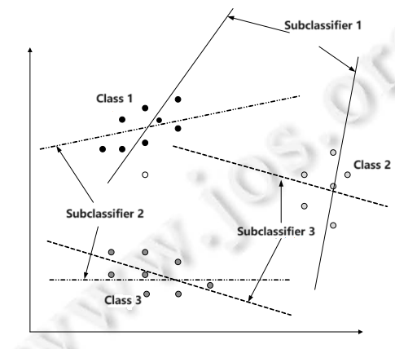

The project goal is to read the following paper, understand and derive the OVO TWSVM algorithm.

(The paper needs to be read: A Twin Multi-Class Classification Support Vector Machine December 2013Cognitive Computation 5(4) DOI:10.1007/s12559-012-9179-7 Authors: Yitian Xu China Agricultural University Rui Guo Laisheng Wang.)

Finally, I will use a set of experimental data to verify the TWSVM algorithm and analyze the results. The data will use the samples provided in HW1.

**3. List of tasks**

Read paper: JAYADEVA, KHEMCHANDNI R, SURESH C.Twin support vector machines for pattern classification[J].IEEE Transactions on Pattern Analysis and Machine Intelligence,2007,29(5):905-910.

Derive algorithm: Twin support vector machine.

Read paper: A Twin Multi-Class Classification Support Vector Machine December 2013Cognitive Computation 5(4) DOI:10.1007/s12559-012-9179-7 Authors: Yitian Xu China Agricultural University Rui Guo Laisheng Wang.

Derive algorithm: One Versus One Twin Multi-Class Classification Support Vector Machine.

Find data for code implementation, from HW1(add one more class) or online dataset.

Implementation of the OVO TWSVM on the data.

Compare and discuss the result.

Put the derivation of algorithms and practical implementation on PowerPoint or Word, for the final presentation

**Expected completion time:** Apr 15th.

**Potential challenges:**

1. For multi-class data, if the number of samples in each class differs too much, a class imbalance problem may occur, and the classifier performs poorly when predicting a few classes. Plan: Choose class-balanced experimental data.
2. For nonlinear classification problems, we do not have a known good strategy for selecting kernel functions, which will greatly affect the performance of TWSVM.
3. It is currently unknown how TWSVM performs on large-scale classification problems. TWSVM may not perform well when the number of samples is too large. Plan: Pay attention and choose an appropriate sample size when choosing implementation dataset.