课程号 ME304 课 程 能源工程基础
序 号 12 签 名 .



Oceanic Carbon Capture and Sequestration (OCCS) : One of The Most Feasible Emergency Strategies Dealing With Climate Change and Global Warming.

Department of Mechanical and Energy Engineering

Mechanical Engineering

Fall Semester, 2017

Author: Jiyu Xie (谢济宇)

Student ID: 11510224

For comments or queries please contact:

Jiyu Xie, 11510224@mail.sustc.edu.cn

CONTENT
Oceanic Carbon Capture and Sequestration (OCCS) :
One of The Most Feasible Emergency Strategies Dealing With Climate Change and Global Warming.

Abstract 5
1. Introduction 5
2. Analysis 8
2.2.1. Ocean’s Capacity of CO₂ 8
2.2.2. Carbon Capture and Sequestration (CCS) 8
2.2.3. Direct Injection of CO₂ into Deep Ocean………………………...………………………… ..... 9
3. Results 11
4. Prospective 12
5. Conclusion 12
Acknowledgements 13
Reference 14
Appendix: 15
Engeneering properties of CO₂ for transportation and storage 15
Reference 18

Oceanic Carbon Capture and Sequestration (OCCS) :

One of The Most Feasible Emergency Strategies

Dealing With Climate Change and Global Warming.

Xie, J. , Junior. Department of Mechanical and Energy Engineering,
Southern University of Science and Technology, Shenzhen, Guangdong, China

Abstract
Research has shown that the level of carbon dioxide (CO₂) released into the atmosphere has increased significantly since the beginning of the industrial era. Unless we do something to reduce the amount of CO₂ entering the atmosphere, the world will experience serious effects of climate change, leading climate catastrophe to the earth, and may change earth to a place where human beings are no longer able to survive. In this case, Oceanic Carbon Capture and Sequestration (OCCS) might be one of the best emergency strategies in dealing with climate change and global warming due to the large capacity of storing CO₂, despite its non-ignorable disadvantages and highly-concerned potential risks(e.g. high financial costs, poptential negative environmental, ecological, geological impacts, etc. ). And by then, it is inevitable for the governments and publics to accept such OCCS strategies, in order to survive.

1. Introduction
One of the greatest international challenges now is reducing the anthroppogenic greenhouse gas (GHG) emissions and their impact on climate change. The burning of fossil fuels, specifically coal, oil, and gas is the primary sources of CO₂. Based on the data of the Global Carbon Project, the total global emissions in 2016 is: coal (40%), oil (34%), gas (19%), cement (6%), flaring (1%)[1] (Figure 1, middle left). And according to the Intergovernmental Panel on Climate Change (IPCC) fifth assessment report[2], the total emission of industial and anthropogenic CO₂ is 2,040 ± 310 GtCO₂ between 1750 and 2011, since the pre-industrial era, while nearly half of the emissions occurred during the past 40 years (Figure 1, top middle). The rapid increase of atmospheric CO₂ led to an increasement of atmospheric CO₂ concentration from 277 pmm to 399 pmm (ppm, parts per million), from 1750 to 2015 (Figure 1, top right). During the year of 2015, the global emission of CO₂ is about 36.4 GtCO₂, and about 27% of the total emisssions was stored in the ocean, leading to ocean acidification; about 17% was stored on terrestrial biosphere (in plants and soils); the rest 56 % have remained in the atmosphere (Figure 1, middle right). The concequences of the global warming including aridification, acidification, sea level rising, polar ice melting, islands disappears, food crisis, financial lost, ecological catastrophe, climate refugees, economical impacts, etc, and every single of them could be a great disaster to the human beings.
In order to slow down the global warming procedure, international negotiations have produced the United Nations Framework Convention on Climate Change (UNFCCC) to achieve a goal of “holding the increase in the global average temperature to well below 2 °C above pre-industrial levels and pursuing efforts to limit the temperature increase to 1.5 °C (ideally) above pre-industrial levels”[3]. Thus, the greenhouse gases should reduce to 40.0 Gt by the year of 2030 (Figure 1, bottom).

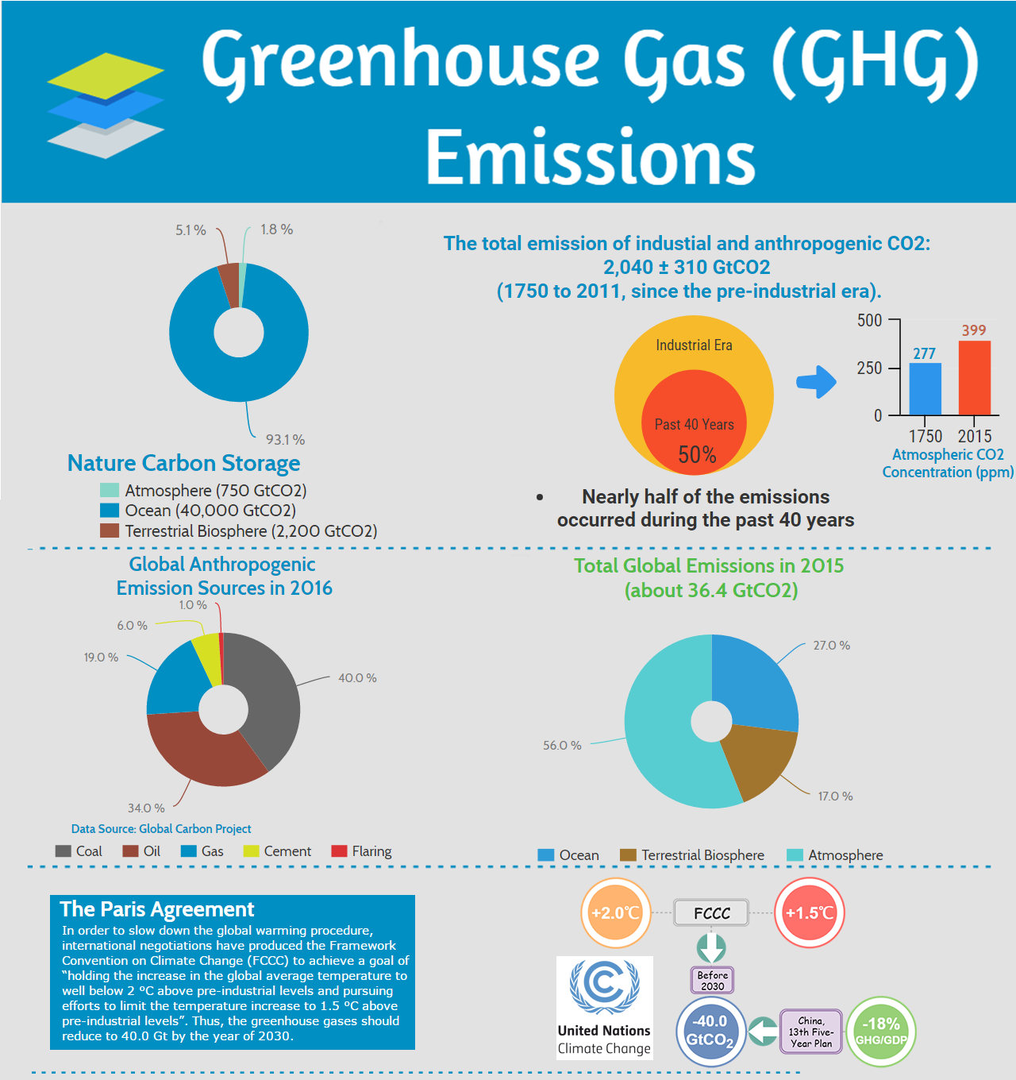
Figure 1. An illustration of Global Greenhouse Gas(GHG) Emissions and a brief introduction of the Paris Agreement.
Data Source: BP 2017; Jackson et al 2017; Global Carbon Budget 2017. Disigned by Jiyu Xie.

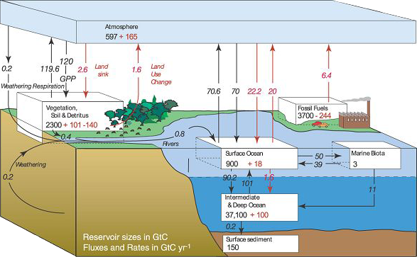
Figure 2. Global Carbon Cycle shows the movement of carbon between land, atmosphere, and oceans[4].
This illustration also compares the natural carbon emissions and anthropogenic carbon emissions.

Great efforts are being made to reduce the emission of CO₂ through improved the efficiency of the conventional fossil fuels and develop new strategy of non-fossil energy sources like wind, solar and nuclear. Nationally Determined Contributions (NDCs) are a cornerstone of the Paris Agreement on climate change, which set out the actions that countries plan to undertake to achieve the agreement’s objectives. But according to an analysis of the International Renewable Energy Agency (IRENA) in December 2017[5], at least United States Dollar (USD) 1.7 trillion (approximately equal to the whole year’s Gross Domestic Product(GDP) of Brazil in 2016, which is about 1.77 trillion[6]) would be needed by 2030 to implement renewable energy targets contained in NDCs worldwide.
So, it seems unlikely to reduce emissions to the level required by the FCCC. Hence, scientists need to consider some new strategies. Carbon capture and sequestration (CCS) has become an idea considered by many scientists as a possibility to deal with emissions problems.
Here I present a possible strategies to deal with the climate change and global warming, which is capturing CO₂ from large, stationary sources (e.g. power plant or chemical factory, etc.), transporting CO₂ through pipeline or shipping, and storing CO₂ in the deep ocean, that is Oceanic Carbon Capture and Sequestration (OCCS).
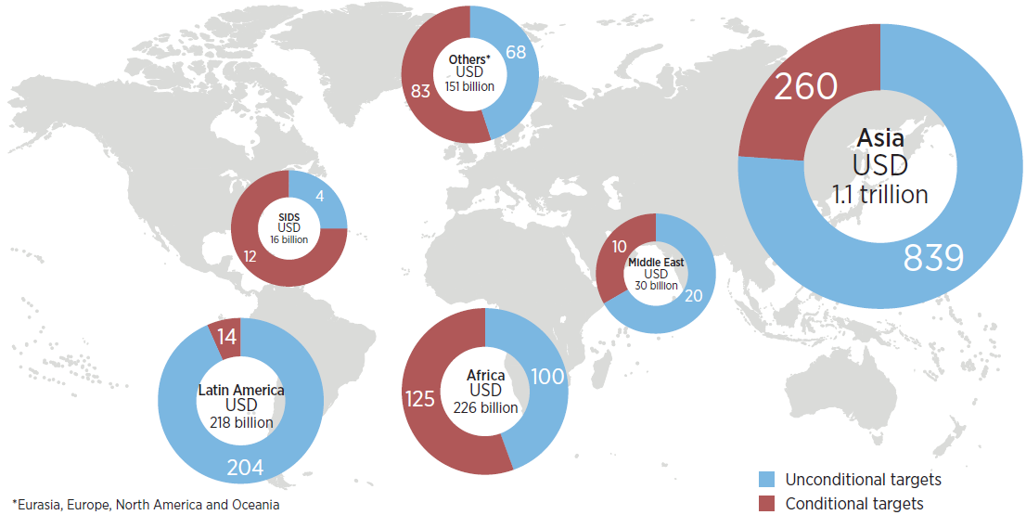
Figure 3. Total investment needed by 2030 for the implementation of
renewable energy targets in current NDCs (USD billion)[5].

2. Analysis

2.1. Ocean’s Capacity of CO₂
The ocean already contains about 40,000 GtC (93.1%) while 750 GtC (1.8%) in the atmosphere and 2,200 GtC (3.1%) in the terrestrial biosphere. And 500 GtCO₂ were absorded from atmosphere out of 1,300 GtCO₂ total anthropogenic emissions over the past 200 years[7] (Figure 1, top left). Sequester CO₂ directly to the deep ocean would accelerate the slow natural processes of carbon storage, which almost 85% of present CO₂ emissions will ultimately enter the ocean indirectly[8]. By doing so, peak atmospheric CO₂ concentration and their increasing rate could be reduced effectively.

2.2. Carbon Capture and Sequestration (CCS)
CCS involves collecting and concentrating the CO₂ produced in industrial and energyrelated sources, transporting CO₂ to a suitable storage location, and then store it away from the atmosphere for a long period of time. Thus, CCS would allow fossil fuels to be used with low emissions of greenhouse gases.
Capture, Transport and Storage are the three main components of the CCS process (Figure 6.). All three components are found in industrial operations today, although mostly not for the purpose of CO₂ sequestration. The capture step involves separating CO₂ from other gaseous products. For fuelburning processes such as those in power plants, separation technologies can be used to capture CO₂ after combustion or to decarbonize the fuel before combustion. The transport step may be required to carry captured CO₂ to a suitable storage site located at a distance from the CO₂ source. To facilitate both transport and storage, the captured CO₂ gas is typically compressed to a high density at the capture facility. Direct injection into the deep ocean, as I proposed, is one of the potential CO₂ storage methods.

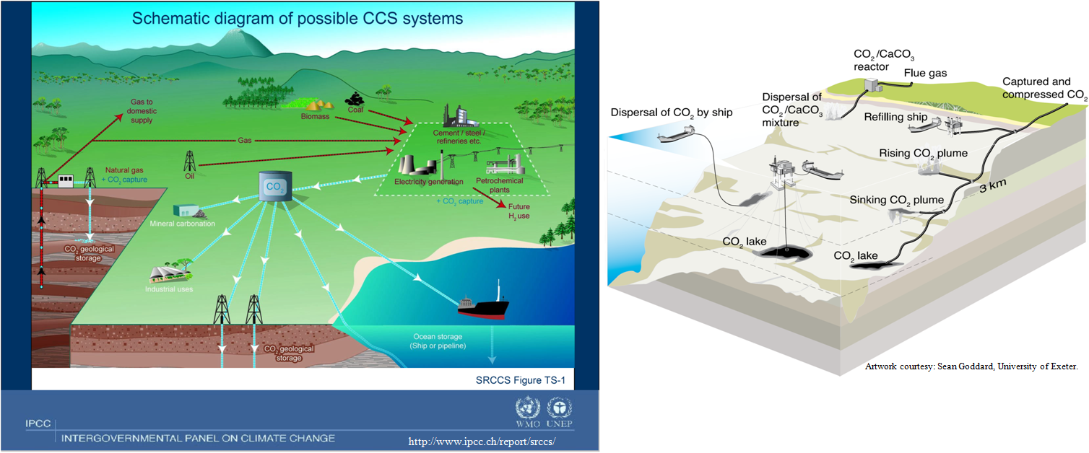
Figure 5. Schematic diagram of possible CCS systems[7]. It shows the sources for which CCS might be relevant,
as well as CO2 transport and storage options (Courtesy CO₂CRC).

2.2.1 CO₂ Capture Processes and Systems
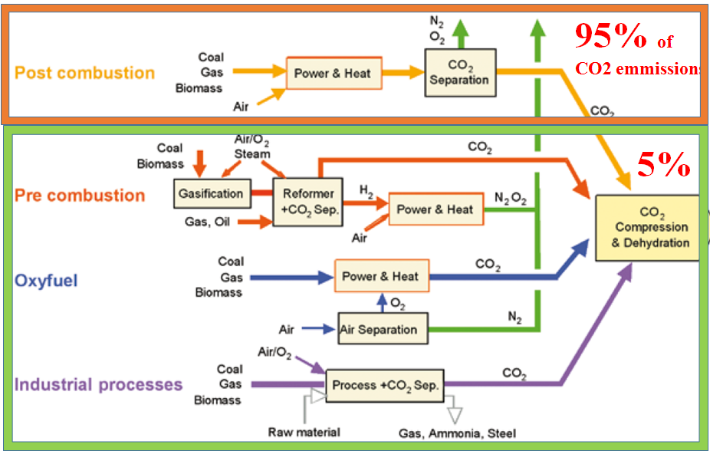
Figure 5. Overview of CO₂ capture processes and systems.
Source: IPCC, Carbon Dioxide Capture and Storage: Technical Summary (2005) Ch3. Capture of CO2, p. 25

2.2.2 CO₂ Transportation Systems
Transporting CO₂ from the capture site to the storage site is necessary for CCS projects. It is expected that we can sequester a large volumn of CO₂ in the deep ocean, thus pipelines and ships are feasible in this case, which are two of the most mature transportation systems for CO₂ at present. There also has some possibilities that transportation systems has been improved greatly in the future. The advantages between them are vary from the transport volume, transport distance, geographical conditions, flexibility requirements, investment decision time etc. Below are some characteristics of pipelines and ships[9,10]:

(1)Pipelines:
• Large volumn, low costs.
• Over 3,100 km of CO₂ pipelines worldwide.
• Capacity: about 44.7 million tonnes per year of CO₂.
• Engineering Standardization: CFR part 195[11] (USA)、CSA Z662[12](Canada)、DNV-RP-J202[13](EU),etc. More engineering requirements details can also be seen in these documents.

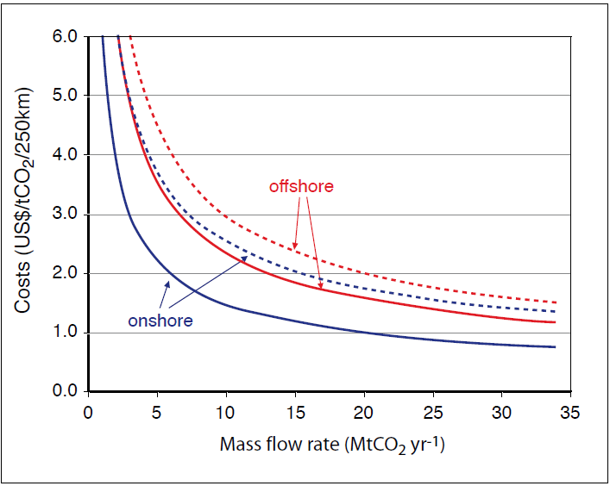
Figure 6. Transport costs for onshore pipelines and offshore pipelines[9], in US$ per tCO₂ per 250 km as a function of the CO₂ mass flow rate. The graph shows high estimates (dotted lines) and low estimates (solid lines).

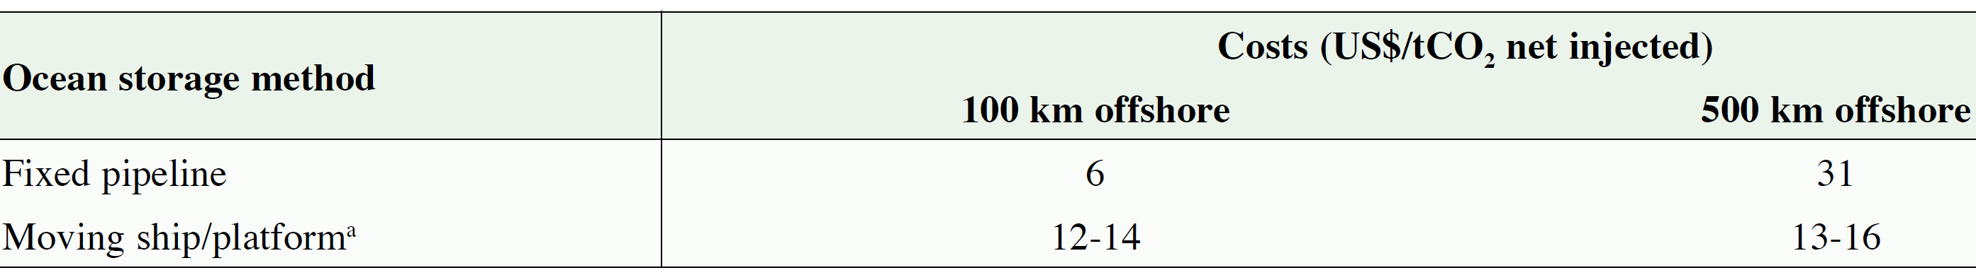
Table 1. Costs for ocean storage at depths deeper than 3,000 m[9] (The costs for the moving ship option are for injection depths of 2,000-2,500 m.)

(2)Ships:
• More flexible.
•Transport of CO₂ by ship in smaller volume (i.e. <1500 m³) is currently practiced in the industry.
•Shipping at lower pressure is preferred.
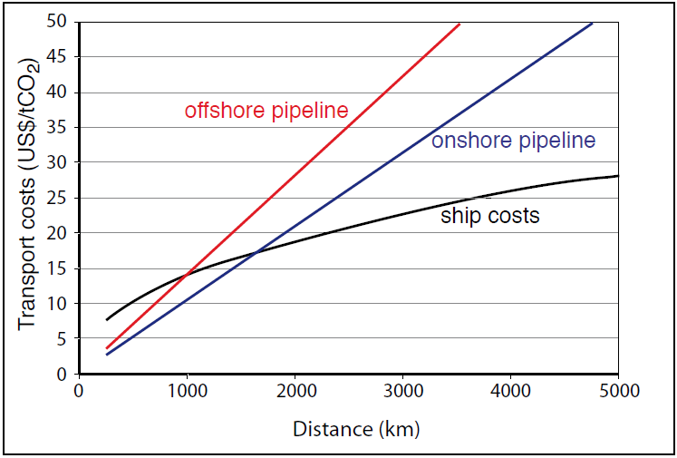
Figure 7. Costs, plotted as US$/tCO₂ transported against distance, for onshore pipelines, offshore pipelines and ship transport[9]. Pipeline costs are given for a mass flow of 6 MtCO₂ yr-1. Ship costs include intermediate storage facilities, harbour fees, fuel costs, and loading and unloading activities. Costs include also additional costs for liquefaction compared to compression.

2.2.3 Direct Injection of CO₂ into Deep Ocean.
Capture relatively pure CO₂ stream generated from power plant or chemical factory, then compressed it so that it can be injected into the mid depth of the ocean (at about 1,500 meters, the CO₂ can be dissolved into the seawater and remains nearly at the same level benearth the surface; at depths of at least 3,000 meters, the CO₂ becomes liquid pools because of the low temperature and high pressure, which will sinks to the bottom of the ocean. The appendix attach to the report gives a brief introduction of the CO₂ properties and sequestration mechanism.
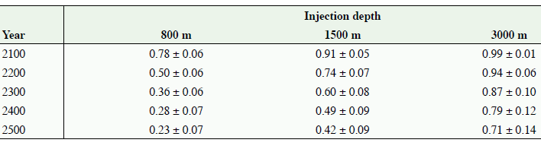
Table 2.. Fraction of CO₂ retained for ocean storage as simulated by seven ocean models for 100 years of continuous injection at three different depths starting in the year 2000[9].

3. Results
The International Energy Agency (IEA) declared earlier this year (2017.6) that CCS is crucial for slowing the rising temperatures and reduing the greenhouse gas emissions. But critics of this technology emphasize that the high expense of this technology is not worth the investment. So, what is the cost for storing carbon in the world’s oceans?
The dominant cost component is the CO₂ capture and compression/liquefaction. Transport costs are the next largest cost factors while pipping and shipping are the major CO₂ transportation methods at present. The costs of monitoring, injection nozzles etc. are expected to be smaller in comparison[9].

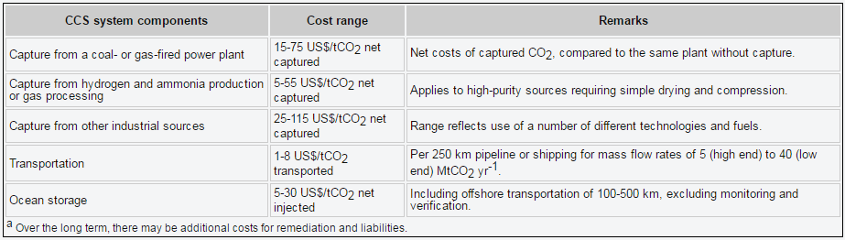
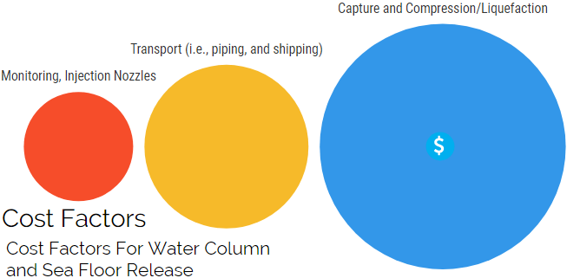
Figure 4. Cost ranges for the components of a CCS system as applied to a given type of power plant or industrial source in 2002. The costs of the separate components cannot simply be summed to calculate the costs of the whole CCS system in US$/CO₂ avoided. All numbers are representative of the costs for large-scale, new installations, with natural gas prices assumed to be 2.8-4.4 US$ GJ⁻¹ and coal prices 1-1.5 US$ GJ⁻¹.
Source: IPCC Carbon Dioxide Capture and Storage: Technical Summary (2005) Ch8. Costs and economic potential, p. 39

4. Prospective
Few published papers can be found which has been studied specifically on site selection for intentional oceanic carbon capture and sequestration, hence, further study needs to be done in order to select sites for ocean storage. Monitoring and verification should also be done in order to monitore the potential leakages from subsea geologic storage, or for verification that such leakage would not occur. Mass and distribution of CO₂ from each point source should also attempt to quantify, and related biological and geochemical parameters should be record too. Overall,the knowledge of deep-sea population and community structure and of deep-sea geological and ecological interactions is still limited. Thus the sensitivities of deep ocean ecosystems to intentional carbon storage and the effects on possibly unidentified goods and services that they may provide remain largely unknown, the mechanism behind oceanic carbon capture and sequestration and the consequences still need further studies. Technologies capturing CO₂ from power plants are still relatively expensive today, so it has great potential for further development to lower CCS costs. Costs can be significantly reduced by improving the thermal efficiency of the plants, reducing the energy penalty for CO₂ capture, improving separation techonlogies, or developing highly efficiency new technologies for CCS. The viability of oceanic carbon sequestration as a greenhouse gas mitigation option will also hinge on social and political considerations. In view of public precaution toward the ocean, the strategy will require that all parties (private, public, non-governmental organizations) be included in ongoing research and debate.

5. Conclusion
Among all these considerations for OCCS are technical feasibility, environmental consequences, economical feasibility (costs,etc.), safety, and international issues (including cross border transport). Ocean sequestration, in other words, would speed up the otherwise centuries- or millennialong process of establishing equilibrium between the atmosphere and the entire ocean. It would not decrease acidification of the entire ocean, but it might limit acidification in the surface waters that are of greatest economic interest to people. And giving people time to improve more efficiency technologies and strategies to reduce green house gas emissions. In a world of limited resources, it may represent the most efficient way to store a lot of carbon quickly. So, OCCS might be one of the best emergency strategies in dealing with climate change and global warming when great climate catastrophe occurs.

Acknowledgements
Grateful acknowledgement is made to my supervisors Prof. Ke Liu, Prof. Li Weng, Prof. Changning Wu, Mr. Gan Li who gave me considerable help by means of suggestion, comments and criticism. The encouragement and unwavering support of them has sustained me through frustration and depression. Without their pushing me ahead, the completion of this thesis would be impossible. In addition, I deeply appreciate the contribution to this thesis made in various ways by my friends and classmates.

Reference
[1] Globalcarbonproject.org. (2018). GCP - Carbon Budget. [online] Available at: http://www.globalcarbonproject.org/carbonbudget/17/presentation.htm [Accessed 18 Jan. 2018].
[2] Change, U. (2018). United Nations Framework Convention on Climate Change. [online] Unfccc.int. Available at: http://unfccc.int/2860.php [Accessed 18 Jan. 2018].
[3] Treaties.un.org. (2018). UNTC. [online] Available at: https://treaties.un.org/pages/ViewDetails.aspx?src=TREATY&mtdsg_no=XXVII-7-d&chapter=27&clang=_en [Accessed 18 Jan. 2018].
[4] Anon, (2018). Global Carbon Cycle.
[5] IRENA (2017), Untapped potential for climate action: Renewable energy in Nationally Determined Contributions, International Renewable Energy Agency, Abu Dhabi.s
[6] Data.worldbank.org. (2018). Brazil | Data. [online] Available at: https://data.worldbank.org/country/brazil [Accessed 18 Jan. 2018].
[7] Dr. Bolland, O. (2009). Carbon dioxide capture. MIT Carbon Sequestration Forum X.
[8] Herzog, H. J., Caldeira, K., & Adams, E. (2001). Carbon sequestration via direct injection. Encyclopedia of Ocean Sciences, 408–414.
[9] Haszeldine, S. (2014). 二氧化碳离岸运输与封存的工程要求国际经验简介, 2014/d01.
[10]Anon, (2018). CSA Z662 Standards and Training for Canadian Oil and Gas Pipelines Systems. [online] Available at: http://z662blog.com/ [Accessed 18 Jan. 2018].
[11] Recommended practice for basic inspection requirements- New pipeline construction 49. (2014).
[12] Veritas, D. N. (2010). Design and Operation of Co 2 Pipelines. Practice, (April).

Appendix:

Engeneering properties of CO₂ for transportation and storage
One must first know the physical and chemical properties of CO₂ before trying to understand how CO₂ can be captured and stored in the deep ocean.

1. Physical properties of CO2:

1.1. Phase diagram of CO₂.
CO₂ is colorless, odorless, and non-flammable gas at standard temperature and pressure, it can also exist as liquid, solid state (dry ice), or super critical phase under certain conditions. There are three key points in CO₂ phase diagram [1]:
(1) Sublimation point: CO₂ sublimates from its solid state to its gaseous phase without leaving any residues at a temperature of 194.7 K (-78.45°C) and 1.01 bar (1 atm, 101 kPa).
(2) Triple point: All three phases (gas, liquid, and solid) of CO₂ coexist in thermodynamic equilibrium at 217 K (-56.15°C) and 5.17 bar (5 atm, 517 kPa).
(3) Critical point: The critical point of CO₂ is 304.25 K (31.10°C) at 73.9 bar (72.9 atm, 7.39MPa). At temperatures and pressures above the critical point, CO₂ behaves as a supercritical fluid known as supercritical carbon dioxide, which has properties between gas and liquid: It can effuse through solids and fill its container like a gas, and have a density like a liquid which can also dissolve materials. It is considered to be the most efficient way for carbon sequestration since it behave like liquid but have a very high density.
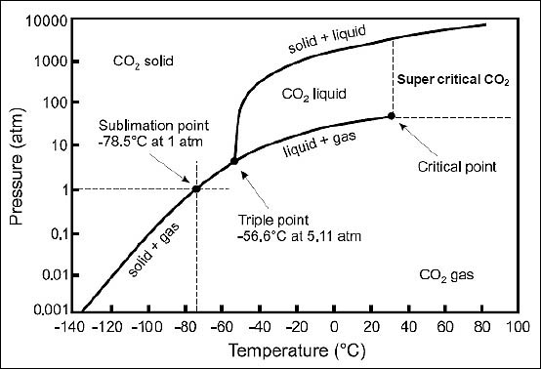

Figure 1. Phase diagram of CO₂[1].

The physical properties of CO₂ in seawater are key factors which will affect its releasing rate from the deep-sea environment. Figure 2 shows the conditions where CO₂ can exist as gas, liquid, solid hydrate, or aqueous phase in seawater.
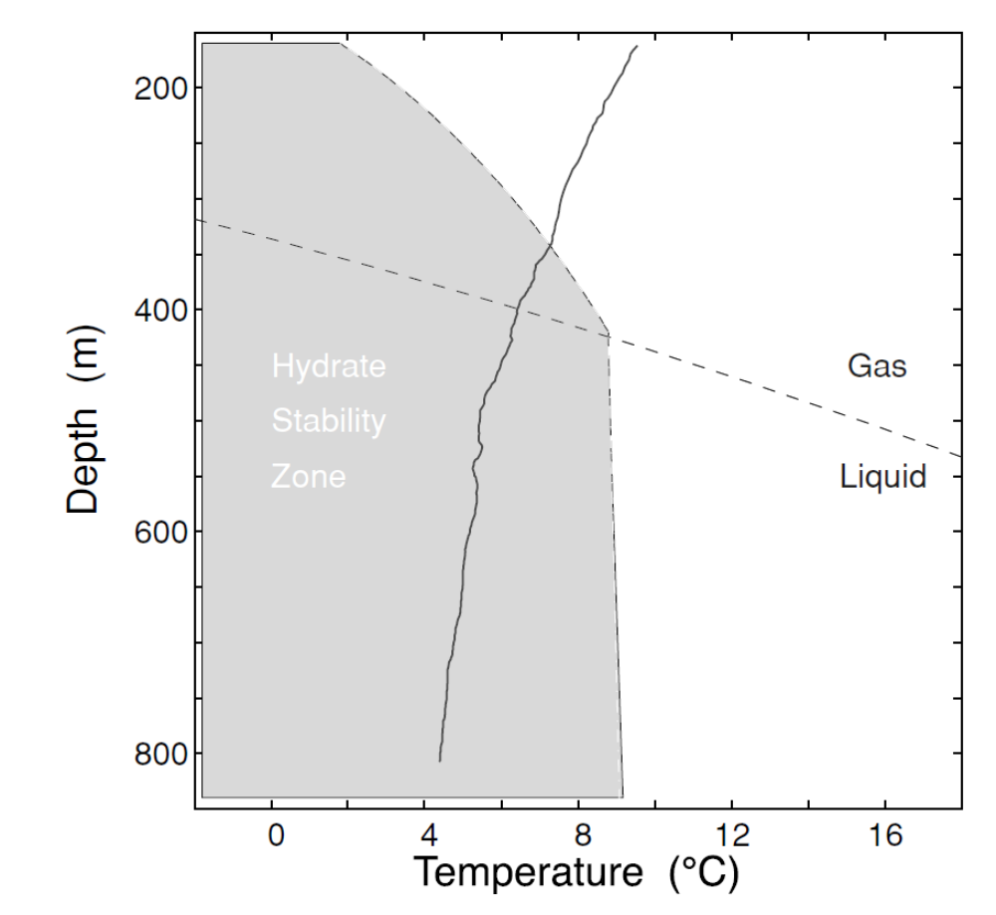

Figure 2. The physical properties of CO2 in seawater[2].
CO₂ sea water phase diagram showing the conditions where CO₂ can exist as gas, liquid, solid hydrate, or aqueous phase in seawater ( Monterey Bay). The pressure of seawater is increasing with the depth of the ocean, and liquid phase CO₂ is stable when temperature and pressure is falling in the region below the dashed line, while gas phase CO₂ is stable under conditions above the dashed line. CO₂ will become carbon dioxide hydrate (CO₂·6H₂O, a solid ice-like crystalline substance) when contacting with the seawater and at temperature and pressure in the shaded region. The solidline curve shows the relationship between the temperature and the depth (at a site off the coast of California), which tells that liquid and hydrated CO₂ can exist below about 400m.

1.2. The density of CO₂.
CO₂ could be released from the deep ocean, but whether it will rise or fall determined by the buoyancy of CO₂. Pure CO₂ would exist as gases at a depth above about 500 m and below that depth it would be liquid. The density of liquid CO₂ is lighter than the seawater between about 500 m to 2700 m, above that depth the CO₂ would rises, since CO₂ is denser than the seawater below 3000 m and will eventually sink and form a lake of CO₂ on the sea floor[3].
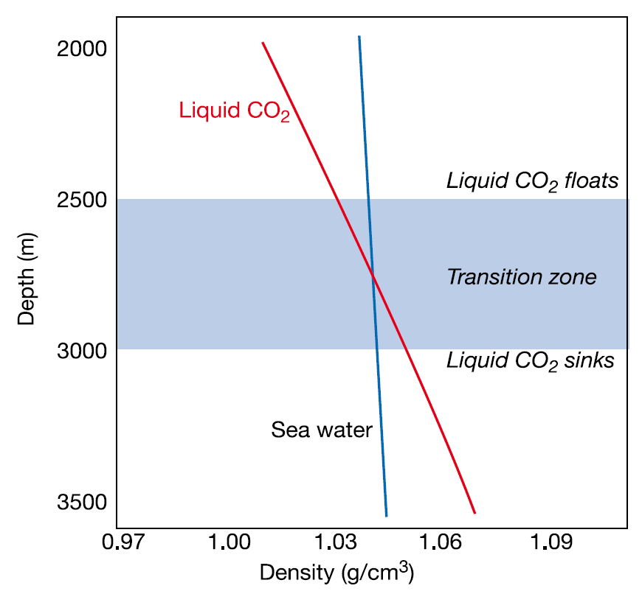

Figure 3. Liquid CO₂ tends to float upward at a depth above 2500 m while it tends to sink downwards below 3000 m, and between these two depth, liquid CO₂ can be neutrally buoyant (neither rises nor falls). (Northwest Atlantic Ocean)[3].

Liquid CO₂ tends to float upward at a depth above 2500 m while it tends to sink downwards below 3000 m, and between these two depth, liquid CO₂ can be neutrally buoyant (neither rises nor falls). (Northwest Atlantic Ocean)

2. Chemical properties of CO₂:
The sum of carbon contained in H₂CO₃, HCO₃⁻, and CO₃²⁻ is called the total Dissolved Inorganic Carbon (DIC). The chemical equilibrium beteween CO₂ and carbonic acid in seawater, the partial pressure of CO₂ (pCO₂) in the atmosphere and the exchange rate between air and sea determine the exchange of atmospheric CO₂ with ocean surface waters[4]. When the carbon concentration is in equilibrium between the atmosphere and the ocean surface water, there will be no carbon flux since there is no concentration gradient, according to Henry’s law.
CO₂ reacts with seawaters and forms carbonic acid (H₂CO₃), then it dissociates into bicarbonate ion (HCO₃⁻), carbonate ion (CO₃²⁻), and hydronium ion (H⁺) by the reactions:

CO₂(g) + H₂O ⇔H₂CO₃(aq) ⇔ HCO₃⁻ + H⁺ ⇔ CO₃²⁻ + 2H⁺

The CO₂ added to the ocean will turn into HCO₃⁻, and thus generate more H⁺ and decrease the concentration of CO₃²⁻, with the result of decreasing pH and making ocean more acidic.
When alkaline minerals, such as CaCO₃, are dissolved in the seawater, the Total Alkalinity (TAlk) increased. Increasing the Talk in the seawater increases the solubility of CO₂. The reaction can be represented by this equation:
CaCO₃(s) ⇔ Ca²⁺ + CO₃²⁻

The Total Alkalinity (TAlk) can be approximately expressed as:

TAlk = HCO₃⁻ + CO₃²⁻ + OH⁻

Since most DIC is in the form of HCO₃⁻, the main reaction for the dissolving CaCO₃ in the surface ocean water is [5]:

CaCO₃(s) + CO₂(g) + H₂O ⇔ Ca²⁺ + HCO₃⁻

When nitrogen is added into seawaters, additional DIC is converted to organic nutrients and exported from the surface layer of the ocean. The alkalinity could be changed by this process, and the primary production (e.g. Photosynthesis process by the phytoplankton and other living organisms) could also be enhanced. This can be considered as following equations[6]:

NH3 + H2O ⇔NH4⁺ + OH⁻

106CO2 + 16NH4⁺ + H2PO4- + 15OH- +91H2O = (CH2O) ¹⁰⁶ (NH₃)¹⁶ (H3PO4) + 5302_{(g)}

Thus the DIC decreases with the consumption of OH- ions, which means that the TAlk decreases. Thus pCO2 is lowered in the surface water and causing carbon flux from the atmosphere.

Reference
[1] En.wikipedia.org. (2018). Carbon dioxide. [online] Available at: https://en.wikipedia.org/wiki/Carbon_dioxide#Physical_properties [Accessed 18 Jan. 2018].
[2] Global.bing.com. (2018). carbon dioxide pressure-temperature phase diagram - Bing images.
[3] Doi.org. (2018). Redirecting. [online] Available at: https://doi.org/10.1016/j.egypro.2011.02.214 [Accessed 18 Jan. 2018].
[4] Dr. Bolland, O. (2009). Carbon dioxide capture. MIT Carbon Sequestration Forum X.
[5] Kheshgi, H. S. (1995). Sequestering atmospheric carbon dioxide by increasing ocean alkalinity. Energy, 20(9), 915-922.
[6] Redfield, A C, B H Ketchum and F A Richards (1963) The influence of organisms on the composition of sea water. The Sea Vol 2

All the data is shown in billion tonnes CO₂ (GtCO₂) 1 Gigatonne (Gt) = 1 billion tonnes = 1×10¹⁵g = 1 Petagram (Pg) 1 kg carbon (C) = 3.664 kg carbon dioxide (CO₂) 1 GtC = 3.664 billion tonnes CO₂ = 3.664 GtCO₂ For more details and information, please go to: IPCC’s official website: http://www.ipcc.ch/report/srccs/ IRENA’s official website: http://www.irena.org/ Global Carbon Budget’s official website: http://www.globalcarbonproject.org/carbonbudget/ Global Carbon Atlas’ official website: http://www.globalcarbonatlas.org/en/content/welcome-carbon-atlas
For more engineering details and information, please go to: UK-China (Guangdong) CCUS Centre. Documents download address: http://www.gdccus.org/en/col.jsp?id=116

