Experiment setup:

Using the FastText train_unsupervised API, and the default parameters. This model reached a score of 0.6487. The default parameters are as follows:

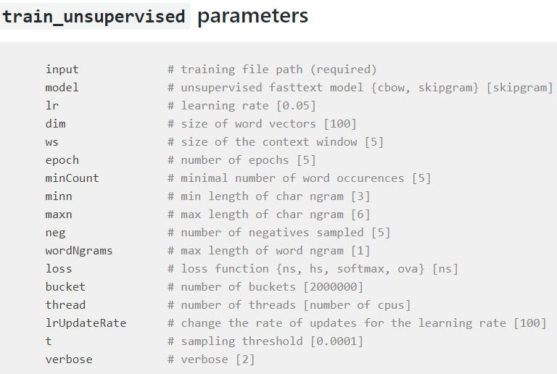

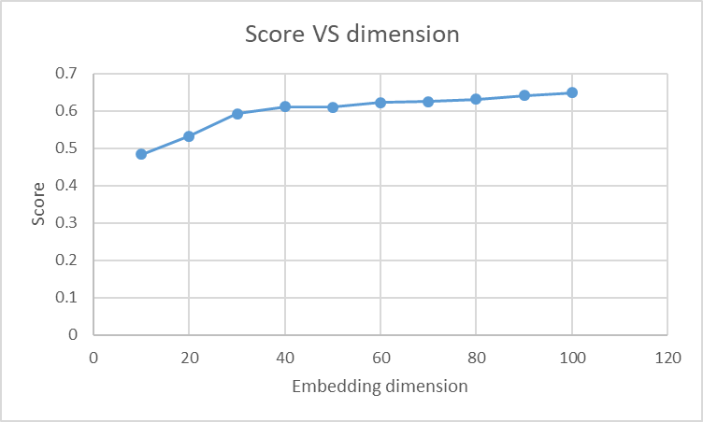1. Change embedding dimensions:

|  |  |
| --- | --- |
| **dimension** | **score** |
| 10 | 0.4834 |
| 20 | 0.5326 |
| 30 | 0.5928 |
| 40 | 0.6114 |
| 50 | 0.6094 |
| 60 | 0.6224 |
| 70 | 0.6248 |
| 80 | 0.6314 |
| 90 | 0.6413 |
| 100 | 0.6487 |

As the embedding dimension increases from 10 to 100, the score increases correspondingly.

The increase is rapid with lower dimensions and gets slower when the dimension gets large.

2. Change amount of training data: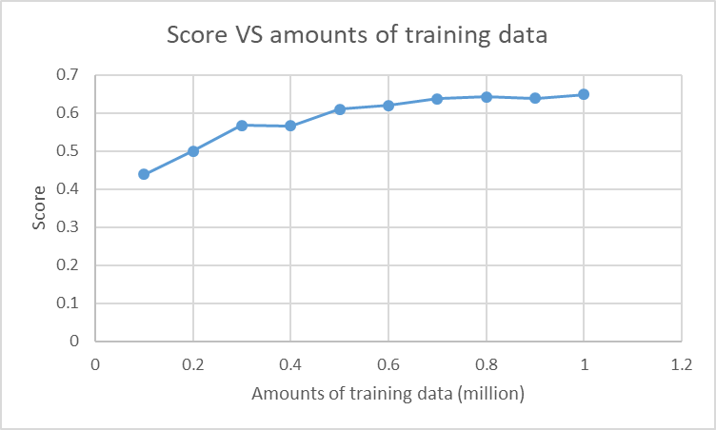

|  |  |  |
| --- | --- | --- |
| **data (million)** | **score** | **embeddings** |
| 0.1 | 0.4381 | 24231 |
| 0.2 | 0.5002 | 36386 |
| 0.3 | 0.5672 | 45565 |
| 0.4 | 0.5661 | 53420 |
| 0.5 | 0.6102 | 60364 |
| 0.6 | 0.6193 | 66550 |
| 0.7 | 0.6368 | 72223 |
| 0.8 | 0.6425 | 77428 |
| 0.9 | 0.6384 | 82331 |
| 1 | 0.6487 | 86965 |

As the amount of training data increases from 0.1 million to 1 million, the score basically increases correspondingly. However, at 0.4 million and 0.9 million, the score decreases a little.

The increase is rapid with small amount of training data and gets slower when the amount of data gets large.

We can also observe that the number of embeddings (i.e., the number of words) increases with the amount of the training data.