ECE408 Final Project
CNN convolution layer gpu accelerator
Team name:
linkthefire

Member:
Jiyu Hu jiyuhu2
rai id: 5d97b1cc88a5ec28f9cb9464

Leihao Chen 675922703 leihaoc2
rai id: 5d97b1b088a5ec28f9cb9430

Anthony Nguyen alnguyn2
rai id: 5d97b1f288a5ec28f9cb94ab

ECE408 Final Project 1
4.1 Implicit Unrolling & Data parallelism 3
Regular Matrix Multiplication 3
Parallelized Batch Matrix Multiplication 3
4.2 Tuning with restrict & loop unrolling 6
Regular Matrix Multiplication Layer 2 6
For loop unrolling & restrict Matrix Multiplication 7
4.3 Multiple kernel implementations for different layer sizes 8
3.1 Unroll and Matrix Multiplication 9
Unrolling and matrix multiplication for convolution 10
Fig 3.1.1 11
Fig 3.1.2 11
Fig 3.1.3 12
Fig 3.1.4 13
Fig 3.1.5 13
Fig 3.1.5 14
3.2 Shared Memory Convolution 15
Fig 3.2.1 15
Fig 3.2.2 16
Fig 3.2.3 17
3.3 Constant Cache Optimization 17
Fig 3.3.1 18
Fig 3.3.2 18
2 GPU implementation 20
1 CPU implementation 22

4.1 Implicit Unrolling & Data parallelism
Description
Performance of matrix multiplication with kernel unrolling is limited by global memory in two ways. First, the unrolling factor is approximately K*K. In the 10000 dataset, the unrolled matrix X cannot fit into global memory. Therefore, a method of mini-batch is used in pervious optimization. We reduce the amount of parallelism in the B (batch) dimension so that unrolled matrix X can fit into global memory. Second, kernel unrolling method requires too much global memory access as discussed in earlier checkpoints.
The first part of this optimization is to avoid explicit kernel unrolling to solve the limitation in global memory size and accessing. Unrolling can be performed when loading the tiles in the matrix multiplication kernel. This reduces the runtime from ~400ms to ~80ms.

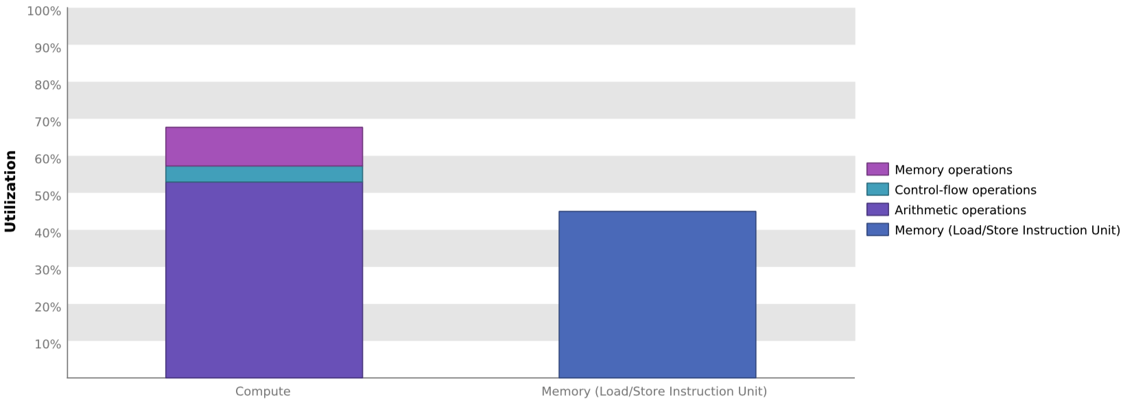Regular Matrix Multiplication

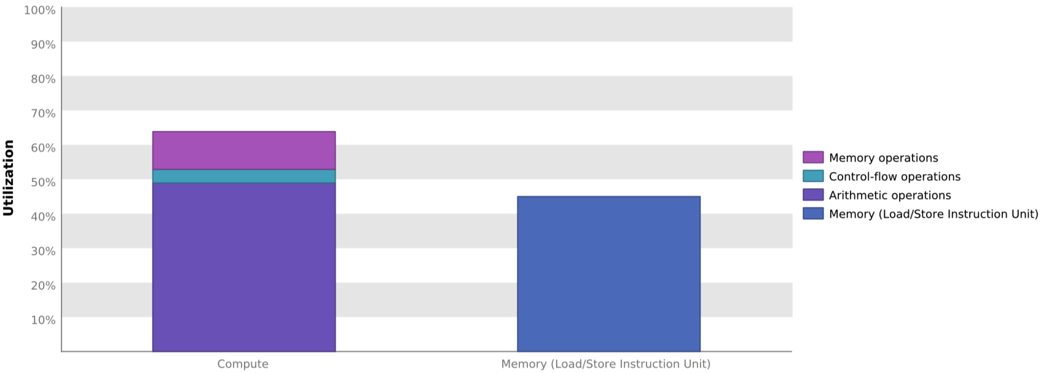 Parallelized Batch Matrix Multiplication
The second part of this optimization is input parallelism in B (batch) dimension. Note that fact that we can using one weight for all pictures. In the tiling loading step, we try to avoid some unnecessary data loading. To do this, instead of letting each block dealing with one input matrix, a third block dimension is added so that we can assign multiple input matrices to one block and use the same weight matrices in the shared memory. To match with this, we added a new dimension for matrix X’s tile, indexed by threadIdx.z. While the shared memory for weight stays the same. This is to some extent similar to tiling in the sense that we partition the input data and reuse the same data in shared memory as much as possible.
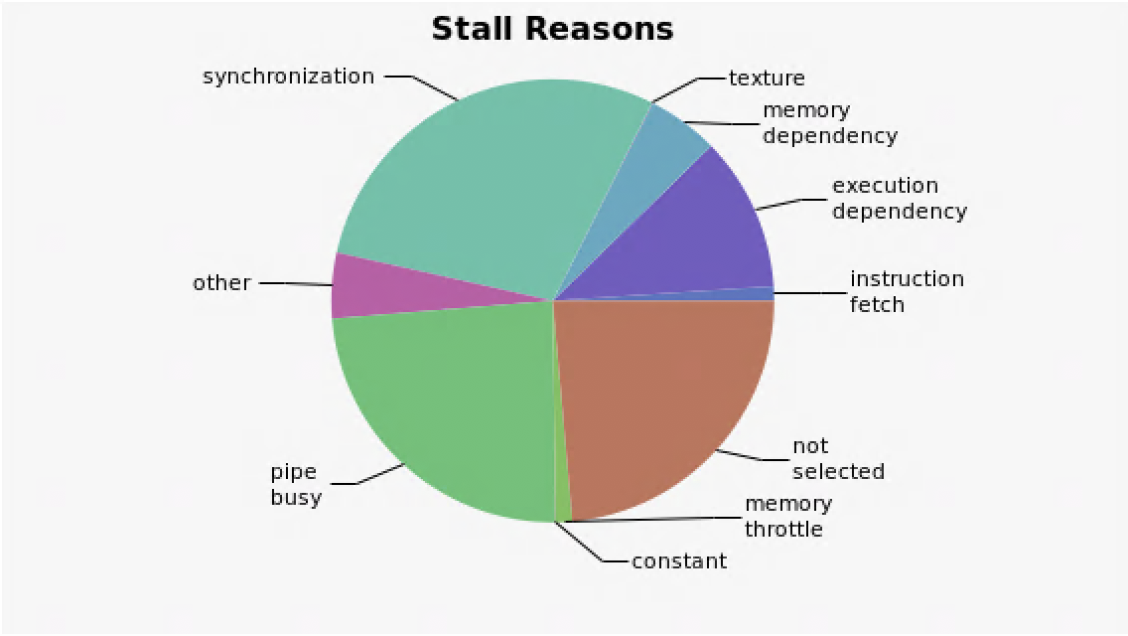
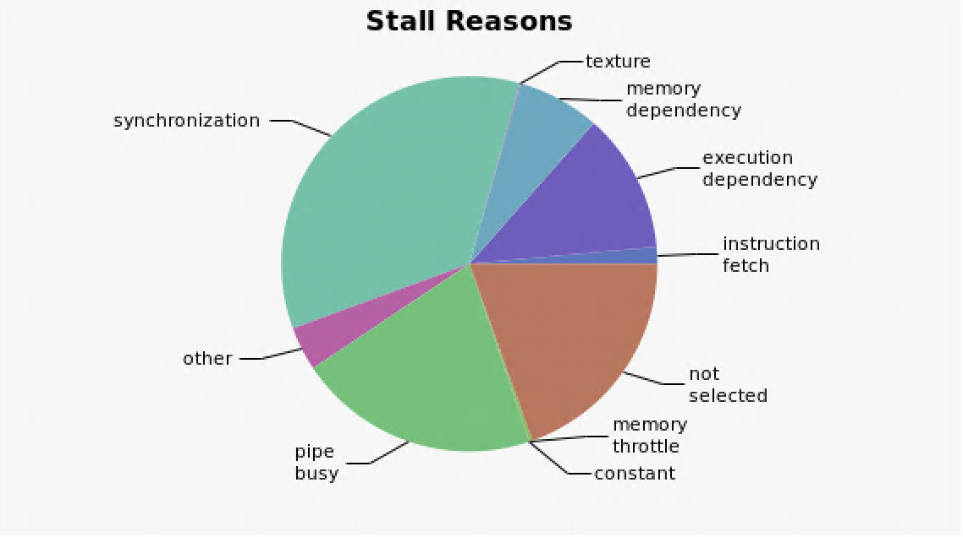
Data parallelism only improve the runtime of layer 1 by ~5ms together with for loop unrolling and restrict tuning. It also makes layer 2 slower. According to our understanding, the main reason for the latency is because of an increased number of for loop iteration in on each thread. Since each CUDA block can only have a maximum of 1,024 threads, we have no choice but to decrease tile size in order to introduce a third dimension to blockDim. This works good for input matrices with small dimensions but has significant drawbacks if the input matrices size is large.
Regular Matrix Multiplication Parallelized Batch Matrix Multiplication

As you can see from the figures above, Regular Matrix Multiplication has more synchronization overhead and memory dependency. This agrees with out reasoning about the potential improvement that Parallelized Batch Matrix Multiplication can bring to the kernel — we load more often from global memory in Regular Matrix Multiplication, and each time we load, we need to synchronize the thread.

This parallel approach has a little portion of control divergence:
subTileB[b][ty][tx] = (Col < numBColumns && temp_row < numBRows && X_b < numBatch) ? x4d(X_b, X_c, X_h + X_p, X_w + X_q) : 0;

This is the line of code to load input matrices into shared memory. We cannot avoid this divergence because total batch number might not be multiple of Batch partition size.

Output
Loading fashion-mnist data... done
Loading model... done
New Inference
Op Time: 0.025720
Op Time: 0.083995
Correctness: 0.7653 Model: ece408

As we can see from the output. Layer 1’s runtime is less than milestone 4 while layer 2’s runtime is longer in contrast.

4.2 Tuning with restrict & loop unrolling
Description
Because all the dimensions are fixed in our case, we can further improve our instructions. Instead of doing control flow in run time, we can calculate the number of iterations for all the for loops. To do this we use the # pragma unroll directives in front deterministic for loops to tell the complier to generate instructions by repeating commands without explicit for loop. Besides, we also include __restrict__ keyword to hint the compiler that we only access the non-overlapping arrays via their pointers. Lastly, const keyword in used for all read only variables to ensure safe access.

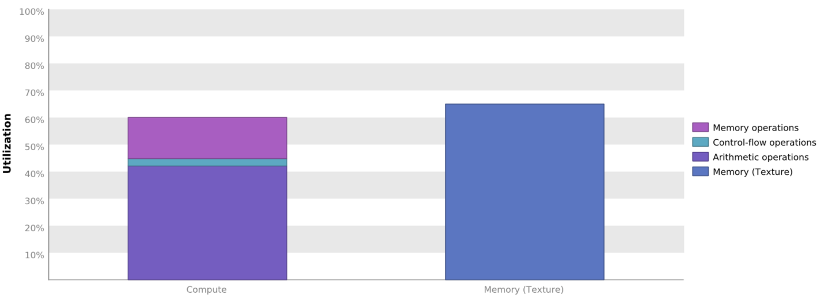Regular Matrix Multiplication Layer 2

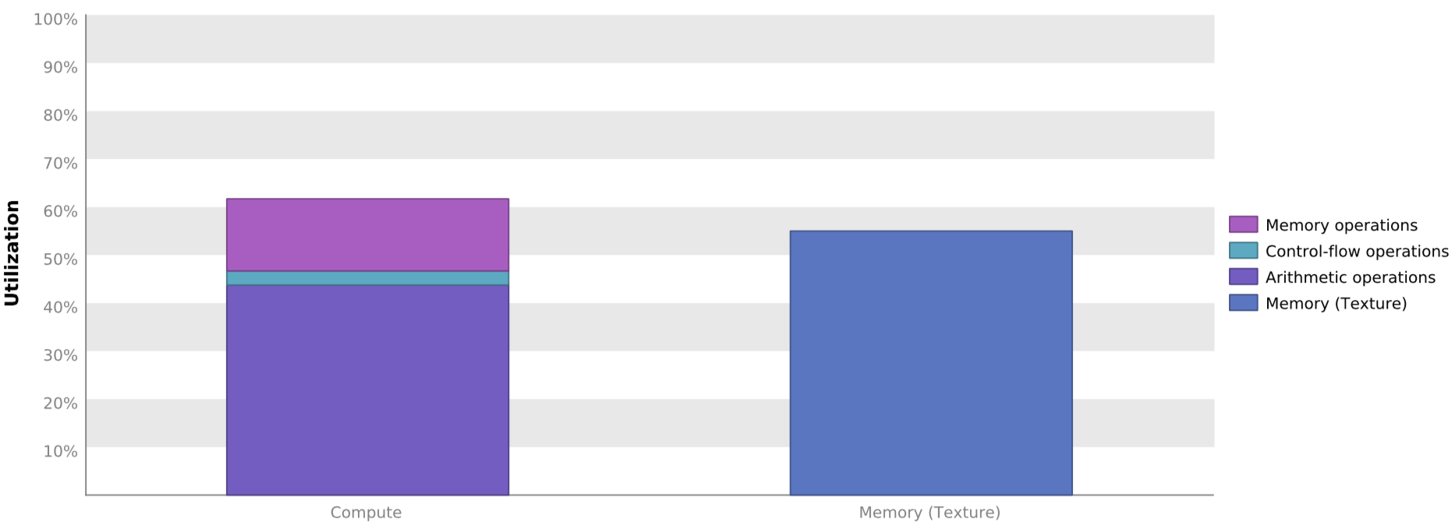 For loop unrolling & restrict Matrix Multiplication
As shown the figures above, before doing these subtle tuning. The matrix multiplication kernel is bounded by both instruction and memory latency. After this optimization Compute utilization increase a little bit, and the kernel is bounded by only memory bandwidth now.
In terms of runtime, adding unroll and restrict along only reduce ~1ms. But after including multiple kernels for different layers. It seems that parallelized matrix multiplication benefits more. A ~5ms speed up is achieve with layer 1 parallelized matrix multiplication. A possible reason for this is in order to add parallel in B (batch) dimension, we reduced the TILE_WIDTH in tiled matrix multiplication. Therefore, introduced more iterations in for loops.

Output

4.3 Multiple kernel implementations for different layer sizes
Description
The optimization Involved using separate kernel Implementations for different layers. The first layer was executed using a parallel matrix multiplication kernel using a (16,16,4) block dimension. Layer 2 was executed using a regular matrix multiplication kernel using a (32,32,1) block dimension. These block dimensions were chosen such that the thread counts are divisible by a warp size (32) to reduce control divergence.
GPU Activities
lorem ipsum

3.1 Unroll and Matrix Multiplication
Description
The optimization unrolls both input data matrices and weight matrices so that we can perform a simple shared memory matrix multiplication on the data to generate the output. The unrolling of weight matrices needs no additional execution since the row-major layout, we only need to change the indexing when we access it as unrolled matrices. For the input data, we run an additional kernel to perform the unroll. The unrolled matrix exceeds the assigned CUDA memory size when we perform op2 for 10000 dataset. So, we partition the input data into small sections and deal with each section sequentially. This slows down the performance of this optimization for the last dataset.
This optimization is based on Chapter 16:

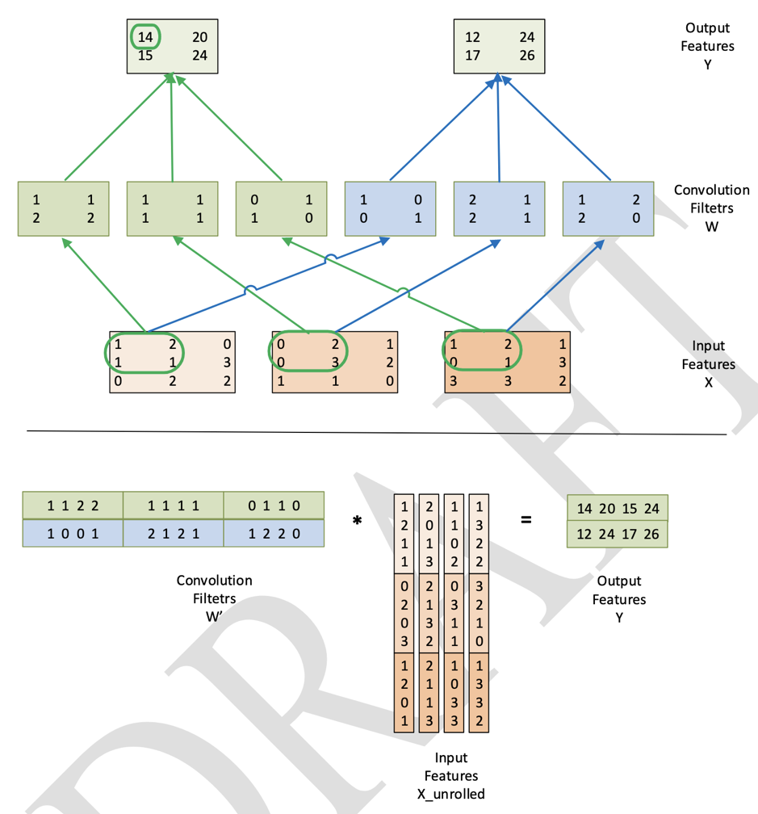

Unrolling and matrix multiplication for convolution
We utilize this optimization because we can transfer a time-complex matrix convolution operation into a faster matrix multiplication operation, but the runtime is about the same for the datasets. According to our understanding, the reason is mainly that the memory utilization grows a lot for this optimization compared to the basic approach. There are much more global and shared memory reads and writes, so even our code becomes more parallel, the overall performance is not better.
We use two kernels for this optimization, one matrix unroll and one matrix multiplication. Matrix multiplication kernel takes more time to finish than the other.
Matrix Multiplication:

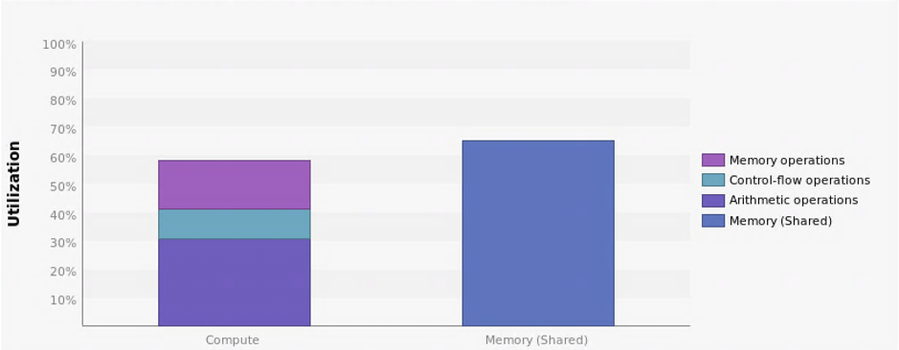

Fig 3.1.1
This kernel is Bounded by Memory Bandwidth.
As we can see from figure 3.1.1, which is kernel performance chart for matrix multiplication, the memory utilization is higher than compute utilization. This is obvious with our implementation since the matrix multiplication kernel accesses shared memory a lot.

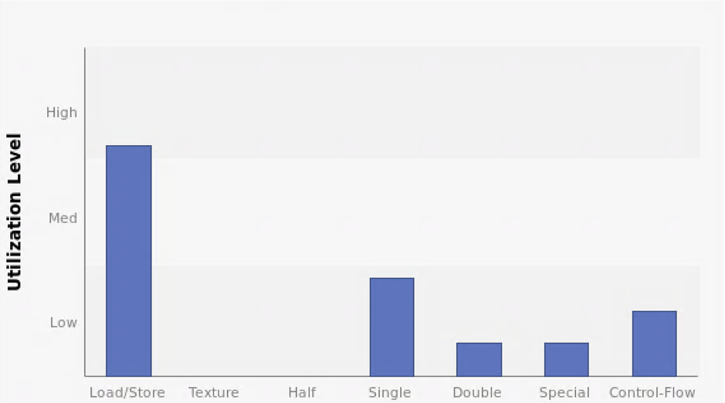

Fig 3.1.2
Figure 3.1.2 is function unit utilization chart, this also indicates that the matrix multiplication kernel mainly spends time on memory load and store.

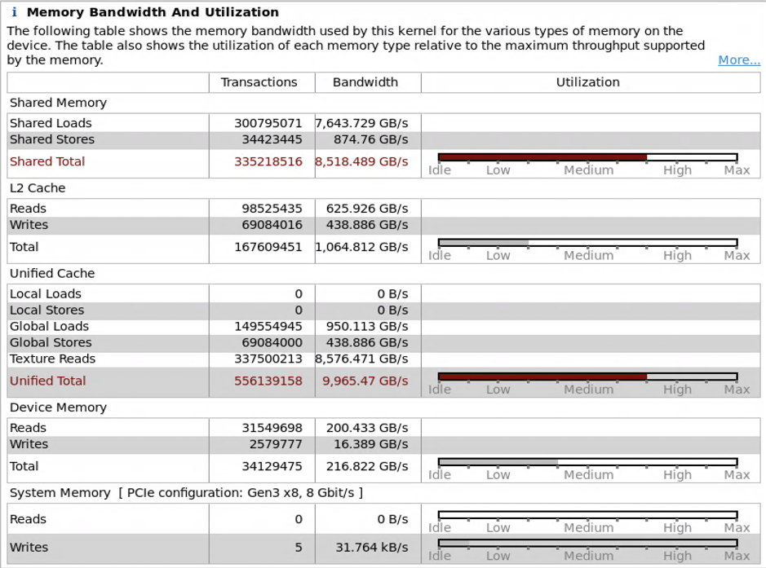

Fig 3.1.3
Figure 3.1.3 is the memory usage of Matrix multiplication kernel. Both shared memory and unified cache memory is accessed frequently. We are utilizing the memory bandwidth pretty well.
Matrix Unroll:
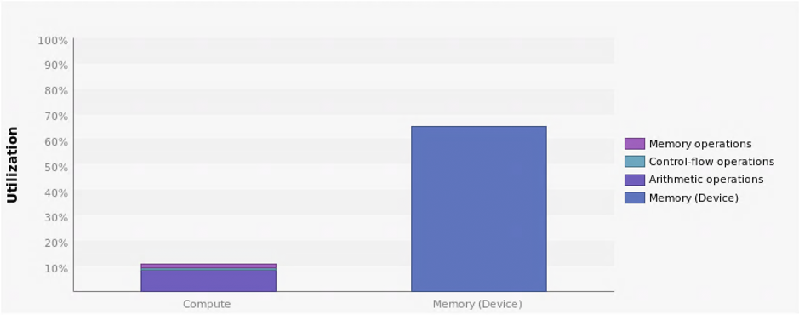

Fig 3.1.4
As we conclude from figure 3.1.4, this kernel’s utilization distribution is very unbalanced. This is consistent with our design since we unroll the matrix, which mainly moves data from one place in memory to another. For further improvement to our optimization, we can abandon this kernel and instead access data from original matrix by changing the indexing in matrix multiplication kernel.

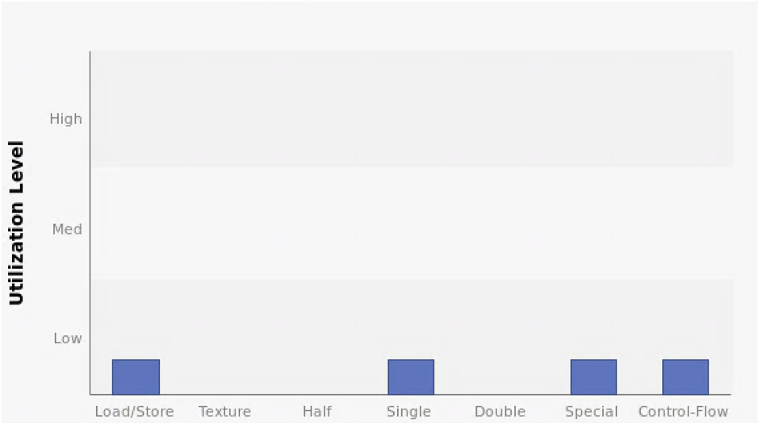

Fig 3.1.5

Figure 3.1.5 shows that utilization level is low for all performances in the kernel. The same reason applies here.

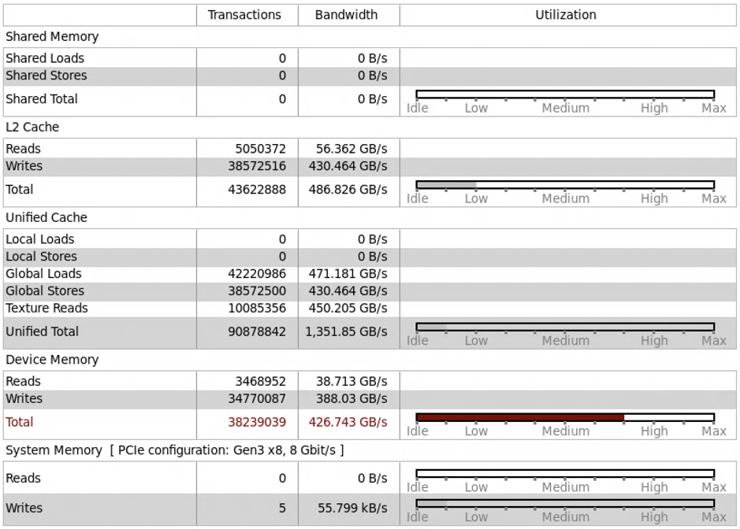

Fig 3.1.5
Memory access is exactly as expected: we perform a lot of global memory access in this kernel.

3.2 Shared Memory Convolution
Description
Kernel performance in checkpoint 3 is bounded by memory. Since all data read and write are global, there is a high demand on memory bandwidth. This optimization use shared memory to reduce memory dependency on convolution kernel execution. Similar to lab: 3D convolution, we preload the data and weight matrices on shared memory.

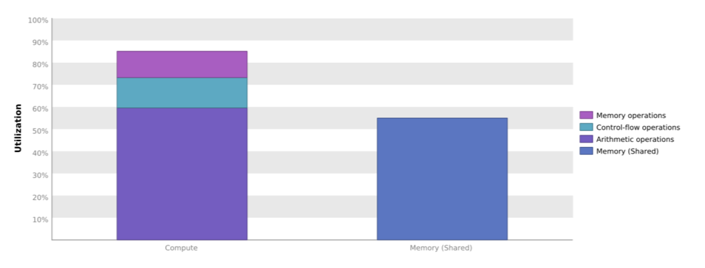

Fig 3.2.1
As we can see from figure 3.2.1, which is kernel performance chart for shared memory convolution, the compute utilization is higher than memory utilization. It kernel is bounded by computation. As further proved in figure 3.2.3 resource analysis. TITIAN V supports 65536 registers for each block and 32 blocks in a SM. The kernel used 10240 registers. Therefore, only 6 block is simultaneously executing on a SM.

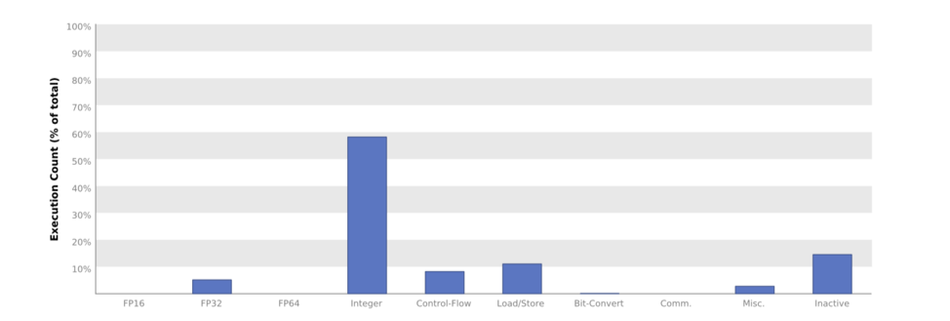

Fig 3.2.2
Figure 3.2.2 is function unit utilization chart, this also indicates that the shared memory kernel mainly spends time on memory load and store.
Line 43 | Divergence = 37.5% [ 3456000 divergent executions out of 9216000 total executions ]

if(t < C * W_unroll && b < B) // when loading shared memory

Line 47 | Divergence = 50% [ 9216000 divergent executions out of 18432000 total executions ]

for(p = 0; p < K; p++){
for(q = 0; q < K; q++){ // for loop for convolution

One major disadvantage of share memory method is the control divergence when transferring data from global memory to shared memory.

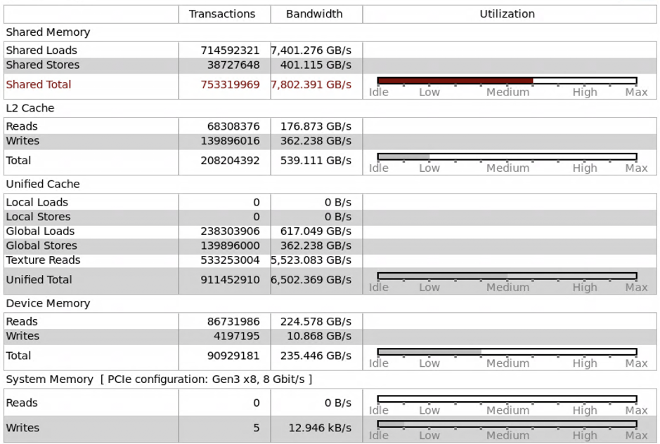

Fig 3.2.3
Figure 3.2.3 is the memory usage of Shared Memory Convolution kernel. Share Memory is properly utilized.

3.3 Constant Cache Optimization
Description
The optimization was to use constant cache memory to load the weighted matrix, then perform the convolution by reading through the constant Cache. The reason for this was because the cache reduces memory traffic by being read-only thus making memory access much quicker. By loading our weighted matrix into a constant cache, it is expected that most of the reads will be accessed from the Cache during convolution execution thus improving performance.
The optimization resulted in a similar performance as it were to the baseline kernel (milestone 3.1). The correctness was the same; however, the computational time was also the same. A major factor to this result is the control divergence seen in line 54 of the kernel. There was 50% control divergence, meaning half the threads in the same warp were executing the same branching behavior. Due to high divergence, the compute utilization of the kernel was low to the point where most of the GPU is idle, as seen in the far-right bar in figure 3.3.1. We can see that the code reaches 20% execution count for Inactive instructions. Meaning that these threads did not execute any code due to control divergence. As we can see from figure 3.3.2, the kernel is also bounded by instruction and memory latency. This shows that the kernel is not fully utilizing the TITAN V to achieve the optimal throughput.

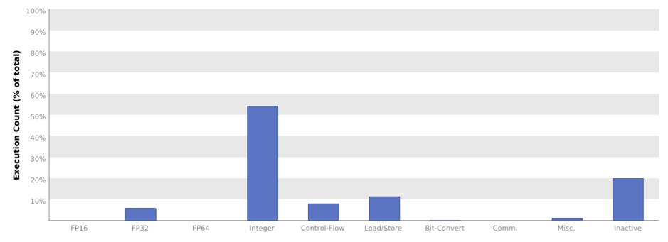

Fig 3.3.1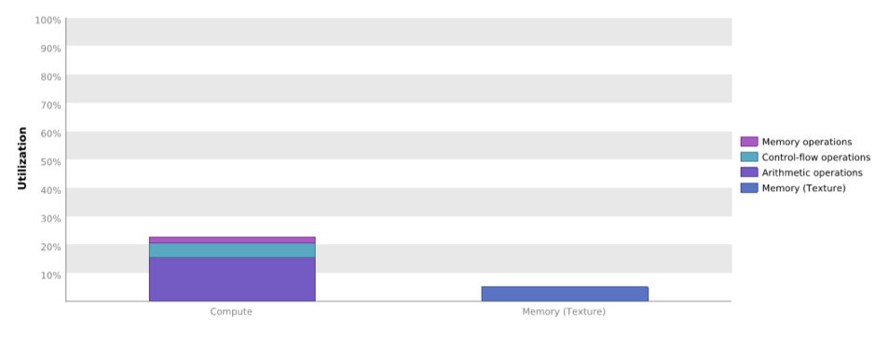

Fig 3.3.2
The reason for trying this optimization was because the constant cache is faster than global memory. By placing the weighted matrix into constant memory, it can be accessed quickly. This is ideal since the weighted matrix is used to calculate every value of the output, so by making these reads quicker, it should cause the overall kernel to be quicker. We believe that the idea is correct; however, the implementation will need to work on optimizing the number of blocks being executed by the kernel to reduce the memory and instruction latency. Along with that, the 50% control divergence causes drastic slow down during execution. We believe by optimizing the control flow branches and finding the optimal grid and block sizes, this optimization can be quicker.

2 GPU implementation
all kernels that collectively consume more than 90% of the program time:
[CUDA memcpy HtoD]

volta_scudnn_128x64_relu_interior_nn_v1 volta_gcgemm_64x32_nt

void fft2d_c2r_32x32(float*, float2 const *, int, int, int, int, int, int, int, int, int, float, float, cudnn::reduced_divisor, bool, float*, float*, int2, int, int)

volta_sgemm_128x128_tn

void op_generic_tensor_kernel(cudnnTensorStruct, float*, cudnnTensorStruct, float const *, cudnnTensorStruct, float const *, float, float, float, float, dimArray, reducedDivisorArray)

void fft2d_r2c_32x32(float2*, float const *, int, int, int, int, int, int, int, int, int, cudnn::reduced_divisor, bool, int2, int, int)

all CUDA API calls that collectively consume more than 90% of the program time:
cudaStreamCreateWithFlags

cudaMemGetInfo

cudaFree

difference between kernels and API calls:
Kernels are C functions defined by the user to execute N times in parallel by N CUDA threads. Therefore, a kernel launch is to execute the user defined C function. API functions are the functions provided by CUDA to execute some operations on CUDA GPU. API function calls are when users adopt the provided CUDA functions.

output of rai running MXNet on the CPU: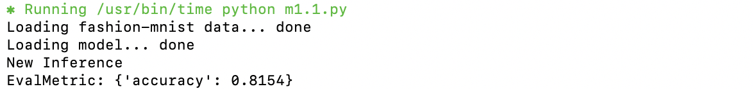

program runtime:

output of rai running MXNet on the GPU:
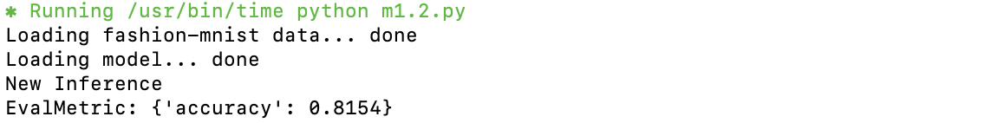

program runtime:

1 CPU implementation
Whole program execution time:

Op times:
