Results

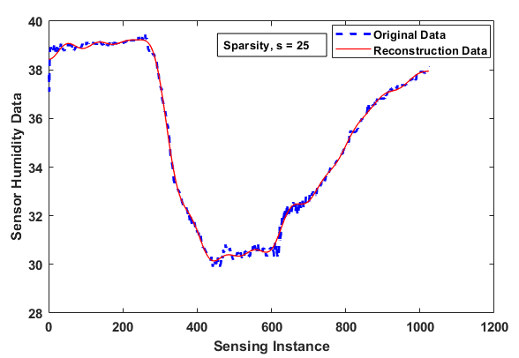

Fig 1: Original vs. reconstructed data for sparsity, *s* = 25

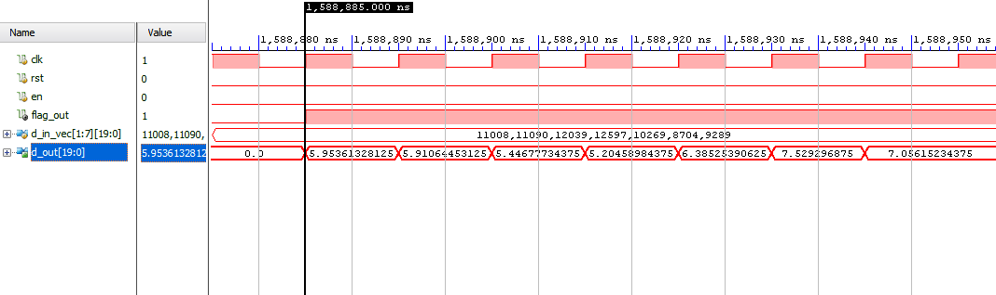

Fig 2: Diagonal matrix inverse Verilog-HDL result

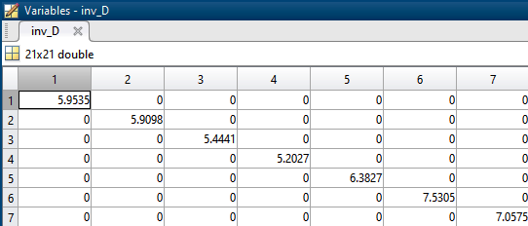

Fig 3: Diagonal matrix inverse MATLAB result

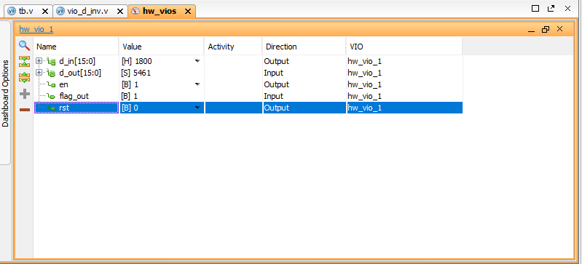

Fig 4: Diagonal matrix inverse FPGA result