Evaluating protein-access and residual totalVI-associated gains in CITE-seq representation learning under distribution shift
Jizhu Yang Research Manuscript | Unpublished manuscript | September 2026
Abstract
Background: CITE-seq representation learning can improve cell-type prediction, but gains may reflect access to paired surface proteins rather than a more complex multimodal representation. We quantified protein-access gain and the residual totalVI-associated contrast using simple RNA-protein controls and stress-tested that residual under distribution shift. Results: In the strict train-only development analysis (7,573/1,921 high-confidence cells), RNA PCA, concat PCA, and totalVI reached macro-F1 0.667, 0.745, and 0.741, respectively. Protein-access gain was +0.078 [cell-level conditional paired-bootstrap 95% interval 0.042, 0.131], whereas the residual totalVI-associated contrast was -0.004 [-0.060, 0.030]. Under transfer, inductive concat remained strong (0.735/0.734); feature-access-matched transductive concat reached 0.636 and 0.767, with totalVI about +0.016 and -0.113 relative to that feature-access control. Protein degradation narrowed residual totalVI-associated contrasts in settings where they were present, and training stochasticity limited precision for small contrasts. Across 10 Lawlor donors, totalVI exceeded capacity-matched scVI (scVI_matched) (mean paired Δ=+0.090; 10/10; donor means 0.794 vs 0.884), while donor-mean protein PCA and concat were stronger under protein-gated labels (0.923 and 0.942). Conclusions: Protein-access gain was substantial and resampling-stable, whereas the residual totalVI-associated contrast was near null and context-dependent.
Background
CITE-seq jointly measures transcriptomes and antibody-derived surface proteins in the same single cells [1]. This paired design is valuable for immune profiling because cell identities and activation states often depend on both transcriptional programs and surface-marker phenotypes. It also creates an interpretation problem: an improved representation may benefit from access to protein measurements, from the modeling procedure, or from an interaction between the two.
Deep generative methods are now widely used for single-cell representation learning. scVI provides an RNA-only variational representation [2], while totalVI extends this framework to paired RNA and protein measurements [3]. Other multimodal approaches, including MOFA+, MultiVI, Cobolt, scMaui, weakly supervised multimodal generative modeling, atlas integration, scArches, and WNN-style analysis, have expanded the range of available strategies for paired or partially paired single-cell data [4-10,14].
A central practical question is whether a complex multimodal representation adds value beyond a simple representation that has access to the same broad feature types. Comparing totalVI only with an RNA-only model can answer whether a particular multimodal workflow performs better than a particular RNA-only workflow, but it does not show how much of the improvement is already obtained by adding paired protein features to a simple baseline. A concatenated RNA-protein PCA control therefore provides an important reference point.
This distinction matters under distribution shift. scArches query adaptation uses unlabeled target features during adaptation [10], whereas a source-only PCA baseline can be applied inductively without fitting on target features. A fairer transfer stress test should include a feature-access-matched transductive concat control. This control matches unlabeled target features but not the learning objective or adaptation algorithm of scArches, so it is a feature-access control rather than an algorithmic replica.
Reliability also depends on protein quality, training stochasticity, and uncertainty behavior. Protein degradation can reveal whether residual totalVI-associated advantage depends on intact antibody-derived signal. Repeated training can show whether small contrasts are large enough to interpret confidently. Classifier predictive uncertainty and latent posterior variance can detect different reliability losses, while selective prediction can reduce retained-cell error at the cost of uneven cell-type retention.
External donor validation adds a biological unit of replication that computational resampling cannot replace. The Lawlor blood CITE-seq dataset provides 10 donors with paired RNA-protein measurements and author labels [13]. Because those labels are protein-gated, strong protein-aligned baselines are expected and should be interpreted as evidence of multimodal measurement value under protein-defined annotation rather than universal superiority of any representation class.
This study makes three contributions. First, we quantify the empirical performance improvement associated with access to paired protein measurements using strong simple multimodal controls and distinguish it from the residual totalVI-associated contrast relative to that simple multimodal baseline. Second, we test whether this residual totalVI-associated contrast persists under source-target shift, feature-access-matched transductive comparison, protein degradation, and training stochasticity. Third, we evaluate reliability using uncertainty-aware selective prediction and donor-level external validation.
Results
Simple multimodal protein-access gain explained much of the internal improvement
The internal development analysis used 9,494 high-confidence healthy-control cells with matched RNA and protein measurements under a strict train-only protocol (7,573 training / 1,921 held-out). Figure 1. Study logic for separating protein-access gain from residual totalVI-associated contrast under a strict train-only protocol (7,573/1,921). RNA PCA (0.667) defines the RNA-only reference, concatenated RNA-protein PCA (0.745) defines the simple multimodal feature-access reference, and totalVI (0.741) defines the complex multimodal representation under study. Central quantities are G_access=+0.078 and G_assoc=-0.004 (descriptive contrasts, not causal architecture effects). R_access is not highlighted as a primary recovery fraction.
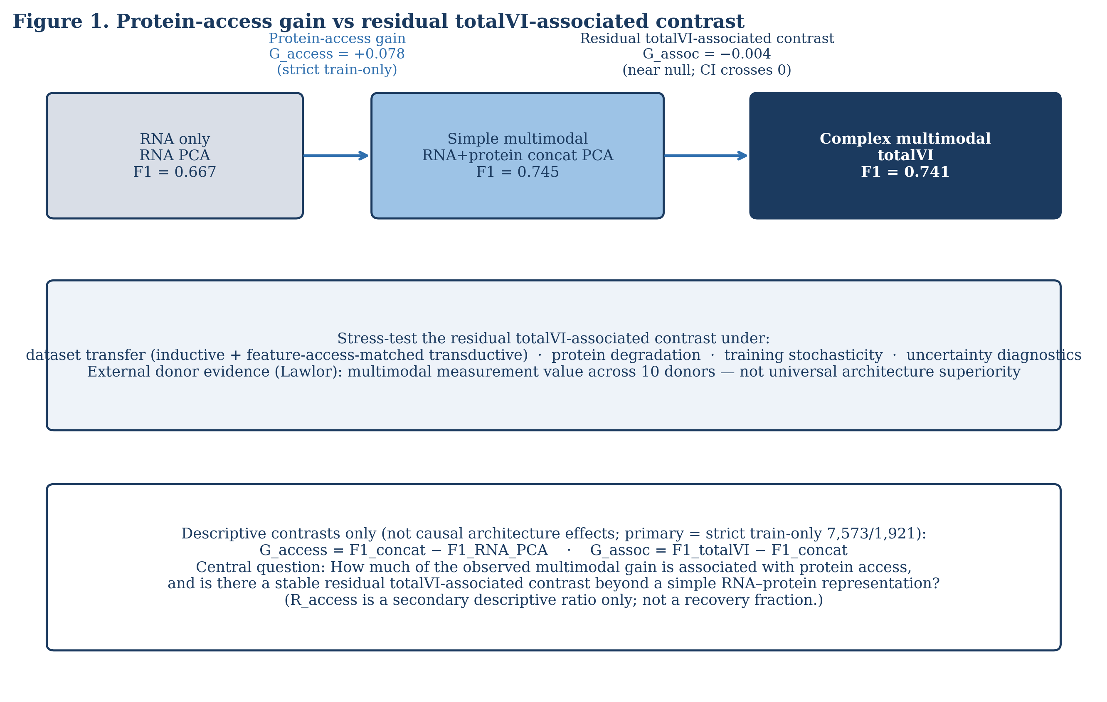
Figure 1.** Study logic for separating protein-access gain from residual totalVI-associated contrast under a strict train-only protocol (7,573/1,921). RNA PCA defines the RNA-only reference, concatenated RNA-protein PCA defines the simple multimodal feature-access reference, and totalVI defines the complex multimodal representation under study. Central question: how much of the observed multimodal gain is associated with protein access, and how much residual improvement remains for totalVI beyond a simple RNA-protein representation? The quantities G_access, G_assoc, and R_access are descriptive contrasts, not causal architecture effects.
Figure 2. Internal development-cohort contrasts under strict train-only information access with bootstrap intervals. RNA PCA reached 0.667, concat reached 0.745, scVI_matched reached 0.709, and totalVI reached 0.741. Cell-level conditional paired-bootstrap 95% intervals with n=10000 were G_access=+0.078 [0.042, 0.131] and G_assoc=-0.004 [-0.060, 0.030] (prop>0=0.355). The G_assoc interval crossed zero, consistent with a near-null residual contrast. These intervals are conditional cell-resampling intervals, not biological confidence intervals.
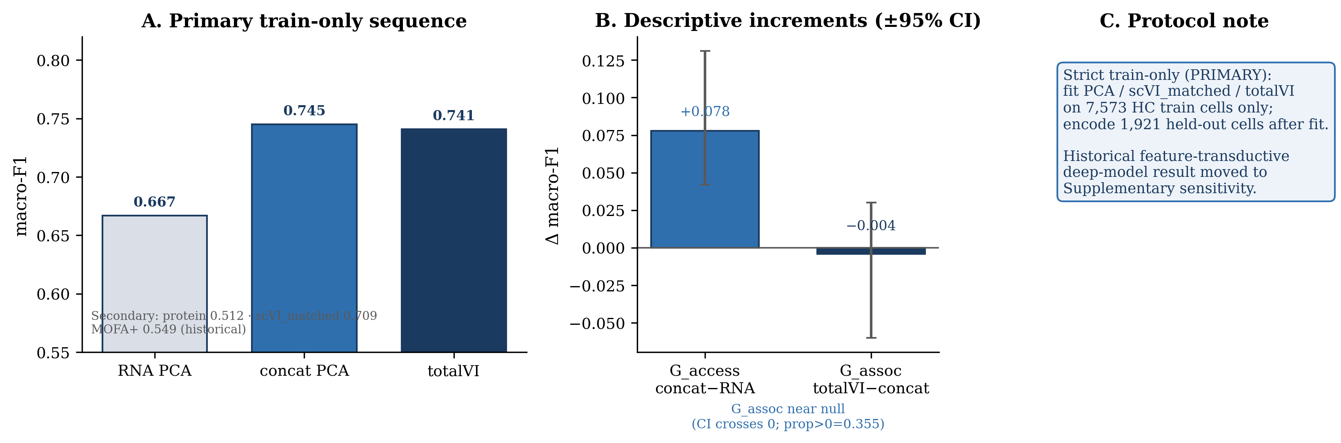
Figure 2.** Internal development-cohort contrasts under strict train-only information access with bootstrap intervals. RNA PCA reached 0.667, concat reached 0.745, scVI_matched reached 0.709, and totalVI reached 0.741. Cell-level conditional paired-bootstrap 95% intervals with n=10000 were G_access=+0.078 [0.042, 0.131] and G_assoc=-0.004 [-0.060, 0.030] (prop>0=0.355). The G_assoc interval crossed zero, consistent with a near-null residual contrast. These intervals are conditional cell-resampling intervals, not biological confidence intervals.
Figure 3. compares source-only inductive concat, the feature-access-matched transductive concat control, scVI_matched, and totalVI across Directions A and B.
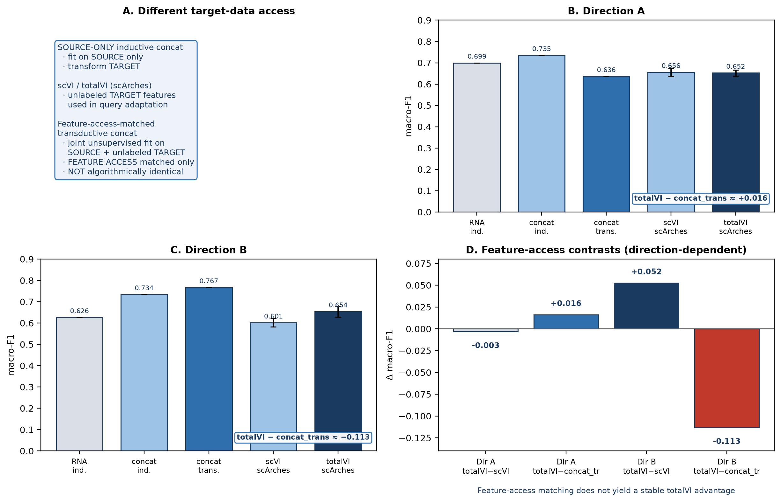
Figure 3.** Transfer comparison across source-only inductive concat, feature-access-matched transductive concat control, scVI_matched, and totalVI. Inductive concat reached 0.735/0.734, feature-access transductive concat reached 0.636/0.767, scVI_matched reached 0.656/0.601, and totalVI reached 0.652/0.654 for Directions A/B (Directions A/B; computational seeds for deep models as in Methods). totalVI minus transductive concat was approximately +0.016 in Direction A and -0.113 in Direction B. The feature-access control matches unlabeled target features but not the learning objective or adaptation algorithm of scArches.
The source-only inductive concat baseline remained strong in both transfer directions, reaching 0.735 in Direction A and 0.734 in Direction B. The feature-access-matched transductive concat control reached 0.636 in Direction A and 0.767 in Direction B. This feature-access control used source plus unlabeled target features for unsupervised representation fitting, while source labels alone were used for classifier training.
scVI_matched reached 0.656 in Direction A and 0.601 in Direction B. totalVI reached 0.652 in Direction A and 0.654 in Direction B. Thus, totalVI was near scVI_matched in Direction A, while Direction B showed a totalVI-scVI_matched difference of +0.052 with 19/20 seeds favoring totalVI.
The comparison against the feature-access control changed the interpretation. totalVI minus transductive concat was approximately +0.016 in Direction A but -0.113 in Direction B. Matching unlabeled target feature access therefore did not yield a stable totalVI advantage. The control matches unlabeled target features but not the learning objective or adaptation algorithm of scArches, so this result should be read as a feature-access-matched stress test, not as proof that the two procedures are otherwise equivalent.
Protein degradation progressively narrowed residual totalVI-associated advantage
Protein degradation asked whether the residual totalVI-associated contrast persisted when antibody-derived signal was corrupted. Figure 4. summarizes training-time degradation with retraining and post-adaptation target-only degradation.
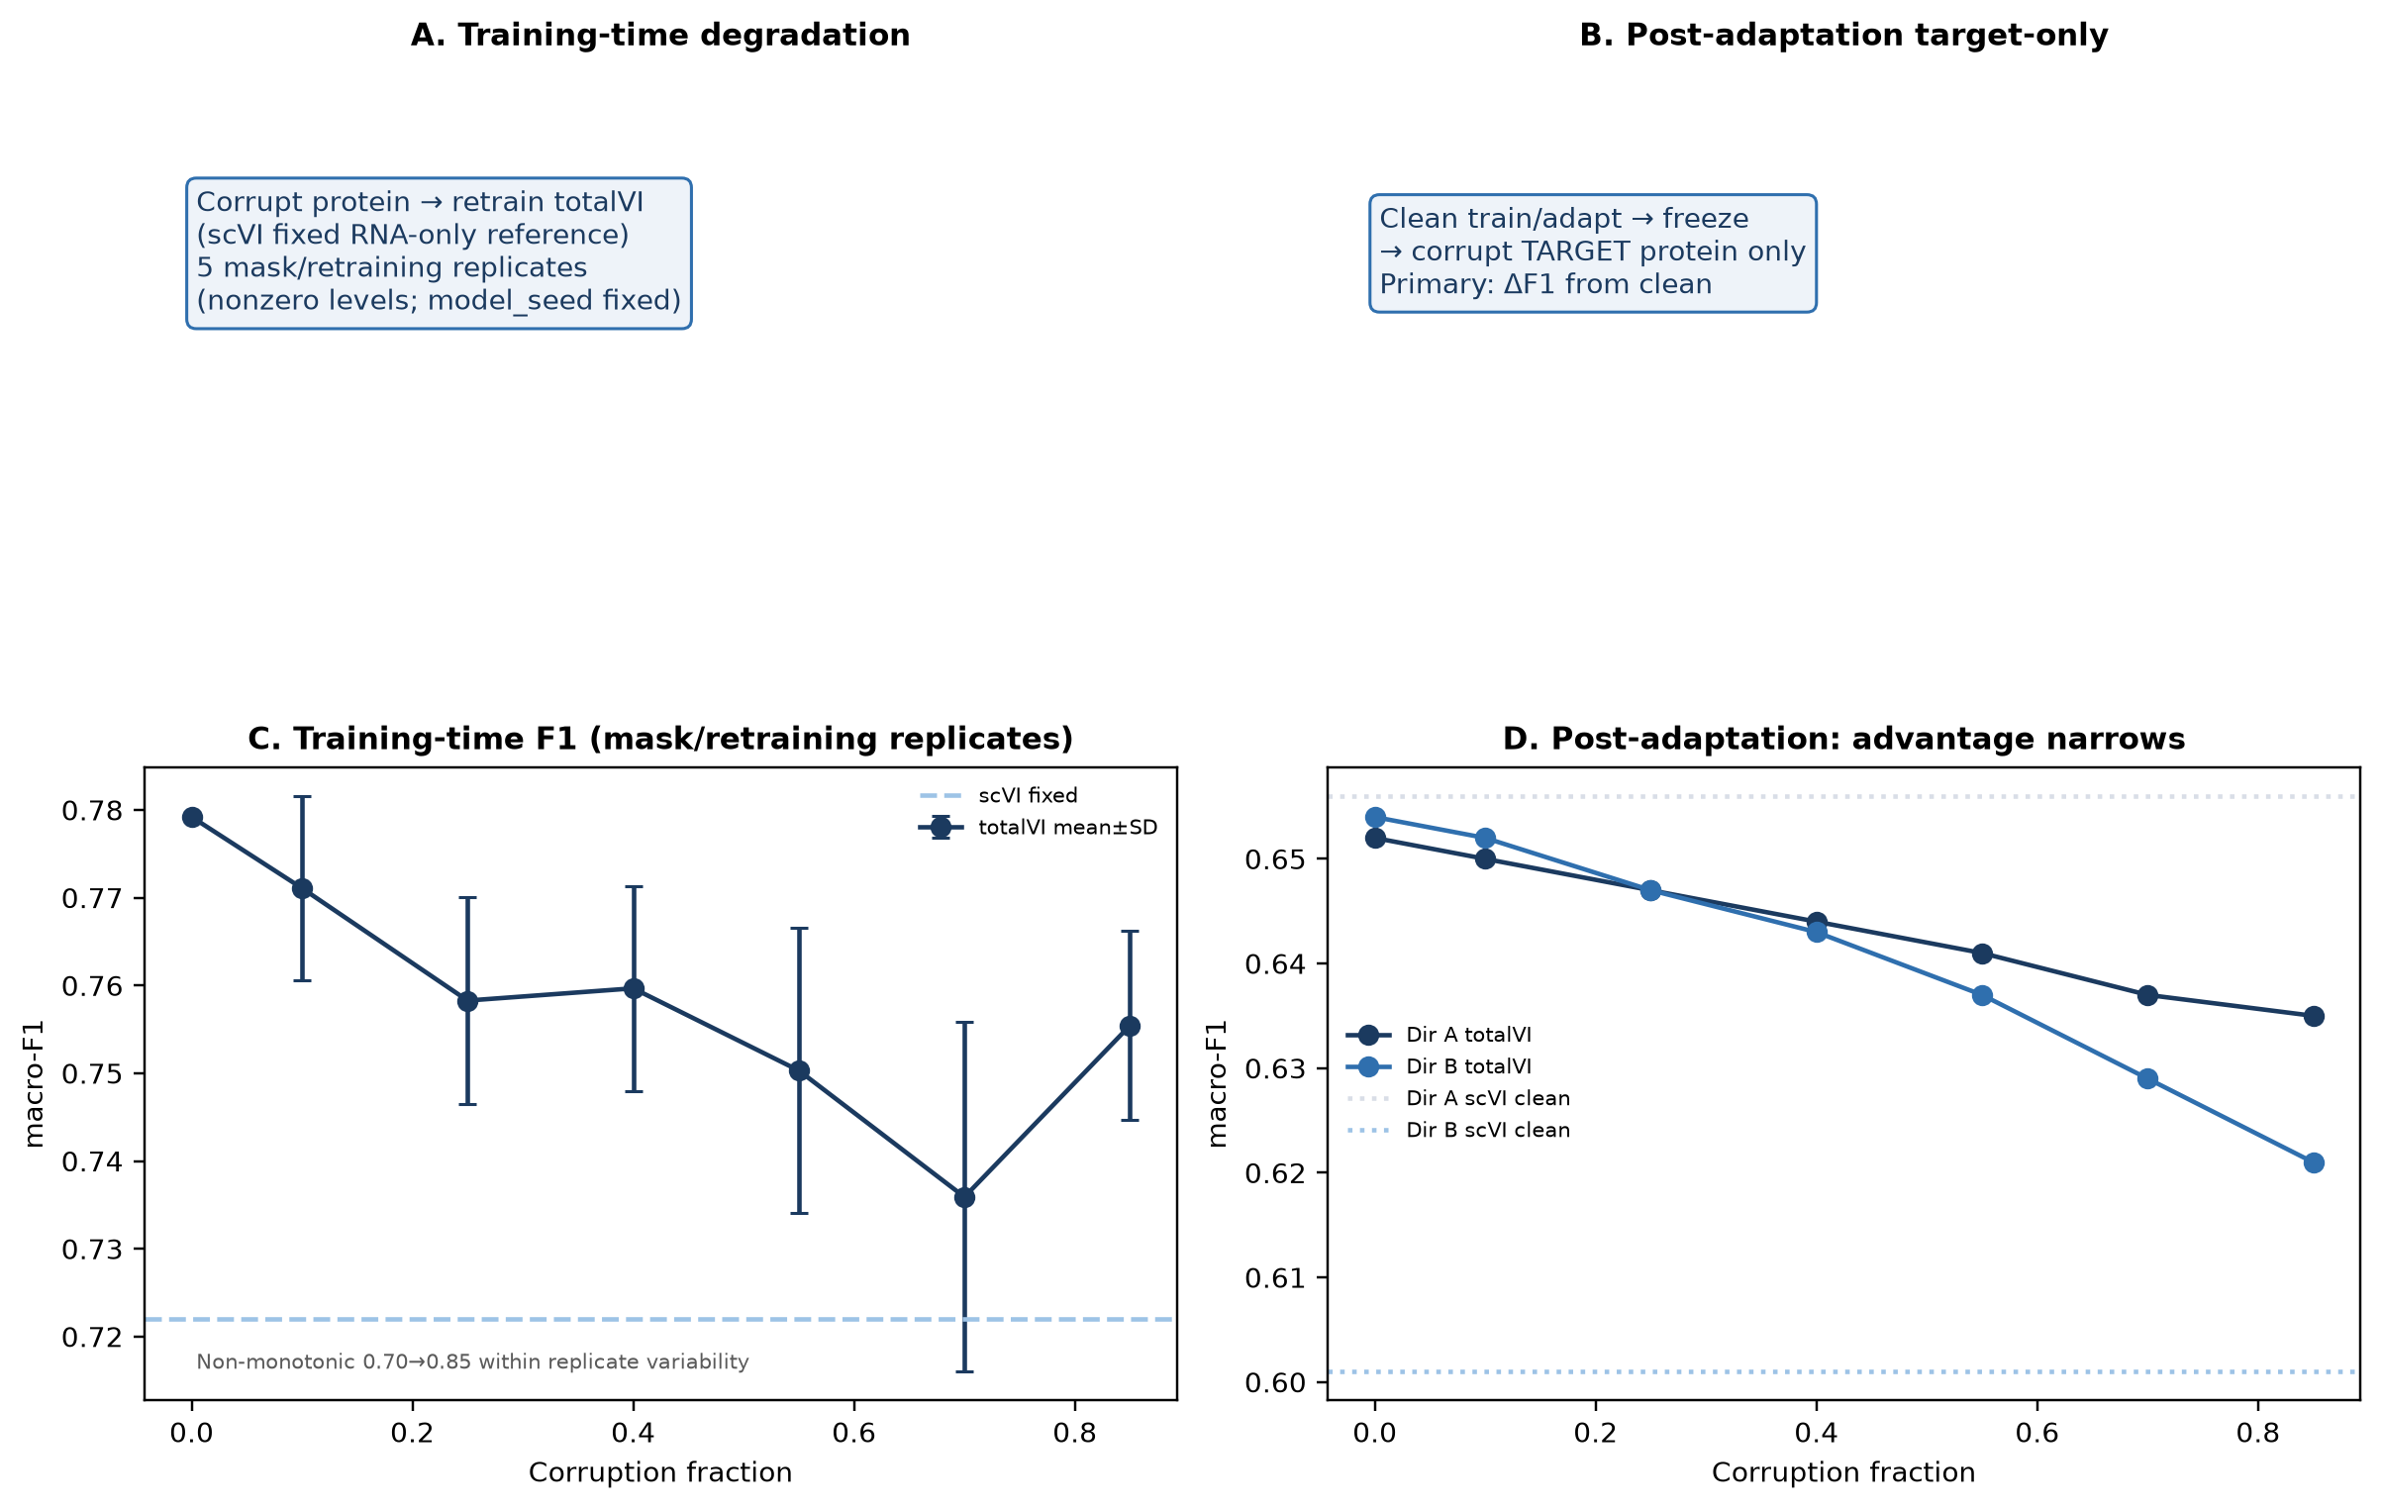
Figure 4.** Protein degradation experiments. Training-time degradation shows mean±SD across five mask/retraining replicates at nonzero corruption levels, with model_seed fixed at 0 and a single clean run at 0.00. Values were 0.779, 0.771±0.010, 0.758±0.012, 0.760±0.012, 0.750±0.016, 0.736±0.020, and 0.755±0.011 across increasing corruption. High-corruption non-monotonicity is interpreted as within mask/retraining variability. Post-adaptation Direction B totalVI declined from 0.654 to 0.621, with clean scVI_matched at 0.601.
Training-time degradation corrupted nonzero protein entries before totalVI training and retrained totalVI at each nonzero corruption level using five mask/retraining replicates with model_seed fixed at 0. The clean point was a single uncorrupted run. Mean macro-F1 values were 0.779 at 0.00 (n=1), 0.771±0.010 at 0.10, 0.758±0.012 at 0.25, 0.760±0.012 at 0.40, 0.750±0.016 at 0.55, 0.736±0.020 at 0.70, and 0.755±0.011 at 0.85. The fixed clean scVI_matched reference was 0.722.
The high-corruption rebound should be interpreted cautiously. Non-monotonic high-corruption means were within mask/retraining variability and are not evidence of improved performance under more severe corruption. The main pattern was a gradual narrowing of the residual totalVI-associated advantage as protein signal quality degraded.
Post-adaptation target-only degradation showed the same direction in the transfer setting where totalVI most clearly exceeded scVI_matched. Direction B totalVI declined from 0.654 to 0.621 at the highest corruption level, while clean scVI_matched was 0.601. Thus, the totalVI advantage over the clean RNA-only reference narrowed but did not disappear in that setting.
Uncertainty diagnostics identified distinct forms of reliability loss
Uncertainty diagnostics were used to characterize reliability loss rather than to define a new primary performance endpoint. Figure 5. shows classifier predictive uncertainty, latent posterior variance, risk-coverage behavior, and training stochasticity summaries.
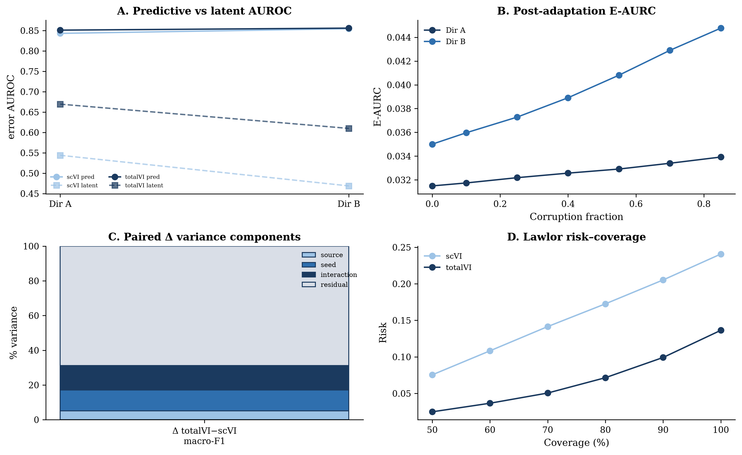
Figure 5.** Uncertainty diagnostics, training stochasticity, and selective prediction. Classifier predictive uncertainty ranked errors with AUROC around 0.84-0.86 internally, while latent posterior variance measured representation-level dispersion. Risk-coverage metrics worsened under Direction B protein corruption, and selective prediction reduced retained-cell error while producing cell-type-dependent retention. Stochasticity summaries show substantial residual run-level variation for small contrasts.
Classifier predictive uncertainty was U=1-max_k p_k, where p_k is the logistic-regression probability for class k. This score ranked classification errors well in PBMC transfer, with predictive error AUROC values around 0.84-0.86. Under Direction B target-only protein corruption, predictive AUROC declined mildly from 0.856 to 0.841, indicating that confidence still ranked errors but became less informative as protein inputs degraded.
Latent posterior variance measured representation-level dispersion, not formal epistemic uncertainty. Direction A latent error AUROC was 0.544±0.054 for scVI_matched and 0.669±0.021 for totalVI. Direction B latent error AUROC was 0.469±0.075 for scVI_matched and 0.610±0.038 for totalVI. Under Direction B corruption, latent AUROC increased from 0.610 to 0.627 while predictive AUROC and risk-coverage summaries worsened. This divergence shows that the two uncertainty signals capture different behavior.
Risk-coverage metrics showed practical reliability loss under degradation. In Direction B, full AURC increased from 0.060 to 0.079, pAURC_[0.5,1.0] increased from 0.112 to 0.144, and E-AURC increased from 0.0350 to 0.0448. Negative log likelihood and Brier score also worsened, whereas expected calibration error was less sensitive.
Training stochasticity limited the precision of small residual totalVI-associated contrasts
Training stochasticity was evaluated because small residual contrasts can be difficult to distinguish from run-level variation. A balanced design varied source subsets, model seeds, and run replicates, and variance components were estimated using method-of-moments expected mean squares.
For scVI_matched macro-F1, the variance fractions were source 2.31%, seed 0.00%, source-by-seed interaction 35.45%, and residual run-level variation 62.23%. For totalVI, the corresponding fractions were source 0.00%, seed 5.62%, interaction 3.24%, and residual 91.13%. For the paired totalVI minus scVI_matched contrast, the fractions were source 5.09%, seed 12.04%, interaction 14.11%, and residual 68.75%.
These summaries explain why small residual totalVI-associated contrasts should be interpreted with repeated-run context. Direction A transfer was effectively near null, and the internal strict train-only G_assoc bootstrap interval crossed zero with a near-null/negative point estimate. Direction B totalVI versus scVI_matched was more consistent because the mean difference was larger and 19/20 seeds favored totalVI, but the feature-access control still showed that residual totalVI advantage was not stable across transfer directions.
Selective prediction reduced error but introduced cell-type-dependent retention
Selective prediction retained cells with lower uncertainty and deferred cells with higher uncertainty. This reduced error among retained cells, especially when classifier predictive uncertainty was used, but it also changed the retained cell-type composition.
At 50% coverage, retention coefficients of variation were approximately 0.88-1.02 in PBMC transfer and approximately 0.57-0.59 in Lawlor donor validation. These values indicate that low-uncertainty retained cells were not a compositionally neutral subset of the evaluated cells.
The practical implication is that risk-coverage curves should be reported together with retention by cell type. Selective prediction can support review workflows, but deferring uncertain cells may preferentially remove rare, transitional, or marker-ambiguous populations. Retained-set accuracy alone would overstate reliability if the retained population shifts away from difficult biological classes.
External donor validation confirmed multimodal information value under protein-gated labels
The Lawlor validation used 10 biological donors and author labels in the labeled subset [13]. Figure 6. presents donor-level validation together with simple protein-aligned baselines.
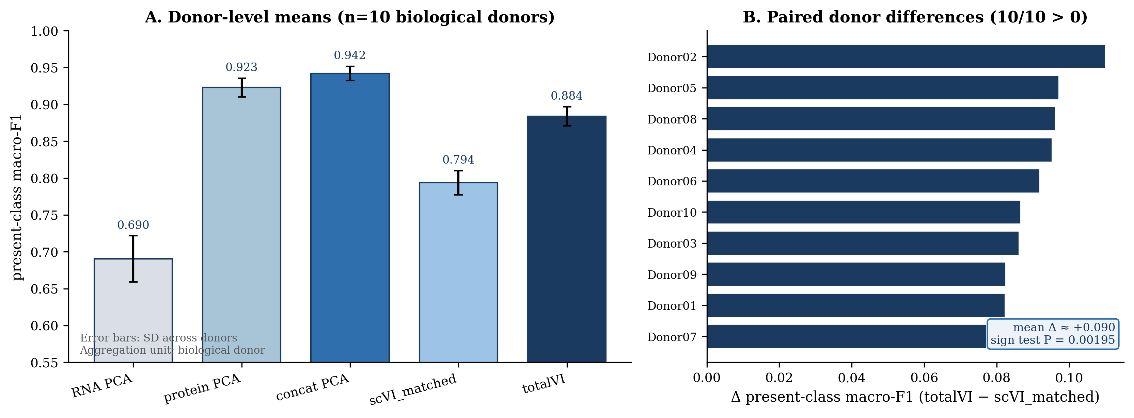
Figure 6.* Lawlor donor-level external validation (aggregation unit = biological donor, n=10). Panel A shows donor-mean ± SD present-class macro-F1 for RNA PCA (0.690), protein PCA (0.923), concat (0.942), scVI_matched (0.794), and totalVI (0.884). Panel B shows paired donor differences totalVI-scVI_matched (10/10 positive; exact two-sided sign test P*=0.00195; mean Δ≈+0.090). Protein-aligned PCA baselines exceed totalVI under protein-gated labels. Error bars are across-donor SDs, not biological confidence intervals for a super-population of donors.
All 10 donors showed a positive totalVI-minus-scVI_matched difference in present-class macro-F1 (exact two-sided sign test, P=0.00195; mean Δ≈+0.090, median≈0.089, SD≈0.010). Donor-mean deep-representation scores were 0.794 for scVI_matched and 0.884 for totalVI. Latent consistency favoring totalVI over scVI_matched was 38/50 across matched fold-by-seed computational comparisons; these are computational comparisons, not biological replicates.
On the same donor aggregation unit (n=10), present-class macro-F1 donor means were 0.690 for RNA PCA, 0.923 for protein PCA, and 0.942 for concatenated RNA-protein PCA. Protein PCA and concat therefore exceeded totalVI under protein-gated labels when compared at the donor level. Because the Lawlor labels were protein-gated, this result is consistent with strong label-modality alignment rather than universal totalVI superiority. The donor analysis therefore supports multimodal measurement value across donors under protein-gated labels, while reinforcing the need to compare complex models with simple multimodal baselines at a matched aggregation unit.
Discussion
Access to paired protein measurements accounted for a substantial part of the observed multimodal performance improvement. Under strict train-only evaluation, the residual totalVI-associated contrast relative to a simple RNA-protein representation was near null and imprecisely estimated, while performance contrasts in other settings remained strongly dependent on evaluation context.
The strict train-only analysis sharpened the distinction between modality access and representation strategy. The protein-access contrast remained essentially unchanged (G_access=+0.078 with a bootstrap interval entirely above zero), whereas the residual totalVI-associated contrast moved from a small positive estimate under an earlier feature-transductive deep-model analysis (G_assocapprox.+0.034) to a near-null estimate under strict train-only fitting (G_assoc=-0.004 [-0.060, 0.030]). This pattern indicates that held-out feature access can materially alter apparent representation-level advantages and reinforces the need for explicitly matched information-access controls. It does not imply that totalVI is generally inferior to concat, nor that complex multimodal models are unnecessary; rather, no stable residual totalVI-associated advantage over concat was observed in the primary internal analysis. The earlier transductive comparison is retained only as a Supplementary information-access sensitivity.
Transfer analysis showed why this caution is necessary. Source-only inductive concat remained strong in both directions. totalVI exceeded scVI_matched consistently in Direction B but not Direction A. More importantly, totalVI did not retain a stable advantage over the feature-access-matched transductive concat control. Because this control matches unlabeled target features but not the learning objective or adaptation algorithm of scArches, it does not prove algorithmic equivalence; it does show that feature access alone can change the apparent residual contrast.
Protein degradation further constrained the interpretation. Training-time corruption gradually narrowed totalVI performance relative to the clean setting, and Direction B post-adaptation degradation reduced totalVI from 0.654 to 0.621. The non-monotonic high-corruption training-time mean was within mask/retraining variability and should not be described as evidence that more severe corruption improves performance.
Uncertainty diagnostics identified different forms of reliability loss. Classifier predictive uncertainty ranked errors and supported selective prediction, while latent posterior variance reflected representation-level dispersion. Because these measures can move differently under degradation, neither should be treated as a complete reliability measure. Selective prediction reduced retained-cell error but introduced cell-type-dependent retention, making coverage composition a necessary companion to risk summaries.
Training stochasticity limited the precision of small residual totalVI-associated contrasts. Residual run-level variation was large in the balanced replication design, especially for totalVI and paired totalVI-scVI_matched contrasts. This does not invalidate larger and direction-consistent effects, but it argues against overinterpreting small differences without matched baselines, repeated runs, and interval estimates.
Lawlor donor validation strengthened the conclusion that paired proteins can be highly valuable across biological donors. The totalVI-scVI_matched donor contrast favored totalVI in all 10 donors, but donor-mean protein PCA and concat exceeded totalVI under protein-gated labels. This is not a contradiction; it shows that when labels depend heavily on surface markers, direct protein-aligned representations can be extremely strong.
Several limitations remain. The internal and transfer analyses are PBMC-focused and classification-centered; conclusions should not be generalized to trajectory inference, perturbation response, or rare-state discovery without testing. Antibody panels are limited (14 shared internal proteins; 12 matched Lawlor proteins). Only one primary complex multimodal model (totalVI) was stress-tested against concat under matched train-only information access, with MOFA+ retained only as a historical secondary baseline; additional multimodal architectures were not newly trained in this revision. Lawlor labels are protein-gated, and only 10 biological donors are available. The feature-access-matched concat control does not reproduce scArches’ learning objective. Entry-wise zero-masking approximates protein degradation; an exploratory PCA-only marker-channel dropout sensitivity is reported in Supplementary Results and does not test totalVI under panel failure. Bootstrap intervals are conditional cell-level intervals, not biological confidence intervals. Uncertainty scores do not guarantee biological label correctness, and selective prediction changes retained cell-type composition. An earlier internal deep-model analysis used unlabeled held-out features during unsupervised representation learning (feature-transductive fitting); after this was identified, the primary analysis was replaced by a strict train-only evaluation, and the earlier result is retained only as an information-access sensitivity. This comparison illustrates that representation-learning access to evaluation features can materially affect apparent model contrasts; it is a methodological distinction between transductive unsupervised representation learning and strict train-only representation learning, not evidence of label leakage. These limits make the conclusion narrower but more reliable: protein access is a strong contributor, while residual totalVI-associated contrast must be demonstrated in each evaluation context under explicitly stated information-access conditions.
Conclusion
Paired protein access produced a substantial and resampling-stable improvement in the evaluated CITE-seq setting. Under strict train-only fitting, the residual totalVI-associated contrast relative to a simple RNA-protein representation was near null and imprecisely estimated. Together with transfer and feature-access-matched analyses, these findings show that apparent multimodal representation gains should be interpreted relative to simple multimodal baselines and explicit information-access conditions.
Methods
Datasets and biological evaluation units
Internal PBMC development and transfer. Analyses used the public scvi-tools / 10x Genomics CITE-seq example files `pbmc_10k_protein_v3.h5ad` and `pbmc_5k_protein_v3.h5ad`, downloaded from the scverse exampledata URLs with a YosefLab/scVI-data GitHub fallback (project `config/config.yaml`). No GEO/SRA accession was present in local metadata, so none is claimed. Datasets were loaded separately and combined by inner join on shared genes and proteins (project loader; the scvi-tools helper was not used as the primary API because it silently intersects features and can fill missing proteins with zero). The combined inner object contained 10,849 cells, 15,792 shared genes, and 14 shared proteins (PBMC10k 6,855 cells; PBMC5k 3,994 cells). Batch labels were dataset identity (`batch` ∈ {PBMC10k, PBMC5k}).
Quality control. Project configuration sets `additional_cell_filter: false`. No additional minimum/maximum gene, count, mitochondrial-fraction, or doublet filters were applied beyond those already present in the downloaded processed objects (documented as inherited from totalVI-style reproducibility preprocessing of the source files). Gene and protein panels for modeling used the shared inner-join universe; highly variable gene selection for PCA baselines is described below and is distinct from VAE training, which used the full shared gene count matrix.
Development evaluation set. Primary internal contrasts used 9,494 high-confidence cells (`annotation_tier_l2 == "high"`, confidence threshold 0.85). Macro-F1 on L2 labels was the primary metric.
Lawlor external cohort. External validation used the Lawlor blood CITE-seq dataset [13] (HCA `efea6426-510a-4b60-9a19-277e52bfa815`; ENA `PRJEB40376` / `ERP124005`). Verified object dimensions after formal preparation: 16,175 singlets; 5,207 author-labeled cells; 12,776 harmonized genes shared with the internal universe; 12 matched proteins; 10 biological donors. Gene identifiers were mapped from Ensembl IDs to gene symbols intersecting the current universe; 55 duplicated symbols were aggregated by summing counts across Ensembl rows. Protein features were alias-harmonized to the internal panel names (e.g., PD-1 ↔ CD279). The labeled evaluation subset retained the seven primary author classes used throughout (B, CD14_Mono, CD4T_Mem, CD4T_Naive, CD8T_Mem, CD8T_Naive, NK). The biological unit was the donor (n = 10). Author labels in the labeled subset are protein-gated. Batch covariate for deep models was sequencing lane (`run_identifier` / `batch`); donor was not supplied as a batch key. Primary donor metric: present-class macro-F1 (classes absent in a donor are excluded for that donor).
Annotation provenance and label-independence audit
Internal development labels were generated through an RNA-only Seurat v4 reference annotation pathway. An RNA-only re-annotation audit agreed with the stored high-confidence labels on all 9,494 evaluated cells (agreement = 1.0). This rules out the simple explanation that the internal protein-access advantage was produced by defining labels from the same protein features used as predictors. It does not independently establish biological correctness of those labels.
Lawlor author labels are protein-gated; strong protein PCA / concat performance is therefore expected under label-modality alignment and is not evidence of universal representation superiority.
Feature preprocessing and PCA representations
Unless noted, unsupervised transforms for internal evaluation were fit on training high-confidence cells only and applied to held-out cells. For transfer, inductive transforms were fit on source cells only.
RNA PCA. Select 2,000 highly variable genes (`scanpy` `flavor="seurat_v3"`); normalize to 1×10⁴ counts per cell; `log1p`; z-score with clipping at ±10; PCA with 10 components (`random_state=0`). (Project `config.yaml` lists `n_top_genes: 4000` for historical VAE-related settings; the primary PCA path hard-codes 2000 and does not read that config value.)
Protein PCA. Centered log-ratio (CLR) transform on raw protein counts with pseudocount 1.0; z-score using training/source mean and sample SD (`ddof=1`); PCA with 10 components.
Concatenated RNA-protein PCA. Concatenate 10 RNA PCs and 10 protein PCs; apply `StandardScaler` fit on training/source concatenated coordinates only (inductive). In the feature-access-matched transductive control, unsupervised RNA/protein transforms, PCA, and final scaling were fit on source + unlabeled target features jointly.
MOFA+. Frozen multimodal factor-analysis baseline on paired RNA-protein inputs (secondary comparator).
Deep representations (scVI_matched and totalVI)
Unless otherwise noted, reported internal and transfer RNA-only deep results use capacity-matched scVI (`scVI_matched`), not the project’s PHASE-3 scVI default (`n_hidden=128`, `n_layers=1`, `gene_likelihood=zinb`, `dropout_rate=0.1`).
scVI_matched: `SCVI` (scvi-tools 1.3.3); `n_latent=20`, `n_hidden=256`, `n_layers=2`, `dropout_rate=0.2`, `gene_likelihood="nb"`, `dispersion="gene"`, `latent_distribution="normal"`, `use_observed_lib_size=True`; `setup_anndata` with `layer="counts"`, `batch_key="batch"`. Training: `max_epochs=200`, `early_stopping=True` (monitor `elbo_validation`, patience 45, mode `min`), `train_size=0.9`, `batch_size=256`. Learning rate was not overridden in code (scvi-tools TrainingPlan default).
totalVI: `TOTALVI`; `n_latent=20`, `n_hidden=256`, `n_layers_encoder=2`, `n_layers_decoder=1`, encoder/decoder dropout 0.2, `gene_likelihood="nb"`, `gene_dispersion="gene"`, `protein_dispersion="protein"`, `latent_distribution="normal"`; protein key `protein_expression` (14 proteins). Training additionally used `lr=4e-3` and `reduce_lr_on_plateau=True`, with the same epoch/early-stopping/batch settings as above.
scArches transfer. For each direction and seed: train source model → `prepare_query_anndata` / `load_query_data` → unsupervised query adaptation (`query_max_epochs=200`, `weight_decay=0.0`) → encode source and target with the adapted model → fit logistic regression on post-adaptation source coordinates → score target. Target labels were not used in fitting. This is unsupervised transductive adaptation, not fully inductive prediction.
Downstream classification
All primary representation comparisons used `sklearn.linear_model.LogisticRegression` with `max_iter=2000`, `solver="lbfgs"`, `random_state` equal to the evaluation seed (development seed 0). `C`, `class_weight`, and `multi_class` were left at scikit-learn 1.5.2 defaults (`C=1.0`, `class_weight=None`, multinomial behavior under `lbfgs`). The same classifier strategy was used across representations so that comparisons focus on representation quality.
Internal split and leakage controls
A stratified train/test split (`test_fraction=0.20`, stratify by `batch`, seed 0) was assigned first on the combined 10,849-cell object, yielding exact partition sizes 8,679 train / 2,170 test. High-confidence restriction (`annotation_tier_l2 == "high"`) was applied second within that split, giving the development evaluation cohorts 7,573 train / 1,921 test (9,494 HC cells total).
Primary internal protocol (strict train-only; matched information access). RNA PCA, protein PCA, concat PCA, scVI_matched, and totalVI unsupervised fits used only the 7,573 high-confidence training cells. Held-out evaluation cells (1,921) were encoded after fitting using frozen transforms/weights (PCA transform; scVI/totalVI `get_latent_representation` with transferred AnnData setup and no query adaptation training). Classifier training used training labels only; held-out labels were used only for scoring. Verified hyperparameters were preserved (`n_latent=20`, matched capacity, `max_epochs=200`, early-stopping patience 45, `batch_size=256`, totalVI `lr=4e-3`, etc.). Artifacts: `results/manuscript_submission_revision/strict_train_only/`.
Supplementary sensitivity (historical feature-transductive deep models). An earlier pipeline trained scVI_matched/totalVI on all 10,849 cells’ features while PCA remained train-only; that unequal-access evaluation is retained only as a Supplementary information-access sensitivity (previous G_assoc≈+0.034 [-0.012, 0.073]; totalVI 0.779) and is not the primary internal result.
Transfer exception. Feature-access-matched transductive concat intentionally uses unlabeled target features for unsupervised fitting only; target labels remain withheld until scoring.
Protein-access and residual totalVI-associated contrasts
G_access = F1_concat - F1_RNA_PCA,quad G_assoc = F1_totalVI - F1_concat,quad Gap_total = F1_totalVI - F1_RNA_PCA,quad R_access = G_access / Gap_total.
G_assoc is a descriptive residual totalVI-associated contrast, not a causal architecture effect: totalVI and concatenated PCA differ in objective, optimization, and representation class. R_access is a secondary descriptive ratio only. Because numerator and denominator are recomputed jointly across bootstrap resamples, R_access is not constrained to [0,1] and is not a recovery fraction, causal mediation proportion, variance-explained quantity, or mechanistic decomposition. Under the primary strict train-only analysis, R_access was approximately 1.05 because the concat point estimate slightly exceeded totalVI; it was therefore not emphasized in the Abstract or Figure 1.
Primary (strict train-only) point estimates: RNA PCA 0.667, concat 0.745, totalVI 0.741; G_access=+0.078, G_assoc=-0.004, Gap_total=+0.074; secondary descriptive R_accessapprox.1.05.
Conditional paired bootstrap
Primary intervals used a cell-level conditional paired bootstrap (B = 10,000; seed 20260923) over held-out cells with fixed prediction vectors for RNA PCA, concat, and totalVI. Each replicate resampled cells with replacement (global, not class-stratified), recomputed macro-F1 and contrasts, and formed percentile 2.5%/97.5% intervals. These are conditional on the evaluated cells and prediction vectors—not donor-level, cohort-generalization, or biological confidence intervals. A class-stratified paired-bootstrap sensitivity (within-class resampling) is reported in Supplementary Results; it does not replace the primary analysis.
Bidirectional transfer and feature-access-matched control
Direction A: PBMC10k→PBMC5k; Direction B: PBMC5k→PBMC10k.
1. Source-only inductive concat: fit HVG/RNA transform, RNA PCA, protein CLR/z/PCA, concat scaling, and classifier on source; apply unchanged to target. 2. Feature-access-matched transductive concat: fit unsupervised steps on source + unlabeled target features; classifier on source labels only. Matches feature access, not scArches’ objective or neural adaptation. 3. scVI_matched / totalVI + scArches as above (20 seeds for primary summaries).
Protein degradation
Training-time: originally nonzero protein entries randomly set to zero (preexisting zeros unchanged) at fractions 0.00, 0.10, 0.25, 0.40, 0.55, 0.70, 0.85; totalVI retrained; five mask/retraining replicates at nonzero levels with `model_seed=0`; clean level n=1. Means are reported without forcing monotonicity; high-corruption rebound is interpreted within mask/retraining variability.
Post-adaptation: clean source training and clean query adaptation → classifier on clean post-adaptation source coordinates → freeze classifier → corrupt target proteins only → re-infer target → evaluate. Cell-type-specific Direction B results are summarized in Supplementary Results.
Marker-channel dropout (sensitivity): entire protein channels zeroed before protein PCA / concat on the development cohort (totalVI not retrained in this sensitivity); see Supplement.
Uncertainty, calibration, and selective prediction
Predictive uncertainty: U_{mathrm{pred},i}=1-max_k p(y_i=kmid z_i) from the downstream logistic regression (not totalVI posterior uncertainty). Latent posterior dispersion: mean posterior variance across latent dimensions d (representation-level dispersion; not formal epistemic uncertainty). Diagnostics included error-detection AUROC/AUPRC, NLL, multiclass Brier score, ECE (equal-frequency and equal-width; equal-frequency treated as primary where both reported), full AURC, pAURC_[0.5,1.0], and E-AURC. Selective prediction ordered cells by increasing uncertainty and retained the lowest-uncertainty fraction; primary risk used accuracy-based risk among retained cells. Macro-F1 and balanced accuracy versus coverage are reported as Supplementary sensitivities because the primary selective metric is accuracy-based.
Training stochasticity and variance decomposition
Balanced computational design: 5 source subsets × 5 model seeds × 2 run replicates (Direction A focus in PHASE 12A), with paired Δ = totalVI - scVI_matched. For representation a, outcomes were modeled as Y_ijr^{(a)}=mu^{(a)}+S_i^{(a)}+G_j^{(a)}+(SG)_{ij}^{(a)}+varepsilon_ijr^{(a)}, and paired differences as Delta_ijr=Y_ijr^{(totalVI)}-Y_ijr^{(mathrm{scVI_matched})}. Here source S is computational source-subset variation, seed G is computational model-seed variation, (SG) is the source×seed interaction, and residual arepsilon is run-level computational variation; none are biological variance components. Variance fractions were estimated by method-of-moments expected mean squares.
Lawlor donor-level external validation
Five deterministic folds held out two donors each so that every donor was a target exactly once; 10 computational seeds per deep-model fold yielded 50 matched scVI_matched-totalVI fold×seed comparisons (computational consistency, e.g. latent AUROC 38/50). Donor-level present-class macro-F1 used seed-averaged within-donor scores for deep models. Simple baselines (RNA/protein/concat PCA) used source-donor-only unsupervised fits and were scored per target donor, then summarized across the same 10 biological donors. Preferred main-text / Figure 6 aggregation unit is therefore the donor for all five representations. Donor-mean present-class macro-F1 values were 0.690 (RNA PCA), 0.923 (protein PCA), 0.942 (concat), 0.794 (scVI_matched), and 0.884 (totalVI). Paired totalVI-scVI_matched donor Δ mean ≈ +0.090 (median ≈ 0.089; SD ≈ 0.010; IQR ≈ 0.013; min/max ≈ +0.077/+0.110; 10/10 donors; exact two-sided sign test P=0.00195). Supplementary Results also retain historical fold-mean PCA aggregates (protein ≈ 0.927; concat ≈ 0.945) for continuity, but side-by-side numerical claims in the main text use donor-level means.
Software and reproducibility
Analyses used Python 3.11.7, scvi-tools 1.3.3, scikit-learn 1.5.2, scanpy 1.10.3, anndata 0.11.4, PyTorch 2.14.0 (verified via project environment logs / `pip show`; CUDA builds used for PHASE 10 server runs; local Mac logs report MPS rather than CUDA), numpy 1.26.4, pandas 2.2.2, scipy 1.13.1, and mofapy2 0.7.5. Environment files: `environment.yml`, `requirements.txt`. Code: https://github.com/Jizhuy/citeseq-protein-access. An immutable archival release and DOI will accompany the submitted version.
Data Availability
The Lawlor Human Cell Atlas dataset is available under HCA project efea6426-510a-4b60-9a19-277e52bfa815 and ENA accessions PRJEB40376 / ERP124005 [13].
PBMC10k/PBMC5k analyses used the public scvi-tools CITE-seq example AnnData files `pbmc_10k_protein_v3.h5ad` and `pbmc_5k_protein_v3.h5ad` (scverse exampledata URLs; YosefLab/scVI-data fallback). No GEO/SRA accession is claimed.
Code Availability
Analysis code and reproducible workflows are publicly available at https://github.com/Jizhuy/citeseq-protein-access.git. An immutable archival release and DOI will accompany the submitted version of the manuscript.
Acknowledgements
I thank Bo Li for valuable discussions, methodological suggestions, and constructive feedback on the framing and interpretation of this work.
Tables
Table 1. Internal development-cohort methods
Representation | Modalities | Macro-F1 | Role
RNA PCA | RNA | 0.667 | RNA-only reference (train-only)
Protein PCA | Protein | 0.512 | Protein-only secondary baseline (train-only)
Concatenated RNA-protein PCA | RNA + protein | 0.745 | Simple multimodal protein-access reference (train-only)
MOFA+ | RNA + protein | 0.549 | Historical secondary baseline (not re-fit train-only)
scVI_matched | RNA | 0.709 | Capacity-matched RNA-only deep (train-only)
totalVI | RNA + protein | 0.741 | Multimodal deep representation (train-only)

Table 2. Core internal contrasts with bootstrap intervals
Contrast | Definition | Estimate | 95% interval | prop>0 | Interpretation
G_access | F1_concat - F1_RNA_PCA | +0.078 | [0.042, 0.131] | 1.0 | Protein-access gain
G_assoc | F1_totalVI - F1_concat | -0.004 | [-0.060, 0.030] | 0.355 | Residual totalVI-associated contrast; near null; interval crosses zero
Gap_total | F1_totalVI - F1_RNA_PCA | +0.074 | [0.029, 0.130] | 1.0 | Total RNA-to-totalVI gap
R_access | G_access / Gap_total | ≈1.05 | [0.680, 2.304] | NA | Descriptive ratio; not constrained to [0,1]

Footnote: Primary values use the strict train-only protocol. Intervals are cell-level conditional paired-bootstrap 95% intervals with n=10000 resamples over evaluated cells. They are not biological confidence intervals. R_access is a secondary descriptive ratio only (not constrained to [0,1]; not a recovery fraction).
Table 3. Transfer contrasts
Direction | Inductive concat | Feature-access transductive concat | scVI_matched | totalVI | totalVI - scVI_matched | totalVI - transductive concat
A | 0.735 | 0.636 | 0.656 | 0.652 | -0.004 | +0.016
B | 0.734 | 0.767 | 0.601 | 0.654 | +0.052 | -0.113

Table 4. Protein degradation training-time results
Protein corruption fraction | totalVI macro-F1
0.00 | 0.779 (n=1)
0.10 | 0.771±0.010
0.25 | 0.758±0.012
0.40 | 0.760±0.012
0.55 | 0.750±0.016
0.70 | 0.736±0.020
0.85 | 0.755±0.011

Table 5. Uncertainty, stochasticity, and selective prediction
Diagnostic | Value
Predictive error AUROC in PBMC transfer | ~0.84-0.86
Direction B predictive AUROC under corruption | 0.856 to 0.841
Direction A latent AUROC, scVI_matched / totalVI | 0.544±0.054 / 0.669±0.021
Direction B latent AUROC, scVI_matched / totalVI | 0.469±0.075 / 0.610±0.038
Direction B full AURC under corruption | 0.060 to 0.079
Direction B pAURC_[0.5,1.0] under corruption | 0.112 to 0.144
Direction B E-AURC under corruption | 0.0350 to 0.0448
PBMC 50% retention CV | ~0.88-1.02
Lawlor 50% retention CV | ~0.57-0.59
scVI_matched variance fractions | source 2.31%; seed 0.00%; interaction 35.45%; residual 62.23%
totalVI variance fractions | source 0.00%; seed 5.62%; interaction 3.24%; residual 91.13%
totalVI-scVI_matched variance fractions | source 5.09%; seed 12.04%; interaction 14.11%; residual 68.75%

Table 6. Lawlor donor-level validation
Metric | Value
Biological donors (aggregation unit) | 10
totalVI - scVI_matched donor-level mean Δ | ≈+0.090
Donors favoring totalVI over scVI_matched | 10/10
Exact two-sided donor-level sign test | *P*=0.00195
RNA PCA donor-mean present-class macro-F1 | 0.690
Protein PCA donor-mean present-class macro-F1 | 0.923
Concat PCA donor-mean present-class macro-F1 | 0.942
scVI_matched donor-mean present-class macro-F1 | 0.794
totalVI donor-mean present-class macro-F1 | 0.884
Latent consistency favoring totalVI | 38/50 computational comparisons

References
1. Stoeckius M, Hafemeister C, Stephenson W, Houck-Loomis B, Chattopadhyay PK, Swerdlow H, et al. Simultaneous epitope and transcriptome measurement in single cells. Nat Methods. 2017;14:865-868. doi:10.1038/nmeth.4380.
2. Lopez R, Regier J, Cole MB, Jordan MI, Yosef N. Deep generative modeling for single-cell transcriptomics. Nat Methods. 2018;15:1053-1058. doi:10.1038/s41592-018-0229-2.
3. Gayoso A, Steier Z, Lopez R, Regier J, Nazor KL, Streets A, et al. Joint probabilistic modeling of single-cell multi-omic data with totalVI. Nat Methods. 2021;18:272-282. doi:10.1038/s41592-020-01050-x.
4. Argelaguet R, Arnol D, Bredikhin D, Deloro Y, Velten B, Marioni JC, et al. MOFA+: a statistical framework for comprehensive integration of multi-modal single-cell data. Genome Biol. 2020;21:111. doi:10.1186/s13059-020-02015-1.
5. Ashuach T, Gabitto MI, Koodli RV, Saldi GA, Jordan MI, Yosef N. MultiVI: deep generative model for the integration of multimodal data. Nat Methods. 2023;20:1222-1231. doi:10.1038/s41592-023-01909-9.
6. Gong B, Zhou Y, Purdom E. Cobolt: integrative analysis of multimodal single-cell sequencing data. Genome Biol. 2021;22:351. doi:10.1186/s13059-021-02556-z.
7. Jeong Y, Ronen J, Kopp W, Lutsik P, Akalin A. scMaui: a widely applicable deep learning framework for single-cell multiomics integration in the presence of batch effects and missing data. BMC Bioinformatics. 2024;25:257. doi:10.1186/s12859-024-05880-w.
8. Wu M, Goodman N. Multimodal generative models for scalable weakly-supervised learning. Adv Neural Inf Process Syst. 2018;31:5580-5590.
9. Luecken MD, Buttner M, Chaichoompu K, Danese A, Interlandi M, Mueller MF, Strobl DC, Zappia L, Dugas M, Colome-Tatche M, Theis FJ. Benchmarking atlas-level data integration in single-cell genomics. Nat Methods. 2022;19:41-50. doi:10.1038/s41592-021-01336-8.
10. Lotfollahi M, Naghipourfar M, Luecken MD, Khajavi M, Buttner M, Wagenstetter M, Avsec Z, Gayoso A, Yosef N, Interlandi M, et al. Mapping single-cell data to reference atlases by transfer learning. Nat Biotechnol. 2022;40:121-130. doi:10.1038/s41587-021-01001-7.
11. Guo C, Pleiss G, Sun Y, Weinberger KQ. On calibration of modern neural networks. Proc Mach Learn Res. 2017;70:1321-1330.
12. Geifman Y, El-Yaniv R. Selective classification for deep neural networks. Adv Neural Inf Process Syst. 2017;30:4878-4887.
13. Lawlor N, Nehar-Belaid D, Grassmann JDS, Stoeckius M, Smibert P, Stitzel ML, Pascual V, Banchereau J, Williams A, Ucar D. Single Cell Analysis of Blood Mononuclear Cells Stimulated Through Either LPS or Anti-CD3 and Anti-CD28. Front Immunol. 2021;12:636720. doi:10.3389/fimmu.2021.636720.
14. Hao Y, Hao S, Andersen-Nissen E, Mauck WM III, Zheng S, Butler A, Lee MJ, Wilk AJ, Darby C, Zager M, et al. Integrated analysis of multimodal single-cell data. Cell. 2021;184:3573-3587.e29. doi:10.1016/j.cell.2021.04.048.
15. Naeini MP, Cooper GF, Hauskrecht M. Obtaining well calibrated probabilities using Bayesian binning. Proc AAAI Conf Artif Intell. 2015;29:2901-2907.
16. Brier GW. Verification of forecasts expressed in terms of probability. Mon Weather Rev. 1950;78:1-3. doi:10.1175/1520-0493(1950)078<0001:VOFEIT>2.0.CO;2.

