Reliability of CITE-seq representations under distribution shift and uncertainty-guided prediction
Jizhu Yang
https://github.com/Jizhuy/robust-multiomics-integration.git
Research Manuscript | Unpublished manuscript | September 2026
Abstract
Background: CITE-seq jointly measures transcriptomes and surface proteins in the same cells, creating an opportunity to test whether RNA-only and multimodal representations remain reliable under dataset shift, protein degradation, stochastic training variation, and uncertainty-guided selective prediction.
Results: In a 9,494-cell healthy-control development cohort, paired protein information improved cell-type macro-F1. RNA PCA reached 0.666, concat PCA 0.745, scVI 0.722, and totalVI 0.779; the totalVI–scVI difference was approximately +0.057 (conditional 95% CI 0.020–0.091), and concat PCA recovered about 40% of this gain. Transfer was asymmetric: Direction A was near null, whereas Direction B showed the clearest totalVI advantage (Δ+0.052; 19/20 seeds). Inductive concat PCA remained strong (~0.73). Post-adaptation target-only protein corruption produced gradual declines, stronger in Direction B. Classifier predictive uncertainty and latent posterior variance provided complementary diagnostics. Separately, Lawlor donor-level validation (n=10) showed mean present-class ΔF1 +0.090 (10/10 donors; 0.888 vs 0.800), while protein PCA/concat baselines were higher under protein-gated author labels.
Conclusions: Paired protein information was a major contributor to improved CITE-seq representation quality. Architecture-specific effects, including totalVI advantages, were secondary and context-dependent. Reliable use therefore required stress testing under transfer, degradation, uncertainty, and donor-level validation.
Keywords: CITE-seq; single-cell multi-omics; representation learning; distribution shift; uncertainty; selective prediction; PBMC

Background
CITE-seq measures RNA expression and antibody-derived surface proteins in the same single cells, linking broad transcriptional state to targeted phenotypic markers [1]. This paired measurement is especially useful in immune profiling, where cell-type labels often depend on both gene-expression programs and surface-marker patterns. A central question is therefore not only whether protein information improves cell-type prediction, but whether that improvement remains reliable when the data distribution changes or the protein modality is degraded.
Deep generative models provide one way to learn compact representations from single-cell data. scVI models transcript counts with a variational autoencoder and provides a widely used RNA-only latent representation [2]. totalVI extends this framework to paired RNA and protein measurements and can represent CITE-seq data in a joint latent space [3]. MOFA+ and weakly supervised multimodal generative modeling provide related factor-analysis and multimodal latent-variable perspectives [4,8].
The broader single-cell integration literature includes MultiVI, Cobolt, scMaui, atlas-level integration benchmarking, and WNN-style multimodal integration as important related methods and evaluation settings rather than experimental comparators in this manuscript [5,6,7,9,14]. The present analysis focuses on a narrower question: how selected RNA-only and multimodal CITE-seq representations behave under repeated reliability stress tests. This framing separates the value of multimodal information from any claim of universal model ranking.
Reliability is broader than internal accuracy. A representation can perform well in a development cohort but fail under source-target shift, donor differences, protein measurement loss, or stochastic variation in model training. These issues are common in CITE-seq analysis because antibody panels, cell compositions, and annotation conventions can differ across studies. A useful evaluation should therefore include internal comparisons, simple baselines, transfer asymmetry, degradation experiments, repeated runs, and uncertainty diagnostics.
Transfer evaluation is particularly important because source-target direction can change the result. scArches-style adaptation allows a query dataset to be incorporated without labels, but the procedure remains unsupervised transductive adaptation rather than a fully inductive application to unseen cells [10]. Distinguishing these settings matters for interpreting how much information the model used during adaptation and how source-trained classifiers are evaluated on target cells.
Uncertainty was included because representation failures are often not visible from macro-F1 alone. Classifier predictive uncertainty, derived from downstream class probabilities, measures ambiguity at the prediction layer. Latent uncertainty, summarized here as mean posterior variance over latent dimensions, measures instability in the inferred representation. Calibration and uncertainty-aware evaluation are therefore relevant for deciding when automated labels should be trusted or deferred [11,15,16].
Selective prediction offers one operational use of uncertainty: retain low-uncertainty cells and defer high-uncertainty cells for review [12]. This can reduce error among retained cells, but it can also change the retained cell-type composition. In single-cell biology, that compositional change is important because rare, transitional, or marker-ambiguous populations may be preferentially deferred.
Together, these analyses ask how reliable CITE-seq representations are when multimodal information is useful but imperfect. The governing interpretation is that protein information can strongly improve representation quality, while architecture-specific advantages remain context-dependent and should be judged jointly with simple multimodal baselines, transfer asymmetry, and donor-level validation.
Results
Study design and evaluation scope
We evaluated RNA-only and multimodal CITE-seq representations across internal development data, reciprocal PBMC transfer, training-time and post-adaptation protein degradation, uncertainty diagnostics, replicated stochastic variation, selective prediction, and an independent 10-donor Lawlor validation. Biological replication (donors) was distinguished explicitly from computational replication (model seeds, folds, mask seeds, and run replicates) (Fig. 1; Table 1).

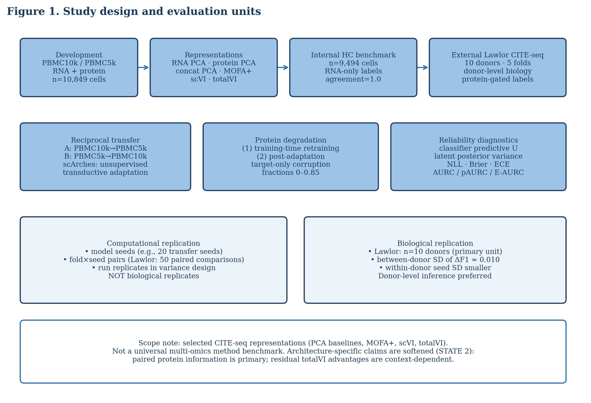
Figure 1 | Study design and evaluation units. Schematic of the analysis spanning development PBMC CITE-seq cohorts, representation families, reciprocal transfer, training-time and post-adaptation protein degradation, uncertainty and selective prediction, variance decomposition, and Lawlor 10-donor external validation. Biological donors are distinguished from computational repetitions such as seeds, folds, mask seeds, and run replicates.
Table 1 | Datasets and study designs
Dataset | Role | Cells | Genes | Proteins | Labels / evaluation
PBMC10k | Development / transfer | 6,855 | 16,727 | 14 | RNA-derived development labels; transfer A/B
PBMC5k | Development / reciprocal transfer | 3,994 | 16,581 | 29 (14 shared) | RNA-derived development labels; transfer A/B
Combined development | Internal benchmark | 10,849 (9,494 HC) | 15,792 shared | 14 shared | High-confidence l2 evaluation
Lawlor Baseline | External donor validation | 16,175 singlets (5,207 labeled) | 12,776 shared | 12 matched | Author protein-gated labels; 10 donors
Lawlor identifiers: HCA efea6426-510a-4b60-9a19-277e52bfa815; ENA PRJEB40376 / ERP124005.

Paired protein information improved internal representation quality
The internal development analysis used 9,494 healthy-control cells with matched RNA and protein measurements. Across representation families, paired protein information improved cell-type macro-F1. RNA PCA reached 0.666, protein PCA alone reached 0.512, concatenated RNA-protein PCA reached 0.745, MOFA+ reached 0.549, scVI reached 0.722, and totalVI reached 0.779. The first internal contrast between totalVI and scVI was +0.057 (cell-level conditional paired-bootstrap 95% CI 0.020–0.091), and the totalVI-minus-concat difference was +0.034. (Fig. 2A,B; Table 2).
The concat PCA baseline was central to interpretation. It substantially exceeded RNA PCA and scVI, recovering approximately 40% of the totalVI-versus-scVI gain without using a specialized deep generative architecture. This result indicates that part of the internal improvement came from the measured protein modality itself, not only from the modeling framework.
Protein PCA alone performed below RNA PCA even though protein information helped strongly when paired with RNA. This pattern is compatible with the structure of CITE-seq panels: the 14 measured proteins were targeted and label-relevant, but too limited to replace genome-wide RNA for the full annotation task. Their strongest value appeared when combined with transcriptomic information. The RNA-only label audit showed identity across all 9,494 high-confidence labels (Fig. 2C).
The RNA-only annotation audit found identical labels across 9,494 cells. This rules out a simple label-mismatch explanation for the RNA-only versus multimodal difference, but it does not independently validate biological correctness. The audit supports the internal comparison as a consistency check while leaving biological label validity to dataset annotation quality and external validation.
The internal development result therefore established a strong protein-information signal and a more cautious model interpretation. totalVI was the best internal representation among the tested methods, but the simple concat baseline showed that paired protein measurements were a major contributor to the gain.

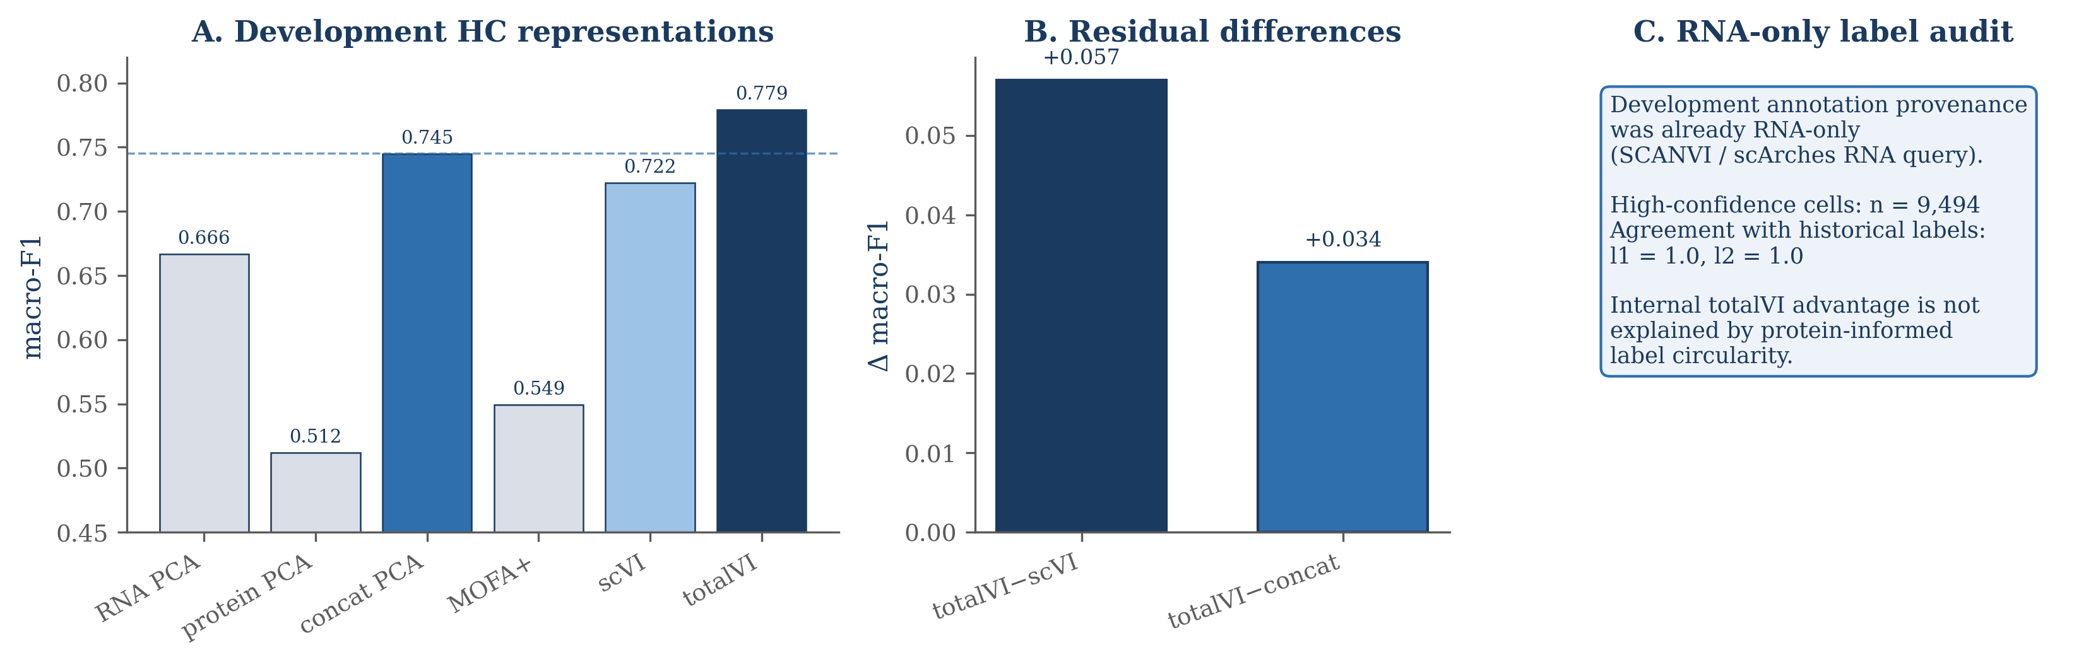
Figure 2 | Information content versus representation strategy in the development high-confidence cohort. Macro-F1 is shown for RNA PCA (0.666), protein PCA (0.512), concat PCA (0.745), MOFA+ (0.549), scVI (0.722), and totalVI (0.779) on n=9,494 cells. Residual differences are totalVI-scVI (+0.057) and totalVI-concat (+0.034). The RNA-only audit showed identical labels across 9,494 cells; the totalVI-scVI interval used a cell-level conditional paired bootstrap (95% CI 0.020-0.091; n=500).

Representation gains were strongly context-dependent under dataset transfer
Bidirectional transfer experiments showed that model-level gains depended strongly on source-target direction. In Direction A, scVI reached 0.656±0.018 and totalVI reached 0.652±0.015, giving a near-null difference. In Direction B, scVI reached 0.601±0.020 and totalVI reached 0.654±0.025, giving Δ+0.052. Direction B therefore provided the clearest evidence of a totalVI advantage under transfer, with 19/20 seeds favoring totalVI. (Fig. 3A-C; Table 2).
The inductive concat PCA baseline again helped anchor the interpretation. It reached 0.735 in Direction A and 0.734 in Direction B, above the adapted VAE latent classifiers in both directions. This does not imply that concat PCA is universally preferable; rather, it shows that aligned RNA-protein features can transfer strongly when a source-only feature transform is sufficient for the task.
The Direction A near-null result prevents overgeneralization from the internal cohort. A totalVI advantage observed internally did not automatically translate into every transfer setting. When the source-target relationship was favorable for RNA-only adaptation, or when protein information did not add label-aligned signal after adaptation, scVI and totalVI performed similarly.
Direction B showed the stronger totalVI transfer result. The mean Δ+0.052 was accompanied by a seed-level pattern favoring totalVI in 19/20 repeated runs. This combination of effect size and repeated-run agreement makes Direction B more persuasive than a single split or single seed would be.
These transfer results support a context-dependent reliability view. Protein information was valuable, but the architecture-specific advantage of totalVI depended on source-target direction and adaptation context. Transfer reliability was therefore not reducible to the internal development ranking.

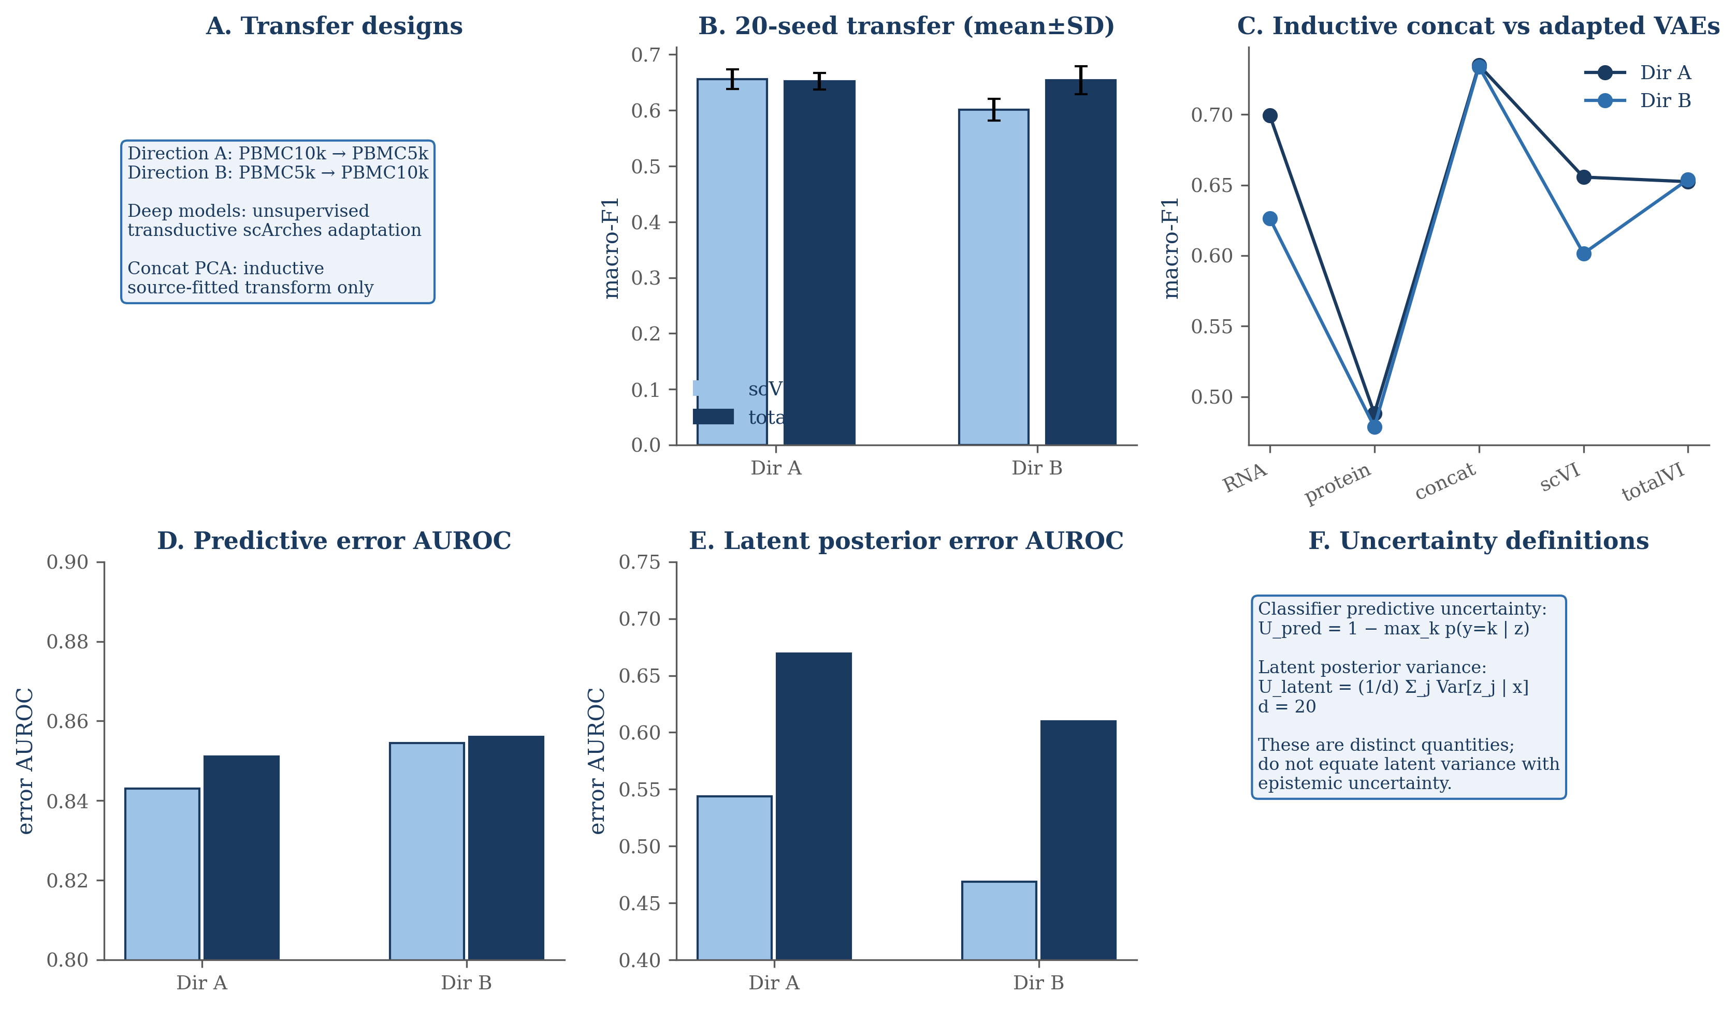
Figure 3 | Dataset transfer and uncertainty. Reciprocal transfer is shown for Directions A and B, contrasting unsupervised transductive scArches adaptation with inductive source-fitted concat PCA. Panels summarize 20-seed mean±SD macro-F1, inductive concat performance (0.735/0.734), predictive error AUROC, latent posterior error AUROC, and uncertainty definitions. The 19/20 seed pattern applies only to PBMC Direction B.

Protein degradation affected training-time and post-adaptation reliability differently
Protein degradation was evaluated in two distinct designs. In the training-time design, protein entries were corrupted before totalVI training, and the resulting totalVI representations were compared with a fixed scVI RNA-only reference. In the post-adaptation design, a clean source-trained model was adapted with unlabeled query data, source and target cells were encoded with the same adapted model, a classifier was trained on clean source post-adaptation latent coordinates, and target protein values were corrupted only afterward for re-inference. (Fig. 4A,B).
Training-time totalVI macro-F1 values across corruption fractions 0.00, 0.10, 0.25, 0.40, 0.55, 0.70, and 0.85 were 0.779, 0.771, 0.758, 0.760, 0.750, 0.736, and 0.755. The scVI reference was 0.722. The non-monotonicity, especially at high corruption, was consistent with additional contribution from training stochasticity and optimization variability.
Post-adaptation degradation gave a different reliability profile. In Direction A, totalVI macro-F1 changed from 0.652 to 0.650, 0.647, 0.644, 0.641, 0.637, and 0.635 as corruption increased. The corresponding ΔF1 values were 0.0000, −0.0025, −0.0058, −0.0087, −0.0113, −0.0153, and −0.0178. (Fig. 4C-E).
Direction B was more sensitive. totalVI macro-F1 changed from 0.654 to 0.652, 0.647, 0.643, 0.637, 0.629, and 0.621, with ΔF1 values of 0.0000, −0.0023, −0.0069, −0.0108, −0.0173, −0.0253, and −0.0328. The decline was gradual rather than abrupt, but it was stronger than in Direction A. (Fig. 4C-E).
Class-level effects showed that global macro-F1 did not capture all vulnerability. In Direction B, CD8 Naive cells showed approximately −0.26 ΔF1 at 0.85 corruption, and CD8 TCM, CD8 TEM, CD4 TCM, CD4 TEM, and CD4 Naive populations were also sensitive. These patterns are consistent with T-cell state distinctions depending on measured surface-marker information. (Fig. 4F).

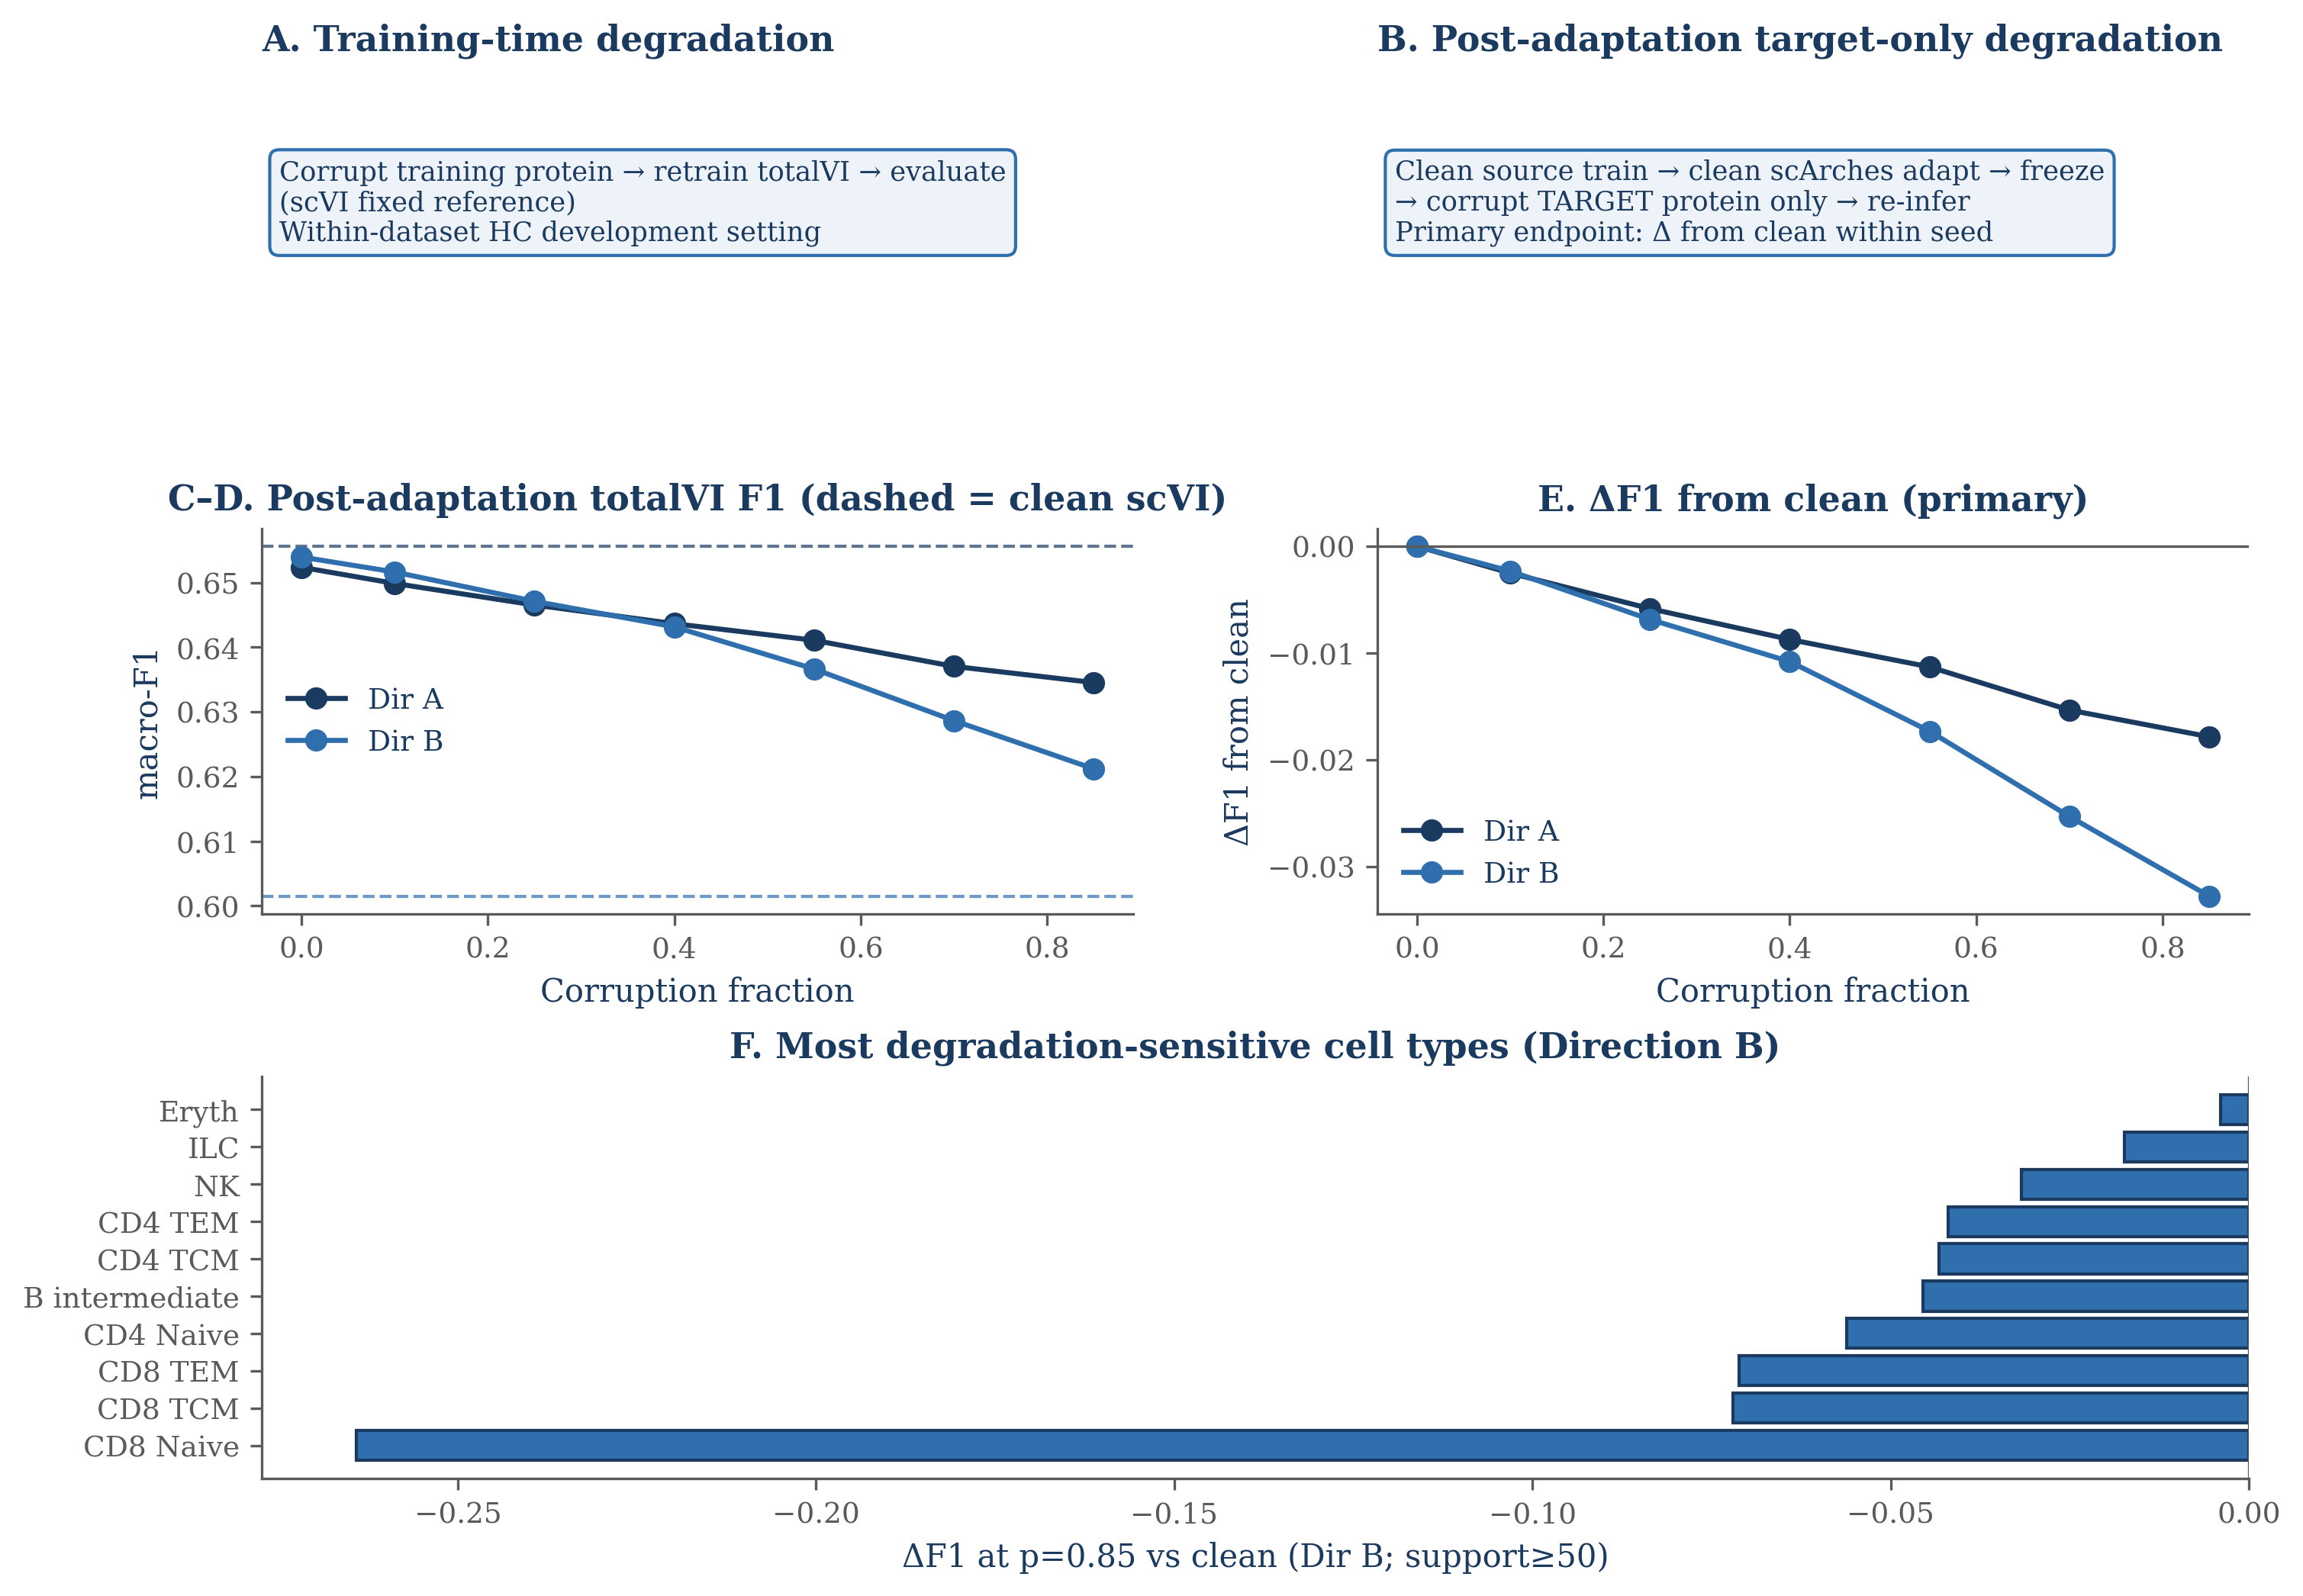
Figure 4 | Protein degradation experiments. Training-time and post-adaptation designs are shown separately. Post-adaptation curves summarize totalVI macro-F1 and Delta F1 from clean for Directions A and B across corruption fractions 0.00, 0.10, 0.25, 0.40, 0.55, 0.70, and 0.85, with five mask seeds at nonzero fractions. Direction B class-level sensitivity includes CD8 Naive Delta F1 approximately -0.26 at 0.85 corruption.

Predictive and latent uncertainty captured distinct aspects of model failure
Predictive uncertainty and latent uncertainty were intentionally separated. Predictive uncertainty was defined as 1 minus the maximum logistic-regression class probability. Latent uncertainty was defined as mean posterior variance over the 20-dimensional latent representation. Reporting both provides complementary information about classifier-level ambiguity and representation-level instability. (Fig. 3D-F).
In PBMC transfer analyses, predictive uncertainty detected errors with AUROC values around 0.84–0.86. Under Direction B post-adaptation protein corruption, predictive AUROC declined from 0.856 to 0.841. This indicates that the classifier probability score remained informative but became less effective for ranking errors as protein measurements were degraded.
Latent uncertainty responded differently. Direction A latent error AUROC was 0.544±0.054 for scVI and 0.669±0.021 for totalVI. Direction B latent error AUROC was 0.469±0.075 for scVI and 0.610±0.038 for totalVI. In the Direction B corruption series, totalVI latent AUROC increased from 0.610 to 0.627 while predictive AUROC decreased. (Fig. 5C,F).
Risk-coverage metrics reinforced this distinction. In Direction A, E-AURC changed from 0.0315 to 0.0339 under degradation. In Direction B, E-AURC increased from 0.0350 to 0.0448. Full AURC in Direction B increased from 0.060 to 0.079, and pAURC_[0.5,1] increased from 0.112 to 0.144. These changes show that protein corruption worsened selective-prediction behavior, especially in the more sensitive transfer direction. (Fig. 5C,F).
The uncertainty results should be interpreted as diagnostic rather than definitive. Predictive uncertainty was stronger for immediate error ranking, while latent variance reflected representation-level instability that could increase under corrupted protein inputs. Neither score independently establishes biological correctness. (Fig. 5C,F).
Training stochasticity contributed materially to reliability variation
Repeated training showed that reliability variation was not explained only by modality or transfer direction. Variance partitioning separated source subset effects, model seed effects, source-by-seed interaction, and residual run-level stochastic variation under the balanced design. (Fig. 5A,B).
For scVI macro-F1, the source fraction was 2.31%, seed fraction was 0.00%, interaction fraction was 35.45%, and residual fraction was 62.23%. For totalVI, source accounted for 0.00%, seed for 5.62%, interaction for 3.24%, and residual for 91.13%. For the paired totalVI-minus-scVI difference, source accounted for 5.09%, seed for 12.04%, interaction for 14.11%, and residual for 68.75%.
The residual term denotes run-level residual or stochastic variation under the experimental design, not irreducible biology. This distinction matters because the balanced design used computational repetitions to estimate training and optimization variability, whereas biological replication was addressed separately through donor-level Lawlor validation.
The stochasticity results explain why small mean differences require caution. In Direction A, the near-null scVI-totalVI difference could plausibly change ordering across repeated runs. In Direction B, the larger mean difference and 19/20 seed pattern gave stronger evidence for a totalVI advantage under transfer.
Selective prediction reduced error while changing retained cell composition
Selective prediction retained lower-uncertainty cells and deferred higher-uncertainty cells. This reduced error among retained cells, particularly when classifier predictive uncertainty was used. The benefit was not neutral, however, because retained cells were not compositionally identical to the full target population. (Fig. 5C-E).
Retention coefficients of variation at 50% coverage were approximately 0.88–1.02 in the internal transfer setting. In Lawlor donor validation, the corresponding values were approximately 0.57–0.59. These values show that selective prediction changed retained cell composition in both settings, with stronger unevenness in the internal transfer analyses.
This compositional shift is important for biological interpretation. Rare, transitional, or marker-ambiguous populations may be deferred at higher rates if they are harder to classify. Selective prediction can therefore support review workflows, but retained-set performance should be reported together with coverage and cell-type retention.
The degradation analyses showed the limits of uncertainty-guided retention. In Direction B, full AURC increased from 0.060 to 0.079 and pAURC_[0.5,1] increased from 0.112 to 0.144 under protein corruption. Selective prediction reduced error on retained cells, but it did not fully offset the reliability loss caused by degraded protein measurements.

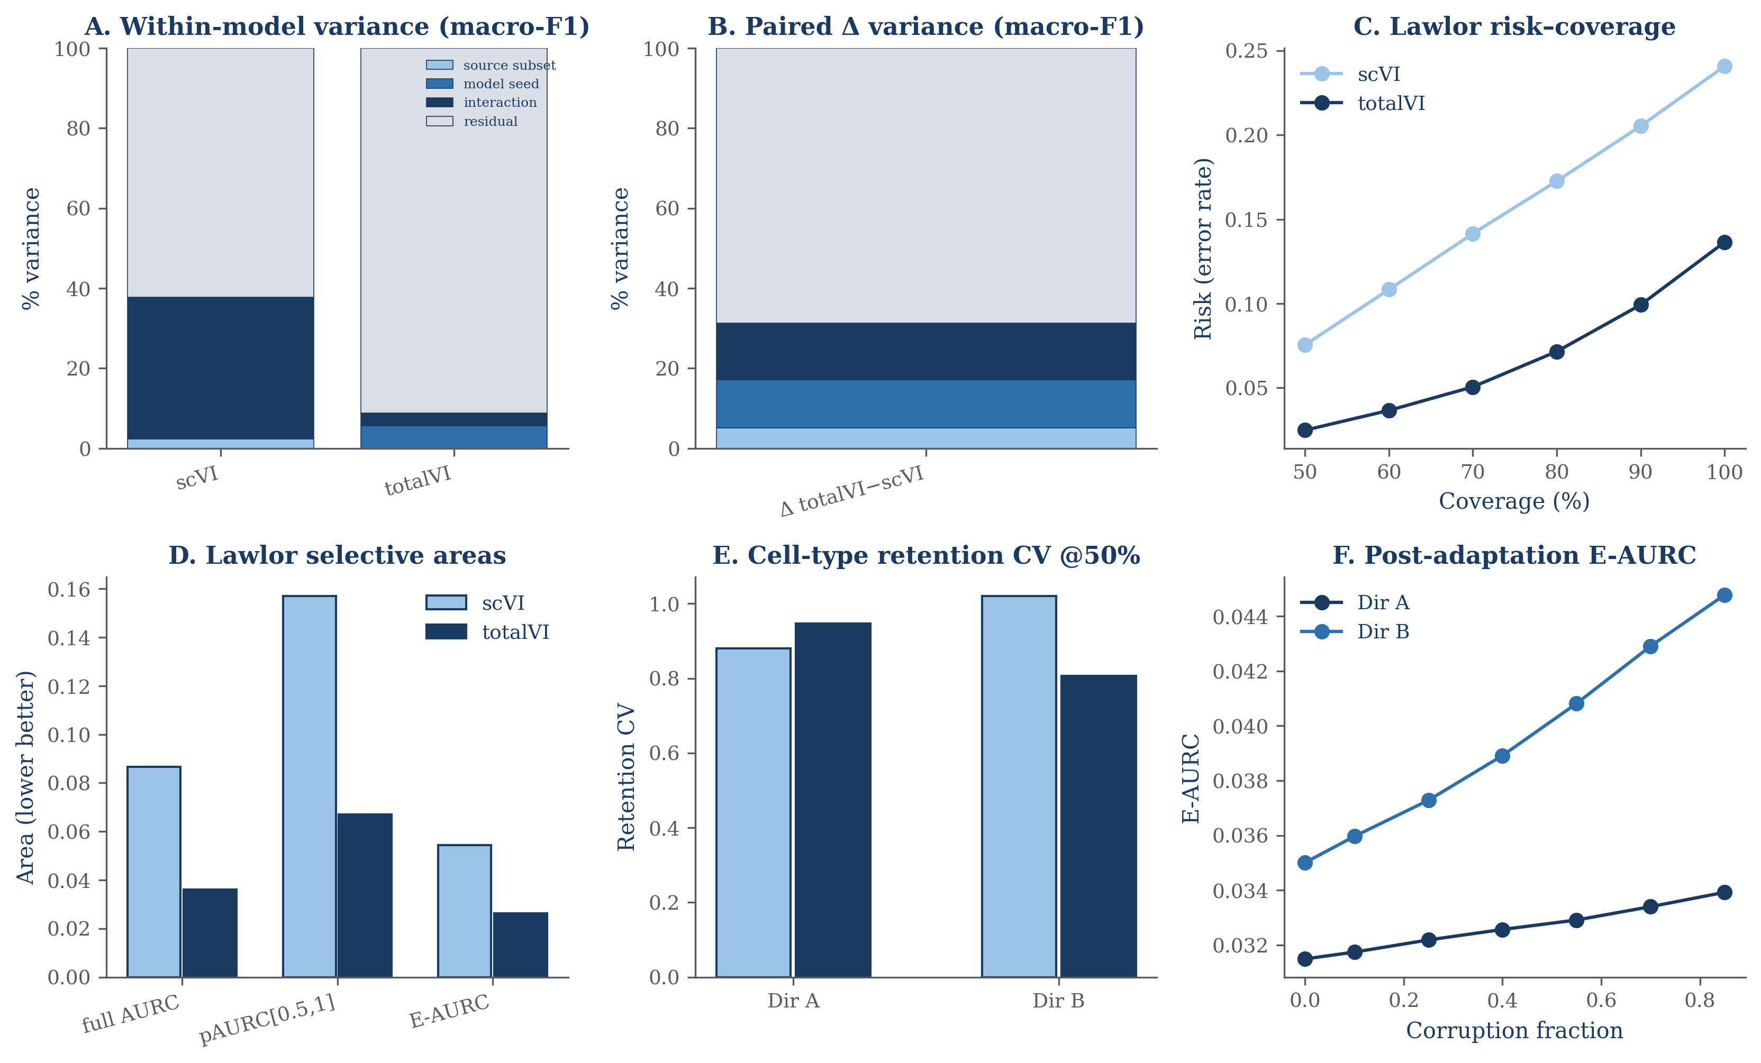
Figure 5 | Training stochasticity and selective prediction. Variance components are shown for within-model macro-F1 and paired totalVI-scVI Delta, with residual denoting run-level residual or stochastic variation under the balanced design. Risk-coverage summaries distinguish full AURC, pAURC_[0.5,1], and E-AURC. Retention coefficients of variation at 50% coverage summarize changes in retained cell composition, and post-adaptation E-AURC illustrates degradation under target-side protein corruption.

Donor-level external validation confirmed the value of multimodal information
External validation used the Lawlor dataset with 10 donors and a labeled subset for evaluation [13]. Present-class donor mean macro-F1 improved by Δ+0.090 for totalVI versus scVI, with all 10 donors favoring totalVI and between-donor SD approximately 0.010. Deep-representation averages were 0.800 for scVI and 0.888 for totalVI. (Fig. 6A-C; Table 2).
Across computational fold-seed evaluations, totalVI had higher macro-F1 in 50/50 comparisons. Latent AUROC favored totalVI in 38/50 comparisons. These fold-seed comparisons describe computational repeatability within the evaluation design, not biological replication; the biological units were the 10 donors.
Uncertainty and risk-coverage metrics also favored totalVI in Lawlor. Predictive error AUROC improved from 0.801 for scVI to 0.838 for totalVI, and latent error AUROC improved from 0.605 to 0.650. Full AURC was 0.087 for scVI and 0.036 for totalVI, pAURC_[0.5,1] was 0.157 versus 0.067, and E-AURC was 0.054 versus 0.026. (Fig. 6E,F).
Simple protein-aligned baselines were very strong in Lawlor. Protein PCA reached approximately 0.927 and concat PCA reached approximately 0.945. These values indicate strong label-modality alignment in the evaluated labeled subset. They also reinforce the main hierarchy of evidence: measured protein information was highly informative, while architecture-specific conclusions remained dependent on the evaluation context. (Fig. 6D).

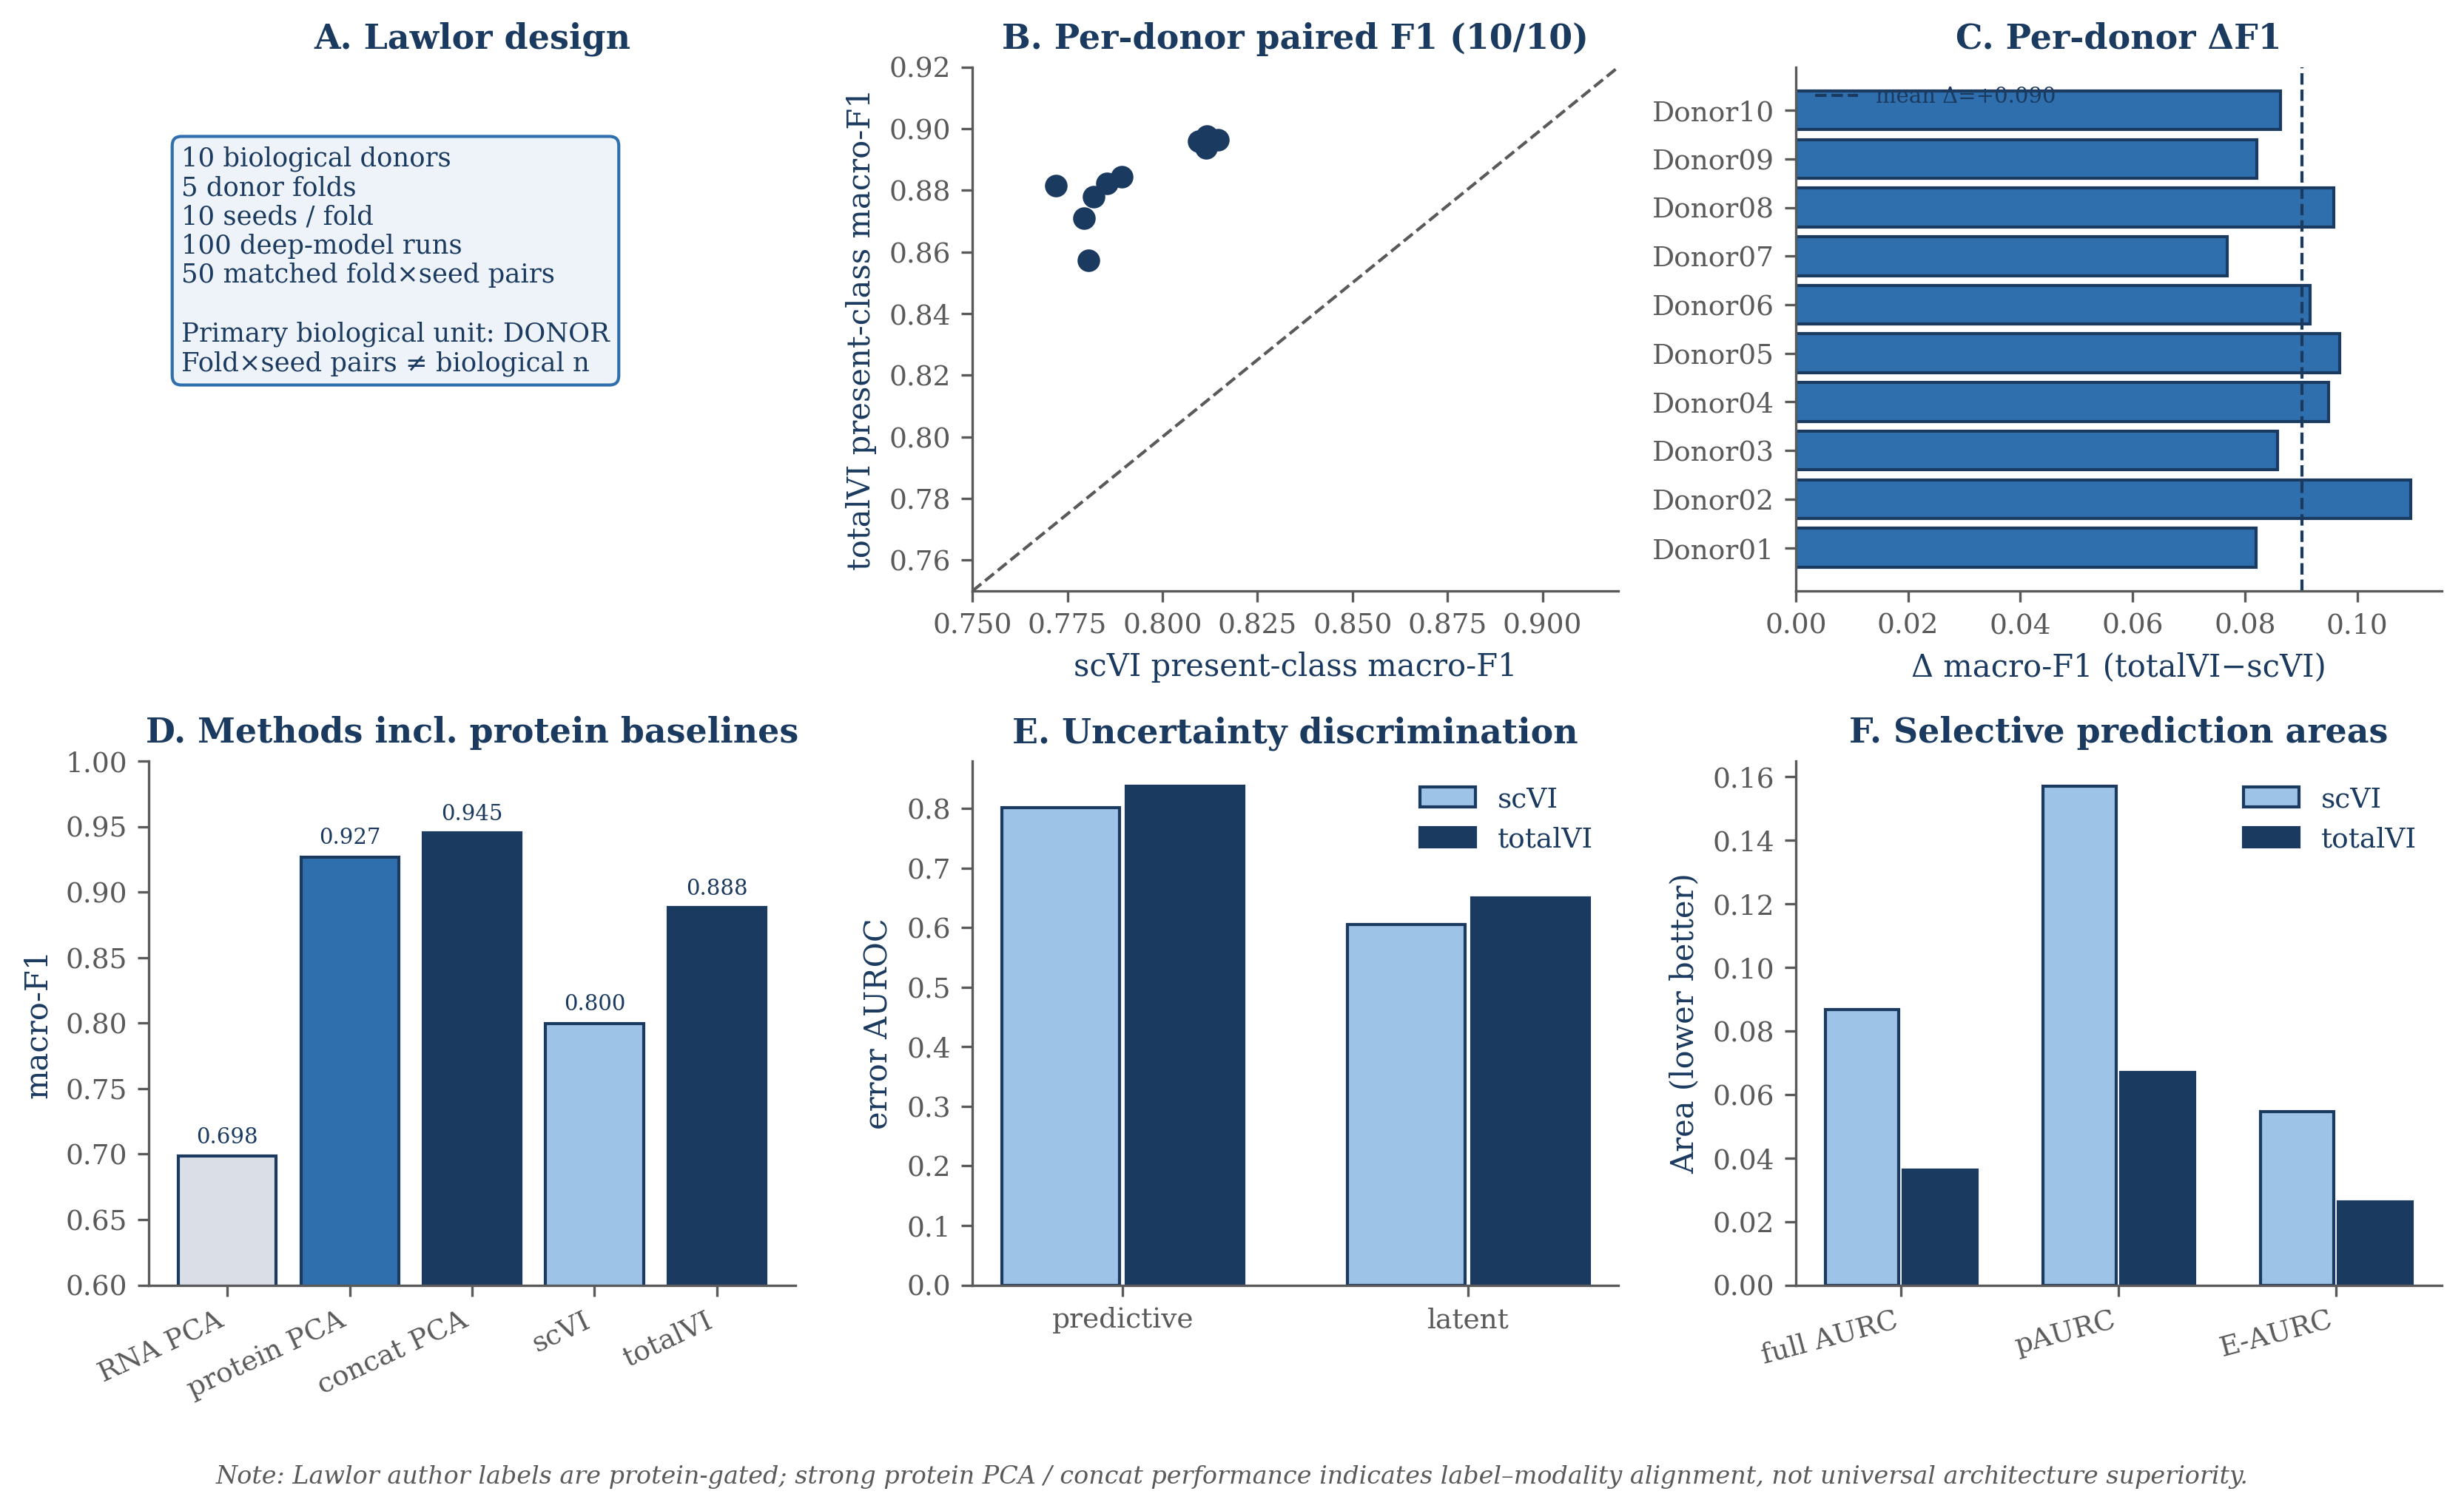
Figure 6 | Lawlor donor-level external validation. The analysis used 10 biological donors and a labeled subset for evaluation. Panels summarize per-donor present-class macro-F1, donor-level Delta F1 (10/10 donors positive; mean Delta approximately +0.090; between-donor SD approximately 0.010), protein PCA (approximately 0.927), concat PCA (approximately 0.945), predictive and latent AUROC, and selective risk-coverage areas. Fold-seed comparisons are computational repetitions, not donor-level replication.
Table 2 | Primary reliability findings
Setting | scVI | totalVI / multimodal | Key interpretation
Development macro-F1 | 0.722 | totalVI 0.779; concat PCA 0.745 | Protein information + model strategy both contribute
Transfer A | 0.656±0.018 | totalVI 0.652±0.015; concat 0.735 | Deep-model difference near null
Transfer B | 0.601±0.020 | totalVI 0.654±0.025; concat 0.734 | 19/20 seeds favor totalVI
Lawlor donor-level | 0.800 | totalVI 0.888; concat 0.945 | 10/10 donors favor totalVI; protein-gated labels
Lawlor predictive AUROC | 0.801 | 0.838 | Classifier error ranking
Lawlor latent AUROC | 0.605 | 0.650 | 38/50 fold×seed pairs favor totalVI
Lawlor full AURC | 0.087 | 0.036 | Lower is better

Discussion
This manuscript evaluated CITE-seq representation reliability across internal development data, reciprocal transfer, protein degradation, stochastic training variation, selective prediction, and donor-level validation. A central result was that paired protein information improved representation quality. That conclusion was supported by internal totalVI performance, strong concat PCA performance, and Lawlor donor-level gains.
The internal development cohort showed that totalVI outperformed scVI, but the concat PCA baseline prevented a purely architecture-centered interpretation. Concat PCA reached 0.745, exceeding RNA PCA and scVI, while totalVI reached 0.779. The most direct explanation is that measured protein markers supplied label-aligned information not fully captured by RNA-only representations.
Transfer analysis made the interpretation more conditional. Direction A showed a near-null totalVI-scVI difference, whereas Direction B showed Δ+0.052 with 19/20 seeds favoring totalVI. This asymmetry is important because it reflects the reality of source-target shift: composition, marker distributions, and label alignment can make one transfer direction much harder than the other.
Protein degradation experiments added another layer. Training-time corruption tested model learning with impaired protein measurements, while post-adaptation corruption tested target-side measurement loss after adaptation and classifier fitting. These designs address different questions and should not be pooled into a single robustness claim. The post-adaptation curves showed gradual declines, stronger in Direction B, and class-level sensitivity for T-cell subsets.
Uncertainty was useful but limited. Predictive uncertainty was the stronger error-ranking signal, with AUROC values around 0.84–0.86 in PBMC transfer, while latent variance captured representation-level instability and responded differently to protein degradation. These results support reporting both scores, but neither should be treated as a calibrated guarantee of biological correctness.
Selective prediction reduced retained-cell error while changing retained cell composition. This is a relevant trade-off for single-cell workflows. Deferred cells may be exactly those that require marker review or manual annotation, but retained-set summaries can become biased if coverage and cell-type retention are not reported.
The Lawlor donor analysis provided external support for the value of multimodal information. TotalVI improved present-class donor macro-F1 over scVI by Δ+0.090 across 10/10 donors, and protein PCA and concat PCA performed even higher under the evaluated protein-aligned labels. This does not establish universal totalVI superiority; it shows that when protein markers closely match label definitions, multimodal information can be highly reliable across donors.
Several limitations remain. The task was cell-type prediction, not trajectory inference, perturbation modeling, or rare-state discovery. The protein panels were limited to available measured markers, and conclusions depend on label-modality alignment. The Lawlor analysis evaluated the labeled subset and present classes per donor. Finally, the bootstrap interval was descriptive and conditional on the sampled target cells, while biological replication was evaluated separately at donor level.
Conclusions
Paired protein information was a major contributor to improved CITE-seq representation quality in this analysis. It improved internal representation performance, supported stronger donor-level validation, and remained informative under several stress tests.
Architecture was secondary and context-dependent. totalVI showed clear advantages in the development cohort, Direction B transfer, and Lawlor donor validation, but Direction A transfer and strong concat PCA baselines showed that model rankings depended on evaluation setting.
Reliable use of CITE-seq representations therefore requires stress tests. Transfer direction, protein degradation, training stochasticity, uncertainty behavior, selective-prediction composition, and donor-level validation all contributed information that a single internal macro-F1 table would miss.
Methods
Datasets, annotations, and evaluation splits
The internal PBMC analysis used PBMC10k (6,855 cells) and PBMC5k (3,994 cells). After feature harmonization, the combined object contained 10,849 cells, 15,792 shared genes, and 14 shared proteins. The pre-specified PHASE2 split used 8,679 training cells and 2,170 held-out cells, stratified by dataset batch (seed 0) before restriction to the 9,494 high-confidence labeled cells. Representation learning and downstream classification respected the established train/test or source/target partitions; held-out macro-F1 was computed on evaluation cells only. The internal totalVI-scVI interval is therefore a cell-level conditional paired-bootstrap interval rather than a biological-generalization interval.
Development labels were generated independently of the evaluated representations. Code audit confirmed that the PHASE6 annotation pathway was RNA-only; the 9,494 high-confidence labels used in the revised analysis were identical to the historical labels. This audit establishes label provenance and rules out a protein-label circularity artifact, but it is not an independent validation of biological correctness.
External validation used the Lawlor Baseline CITE-seq cohort [13]: 16,175 singlets across 10 donors, with 5,207 author-labeled cells, 12,776 harmonized genes, and 12 matched proteins. Gene identifiers were mapped with Ensembl GRCh37.87 and duplicate symbol mappings were summed. Protein aliases were harmonized across the 12-protein panel. Author-provided protein-gated labels were used only for external evaluation.
Feature processing and representation methods
RNA counts were processed by selecting 2,000 highly variable genes using the seurat_v3 procedure, normalizing counts to 1e4 per cell, applying log1p transformation, scaling with clipping at 10, and computing 10 RNA principal components. Protein features were centered log-ratio transformed, z-scored using the train or source data, and represented by 10 protein principal components.
The concat baseline concatenated 10 RNA PCs and 10 protein PCs, then applied `StandardScaler` on the train or source data. For transfer, this was an inductive source-only fit applied to target cells without query-label information. RNA PCA, protein PCA, concat PCA, MOFA+, scVI, and totalVI were compared as representation methods.
MOFA+ was included as a frozen historical embedding (`mofa_seed0`). `mofapy2` was used historically, and the frozen MOFA+ embedding with comparable latent dimension was used as a baseline without adding unsupported hyperparameter claims.
The matched scVI configuration used `n_latent=20`, `n_hidden=256`, `n_layers=2`, `dropout=0.2`, `gene_likelihood=nb`, `dispersion=gene`, and `latent_distribution=normal`. The totalVI configuration used `n_latent=20`, `n_hidden=256`, two encoder layers, one decoder layer, `dropout=0.2`, and `gene_likelihood=nb`.
Downstream classifiers used `sklearn.linear_model.LogisticRegression` with `max_iter=2000`, `solver=lbfgs`, and `random_state=seed`. The software environment used Python 3.11.7, scikit-learn 1.5.2, and scvi-tools 1.3.3.
For every inductive PCA/concat evaluation, highly variable gene selection, centering, scaling, PCA fitting, protein standardization, and the downstream classifier were fitted on training/source cells only and then applied unchanged to held-out target cells. In Lawlor, these transformations were fitted using the eight source donors within each fold and applied to the two held-out target donors. No target labels were used during preprocessing or model fitting.
Internal development-cohort evaluation
The healthy-control development cohort contained 9,494 cells. It was used to compare RNA PCA, protein PCA, concat PCA, MOFA+, scVI, and totalVI using the shared logistic-regression classifier. The held-out comparison used the established train/test partition described above (Fig. 2).
Internal macro-F1 values were RNA PCA 0.666, protein PCA 0.512, concat PCA 0.745, MOFA+ 0.549, scVI 0.722, and totalVI 0.779. The totalVI-minus-scVI difference was +0.057, and the totalVI-minus-concat difference was +0.034. The internal totalVI-minus-scVI interval used a target-cell paired bootstrap with n=500 resamples; the interval is descriptive and conditional on the evaluated target cells. Biological replication was addressed separately by Lawlor donor-level validation.
Bidirectional transfer and unsupervised transductive adaptation
Bidirectional transfer reversed which internal PBMC dataset served as source and which served as target. Direction A produced scVI macro-F1 0.656±0.018 and totalVI macro-F1 0.652±0.015. Direction B produced scVI macro-F1 0.601±0.020 and totalVI macro-F1 0.654±0.025, for Δ+0.052, with 19/20 seeds favoring totalVI. The inductive concat baseline reached 0.735 in Direction A and 0.734 in Direction B.
Generative-model transfer used unsupervised transductive scArches query adaptation [10]. A clean source model was adapted using unlabeled query data. After adaptation, source and target cells were encoded with the same adapted model. The classifier was trained on clean source post-adaptation latent coordinates and evaluated on target cells. This procedure used unlabeled target data during adaptation and was therefore not fully inductive.
scArches query adaptation used unlabeled target features and is therefore described as unsupervised transductive adaptation, not fully inductive prediction. After adaptation, source and target embeddings were always recomputed with the same adapted query model before classifier fitting and evaluation. This post-adaptation coordinate rule avoids mixing pre-adaptation source embeddings with post-adaptation target embeddings.
Protein degradation experiments
Protein corruption was entry-wise. At each nonzero corruption fraction, originally non-zero measured protein entries were randomly selected and set to zero; preexisting zeros were unchanged. Corruption fractions were 0.00, 0.10, 0.25, 0.40, 0.55, 0.70, and 0.85, with five mask seeds at nonzero fractions.
Training-time degradation retrained totalVI after corrupting protein measurements, while the scVI RNA-only reference remained fixed. Training-time totalVI macro-F1 values were 0.779, 0.771, 0.758, 0.760, 0.750, 0.736, and 0.755 across increasing corruption fractions; the fixed scVI reference was 0.722.
Post-adaptation degradation used a clean source training procedure followed by unsupervised transductive scArches query adaptation. Source and target cells were encoded with the same adapted model, the classifier was trained on clean source post-adaptation latent coordinates and frozen, and then target protein values only were corrupted and re-inferred. Source classifier training remained clean, and the procedure was not fully inductive.
Post-adaptation Direction A macro-F1 values were 0.652, 0.650, 0.647, 0.644, 0.641, 0.637, and 0.635, with ΔF1 values 0.0000, −0.0025, −0.0058, −0.0087, −0.0113, −0.0153, and −0.0178. Direction B macro-F1 values were 0.654, 0.652, 0.647, 0.643, 0.637, 0.629, and 0.621, with ΔF1 values 0.0000, −0.0023, −0.0069, −0.0108, −0.0173, −0.0253, and −0.0328. In Direction B, CD8 Naive cells showed approximately −0.26 ΔF1 at 0.85 corruption.
Uncertainty, calibration, and selective prediction
Classifier predictive uncertainty for cell i was defined as
U_pred,i = 1 - max_k p(y_i = k | z_i).
Latent posterior dispersion was defined as the mean posterior variance over d = 20 latent dimensions:
U_latent,i = (1/d) Σ_j Var(z_ij | x_i).
Error discrimination used AUROC and AUPRC. Probability quality was summarized by negative log-likelihood and multiclass Brier score [16], and calibration by expected calibration error (ECE; 15 bins), with equal-frequency binning primary and equal-width binning as sensitivity [11,15]. Selective prediction ranked cells by ascending classifier predictive uncertainty. Risk(c) was one minus accuracy among retained cells at coverage c. Full AURC, pAURC_[0.5,1], and excess AURC (E-AURC) were reported separately; lower values indicate better selective performance.
Selective prediction retained lower-uncertainty cells and deferred higher-uncertainty cells. Cell-type retention was summarized at 50% coverage. Retention coefficients of variation were approximately 0.88–1.02 internally and approximately 0.57–0.59 in Lawlor donor validation.
Training stochasticity and variance decomposition
Training stochasticity used a balanced 5 source-subset × 5 model-seed × 2 run-replicate design, analyzed separately for scVI and totalVI. For model a, the per-model decomposition was
Y_ijr^(a) = μ^(a) + S_i^(a) + G_j^(a) + (SG)_ij^(a) + ε_ijr^(a).
Here i indexes source subset, j model seed, and r run replicate. Method-of-moments estimators derived from expected mean squares were used for source, seed, source-by-seed interaction, and residual components. In this balanced design, the corrected REML check was numerically consistent with the MoM estimates.
Architecture-dependent variability was assessed separately through a paired model-difference cube,
Δ_ijr = Y_ijr^(totalVI) - Y_ijr^(scVI),
Δ_ijr = μ_Δ + S_i^Δ + G_j^Δ + (SG)_ij^Δ + ε_ijr^Δ.
The residual term is interpreted as run-level residual/stochastic variation under the implemented replication scheme; it is not irreducible biological variability.
Lawlor donor-level validation and statistical units
Lawlor evaluation used five deterministic donor folds, each holding out two donors so that every donor served as target exactly once. Each deep-model fold was evaluated across 10 computational seeds, yielding 100 model runs and 50 paired scVI-totalVI fold×seed comparisons. The biological evaluation unit was the donor (n=10), whereas fold×seed pairs quantify computational repeatability and are not independent biological replicates.
The batch covariate was sequencing lane/run_identifier rather than donor, preventing donor identity from being supplied as the batch variable. For PCA, protein PCA, and the 10+10 concatenated baseline, all centering, scaling, PCA fitting, concatenation scaling, and classifier fitting were performed on source donors only within each fold and then applied to held-out target donors. Present-class macro-F1 was the primary donor-level metric; a fixed-ontology sensitivity analysis was retained in the revision artifacts.
Across donors, the totalVI-scVI present-class macro-F1 difference averaged approximately +0.090, with all 10 donors positive and between-donor SD approximately 0.010. Seed variation was summarized within donor/fold separately. Counts such as 50/50 macro-F1 wins or 38/50 latent-AUROC wins describe computational paired consistency only.
Software and reproducibility
Analyses were conducted in Python 3.11.7. scVI and totalVI used scvi-tools 1.3.3; downstream logistic regression used scikit-learn 1.5.2 with max_iter=2000, solver="lbfgs", and random_state equal to the evaluation seed. The analysis code and reproducible workflows are maintained in a version-controlled research repository and are available upon request.
Data and code availability
The analyses use publicly available PBMC CITE-seq resources. The independent Lawlor cohort is available through HCA project efea6426-510a-4b60-9a19-277e52bfa815 and ENA project PRJEB40376 / ERP124005. Analysis code and reproducibility materials are maintained with the research project and can be provided for academic review.
References
1. Stoeckius M, Hafemeister C, Stephenson W, Houck-Loomis B, Chattopadhyay PK, Swerdlow H, et al. Simultaneous epitope and transcriptome measurement in single cells. Nat Methods. 2017;14:865-868. doi:10.1038/nmeth.4380. 2. Lopez R, Regier J, Cole MB, Jordan MI, Yosef N. Deep generative modeling for single-cell transcriptomics. Nat Methods. 2018;15:1053-1058. doi:10.1038/s41592-018-0229-2. 3. Gayoso A, Steier Z, Lopez R, Regier J, Nazor KL, Streets A, et al. Joint probabilistic modeling of single-cell multi-omic data with totalVI. Nat Methods. 2021;18:272-282. doi:10.1038/s41592-020-01050-x. 4. Argelaguet R, Arnol D, Bredikhin D, Deloro Y, Velten B, Marioni JC, et al. MOFA+: a statistical framework for comprehensive integration of multi-modal single-cell data. Genome Biol. 2020;21:111. doi:10.1186/s13059-020-02015-1. 5. Ashuach T, Gabitto MI, Koodli RV, Saldi GA, Jordan MI, Yosef N. MultiVI: deep generative model for the integration of multimodal data. Nat Methods. 2023;20:1222–1231. doi:10.1038/s41592-023-01909-9. 6. Gong B, Zhou Y, Purdom E. Cobolt: integrative analysis of multimodal single-cell sequencing data. Genome Biol. 2021;22:351. doi:10.1186/s13059-021-02556-z. 7. Jeong Y, Ronen J, Kopp W, Lutsik P, Akalin A. scMaui: a widely applicable deep learning framework for single-cell multiomics integration in the presence of batch effects and missing data. BMC Bioinformatics. 2024;25:257. doi:10.1186/s12859-024-05880-w. 8. Wu M, Goodman N. Multimodal generative models for scalable weakly-supervised learning. Adv Neural Inf Process Syst. 2018;31:5580–5590. 9. Luecken MD, Büttner M, Chaichoompu K, Danese A, Interlandi M, Mueller MF, Strobl DC, Zappia L, Dugas M, Colomé-Tatché M, Theis FJ. Benchmarking atlas-level data integration in single-cell genomics. Nat Methods. 2022;19:41–50. doi:10.1038/s41592-021-01336-8. 10. Lotfollahi M, Naghipourfar M, Luecken MD, Khajavi M, Büttner M, Wagenstetter M, Avsec Ž, Gayoso A, Yosef N, Interlandi M, et al. Mapping single-cell data to reference atlases by transfer learning. Nat Biotechnol. 2022;40:121–130. doi:10.1038/s41587-021-01001-7. 11. Guo C, Pleiss G, Sun Y, Weinberger KQ. On calibration of modern neural networks. Proc Mach Learn Res. 2017;70:1321–1330. 12. Geifman Y, El-Yaniv R. Selective classification for deep neural networks. Adv Neural Inf Process Syst. 2017;30:4878–4887. 13. Lawlor N, Nehar-Belaid D, Grassmann JDS, Stoeckius M, Smibert P, Stitzel ML, Pascual V, Banchereau J, Williams A, Ucar D. Single Cell Analysis of Blood Mononuclear Cells Stimulated Through Either LPS or Anti-CD3 and Anti-CD28. Front Immunol. 2021;12:636720. doi:10.3389/fimmu.2021.636720. 14. Hao Y, Hao S, Andersen-Nissen E, Mauck WM III, Zheng S, Butler A, Lee MJ, Wilk AJ, Darby C, Zager M, et al. Integrated analysis of multimodal single-cell data. Cell. 2021;184:3573–3587.e29. doi:10.1016/j.cell.2021.04.048. 15. Naeini MP, Cooper GF, Hauskrecht M. Obtaining well calibrated probabilities using Bayesian binning. AAAI. 2015;29:2901-2907. doi:10.1609/aaai.v29i1.9602. 16. Brier GW. Verification of forecasts expressed in terms of probability. Mon Weather Rev. 1950;78:1-3. doi:10.1175/1520-0493(1950)078<0001:VOFEIT>2.0.CO;2.

