

Applied Signals & System (ECE – 205)

Lab-3 Report

Batch- ECE- IoT-1

**Submitted by – Jjateen Gundesha (BT22ECI002) Submitted to - Dr. Nikhil Agrawal**

**Aim:**To explore Parseval's Theorem and the Fourier Transform Time Scaling Property. Parseval's Theorem establishes a relationship between the energy of a signal in the time domain and its frequency domain representation. Additionally, we will investigate how scaling a signal in the time domain affects its Fourier transform. Furthermore, this lab introduces the Laplace transform and examines its properties.

**Theory:**

**Parseval's Theorem:**

Parseval's theorem is a fundamental property of signals in both time and frequency domains. It states that the total energy of a signal in the time domain is equal to the total energy of its Fourier Transform in the frequency domain. Mathematically, it is expressed as:



Where:

* x(t) is the time-domain signal.
* X(ω) is its Fourier Transform.

**MATLAB Code**

clc

clear all

close all

step_omega=0.01*pi;

step_size_t=0.1;

t=-40:step_size_t:40;

length_t=length(t);

omegax=-(1/step_size_t)*pi:step_omega:(1/step_size_t)*pi;

length_omega=length(omegax);

expo_omega = zeros(length_omega, length(t)); % Initialize expo_omega with the correct dimensions

for ii=1:length_omega

expo_omega(ii,:)=exp(-1j*omegax(ii).*t);

end

[x_t_1] = signal_gen(t, 5, 1, 0.2, 0.5, 10,...

step_size_t, length_t);

%Enery of the signal in time domain

data=abs(x_t_1).^2;

energy_t=my_int_fun(data, step_size_t);

subplot(3,1,1), plot(t, [x_t_1])

[X_omega_1, omegax] = computation_of_FT(x_t_1, step_size_t, expo_omega, omegax, length_omega);

%Magnitute spectrum

X_omega_Mag_1=abs(X_omega_1);

%Phase of the

Angle_X_omega_1=atan(imag(X_omega_1)./real(X_omega_1) );

%Enery of the signal in Fre. domain

data=abs(X_omega_Mag_1).^2;

energy_fre=(1/(2*pi))*my_int_fun(data, step_omega);

%Integration function

subplot(3,1,2), plot(omegax, [X_omega_Mag_1] );

subplot(3,1,3), bar([energy_t, energy_fre ]);

pause(1)

[energy_t, energy_fre ]

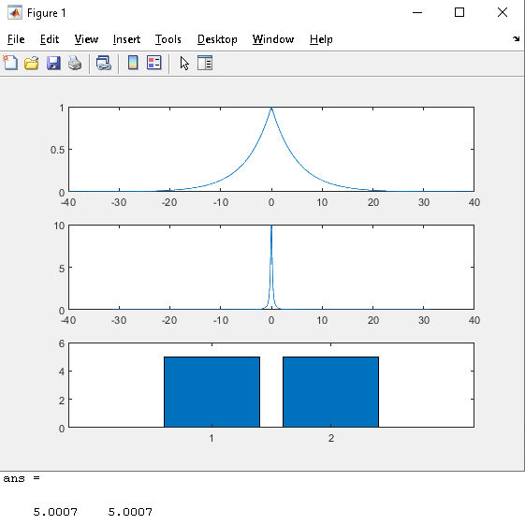

**Fourier Transform Time Scaling Property:**

The Fourier Transform Time Scaling property relates changes in the time domain to the frequency domain. It states that compressing or expanding a signal in the time domain results in a corresponding compression or expansion in the frequency domain. Mathematically, for a time-scaled signal

x(at), the Fourier Transform is given by:



**MATLAB Code**

clc

clear all

close all

step_omega=0.1*pi;

step_size_t=0.01;

t=-40:step_size_t:40;

length_t=length(t);

omegax=-(1/step_size_t)*pi:step_omega:(1/step_size_t)*pi;

length_omega=length(omegax);

expo_omega = zeros(length_omega, length(t)); % Initialize expo_omega with the correct dimensions

for ii=1:length_omega

expo_omega(ii,:)=exp(-1j*omegax(ii).*t);

end

[x_t_1] = signal_gen(t, 9, 1, 0.7, 1, 10,...

step_size_t, length_t);

[x_t_2] = signal_gen(t, 9, 1, 0.7, 1, 20,...

step_size_t, length_t);

subplot(3,1,1), plot(t, [x_t_1; x_t_2])

[X_omega_1, omegax] = computation_of_FT(x_t_1, step_size_t, expo_omega, omegax, length_omega);

[X_omega_2, omegax] = computation_of_FT(x_t_2, step_size_t, expo_omega, omegax, length_omega);

%Magnitute spectrum

X_omega_Mag_1=abs(X_omega_1);

X_omega_Mag_2=abs(X_omega_2);

%Phase of the

Angle_X_omega_1=atan(imag(X_omega_1)./real(X_omega_1) );

Angle_X_omega_2=atan(imag(X_omega_2)./real(X_omega_2) );

%theoertical calculation of phase and magnitute

for ii=1:length(omegax)

X_omega_Mag_the(ii)=0;

Angle_X_omega_the(ii)=0;

end

subplot(3,1,2), plot(omegax, [X_omega_Mag_1; X_omega_Mag_2] );

subplot(3,1,3), plot(omegax, [Angle_X_omega_1; Angle_X_omega_2] );

pause(1)

figure, plot(omegax/(2*pi), real([X_omega_1; X_omega_2]) );

% [x_t_recover, t] = computation_of_IFT...

% (X_omega, omegax, step_omega, t);

% subplot(2,2,4), plot(t, real(x_t_recover));

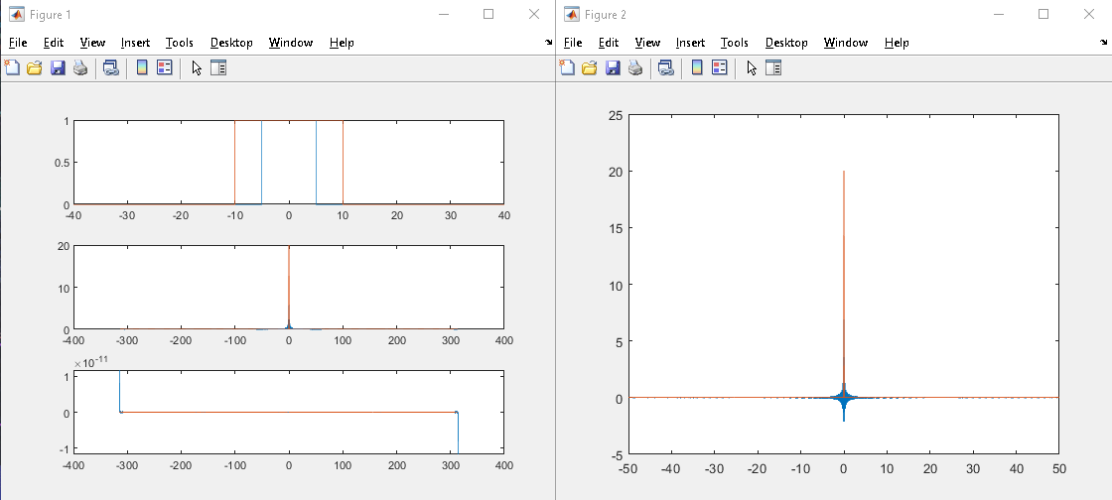

**Conclusion:**

In conclusion, Parseval's theorem provides a useful tool for comparing the energy of a signal in both the time and frequency domains. The Fourier Transform time scaling property allows us to understand how changes in the time domain affect the frequency domain representation of a signal. These concepts are fundamental to signal processing and have practical applications in various fields.