

Applied Signals & System (ECE – 205)

Lab-3 Report

Batch- ECE- IoT-1

**Submitted by – Jjateen Gundesha (BT22ECI002) Submitted to - Dr. Nikhil Agrawal**

**Aim:**To explore Parseval's Theorem and the Fourier Transform Time Scaling Property. Parseval's Theorem establishes a relationship between the energy of a signal in the time domain and its frequency domain representation. Additionally, we will investigate how scaling a signal in the time domain affects its Fourier transform. Furthermore, this lab introduces the Laplace transform and examines its properties.

**Theory:**

**Parseval's Theorem:**

Parseval's theorem is a fundamental property of signals in both time and frequency domains. It states that the total energy of a signal in the time domain is equal to the total energy of its Fourier Transform in the frequency domain. Mathematically, it is expressed as:



Where:

* x(t) is the time-domain signal.
* X(ω) is its Fourier Transform.

**MATLAB Code**

clc

clear all

close all

step_omega=0.01*pi;

step_size_t=0.1;

t=-40:step_size_t:40;

length_t=length(t);

omegax=-(1/step_size_t)*pi:step_omega:(1/step_size_t)*pi;

length_omega=length(omegax);

expo_omega = zeros(length_omega, length(t)); % Initialize expo_omega with the correct dimensions

for ii=1:length_omega

expo_omega(ii,:)=exp(-1j*omegax(ii).*t);

end

[x_t_1] = signal_gen(t, 5, 1, 0.2, 0.5, 10,...

step_size_t, length_t);

%Enery of the signal in time domain

data=abs(x_t_1).^2;

energy_t=my_int_fun(data, step_size_t);

subplot(3,1,1), plot(t, [x_t_1])

[X_omega_1, omegax] = computation_of_FT(x_t_1, step_size_t, expo_omega, omegax, length_omega);

%Magnitute spectrum

X_omega_Mag_1=abs(X_omega_1);

%Phase of the

Angle_X_omega_1=atan(imag(X_omega_1)./real(X_omega_1) );

%Enery of the signal in Fre. domain

data=abs(X_omega_Mag_1).^2;

energy_fre=(1/(2*pi))*my_int_fun(data, step_omega);

%Integration function

subplot(3,1,2), plot(omegax, [X_omega_Mag_1] );

subplot(3,1,3), bar([energy_t, energy_fre ]);

pause(1)

[energy_t, energy_fre ]

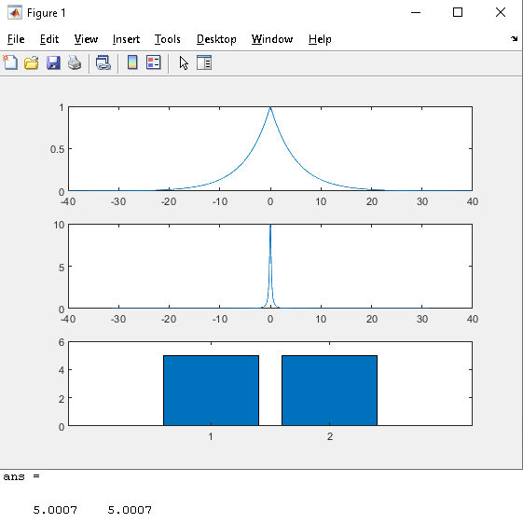

**Fourier Transform Time Scaling Property:**

The Fourier Transform Time Scaling property relates changes in the time domain to the frequency domain. It states that compressing or expanding a signal in the time domain results in a corresponding compression or expansion in the frequency domain. Mathematically, for a time-scaled signal

x(at), the Fourier Transform is given by:



**MATLAB Code**

clc

clear all

close all

step_omega=0.1*pi;

step_size_t=0.01;

t=-40:step_size_t:40;

length_t=length(t);

omegax=-(1/step_size_t)*pi:step_omega:(1/step_size_t)*pi;

length_omega=length(omegax);

expo_omega = zeros(length_omega, length(t)); % Initialize expo_omega with the correct dimensions

for ii=1:length_omega

expo_omega(ii,:)=exp(-1j*omegax(ii).*t);

end

[x_t_1] = signal_gen(t, 9, 1, 0.7, 1, 10,...

step_size_t, length_t);

[x_t_2] = signal_gen(t, 9, 1, 0.7, 1, 20,...

step_size_t, length_t);

subplot(3,1,1), plot(t, [x_t_1; x_t_2])

[X_omega_1, omegax] = computation_of_FT(x_t_1, step_size_t, expo_omega, omegax, length_omega);

[X_omega_2, omegax] = computation_of_FT(x_t_2, step_size_t, expo_omega, omegax, length_omega);

%Magnitute spectrum

X_omega_Mag_1=abs(X_omega_1);

X_omega_Mag_2=abs(X_omega_2);

%Phase of the

Angle_X_omega_1=atan(imag(X_omega_1)./real(X_omega_1) );

Angle_X_omega_2=atan(imag(X_omega_2)./real(X_omega_2) );

%theoertical calculation of phase and magnitute

for ii=1:length(omegax)

X_omega_Mag_the(ii)=0;

Angle_X_omega_the(ii)=0;

end

subplot(3,1,2), plot(omegax, [X_omega_Mag_1; X_omega_Mag_2] );

subplot(3,1,3), plot(omegax, [Angle_X_omega_1; Angle_X_omega_2] );

pause(1)

figure, plot(omegax/(2*pi), real([X_omega_1; X_omega_2]) );

% [x_t_recover, t] = computation_of_IFT...

% (X_omega, omegax, step_omega, t);

% subplot(2,2,4), plot(t, real(x_t_recover));

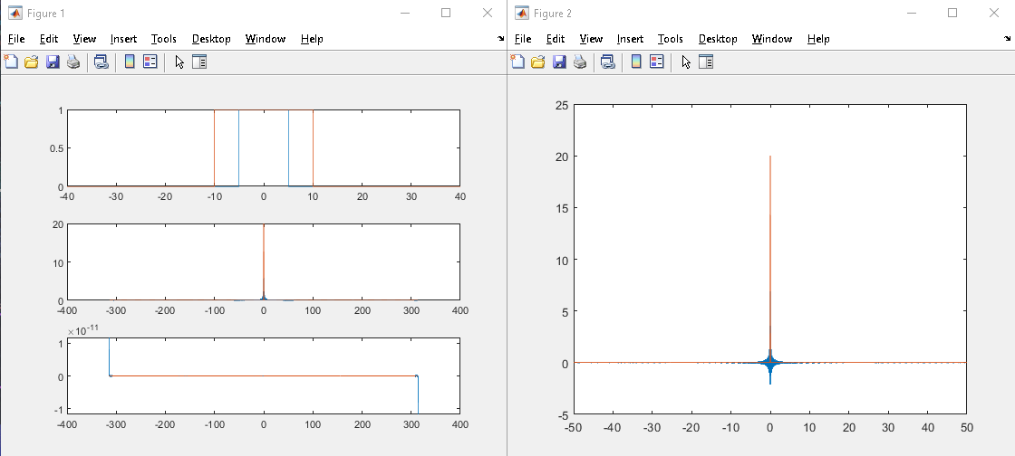

**Laplace Transform:**

The Laplace transform is a powerful mathematical tool used in engineering and physics to analyse linear time-invariant (LTI) systems. It transforms a function of time, often denoted as x(t), into a complex function of a complex variables, denoted as X(s), where s=σ+jω. The Laplace transform of a continuous-time signal x(t) is defined by the integral:



where s is a complex variable. The Laplace transform provides a convenient way to analyse and solve linear differential equations and systems of differential equations with initial conditions.

**MATLAB Code**

function [int_ans] = my_int_fun(data, step_size)

%Integration function

% Detailed explanation goes here

int_ans=(step_size/2)*...

(data(1,1)+data(1,end)...

+2*sum(data(1,2:end-1)));

end

function [X_s, s] = computation_of_LT(x_t, step_t, expo_s, s, length_s)

% This program will compute the Laplace transform

% Input: signal, time step, exponentials, Laplace variable, and length of Laplace variable

for ii = 1:length_s

temp = x_t .* expo_s(ii, :);

X_s(ii) = my_int_fun(temp, step_t);

end

end

clc

clear all

close all

step_s = 0.1;

s = -40:step_s:40;

length_s = length(s);

step_size_t = 0.1;

t = -40:step_size_t:40;

length_t = length(t);

for ii = 1:length_s

expo_s(ii,:) = exp(-s(ii) * t);

end

[x_t_1] = signal_gen(t, 2, 1, 0, 0, 0, step_size_t, length_t);

subplot(3,1,1), plot(t, [x_t_1])

[X_s_1, s] = computation_of_LT(x_t_1, step_size_t, expo_s, s, length_s);

% Magnitude spectrum

X_s_Mag_1 = abs(X_s_1);

% Phase of the Laplace transform

Angle_X_s_1 = atan(imag(X_s_1)./real(X_s_1));

% Theoretical calculation of phase and magnitude

for ii = 1:length(s)

X_s_Mag_the(ii) = 0;

Angle_X_s_the(ii) = 0;

end

subplot(3,1,2), plot(s, [X_s_Mag_1]);

subplot(3,1,3), plot(s, [Angle_X_s_1]);

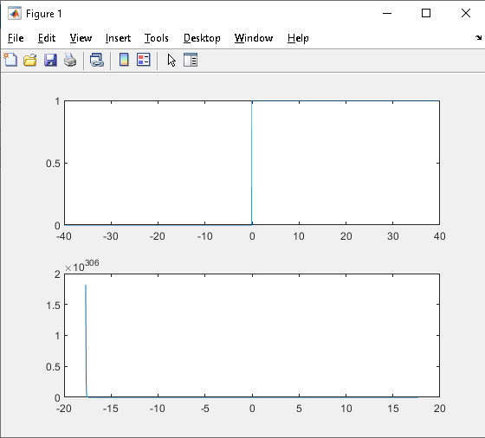

**Conclusion:**

In conclusion, Lab 5 provided valuable insights into Parseval's Theorem, the Fourier Transform Time Scaling Property, and introduced the Laplace transform. These concepts are essential for understanding the relationship between time and frequency domains in signal processing applications. The exploration of these properties enhances our ability to analyze and manipulate signals effectively.