 

Applied Signals & System (ECE – 205)

Lab-1 Report

Batch- ECE- IoT-1

**Submitted by – Jjateen Gundesha (BT22ECI002) Submitted to - Dr. Nikhil Agrawal**

**Aim -** To generate all fundamental Continuous Signals in MATLAB.

**Theory –** All the fundamental signals which we are going to produce are-

* **Unit impulse-** A unit impulse, often denoted as δ(t), is a mathematical function used in signal processing and mathematics. It is also known as the Dirac delta function and is defined as follows:

δ (t) = 0 for t ≠ 0

δ(t) = ∞ for t = 0

The unit impulse is characterized by the property that its integral over the entire real line is equal to 1:

∫ δ(t) dt = 1

* **Unit step -** A unit step function, often denoted as u(t), is another mathematical function commonly used in signal processing and mathematics. It is also known as the Heaviside step function and is defined as follows:

u(t) = 0 for t < 0 u(t) = 1 for t ≥ 0

* **Unit ramp-** The unit ramp function, often denoted as r(t), is a mathematical function that represents a linear increase with time. It is sometimes referred to as the ramp function or simply the ramp. The unit ramp function is defined as follows:

r(t) = 0 for t < 0

r(t) = t for t ≥ 0

* **Signum function (sgn (t)) -** The unit ramp function, often denoted as r(t), is a mathematical function that represents a linear increase with time. It is sometimes referred to as the ramp function or simply the ramp. The unit ramp function is defined as follows:

r(t) = 0 for t < 0

r(t) = t for t ≥ 0

* **Single sided exponential -**  A single-sided exponential function, often referred to as a one-sided exponential function, is a mathematical function that describes exponential growth or decay over a specified interval of time, typically for values greater than or equal to zero.
* **Double sided exponential -** A double-sided exponential function is a mathematical function that describes exponential growth and decay in both positive and negative directions from a reference point, often centered around t = 0.
* **Sin function -** The sine function, often denoted as "sin(x)," is a fundamental trigonometric function in mathematics. It describes a periodic oscillatory behavior and is used to model various wave-like phenomena, such as sound waves, electromagnetic waves, and mechanical vibrations.
* **Cos function -** The cosine function, often denoted as "cos(x)," is another fundamental trigonometric function in mathematics. Like the sine function, it describes a periodic oscillatory behavior and is used to model various wave-like phenomena, such as sound waves, electromagnetic waves, and mechanical vibrations.
* **Sinc function -** The sinc function, often denoted as "sinc(x)," is a mathematical function that arises in various areas of mathematics, physics, engineering, and signal processing. It is defined as follows:

sinc(x) = sin(x) / x

* **Gate function -** The gate function, often referred to as a rectangular pulse or rectangular function, is a mathematical function used to describe a signal or waveform that is "on" or "active" for a certain duration and "off" or "inactive" for the rest of the time.

g(t) = 1, for a ≤ t ≤ b

g(t) = 0, otherwise

**Code :**

**1) Unit impulse:**

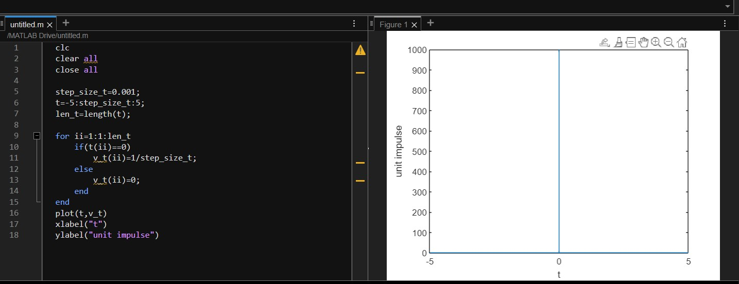clc

clear all

close all

stepsize_t=0.001;

t = -5 : 0.001 : 5;

len_t = length(t);

for ii = 1:1:len_t

if(t(ii)==1) %can shift impulse from this

v_t(ii)=1/stepsize_t;

else

v_t(ii)=0;

end

end

plot(t,v_t)

xlabel("t")

ylabel("unit impulse")

**2) Unit step:**

clc

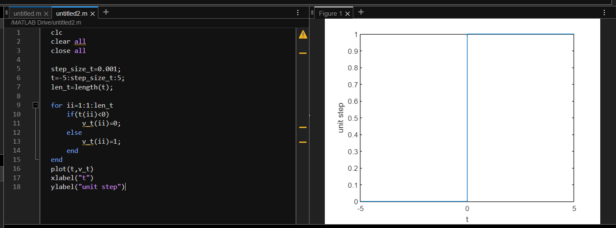clear all

close all

stepsize_t=0.001;

t = -5 : 0.001 : 5;

len_t = length(t);

for ii = 1:1:len_t

if(t(ii)>=0) %can shift graph from this

v_t(ii)=1;

else

v_t(ii)=0;

end

end

plot(t,v_t)

xlabel("t")

ylabel("unit step")

**3) Unit ramp:**

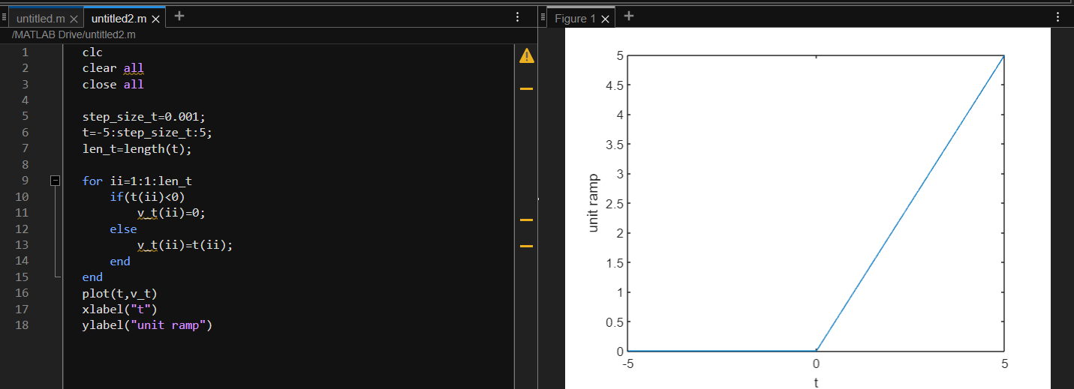clc

clear all

close all

stepsize_t=0.001;

t = -5 : 0.001 : 5;

len_t = length(t);

for ii = 1:1:len_t

if(t(ii)>0) %can shift graph from this

v_t(ii)=t(ii);

else

v_t(ii)=0;

end

end

plot(t,v_t)

xlabel("t")

ylabel("unit ramp ")

**4) Signum function:**

clc

clear all

close all

a=0.5;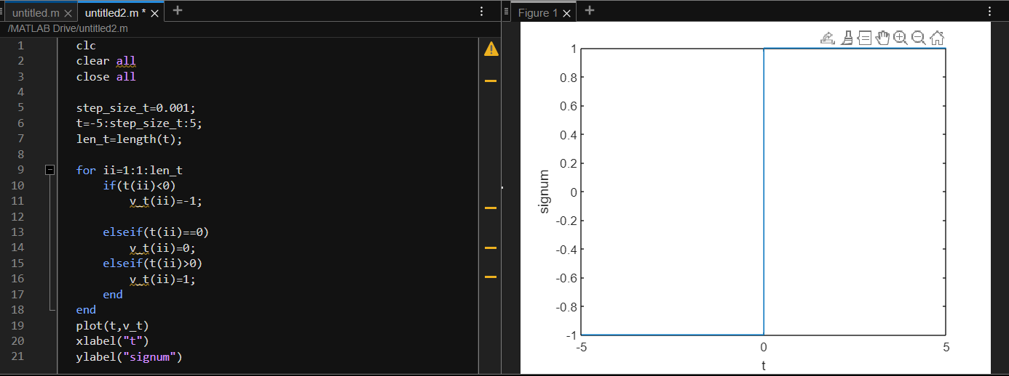stepsize_t=0.001;

t = -5 : 0.001 : 5;

len_t = length(t);

for ii = 1:1:len_t

if(t(ii)>0) %can shift graph from this

v_t(ii)=1;

elseif(t(ii)<0) %can shift graph from this

v_t(ii)=-1;

else

v_t(ii)=0;

end

end

plot(t,v_t)

xlabel("t")

ylabel("signum")

**5) Single sided exponential:**

clc

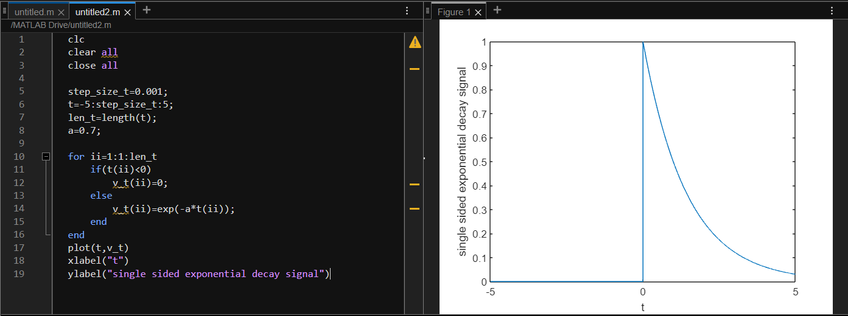clear all

close all

a=0.5;

stepsize_t=0.001;

t = -5 : 0.001 : 5;

len_t = length(t);

for ii = 1:1:len_t

if(t(ii)<0) %can shift graph from this

v_t(ii)=0;

else

v_t(ii)=exp(-a*t(ii));

end

end

plot(t,v_t)

xlabel("t")

ylabel("single sided exponential decay signal")

**6) Double sided exponential:**

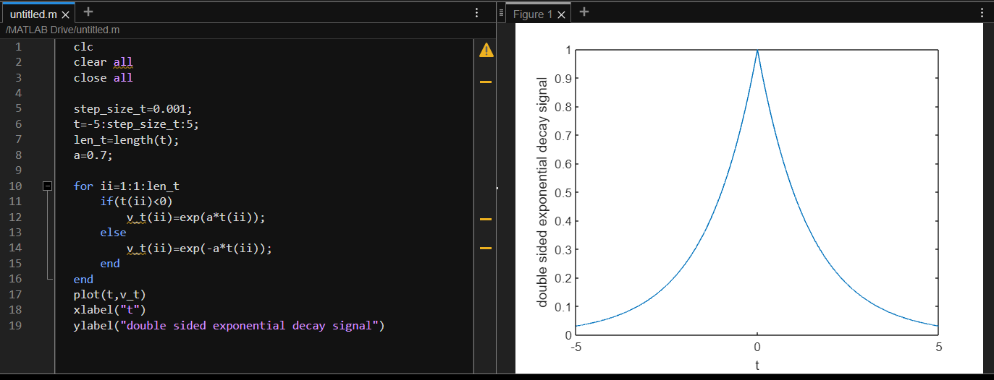clc

clear all

close all

a=0.5;

stepsize_t=0.001;

t = -5 : 0.001 : 5;

len_t = length(t);

for ii = 1:1:len_t

v_t(ii)=exp(-a*abs(t(ii)));

end

plot(t,v_t)

xlabel("t")

ylabel("double sided exponential decay signal")

**7) Sin function:**

clc

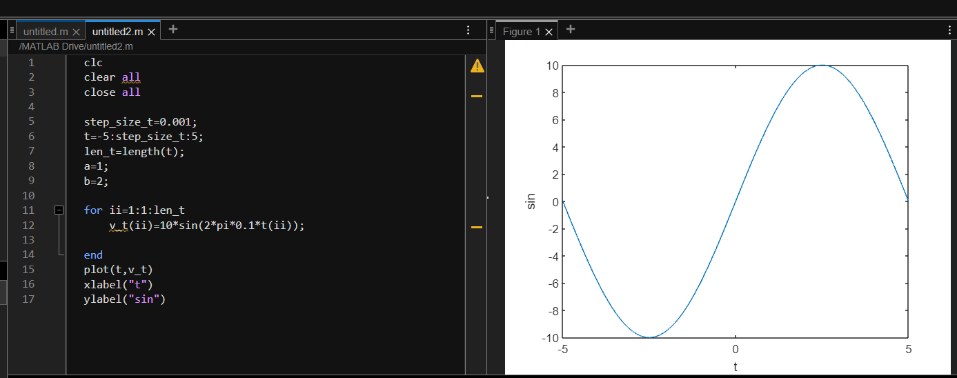clear all

close all

a=0.5;

stepsize_t=0.001;

t = -5 : 0.001 : 5;

len_t = length(t);

for ii = 1:1:len_t

v_t(ii)=sin(t(ii));

end

plot(t,v_t)

xlabel("t")

ylabel("sin")

**8) Cos function:**

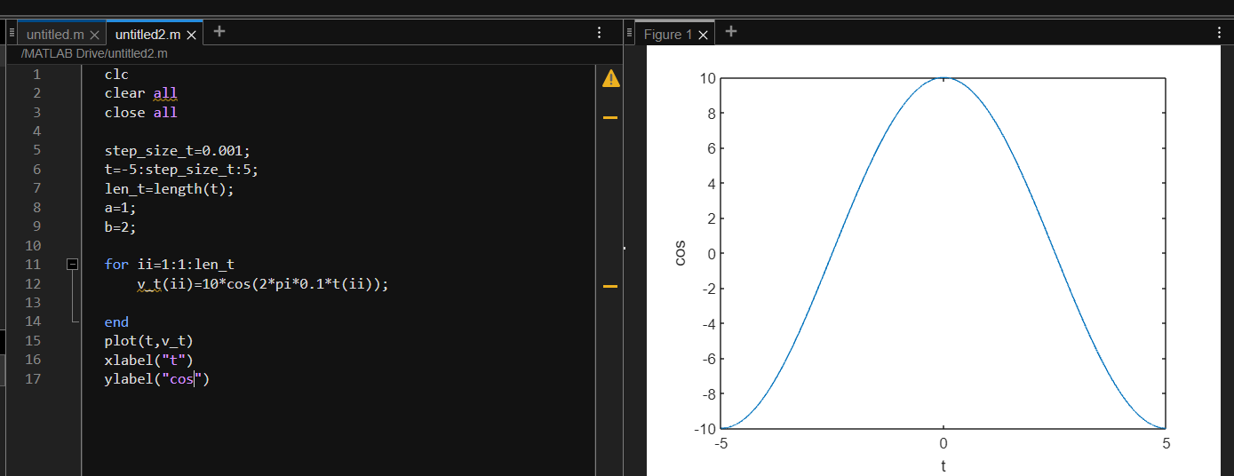clc

clear all

close all

a=0.5;

stepsize_t=0.001;

t = -5 : 0.001 : 5 ;

len_t = length(t);

for ii = 1:1:len_t

v_t(ii)=cos(t(ii));

end

plot(t,v_t)

xlabel("t")

ylabel("cos")

**9) Sinc function:**

clc

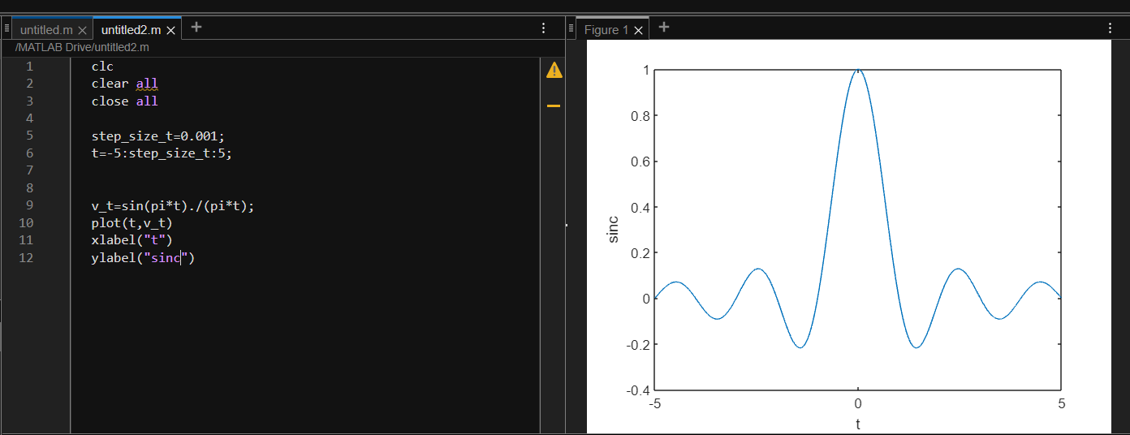clear all

close all

a=0.5;

stepsize_t=0.001;

t = -5 : 0.001 : 5;

len_t = length(t);

for ii = 1:1:len_t

v_t(ii)=sin(2*pi*t(ii))/(2*pi*t(ii));

end

plot(t,v_t)

xlabel("t")

ylabel("sinc")

**10) Gate function:**

clc

clear all

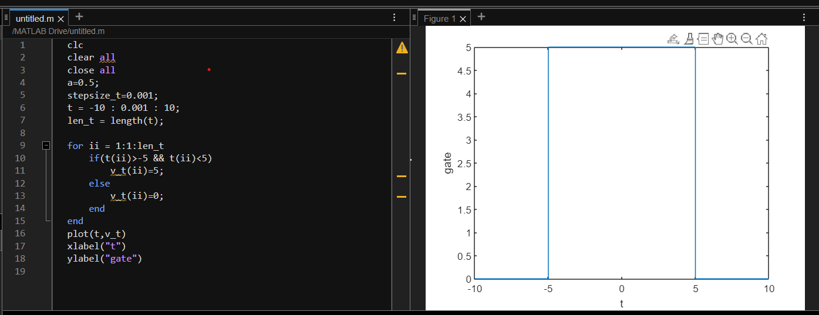close all

a=0.5;

stepsize_t=0.001;

t = -10 : 0.001 : 10;

len_t = length(t);

for ii = 1:1:len_t

if(t(ii)>-5 && t(ii)<5)

v_t(ii)=5;

else

v_t(ii)=0;

end

end

plot(t,v_t)

xlabel("t")

ylabel("gate ")

**Conclusion**: By generating and working with these fundamental continuous signals in MATLAB, we gained a deeper understanding of their characteristics, behavior, and mathematical representations. These signals play a pivotal role in numerous engineering and scientific applications, serving as the basis for more complex signal manipulation, analysis, and processing.