Frontent Assignment

part 1: Web designging

part 2: Advance javascript

part:3 RectJs

module 1) -foundation

Do search for for web-site,http,URL etc given topics in lecture.

Module 2)Fondamentals of IT

do search for domin,hosting,SEO etc.

Module 2)HTML

* Are the HTML tags and elements the same thing?

:-HTML elements and tags are a lot different.

HTML Tags are building blocks of HTML

this tags is used in pairs

tags is considered as the start with<this bracket and ends with >this bracket

element in HTML close the content in between the tags.

it's depends on the HTML structure.

* what are the tags and attribute in HTML?

HTML start with < -less than and ends with > - greaterthan.

* What are the void elements in HTML ?with examples.

void elements are self-closing elements.

void elements are use for breaks the line and underline for 100%

width of the page.

examples:- <br>,<hr>,<img>,etc.

* what are the HTML entities?with examples.

HTML entities are <>,=,-,etc.

What are different types of lists in HTML? With Example.

there are 3 types list in html:-

1.ol

2.ul

3.dl

• What is the ‘class’ attribute in HTML? With Example.

the class attribute is define any url.

example :

.class="one"

• What is the difference between the ‘id’ attribute and the ‘class’ attribute of HTML elements? With Example.

class attribute is used for maltipes and id is used for ID attribute is used for within the page in HTML.

examples:-

ID= for define the id we are use #(hash)

class=for define the class we are use .(dot)

#one

.one

• What are the various formatting tags in HTML?

varios formatting tags are use for colorsheets,size and fonts.

examples:-

<br>

<i>

<hr>

<strong>

<mark>

<small>

• How is Cell Padding different from Cell Spacing? With Example.

cell pading id inner space of the cell.

cell spacing is outer space of the cell.

• How can we club two or more rows or columns into a single row or column in an HTML

table? With Example.

for clubbing the rows we are using the colspan.

clubbing the column we are using colspan.

colspan="2"

rowspan="2".

• What is the difference between a block-level element and an inline element?

block level element is break the full width of page.

<p>

<div>

inline element is covering the full width of the page.

<a>

<b>

<br>

<table>

<textarea>

<Div>

• How to create a Hyperlink in HTML? With Example.

for creating anyhyperlink there is tag.

tag is <a>

example

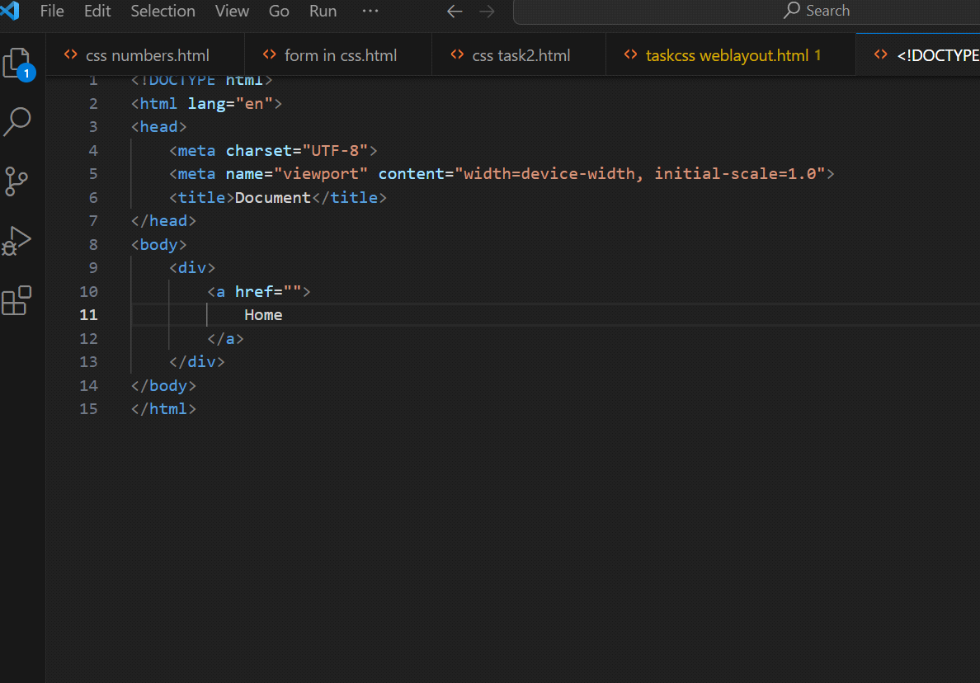

• What is the use of an iframe tag? With Example.

iframe tag is use for any img,icon,and logo.

• What is the use of a span tag? Explain with example?

The <span> tag is an inline container used to mark up a part of a text, or a part of a document.

it also in table and div.

• How to insert a picture into a background image of a web page? With Example.

<img> tag in HTML is insert image in background of the web page.

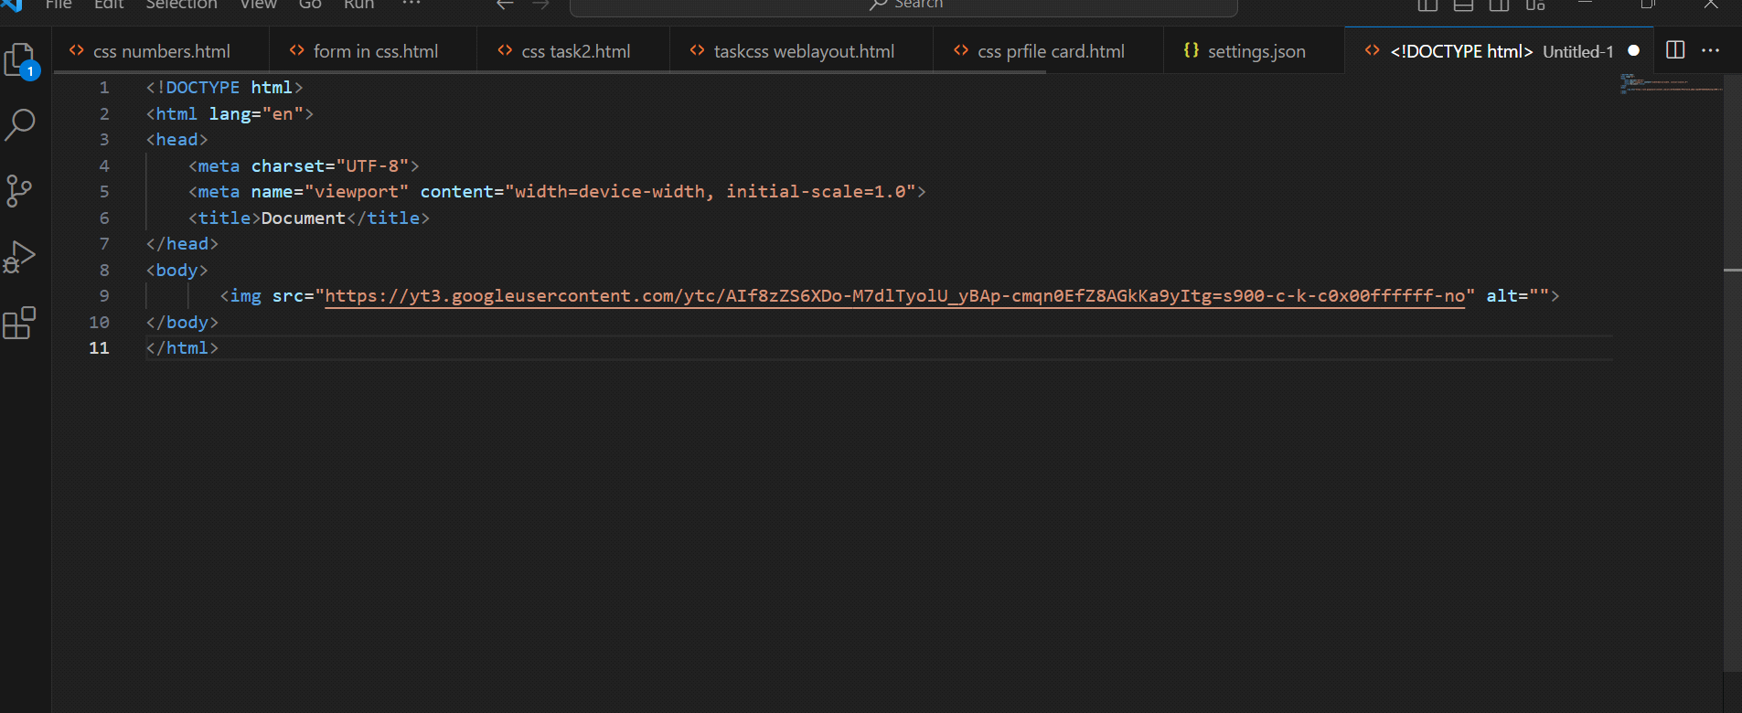

• How are active links different from normal links?

active link are typically link to lead the web site. normal link are are broken.normal link colour is purple and active link colour is blue.

• What are the different tags to separate sections of text?

tags is used toseparate the line of text.ut breaks the current line and new line.

like: <br>

<p>

<blockquote>

• What is difference between HTML and XHTML?

HTML's primary purpose is to display content, given in a text-based document, in a graphical form in the browser. In contrast, XML allows different applications to exchange and store data and its structure in a way that is universally understood.

• What are logical and physical tags in HTML?

logical tag are define the value of tag.

<same>

<strong>

physical tags are inserting the font and web page.

<b>

• Create below example using only HTML tags without CSS.

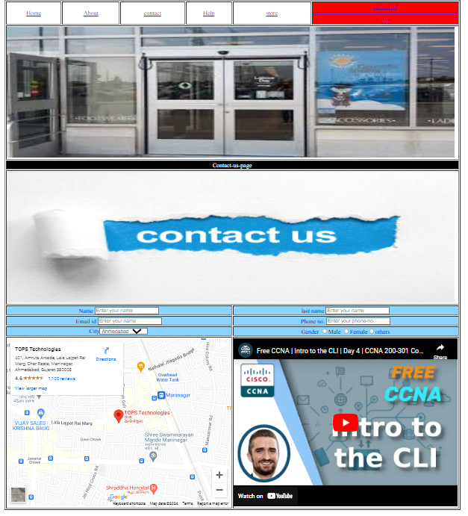

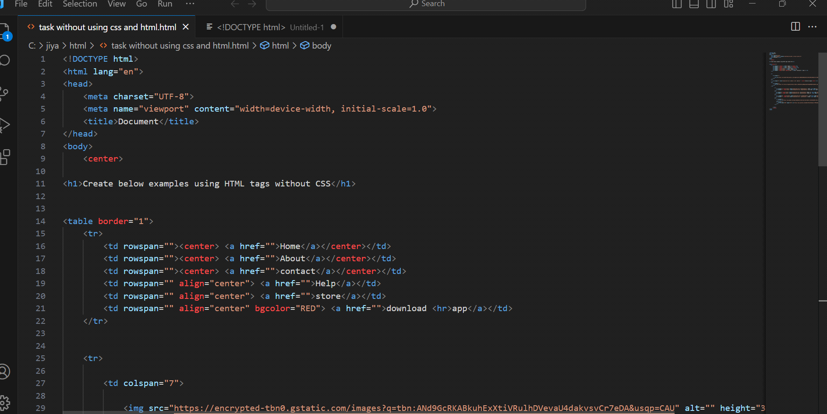

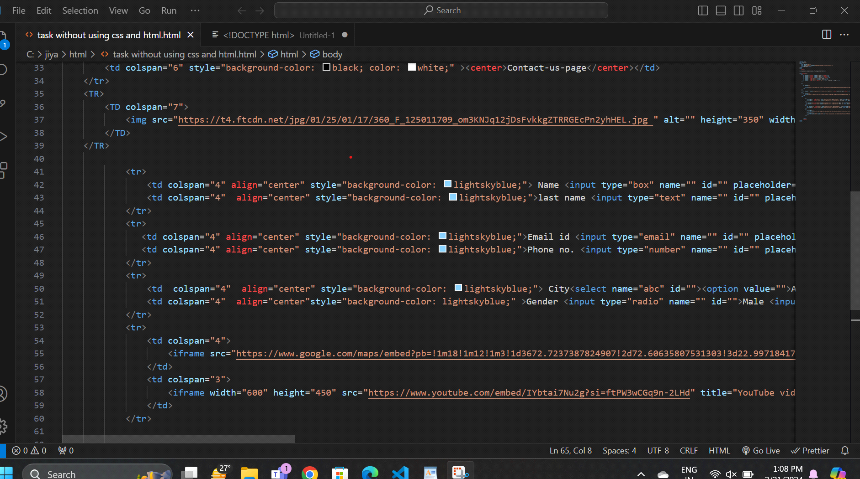

Module 4) CSS and CSS 3

• What are the benefits of using CSS?

1)CSS is inserting the fonts and font/text size.

2) Faster Page Speed. More code means slower page speed and don't scroll the page.

3)Decorations the texts,colours,and web page.

• What are the disadvantages of CSS?

1)CSS is not secure.

2)it takes a lot of time to creat anything

3)it isn't flexible as other webpage developers like dreamweaver

• What is the difference between CSS2 and CSS3?

CSS is old colors of format.but CSS3 is different gradient colors and sades.

just like:-

RDBA,HSLA,HSL and other color gradient.

• Name a few CSS style components

1)inline css

2)internal css

3)external css

• What do you understand by CSS opacity?

CSS opacity can change color and transparent any background colors.css opacity is 0 to 1.

0 is completely transparent color.

• How can the background color of an element be changed?

selecting the elements and define the class name or id name tham apply background-color property on it to set the background color.

• How can image repetition of the backup be controlled?

repeating controlled bt using the background-repeat property.

• What is the use of the background-position property?

the background-position property sets the initialposition for each image.

• Which property controls the image scroll in the background?

background-attachment property sets image scroll in the background.

• Why should background and color be used as separate properties?

color is referring to the text color in that element.

background is shorthand to combine many background tags into one line

• How to center block elements using CSS1?

we can specify by the margin top and left or right for the center

• How to maintain the CSS specifications?

CSS specifications maintain by the word wibe web.

• What are the ways to integrate CSS as a web page?

There are three ways of integrate a style sheet:

1)External CSS.

2)Internal CSS.

3)Inline CSS.

• What is embedded style sheets?

An embedded style sheet is declared within the <head> element .

It applies to the whole document, rather than just one element.

• What are the external style sheets?

external style sheet is creat other web page.

with external style sheet you can change the look of entire website bt changing just file.

• What are the advantages and disadvantages of using external style sheets?

page loading time is very slow.

small numbers of stylesheet definitions

until the external stylesheet is load it may not posible to render the documents.

• What is the meaning of the CSS selector?

CSS selector is heart and soul of the CSS.

CSS selectore define which HTML code you going to be manipulating with

css code.

• What are the media types allowed by CSS?

1)all Suitable for all devices.

2)aural Intended for speech synthesizers.

3)braille Intended for braille tactile feedback devices.

4)embossed Intended for paged braille printers.

• What is the rule set?

A rule set is a collection of elements and x elements.