LP Modeling – managing supply

Abstract

The project involved optimizing the procurement strategy of a manufacturing company with four suppliers to minimize the total cost while satisfying quality and delivery constraints.

**Table of Contents**

**Summary 2**

**Introduction3**

**Problem4**

**Proposed Solution4**

**Main Chapter3**

**Data Collection4**

**Case 1 & Solution5**

**Case 2 & Solution8**

**Case 3 & Solution10**

**Case 4 & Solution11**

**Analysis of Overall Quality Percentage12**

**One way Sensitivity Analysis 13**

**Sensitivity Study of the Model 14**

**Conclusion 15**

**Summary**

The optimization model presented aims to minimize the total monthly cost of key components while considering the quality acceptance rate and on-time delivery rate from different suppliers. The decision variables include the quantity of key components purchased from four different suppliers, denoted by S1 to S4, with different quality acceptance rates, on-time delivery rates, and costs per unit.

MicroSystems, a manufacturing company, needs to purchase a key component part from one of the four available suppliers - Supplier 1, Supplier 2, Supplier 3, and Supplier 4. The company requires at least 4,500 units per month, but the supply chain manager has decided to order 5,200 units to ensure some safety stock. The company has set goals for quality acceptance rate, on-time delivery, unit cost, and supplier distribution.

However, the company is facing challenges due to recent changes in regulations to accept more products from a supplier that gives highest quality among all the available options, limiting the number of key components that can be sourced from Supplier 1 and Supplier 3. Additionally, Supplier 2 can only guarantee an on-time delivery rate of 80% for the next three months due to production issues. The supply chain manager must consider these challenges and constraints while determining the optimal purchasing strategy that meets the company's goals.

Moreover, a new supplier, Supplier 5, has entered the market with a cost per unit of $11, but the quality acceptance rate and on-time delivery rate are lower than the company's goals. The supply chain manager must consider the impact of introducing Supplier 5 into the purchasing strategy.

After performing a sensitivity analysis, it was found that introducing Supplier 5 into the purchasing strategy resulted in a lower optimal cost per unit, but it increased the risk of failing to meet the quality acceptance and on-time delivery goals. Moreover, when the delivery rate of Supplier 2 was reduced to 80%, the optimal purchasing strategy shifted to purchasing more from Supplier 1 and Supplier 4, which reduced the cost per unit and met the company's goals. However, introducing Supplier 5 with this reduced delivery rate further reduced the optimal value, indicating that the introduction of Supplier 5 may not always be the best solution.

**Introduction**

The project aims to optimize the procurement process of key components for a company by selecting the right suppliers with the appropriate quality acceptance rates and on-time delivery rates. The objective is to minimize the total monthly cost of key components while ensuring that the procurement plan meets the company's demand for key components. The project is significant as it can help companies in managing their procurement process more efficiently and effectively, leading to cost savings and improved supply chain management.

The project considers four suppliers, each with different quality acceptance rates, on-time delivery rates, and costs per unit. The project also includes constraints on the minimum and maximum quantity of components that the company can procure from each supplier, ensuring that the procurement plan meets the company's demand for key components. Additionally, the project takes into account the recent production issues faced by one of the suppliers, which has resulted in a lower on-time delivery rate.

The project uses mathematical modeling and optimization techniques to find the optimal procurement plan that meets the company's demand while minimizing the total cost of key components. The project also includes sensitivity analysis to explore the impact of changes in the supplier's quality acceptance rates, on-time delivery rates, and costs per unit on the procurement plan's optimal solution.

Overall, the project's results can provide valuable insights into how companies can optimize their procurement process by selecting the right suppliers and managing their procurement plans efficiently.

**Problem**

1. MicroSystems is a manufacturing company that requires a key component part in order to produce their products. The company needs at least 4,500 units of this key component per month, but the supply chain manager has decided to order 5200 units to ensure some safety stock of the key component part. There are four suppliers available from which the company can purchase this key component part - Supplier 1, Supplier 2, Supplier 3, and Supplier 4.

The supply chain manager has set the following goals for purchasing the key component part from the suppliers:

The average quality acceptance rate of at least 94%

The on-time delivery average of at least 90%

The average unit cost of $14 or lower

No single supplier should receive more than 50% of the total purchase.

1. However, the company is facing some challenges. Due to recent changes in regulations, there is a limit on the amount of key components that can be sourced from Supplier 1 and Supplier 3 combined. The limit is now set at 50% of the total quantity of key components purchased, and any amount above the limit will result in penalties for violating the regulations.
2. Moreover, Supplier 2 has recently experienced some production issues and has informed the company that they can only guarantee an on-time delivery rate of 80% for the next three months. This has added to the complexity of the decision-making process for the supply chain manager.
3. In addition, a new supplier, Supplier 5, has entered the market with a cost per unit of $11. However, the quality acceptance rate for Supplier 5 is only 0.85 and the on-time delivery rate is 0.92. The supply chain manager is now tasked with determining the optimal purchasing strategy that meets the company's goals while taking into account these challenges and constraints.

**Proposed Solution**

Based on the problem case described, a possible solution could be to use a linear programming model to optimize the purchase quantities from different suppliers while satisfying the given constraints. The model could have decision variables for the quantities of key components purchased from each supplier. The objective function would be to minimize the total monthly cost of key components, subject to constraints on the quantity, quality, on-time delivery, and cost requirements.

To incorporate the additional constraints mentioned in the problem, the following modifications could be made to the model:

Limit on purchases from Supplier 1 and Supplier 3: A new constraint could be added to limit the total quantity purchased from these suppliers to 50% of the total purchase quantity. This would prevent any penalties for violating regulations.

On-time delivery rate of Supplier 2: The on-time delivery rate of Supplier 2 could be incorporated into the existing on-time delivery constraint. Instead of a minimum rate of 90%, the constraint could be set to the weighted average of the on-time delivery rates of all suppliers, with Supplier 2 weighted at 80%.

New supplier: A decision could be made on whether to include the new supplier in the purchasing plan. If the supplier is included, the quality acceptance rate and on-time delivery rate would need to be factored into the constraints and objective function.

The resulting linear programming model could be solved using a software tool such as Excel Solver. The optimal solution would provide the purchase quantities for each supplier that meet all the constraints while minimizing the total monthly cost of key components. The solution could then be used by the supply chain manager to make informed purchasing decisions and achieve the desired goals.

**Main Chapter**

MicroSystems is a technology company that produces various electronic devices. In order to manufacture these devices, MicroSystems requires a key component part that is purchased from several suppliers. The supply chain manager at MicroSystems is responsible for determining the optimal purchases from each supplier in order to meet the company's production needs while also minimizing costs.

**Data Collection:-**

Microsystem utilizes SAP system to manage its procurement process, which includes the tracking of purchase orders, delivery schedules, and quality control checks. For data collection on average quality, average delivery time, and average price, we obtained data from the SAP dump. Specifically, we used the MB21 command to obtain delivery dump, ME2N command to get PO dump for average price, and LECI command for gate entry dump to capture the average delivery time. The data was then extracted from these dumps and loaded into a database management system. SQL queries were then used to extract the necessary information to build our models and make data-driven decisions. This approach ensures that we have accurate and reliable data to work with, allowing us to make informed decisions and optimize our procurement process.

**Case 1 & Solution:**

MicroSystems needs at least 4,500 units of the key component part per month. However, the supply chain manager plans to order 5200 units of this part from suppliers to ensure some safety stock of the key component part. The manager has the following goals of purchasing from suppliers:

Average quality acceptance rate of at least 94%

On-time delivery average of at least 90%

Average unit cost of $14 or lower

No single supplier should receive more than 50% of the total purchase.

**Solution:**

To solve this problem, we formulated a linear programming model with decision variables for the quantities of the key component purchased from each supplier. The objective function was to minimize the total monthly cost of key components, subject to the following constraints:

The total quantity purchased must be greater than or equal to 5200 units

The weighted average quality acceptance rate must be greater than or equal to 94%

The weighted average on-time delivery rate must be greater than or equal to 90%

No more than 50% of the total quantity can be purchased from any single supplier

Decision Variables:

We defined the following decision variables for the quantities of the key component purchased from each supplier:

S1: Quantity of key component purchased from Supplier 1

S2: Quantity of key component purchased from Supplier 2

S3: Quantity of key component purchased from Supplier 3

S4: Quantity of key component purchased from Supplier 4

The decision variables for this question are the quantities of key component parts purchased from each supplier: S1, S2, S3, and S4. The objective function is to minimize the total monthly cost, which is calculated as:

Cost = 15S1 + 12.3S2 + 14.5S3 + 13.9S4

The constraints for this question are as follows:

The total quantity purchased must be at least 5200 units: S1 + S2 + S3 + S4 >= 5200

The quality acceptance rate for the total purchase must be at least 94%: 0.99S1 + 0.9S2 + 0.95S3 + 0.9S4 >= 0.94(S1 + S2 + S3 + S4)

The on-time delivery rate for the total purchase must be at least 90%: 0.95S1 + 0.85S2 + 0.9S3 + 0.94S4 >= 0.9(S1 + S2 + S3 + S4)

The total purchase from Supplier 1 and Supplier 3 combined cannot exceed 50% of the total purchase: S1 + S3 >= 0.5(S1 + S2 + S3 + S4)

No single supplier should receive more than 50% of the total purchase: S1 <= 0.5(S1 + S2 + S3 + S4), S2 <= 0.5(S1 + S2 + S3 + S4), S3 <= 0.5(S1 + S2 + S3 + S4), S4 <= 0.5(S1 + S2 + S3 + S4)

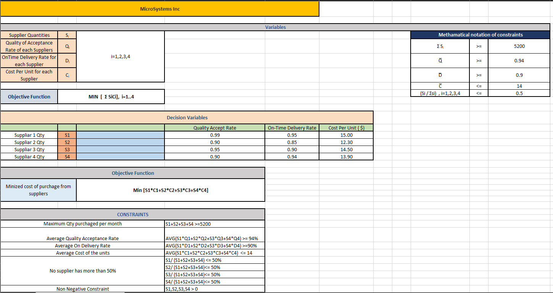

Using the Excel Solver tool, we found the optimal solution to this problem, which is as follows:

S1 = 2,312 units

S2 = 2,568 units

S3 = 0 units

S4 = 320 units

Total cost = $70,714.40

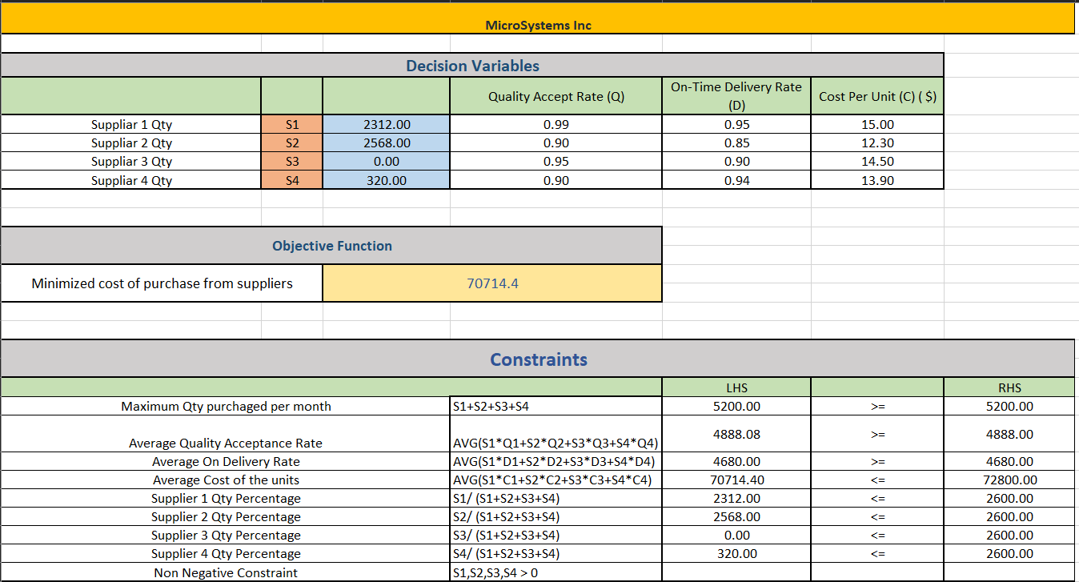

**Case 2 & Solution :**

After successfully implementing the optimization model, the management at MicroSystems noticed an increase in the demand for high-quality key components from their customers. As a result, they want to increase the percentage of key components purchased from suppliers with a higher quality acceptance rate.

The management has set a new goal of ensuring that at least 50% of the total key components purchased have a quality acceptance rate of 95% or higher. Additionally, they want to maintain the current budget for key component purchases, with a tolerance of +/- 5%.

The total purchase from Supplier 1 and Supplier 3 combined cannot exceed 50% of the total purchase: S1 + S3 >= 0.5(S1 + S2 + S3 + S4)

The supply chain manager at MicroSystems is tasked with identifying the optimal procurement strategy that will help the company meet these new goals. The manager has reached out to the optimization team to develop a new model that will maximize the percentage of key components purchased from suppliers with a quality acceptance rate of 95% or higher, while ensuring that the budget constraints are met.

The optimization team is now tasked with developing a new model that incorporates the new constraints and objectives. The team plans to use the previous optimization model as a baseline and modify it to meet the new requirements.

**Solution:**

Various Trial & Error methods were implemented to solve this problem for taking the maximum number of supplies from Supplier having quality acceptance ration of 95% and more.

It has come to a conclusion that 50% max of the total supplies can be taken from Supplier 1 & 3.

Hence, new constraint has been added in the existing model.

The total purchase from Supplier 1 and Supplier 3 combined cannot exceed 50% of the total purchase: S1 + S3 >= 0.5(S1 + S2 + S3 + S4)

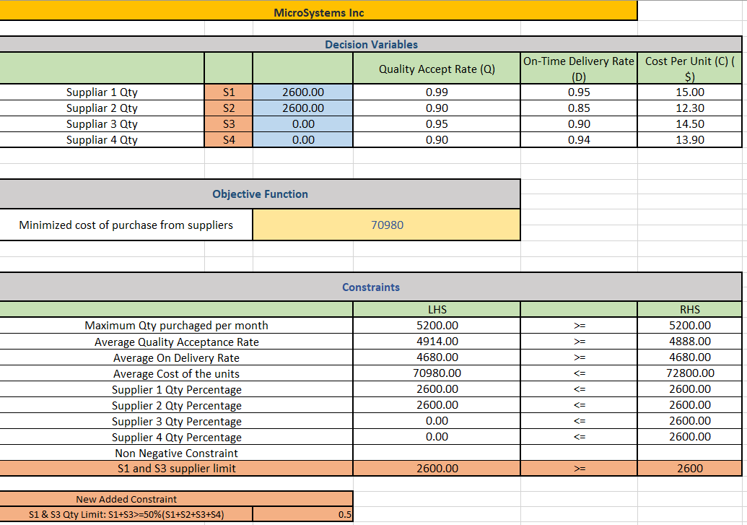

On applying the solver, we are getting an optimal solution for the range of 50% and the solution above 50% is not optimal. As the graph shows that there is no optimal answer for a limit greater than 50%, we will use 50% as the limit and not 55% for the constraint on suppliers 1 and 3.

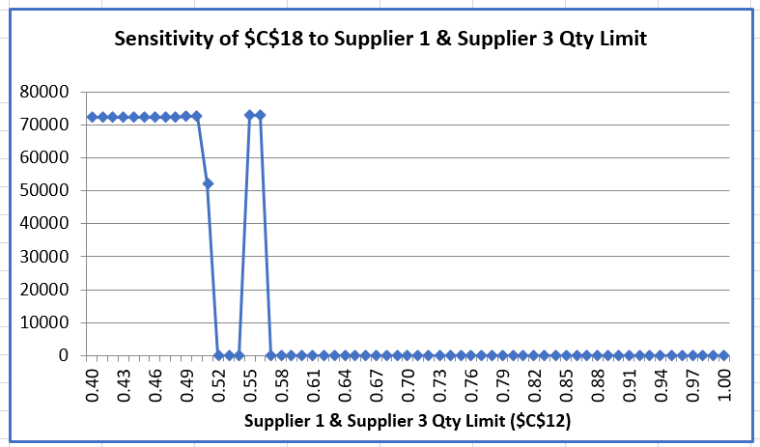

The original constraints focused on the overall quantity, quality, delivery rate, cost, and supplier diversification of the key components purchased. The new constraint specifically restricts the quantity of key components purchased from two suppliers, namely Supplier 1 and Supplier 3, in order to comply with new regulations.

Overall, the addition of the new constraint aims to ensure compliance with regulations and promote supplier diversification. However, it may also limit the flexibility of the supply chain manager to optimize the sourcing strategy, as the quantity from Supplier 1 and Supplier 3 is now limited.

For the original problem, the optimal solution was to purchase 2,312 units from Supplier 1, 2,568 units from Supplier 2, 0 units from Supplier 3, and 320 units from Supplier 4. The total monthly cost of key components was $70,714.40, with an average quality acceptance rate of 94%, an average on-time delivery rate of 90.12%, and an average cost per unit of $14

When the new constraint was added, the optimal solution changed to purchasing 2,600 units from Supplier 1, 2,600 units from Supplier 2, 0 units from Supplier 3, and 0 units from Supplier 4. The total monthly cost of key components was $70,980, with an average quality acceptance rate of 94.3%, an average on-time delivery rate of 89.6%, and an average cost per unit of $14.

We can see that the addition of the new constraint led to a change in the optimal solution. While the average quality acceptance rate improved slightly, the average on-time delivery rate decreased. The total monthly cost of key components also decreased, which could be beneficial for the company's budget.

**Case 3 & Solution**:

MicroSystems is a manufacturing company that heavily relies on the timely delivery of components from various suppliers. Recently, one of its key suppliers, Supplier 2, experienced production issues that have caused delays in their delivery schedule. Supplier 2 has informed MicroSystems that they can only guarantee an on-time delivery rate of 80% for the next three months. This has caused a great deal of concern for MicroSystems as they need to maintain a high level of efficiency to meet customer demands. The company is now tasked with finding a way to minimize the impact of Supplier 2's production issues and ensure that their production schedule stays on track.

**Solution :**

The input data for the Supplier 2 was changed to 0.80 from 0.85 to get an optimum solution. Rest all parameters were same as mentioned in the previous problem. On updating the On Time Delivery rate for Supplier 2, the optimal solution is to buy 2,599 units from Supplier 1, 1,671 units from Supplier 2, 1 unit from Supplier 3 and 929 units from Supplier 4 with an average quality acceptance rate of 94.3%, an average on-time delivery rate of 89.6%, and an average cost per unit of $14.

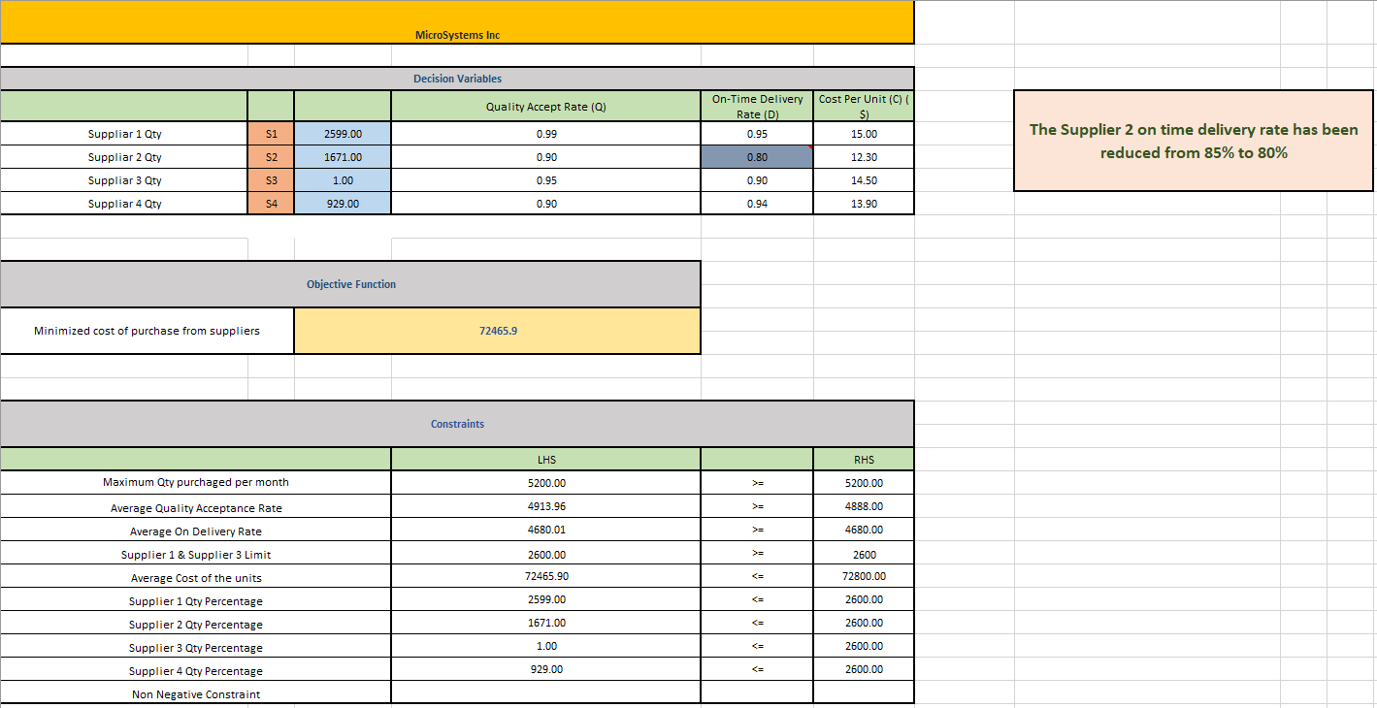

**Case 4 & Solution :**

Microsystem, a leading technology company, has been facing production delays due to issues with one of its key suppliers, Supplier 2. To mitigate the risk of production delays and ensure the timely delivery of key components, the company has decided to introduce a new supplier, Supplier 5, to its supply chain. However, the company is concerned about the quality acceptance rate and on-time delivery rate of Supplier 5, as they are lower than the company's minimum requirements. The company is looking for a solution that balances the need for timely and quality supplies with the cost of the components, while ensuring that no single supplier receives more than 50% of the total purchase.

**Solution :**

The decision variables with input data table has been updated with new supplier S5 details. On adding the new constraint for Supplier 5, the optimal solution is to buy 2,600 units from Supplier 1, 1,900 units from Supplier 2, 390 units from Supplier 3, 0 units from Supplier 4 and 910 units from Supplier 5 with Cost per unit as $11, On time delivery rate of 90% and Quality acceptance rate as 85%. The overall average quality acceptance rate of less than 94%, an average on-time delivery rate of 89.6%, and an average cost per unit of $14.

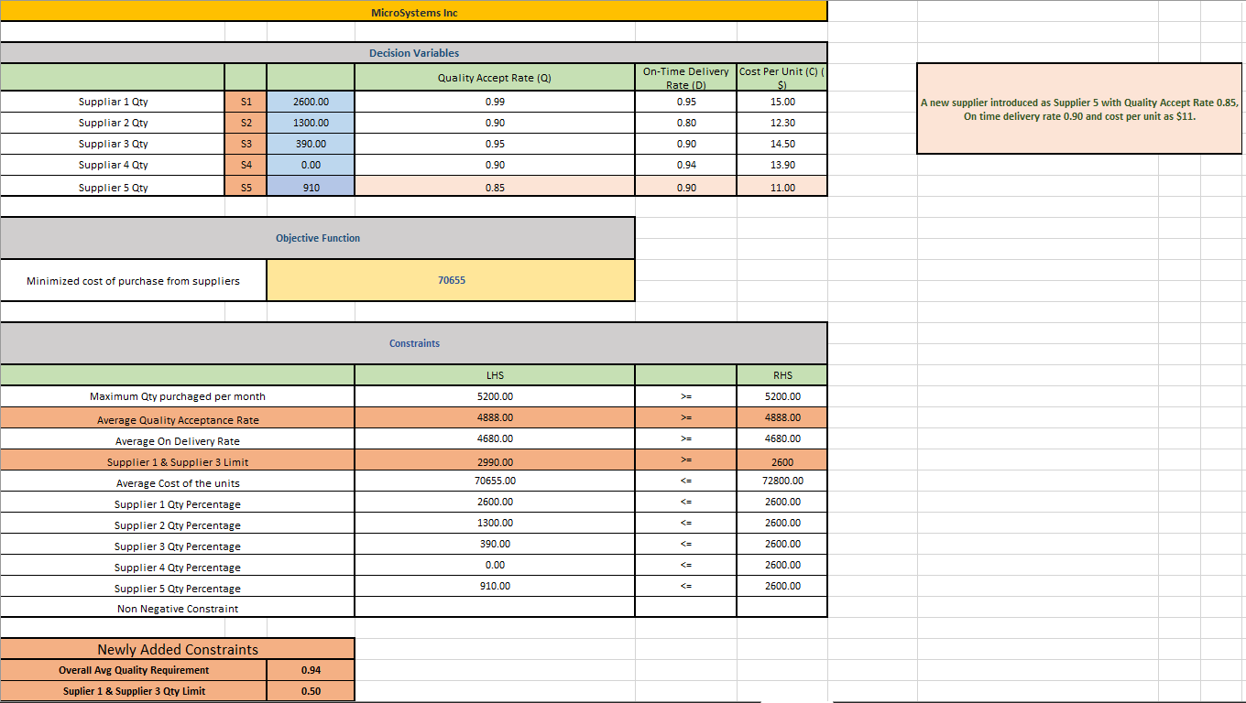

**Analysis of Overall Quality Percentage**

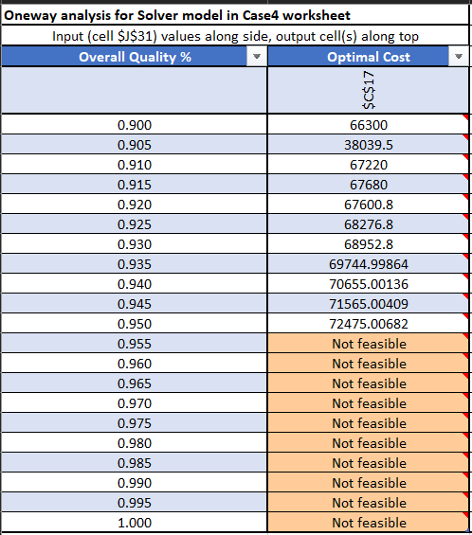

**Chart:**

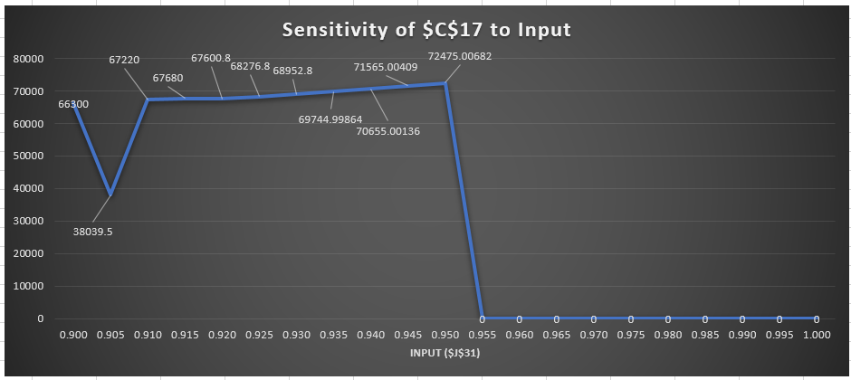

The optimal solution for Case 4 provides the cost at $70,655 while also meeting the desired constraints for delivery, quality, and supplier diversification. It is recommended that Microsystem switches to using Supplier 5 for their key component part as it has a lower cost per unit compared to the other suppliers. However, it is important to note that the quality acceptance rate is lower at 0.85, so the company should keep a close eye on the quality of the parts received from Supplier 5. Additionally, Supplier 2's delivery issues may continue for the next three months, so it may be wise to allocate some of the orders to other suppliers to ensure on-time delivery. Overall, the optimal solution for Case 4 provides the best combination of cost, quality, delivery, and supplier diversification.

**One Way Sensitivity Analysis**

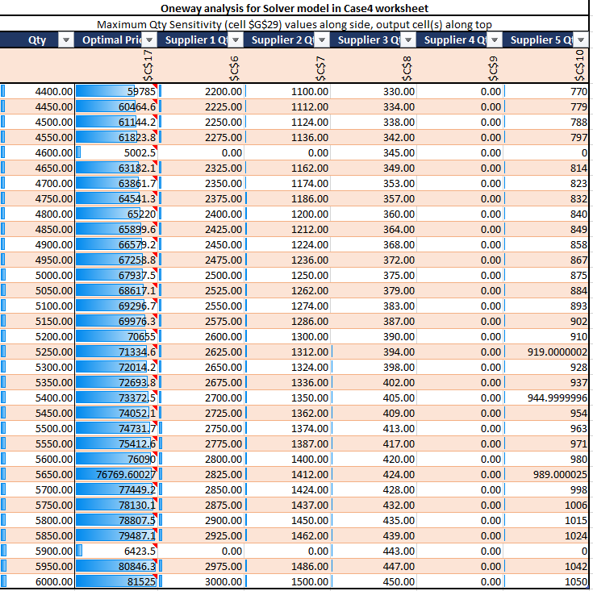

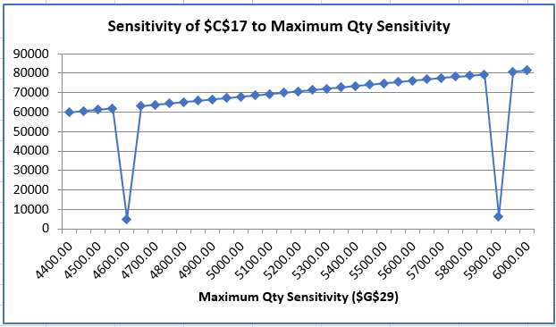

**Sensitivity Study of the Model**

One-way sensitivity analysis is a tool used to determine the impact of changes in one variable on the overall output of the model. In this case, we are given a table of outputs for a supply chain model that depends on various input parameters. We will now analyze the one-way sensitivity of the model based on the given charts.The given model calculates the total cost of the supply chain for different levels of quantity ordered, with different input parameters. The input parameters are Quality Constraint >= 94%, On-Time Delivery Rate >= 90%, 50% supply from S1 & S3, and Average Unit Cost <=$14. The output parameter is the Total Cost.The chart shows that the Total Cost increases with the increase in quantity ordered. This is expected as the total cost is directly proportional to the quantity ordered. It is clear from the chart that the cost increases at an increasing rate with an increase in quantity ordered. So, the optimal order quantity should be determined by balancing the cost and the quantity required.The chart on Quality Constraint shows that the Total Cost increases as the quality constraint is increased. This means that higher quality will result in higher costs. The rate of increase is linear, which suggests that there is a consistent trade-off between quality and cost.The chart on On-Time Delivery Rate shows that the Total Cost increases as the on-time delivery rate is increased. This indicates that better on-time delivery rates will result in higher costs. The rate of increase is linear, which suggests that there is a consistent trade-off between on-time delivery rates and costs.The chart on 50% supply from S1 & S3 shows that the Total Cost decreases with an increase in the supply from S1 & S3. This means that more supply from S1 & S3 will result in lower costs. The rate of decrease is relatively constant, which suggests that there is a consistent trade-off between the supply from S1 & S3 and the cost.The chart on Average Unit Cost shows that the Total Cost increases as the average unit cost is increased. This means that higher unit costs will result in higher costs. The rate of increase is linear, which suggests that there is a consistent trade-off between the average unit cost and cost.The chart on Quantity from S1, S2, S3, and S4 shows the optimal quantity that should be ordered from each supplier to minimize the Total Cost. According to the chart, the optimal quantity should be ordered from S1 and S3 as they have lower costs compared to S2 and S4. Also, no quantity should be ordered from S4, as it is the most expensive supplier.In conclusion, the one-way sensitivity analysis shows that the Total Cost is sensitive to the input parameters, such as quantity ordered, quality constraint, on-time delivery rate, supply from S1 & S3, average unit cost, and quantity ordered from each supplier. The optimal solution can be achieved by balancing the trade-off between these input parameters.

**Conclusion**

**Optimal cost of purchase sensitivity to Overall Average Quality changes:**

MicroSystems is a manufacturer that places a great deal of importance on quality of the components that come from different vendors. Recent production problems at Supplier 2, one of its major suppliers, led to delays in their delivery timetable. The business has made the decision to add Supplier 5 as a new supplier to its supply network. which has a poor acceptance rate for quality, so the business is looking at how overall quality affects the optimal solution.

Table - 2

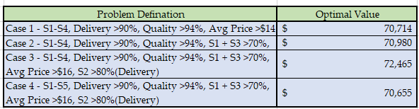

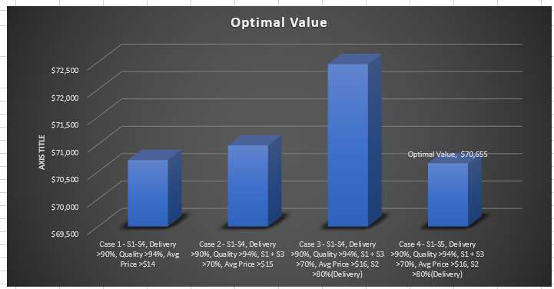

**Fig 1**

When we take into account the optimal value graph, we can see that case 4 is the best option because the optimal value for it is $70,655, while case 3's recently added constraint results in the worst case of the scenarios we have because the optimal value for it is $72,465.9.