**Lab Worksheet 01**

**Q1**

**Code:**

package Q_01;  
import javax.swing. *;  
  
public class SampleWindow1 {  
 public static void main(String[] args) {  
 JFrame myWindow;  
 myWindow = new JFrame();  
 myWindow.setSize(800, 600);  
 myWindow.setTitle("Welcome to Java");  
 myWindow.setVisible(true);  
 }  
}

**Output:**

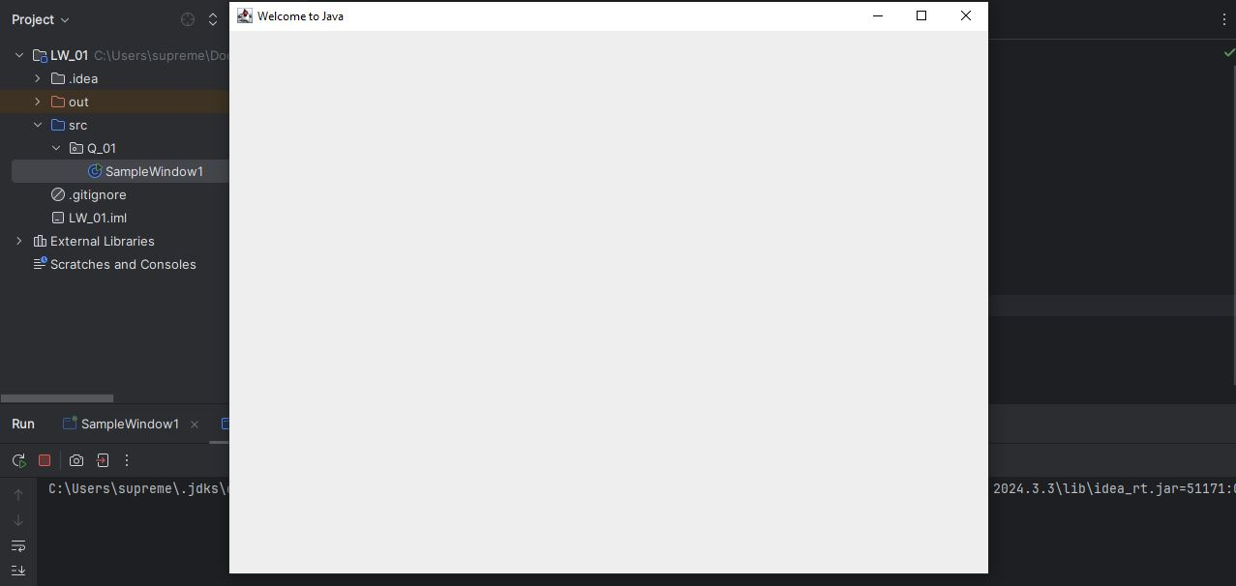

**Q2**

**Code:**

package Q_02;  
import javax.swing. *;  
import java.util.Scanner;  
  
public class SampleWindow2 {  
 public static void main(String[] args) {  
 Scanner scanner = new Scanner(System.*in*);  
 String firstName;  
 System.*out*.print("Enter your first name: ");  
 firstName = scanner.next();  
 String lastName;  
 System.*out*.print("Enter your last name: ");  
 lastName = scanner.next();  
 scanner.close();  
  
 String fullName = firstName + " " + lastName;  
  
 JFrame frame;  
 frame = new JFrame(fullName);  
 frame.setSize(400, 300);  
 frame.setVisible(true);  
 }  
}

**Output:**

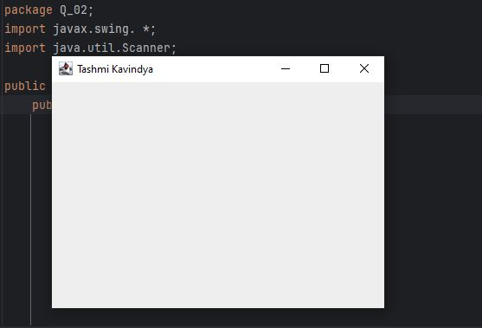

**Q3**

**Code:**

package Q_03;  
import java.util.Scanner;  
  
public class FullName {  
 public static void main(String[] args) {  
 Scanner scanner = new Scanner(System.*in*);  
 System.*out*.print("Enter first name: ");  
 String firstName = scanner.next();  
 System.*out*.print("Enter middle name: ");  
 String middleName = scanner.next();  
 System.*out*.print("Enter last name: ");  
 String lastName = scanner.next();  
 scanner.close();  
  
 String fullName = firstName + " " + middleName.charAt(0) + ". " + lastName;  
  
 System.*out*.println("Full Name: " + fullName);  
 }  
}

**Output:**

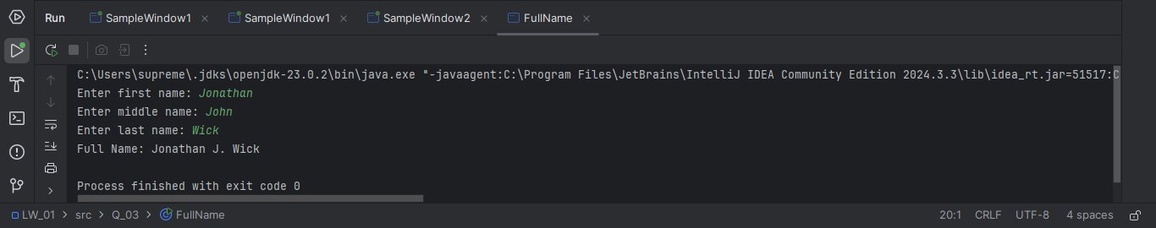

**Q4**

**Code:**

package Q_04;  
import java.util.Date;  
import java.text.SimpleDateFormat;  
  
public class DateDisplay {  
 public static void main(String[] args) {  
 Date today;  
 SimpleDateFormat sdf;  
 today = new Date();  
 sdf = new SimpleDateFormat("dd MMMM yyyy");  
 System.*out*.println(sdf.format(today));  
 }  
}

**Output:**

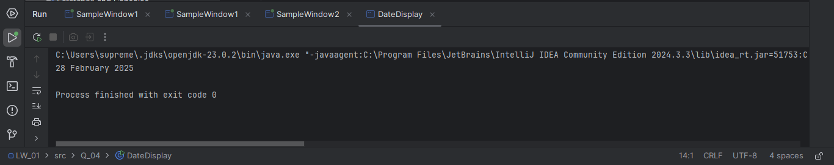

**Q5**

**Code:**

package Q_05;  
import java.util.Date;  
import java.text.SimpleDateFormat;  
  
public class FormattedDate {  
 public static void main(String[] args) {  
 Date today;  
 SimpleDateFormat sdf;  
 today = new Date();  
 sdf = new SimpleDateFormat("EEEE, MMMM dd, yyyy");  
 System.*out*.println(sdf.format(today));  
 }  
}

**Output:**

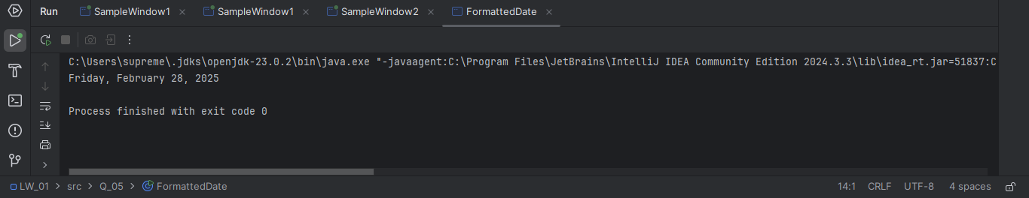

**Q6**

**Code:**

package Q_06;  
import javax.swing. *;  
import java.util.Scanner;  
  
public class SampleWindow3 {  
 public static void main(String[] args) {  
 Scanner scanner = new Scanner(System.*in*);  
 System.*out*.print("Enter the width in pixels: ");  
 int W = scanner.nextInt();  
  
 System.*out*.print("Enter the height in pixels: ");  
 int H = scanner.nextInt();  
  
 scanner.nextLine();  
  
 System.*out*.print("Enter the frame title: ");  
 String frameTitle = scanner.nextLine();  
  
 scanner.close();  
  
 JFrame frame;  
 frame = new JFrame(frameTitle);  
 frame.setSize(W, H);  
 frame.setVisible(true);  
  
 }  
}

**Output:**

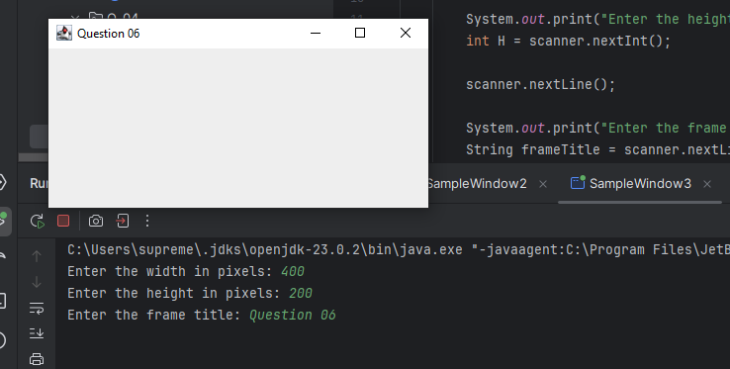

**Q7**

**Code:**

package Q_07;  
import javax.swing.*;  
import java.text.SimpleDateFormat;  
import java.util.Date;  
  
public class TimeInTitle {  
 public static void main(String[] args) {  
 Date now = new Date();  
  
 SimpleDateFormat timeFormat = new SimpleDateFormat("hh:mm:ss a");  
  
 String currentTime = timeFormat.format(now);  
  
 JFrame frame = new JFrame(currentTime);  
 frame.setSize(500,300);  
 frame.setVisible(true);  
 }  
}

**Output:**

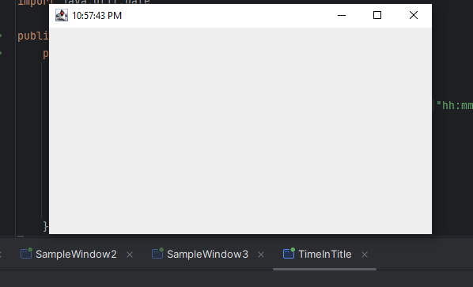

**Q8**

**Code:**

package Q_08;  
import java.util.Scanner;  
  
public class ExclamationMark {  
 public static void main(String[] args) {  
 Scanner scanner = new Scanner(System.*in*);  
 System.*out*.print("Enter a string with a single exclamation mark: ");  
 String input = scanner.nextLine();  
 scanner.close();  
  
 int index = input.indexOf('!');  
  
 if (index != -1) {  
 String before = input.substring(0, index).trim();  
 String after = input.substring(index + 1).trim();  
  
 System.*out*.println(before);  
 System.*out*.println(after);  
 }  
 else {  
 System.*out*.println("Error. No exclamation mark found in the input");  
 }  
 }  
}

**Output:**

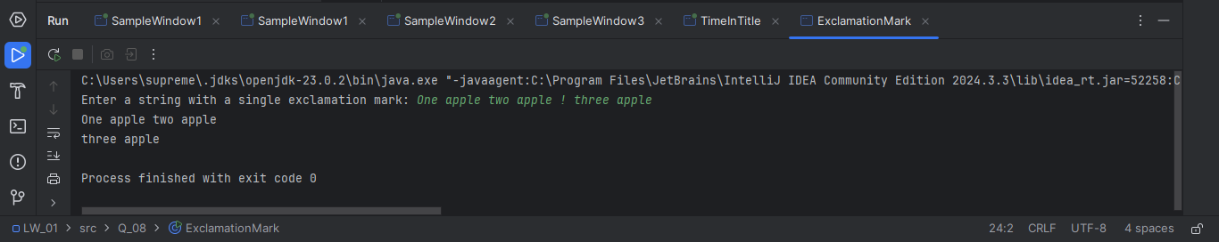

**Q9**

**Code:**

package Q_09;  
import java.util.Scanner;  
  
public class StringDetails {  
 public static void main(String[] args) {  
 Scanner scanner = new Scanner(System.*in*);  
 System.*out*.print("Enter a string: ");  
 String input = scanner.nextLine();  
 scanner.close();  
  
 System.*out*.println(input.length());  
 System.*out*.println(input.charAt(0));  
 System.*out*.println(input.charAt(input.length() - 1));  
 }  
}

**Output:**

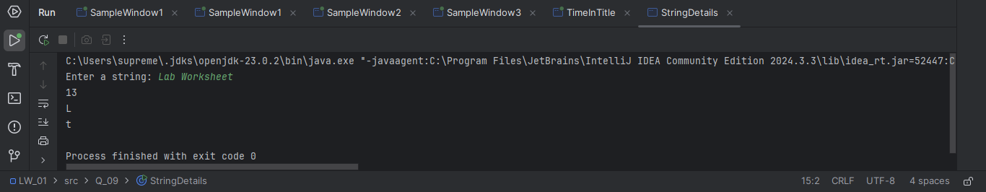

**Q10**

**Code:**

package Q_10;  
import java.util.Scanner;  
  
public class MiddleCharacter {  
 public static void main(String[] args) {  
 Scanner scanner = new Scanner(System.*in*);  
 System.*out*.print("Enter an odd-length word: ");  
 String word = scanner.next();  
 scanner.close();  
  
 int length = word.length();  
  
 if (length % 2 == 1) {  
 int middleIndex = length / 2;  
 System.*out*.println(word.charAt(middleIndex));  
 }  
 else {  
 System.*out*.println("Error. The word doesn't have odd number of characters.");  
 }  
 }  
}

**Output:**

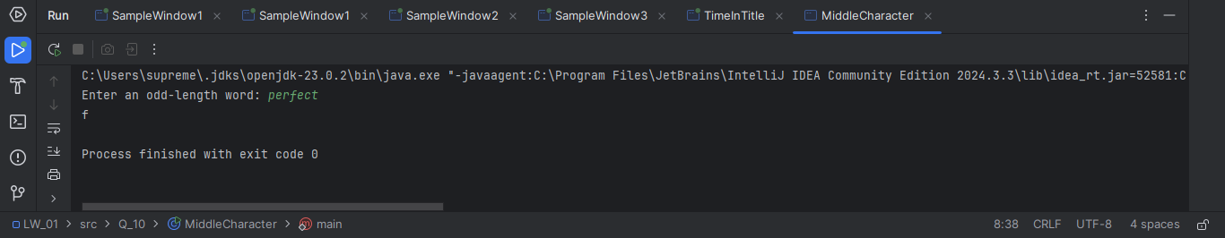

**Q11**

**Code:**

package Q_11;  
import java.util.Scanner;  
  
public class FullNameConverter {  
 public static void main(String[] args) {  
 Scanner scanner = new Scanner(System.*in*);  
 System.*out*.print("Enter your first name: ");  
 String firstName = scanner.next();  
 System.*out*.print("Enter your middle name: ");  
 String middleName = scanner.next();  
 System.*out*.print("Enter your last name: ");  
 String lastName = scanner.next();  
 scanner.close();  
  
 System.*out*.println(lastName + ", " + firstName + " " + middleName.charAt(0) + ".");  
  
 }  
}

**Output:**

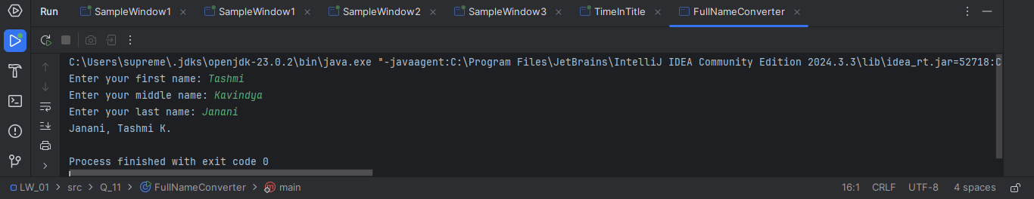

**Q12**

**Code:**

package Q_12;  
import javax.swing.*;  
  
public class FirstFrame {  
 public static void main(String[] args) {  
  
 JFrame frame = new JFrame();  
 frame.setSize(300,200);  
 frame.setTitle("My First Frame");  
 frame.setLocation(100,50);  
 frame.setDefaultCloseOperation(JFrame.*EXIT_ON_CLOSE*);  
 frame.setVisible(true);  
 }  
}

**Output:**

