**CTEC 22043**

**Object Oriented Programming**

**Lab Worksheet 02: Numerical Data**

**Q1:**

**Code:**

package Q_01;  
  
public class NumericalExpression {  
 public static void main(String[] args) {  
  
 int A = 10;  
 int B = 20;  
 int C = 5;  
 int X = 30;  
 int Y = 15;  
 int r = 7;  
  
 double a = Math.*sqrt*(Math.*pow*(B,2) + 4 * A * C);  
 double b = Math.*sqrt*(X + 4 * Math.*pow*(Y,3));  
 double c = Math.*cbrt*(X * Y);  
 double d = Math.*PI* * Math.*pow*(r,2);  
  
 System.*out*.println("a. " + a);  
 System.*out*.println("b. " + b);  
 System.*out*.println("c. " + c);  
 System.*out*.println("d. Area of the circle: " + d);  
  
 }  
}

**Output:**

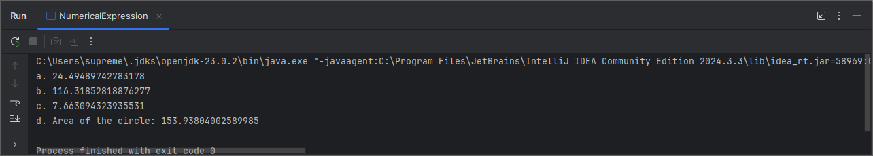

**Q2**

**Code:**

package Q_02;  
import java.util.Scanner;  
  
public class CmToFeetInches {  
 public static void main(String[] args) {  
 Scanner scanner = new Scanner(System.*in*);  
  
 System.*out*.print("Enter length in centimeters: ");  
 double cm = scanner.nextDouble();  
  
 double totalInches = cm / 2.54;  
 int feet = (int) (totalInches / 12);  
 double inches = totalInches % 12;  
  
 System.*out*.println(cm + " cm = " + feet + " feet " + inches + " inches");  
  
 scanner.close();  
 }  
}

**Output:**

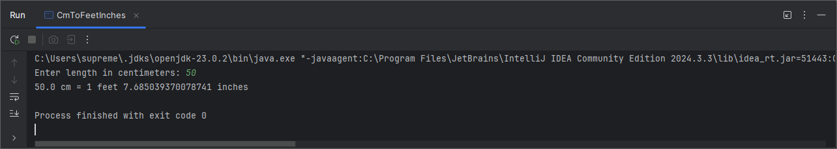

**Q3**

**Code:**

package Q_03;  
import java.util.Scanner;  
  
public class CelsiusToFahrenheit {  
 public static void main(String[] args) {  
 Scanner scanner = new Scanner(System.*in*);  
  
 System.*out*.print("Enter the temperature in Celsius: ");  
 double celsius = scanner.nextDouble();  
  
 double fahrenheit = (1.8 * celsius) + 32;  
  
 System.*out*.print(celsius + " degrees celsius = " + fahrenheit + " degrees fahrenheit ");  
  
 scanner.close();  
 }  
}

**Output:**

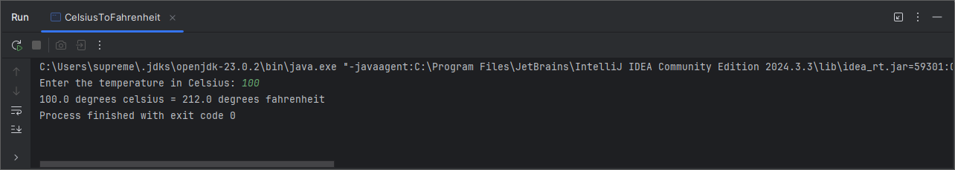

**Q4**

**Code:**

package Q_04;  
import java.util.Scanner;  
  
public class CaloriesNeeds {  
 public static void main(String[] args) {  
 Scanner scanner = new Scanner(System.*in*);  
  
 System.*out*.print("Enter the body weight in pound: ");  
 double bodyWeight = scanner.nextDouble();  
  
 double calories = bodyWeight * 19;  
  
 System.*out*.println("You need " + calories + " calories per day: ");  
  
 scanner.close();  
 }  
}

**Output:**

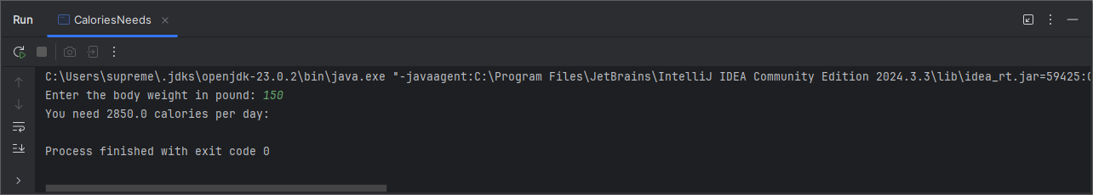

**Q5**

**Code:**

package Q_05;  
import java.util.Scanner;  
  
public class FahrenheitToCelsius {  
 public static void main(String[] args) {  
 Scanner scanner = new Scanner(System.*in*);  
  
 System.*out*.print("Enter temperature in Fahrenheit: ");  
 double fahrenheit = scanner.nextDouble();  
  
 double celsius = (5.0/9.0) * (fahrenheit - 32);  
  
 System.*out*.println(fahrenheit + " degrees Fahrenheit = " + celsius + " degrees Celsius");  
  
 scanner.close();  
 }  
}

**Output:**

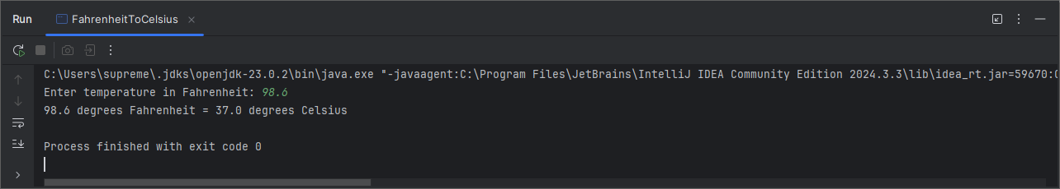

**Q6**

**Code:**

package Q_06;  
import java.util.Scanner;  
  
public class AgeCalculator {  
 public static void main(String[] args) {  
 Scanner scanner = new Scanner(System.*in*);  
  
 System.*out*.print("Enter your birth year: ");  
 int birthYear = scanner.nextInt();  
  
 int currentYear = java.util.Calendar.*getInstance*().get(java.util.Calendar.*YEAR*);  
  
 int age = currentYear - birthYear;  
  
 System.*out*.println("You were born in " + birthYear + " and will be " + age + " this year.");  
  
 scanner.close();  
  
 }  
}

**Output:**

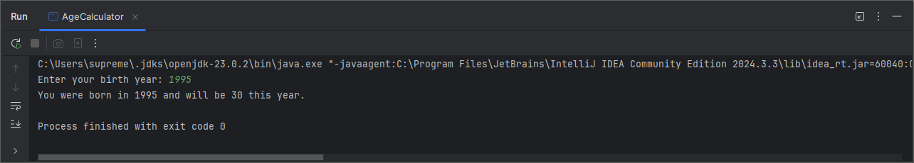

**Q7**

**Code:**

package Q_07;  
import java.util.Scanner;  
  
public class BMICalculator {  
 public static void main(String[] args) {  
 Scanner scanner = new Scanner(System.*in*);  
  
 System.*out*.print("Enter your weight in kilograms: ");  
 int w = scanner.nextInt();  
  
 System.*out*.print("Enter your height in centimeters: ");  
 int h = scanner.nextInt();  
  
 double bmi = w / (Math.*pow*((h / 100.0),2));  
  
 System.*out*.println("BMI = " + bmi);  
  
 scanner.close();  
 }  
}

**Output:**

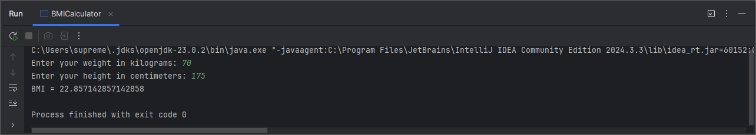

**Q8**

**Code:**

package Q_08;  
import java.util.Scanner;  
  
public class SphereVolume {  
 public static void main(String[] args) {  
 Scanner scanner = new Scanner(System.*in*);  
  
 System.*out*.print("Enter the radius in meter: ");  
 int r = scanner.nextInt();  
  
 double v = (4.0/3.0) * (Math.*PI* * (Math.*pow*(r,3)));  
  
 System.*out*.println("The volume of the sphere is: " + v + " cubic meter.");  
  
 scanner.close();  
 }  
}

**Output:**

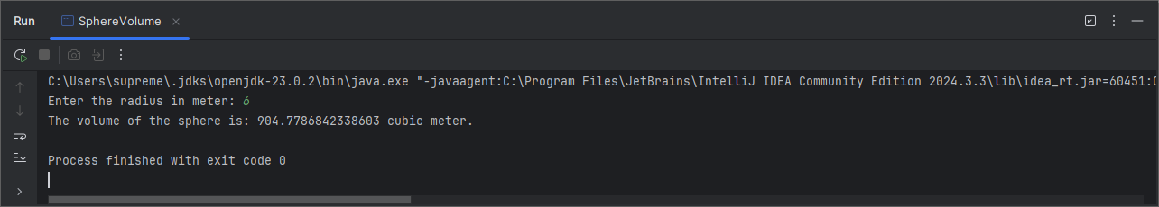

**Q9**

**Code:**

package Q_09;  
import java.util.Scanner;  
  
public class InvestmentCalculator {  
 public static void main(String[] args) {  
 Scanner scanner = new Scanner(System.*in*);  
  
 System.*out*.print("Enter your investment in dollars: ");  
 double P = scanner.nextDouble();  
  
 System.*out*.print("Enter the interest rate in percentage: ");  
 double R = scanner.nextDouble();  
  
 System.*out*.print("Enter the number of years: ");  
 int N = scanner.nextInt();  
  
 double A = P * Math.*pow*(1 + (R/100),N);  
  
 double earnedMoney = A - P;  
  
 System.*out*.println(earnedMoney + " $ earned after " + N + " years " );  
  
 scanner.close();  
 }  
}

**Output:**

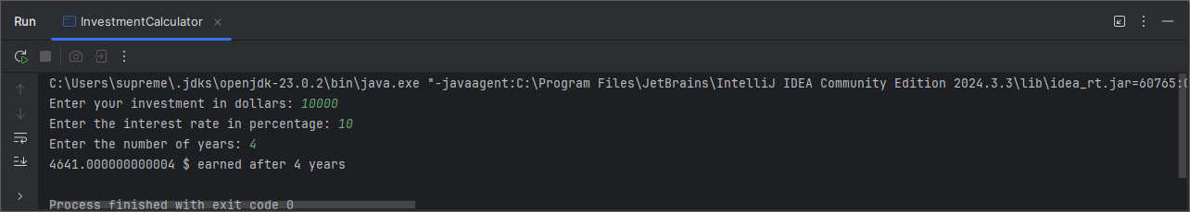

**Q10**

**Code:**

package Q_10;  
import java.util.Scanner;  
  
public class LoanCalculator {  
 public static void main(String[] args) {  
 Scanner scanner = new Scanner(System.*in*);  
 final int MONTHS_IN_YEAR = 12;  
  
 System.*out*.print("Enter the loan amount: ");  
 double loanAmount = scanner.nextDouble();  
  
 System.*out*.print("Enter the annual interest rate (in percentage): ");  
 double annualInterestRate = scanner.nextDouble();  
  
 System.*out*.print("Enter the loan period in years: ");  
 int loanPeriod = scanner.nextInt();  
  
 double monthlyInterestRate = annualInterestRate / 100.0 / MONTHS_IN_YEAR;  
  
 int numberOfPayments = loanPeriod * MONTHS_IN_YEAR;  
  
 double monthlyPayment = (loanAmount * monthlyInterestRate) / (1 - Math.*pow*(1 / (1 + monthlyInterestRate), numberOfPayments));  
  
 double totalPayment = monthlyPayment * numberOfPayments;  
  
 System.*out*.printf("Your monthly payment is: %.2f\n", monthlyPayment);  
 System.*out*.printf("Your total payment is: %.2f\n", totalPayment);  
  
 scanner.close();  
 }  
}

**Output:**

