**CTEC 22043**

**Object Oriented Programming**

**Lab Worksheet 03: Defining Classes**

**Q01**

**Code:**

package Q_01;  
  
public class Temperature {  
 private double celsius;  
  
 public Temperature(){  
 this.celsius = 0.0;  
 }  
  
 public Temperature(double celsius){  
 this.celsius = celsius;  
 }  
  
 public double toFahrenheit(){  
 return celsius * 9 / 5 + 32;  
 }  
  
 public double toCelsius(){  
 return celsius;  
 }  
  
 public void setCelsius(double celsius){  
 this.celsius = celsius;  
 }  
  
 public void setFahrenheit(double fahrenheit){  
 this.celsius = (fahrenheit - 32) * 5 / 9;  
 }  
}

package Q_01;  
import java.util.Scanner;  
  
public class Main {  
 public static void main(String[] args) {  
 Scanner scanner = new Scanner(System.*in*);  
  
 System.*out*.print("Enter temperature in celsius: ");  
 double celsius = scanner.nextDouble();  
 Temperature temp = new Temperature(celsius);  
 System.*out*.println("Equivalent Fahrenheit: " + temp.toFahrenheit());  
 }  
}

**Output:**

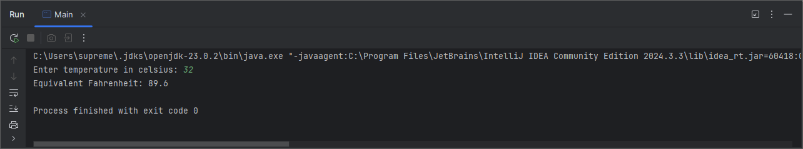

**Q02**

**Code:**

package Q_02;  
import Q_01.Temperature;  
  
import java.util.Scanner;  
  
public class Main {  
 public static void main(String[] args) {  
 Scanner scanner = new Scanner(System.*in*);  
  
 System.*out*.print("Enter temperature in Fahrenheit: ");  
 double fahrenheit = scanner.nextDouble();  
 Temperature temp1 = new Temperature();  
 temp1.setFahrenheit(fahrenheit);  
 System.*out*.println("Equivalent Celsius: " + temp1.toCelsius());  
 }  
}

**Output:**

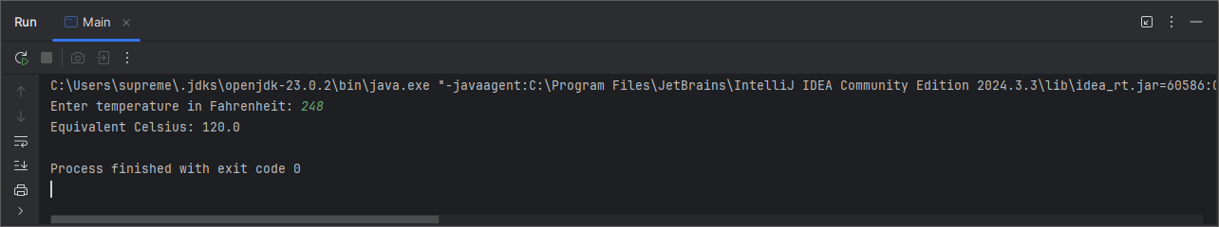

**Q03**

**Code:**

package Q_03;  
  
public class Circle {  
 private double radius;  
  
 public Circle(double radius) {  
 this.radius = radius;  
 }  
  
 public void setRadius(double radius) {  
 this.radius = radius;  
 }  
  
 public double computeArea() {  
 return Math.*PI* * radius * radius;  
 }  
  
 public double computeCircumference() {  
 return 2 * Math.*PI* * radius;  
 }  
}

package Q_03;  
import java.util.Scanner;  
  
public class Main {  
 public static void main(String[] args) {  
 Scanner scanner = new Scanner(System.*in*);  
  
 System.*out*.print("Enter inner radius: ");  
 double ri = scanner.nextDouble();  
  
 System.*out*.print("Enter outer radius: ");  
 double ro = scanner.nextDouble();  
  
 Circle innerCircle = new Circle(ri);  
 Circle outerCircle = new Circle(ro);  
  
 double area = outerCircle.computeArea() - innerCircle.computeArea();  
 System.*out*.println("Shaded area: " + area);  
 }  
}

**Output:**

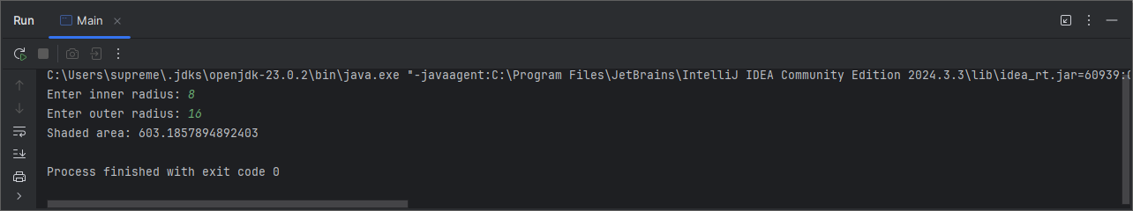

**Q04**

**Code:**

package Q_04;  
  
public class Owner {  
 private String ownerName;  
 private String phoneNo;  
  
 public Owner(String ownerName, String phoneNo) {  
 this.ownerName = ownerName;  
 this.phoneNo = phoneNo;  
 }  
  
 public String getOwnerName() {  
 return ownerName;  
 }  
  
 public String getPhoneNo() {  
 return phoneNo;  
 }  
}

package Q_04;  
  
public class Bicycle {  
 private Owner owner;  
  
 public Bicycle(String ownerName, String phoneNo) {  
 this.owner = new Owner(ownerName, phoneNo);  
 }  
  
 public void setOwner(Owner owner) {  
 this.owner = owner;  
 }  
  
 public Owner getOwner() {  
 return owner;  
 }  
}

package Q_04;  
  
public class BicycleTest {  
 public static void main(String[] args) {  
 Bicycle myBike = new Bicycle("Janani", "0768765764");  
 System.*out*.println("owner:" + myBike.getOwner().getOwnerName());  
 System.*out*.println("Phone No: " + myBike.getOwner().getPhoneNo());  
 }  
}

**Output:**

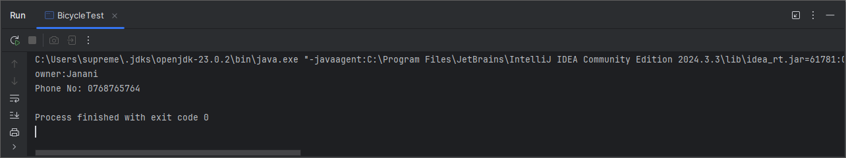

**Q05**

**Code:**

package Q_05;  
  
public class Course {  
 private String courseName;  
 private String courseCode;  
 private Lecturer lecturer;  
  
 public Course(String courseName, String courseCode, Lecturer lecturer) {  
 this.courseName = courseName;  
 this.courseCode = courseCode;  
 this.lecturer = lecturer;  
 }  
  
 public String getCourseName() {  
 return courseName;  
 }  
  
 public void setCourseName(String courseName) {  
 this.courseName = courseName;  
 }  
  
 public String getCourseCode() {  
 return courseCode;  
 }  
  
 public void setCourseCode(String courseCode) {  
 this.courseCode = courseCode;  
 }  
  
 public Lecturer getLecturer() {  
 return lecturer;  
 }  
  
 public void setLecturer(Lecturer lecturer) {  
 this.lecturer = lecturer;  
 }  
}

package Q_05;  
  
public class Lecturer {  
 private String lecturerName;  
 private String courseTeaching;  
  
 public Lecturer(String lecturerName, String courseTeaching) {  
 this.lecturerName = lecturerName;  
 this.courseTeaching = courseTeaching;  
 }  
  
 public String getLecturerName() {  
 return lecturerName;  
 }  
  
 public void setLecturerName(String lecturerName) {  
 this.lecturerName = lecturerName;  
 }  
  
 public String getCourseTeaching() {  
 return courseTeaching;  
 }  
  
 public void setCourseTeaching(String courseTeaching) {  
 this.courseTeaching = courseTeaching;  
 }  
}

package Q_05;  
  
public class Student {  
 private String studentName;  
 private String degreeName;  
 private String courseFollowing;  
  
 public Student(String studentName, String degreeName, String courseFollowing) {  
 this.studentName = studentName;  
 this.degreeName = degreeName;  
 this.courseFollowing = courseFollowing;  
 }  
  
 public String getStudentName() {  
 return studentName;  
 }  
  
 public void setStudentName(String studentName) {  
 this.studentName = studentName;  
 }  
  
 public String getDegreeName() {  
 return degreeName;  
 }  
  
 public void setDegreeName(String degreeName) {  
 this.degreeName = degreeName;  
 }  
  
 public String getCourseFollowing() {  
 return courseFollowing;  
 }  
  
 public void setCourseFollowing(String courseFollowing) {  
 this.courseFollowing = courseFollowing;  
 }  
}

package Q_05;  
  
public class Main {  
 public static void main(String[] args) {  
  
 Lecturer lecturer = new Lecturer("Dr.Nihal", "Structured Programming");  
  
 Course course = new Course("Structured Programming", "CTEC 12073",lecturer);  
  
 Student student = new Student("Janani H.M.T.K", "BICT", course.getCourseName());  
  
 System.*out*.println("Course Details:");  
 System.*out*.println("Course Name: " + course.getCourseName());  
 System.*out*.println("Course Code: " + course.getCourseCode());  
 System.*out*.println("Lecturer: " + course.getLecturer().getLecturerName());  
  
 System.*out*.println("\n");  
  
 System.*out*.println("Student Details:");  
 System.*out*.println("Student Name: " + student.getStudentName());  
 System.*out*.println("Degree: " + student.getDegreeName());  
 System.*out*.println("Following Course: " + student.getCourseFollowing());  
 }  
}

**Output:**

