CTEC 22043
Object Oriented Programming
Lab Worksheet 04: Selection Statements

Q01
Code:
package Q_01;
import java.util.Scanner;
public class SmallestNumber {
public static void main(String[] args) {
Scanner scanner = new Scanner(System.in);
System.out.print("Enter the first number: ");
int num1 = scanner.nextInt();
System.out.print("Enter the second number: ");
int num2 = scanner.nextInt();
System.out.print("Enter the third number: ");
int num3 = scanner.nextInt();
if (num1 < num2) {
if (num1 < num3) {
System.out.println("The smallest number is: " + num1);
} else {
System.out.println("The smallest number is: " + num3);
}
}
else if (num2 < num3) {
System.out.println("The smallest number is: " + num2);
} else {
System.out.println("The smallest number is: " + num3);
}
scanner.close();
}
}

Output:
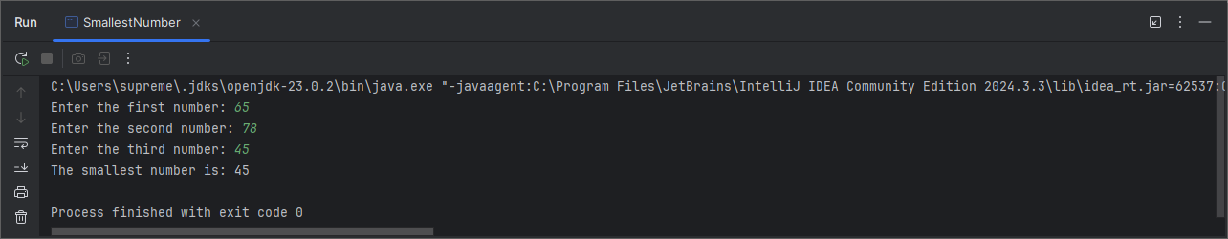

Q02
Code:
package Q_02;
import java.util.Scanner;
public class Main {
public static void main(String[] args) {
Scanner scanner = new Scanner(System.in);
System.out.println("0. Magenta");
System.out.println("1. Cyan");
System.out.println("2. Red");
System.out.println("3. Blue");
System.out.println("4. Green");
System.out.println("Select one color from the above list: ");
int selection = scanner.nextInt();
switch (selection) {
case 0:
System.out.println("You selected Magenta");
break;
case 1:
System.out.println("You selected Cyan");
break;
case 2:
System.out.println("You selected Red");
break;
case 3:
System.out.println("You selected Blue");
break;
case 4:
System.out.println("You selected Green");
break;
default:
System.out.println("Invalid selection");
}
scanner.close();
}
}

Output:
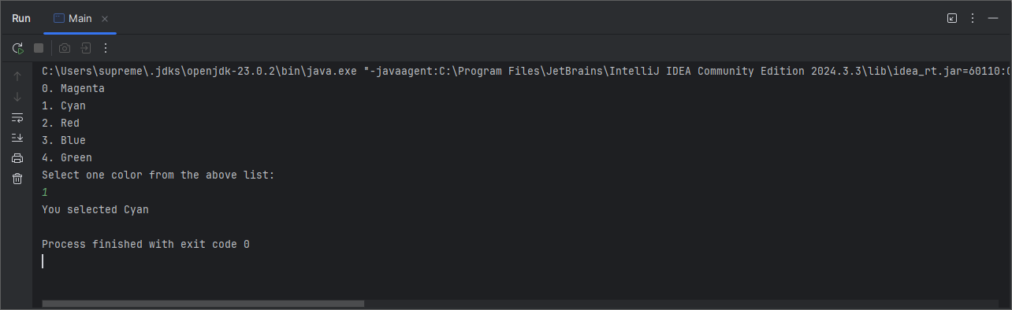

Q03
Code:
package Q_03;
import java.util.Scanner;
public class PowerToName {
public static void main(String[] args) {
Scanner scanner = new Scanner(System.in);
System.out.print("Enter a power of 10 (6,9,12 etc): ");
int power = scanner.nextInt();
switch(power) {
case 6:
System.out.println("Million");
break;
case 9:
System.out.println("Billion");
break;
case 12:
System.out.println("Trillion");
break;
case 15:
System.out.println("Quadrillion");
break;
case 18:
System.out.println("Quintillion");
break;
case 21:
System.out.println("Sextillion");
break;
case 30:
System.out.println("Nonillion");
break;
case 100:
System.out.println("Googol");
break;
default:
System.out.println("No corresponding word for this power");
}
scanner.close();
}
}

Output:
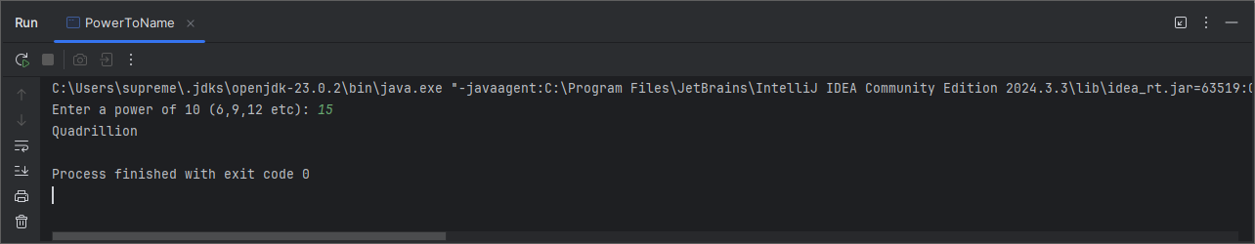
Q04
Code:
package Q_04;
import java.util.Scanner;
public class LeapYear {
public static void main(String[] args) {
Scanner scanner = new Scanner(System.in);
System.out.print("Enter a year: ");
int year = scanner.nextInt();
if (year % 4 == 0) {
if (year % 100 != 0) {
System.out.println(year + " is a leap year");
} else if (year % 400 == 0) {
System.out.println(year + " is a leap year");
} else {
System.out.println(year + " is not a leap year");
}
} else {
System.out.println(year + " is not a leap year");
}
scanner.close();
}
}

Output:
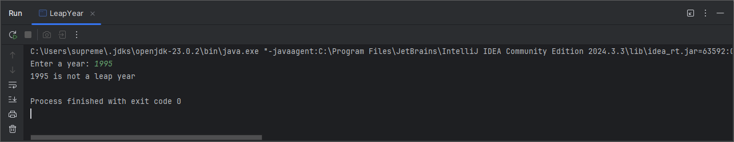

Q05
Code:
package Q_05;
import java.util.Scanner;
public class MyJavaLoFatBurgers {
public static void main(String[] args) {
Scanner scanner = new Scanner(System.in);
double total = 0;
boolean valid = true;
System.out.println("1. Tofu Burger - $3.49");
System.out.println("2. Cajun Chicken - $4.59");
System.out.println("3. Buffalo Wings - $3.99");
System.out.println("4. Rainbow Fillet - $2.99");
System.out.print("Select Entree: ");
int entree = scanner.nextInt();
switch (entree) {
case 1:
total += 3.49;
break;
case 2:
total += 4.59;
break;
case 3:
total += 3.99;
break;
case 4:
total += 2.99;
break;
default:
System.out.println("Invalid entree selection");
valid = false;
}
System.out.println("1. Rice Cracker - $0.79");
System.out.println("2. No-Salt Fries - $0.69");
System.out.println("3. Zucchini - $1.09");
System.out.println("4. Brown Rice - $0.59");
System.out.print("Select Side Dish: ");
int sideDish = scanner.nextInt();
switch (sideDish) {
case 1:
total += 0.79;
break;
case 2:
total += 0.69;
break;
case 3:
total += 1.09;
break;
case 4:
total += 0.59;
break;
default:
System.out.println("Invalid side dish selection");
valid = false;
}
System.out.println("1. Cafe Mocha - $1.99");
System.out.println("2. Cafe Latte - $1.90");
System.out.println("3. Espresso - $2.49");
System.out.println("4. Oolong Tea - $0.99");
System.out.print("Select Drink: ");
int drink = scanner.nextInt();
switch (drink) {
case 1:
total += 1.99;
break;
case 2:
total += 1.90;
break;
case 3:
total += 2.49;
break;
case 4:
total += 0.99;
break;
default:
System.out.println("Invalid drink selection");
valid = false;
}
scanner.close();
if (valid) {
System.out.println("Your selections are: Entree #" + entree + ", Side Dish #" + sideDish + " and Drink #" + drink);
System.out.printf("Your total price is: $%.2f%n", total);
}
}
}
Output:
