CTEC 22043
Object Oriented Programming
Lab Worksheet 05: Repetition Statements

Q01
Code:
package Q_01;
public class Main {
public static void main(String[] args) {
for (int i = 10; i < 50; i++) {
System.out.print(i + " ");
if ((i - 9) % 10 == 0) {
System.out.println();
}
}
}
}

Output:
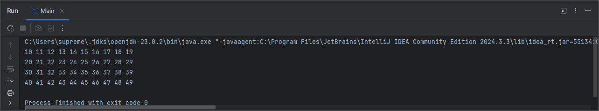

Q02
Code:
package Q_02;
import java.util.Scanner;
public class NumOfDigits {
public static void main(String[] args) {
Scanner scanner = new Scanner(System.in);
int number;
do {
System.out.print("Enter an integer (negative to stop): ");
number = scanner.nextInt();
if (number >= 0) {
int temp = number;
int digitCount = 0;
if (temp == 0) {
digitCount = 1;
} else {
while (temp != 0) {
temp /= 10;
digitCount++;
}
}
System.out.println("Number of digits: " + digitCount);
}
} while (number >= 0);
scanner.close();
}
}

Output:
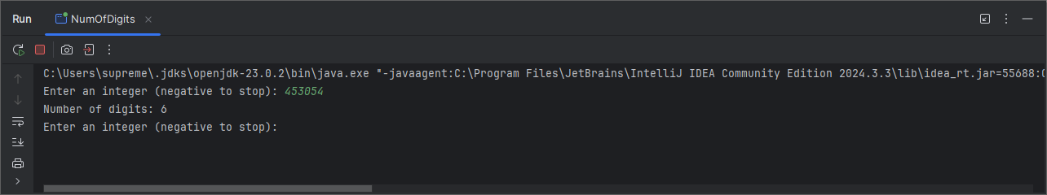

Q03
Code:
package Q_03;
import java.util.Scanner;
public class MultiplicationTable {
public static void main(String[] args) {
Scanner scanner = new Scanner(System.in);
System.out.print("Enter the number: ");
int n = scanner.nextInt();
for (int i = 1; i <= 10; i++) {
System.out.println(n + " x " + i + " = " + (n * i));
}
}
}

Output:
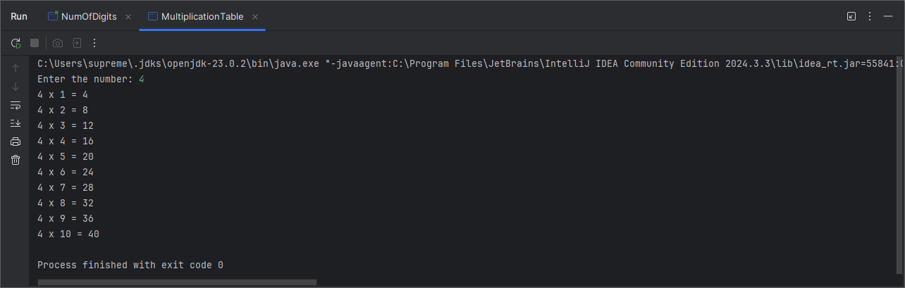

Q04
Code:
package Q_04;
import java.util.Scanner;
public class AsteriskPyramid {
public static void main(String[] args) {
Scanner scanner = new Scanner(System.in);
System.out.print("Enter number of rows: ");
int rows = scanner.nextInt();
for (int i = 1; i <= rows; i++) {
for (int j = 1; j <= rows - i; j++) {
System.out.print(" ");
}
for (int k = 1; k <= (2 * i - 1); k++) {
System.out.print("*");
}
System.out.println();
}
}
}

Output:
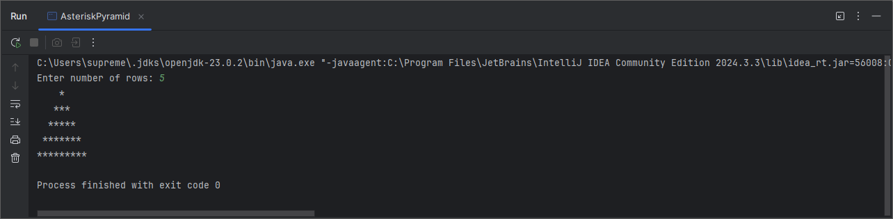
Q05
Code:
package Q_05;
import java.util.Scanner;
public class PalindromeChecker {
public static void main(String[] args) {
Scanner scanner = new Scanner(System.in);
System.out.print("Enter a word or a phrase: ");
String input = scanner.nextLine();
String cleanedInput = input.replaceAll("[^a-zA-Z0-9]", "").toLowerCase();
boolean isPalindrome = isPalindrome(cleanedInput);
if (isPalindrome) {
System.out.println("It is a palindrome.");
} else {
System.out.println("It is not a palindrome.");
}
scanner.close();
}
public static boolean isPalindrome(String str) {
int left = 0;
int right = str.length() - 1;
while (left < right) {
if (str.charAt(left) != str.charAt(right)) {
return false;
}
left++;
right--;
}
return true;
}
}
Output:
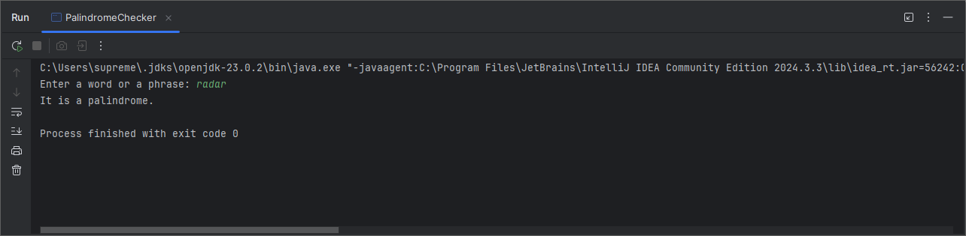

Q06
Code:
package Q_06;
import java.util.Scanner;
import java.util.Random;
public class GuessTheNumber {
public static void main(String[] args) {
Scanner scanner = new Scanner(System.in);
Random random = new Random();
int targetNumber = random.nextInt(100) + 1;
int guess = 0;
System.out.println("I'm thinking a number between 1 and 100. can u guess it? ");
while (guess != targetNumber) {
System.out.print("Enter you guess: ");
guess = scanner.nextInt();
if (guess < targetNumber) {
System.out.println("Lower");
} else if (guess > targetNumber) {
System.out.println("Higher");
} else {
System.out.println("Correct! You guessed the number.");
}
}
scanner.close();
}
}

Output:
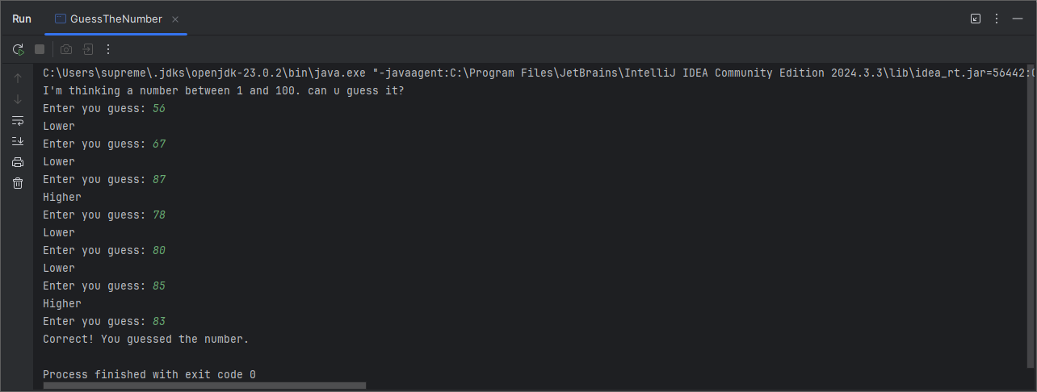
Q07
Code:
package Q_07;
import java.util.Scanner;
public class WordReplacer {
public static void main(String[] args) {
Scanner scanner = new Scanner(System.in);
System.out.print("Enter the sentence: ");
String sentence = scanner.nextLine();
System.out.print("Enter the word to be replaced: ");
String oldWord = scanner.nextLine();
System.out.print("Enter the replacement word: ");
String newWord = scanner.nextLine();
String modifiedSentence = replaceWord(sentence , oldWord , newWord);
System.out.println("Modified sentence: " + modifiedSentence);
}
public static String replaceWord(String sentence, String oldWord, String newWord) {
String[] words = sentence.split(" ");
for (int i = 0; i < words.length; i++) {
if (words[i].equalsIgnoreCase(oldWord)) {
words[i] = newWord;
}
}
return String.join(" ",words);
}
}
Output:
