原始資料、數據

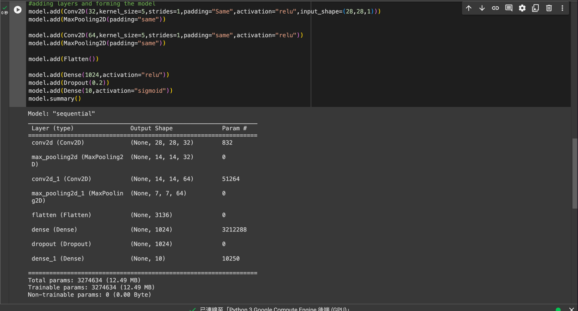

val_loss: 0.0393 – val_accuracy: 0.9865

val_loss: 0.0274 – val_accuracy: 0.9903

val_loss: 0.0259 – val_accuracy: 0.9910

val_loss: 0.0251 – val_accuracy: 0.9920

val_loss: 0.0325 – val_accuracy: 0.9893

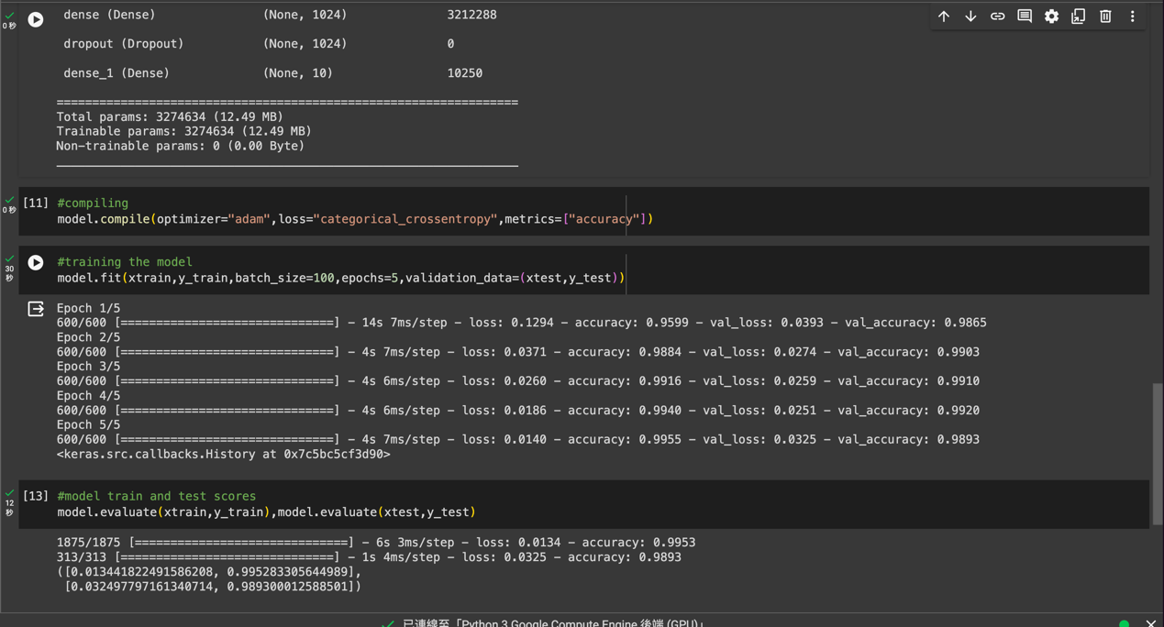

把所有activation換成sigmoid

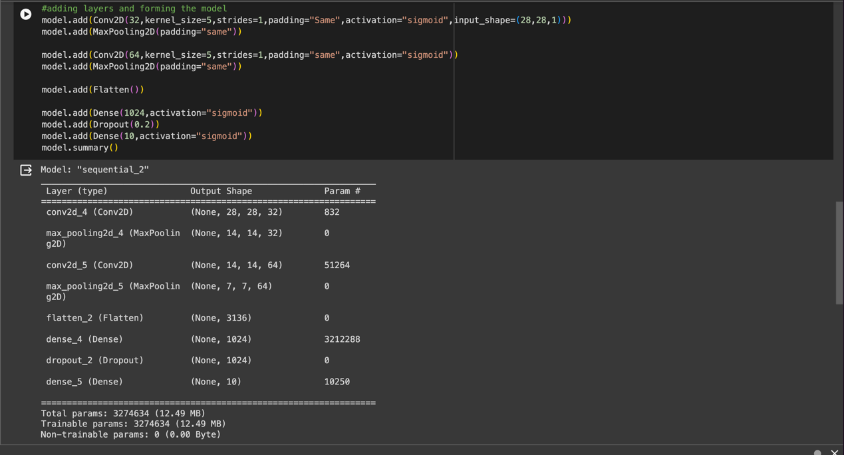

val_loss: 0.2559 - val_accuracy: 0.9249

val_loss: 0.1176 - val_accuracy: 0.9605

val_loss: 0.0914 - val_accuracy: 0.9696

val_loss: 0.0642 - val_accuracy: 0.9796

val_loss: 0.0567 - val_accuracy: 0.9803

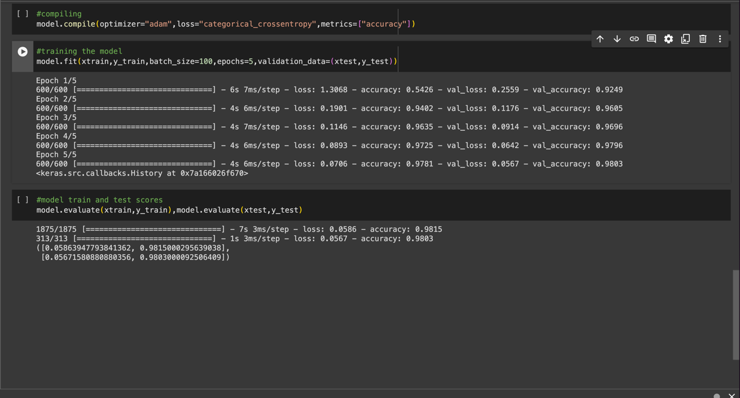

把所有activation換成relu

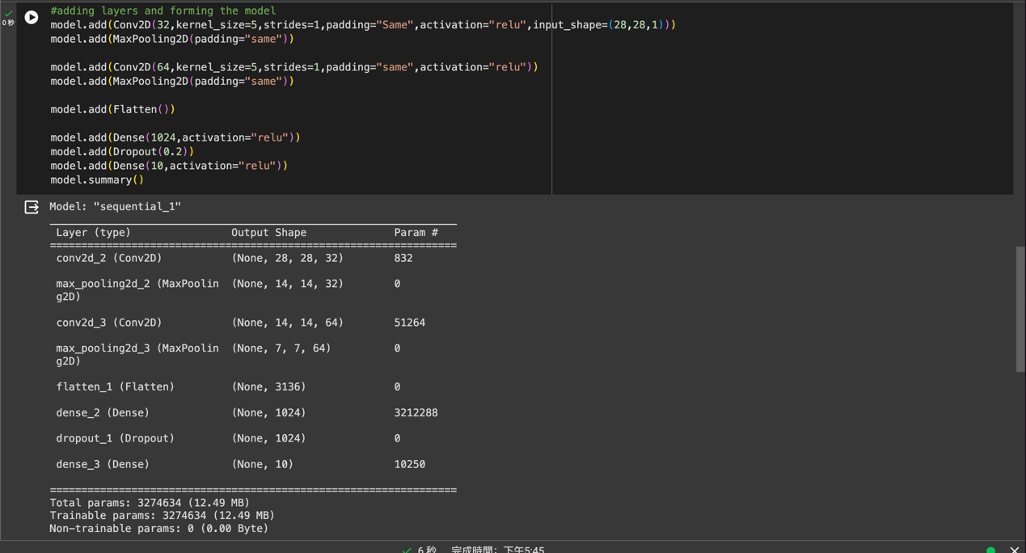

val_loss: nan - val_accuracy: 0.0980

val_loss: nan - val_accuracy: 0.0980

val_loss: nan - val_accuracy: 0.0980

val_loss: nan - val_accuracy: 0.0980

val_loss: nan - val_accuracy: 0.0980

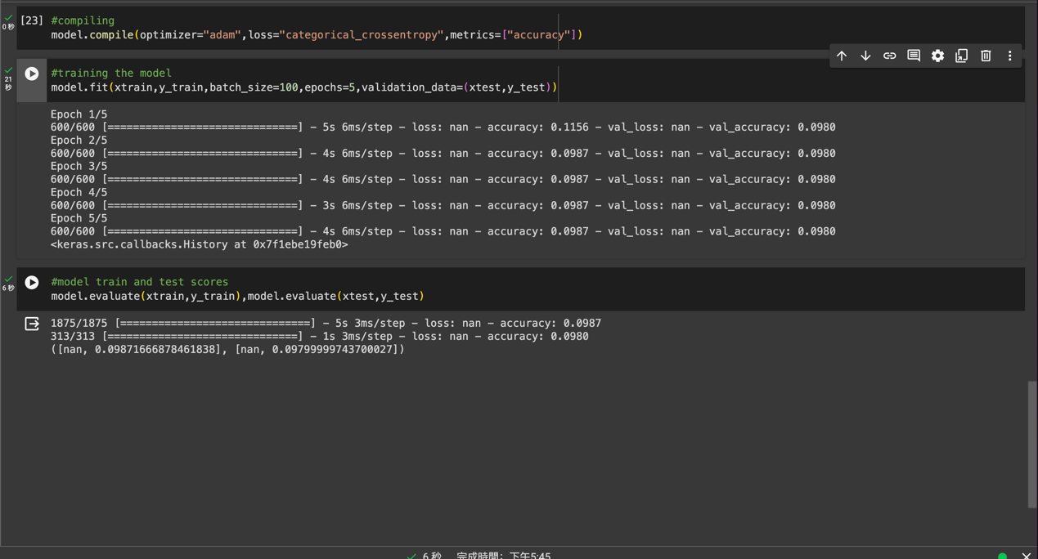

把所有activation換成LeakyReLU

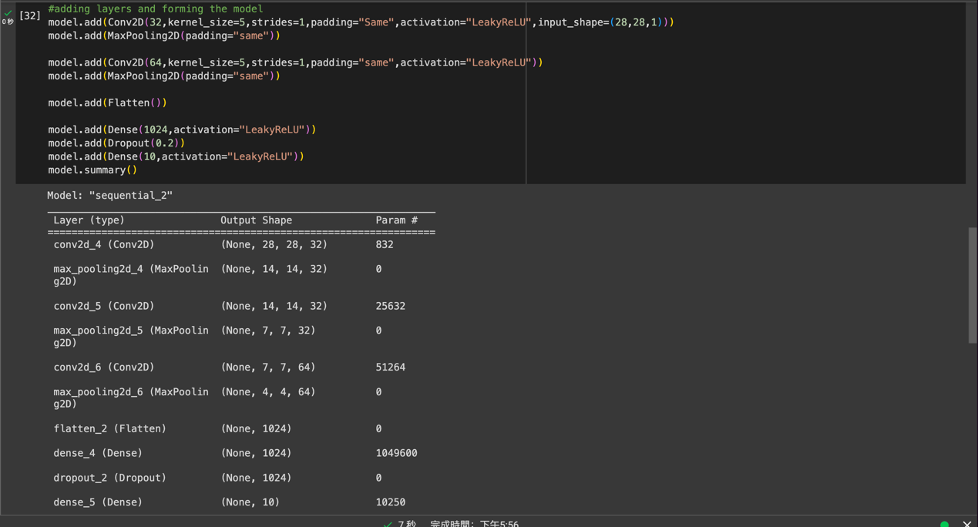

val_loss: 9.5355 - val_accuracy: 0.1135

val_loss: 9.5355 - val_accuracy: 0.1135

val_loss: 9.5355 - val_accuracy: 0.1135

val_loss: 9.5355 - val_accuracy: 0.1135

val_loss: 9.5355 - val_accuracy: 0.1135

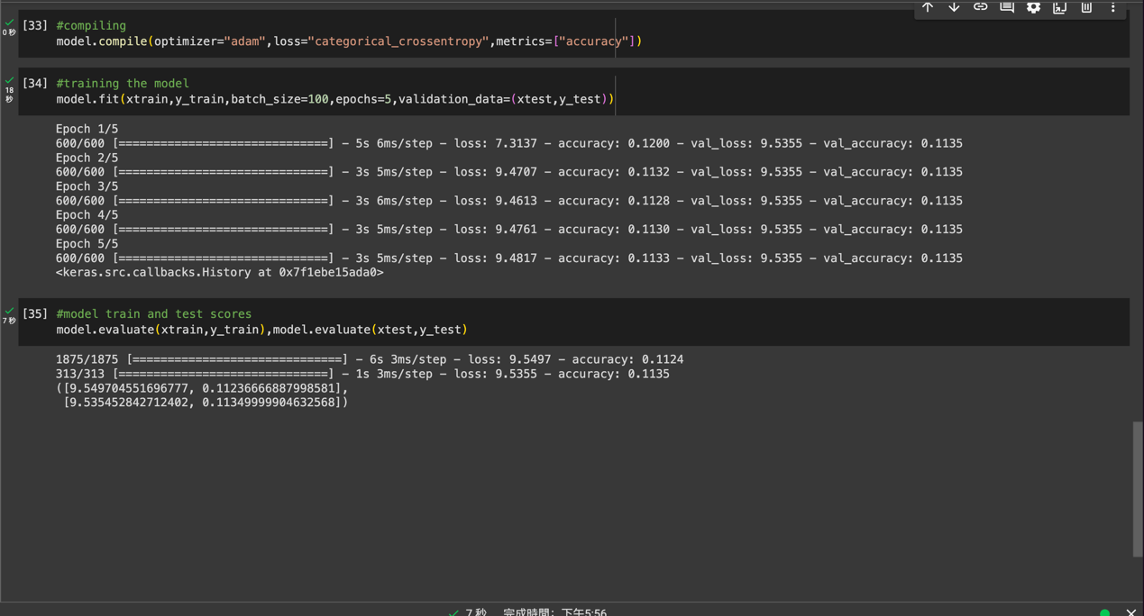

把所有activation換成PReLU

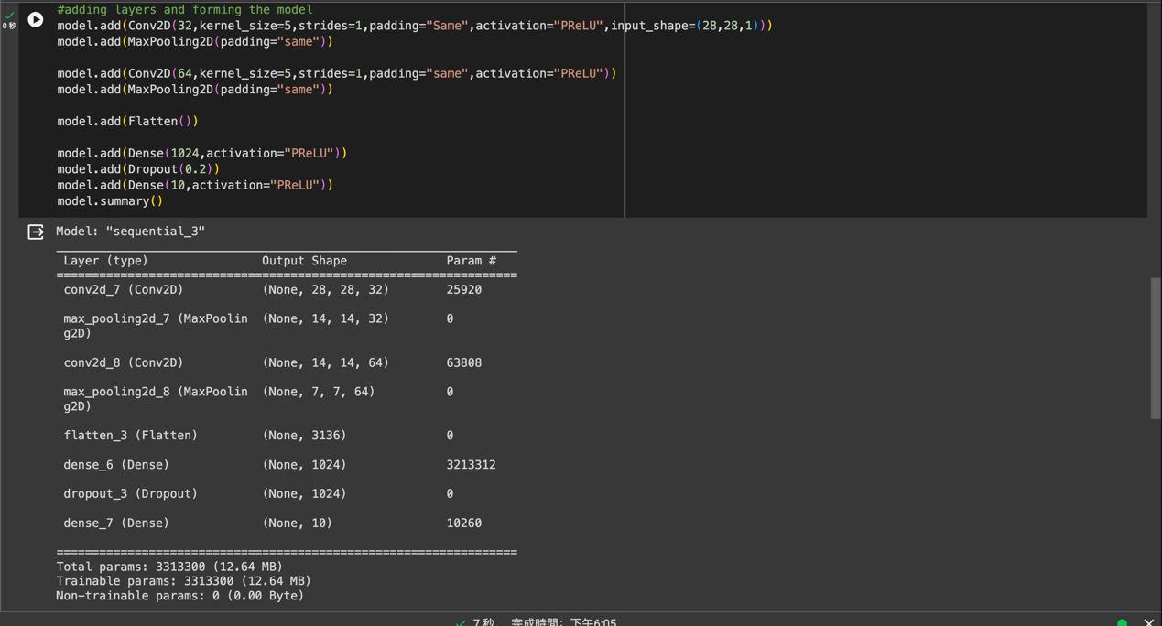

val_loss: 9.7160 - val_accuracy: 0.3904

val_loss: 9.7611 - val_accuracy: 0.2534

val_loss: 9.7063 - val_accuracy: 0.3891

val_loss: 9.7063 - val_accuracy: 0.3894

val_loss: 9.7160 - val_accuracy: 0.3850

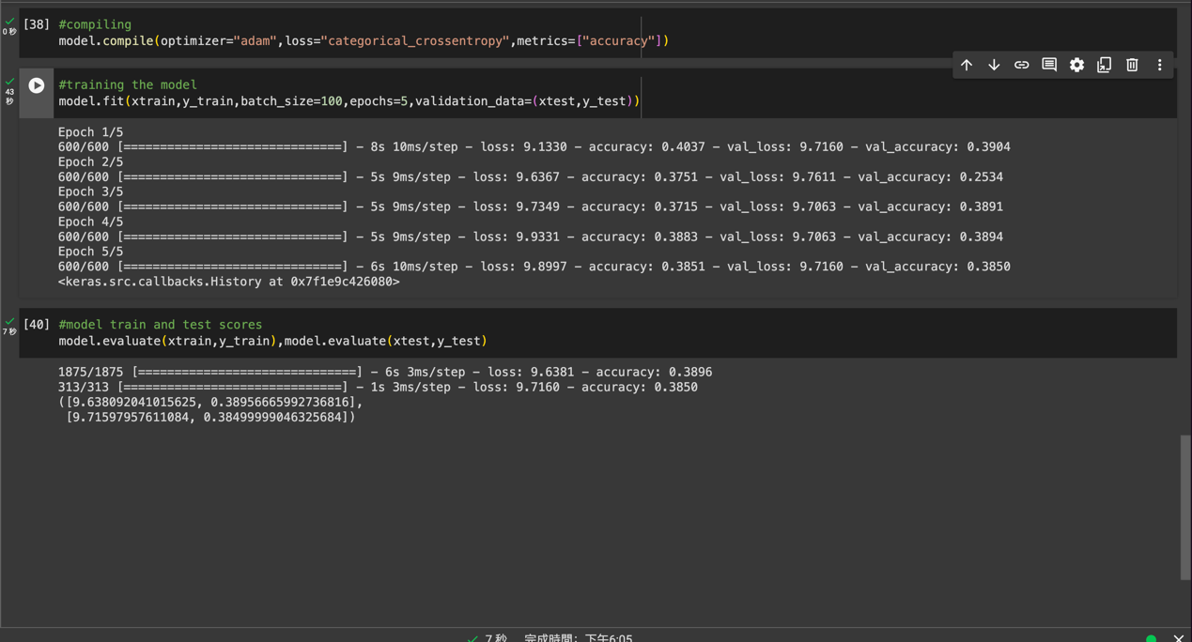

把所有activation換成ELU

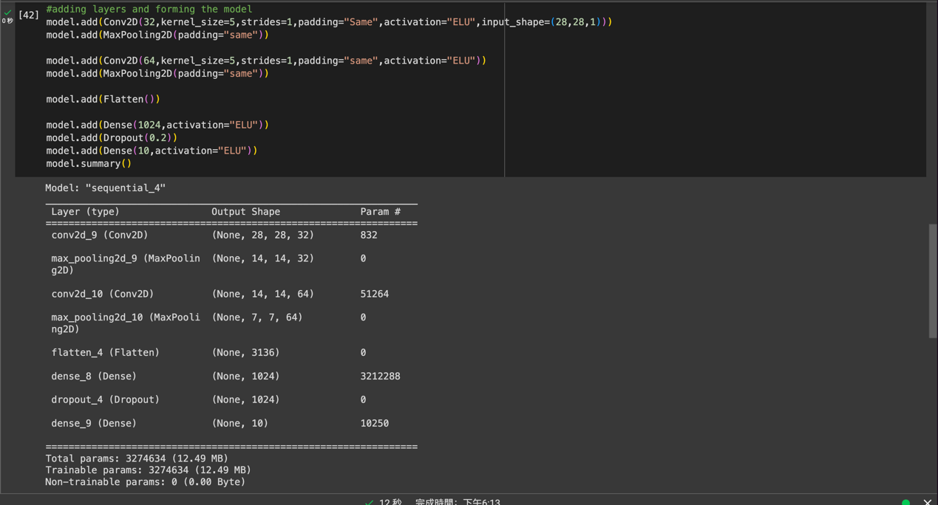

val_loss: 1.9112 - val_accuracy: 0.8155

val_loss: 3.4770 - val_accuracy: 0.7305

val_loss: 0.4138 - val_accuracy: 0.9294

val_loss: 0.5062 - val_accuracy: 0.9103

val_loss: 0.6369 - val_accuracy: 0.9236

