**STRONG TYPED ENUM:**

Why should i go for strong typed enum?

* It is scoped.
* It is allows forward declaration.
* Comparison of different enum type is not possible

**Program_01:**

To c++98 enum is unscoped to make it scoped, we used namespace

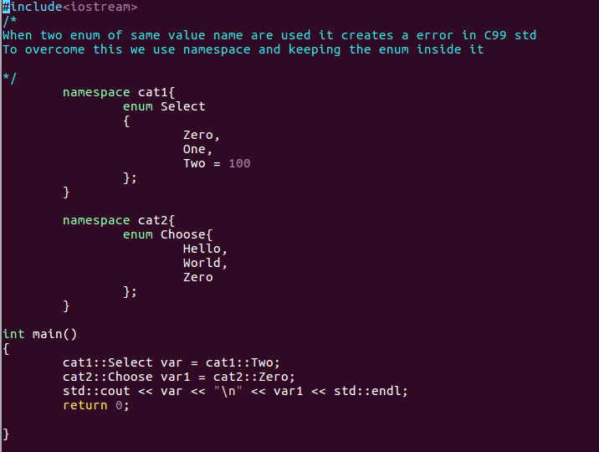

Output:



**Program_02:**

When we dont specify the data correctly to enum. It will result in error and compilation error is obtained.

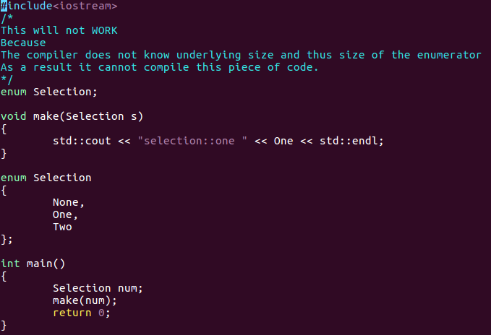

**Program_03:**

Implicit conversion in c++98

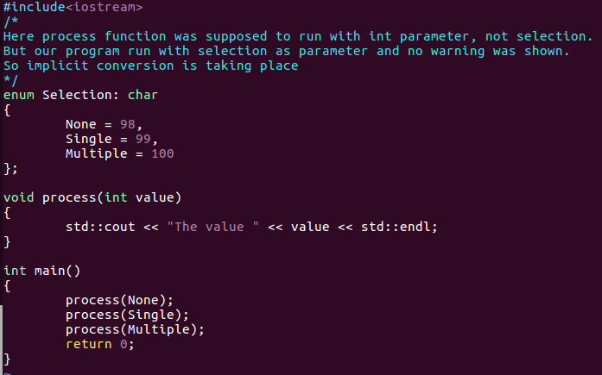

Output:



**Program_04:**

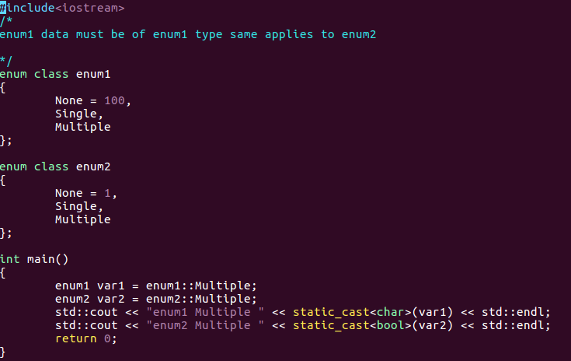

Output:



**Program_05:**

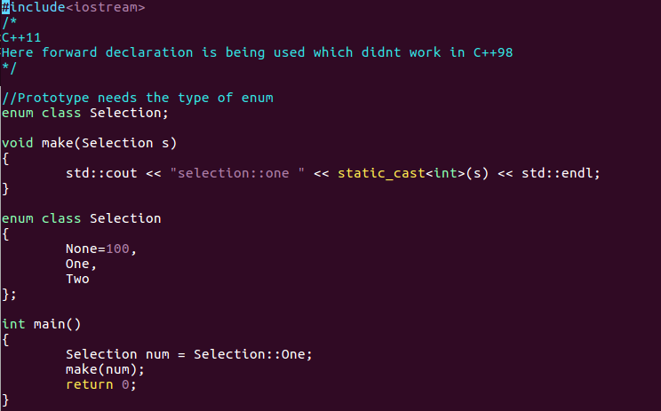

**Output:**

Selection::one 101

**Program_06:**

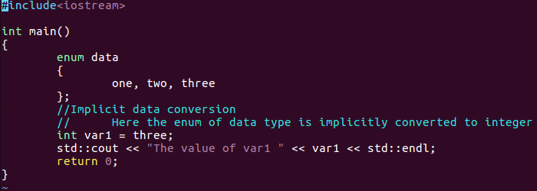

**Output:**

The value of var1 2