**INITIALIZER LIST**

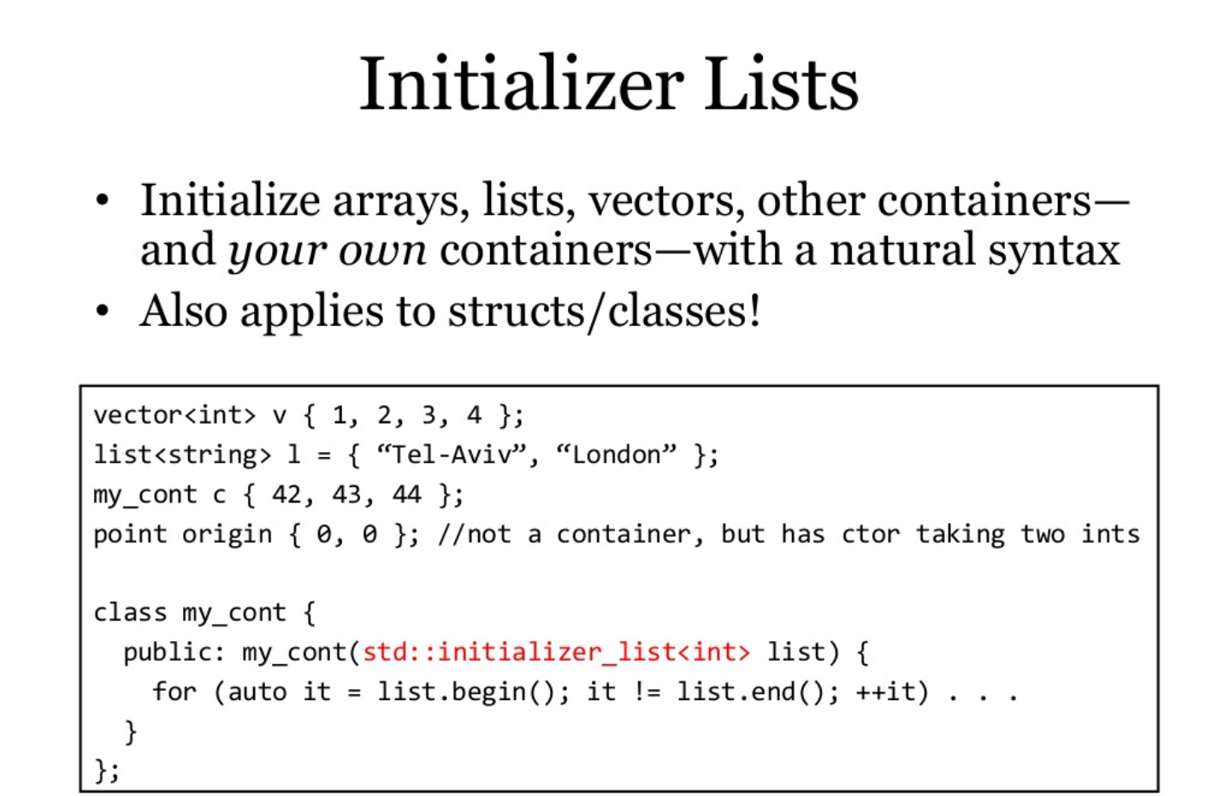

*Before C++11 it was easy to initialize an array with with default elements like,*

// Initializing array with default values int arr[]= {1,2,3,4,5};

|  |  |
| --- | --- |
| 1  2 | // Initializing array with default values  int arr[]= {1,2,3,4,5}; |

But there was no way no to initialize other containers like vector, list and map etc.

It is also used to initialized the members of the class in constructor.

**Why do we need to use it?**

Basically copying and pasting from Bjarne Stroustrup's "The C++ Programming Language 4th Edition":

List initialization does not allow narrowing (§iso.8.5.4). That is:

* An integer cannot be converted to another integer that cannot hold its value. For example, char to int is allowed, but not int to char.
* A floating-point value cannot be converted to another floating-point type that cannot hold its value. For example, float to double is allowed, but not double to float.
* A floating-point value cannot be converted to an integer type.
* An integer value cannot be converted to a floating-point type.

Example:

void fun(double val, int val2) {

int x2 = val; // if val==7.9, x2 becomes 7 (bad)

char c2 = val2; // if val2==1025, c2 becomes 1 (bad)

int x3 {val}; // error: possible truncation (good)

char c3 {val2}; // error: possible narrowing (good)

char c4 {24}; // OK: 24 can be represented exactly as a char (good)

char c5 {264}; // error (assuming 8-bit chars): 264 cannot be

// represented as a char (good)

int x4 {2.0}; // error: no double to int value conversion (good)

}

The only situation where = is preferred over {} is when using auto keyword to get the type determined by the initializer.

Example:

auto z1 {99}; // z1 is an initializer_list<int>

auto z2 = 99; // z2 is an int

## Conclusion

Prefer {} initialization over alternatives unless you have a strong reason not to.