How missing values are handled
This pipeline does not fill in or guess missing values. Instead, it cleans known missing-value codes, reports missingness, and excludes missing observations when necessary.
- Special codes are converted to NA
  - DHS codes such as 98 or 99 may mean "don't know" or "not applicable."
  - These are converted to NA.
  - For example, an fgm_age of 98 will become NA, rather than being treated as age 98.
- Different types of missingness are identified
  - The pipeline distinguishes between:
    - Structural missingness – the question was never asked because it wasn't applicable.
    - Missing information – the question should have been answered but wasn't.
  - The QA report shows these separately so large amounts of missing data can be detected.
- Rows with missing outcomes are excluded
  - For example, respondents without a known FGM outcome are excluded from the FGM analysis.
  - No value is guessed or imputed.
- Models exclude rows with missing variables
  - R's models generally use complete cases.
  - If a model needs age, ethnicity, and FGM status, a respondent missing one of those variables will be excluded from that particular model.
  - Therefore, different models may have different sample sizes.
- Missing GPS only affects maps
  - DHS uses (0,0) to indicate missing GPS coordinates.
  - Those clusters are excluded from maps.
  - However, their respondents are still included in statistical analyses.
- Daughters are handled the same way
  - Daughters without a known FGM status are excluded from the daughter-level analysis.
  - Again, nothing is imputed.

In short
Clean known missing-value codes → report missingness → exclude missing observations where necessary → never guess or fill in missing values.

Nigeria DHS 2024 — Sample and Analysis Population
Stage / Population | Number (n) | Explanation
Women interviewed (ages 15–49) | 39,050 | Total women included in the DHS individual survey
Women with known FGM status | 23,474 | Women with a non-missing FGM outcome (fgm_event)
Women with structural missing FGM status | 15,576 | Not asked the FGM status question because of the g100 skip pattern
Daughters aged 0–14 reconstructed | 23,683 | Daughters identified from the DHS daughters' roster; these are separate individuals from the interviewed women
Total FGM event records (fgm_events_all) | 47,157 | 23,474 women + 23,683 daughters
Records with missing/invalid event time | 2,473 | Known FGM-positive cases without a valid age at cutting
└─ Respondent records | 2,443 | FGM-positive women with missing/invalid age at cutting
└─ Daughter records | 30 | FGM-positive daughters with missing/invalid age at cutting
Records retained for risk-incidence analysis | 44,684 | Records with a valid time value (≤49 years)
└─ fgm_event = 0 | 37,328 | No FGM event recorded
└─ fgm_event = 1 | 7,356 | FGM event recorded
Attitudinal analysis population (attitude_all) | 20,916 | Respondents with a usable response on whether FGM should continue

Key figures to highlight
39,050 women were interviewed → 47,157 combined woman/daughter FGM records → 44,684 records were eligible for the time-to-event analysis after excluding 2,473 known FGM-positive records with missing/invalid age at cutting.
This distinction is important because 47,157 is the size of the harmonized FGM event dataset, while 44,684 is the actual analytic sample used by the risk-incidence model.

- Hazard Model Specification

Gg

Methodology
FGM data from the Nigeria DHS were cleaned and prepared using information on age at cutting, current age, birth cohort, region/state, residence, ethnicity, reporting type, survey cluster and sampling weight. Birth cohorts were grouped into five-year intervals, and records with unknown or invalid FGM information were excluded where necessary.
The data were expanded into person-year records, with one row representing each year of age during which an individual was observed and remained at risk. The event indicator was coded as 1 in the age-year when FGM occurred and 0 before the event or censoring. Individuals who had not experienced FGM by the survey were treated as right-censored.
A survey-weighted discrete-time hazard model was fitted using logistic regression. The model included age, birth cohort, residence, region, ethnicity and reporting type, while DHS weights, clusters and strata were incorporated through the survey package. Coefficients, odds ratios, standard errors and p-values were estimated to describe differences in FGM risk.
For mapping, the person-year data were grouped by region, birth cohort and reporting type. Survey-weighted regional risk estimates were calculated and joined to Nigeria’s geographic boundary data. Choropleth maps were then produced using a common colour scale, with darker colours representing higher estimated FGM risk.
The main R packages used were dplyr, tidyr, survey, ggplot2, sf, survival, mgcv and INLA.

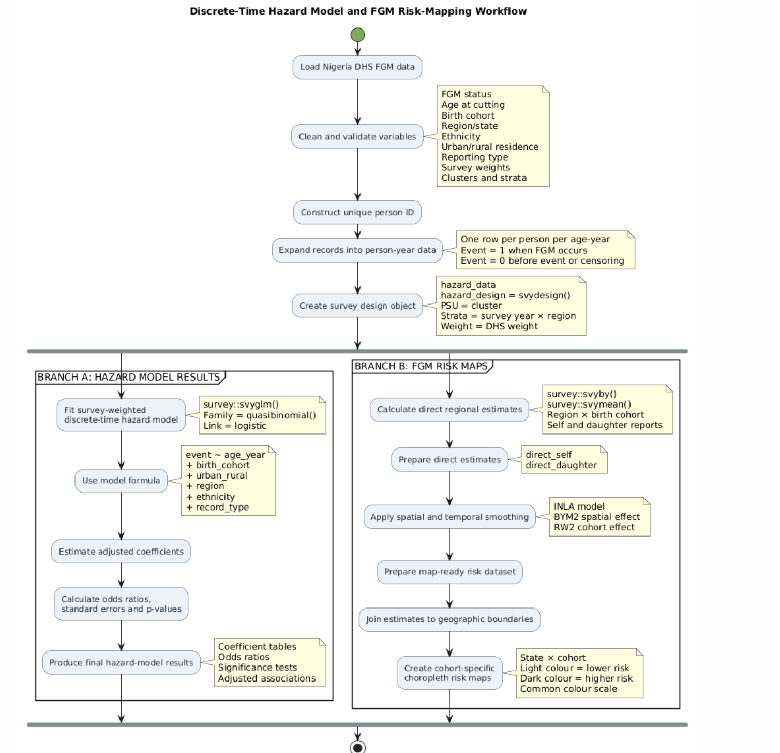

8.1 Overview
Two hazard models were specified to examine the timing and risk of female genital mutilation (FGM) across the life course. Both models use the same substantive predictors, with additional covariates included conditionally depending on the number of distinct categories observed in the combined dataset.
The models incorporate age-specific exposure time, birth cohort, geographical and demographic characteristics, and reporting source. This specification enables the analysis to assess differences in FGM risk across age groups and generations while accounting for individual and contextual characteristics.

8.2 Predictor Variables
The core predictors included in both hazard model

s are presented in Table 1.
Table 1. Core Predictors Included in the Hazard Models
Predictor | Description and analytical role
age_year | Age in completed years at risk of experiencing FGM. This is the time scale used in the discrete-time hazard model.
birth_cohort | Five-year birth-year bands used to capture changes in FGM risk across generations and assess whether the risk of FGM is declining over time.
urban_rural | Type of residence, distinguishing urban and rural populations.
region | Geographical location, represented by state or zone depending on the survey round. This variable is obtained through the geography-file join.
ethnicity | Grouped ethnic categories, consisting of the eight largest ethnic groups and an “Other” category, as constructed in Section 11.

8.3 Conditional Predictors
Two additional variables are included only when the combined dataset contains at least two distinct categories. This approach prevents the inclusion of single-level factors that cannot contribute meaningful contrasts to the model.
- Survey type (survey_type): This variable distinguishes between DHS and MICS survey rounds. It is relevant when multiple survey programmes are combined for a country. For the current Nigeria 2024 analysis, only one DHS round is included; consequently, survey_type is constant and is excluded from the model.
- Record type (record_type): This variable distinguishes between respondent self-reports and reconstructed daughter records. It is included in the current analysis because both reporting sources are present in the dataset. In the earlier model run, record_type was statistically significant (p = 0.002), indicating a difference in FGM reporting or recording patterns between the two sources. Its inclusion therefore helps account for potential reporting-source differences in the estimated hazard.

8.4 Model Specification for Nigeria 2024
For the Nigeria 2024 dataset, the active model specification is:
event ~ age_year + birth_cohort + urban_rural +
region + ethnicity + record_type
The model includes the occurrence of FGM as the event outcome, with age in years serving as the discrete time scale. The Cox proportional hazards version additionally incorporates a cluster-level frailty term to account for unobserved heterogeneity among individuals residing within the same sampling cluster.

8.5 Survey Design and Clustering
The analysis distinguishes between substantive predictors and statistical design components.
- Cluster-level frailty (cluster): Included in the Cox model as a random effect to account for unobserved cluster-level influences, such as shared local exposure and contextual factors. It is not interpreted as a conventional fixed-effect predictor.
- Primary sampling unit (psu), strata (strata), and survey weights (weight): These variables are used to construct the survey design object (hazard_design). They account for the complex survey sampling design and contribute to the estimation of appropriate standard errors and population-representative estimates. They do not form part of the substantive mean structure of the model.
This distinction ensures that the hazard models account for both individual-level and contextual factors while appropriately incorporating the survey design.

9. Treatment of FGM Age at Cutting in Time-to-Event Analysis

9.1 Overview
The time-to-event analysis requires the age at which FGM occurred to be identified for individuals who experienced the event. The data processing distinguishes between valid age-at-cutting values, including age zero, and missing or unrecorded ages. These cases have different implications for the construction of the event time.

9.2 Treatment of Age at Cutting Equal to Zero
An age-at-cutting value of zero is treated as a valid observation rather than missing data. In the data preparation stage, the age at cutting is retained when it falls within the inclusive range of 0 to 49 years:
fgm_age_raw = as.numeric(g106)

fgm_age = if_else(
fgm_age_raw %in% 0:49,
fgm_age_raw,
NA_real_
)
The inclusion of zero is important because FGM reported as occurring before the first birthday is coded as age zero in the relevant DHS data. Such observations are therefore retained in the analysis.
For individuals who experienced FGM, the event time is assigned as the recorded age at cutting:
time = if_else(
fgm_event == 1,
fgm_age,
pmin(age, max_age_years)
)
Consequently, an individual cut in infancy has:
- fgm_event = 1
- time = 0
When the data are subsequently expanded into person-time records, the event is assigned to age zero:
age_year = 0:floor(time)

event = dplyr::if_else(
age_year == floor(time) & fgm_event == 1,
1L,
0L
)
For an individual with time = 0, the resulting person-time record is:
age_year | event
0 | 1
This is the intended representation of an event occurring at age zero. Therefore, age zero is retained and correctly modeled as a valid event time.

9.3 Treatment of Missing Age at Cutting
Missing age-at-cutting values are treated differently from age zero. The data preparation step converts values outside the valid range of 0 to 49 years to NA. These may include survey-specific codes for unknown age at cutting, such as 98, or genuine non-response.
For individuals who are known to have experienced FGM but whose exact age at cutting is unavailable, the resulting values are:
- fgm_event = 1
- fgm_age = NA
- time = NA
The event is therefore known to have occurred, but its timing cannot be determined from the available data.

9.4 Implications for the Current Hazard Analysis
The current hazard-model workflow requires a numeric event time. The subsequent filtering step is:
filter(time <= max_age_years)
Records with time = NA do not satisfy this condition and are consequently excluded from the hazard dataset.
This means that respondents who are known to have experienced FGM but have an unknown age at cutting are currently omitted from the time-to-event analysis. They are not treated as non-events; rather, they are excluded because the model cannot assign their event to a specific age.
In the earlier analysis, 2,473 records were identified as known FGM-positive cases with missing age at cutting. These records represent a potential source of information loss in the current hazard-model implementation.

9.5 Summary of Age-at-Cutting Treatment
Age-at-cutting category | Treatment in the current workflow | Implication
Valid age, 1–49 years | Retained | Event assigned to the recorded age.
Age zero | Retained as valid | Event assigned to age zero.
Missing or unknown age (NA) | Excluded by the time filter | Known FGM-positive cases are omitted because event timing is unavailable.
Valid non-event observation | Follow-up time assigned using the available age and maximum age limit | Individual contributes person-time up to the observed follow-up limit.

9.6 Methodological Consideration
The exclusion of known FGM-positive cases with missing age at cutting should be explicitly acknowledged as a limitation of the current analysis. Although these observations cannot be assigned an exact event time, their exclusion may affect the estimated age-specific hazard if the missingness is associated with the timing of FGM or with characteristics of the affected individuals.
A potential methodological improvement would be to investigate an appropriate strategy for handling unknown event times, such as interval-censoring methods or sensitivity analyses, subject to the available survey information and the assumptions of the selected model. Any such approach should preserve the distinction between individuals who experienced FGM and those who did not, while appropriately representing uncertainty in the age at which the event occurred.

10. Data Files and Their Roles in the Analysis
The analysis uses three distinct datasets: person_level.rds, combined/NGA_fgm_events.rds, and combined/NGA_attitude.rds. Although these datasets originate from the same harmonized survey data, they differ in their structure, population coverage, filtering criteria, and analytical purpose.

Table 1. Comparison of the Analytical Datasets
Characteristic | person_level.rds (per-year) | combined/NGA_fgm_events.rds | combined/NGA_attitude.rds
Rows | 39,050 | 47,157 (23,474 self + 23,683 daughters) | 20,916
Columns | 36 | 20 | 19
Population covered | Survey respondents only | Respondents and reconstructed daughters | Survey respondents only
Filtering | Unfiltered; includes all respondents | Filtered to records with known fgm_event | Filtered to records with known supports_continuation
Ethnicity variable | ethnicity_raw (raw categories) | ethnicity (top 8 groups + “Other”) | ethnicity (grouped categories)
Temporal coverage | One specific survey year | All available survey years, stacked | All available survey years, stacked
Analytical purpose | Per-year audit and reference dataset | FGM risk and incidence analysis | FGM attitudinal analysis
Downstream notebook | None | FGM_Risk_Incidence.ipynb | FGM_Attitudinal_Incidence.ipynb

10.1 Description of the Datasets

10.1.1 person_level.rds — Per-year Reference Dataset
This dataset contains the complete, unfiltered records of respondents interviewed in a specific survey year. It comprises 39,050 rows and 36 columns, including harmonized demographic, geographical, FGM-related, and attitudinal variables.
The dataset preserves the original respondent-level information, including raw regional labels and raw ethnicity categories, and is intended primarily for data auditing, quality assessment, and reference. It provides a means of examining the structure and content of a particular year's data without returning to the original .dta file.

10.1.2 combined/NGA_fgm_events.rds — FGM Risk and Incidence Dataset
This is a narrow, purpose-built dataset for the FGM hazard and incidence analysis. It contains 47,157 records and 20 columns, with only the variables required by the risk-incidence model.
Unlike the per-year respondent dataset, it includes both respondent self-reports and reconstructed daughter records. Of the 47,157 observations, 23,474 are self records and 23,683 are daughter records. The daughter records are reconstructed from the household roster variables (g121–g124) and do not represent respondents who were directly interviewed.
The dataset is filtered to retain records with a known fgm_event and combines all available survey years into a single analytical file. Ethnicity is represented using grouped categories consisting of the eight largest ethnic groups and an “Other” category.

10.1.3 combined/NGA_attitude.rds — FGM Attitudinal Dataset
This dataset is designed specifically for the attitudinal analysis of FGM. It contains 20,916 records and 19 columns, retaining only variables required by the attitudinal model.
The dataset includes respondents only and is filtered to retain observations with a known supports_continuation response. It combines all available survey years and uses the grouped ethnicity variable to ensure consistency with the analytical framework.

10.2 Key Differences Between the Datasets
The three datasets differ in three principal ways:
- Population coverage: person_level.rds and NGA_attitude.rds contain respondents only, whereas NGA_fgm_events.rds includes both respondents and reconstructed daughters.
- Data processing: person_level.rds is unfiltered and retains the broader set of harmonized variables. The two combined datasets are filtered extracts designed for their respective models.
- Analytical purpose: The per-year dataset serves as an audit and reference file, while the combined datasets provide the model-ready data required for FGM risk-incidence and attitudinal analyses.

10.3 Summary
In summary, person_level.rds represents the complete respondent-level data for a particular survey year, whereas the combined datasets are analytical extracts tailored to specific modeling objectives. The FGM risk-incidence dataset is further augmented with reconstructed daughter records, allowing the analysis to incorporate additional information on FGM events that is not present in the per-year respondent dataset.

FGM Risk Incidence Methodology — Brief Overview

Core Concept
The Demographic and Health Survey (DHS) is a cross-sectional survey in which each woman is interviewed once. However, because FGM usually occurs early in life and is generally irreversible, the survey can provide retrospective information about FGM experiences across several decades. Each woman’s FGM status and age at cutting provide information about the experience of her birth cohort.
The methodology therefore uses retrospective FGM histories to estimate the age-specific risk of undergoing FGM, rather than relying only on overall prevalence.

1. Time-to-Event Framework
The analysis treats each individual as a survival or time-to-event record. The main variables are:
- fgm_event: whether the individual experienced FGM, coded as 1 for an event and 0 for no recorded event.
- time: age at cutting for individuals who experienced FGM, or current age for individuals who had not experienced FGM.
For individuals who have not experienced FGM, their current age represents the point at which observation ends. These records are treated as right-censored because the individual may experience FGM later.
This framework estimates the risk of undergoing FGM at each age, conditional on not having experienced FGM previously. This is different from estimating simple prevalence, which only measures the proportion of individuals who have already experienced FGM.

2. Person-Time Expansion
Each individual is expanded into a series of age-specific records representing the years during which they were at risk of experiencing FGM.
For example:
- An individual cut at age 5 contributes records up to the age of cutting.
- An individual who has not been cut and is currently aged 20 contributes records up to age 20 and is right-censored at that age.
This process is implemented through make_person_time(). The resulting dataset supports discrete-time hazard modelling by creating one observation for each year of exposure or risk.

3. Complementary Modelling Approaches
The methodology uses several modelling approaches to assess the robustness and consistency of the findings.

3.1 Kaplan–Meier Survival Analysis
Kaplan–Meier survival curves provide the baseline analysis. They estimate the probability of remaining free from FGM across age and allow comparisons between birth cohorts.
This represents the simplest and original UNFPA analytical approach and is retained as a reference against which the other models are compared.

3.2 Discrete-Time Hazard and Cox Models
The discrete-time hazard model estimates the probability of experiencing FGM at a given age, conditional on not having experienced it previously. The model is estimated using DHS sampling weights and survey design information.
A Cox proportional hazards model with cluster-level frailty is also used. The frailty term represents unobserved factors shared by individuals within the same community or sampling cluster, such as local cultural practices, social norms, or common exposure to FGM-related influences.
- Handles censoring: It recognises that younger girls have had less time to experience FGM than older women. For example, a 3-year-old and a 45-year-old cannot be treated as having the same level of risk simply because neither has been cut.
- Separates age and generation effects: It shows whether FGM risk is related to a person’s age or to the generation she belongs to. This helps determine whether FGM is decreasing among younger generations or simply occurs at different ages.

3.3 Generalized Additive Model
A Generalized Additive Model (GAM) is used to estimate nonlinear patterns across age and birth cohort. Penalized splines help identify gradual changes in FGM risk without requiring the relationship to be strictly linear.
This approach helps avoid:
- Overfitting when analysing individual birth cohorts; and
- Underfitting when the decline in FGM risk is genuinely nonlinear.

4. Spatial Small-Area Estimation
The methodology includes a spatial small-area estimation component for producing more stable estimates in areas with small sample sizes.
Bayesian spatial smoothing, using approaches such as INLA/SUMMER, combines:
- State- or region-level information;
- Spatial random effects;
- Birth cohort or period effects; and
- Neighbouring-area information.
A BYM2 spatial random effect allows neighbouring areas to borrow statistical strength from one another. A random-walk component is used to model changes across birth cohorts or periods.
This component is currently disabled because it requires an appropriate administrative-level polygon shapefile. The available DHS geographic data provide cluster locations but do not yet provide the required administrative boundary polygons.
Methodology
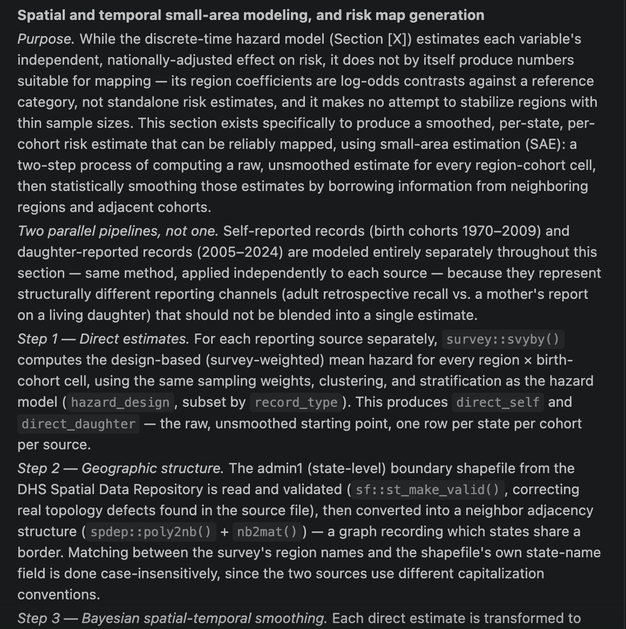
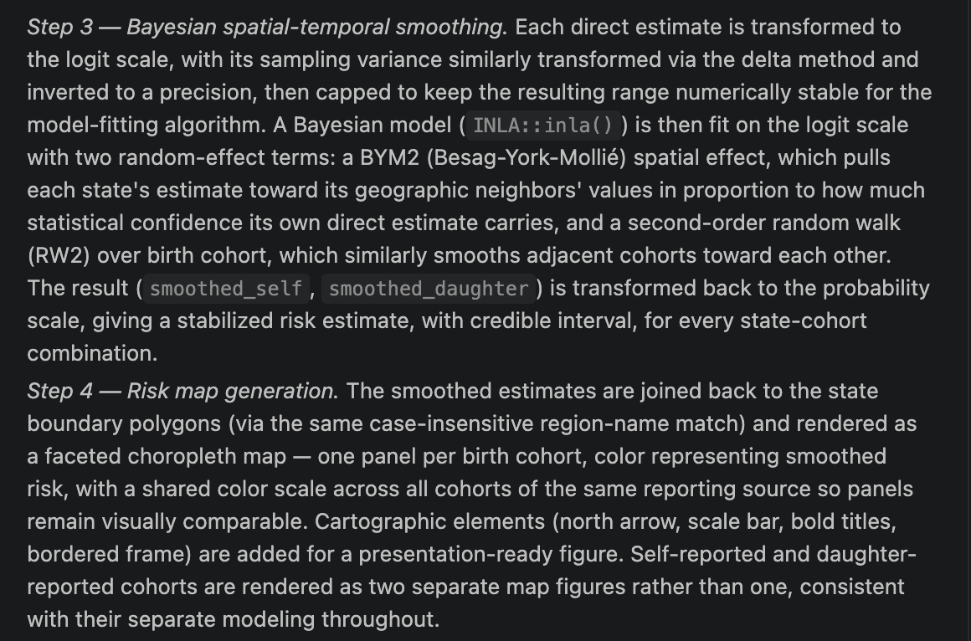

5. Lexis Heatmap and Changepoint Detection
A Lexis heatmap presents FGM risk across age and birth cohort in a single age–cohort surface. This helps identify differences in FGM timing between generations and age groups.
Changepoint detection is also applied using changepoint::cpt.mean. This identifies potential points at which the average level of FGM risk changed substantially.
The purpose is to move beyond a descriptive conclusion such as “FGM prevalence is declining” and estimate when a meaningful change in the pattern may have started.

6. Validation and Machine-Learning Cross-Check
The findings from the different analytical approaches are compared to assess consistency.
The validation process includes:
- Comparing Kaplan–Meier estimates with model-based hazard estimates;
- Comparing results from discrete-time hazard, Cox, and GAM models;
- Assessing whether the estimated direction of change is consistent across methods; and
- Using a Random Survival Forest as an independent, non-parametric cross-check.
The Random Survival Forest model helps assess which covariates are most relevant to FGM timing without imposing the same functional assumptions as the regression models.

7. Additional Methodological Enhancements
Several improvements were introduced after applying the methodology to real DHS data.

7.1 Ethnicity
Ethnicity was added as a covariate. In Nigeria, the raw ethnicity variable contains approximately 350 categories, many of which have very small sample sizes. To make modelling more stable and interpretable, the analysis retains the largest ethnic groups and combines the remaining categories into an “Other” group.

7.2 Daughters’ Roster Augmentation
The daughters’ roster was used to reconstruct daughters aged 0–14 as separate FGM event records.
This improves the analysis in two ways:
- It increases the number of available FGM records; and
- It provides more current information for younger birth cohorts.
This is important because women’s retrospective self-reports are less informative for recent birth cohorts, particularly when younger girls have not yet had sufficient time to experience FGM. Including daughters’ records therefore strengthens the analysis of more recent patterns.

7.3 Data and Modelling Corrections
Several technical corrections were identified during the end-to-end application of the methodology. These included:
- Correctly nesting survey strata across multiple survey rounds;
- Correcting DHS variable mappings in the original configuration;
- Resolving formula and data-type issues in the machine-learning cross-check; and
- Improving the handling of missing and invalid event times.
These corrections improve the reliability, reproducibility, and interpretability of the resulting estimates.

Summary
The FGM risk-incidence methodology combines retrospective DHS histories, survival analysis, person-time expansion, survey-weighted regression, spatial modelling, cohort analysis, changepoint detection, and machine-learning validation.
The overall objective is to estimate not only how many women have experienced FGM, but also:
- At what ages FGM is most likely to occur;
- How risk differs across birth cohorts and regions;
- Whether FGM risk is declining over time;
- When major changes in risk may have occurred; and
- Which demographic, social, geographic, and cultural factors are associated with the timing of FGM.

6. Kaplan–Meier Survival Analysis and Estimation of FGM Incidence Risk

6.1 Overview
Sections 6 and 7 use the same underlying Kaplan–Meier model (km_fit). The distinction between the two sections lies in how the model is used. Section 6 focuses on visualizing survival curves to examine differences in FGM timing across birth cohorts, while Section 7 extracts age-specific risk estimates for reporting and further analysis.

6.2 Section 6: Kaplan–Meier Survival Analysis
Section 6 fits a Kaplan–Meier survival model stratified by birth cohort using the following specification:
km_fit <- survival::survfit(
survival::Surv(time, fgm_event) ~ birth_cohort,
data = fgm_events
)
The model estimates the probability of remaining free from FGM up to each age, separately for each birth cohort. The resulting survival curves provide a visual representation of differences in the timing of FGM across generations.
The Kaplan–Meier curves are useful for assessing:
- Differences in the timing of FGM across birth cohorts.
- Whether younger birth cohorts exhibit higher probabilities of remaining free from FGM at comparable ages.
- The overall shape and pattern of FGM risk across the life course.
However, the survival curve primarily provides a graphical representation of the results. Specific age-related risk estimates must be extracted from the fitted model to produce numerical values suitable for reporting.

6.3 Section 7: Estimation of FGM Incidence Risk
Section 7 uses the same fitted Kaplan–Meier model (km_fit) to obtain survival estimates at selected reference ages. The reference ages are defined as:
reference_ages <- c(1, 2, 5, 8, 10, 15, 18)

risk_table <- summary(
km_fit,
times = reference_ages,
extend = TRUE
)
These ages represent key reporting milestones for examining the timing of FGM. In particular, age 5 is a useful reference point for comparing early childhood FGM risk across birth cohorts.
The extracted survival estimates are converted into cumulative FGM risk using the relationship:
fgm_risk = 1 - survival
Where:
- survival represents the estimated probability of remaining free from FGM by a given age.
- fgm_risk represents the estimated probability of having experienced FGM by that age.
Confidence intervals are also obtained and transformed accordingly to provide the lower and upper bounds of the estimated cumulative risk.

6.4 Differences Between Sections 6 and 7
Characteristic | Section 6: Kaplan–Meier Baseline | Section 7: Estimate FGM Incidence Risk
Model used | km_fit | Same km_fit object
Main purpose | Visualize survival patterns | Extract numerical risk estimates
Output | Kaplan–Meier survival curves | Age-specific risk table
Age representation | Continuous survival curve across observed ages | Selected reference ages: 1, 2, 5, 8, 10, 15, and 18
Main measure | Probability of remaining free from FGM | Probability of having experienced FGM by a specified age
Interpretation | Shows the shape of FGM timing differences across birth cohorts | Provides numerical estimates that can be quoted and compared
Confidence intervals | Displayed as part of the survival-curve estimates, where applicable | Reported as lower_ci and upper_ci
Export | Graphical output | NGA_km_risk_by_age.csv

6.5 Interpretation of the Risk Estimates
The risk estimates generated in Section 7 provide a direct way to communicate the cumulative probability of experiencing FGM by selected ages.
For example, an estimate could be reported in the following format:
By age 5, women born between 1990 and 1994 had an estimated 23% cumulative risk of experiencing FGM (95% confidence interval: 19%–27%).
This type of result is more suitable for inclusion in statistical tables, policy briefs, and narrative reporting than a survival curve alone.

6.6 Summary
Section 6 and Section 7 are complementary components of the same Kaplan–Meier analysis. Section 6 fits and visualizes the survival model, providing an overview of age-specific FGM timing across birth cohorts. Section 7 queries the fitted model at selected reference ages, transforms survival probabilities into cumulative FGM risk, and produces an exportable table with confidence intervals.
Therefore, neither section represents an entirely separate risk-incidence model. Rather, Section 6 provides the survival analysis and graphical interpretation, while Section 7 extracts the numerical risk estimates used for reporting.

8. Multivariable Hazard Models for FGM Risk

8.1 Overview
Section 8 estimates the factors associated with the timing of female genital mutilation (FGM) using two complementary statistical approaches. Both models address the same substantive question: how does the risk of experiencing FGM vary by age, birth cohort, residence, region, ethnicity, and reporting source?
The models differ in how they account for similarities among women residing in the same sampling cluster. The first approach uses survey-design-based estimation to account for the complex sampling design and obtain appropriate standard errors. The second approach explicitly models unobserved cluster-level heterogeneity through a frailty term.
Using two approaches provides a useful robustness assessment. Agreement in the direction and substantive interpretation of the estimated associations can strengthen confidence in the findings. Differences between the models should be examined to understand the influence of clustering, survey design, and model assumptions.

8.2 Model Specifications

Model 1: Survey-Design-Based Discrete-Time Hazard Regression
The first model, hazard_model_design_based, is estimated using svyglm() with a quasibinomial family. It is fitted to the person-time expanded dataset, where each observation represents an individual at a specific age-year.
The outcome variable, event, indicates whether FGM occurred during that particular age-year. The model is specified as:
hazard_model_design_based <- svyglm(
event ~ age_year + birth_cohort + urban_rural +
region + ethnicity + record_type,
design = hazard_design,
family = quasibinomial()
)
The survey design is defined as:
hazard_design <- survey::svydesign(
ids = ~cluster,
strata = ~interaction(survey_year, region),
weights = ~weight,
data = hazard_data,
nest = TRUE
)
This approach accounts for the complex survey design through sampling clusters, stratification, and survey weights. The resulting standard errors reflect the survey design and are used to assess the statistical significance of the estimated associations.
The model estimates age-specific FGM hazard on the discrete-time scale. The coefficients are expressed on the log-odds scale because the model uses a quasibinomial link.

Model 2: Cox Proportional-Hazards Model with Cluster Frailty
The second model, hazard_model_frailty, is estimated using the Cox proportional-hazards framework with a cluster-level frailty term:
hazard_model_frailty <- survival::coxph(
survival::Surv(age_year, age_year + 1, event) ~
birth_cohort + urban_rural + region + ethnicity +
record_type + survival::frailty(cluster),
data = hazard_data
)
The model explicitly incorporates a random effect for each sampling cluster. The frailty term captures unobserved cluster-level characteristics that may influence FGM risk, such as shared cultural practices, community norms, or other contextual factors not fully explained by the measured covariates.
The Cox model estimates relative hazard through hazard ratios. A hazard ratio greater than one indicates a higher instantaneous risk of experiencing FGM, while a hazard ratio below one indicates a lower instantaneous risk, relative to the reference category.

8.3 Comparison of the Two Hazard Models
Characteristic | Model 1: Survey-design-based hazard model | Model 2: Cox frailty model
Model object | hazard_model_design_based | hazard_model_frailty
Estimation function | svyglm() | coxph()
Statistical framework | Discrete-time hazard regression | Cox proportional-hazards regression
Outcome | event: FGM occurred during a specific age-year | FGM event represented through the survival response
Data structure | Person-time expanded data | Person-time expanded data
Core predictors | Age, birth cohort, residence, region, ethnicity, record type | Birth cohort, residence, region, ethnicity, record type
Cluster handling | Survey design accounts for clustering in variance estimation | frailty(cluster) explicitly models cluster-level heterogeneity
Survey design | Includes clusters, strata, and weights | Survey weights and stratification are not included in the supplied Cox formula
Main effect measure | Coefficients on the log-odds scale | Hazard ratios obtained by exponentiating coefficients
Main purpose | Estimate discrete-time hazard associations with survey-adjusted uncertainty | Estimate relative hazards while accounting for unobserved cluster-level variation

8.4 Results from the Survey-Design-Based Hazard Model
The survey-design-based model was fitted using 738,925 person-time observations, with 7,356 recorded FGM events.

Age and Birth Cohort
Age was strongly associated with the discrete-time hazard of FGM. The coefficient for age_year was −0.460 (p < 0.001), indicating that the odds of experiencing FGM during a given age-year decreased as age increased, conditional on the other variables in the model.
Relative to the reference birth cohort, the estimated coefficients for most birth cohorts were negative. This indicates lower modeled FGM hazard among these cohorts compared with the reference group.
The strongest negative associations were observed among the 1995–1999, 2000–2004, 2010–2014, and 2015–2019 birth cohorts. However, the 2020–2024 cohort was not statistically different from the reference category at the 5% significance level.

Residence
Urban residence was associated with a lower discrete-time FGM hazard compared with the reference residence category. The coefficient was −0.506 (p < 0.001), suggesting a statistically significant difference in modeled hazard between urban and rural residence.

Region
Significant regional differences were observed. Relative to the reference region, positive coefficients were observed for Ekiti, Imo, Jigawa, Kaduna, Katsina, Kwara, and Nasarawa, indicating higher modeled hazard in these regions.
Negative coefficients were observed for Gombe, Kebbi, Niger, Sokoto, Taraba, and Yobe, indicating lower modeled hazard relative to the reference region.
These results demonstrate substantial geographical heterogeneity in FGM hazard after adjustment for age, birth cohort, residence, ethnicity, and record type.

Ethnicity
Several ethnic groups showed statistically significant differences in modeled FGM hazard relative to the reference ethnic category.
Negative coefficients were observed for Ibibio, Igbo/Ibo, Ijaw/Izon, Kanuri/Beriberi, Other, Tiv, and Yoruba. The Hausa coefficient was not statistically significant.
The largest negative association was observed for the Tiv ethnic group (coefficient = −4.280, p < 0.001), although the estimate should be interpreted with caution because of its relatively large standard error.

Record Type
The record_type variable was statistically significant. The coefficient for self records was −0.360 (p = 0.002), indicating a difference in modeled hazard between self-reported records and the reference record type.
This finding suggests that reporting source may influence the observed distribution of FGM events and should be retained as an adjustment variable in the analysis.

8.5 Results from the Cox Frailty Model
The Cox frailty model was fitted to 738,925 observations and 7,356 events. The estimated variance of the cluster-level random effect was 0.951, indicating meaningful heterogeneity between clusters.
The frailty term was highly statistically significant (likelihood ratio test p < 0.001), supporting the inclusion of a cluster-level random effect in the Cox model.

Residence
Urban residence was associated with a lower hazard of FGM compared with the reference residence category.
Predictor | Hazard ratio | 95% Confidence interval | p-value
Urban residence | 0.727 | 0.625–0.846 | <0.001
This corresponds to approximately 27% lower modeled hazard for urban residence relative to the reference category.

Region
The Cox frailty model identified significant regional differences in FGM hazard.
Region | Hazard ratio | 95% Confidence interval | p-value
Bayelsa | 2.502 | 1.268–4.936 | 0.008
Delta | 2.243 | 1.245–4.043 | 0.007
Edo | 1.948 | 1.067–3.555 | 0.030
Ekiti | 3.944 | 2.120–7.336 | <0.001
Gombe | 0.322 | 0.162–0.641 | 0.001
Imo | 2.545 | 1.484–4.364 | <0.001
Jigawa | 5.386 | 3.022–9.602 | <0.001
Kaduna | 4.546 | 2.542–8.131 | <0.001
Kano | 2.473 | 1.390–4.400 | 0.002
Katsina | 9.454 | 5.477–16.319 | <0.001
Kebbi | 0.134 | 0.069–0.261 | <0.001
Kwara | 4.566 | 2.490–8.372 | <0.001
Nasarawa | 3.201 | 1.779–5.760 | <0.001
Niger | 0.435 | 0.223–0.850 | 0.015
Ondo | 2.249 | 1.197–4.223 | 0.012
Osun | 2.029 | 1.100–3.743 | 0.024
Sokoto | 0.271 | 0.145–0.508 | <0.001
Taraba | 0.239 | 0.071–0.807 | 0.021
Yobe | 0.492 | 0.256–0.944 | 0.033
The largest estimated hazard ratio was observed in Katsina (HR = 9.454), while the lowest was observed in Kebbi (HR = 0.134). These estimates indicate substantial geographical differences in FGM hazard after adjustment for the covariates included in the model.

Ethnicity
Ethnic group | Hazard ratio | 95% Confidence interval | p-value
Hausa | 1.047 | 0.929–1.181 | 0.450
Ibibio | 0.239 | 0.138–0.414 | <0.001
Igbo/Ibo | 0.543 | 0.411–0.717 | <0.001
Ijaw/Izon | 0.204 | 0.128–0.325 | <0.001
Kanuri/Beriberi | 0.813 | 0.640–1.032 | 0.089
Other | 0.574 | 0.492–0.670 | <0.001
Tiv | 0.022 | 0.005–0.099 | <0.001
Yoruba | 0.950 | 0.752–1.200 | 0.670
The Cox frailty model indicates lower modeled FGM hazards among several ethnic groups relative to the reference category. The Tiv group had the lowest estimated hazard ratio (HR = 0.022), although this estimate should be interpreted cautiously given the uncertainty associated with the coefficient.

Record Type
Self records had a hazard ratio of 0.590 (95% CI: 0.497–0.701; p < 0.001) relative to the reference record type.
This suggests a statistically significant difference in modeled hazard between self-reported and reconstructed daughter records, reinforcing the importance of accounting for reporting source in the analysis.

8.6 Model Diagnostics and Overall Fit
The Cox frailty model reported a concordance statistic of 0.891 (standard error = 0.002), indicating strong discrimination between observations with different modeled event risks.
The likelihood ratio test was statistically significant (p < 0.001), indicating that the fitted model provides substantial explanatory information relative to a model without the included effects.
The estimated variance of the cluster frailty term was 0.951, suggesting that unobserved cluster-level factors contribute to differences in FGM hazard.

8.7 Interpretation and Methodological Considerations
The two models identify broadly consistent patterns for several key predictors, particularly urban residence, regional variation, ethnicity, and record type. This provides a useful cross-check of the substantive findings.
However, the models should not be interpreted as identical estimates because they use different statistical frameworks and account for clustering differently. The survey-design-based model incorporates survey sampling weights, stratification, and clustering in the estimation of uncertainty, whereas the Cox model explicitly models cluster-level heterogeneity through a frailty term.
The Cox frailty model output also shows extremely large and unstable coefficients for the birth cohort variables, with very large standard errors and confidence intervals extending from zero to infinity. These estimates indicate potential estimation problems, such as sparse events or separation, and should not be interpreted as reliable hazard ratios without further investigation.

8.8 Summary
Section 8 provides a multivariable assessment of factors associated with FGM hazard using two complementary approaches. The survey-design-based discrete-time hazard model accounts for the complex survey design, while the Cox frailty model explicitly incorporates unobserved cluster-level heterogeneity.
Both approaches indicate important differences in FGM hazard by residence, region, ethnicity, and reporting source. The findings highlight the importance of accounting for demographic, geographical, and contextual factors when estimating FGM risk.
The agreement between the two models for several substantive predictors supports the robustness of these associations. Nevertheless, the unstable birth cohort estimates in the Cox frailty model require additional diagnostic assessment before the model can be considered suitable for definitive inference on cohort-specific hazard ratios.

8. Comparison of the Two Hazard Models
Two complementary hazard models were estimated to assess the timing and predictors of FGM occurrence:
- A survey-weighted discrete-time hazard model using svyglm() with a quasibinomial specification.
- A Cox proportional hazards model with a shared frailty term for the survey cluster.
The two models produced broadly consistent findings, but they did not agree on every predictor. The strongest agreement was observed for urban–rural residence, record type, and several regional and ethnic differences.

8.1 Areas of Agreement
Both models indicated that respondents from urban areas had a lower FGM hazard than those from rural areas. In the survey-weighted model, the coefficient for urban residence was negative and statistically significant. The Cox model produced a hazard ratio of approximately 0.73, indicating that the estimated hazard among urban respondents was about 27% lower than that of rural respondents, holding other variables constant.
The models also agreed on the effect of record type. Self-reported respondent records had a lower estimated FGM hazard than daughter records. This finding was statistically significant in both models, suggesting that the distinction between respondent and reconstructed daughter records is substantively important.
There was also broad agreement across several regional and ethnic categories. Both models identified higher estimated hazard in regions such as Ekiti, Imo, Jigawa, Kaduna, Katsina, Kwara, and Nasarawa. Similarly, both models indicated lower hazard among several ethnic groups, including Ibibio, Igbo/Ibo, Ijaw/Izon, Other, and Tiv. These consistent patterns provide greater confidence that the corresponding differences are not solely attributable to the choice of modelling framework.
hazard_model_design_based — a survey-weighted regression estimating the probability of being cut at each age, given age, birth cohort, region, ethnicity, and urban/rural. It uses the DHS sample design (clusters/strata/weights) to get correct standard errors, since ignoring clustering would make the results look more certain than they really are.
hazard_model_frailty — the same idea, same covariates, but instead of just correcting standard errors for clustering, it explicitly adds a random effect per cluster (frailty(cluster)) — capturing unmeasured local factors (community norms, a local practitioner) that make cutting risk vary place to place beyond what age/cohort/region/ethnicity alone explain.
In short: both estimate the same "what predicts cutting risk" question — one corrects for clustering statistically, the other models clustering directly as its own effect — run together as a cross-check on each other.

8.2 Areas of Partial Agreement
The models did not always produce the same statistical significance levels for every region or ethnic group. For example, some regions were statistically significant in one model but not in the other. Differences in significance may reflect the different estimation frameworks, the treatment of clustering, the use of survey weights, and the assumptions underlying the Cox frailty model.
Similarly, Kanuri/Beriberi and Yoruba were statistically significant in the survey-weighted model but were not statistically significant in the Cox model. These findings should therefore be interpreted cautiously rather than being presented as fully robust across both approaches.

8.3 Birth-Cohort Effects
The greatest disagreement occurred for birth-cohort effects. The survey-weighted discrete-time hazard model showed a clear pattern of lower FGM hazard among several later birth cohorts relative to the reference cohort. This pattern is consistent with a reduction in the risk of FGM among more recent generations.
In contrast, the birth-cohort estimates from the Cox frailty model were unstable. Several coefficients were either estimated as zero or were associated with extremely large standard errors. The resulting hazard ratios were exceptionally large, with confidence intervals extending from zero to infinity. This indicates potential problems with sparse data, separation, or limited identifiability between birth cohort and the age-based time structure.
Consequently, the birth-cohort estimates from the Cox model were not interpreted substantively. The survey-weighted discrete-time model was retained as the primary basis for interpreting birth-cohort patterns, while the Cox frailty model was used as a complementary robustness analysis.

8.4 Interpretation of Age
The age terms in the two models are not directly comparable. In the survey-weighted discrete-time model, age_year is included as an explanatory variable and its negative coefficient indicates that the probability of experiencing FGM decreases across the observed age intervals.
In the Cox model, age is used as the underlying time scale through:
Surv(age_year, age_year + 1, event)
Therefore, age is not estimated as an ordinary covariate in the Cox model. The age effect from the survey-weighted model should not be compared directly with a conventional age coefficient from the Cox model.

8.5 Overall Assessment
Overall, the two models provide supporting but not identical evidence. They agree on the main findings concerning urban–rural residence, record type, and several regional and ethnic differences. However, the agreement is incomplete for individual categories, and the Cox birth-cohort estimates are clearly unstable.
The survey-weighted discrete-time hazard model is therefore considered the primary model for substantive interpretation because it directly incorporates the survey design and provides interpretable age-specific event probabilities. The Cox frailty model is retained as a complementary analysis to assess whether the main findings remain broadly consistent after accounting for clustering at the survey-cluster level.
The results should consequently be described as showing broad directional agreement between the models, rather than complete agreement across all predictors and statistical significance levels.

Summary of the Design-Based Hazard Model Results
The survey-weighted discrete-time hazard model estimates how different factors are associated with the likelihood of experiencing FGM during a specific age interval. The model uses a logistic link, meaning that coefficients are expressed as changes in log-odds.
- Negative coefficients indicate lower FGM risk compared with the reference group.
- Positive coefficients indicate higher FGM risk.
- The size of the coefficient shows the strength and direction of the association.
For example, the coefficient for the 2000–2004 birth cohort is −0.87. This means that, compared with the 1970–1974 reference cohort, the 2000–2004 cohort has lower estimated odds of experiencing FGM during a given year. Exponentiating the coefficient gives an odds ratio of approximately 0.42, suggesting about 58% lower odds, holding other factors constant.

Interpretation of p-values
The p-value indicates whether the observed association is likely to be due to sampling variation if there were no real association.
- p-value below 0.05: statistically significant association.
- p-value above 0.05: insufficient evidence of a statistically significant association.
The model calculates standard errors while accounting for the DHS survey design, including sampling weights, clustering, and stratification. This helps produce more appropriate estimates of uncertainty.
In summary: the coefficient shows the direction and strength of the association, while the p-value shows how strong the evidence is for that association.

Figure 9. Smoothed birth-cohort effect on FGM risk in Nigeria
The figure presents the smoothed relationship between birth cohort and the predicted risk of experiencing FGM. Rather than estimating a separate effect for each five-year birth-cohort category, the penalized spline model fits a continuous curve across cohort midpoints. The shaded area represents the approximate 95% confidence interval around the predicted risk.
The estimated risk declines steadily among women born from the early 1970s through approximately the 1995–2000 cohorts. This pattern suggests that the likelihood of experiencing FGM has generally decreased across successive generations, consistent with the broader evidence of declining FGM prevalence among younger cohorts.
The curve reaches its lowest point around the 2000 birth cohort, after which the predicted risk appears to increase slightly among the most recent cohorts. However, this apparent increase should be interpreted cautiously. The youngest cohorts are represented predominantly by daughter records rather than self-reported respondent records, and the smoothing model does not currently adjust for record_type. The upward movement may therefore reflect differences between self-reported and daughter records rather than a genuine reversal in FGM trends.
The confidence band is also wider at the oldest and youngest cohort ranges, indicating greater uncertainty where the available data are relatively limited. The central portion of the curve is therefore more reliable than the estimates at the extremes.
Overall, the figure provides evidence of a broad decline in FGM risk across successive birth cohorts in Nigeria. The apparent increase among the youngest cohorts should not be interpreted as a confirmed resurgence without further analysis controlling for record type and assessing the sensitivity of the results to the youngest cohorts.
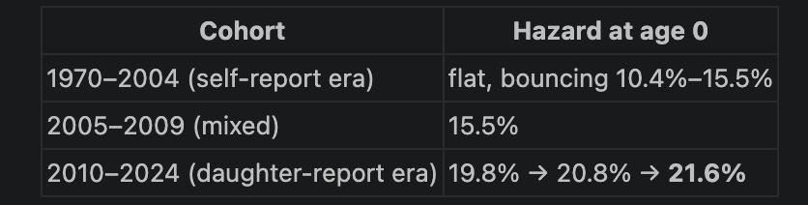
the 2024 Nigeria DHS interviews women aged 15–49 directly. For a woman to self-report her own FGM status, she has to be old enough to be a survey respondent. In the 2024 survey:
- Born ≤2009 → she's 15+ in 2024 → she can be interviewed and self-report → self-report exists
- Born 2010 or later → she's 14 or younger in 2024 → she's below the minimum respondent age → she cannot be interviewed herself, full stop

No — precise answer: we have not used the actual UN IGME B3 model. I just checked every place SUMMER appears in this notebook, and it's only ever library(SUMMER) — loaded, never called. Your own notebook's markdown (Section 11) is already honest about this; it says the custom INLA formula is "the SUMMER style small area hazard framework," and explicitly notes SUMMER::smoothDirect() would be the ready-made wrapper for it, but the code writes the INLA call out by hand instead "for transparency."
What we actually built is a simplified, hand-rolled cousin of that family — f(region_id, model="bym2") + f(cohort_id, model="rw2") fit with family = "gaussian" directly on the point estimates. That shares the general philosophy (borrow strength across space via BYM2, across time via a smooth random effect instead of treating each area/cohort as independent) but differs from B3 in three concrete ways:
- B3 uses penalized B-splines over continuous time with an explicit bias-adjustment term for data source; ours uses a discrete RW2 over 11 cohort bins with no bias term at all.
- B3/SUMMER's proper implementation weights each direct estimate by its own sampling variance (a region with 30 respondents gets less influence than one with 544); our Gaussian INLA call only sees point estimates, not their precision — a real gap, already flagged as Recommendation #3.
- Most relevant to everything we've been doing today: B3's whole reason for existing is stitching together data sources with known, different biases into one coherent trend — that's exactly the self-report-vs-daughter-report problem this conversation just spent an hour on. We tested that idea ad hoc (record_type as a covariate, a fixed offset), but we never adopted B3's actual mechanism for it.
So the honest framing for your write-up: the notebook is inspired by the UN IGME B3 / SUMMER small-area methodology, not an implementation of it. If you want the real thing, switching Section 11 to SUMMER::smoothDirect() would get you proper variance-weighting and is the natural next step — and given today's findings, it's worth checking whether SUMMER's own source-bias-adjustment machinery handles the self/daughter split more rigorously than our manual attempts did. Want me to look into what that would take?

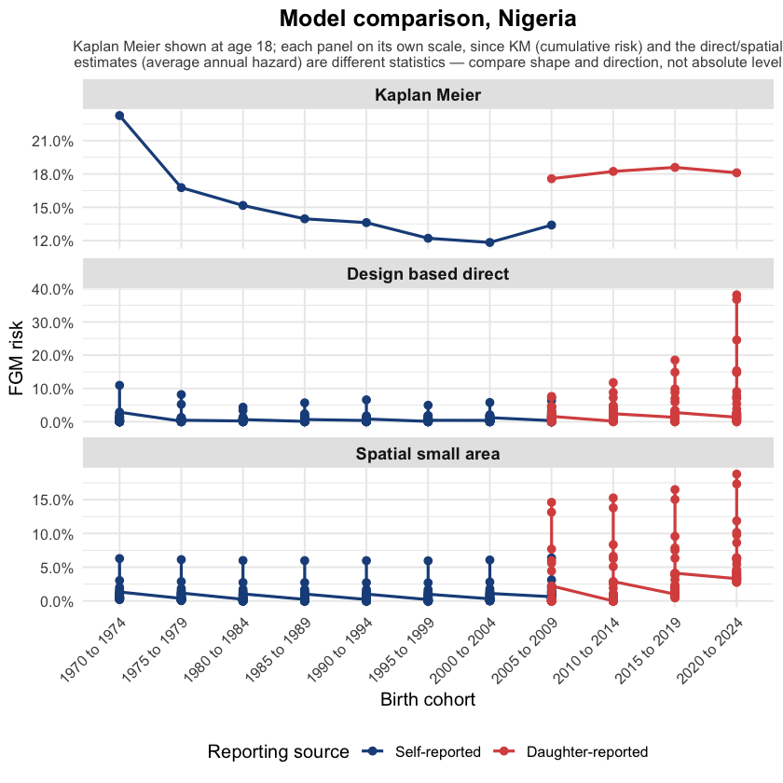
Let me break this into the three questions you're really asking: what "design based direct" means, why the y-axes differ so much, and what the overall pattern tells you.
What "design based direct" is: it's the rawest, least-processed estimate in the whole comparison — for every region × birth cohort combination, it's just the survey-weighted average of event (survey::svyby(..., survey::svymean)), computed directly from the sample using the DHS's own sampling weights, clustering, and stratification, with zero smoothing or borrowing of information across regions or cohorts. "Design-based" is statistics terminology meaning the estimate's validity comes from the known probability sampling design itself (Horvitz-Thompson-style weighting), not from a statistical model imposing any structure. It's the honest, unadjusted starting point that the spatial model (BYM2/INLA) then smooths.
Why the y-axes differ so much between panels — two separate reasons:
- Kaplan-Meier vs. the other two is the statistic-type difference we already covered: KM is cumulative probability of ever being cut by age 18 (one number per cohort, nationally); the other two are average annual hazard — a much smaller number by construction, since it's spread across every year of exposure rather than accumulated.
- "Design based direct" (max ~40%) vs. "Spatial small area" (max ~19%) is a different, and honestly more interesting, reason: both panels are actually showing 37 individual state-level points per cohort, not one national number — that's why you see a vertical spray of dots at each cohort rather than a single clean line. The raw direct estimates include noisy outliers (a small state with few respondents in the newest cohort can land on an extreme value just by chance — we saw earlier that Taraba had only 30 respondents in the 2020–2024 cohort). The spatial model's whole job is to pull those noisy extremes toward their neighboring states' values ("borrowing strength"), which is exactly what you're seeing: the smoothed panel's peak drops from ~40% to ~19% because BYM2 is doing what it's designed to do — taming small-sample noise rather than treating a single unstable estimate as real.
What it tells you overall: despite being three genuinely different methods — nonparametric survival curves, raw unsmoothed survey estimates, and Bayesian spatial smoothing — all three agree on the same qualitative shape: self-reported cohorts decline then flatten, daughter-reported cohorts rise sharply toward the most recent cohort. That agreement across very different methodologies is the actual point of a model validation chart — it's evidence the pattern isn't an artifact of any one modeling choice, even though the exact numbers differ because each method is measuring something slightly different and at a different level of aggregation.
did we do small area estimates in this work??
Yes — that's exactly what Section 10–12 of FGM_Risk_Incidence.ipynb does, even though the notebook doesn't use that exact term everywhere. Small area estimation (SAE) means: you want reliable estimates for many small subgroups (here, 37 states × 11 birth cohorts = 407 cells), but most of those cells have too few respondents individually to trust on their own — so you borrow strength from nearby areas/periods to stabilize the noisy ones. That's precisely the two-step pipeline you have:
- Direct estimates (direct_self/direct_daughter) — the raw, unsmoothed survey-weighted estimate for each region × cohort cell. This is standard SAE terminology: "direct" means computed straight from the sample in that cell alone, no borrowing.
- Smoothed/modeled estimates (smoothed_self/smoothed_daughter, via INLA::inla() with a BYM2 spatial term + RW2 cohort term) — this is the actual small-area-estimation step: it pulls each noisy direct estimate toward its geographic neighbors and adjacent cohorts, which is exactly why the "Spatial small area" panel in your validation chart had a much lower, more believable peak (~19%) than the raw "Design based direct" panel's noisy outlier (~40%) we just discussed.
So yes, genuinely — you built a working Bayesian spatial small-area estimation pipeline, in the same broad methodological family as the UN IGME/SUMMER framework (BYM2 spatial smoothing + temporal random walk, borrowing strength across sparse regions).
The honest caveat, which we already covered: it's a simplified, hand-rolled version, not the actual SUMMER::smoothDirect() or UN IGME B3 implementation — it doesn't yet properly weight each direct estimate by its own sampling variance (a region with 30 respondents and a region with 544 currently get treated with equal trust before smoothing), and it uses a plain Gaussian likelihood rather than a proper binomial/logit model. Those are real, fixable gaps (Recommendation #3), but the core SAE architecture — direct estimates + spatial-temporal Bayesian smoothing — is genuinely in place and working.
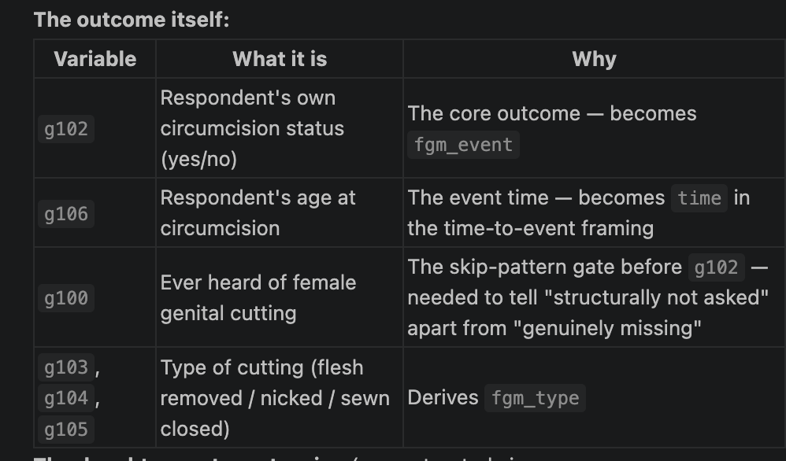
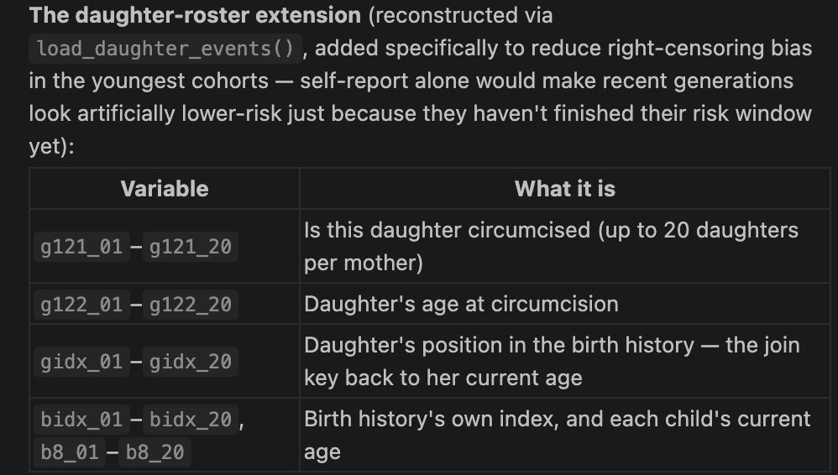
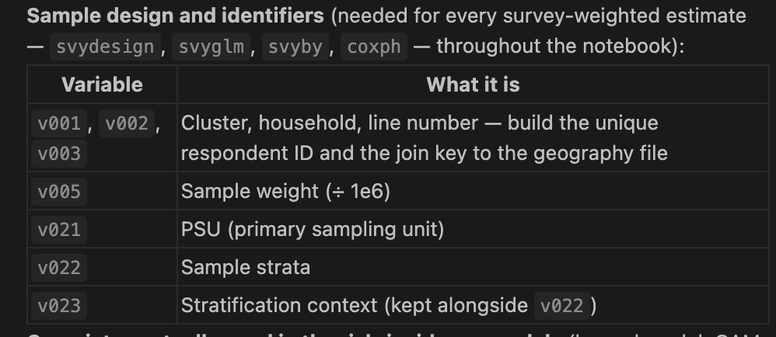
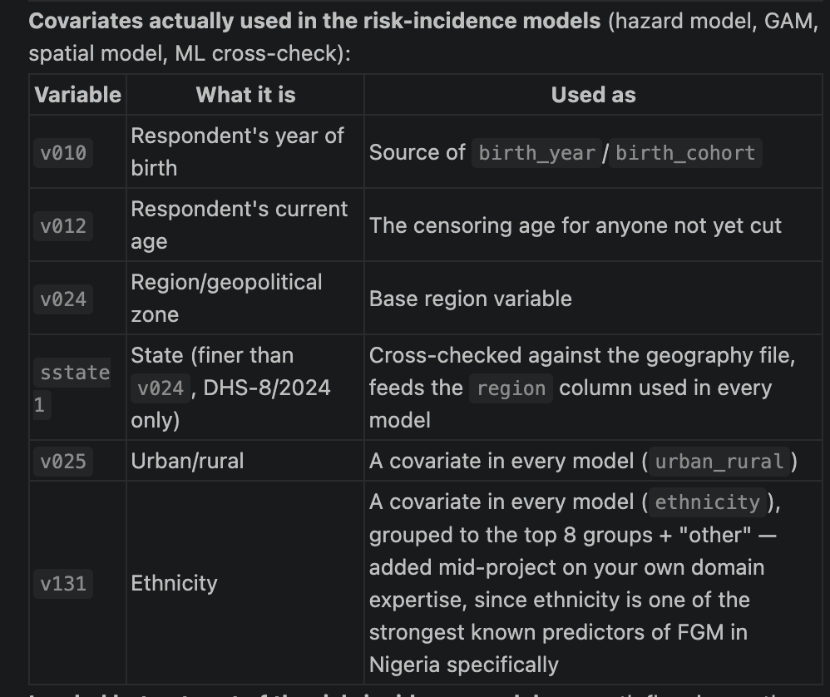

Censoring and the Risk Set
In survival analysis, censoring occurs when a person has not experienced FGM by the time the survey ends. We know that the person remained uncut up to their current age, but we do not know what happens afterward.
For example, a three-year-old girl who has not been cut is observed only up to age three, while a 45-year-old woman who has not been cut has been observed through most of the usual age range for FGM. Both are coded as event = 0, but they contribute information for different lengths of time.
An uncut person is considered at risk only during the ages they have actually been observed and have not yet experienced FGM. “At risk” does not mean that the person is expected to be cut; it simply means that the event has not yet occurred and observation is ongoing.
This is why the analysis uses both time and fgm_event:
- fgm_event = 1: FGM occurred, and time is the age at cutting.
- fgm_event = 0: FGM had not occurred by the end of observation, and time is the person’s current age or the observation limit.
This approach prevents young girls who have not yet reached the usual age of cutting from being treated as permanently protected. It also allows the models to distinguish between people with different lengths of observation. Estimates for the youngest birth cohorts should therefore be interpreted cautiously because many individuals in these cohorts are still censored.

Questions
- FGM at zero is taken within the 0-49 age bracket but how are we treating NA cases

What this session added
- Added ethnicity as a covariate, grouped into major ethnic groups and “Other.”
- Added daughters aged 0–14 as separate event records, improving estimates for recent birth cohorts.
- Fixed issues identified during full data testing, including survey design nesting, DHS variable mappings, and machine-learning formula/type errors.

