Attitudes to FGM, Kenya
Support for continuing FGM among women and men, and how it relates to the practice
Kenya · DHS 1998, 2003, 2008–09, 2014 and 2022 · all rounds pooled

1. Introduction
Social norms sustain FGM, so support for its continuation is a leading indicator of whether the practice will persist. This report estimates the share of women and men who think FGM should continue, nationally, by province and county, and by birth cohort, and compares it with where FGM is practised.

2. Data
Respondents who had heard of FGM were asked whether it should continue or stop; "depends" and "don't know" answers are excluded. Women were asked in DHS 1998, 2008–09, 2014 and 2022 (DHS 2003 did not ask); men only in DHS 2014 and 2022. Our estimates reproduce the official DHS figures.
Table 1. Respondents and support for continuing FGM by survey round (direct survey-weighted estimates)
Survey round | Women answering | Women: support (%) | Men answering | Men: support (%)
DHS 1998 | 7,314 | 21.3 | – | –
DHS 2008–09 | 7,609 | 10.3 | – | –
DHS 2014 | 14,073 | 6.3 | 11,507 | 9.5
DHS 2022 | 15,890 | 4.4 | 12,878 | 4.9
Total | 44,886 |  | 24,385

3. Results

3.1 Support has fallen sharply
Among women, support for continuation fell from 21.3% in 1998 to 10.3% (2008–09), 6.3% (2014) and 4.4% (2022). Among men it fell from 9.5% (2014) to 4.9% (2022). Men were more supportive than women in 2014 (+3.2 points, p < 0.001) but not in 2022 (+0.5 points, not significant) (Figures 1 and 2).
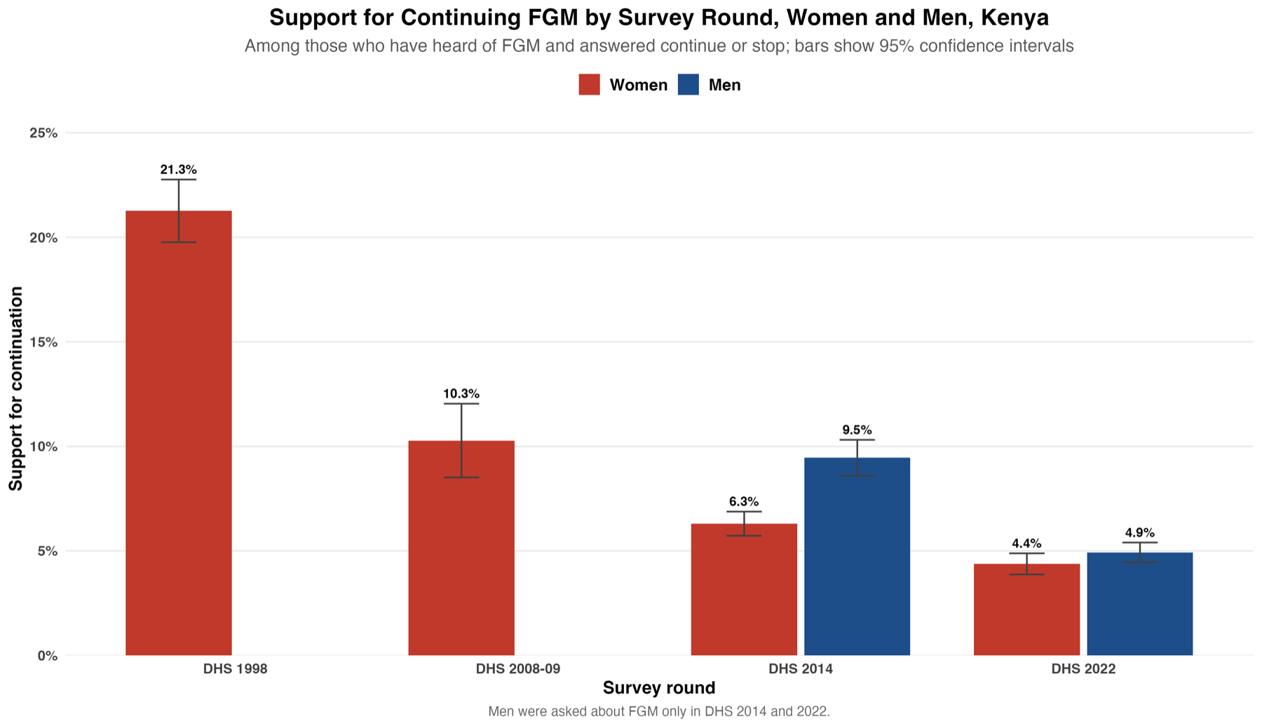
Figure 1. Support for continuing FGM by survey round, women and men (95% CI)
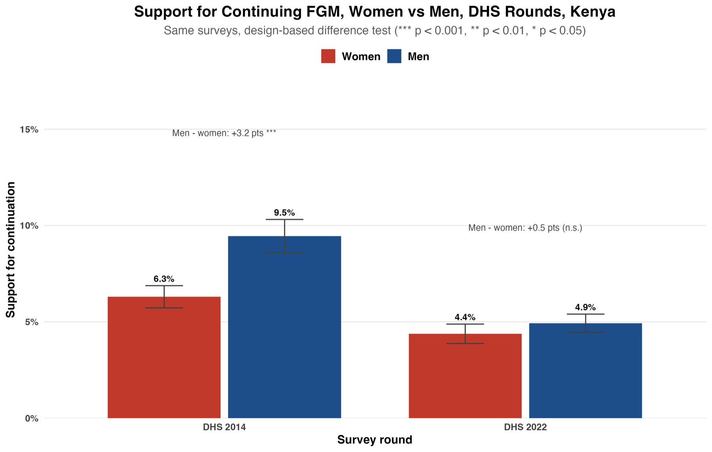
Figure 2. Women and men in the same DHS rounds, with the design-based difference test

3.2 Where support is highest
Pooling all rounds, support is 85.6% among women and 66.9% among men in North Eastern, against 3–18% among women and 2–8% among men elsewhere; among women it is next highest in Nyanza (18.0%) (Figure 3). By county in 2022, women's support is highest in Mandera (90.5%), Wajir (81.2%) and Garissa (67.5%), and men's (2014 and 2022 pooled) in Mandera (87.0%), Wajir (66.1%) and Garissa (50.0%) (Figures 4 and 5).
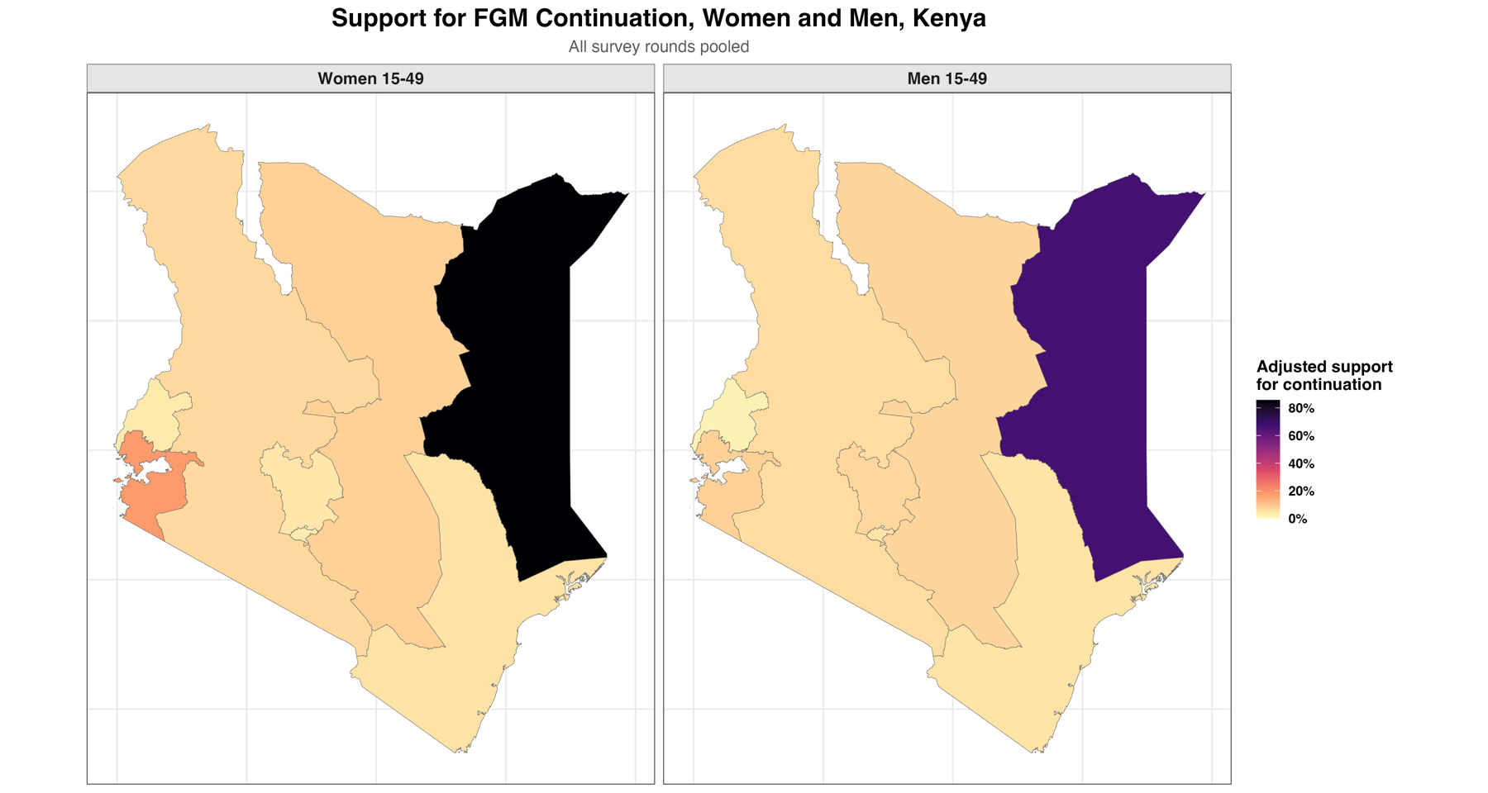
Figure 3. Covariate-adjusted support for continuing FGM by province, women and men, all rounds pooled
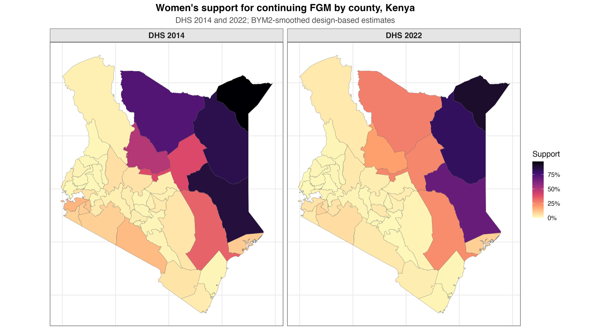
Figure 4. Women's support for continuing FGM by county, DHS 2014 and 2022
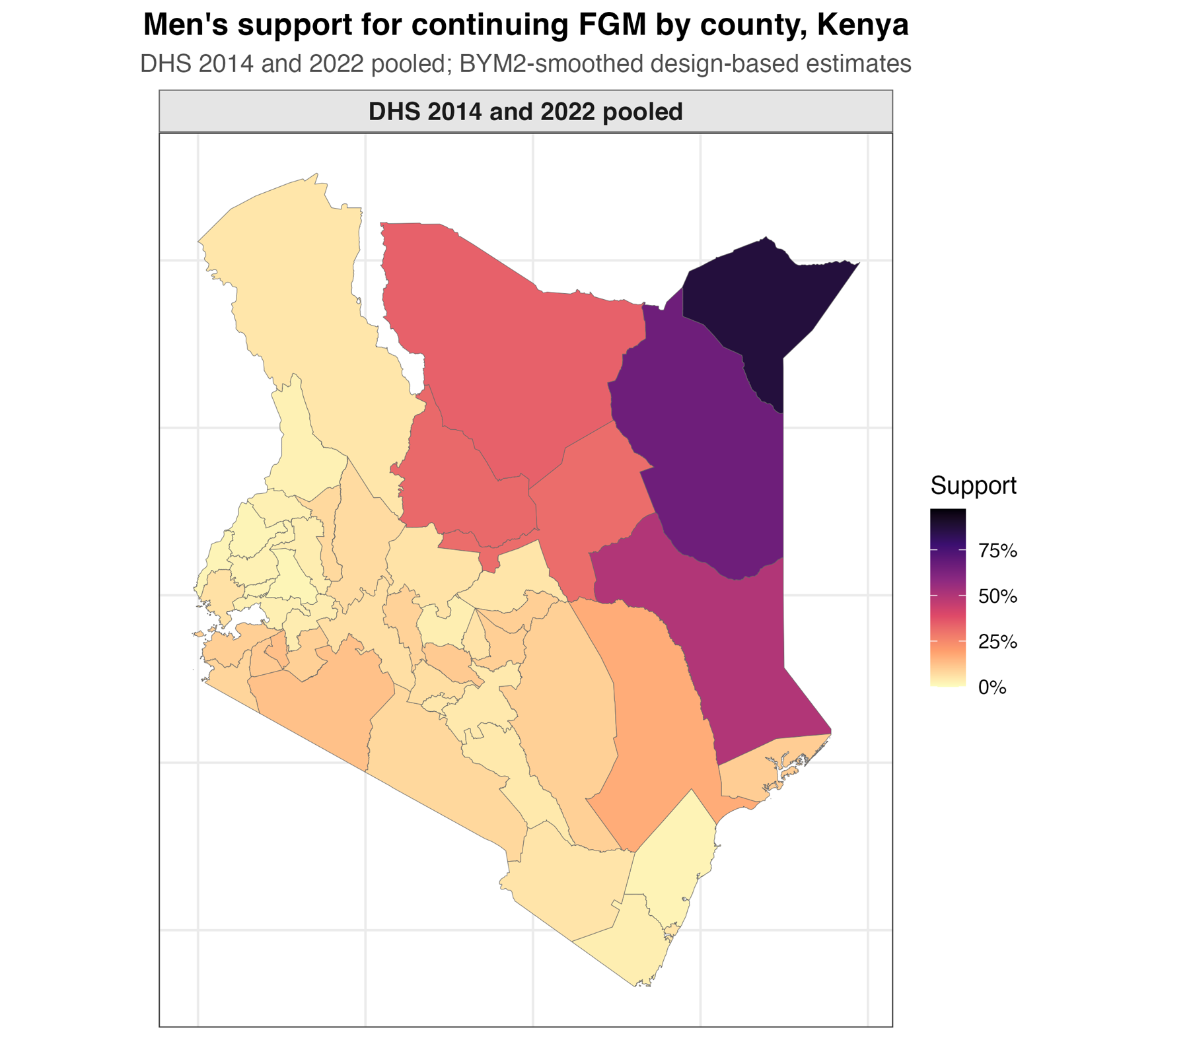
Figure 5. Men's support for continuing FGM by county, DHS 2014 and 2022 pooled

3.3 Who supports continuation
Table 2. Survey-weighted covariate-adjusted model: odds of supporting continuation
Characteristic (reference) | Group | Women: odds ratio | Men: odds ratio
Own FGM status (cut) | Not cut | 0.12 | –
Ethnicity (Kalenjin) | Somali | 7.10 | 6.71
 | Kisii | 4.16 | 2.75
 | Maasai | 3.29 | 2.34
Religion (Christian) | Islam | 2.05 | 2.28
 | Traditional religion | 6.03 | 7.27
Education (none) | Primary | 0.49 | 0.64
 | Secondary or higher | 0.26 | 0.33
Wealth (middle) | Poorest | 1.35 | 1.46
 | Richest | 1.10 | 0.58
Residence (rural) | Urban | 1.00 | 1.08
All odds ratios are adjusted for every factor shown, age, survey round and province.
Women who have not been cut have 88% lower odds of supporting continuation. Support is highest among Somali respondents and followers of traditional religion, and falls with education.

4. How attitudes relate to prevalence
This section compares support for continuation with FGM prevalence nationally across survey rounds and across counties, and asks whose attitudes, women's or men's, are more closely associated with prevalence. Kenya's 8 provinces are too few for this analysis, so it uses the 47 counties (DHS 2014 and 2022 pooled). All results are associations, not causes.

4.1 National level: attitudes and prevalence fell together
Women's support and women's prevalence fell together across the four rounds with both measures (correlation 0.98) (Table 3, Figure 6). Men's attitudes and girls' prevalence were measured in only two rounds, too few to correlate.
Table 3. National FGM prevalence and support for continuation by survey round (%)
Survey round | Prevalence, women 15–49 | Prevalence, girls 0–14 | Support, women | Support, men
DHS 1998 | 37.7 | – | 21.3 | –
DHS 2003 | 32.2 | – | – | –
DHS 2008–09 | 27.1 | – | 10.3 | –
DHS 2014 | 21.0 | 2.9 | 6.3 | 9.5
DHS 2022 | 14.8 | 1.6 | 4.4 | 4.9

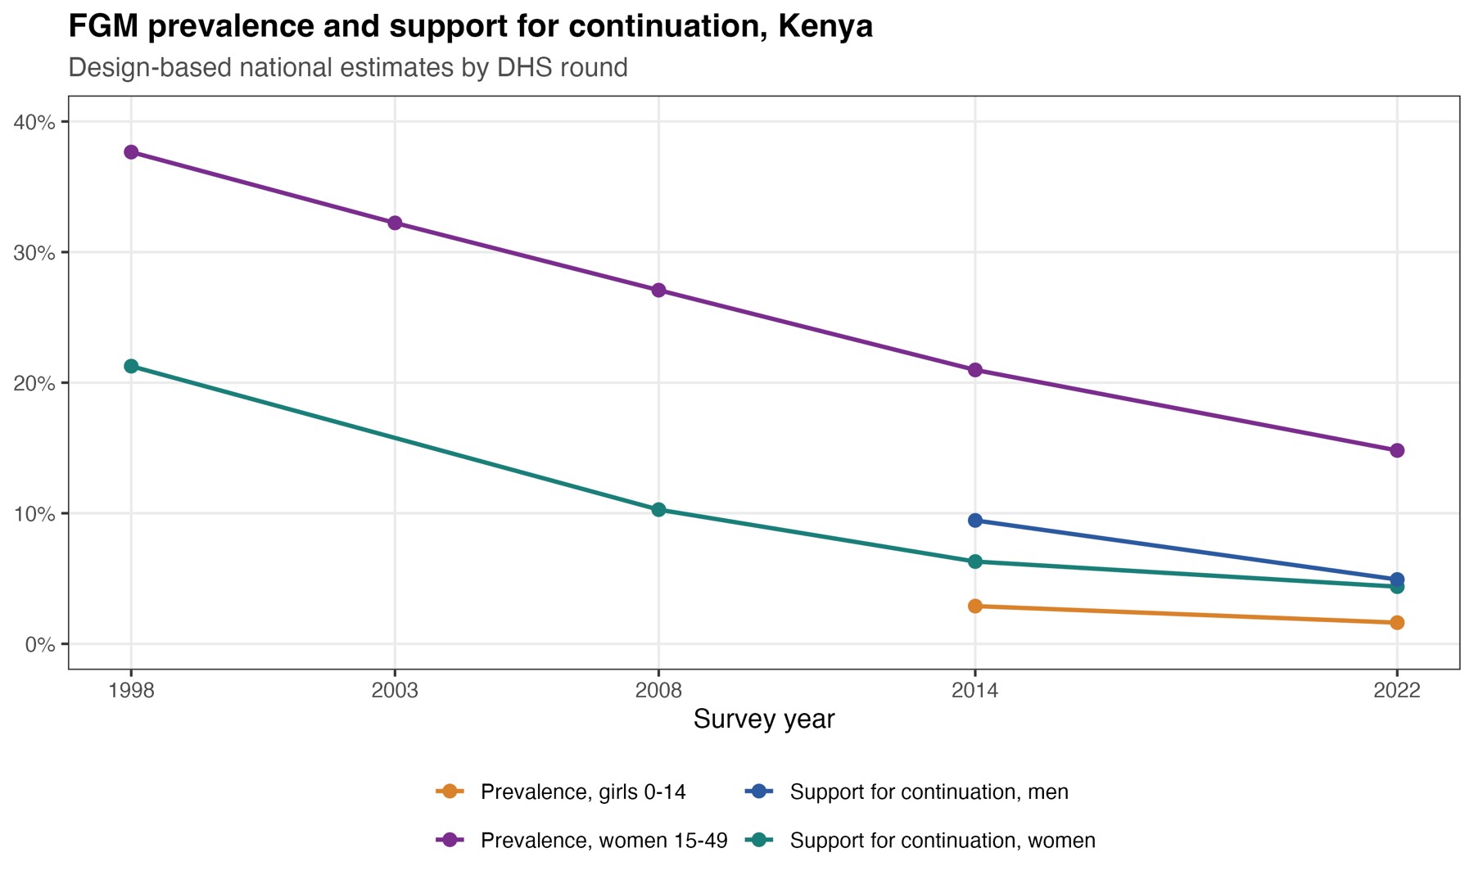
Figure 6. National FGM prevalence and support for continuation by survey round

4.2 County level: attitudes track prevalence closely
Across the 47 counties, women's support correlates 0.93 with girls' prevalence and 0.79 with women's prevalence; men's support correlates 0.91 and 0.79 (Table 4, Figure 7). Rank correlations are lower (0.69–0.81), because the relationship is driven by the North Eastern counties, where both prevalence and support are very high.
Table 4. County-level correlation between FGM prevalence and support for continuation (47 counties, DHS 2014 and 2022 pooled)
Prevalence measure | Attitudes of | Correlation (95% CI) | p-value | Variation explained
Girls 0–14 (current practice) | Women | 0.93 (0.87–0.96) | <0.001 | 86%
 | Men | 0.91 (0.85–0.95) | <0.001 | 83%
Women 15–49 (past practice) | Women | 0.79 (0.65–0.88) | <0.001 | 62%
 | Men | 0.79 (0.65–0.88) | <0.001 | 63%
Pearson correlations between BYM2-smoothed county estimates. Variation explained = R² of each attitude measure alone.
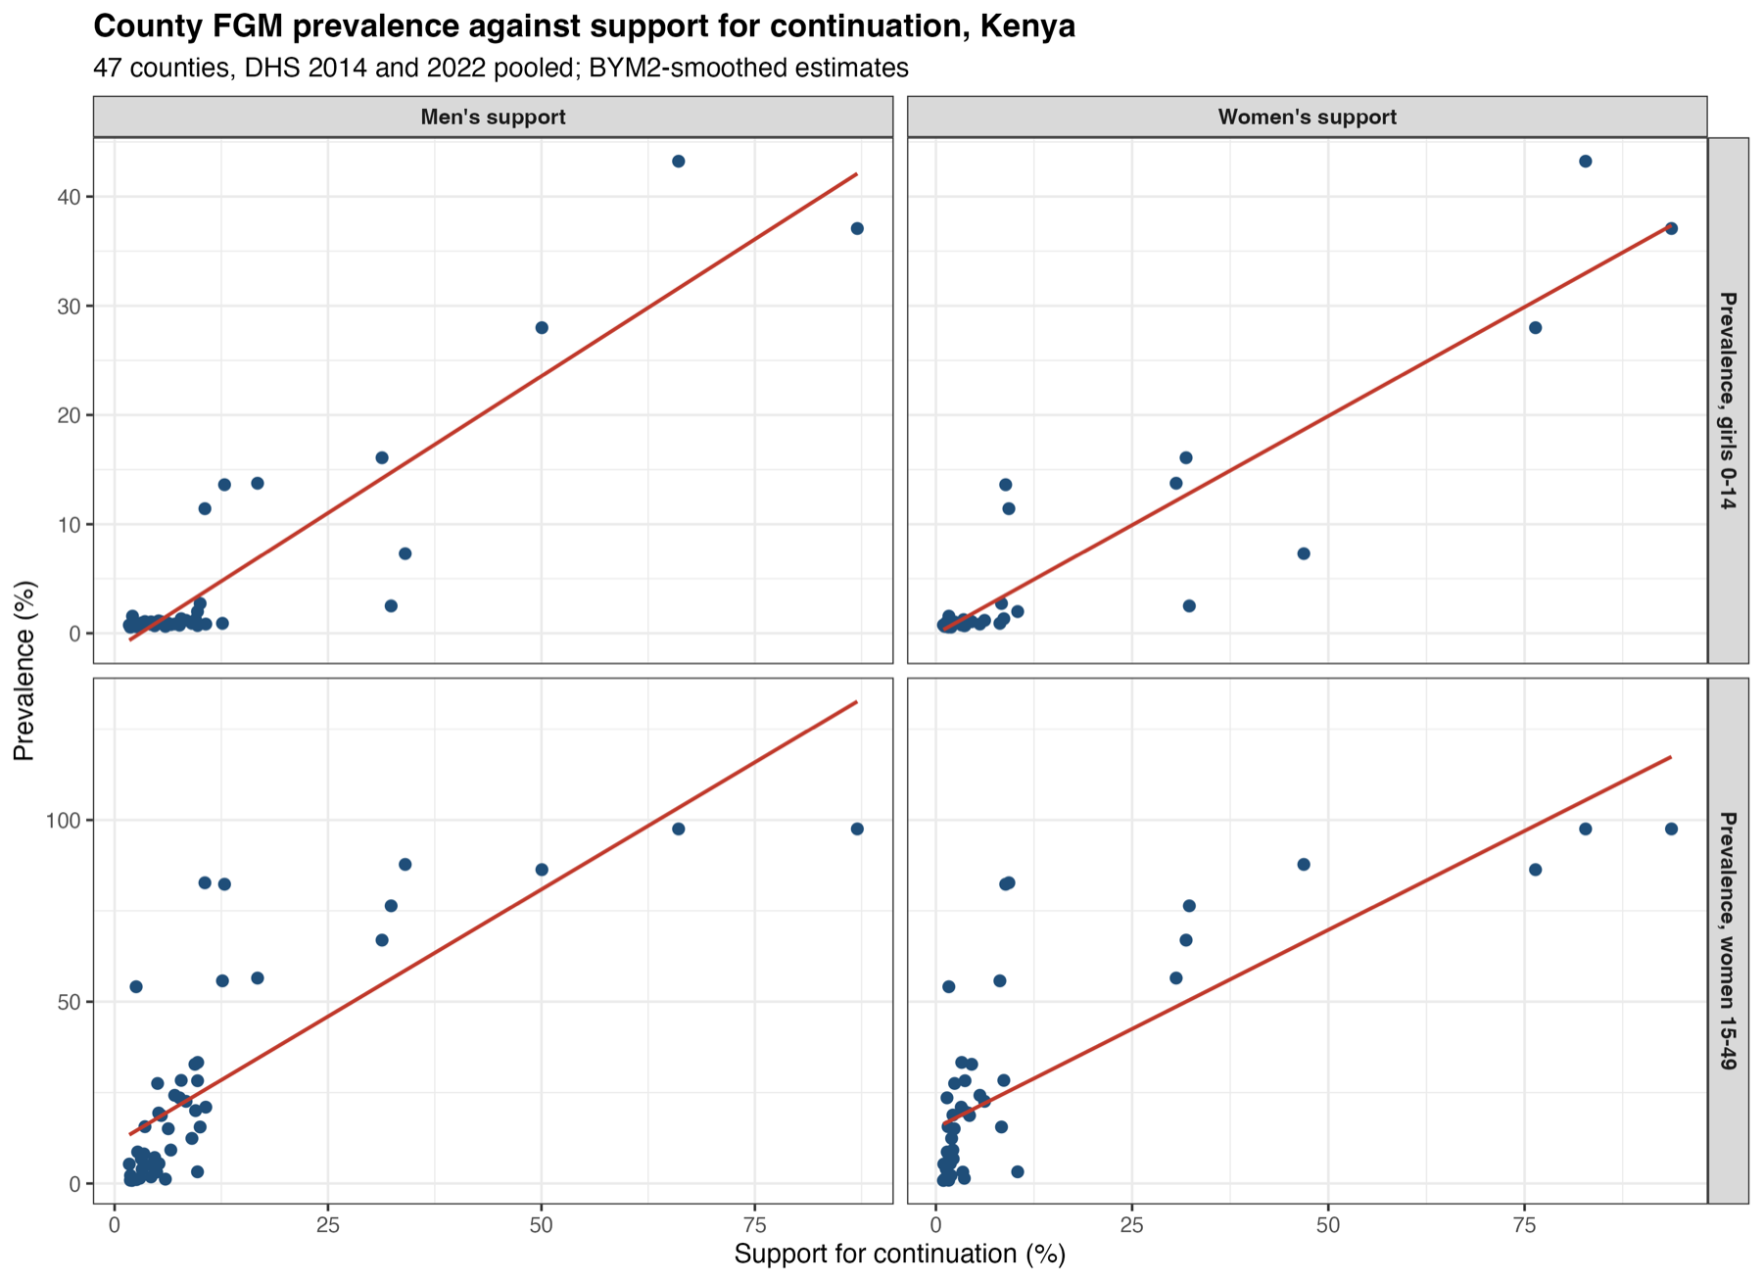
Figure 7. County FGM prevalence against support for continuation, women and men

4.3 Whose attitudes matter more?
Women's and men's support are almost identical across counties (correlation 0.98), so their separate associations can only be estimated weakly. With both in the same county model, women's support remains associated with girls' prevalence (+7.3 percentage points per standard deviation, 95% CI 2.5–12.0; p = 0.003) while men's adds nothing (+1.4 points, p = 0.57). For women's prevalence neither can be separated from the other. In Kenya, therefore, women's and men's attitudes move together; where they differ, women's attitudes are the closer correlate of whether girls are being cut, as in Nigeria.

4.4 Local pattern
In the cluster data (DHS 2008–09, 2014 and 2022), clusters where most women support continuation are almost all in North Eastern (97% of its clusters, against 0–10% elsewhere); for men, 84% of North Eastern clusters (Figure 8).
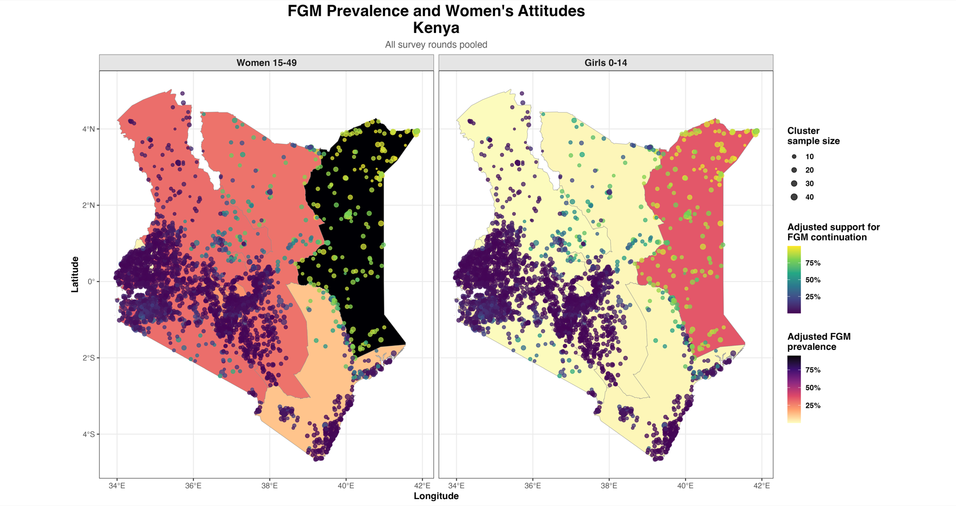
Figure 8. FGM prevalence by province and women's support for continuation by survey cluster

5. Comparison with Kenya's subnational MICS
Table 5. Women's support for continuing FGM, subnational MICS compared with DHS for the same area
MICS survey | MICS support (%) | DHS comparison | DHS support (%)
Nyanza 2011 | 22.3 | DHS 2008–09 / 2014, Nyanza | 20.1 / 8.9
Bungoma 2013–14 | 1.8 | DHS 2014, Bungoma | 2.1
Kakamega 2013–14 | 3.0 | DHS 2014, Kakamega | 1.3
Turkana 2013–14 | 6.4 | DHS 2014, Turkana | 2.4
Mombasa informal settlements 2009 | 4.0 | DHS 2014, Mombasa county | 2.0

Support agrees between MICS and DHS where they were collected at the same time (Bungoma, Kakamega, Turkana, all 1–6%). In Nyanza, MICS 2011 (22.3%) sits between DHS 2008–09 (20.1%) and DHS 2014 (8.9%), consistent with a sharp fall in support after 2011.

6. Conclusions
- Support for continuing FGM in Kenya has fallen from about one woman in five in 1998 to under one in twenty in 2022, and among men from 9.5% to 4.9% since 2014.
- Support remains a majority view in the North Eastern counties of Mandera, Wajir and Garissa, among both women and men.
- Women who are cut, Somali and traditional-religion respondents, and those with little education are most supportive.
- Women's and men's attitudes move together across counties; women's support is the closer correlate of girls' prevalence, so norm-change work in the North East should reach both, with mothers as a priority.

