FGM Prevalence, Kenya
How common FGM is among women and girls, where, and how it has changed
Kenya · DHS 1998, 2003, 2008–09, 2014 and 2022 · all rounds pooled

1. Introduction
Prevalence is the share of women and girls who have ever been cut (SDG indicator 5.3.2). This report estimates it nationally, for the 8 former provinces (every round) and the 47 counties (DHS 2014 and 2022), pooling every Kenya DHS round with an FGM module, and describes change across survey years and birth cohorts. Province estimates come from a survey-weighted model that combines all rounds, adjusts for ethnicity, wealth, education, religion, residence and age, and borrows strength between neighbouring provinces.

2. Data
Five DHS rounds are pooled. Women aged 15–49 come from all five; girls aged 0–14, reported by their mothers, come from DHS 2014 and 2022. Women who had never heard of FGM, and their daughters, are counted as not cut. In DHS 2014 and 2022 the FGM questions were asked only in the long-questionnaire subsample. Kenya has no national MICS; its five subnational MICS are compared in section 4. Our estimates reproduce the official DHS national figures for every round (women's prevalence, awareness, girls' prevalence and attitudes, all within 0.1 points).
Table 1. Women and girls with a known FGM status, by survey round
Survey round | Women 15–49 | Women cut | Girls 0–14 | Girls cut
DHS 1998 | 7,873 | 2,748 | – | –
DHS 2003 | 8,174 | 2,724 | – | –
DHS 2008–09 | 8,433 | 2,541 | – | –
DHS 2014 | 14,734 | 4,377 | 13,189 | 739
DHS 2022 | 16,902 | 4,036 | 13,525 | 689
Total | 56,116 | 16,426 | 26,714 | 1,428
Girls include the daughters of mothers who had never heard of FGM, counted as not cut. DHS 1998 did not sample North Eastern province.

3. Results

3.1 National prevalence has more than halved
Among women aged 15–49, prevalence fell from 37.7% in DHS 1998 to 32.2% (2003), 27.1% (2008–09), 21.0% (2014) and 14.8% (2022). Among girls aged 0–14 it was 2.9% in 2014 and 1.6% in 2022 (Figure 1). Girls' prevalence is far below lifetime risk, because most Kenyan girls are cut at ages 5–15 and many have not yet reached those ages.
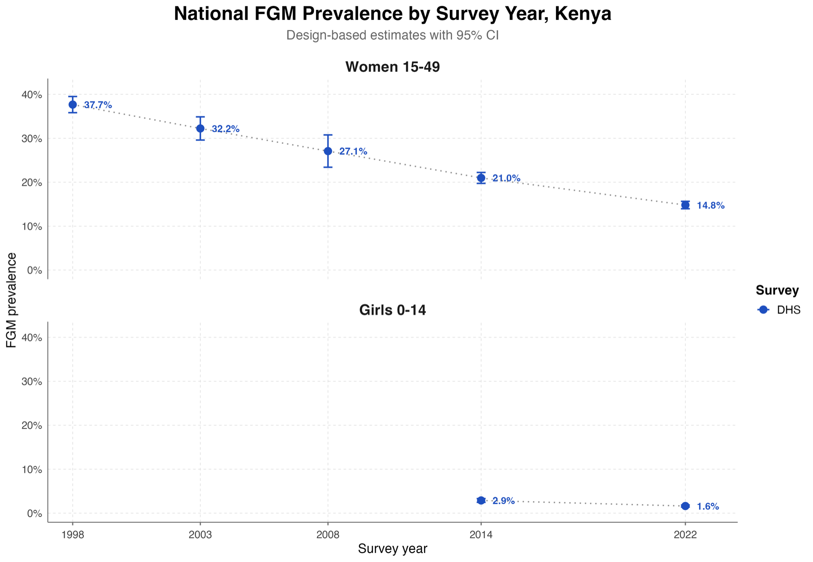
Figure 1. National FGM prevalence by survey year, design-based estimates with 95% CI

3.2 North Eastern stands apart
Pooling all rounds, model-based prevalence among women is 95.0% in North Eastern, then 34.7% in Nyanza, 30.5% in Rift Valley, 29.3% in Eastern and 21.7% in Central, and lowest in Coast (11.8%), Nairobi (10.9%) and Western (1.7%) (Figure 2). Among girls it is 35.4% in North Eastern and 4.0% in Nyanza, and under 2% in every other province (Figure 3).
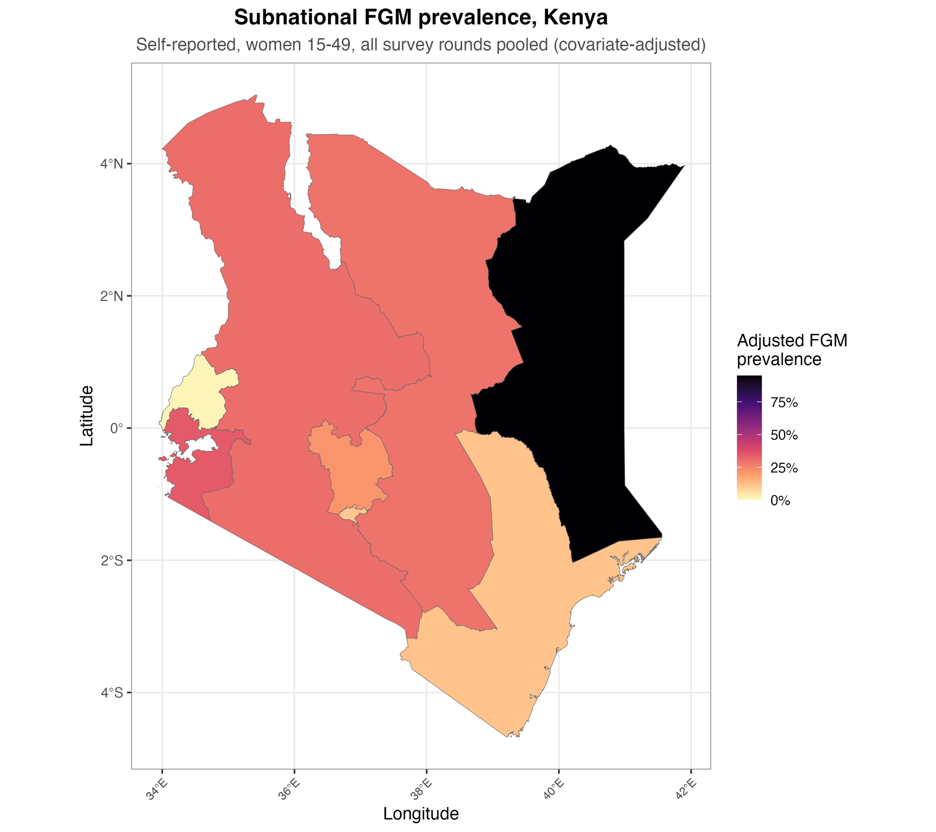
Figure 2. Covariate-adjusted FGM prevalence among women 15–49 by province, all rounds pooled
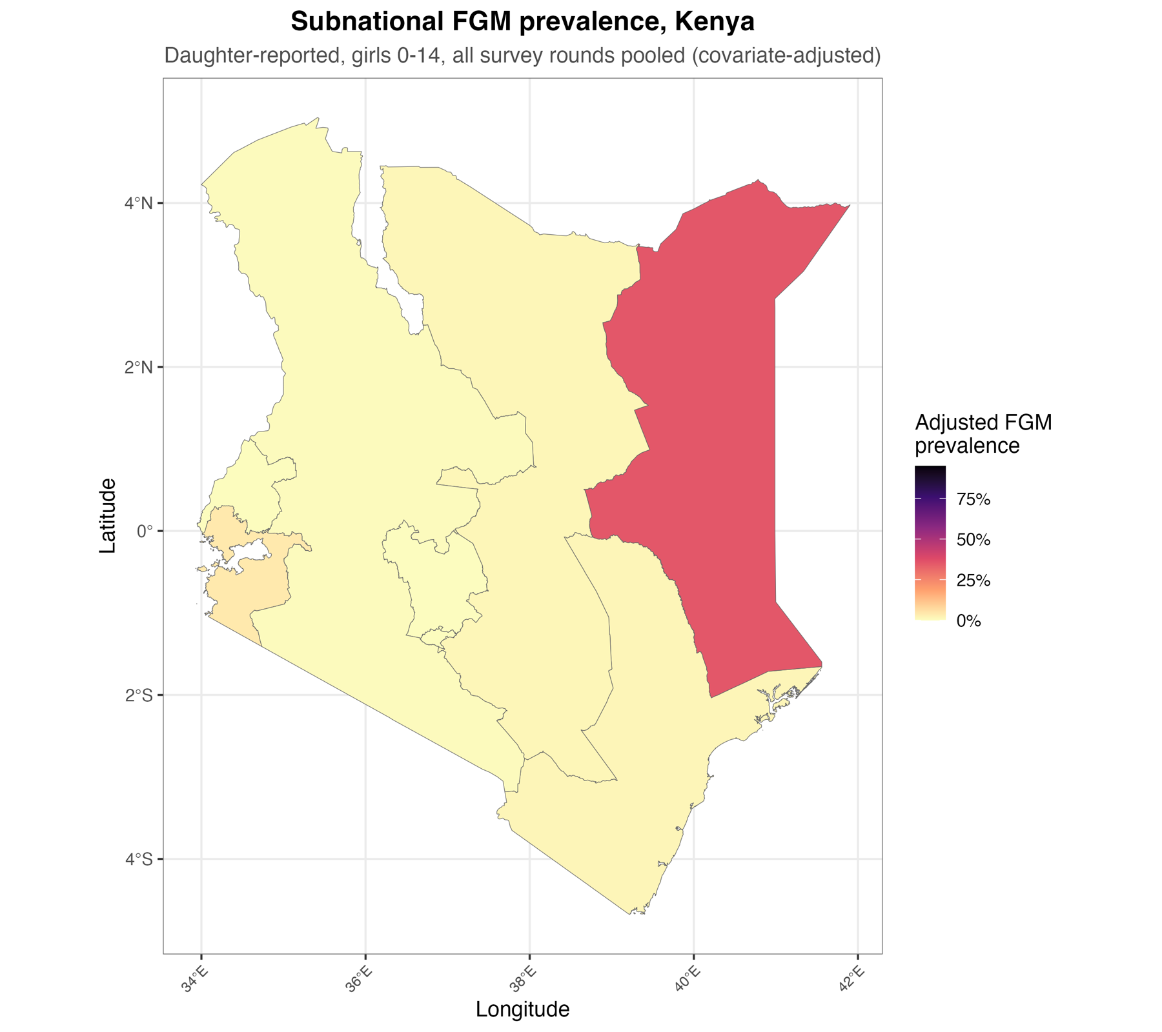
Figure 3. Covariate-adjusted FGM prevalence among girls 0–14 by province, all rounds pooled

3.3 Counties
In DHS 2022, prevalence among women is highest in Wajir (96.3%), Mandera (95.9%), Marsabit (82.9%), Garissa (80.4%), Kisii (76.6%), Nyamira (74.1%), Samburu (73.3%) and Isiolo (65.6%); ten counties exceed 50% and two are below 1% (Figure 4). Among girls it is highest in Wajir (42.4%), Mandera (27.4%), Garissa (23.9%), Isiolo (12.8%) and Tana River (11.3%), and under 1% in 14 counties (Figure 5). Between 2014 and 2022, girls' prevalence fell sharply in Kisii (18.5% to 4.2%), Nyamira (19.8% to 5.3%) and Mandera (50.3% to 27.4%).
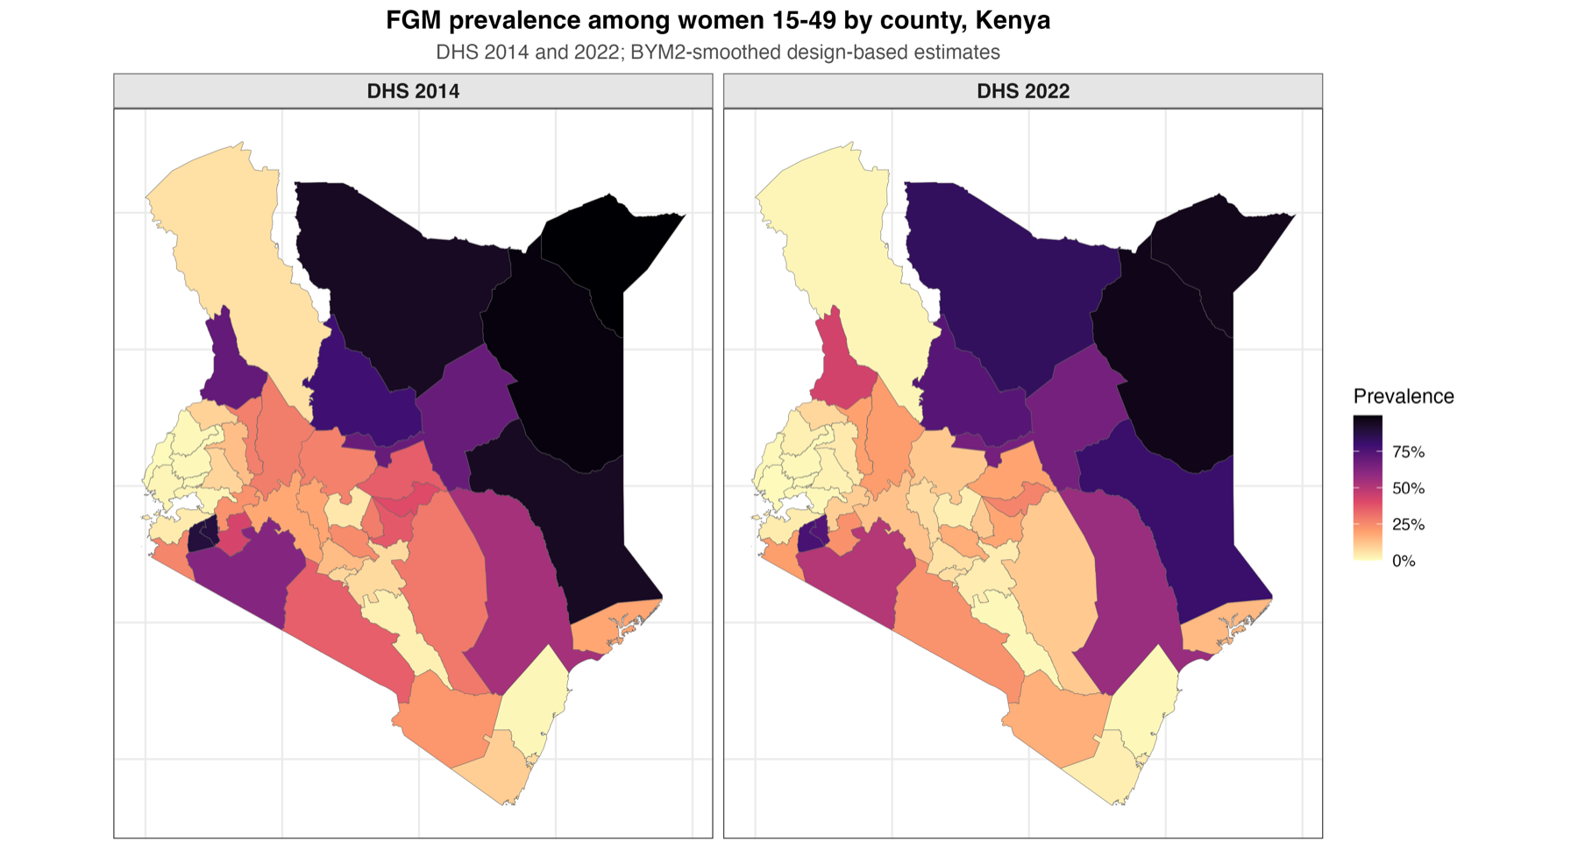
Figure 4. FGM prevalence among women 15–49 by county, DHS 2014 and 2022 (BYM2-smoothed)
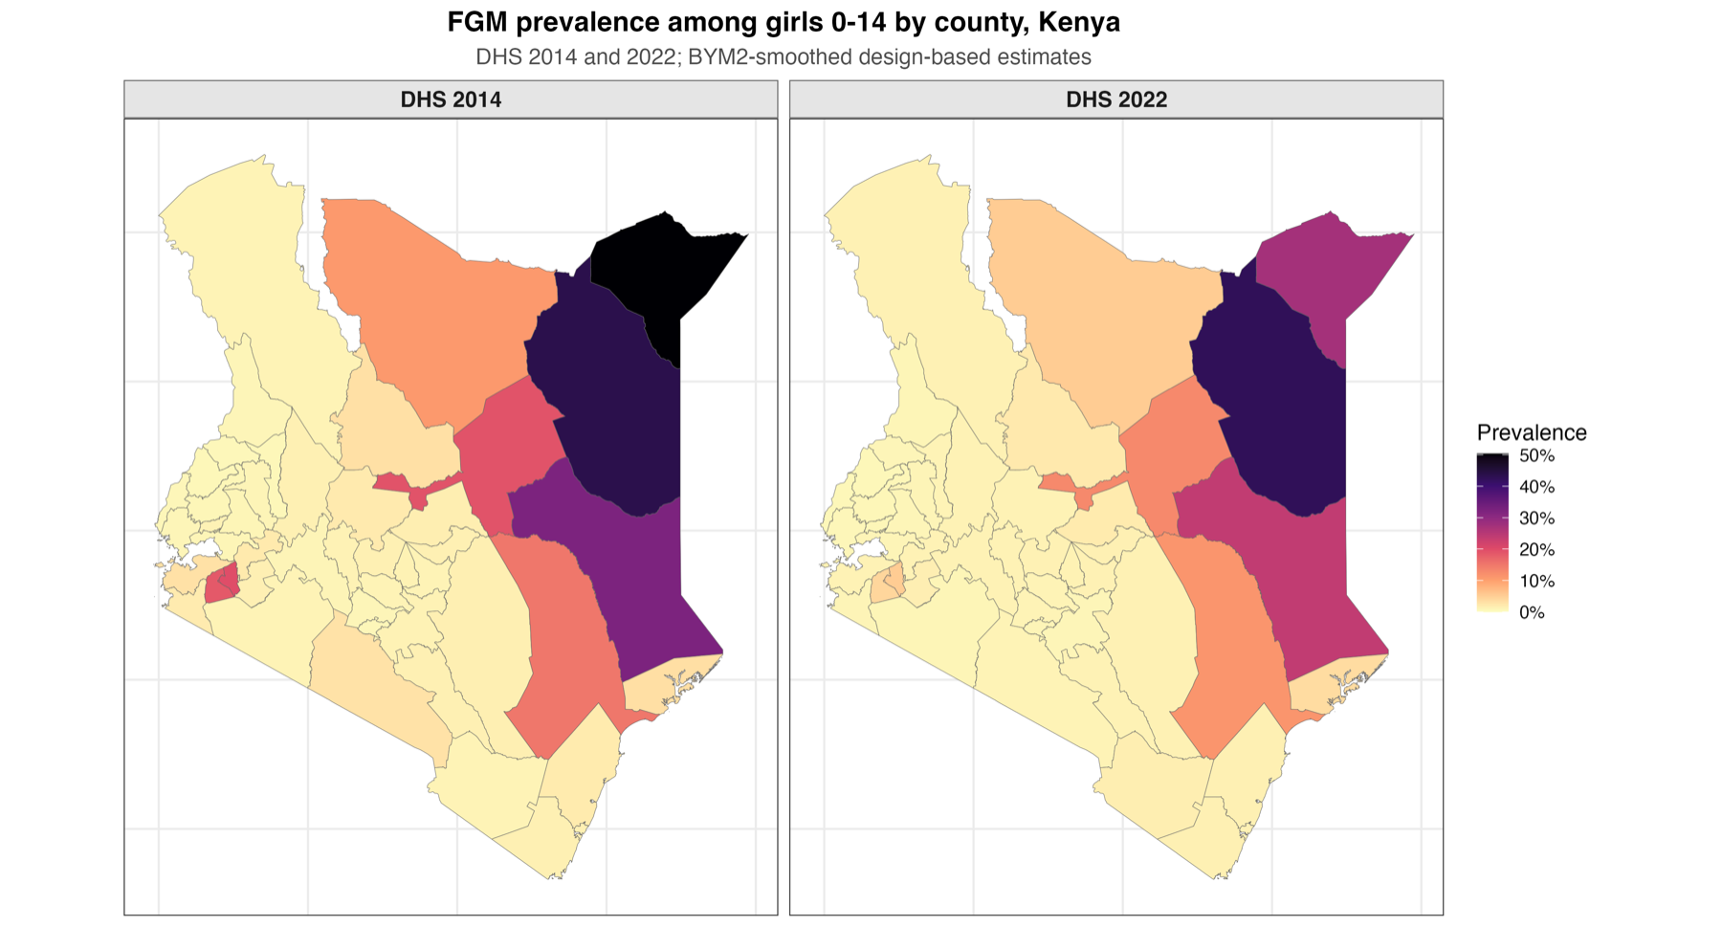
Figure 5. FGM prevalence among girls 0–14 by county, DHS 2014 and 2022 (BYM2-smoothed)

3.4 Prevalence has declined across birth cohorts
Among women, model-based prevalence falls from 56.5% for those born in 1945–49 to 34.1% (1970–74), 19.1% (1985–89), 11.2% (1995–99) and 8.9% (2005–09); the pooled average over all rounds is 24.1% (Figure 6). Among girls it falls from 5.3–6.9% for those born in 1995–2004 to 1.4% (2010–14), largely because younger girls have not yet reached the ages of cutting.
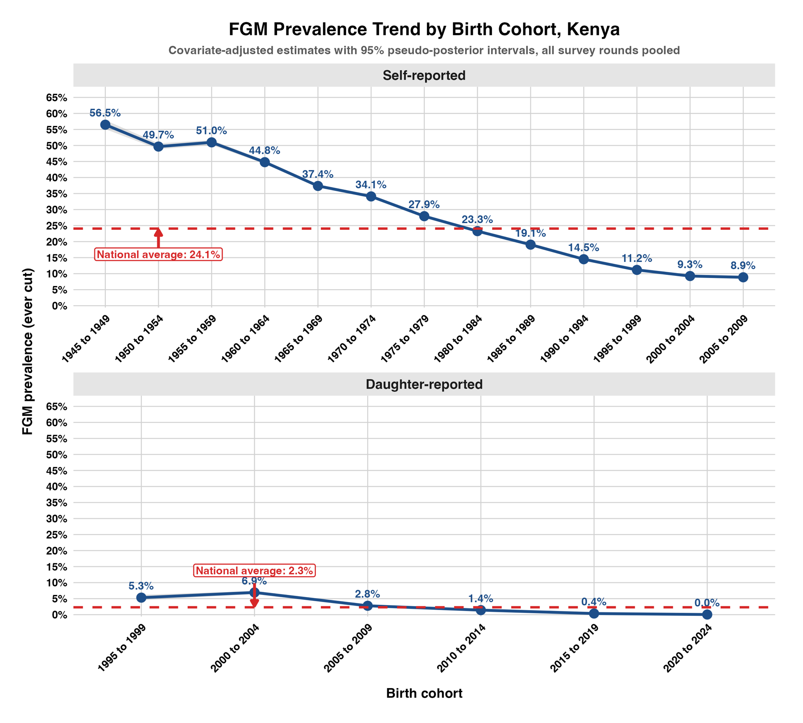
Figure 6. FGM prevalence by birth cohort, covariate-adjusted, all rounds pooled

3.5 Composition and consistency
Relative to Kalenjin women, the odds of being cut are much higher among Kisii (20.5), Maasai (10.0) and Somali (5.9) women and close to zero among Luo, Luhya and Mijikenda/Swahili women. Muslim women (4.8) and the poorest (1.8) have higher odds, and secondary education (0.24) and urban residence (0.77) lower odds. As a consistency check, the pooled model reproduces the province direct estimates within 0.25 percentage points. Because almost no girls are cut in some groups (e.g. Kikuyu), the model uses a weakly informative prior on its coefficients, without which estimates for low-prevalence provinces were unstable.

4. Comparison with Kenya's subnational MICS
Kenya has no national MICS. Five MICS cover single areas and are compared with DHS for the same area, closest in time: Bungoma, Kakamega and Turkana MICS 2013–14 with DHS 2014 for the same county; Nyanza MICS 2011 with DHS 2008–09 and 2014 for Nyanza province; and Mombasa informal settlements MICS 2009 with DHS 2014 for the whole of Mombasa county.
Table 2. FGM prevalence among women 15–49 (%), subnational MICS compared with DHS for the same area
MICS survey | MICS prevalence (95% CI) | DHS comparison | DHS prevalence (95% CI) | Difference (p)
Nyanza 2011 | 36.5 (30.9–42.0) | DHS 2014, Nyanza | 32.4 (27.7–37.2) | +4.1 (0.27)
Bungoma 2013–14 | 2.1 (1.0–3.2) | DHS 2014, Bungoma | 1.2 (0.0–2.3) | +0.9 (0.27)
Kakamega 2013–14 | 1.2 (0.5–1.8) | DHS 2014, Kakamega | 0.8 (0.0–1.7) | +0.3 (0.55)
Turkana 2013–14 | 3.2 (0.0–7.9) | DHS 2014, Turkana | 3.7 (0.0–8.4) | −0.5 (0.89)
Mombasa informal settlements 2009 | 12.4 (10.0–14.8) | DHS 2014, Mombasa county | 7.4 (2.8–12.1) | +5.0 (0.07)
Nyanza also: DHS 2008–09 33.9% (19.4–48.4). Mombasa is indicative only: informal settlements are a subset of the county.
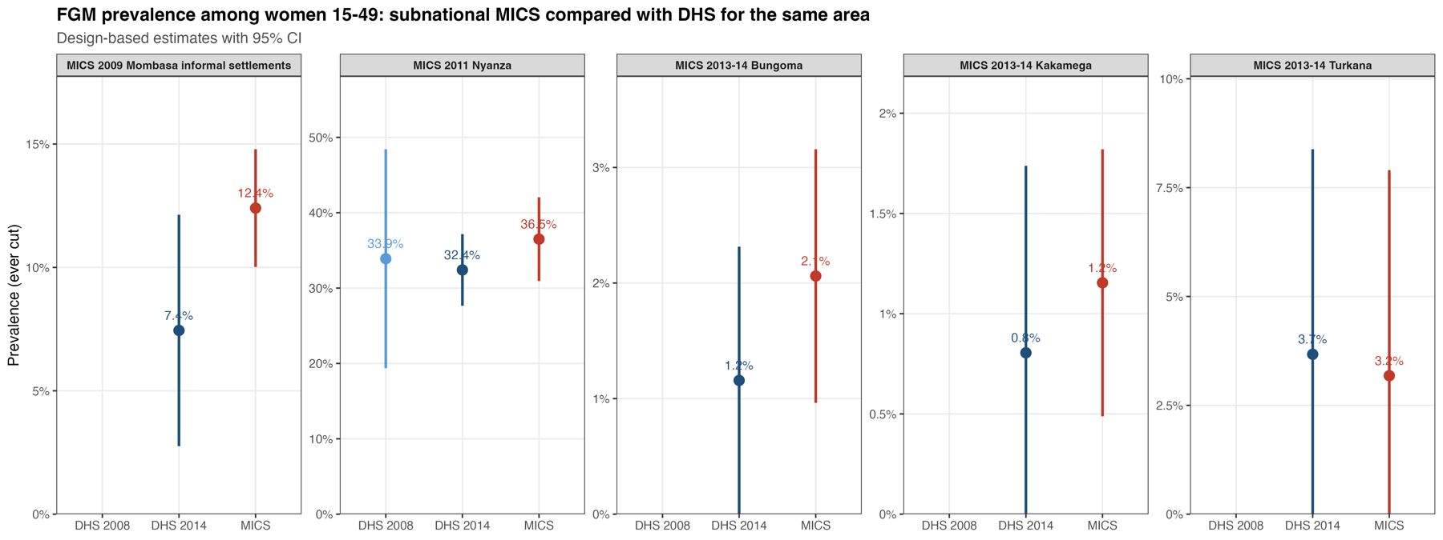
Figure 7. FGM prevalence among women, subnational MICS compared with DHS for the same area
MICS and DHS agree for every area; none of the differences is statistically significant. This independent check supports the DHS-based provincial and county estimates.

5. Conclusions
- FGM prevalence among women in Kenya fell from 37.7% in 1998 to 14.8% in 2022, and among girls from 2.9% (2014) to 1.6% (2022).
- Prevalence remains near-universal in North Eastern (Wajir, Mandera, Garissa) and high in Kisii, Nyamira, Marsabit, Samburu and Isiolo.
- Girls' prevalence fell sharply between 2014 and 2022 in Kisii and Nyamira, but remains high among girls in Wajir, Mandera and Garissa.
- Subnational MICS confirm the DHS estimates for the areas they cover.

