FGM Risk Incidence, Kenya
At what age girls are cut, how risk has changed across generations, and how robust the estimates are to reporting
Kenya · DHS 1998, 2003, 2008–09, 2014 and 2022 · all rounds pooled

1. Introduction
Female genital mutilation (FGM) is performed once and cannot be reversed, so a woman's report of whether and at what age she was cut is a record of what happened to her birth cohort, often decades before the survey. Risk incidence uses these reports to estimate the probability of being cut at each age, by birth cohort and by area.
This report pools every Kenya Demographic and Health Survey (DHS) that recorded age at cutting. Pooling gives longer cohort coverage than any single survey and observes each cohort several times, which allows the sensitivity of the results to reporting to be tested (section 4). Unlike Nigeria and Burkina Faso, most cutting in Kenya happens at ages 5–15, so the key indicator is the risk of being cut by age 15.

2. Data
Four DHS rounds record women's age at cutting: 1998, 2008–09, 2014 and 2022. DHS 2003 asked only whether a woman had been cut, not when, and is used for prevalence only. Kenya has no national MICS; its five subnational MICS are compared in section 5. Two kinds of history are analysed:
- Women's own histories: women aged 15–49 in the four rounds, covering birth cohorts 1945–49 to 2005–09.
- Daughters' histories: girls aged 0–14 reported by their mothers in DHS 2014 and 2022, the two rounds that list every daughter, covering birth cohorts 1995–99 to 2020–24.
Women who have never heard of FGM, and their daughters, are counted as not cut (DHS convention). In DHS 2014 and 2022 the FGM questions were asked only in the long-questionnaire subsample (about half of women). No cut case was dropped for lacking an exact age: "during infancy" answers were spread over ages 0–4 and "don't know", missing or inconsistent ages over ages 0 to the current age, using women of the same survey and birth cohort who gave an exact age. Our estimates reproduce the official DHS national figures for every round.
Table 1. Records used for risk incidence, by survey round
Survey round | Women's histories | Women cut | Exact age | "During infancy" | Age unknown | Daughters' histories | Daughters cut
DHS 1998 | 7,873 | 2,748 | 2,650 | – | 98 | – | –
DHS 2008–09 | 8,433 | 2,541 | 2,391 | 49 | 101 | – | –
DHS 2014 | 14,734 | 4,377 | 4,249 | 66 | 62 | 13,189 | 739
DHS 2022 | 16,902 | 4,036 | 3,924 | 30 | 82 | 13,525 | 689
Total | 47,942 | 13,702 | 13,214 | 145 | 343 | 26,714 | 1,428
In total, 74,656 histories (15,130 cut). DHS 1998 had no "during infancy" code. Daughters include those of mothers who never heard of FGM (counted as not cut). DHS 2003 (8,174 women, 2,724 cut) did not ask age at cutting.

3. Results

3.1 Most girls are cut at ages 5–15
Only 2–4% of cut women report being cut before age 5; 19–30% report ages 5–9, 42–45% ages 10–14 and 22–32% age 15 or older. In the discrete-time hazard model the annual odds of being cut, relative to ages 0–4, are 13 times higher at ages 5–9, 52 times at 10–14 and 19 times at 15 and older. Figures 1 and 2 show the probability of remaining uncut by birth cohort; the fall is concentrated between ages 5 and 16.
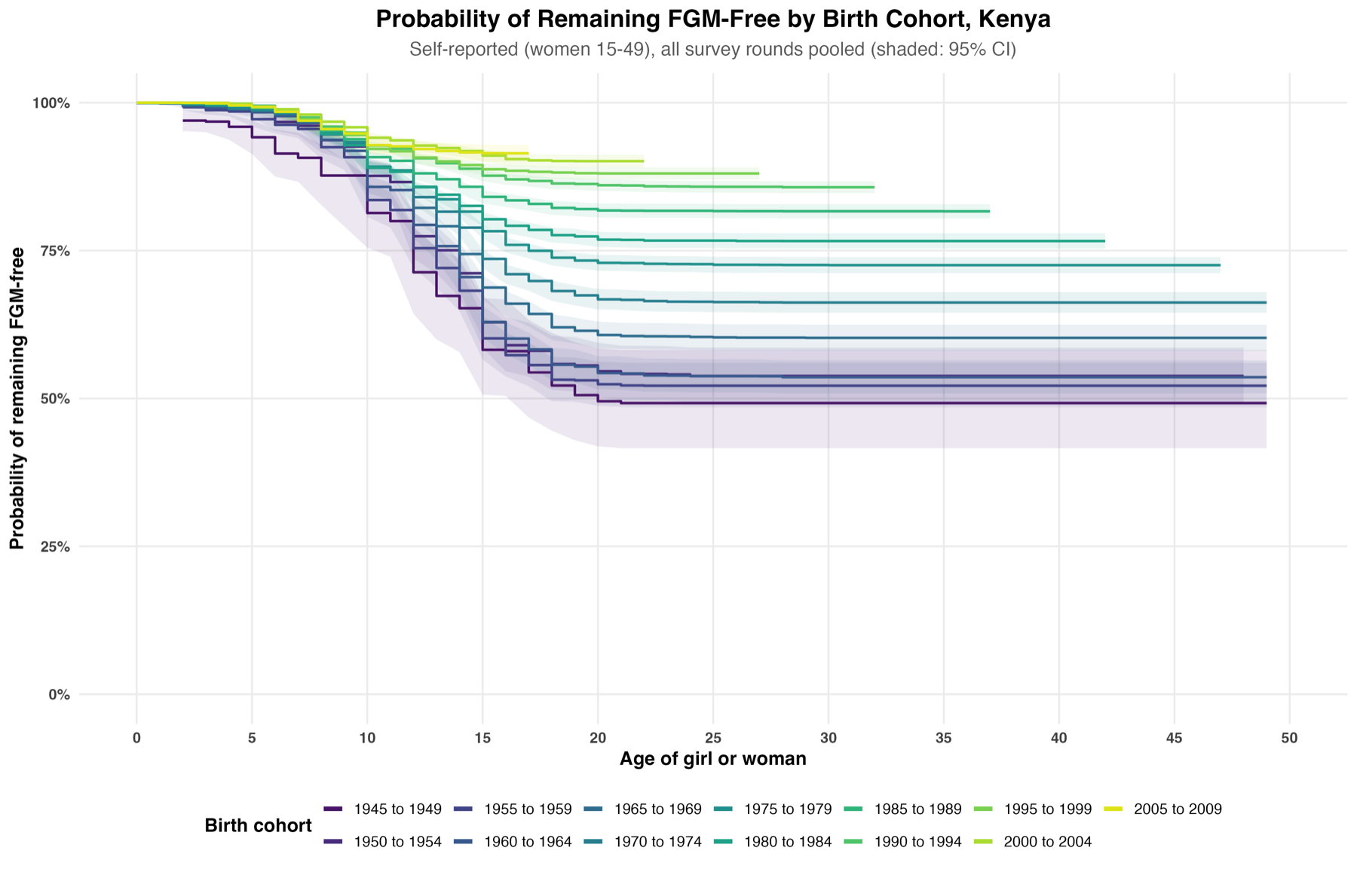
Figure 1. Probability of remaining FGM-free by age and birth cohort, women's own reports (all rounds pooled)
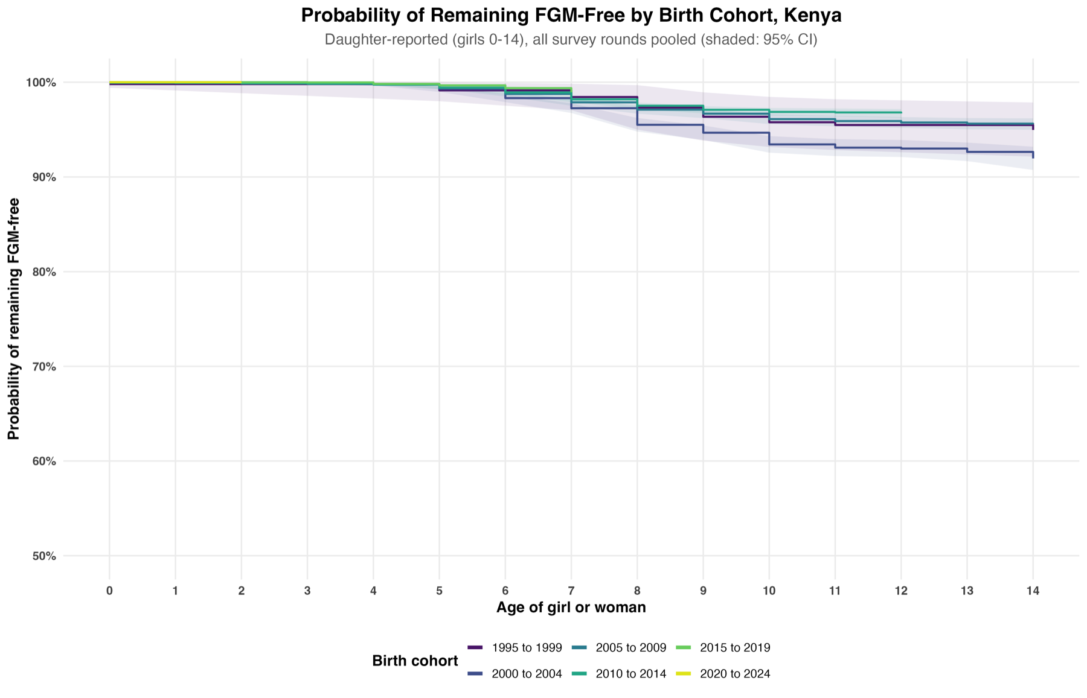
Figure 2. Probability of remaining FGM-free by age and birth cohort, mothers' reports for daughters aged 0–14

3.2 Risk has fallen steadily for four decades
Women's risk of being cut by age 15 is 37–42% for women born in 1945–64, then falls to 26.4% (1970–74), 19.7% (1980–84), 15.9% (1985–89), 11.3% (1995–99) and 8.5% (2005–09) (Figure 3). In the hazard model, the odds of being cut fall from 0.68 (1965–69, relative to 1945–49) to 0.30 (1985–89), 0.16 (2000–04) and 0.09 (2010–14); no single change point was detected. Mothers report that 3–7% of daughters born since 1995 were cut by age 10, and 3.1% of those born in 2010–14.
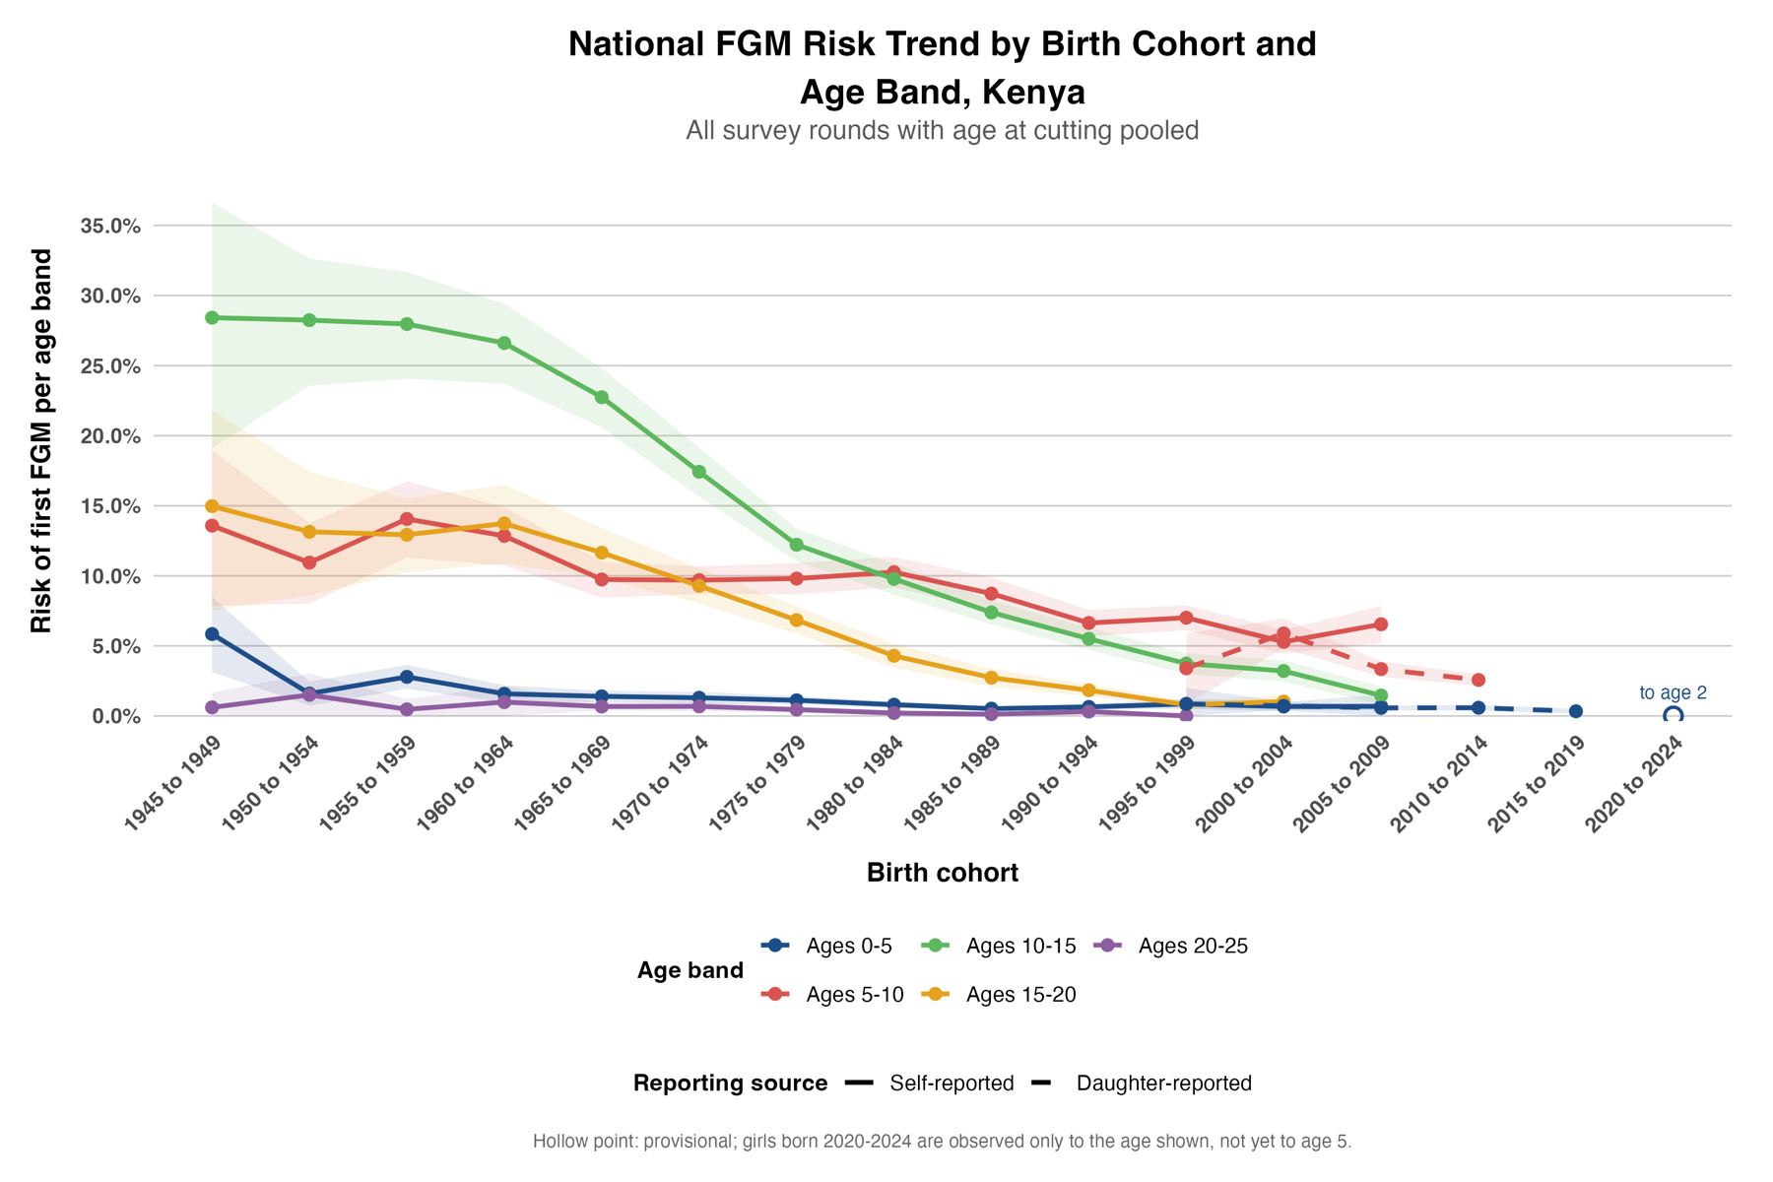
Figure 3. Risk of first FGM within each age band, by birth cohort and reporting source (pooled Kaplan–Meier)

3.3 Who is at risk
Table 2. Survey-weighted discrete-time hazard model: annual odds of being cut
Factor (reference) | Group | Odds ratio | 95% CI
Age (0–4) | 5–9 | 13.49 | 11.49–15.84
 | 10–14 | 51.68 | 43.05–62.04
 | 15+ | 18.97 | 15.47–23.27
Residence (rural) | Urban | 0.57 | 0.52–0.63
Ethnicity (Kikuyu) | Somali | 20.33 | 13.89–29.76
 | Kisii | 13.88 | 10.97–17.57
 | Maasai | 7.98 | 6.74–9.46
 | Kalenjin | 2.18 | 1.85–2.57
 | Meru/Embu | 1.04 | 0.83–1.30
 | Kamba | 0.50 | 0.39–0.64
 | Mijikenda/Swahili | 0.22 | 0.13–0.37
 | Luhya | 0.06 | 0.04–0.09
 | Luo | 0.01 | 0.01–0.03
Reporting source (daughter) | Woman's own report | 1.06 | 0.90–1.24
All odds ratios are adjusted for age group, birth cohort, residence, ethnicity, province and reporting source. Province effects, relative to Central, are highest in North Eastern (4.12), Eastern (2.00) and Nyanza (1.54) and lowest in Western (0.17). The 2020–24 cohort has no reported cases and is not interpreted.
Ethnicity dominates: risk is highest among Somali, Kisii and Maasai girls and very low among Luo, Luhya and Mijikenda/Swahili girls. Urban residence lowers the annual odds by 43%. Women's own reports and mothers' reports give the same odds once other factors are held constant.

3.4 North Eastern stands apart
Among women born in 2005–09, smoothed risk is 72% at ages 5–10 and a further 22% at ages 10–15 in North Eastern; in every other province the risk at ages 5–15 is under 15% (Figures 4 and 5). Among daughters born in 2010–14, risk at ages 5–10 is 65% in North Eastern and under 5% elsewhere.
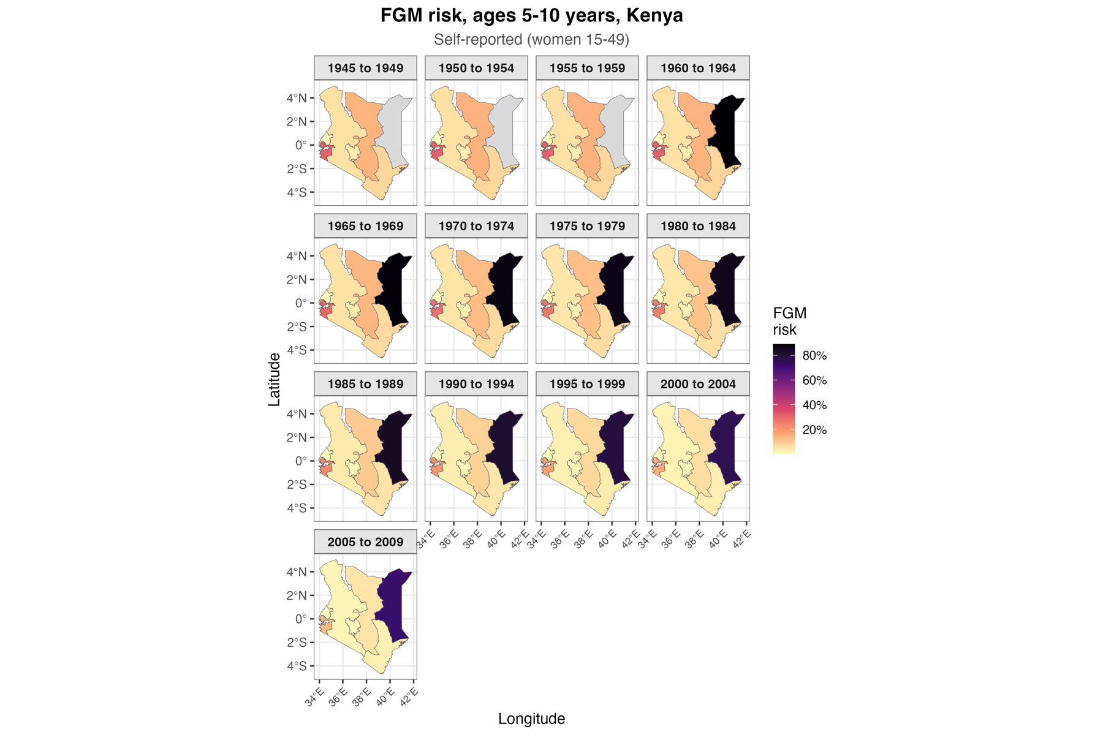
Figure 4. Smoothed risk of FGM at ages 5–10 by province and birth cohort, women's own reports
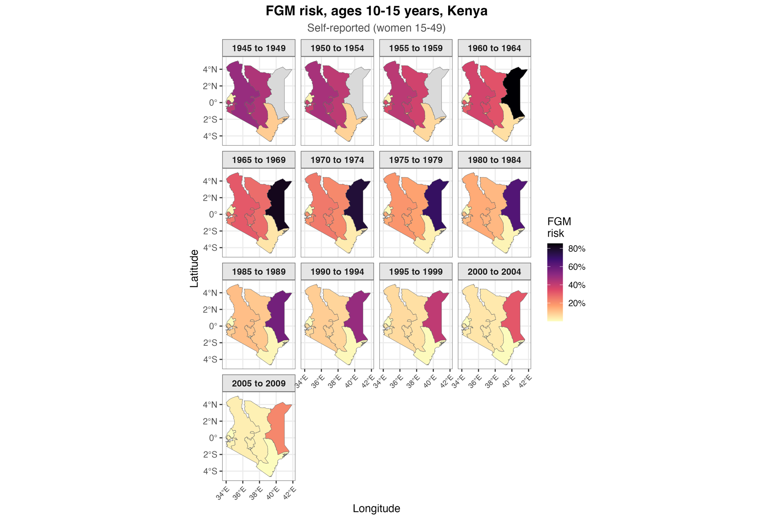
Figure 5. Smoothed risk of FGM at ages 10–15 by province and birth cohort, women's own reports

3.5 Validation
The pooled national estimates reproduce the survey-weighted Kaplan–Meier estimator exactly. The covariate-adjusted spatial model agrees with province direct estimates (correlation 0.87 for women and 0.96 for daughters).

4. Sensitivity analysis
Risk incidence assumes that women recall, and are willing to report, whether and when they were cut. Because pooling observes each birth cohort several times, we can test that assumption. Checks on women's own reports use the risk of being cut by age 15; the comparison with mothers' reports uses risk by age 10, because daughters are observed only to age 14.

4.1 The same cohort gives similar answers in different surveys
Women born in 1975–79 report a risk by age 15 of 23.3% in DHS 1998, 23.4% in DHS 2008–09, 22.1% in DHS 2014 and 18.4% in DHS 2022; women born in 1965–69 report 30.8%, 31.6% and 31.5% (Table 3, Figure 6). Unlike Burkina Faso, reporting is stable up to DHS 2014. DHS 2022 gives lower figures for cohorts born before 1985 (17.8% against 24.6–30.5% for women born in 1970–74), consistent with growing reluctance to report since FGM was criminalised in 2011.
Table 3. Risk of FGM by age 15 (%), same birth cohort reported in successive surveys (women's own reports)
Birth cohort | DHS 1998 | DHS 2008–09 | DHS 2014 | DHS 2022
1955–59 | 40.2 | 36.9 | – | –
1960–64 | 38.0 | 35.8 | 36.1 | –
1965–69 | 30.8 | 31.6 | 31.5 | –
1970–74 | 30.5 | 28.0 | 24.6 | 17.8
1975–79 | 23.3 | 23.4 | 22.1 | 18.4
1980–84 | 24.0 | 21.5 | 18.5 | 16.7
1985–89 | – | 16.1 | 15.7 | 16.1
1990–94 | – | 14.1 | 12.5 | 11.2
1995–99 | – | – | 11.4 | 11.1
2000–04 | – | – | – | 8.9
2005–09 | – | – | – | 8.5

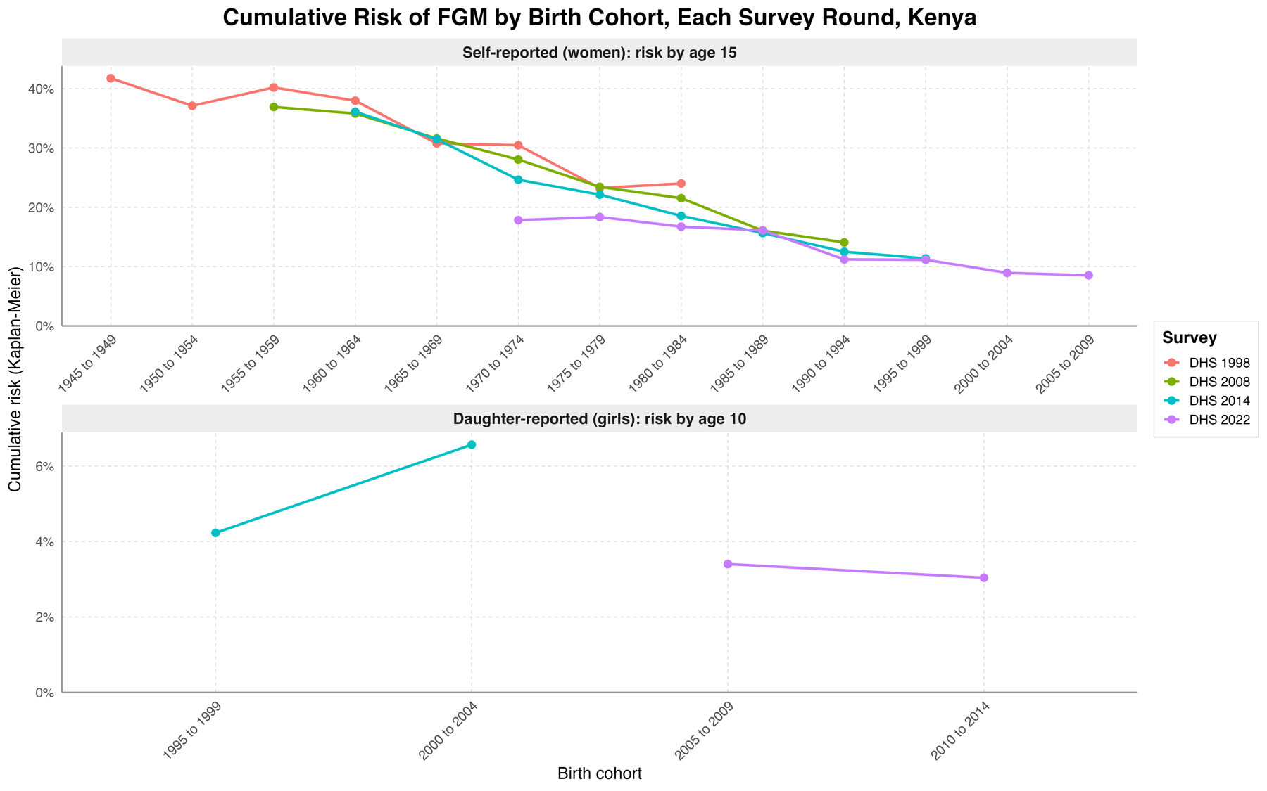
Figure 6. Cumulative risk of FGM by birth cohort, estimated separately in each survey round (women by age 15, girls by age 10)

4.2 Holding age at interview fixed, the decline is unchanged
Using only women interviewed at ages 20–29, risk by age 15 falls from 30.5% (born 1970–74) to 20.6% (1980–84), 11.8% (1990–94) and 9.5% (2000–04), the same path as the all-ages series (Table 4, Figure 7). The decline is robust to age at interview.

4.3 Women's own reports and mothers' reports agree
For girls born in 2000–04, risk by age 10 is 5.9% from women's own reports and 6.6% from mothers' reports; for 2005–09 it is 7.2% and 3.9%. Both sources show low and falling risk among recent cohorts (Table 4). Because Kenyan girls are cut older, most remember and report their own cutting.
Table 4. Risk of FGM (%) under alternative reporting assumptions
Birth cohort | Women, all ages: by 15 | Women aged 20–29: by 15 (95% CI) | Own reports: by 10 (95% CI) | Mothers' reports: by 10 (95% CI)
1965–69 | 31.2 | 31.3 (26.0–36.2) | 11.0 (9.6–12.3) | –
1970–74 | 26.4 | 30.5 (27.4–33.4) | 10.9 (9.8–11.9) | –
1975–79 | 21.7 | 22.6 (19.4–25.8) | 10.8 (9.6–12.0) | –
1980–84 | 19.7 | 20.6 (16.4–24.6) | 11.0 (9.9–12.1) | –
1985–89 | 15.9 | 16.2 (14.2–18.1) | 9.2 (8.0–10.4) | –
1990–94 | 12.3 | 11.8 (10.5–13.2) | 7.2 (6.3–8.2) | –
1995–99 | 11.3 | 11.1 (9.6–12.7) | 7.8 (6.9–8.7) | 4.2 (1.5–6.9)
2000–04 | 8.9 | 9.5 (7.8–11.2) | 5.9 (5.0–6.9) | 6.6 (5.4–7.8)
2005–09 | 8.5 | – | 7.2 (5.7–8.7) | 3.9 (3.3–4.5)
2010–14 | – | – | – | 3.1 (2.7–3.6)

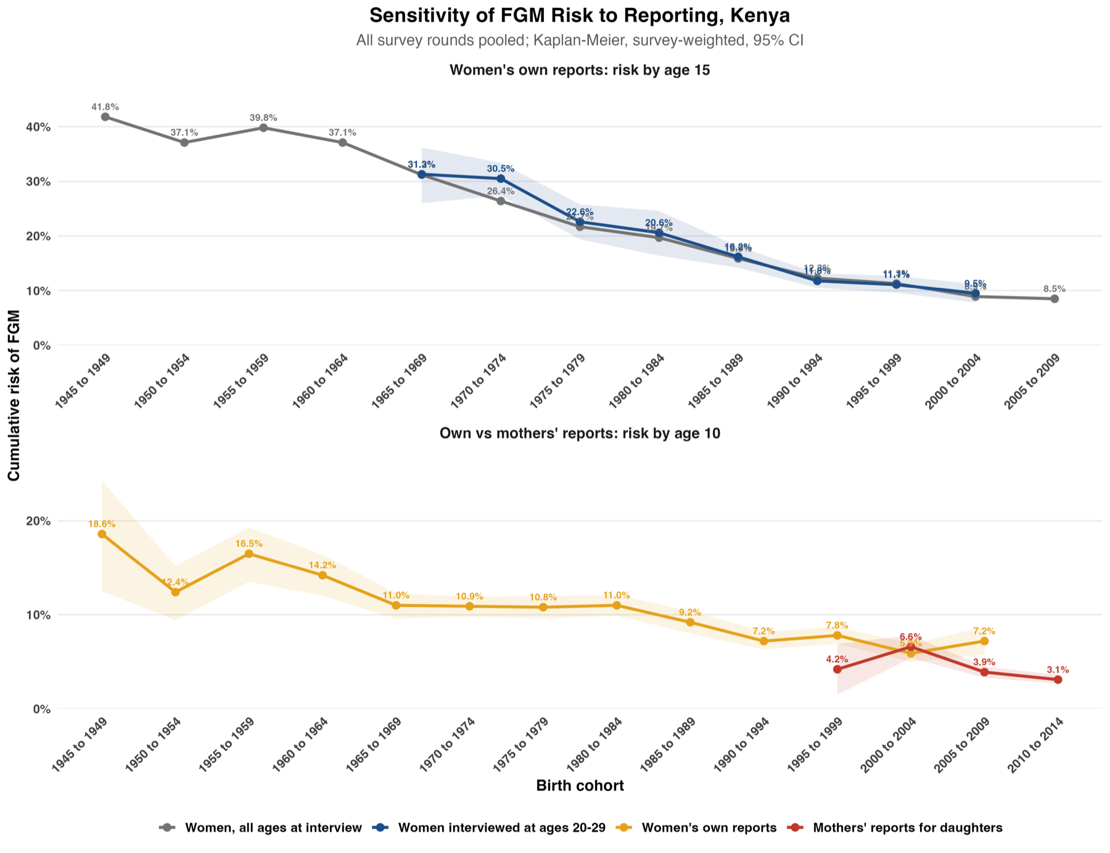
Figure 7. Risk of FGM by age 15 (all ages vs fixed age at interview) and by age 10 (own vs mothers' reports)

4.4 Further checks
- Age at interview within cohort. No consistent pattern: women born in 1985–89 report 15.5% at ages 15–24, 15.7% at 25–34 and 17.2% at 35–49.
- DHS and MICS. Not possible nationally, as Kenya has no national MICS; the subnational MICS agree with DHS for the same areas (section 5 and the prevalence report).
- Estimating vague and unknown ages. Using only exact ages changes risk by age 15 by under 3 points for every cohort, because almost all Kenyan women give an exact age.

4.5 What the sensitivity analysis adds
In Kenya the results are robust to how and when women report: the same cohorts give similar answers across rounds, the decline holds at a fixed age at interview, own and mothers' reports agree, and the handling of vague ages makes almost no difference. The one sign of under-reporting is DHS 2022, where older cohorts report less cutting than in earlier rounds, which may reflect the 2011 criminalisation of FGM.

5. Comparison with Kenya's subnational MICS
MICS 2013–14 asked women their age at cutting in Bungoma, Kakamega and Turkana counties. FGM is rare there (1–4% of women), so only 38, 11 and 31 women were cut in the MICS samples, and 6, 3 and 13 in DHS 2014. In Bungoma most MICS respondents report cutting at 15 or older (60%), in line with initiation-age cutting in the area, while Turkana reports mostly ages 5–14; the DHS samples are too small for a meaningful comparison. Nationally, DHS 2014 and 2022 agree closely on the age pattern (2% before age 5, 27–30% at 5–9, 43–45% at 10–14).

6. Conclusions
- FGM in Kenya is mostly performed at ages 5–15, so prevention must reach girls through primary-school age and early adolescence.
- Risk of being cut by age 15 has fallen from about 40% for women born before 1965 to under 10% for those born since 2000, and mothers report around 3% of girls born in 2010–14 cut by age 10.
- Risk remains extremely high in North Eastern province, where most girls born in 2005–09 were cut by age 15, and among Somali, Kisii and Maasai communities.
- The estimates are robust to reporting, but DHS 2022 suggests some under-reporting by older women since the 2011 law.

