Name: Julio Barros
Pfsense Firewall
For the firewall, I used pfSense with a slightly different configuration than what the professor suggested for issues encountered in previous classes. The main differences were the RAM allocation and the CPU. As you can see in the screenshot below,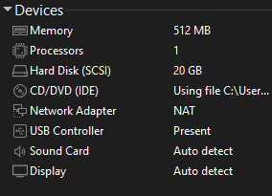

Security Onion
For Security Onion, the standard configuration worked fine. I followed the professor's recommendations and added the extra CPU and RAM as suggested. However, while installing the .iso, I encountered an error due to insufficient storage space. I resolved this issue by adding an additional 60GB, as I had a 512GB SSD dedicated solely for school use.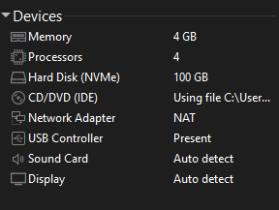

Kali
I have been using the same virtual machine since my junior year, since I upgraded my computer I upgraded the machine settings as well, Kali installing process is very simple and easy from what I remember you just need to download the .iso from kali website and add the specific things to the virtual machine settings.
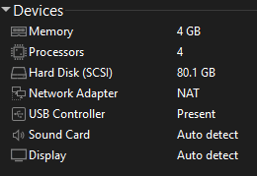
Windows Desktop
For Windows, they provide a tool to create an .iso from your own Windows key. I used this to create my Windows 10 .iso and added it to VMware along with the other virtual machines. Since Windows sometimes tends to crash in virtual machine environments, I allocated a few extra CPUs and more RAM to ensure smoother performance and for my peace of mind, as you can see in the photo below.
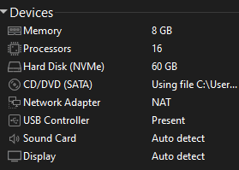
And the whole system has been set like that so far.

