Seamless 2D and 3D image mosaicking of microscopic images of reactor core components

Aim:

To stitch 2D microscopic images of Reactor Core Components and then obtaining the stitched image’s 3d view to analyse it.

Abstract:

This project helps tackle this problem by implementing stitching of multiple microscopic images of the component into single image so that the resolution in improved and detection and categorization is accurate. After getting the stitched image and implementing a deep learning network for segmentation of the artifact is done for the length, width, 3D model will also be created for getting depth of the crack.

Achievements:

1. We were able to stitch the images obtained from microscope very precisely, we calibrated the camera to obtain the pixel-to-mm, using it we calculated the overlapping region and then concatenated the images.

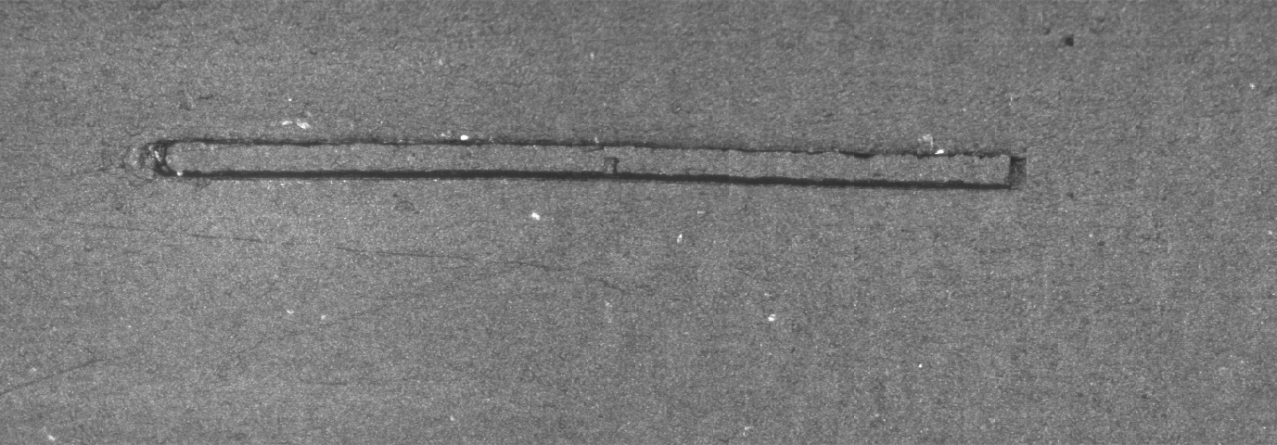

Fig. 1A. Before calibration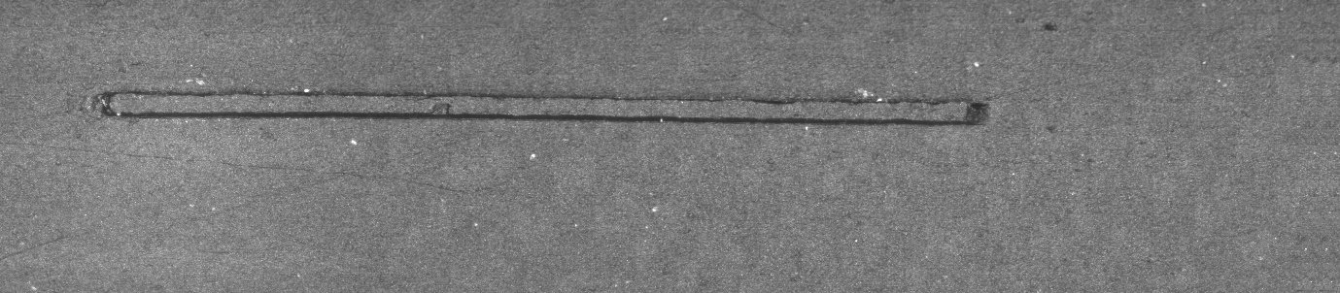

Fig. 1B. After calibration

1. Using a pre-trained model by Midas, we feed the obtained stitched image as input to the model which results in a depth map of the image.
2. We are able to host the UI for the depth map model on local and public IP.

Our findings:

1. **ZoeDepth**

Demonstrates unprecedented zero-shot cross-dataset generalization capability to 8 unseen datasets with up to 11x better metrics over SOTA.

Methodology

Two-stage training:

1. Relative depth pre-training on diverse datasets for generalization
2. ii) Adding lightweight metric heads and fine-tuning

Metric heads use proposed metric bins module with novel attractor layers for bin refinement across decoder features.

Flexible framework allows different relative and metric dataset combinations.

Routing input images to suitable domain expert head during inference.

Results

Sets new SOTA on NYU Depth v2 even without relative pre-training, validating metric bins design.

Further boosts SOTA with additional relative pre-training.

Generalizes much better to unseen datasets than prior work due to diversity of pre-training.

Careful experimentation provides insight into contribution of individual components.

Problem Context and Related Work:

MIDAS

Monocular depth estimation is an important but ill-posed problem with applications in 3D reconstruction, robotics, image editing etc.

Learning-based approaches using dataset mixing and scale-invariant losses (MiDaS) have shown promising generalizability.

Recent vision transformers have advanced image encoders, but their utility for depth prediction is relatively unexplored.

Methods:

Explores various transformer and convolutional encoders with MiDaS decoder.

Uses multi-dataset, multi-objective training strategy of prior MiDaS versions.

Makes lightweight decoder modifications to support different encoders.

Results:

Extensive experiments reveal performance/speed tradeoffs with different backbones.

Promising results when combining with pipelines for metric depth estimation and image generation.

Limitations:

Limited exploration of larger backbone variants.

Applicability to diverse domains like medical imaging remains unvalidated.

Encoder-decoder co-design could further improve accuracy.