Jack Kotheimer

17816 Bishop Rd

Tinley Park, IL 60487

(708) 710-6649

jkotheimer9@gmail.com

Thursday, August 27th, 2020

Dear Discover Financial Services hiring manager,

With regards to your need for a business technology intern, I write you this letter in which, instead of reiterating my resume, I will give your mind a break and tell you my favorite things about myself.

I am the person who not only sits down and happily hacks away at the work that has been given to me, but I really enjoy bringing people together. Working in teams is something I genuinely look forward to because I love turning awkward and uncomfortable idea pitches into more dynamic and natural conversations about the best ways to attack a problem. Development teams should never be approached as “my idea vs. your idea” - its more like “our ideas vs. the problem”.

Speaking of problems, I love solving problems for fun - I can solve a Rubik's cube in under 25 seconds, a skill I decided to teach myself one day because I was between coding projects. On the more technical side (and at the risk of being ~*that guy*~), I have Arch Linux installed on all of my machines, which, if you are familiar with Arch Linux, is a hell of a puzzle to install on it's own. At the end of the day, I want to contribute my skillset to a greater cause.

If you’ve made it this far, thank you for your time – my resume is attached and will tell you more about my professional accomplishments. I look forward to the opportunity to discuss my qualifications with you further.

Best regards,

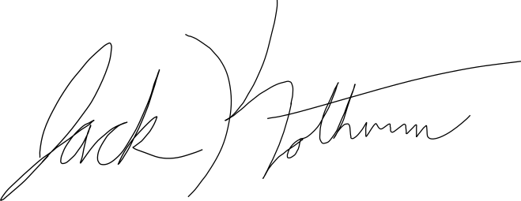

Jack Kotheimer