**EXP NO: 06(FTP)**

1. **Software:**

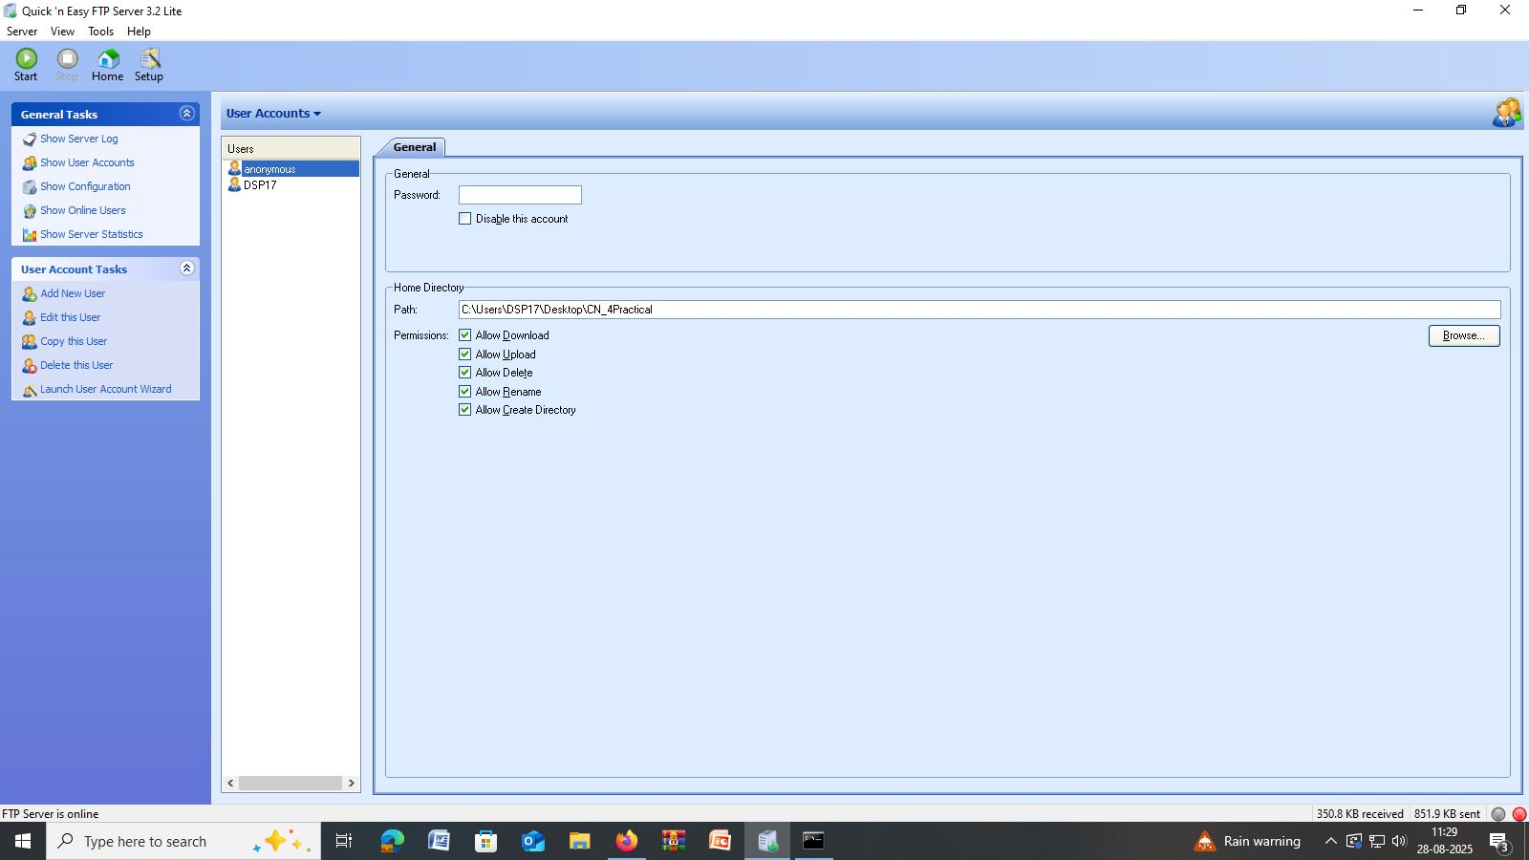

1. **Shared folders/ Directory:**