**EXPERIMENT-1 <<Part-A>>**

%Name: Jay Kotwal

% Roll_No: 32137

clc;

clear;

close all;

Name=input("Enter the Name: ",'s');

Roll_No=input("Enter the Roll Number: ");

disp(Name);

disp(Roll_No);

pkg load statistics;

% EXPERIMENT-1 <<Part-A>>

% Write a program to plot PDF of a Gaussian (Normal) Random Variable for:

% CASE-1 Standard Gaussian: mean = 0 and standard deviation = 1

% CASE-2 General Gaussian: mean = 1 and standard deviation = 1

% CASE-3 General Gaussian: mean = -1 and standard deviation = 1

% CASE-4 General Gaussian: mean = 0 and standard deviation = 1.5

% CASE-5 General Gaussian: mean = 0 and standard deviation = 0.5

% CASE-6 General Gaussian: mean = 1 and standard deviation = 0.5

% Plotting Case-1:

m = 0; # Given: mean = 0

sd = 1; # Given: standard deviation = 1

x=-6:0.1:6; # Define suitable range of x values (as per our choice).

y=normpdf(x,m,sd); # Calculate values of Normal PDF for all xs.

# Note: The 'normpdf' function belongs to the statistics package.

# To load the package,run 'pkg load statistics' from the Octave prompt

# in command window before running this program.

figure(1) # Open a figure window named as figure-1.

# We wish to plot all the cases (Total 6 Plots) in the same figure window.

# Use 2 rows & 3 columns so that we have total 6 plots as shown below.

# +-----+-----+-----+

# | 1 | 2 | 3 |

# +-----+-----+-----+

# | 4 | 5 | 6 |

# +-----+-----+-----+

subplot(2,3,1) # The plot (Case-1) will be on location-1 as shown above.

plot(x,y) # To plot Case-1 (y vs x).

axis([-6 6 0 1]) # x-axis ranges from -6 to 6 & y-axis ranges from 0 to 1.

xlabel('x values----->');

ylabel('PDF--->');

title('CASE-1: mean=0, std dev=1') # Title of the plot

grid on;

% Plotting Case-2:

% Write the code yourself to plot Case-2 on Location-2 with given mean and

% standard deviation.

m = 1; # Given: mean = 1

sd = 1; # Given: standard deviation = 1

x=-6:0.1:6; # Define suitable range of x values (as per our choice).

y=normpdf(x,m,sd); # Calculate values of Normal PDF for all xs.

subplot(2,3,2) # The plot (Case-1) will be on location-1 as shown above.

plot(x,y) # To plot Case-1 (y vs x).

axis([-6 6 0 1]) # x-axis ranges from -10 to 10 & y-axis ranges from 0 to 1.

xlabel('x values----->');

ylabel('PDF--->');

title('CASE-2: mean=1, std dev=1') # Title of the plot

grid on;

% Plotting Case-3:

% Write the code yourself to plot Case-2 on Location-3 with given mean and

% standard deviation.

m=-1;

sd= 1;

x=-6:0.1:6;

y=normpdf(x,m,sd);

subplot(2,3,3);

plot(x,y);

axis([-6 6 0 1]);

xlabel('x Values ---->');

ylabel('PDF--->');

title('CASE-3: mean=-1 std=1');

grid on;

% Plotting Case-4:

% Write the code yourself to plot Case-2 on Location-4 with given mean and

% standard deviation.

m=0;

sd= 1.5;

x=-6:0.1:6;

y=normpdf(x,m,sd);

subplot(2,3,4);

plot(x,y);

axis([-6 6 0 1]);

xlabel('x Values ---->');

ylabel('PDF--->');

title('CASE-4: mean=0 std=1.5');

grid on;

% Plotting Case-5:

% Write the code yourself to plot Case-2 on Location-5 with given mean and

% standard deviation.

m=0;

sd= 0.5;

x=-6:0.1:6;

y=normpdf(x,m,sd);

subplot(2,3,5);

plot(x,y);

axis([-6 6 0 1]);

xlabel('x Values ---->');

ylabel('PDF--->');

title('CASE-5: mean=0 std=0.5');

grid on;

% Plotting Case-6:

% Write the code yourself to plot Case-2 on Location-6 with given mean and

% standard deviation.

% standard deviation.clc;

m=-1;

sd= 0.5;

x=-6:0.1:6;

y=normpdf(x,m,sd);

subplot(2,3,6);

plot(x,y);

axis([-6 6 0 1]);

xlabel('x Values ---->');

ylabel('PDF--->');

title('CASE-6: mean=1 std=0.5');

grid on;

**Output:**

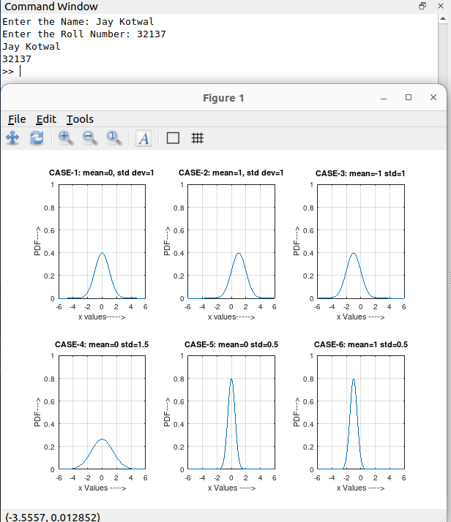

**EXPERIMENT-1 <<Part-B>>**

% Program to plot PSD and Autocorrelation of White Gaussian Random Process

%Name: Jay Kotwal

% Roll_No: 32137

clc;

clear;

close all;

Name=input("Enter the Name: ",'s');

Roll_No=input("Enter the Roll Number: ");

clc;

clear all;

close all;

pkg load statistics;

y=normrnd(0,1,1,200);

Gy=periodogram(y);

Ry=abs(ifft(Gy,256));

Ry=[Ry(130:256)' Ry(1:129)'];

t=-127:1:128;

figure

subplot(1,2,1)

plot(Gy)

xlabel('frequencysamples');

title('PSD')

subplot(1,2,2)

stem(t,Ry)

xlabel('time shift')

title('autocorrelation')

**Output:**

