KSA/RC/2021/P1FORM

KENYA SPACE AGENCY

**RESEARCH CHAIR**

❖ **Small-scale Crop Mapping using Artificial Intelligence/Machine Learning (AI/ML)**

**PROPOSAL APPLICATION by JKUAT**

**2021/2022 FINANCIAL YEAR**

|  |
| --- |
| (Expand the spaces provided in this form to fit your content. TheCONCEPT NOTEshould not exceed 20 pages(Candara 12, single line spacing)excluding appendices |
| PROPOSED PROJECT DETAILS |
| **TITLE OF RESEARCH:** Small-scale Crop Mapping Using Artificial Intelligence/ Machine Learning  **Project Summary**  The project involves development of a web-based application for small-scale crop mapping using Artificial Intelligence (AI) and Machine Learning (ML). It is aimed at capitalizing on the technical expertise in JKUAT and other institutions of higher learning in exploitation of satellite image data acquisition and ingestion techniques for small-scale crop mapping towards estimation of the crop area, crop status, crop yields and assessment of the food security situation in the country.  The research chair activities will entail the design, testing and implementation of a web application for automatic acquisition/ download, pre-processing, analysis and classification of satellite imagery using AI and ML algorithms. The proposed web application will be designed and implemented with a view of providing users with varying levels of expertise and needs access to a variety of satellite image products, ranging from raw image data to scientific products.  The project is intended to enhance the capacity and capabilities of the country in taking a more proactive information-based approach towards food security. The project team consists of 6 students from a range of disciplines in which gender representation has been ensured. A faculty member from the JKUAT Department of Geomatic Engineering and Geospatial Information Systems (GEGIS) will guide the students in implementation of the project. |
| **Project budget:** Ksh (500,000.) |



**1.0 Background to the project (***Provide information on the problem being solved***).** The second sustainable development goal (SDG-2) on ‘zero hunger’ recognizes that, while the number of undernourished people has reduced over the years, there is an urgent need to promote and support sustainable agriculture, small-scale farmers and equal access to land, technology and markets (Assembly, 2015). The aspect of promotion and support of small-scale farmers and access to technology is particularly important in Africa, where approximately 80% of the available cropland is cultivated by smallholder or small-scale farmers (Aguilar et al., 2018). Doubling agricultural productivity of small-scale food producers, implementing resilient agricultural practices that strengthen the capacity for adaptation to climate change, and increasing investment in agriculture through agricultural

|  |
| --- |
| research and technological development, are some of the targets of SDG-2 that need to be aligned with the four pillars of food security: availability, access, utilization, and stability (Gil et al., 2019).  From an economic perspective crop cultivation is a significant and pertinent economic activity in Kenya, whose monitoring should be pursued. According to the Kenya Economic Survey (2021), the percentage contribution of crop cultivation to the Gross Domestic Product (GDP) in 2020 was 16.6%. In addition, the National Agricultural Investment Plan (NAIP, 2019 – 2024) highlights the limitations of the data that is currently available on agriculture, and the need for an increased capacity to use data from innovation, research and technology in agriculture. Data on the areas of crop cultivation, the types of crops that are under cultivation, and the status of crops during the growing season can aid in implementation of precision agriculture, thereby helping small-scale farmers to appropriately apply inputs and saving on production costs. Further, estimation of yield can help the country to plan for food shortages or surplus thus ensuring food security.  Crop mapping of smallholder agriculture is a non-trivial exercise, which requires procedures that can handle temporally, spatially, and spectrally complex data, since small- scale crop cultivation tends to be spatiotemporally heterogeneous and diverse (Ibrahim et al., 2021). Remote sensing imagery acquired by sensors aboard satellites and Unmanned Aerial Vehicles (UAVs) at varying spatial and temporal scales provide an excellent source of data for the mapping and continuous monitoring of small-scale crop cultivation. Satellite- derived estimations and predictions of crop features and outputs include crop monitoring models and applications centered around five main areas including: biomass and yields estimation, vegetation and water stress monitoring, crop acreage estimation, crop type proportion mapping and crop phenological development (Zhang et al., 2016). The proposed research will involve exploitation of AI and ML procedures including image signal processing for multi-spatiotemporal image correction and classification. A web-based application will allow access to derived estimates on cropland area and crop features using optical remote sensing satellite imagery. The application will be designed and implemented with a view of providing near-real-time data on crop cultivation areas and their status using a variety of satellite image products including Landsat-8/ 9, Sentinel-2A/2B and Sentinel- 1A/1B. |
| **2.0. Justification(***A clear justification for the proposed application’s relevance and*  *uniqueness***)**  Small-scale crop cultivation is characterized by varied crop types, crop varieties, tillage practices, and planting times, thus necessitating multi-temporal classification approaches which utilize time-series data (Nduati et al., 2019). In order to get up-to-date information of the land under crop cultivation and the crop growth and performance status of the crops at any instance in time, the most recently available satellite imagery is required. However, optical satellite imagery have varied temporal and spatial resolution, and the imagery may be severely affected by atmospheric artefacts, thus making information retrieval difficult or impossible due to missing data. In order to overcome this, active radar remote sensing missions, such as the Sentinel-1 C-band SAR active sensor, can be used since they can acquire data about the earth's surface at any time of the day or night, regardless of |



weather and environmental conditions. A major drawback of radar data is that the data require expert processing and interpretation thus limiting access to non-expert application users. In addition, optical sensors acquire data in a variety of spectral bands from which indices that are much better documented can be derived and directly applied by users with little to no experience with GIS and remote sensing. We propose the use of AI and ML algorithms that will be implemented and run on a server as per the data request made by a user. Since the datasets proposed, that is Landsat-8/ 9, Sentinel-2A/2B and Sentinel-1A/1B, have varied temporal resolution, the synthesis of these data sets using AI and ML will provide a continuum of images and products that can be used for monitoring crop production.

Web Map Tile Service was selected over Web Map Service as it is more suited to requirements of the project. Main advantage of tiles is that they can be pre-renderd on the server side, and cached on the client side. This will reduce waiting time for the data and bandwith. Given that time is a factor, we will want to pubish data as fast as possible. The faster model is therefor ideal.

Furthermore, WMTS will provide raster satelite imagery data at multiple resolutions in predefined imagery tiles (PNG and JPEG formats) making it more scalable and high-performing than a web map service.

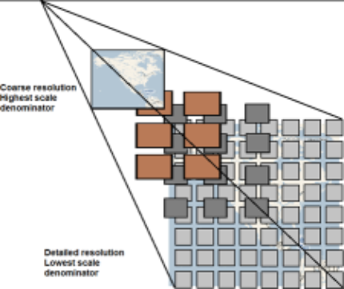Course resolution Highest scale denominator

Detailed resolution Lowest scale denominator

*Source: https://gcs-docs.s3.amazonaws.com/EVWHS/Miscellaneous/DevGuides/WMTS/WMTS_MapTile.htm*

Figure 2.1: WMTS service divided into tiles

|  |
| --- |
| **3.0 Project objective(s) (***The objectives stated must be specific, measurable, realistic and attainable within the given project time frame***)**  Main Objective  To design, develop and implement a web-based application for the access/ download, processing, classification and retrieval of small-scale cropland specific features and outputs.  Specific Objectives  a) To develop a web-based application for the automatic download of Landsat 8/9, Sentinel-2A/2B, and Sentinel-1A/1B images of Kenya from their respective hubs/ portals.  b) To implement real-time image processing and archiving for retrieval of the Landsat 8/9, Sentinel-2A/2B, and Sentinel-1A/1B images of Kenya, as they become available.  c) To develop and implement AI/ ML image classification algorithms for mapping of land cover and final estimation and retrieval of crop area, crop status indices and crop yield. |
| **4.0 Expected outputs of the project (***Clearly state the project expected outputs which should be realistic and quantifiable. The stated expected outputs should be clearly linked to your project objectives***).**  The following are the expected outputs from the research chair project:  a) A General User Interface designed to handle user-requests for search and discovery of Landsat 8/9, Sentinel-2A/2B, and Sentinel-1A/1B images over selected area(s) within Kenya and selected time/ date range(s).  b) Backend-processing of the Landsat 8/9, Sentinel-2A/2B, and Sentinel-1A/1B images for the selected area(s) and date(s) using AI/ML algorithms.  c) Delivery of cropland area estimation and crop status indices from the back-end processing as per user requests via the web application for download. |



|  |
| --- |
| **5.0Research design and methodology** **(***Provide clear descriptions of software development model adopted, system design and modules and methodology***)**  5.0.1 **Study Area**  **Study Area Map**C:\Users\Carol\Downloads\WhatsApp Image 2021-12-03 at 2.01.24 PM.jpeg |



**Justification for choice of study area**

Mwea west is a sub county in Kirinyaga. The sub county is ideal for the study because it is known for rice production in the Mwea Tebere irrigation scheme as well as other horticultural crops grown in small holder farms. Rice is the third staple food in kenya, grown by small holder farmers in Mwea West subcounty. The climatic conditions of Mwea West are highly unreliable, raising agricultural hazards and bringing about huge losses to farmers. The system for rice intensification is a farming method introduced in the scheme in the recent years to maximize rice production using low water requirements and mechanical weeders. This has been a great solution to address the problem of water shortage in Mwea West, as well as increasing productivity and quality of the rice. The SRI is a green way of achieving sustainable development goals of food security. Rice farming is a form of aquatic agriculture, which is done on paddies. Sentinel 1 is ideal in mapping and monitoring rice production. It carries an advanced all weather radar which is highly sensitive to water logged ground. It is ideal in providing timely data for the study and predicting climatic conditions to avoid damage from natural disasters such as El Niño and drought.

Besides rice farming, Mwea West is known for production of other horticultural crops such as tomatoes, onions, French beans, maize and beans among others. Mwea West subcounty has favourable climatic conditions for flying UAVs, which the institution has acquired to monitor the dry land horticultural farms to acquire high resolution imagery. The imagery is useful in topographical mapping to monitor crop health and minimize farm inputs and pesticides through precision farming methods. Sentinel 2 satellite imagery data is also readily available and provides high spatial and temporal resolution imagery for precision agriculture.

.



**5.1 Objective 1**: To develop a web-based application for the automatic download of Landsat 8/9, Sentinel-2A/2B, and Sentinel-1A/1B images of Kenya from their respective hubs/ portals

A web-based application employing an integration of user-friendly client GUI and server applications will be designed, developed and implemented. The general architecture will consist of three (3) main modules that work seamlessly to address near-real time functionalities: -

* Frontend:

This will include the client user interface that will enable the end consumer(Farmer, technical, political, economic or any other interested parties) to input/query their service of choice via HTTPs get requests.This will run on the browser and native Mobile application to enable users to interact with the web app and or portal by consuming functionalities like read and write as they wish. For example:

* + - Which areas best support which crop type for maximum yield?
    - Which areas are currently covered by which crop (Classification logic)?
    - What is the general crop health at a given phenological stage of growth?-Crop yield forecast?
    - How has environmental factors e.g rain been feeding the small scale crops in the recent past?
    - Which region(s) were highly affected by the previous crop pest and diseases(If any)-Crop health diagnosis?
    - Which regions are nutritionally succeptible to poor yield?~Predictive insights.
* Backend :

This is where the web services and APIs used by front-end architecture and mobile app reside. This will enable server-side web application logic to integrate with the client-side. This will be through the maintenance of the crop mapping central database, making sure that it has high performance and agile responsiveness to requests from the client/user side. Most of the spatial backend logic will be handled by the Google Earth Engine Cloud platform especially now that it hosts a vast variety of spatial datasets in cloud repository that gets updated on a near daily basis.

* Full-Time hosting services:

This will make the applications and websites accessible to any user who has access to cloud resources like internet. Will constitute a network of connected virtual and physical cloud servers to host the application and website, ensuring greater flexibility and scalability specially to run the complex machine learning and AI enabled algorithms.

Key Functional features of the proposed hosting services:

* Web and Mobile Applications and solutions are deployed on a cloud network like Google Cloud Platform (GCPs) for easy sync with the GEE backend logic.
* Resources are scaled to user needs as indicated in the front-end logic.
* Querying support using SQL (including PostgreSQL) or NoSQL databases like spatial GeoJSONs.
* Enables the Small-Scale Crop Mapping Solutions are to run autonomously and controlled using APIs, web portals, and the mobile apps.



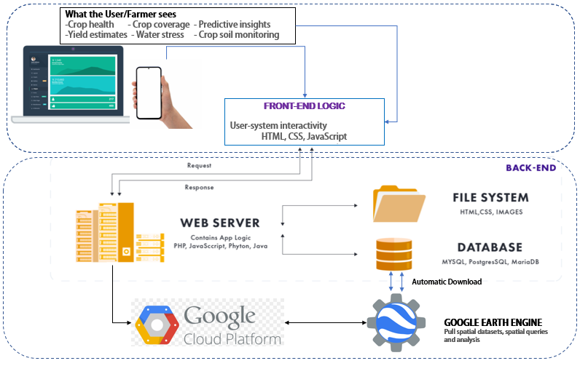

*Fig: Web and Mobile based Client-server architecture, to automatically download from*

*GEE query and display results*





**5.2 Objective 2:** To implement real-time image processing and archiving for retrieval of the Landsat 8/9, Sentinel-2A/2B, and Sentinel-1A/1B images of Mwea West, as they become available.

Real-time geo-processing functionalities is considered key especially when near-time decisions need to be achieved. This will be implemented by running on the server, background image processing algorithms will be running and processing the image data to various levels, as may be requested by the user. The main processing algorithms include:

1. Landsat 8 and Sentinel-2A/2B: At-sensor radiance and TOA reflectance, Surface reflectance, Compositing, Cloud Masking and Mosaicking.
2. Sentinel 1A/1B: Pixel-wise derivation of the backscatter coefficient through application of orbit file, GRD border noise removal, thermal noise removal, radiometric calibration, and terrain correction (orthorectification).
3. The preprocessed image will then be fed into Machine Learning/ AI algorithms like Neural networks, Support Vector Machine Classifiers, Decision trees to perform the AI/ML logic.

**5**.3 **Objective 3**: To develop and implement AI/ ML image classification algorithms for mapping of land cover and final estimation and retrieval of crop area, crop status indices and crop yield.

During the client data access request process, users will be required to stipulate which kind of data output they wish to view or download. This research will implement automatic AI/ML-driven classification algorithms as implied in 5.2(c) above to generate:

1. Land cover classification (general), depicting all classes as outlined by the UN Land Cover Classification System’s initial ‘Dichotomous Phase’, in which eight major land cover types are defined:

(1) Cultivated and Managed Terrestrial Areas,

(2) Natural and Semi-Natural Terrestrial Vegetation,

(3) Cultivated Aquatic or Regularly Flooded Areas,

(4) Natural and Semi-Natural Aquatic or Regularly Flooded Vegetation,

(5) Areas associated with artificial bare lands

(6) Artificial Waterbodies, 

(7) Snow and Ice, and

(8) Natural Waterbodies, Snow and Ice (Di Gregorio, 2005).

1. Cropland area including Cultivated and Managed Terrestrial Areas and Cultivated Aquatic Regularly Flooded Area
2. Crop-related indices including Normalized Difference Vegetation Index (NDVI), Normalized Difference Red Edge (NDRE) index, Modified Soil Adjusted Vegetation Index (MSAVI), Normalized Difference Moisture Index (NDMI) and Red edge Chlorophyll (ReCl) index.
3. Field-scale time series analytics derived from the indices above.



The classification of the satellite images will require ground reference data collected at regular intervals over the course of the research project. JKUAT possesses two state of the art drones (multi-spectral and LiDAR) and RTK-GNSS survey equipment which will be used for the ground truth data acquisition exercises.

The figure below shows the methodological workflow that is to be adopted in the implementation.

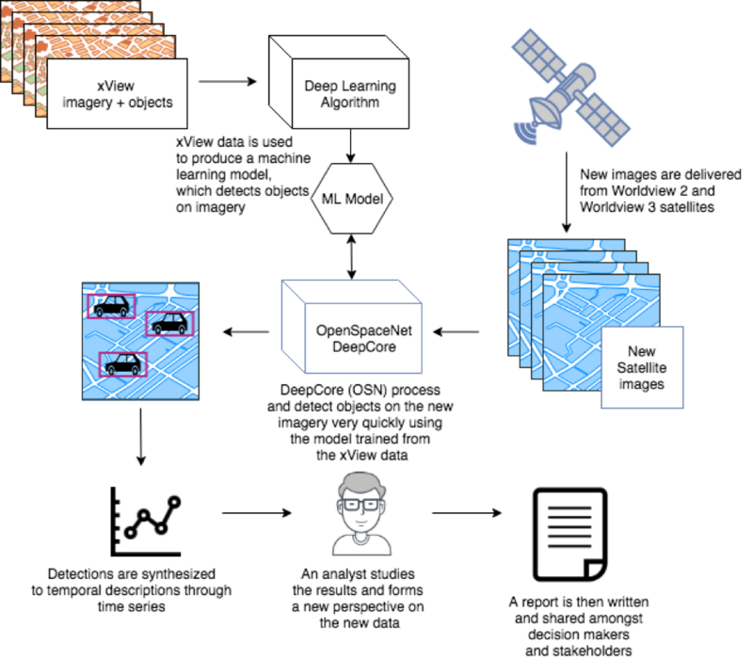

|  |  |  |  |  |  |  |  |  |  |  |  |  |  |  |  |  |  |  |  |  |  |  |  |  |  |  |  |  |  |  |  |  |  |  |  |  |
| --- | --- | --- | --- | --- | --- | --- | --- | --- | --- | --- | --- | --- | --- | --- | --- | --- | --- | --- | --- | --- | --- | --- | --- | --- | --- | --- | --- | --- | --- | --- | --- | --- | --- | --- | --- | --- |
| **6.0 Work plan & estimated budget (***Provide a clear project work plan of the activities, timelines and detailed budget cost estimate for the development of the mobile and web applications in the template below. This should include personnel, equipment and other related cost***).**  Note: Administration and personnel cost should not exceed Ksh 100,000 of the total award.   |  |  |  |  | | --- | --- | --- | --- | | Expected outcome 1: A web-service for search and discovery of Landsat 8/9, Sentinel- 2A/2B, and Sentinel-1A/1B images. | | | | | Module Development | Expected Output | Timeline | Estimated Budget | | WMTS design, development and implementation | Web-based application | 2 months | Purchase of Hardware and cloud subscription - 400,000 | | Expected outcome 2: Backend-processing of the Landsat 8/9, Sentinel-2A/2B, and Sentinel-1A/1B images for the selected area(s) and date(s) using AI/ML algorithms. | | | | | Compilation and testing of AI/ML Google Earth Engine processing algorithms | Processing algorithms | 3 months | Covered within Expected outcome 1 | | Expected outcome 3: A web service archiving processed and classified imagery for future requests.  Expected outcome 4: Delivery of cropland area estimation and crop status indices from the back-end processing as per user requests via the web application for download. | | | | | Processed imagery archiving | Standards and definition of archive database structure | 3 months | Covered within Expected outcome 1 | | Image classification using AI/ ML algorithms | Processing algorithms; Land cover maps; Cropland area maps; Crop-related indices | 3 months | Covered within Expected outcome 1 | | Ground reference data collection survey | Ground reference data | 1 month | Research expenses for personnel (airtime, internet bundles, transport) - 100,000 | |
| **7.0. References** (Provide all references used in your proposal)  1. Aguilar, R., Zurita-Milla, R., Izquierdo-Verdiguier, E., & A De By, R. (2018). A cloud-based multi- temporal ensemble classifier to map smallholder farming systems. Remote sensing, 10(5), 729.  2. Assembly, G. (2015). Sustainable development goals. SDGs Transform Our World, 2030.  3. Gil, J. D. B., Reidsma, P., Giller, K., Todman, L., Whitmore, A., & van Ittersum, M. (2019). Sustainable development goal 2: Improved targets and indicators for agriculture and food security. Ambio, 48(7), 685-698.  4. Bosc, P. M., Berdegué, J., Goïta, M., van der Ploeg, J. D., Sekine, K., & Zhang, L. (2013). Investing in smallholder agriculture for food security (No. 6). HLPE.  5. <https://www.agck.or.ke/Downloads/NATIONAL-AGRICULTURE-INVESTMENT-PLAN-NAIP.pdf>  6. <https://www.knbs.or.ke/wp-content/uploads/2021/09/Economic-Survey-2021.pdf>  7. Ibrahim, E. S., Rufin, P., Nill, L., Kamali, B., Nendel, C., & Hostert, P. (2021). Mapping Crop Types and Cropping Systems in Nigeria with Sentinel-2 Imagery. Remote Sensing, 13(17), 3523.  8. Nduati, E., Sofue, Y., Matniyaz, A., Park, J. G., Yang, W., & Kondoh, A. (2019). Cropland Mapping Using Fusion of Multi-Sensor Data in a Complex Urban/Peri-Urban Area. Remote Sensing, 11(2), 207.  9. Zhang, X., Zhang, M., Zheng, Y., & Wu, B. (2016). Crop mapping using PROBA-V time series data at the Yucheng and Hongxing farm in China. Remote Sensing, 8(11), 915.  10. Di Gregorio, A. (2005). Land cover classification system: classification concepts and user manual: LCCS (Vol. 2). Food & Agriculture Org..  10 |

|  |  |  |  |  |  |  |  |  |  |  |  |  |  |
| --- | --- | --- | --- | --- | --- | --- | --- | --- | --- | --- | --- | --- | --- |
| Faculty lead | |  |  | | --- | --- | | Name | Dr. Eunice Nduati | | Institution | Jomo Kenyatta University of Agriculture and Technology | | Email | [enduati@jkuat.ac.ke](mailto:enduati@jkuat.ac.ke) | | Mobile | 0759 81 44 99 | | Signature |  | | Date | 2021/12/01 | |
| Student researcher 1 | |  |  | | --- | --- | | Name | Macheche Timothy Simiyu | | Institution | Jomo Kenyatta University of Agriculture and Technology | | Email | [macheche.timothy@students.jkuat.ac.ke](mailto:macheche.timothy@students.jkuat.ac.ke) | | Mobile | 0705 85 20 91 | | Course | B.Sc. Geomatic Engineering and Geospatial Information Systems | | School | School of Civil, Environmental and Geospatial Engineering | |
| Student researcher 2 | |  |  | | --- | --- | | Name | Orera Anita Carolyne | | Institution | Jomo Kenyatta University of Agriculture and Technology | | Email | [orera.anita@students.jkuat.ac.ke](mailto:orera.anita@students.jkuat.ac.ke) | | Mobile | 0758 83 34 45 | | Course | B.Sc. Geomatic Engineering and Geospatial Information Systems | | School | School of Civil, Environmental and Geospatial Engineering | |
| Student researcher 3 | |  |  | | --- | --- | | Name | Wainoi Evalyne Nyawira | | Institution | Jomo Kenyatta University of Agriculture and Technology | | Email | [wainoi.evalyne@students.jkuat.ac.ke](mailto:wainoi.evalyne@students.jkuat.ac.ke) | | Mobile | 0701 01 03 94 | | Course | B.Sc. Geospatial Information Science | | School | School of Civil, Environmental and Geospatial Engineering | |
| Student researcher 4 | |  |  | | --- | --- | | Name | Otieno Ibrahim | | Institution | Jomo Kenyatta University of Agriculture and Technology | | Email | [odhiambo.ibrahim@students.jkuat.ac.ke](mailto:odhiambo.ibrahim@students.jkuat.ac.ke) | | Mobile | 0703 81 83 11 | | Course | B.Sc. Computer technology | | School | School of Computing and IT | |
| Student researcher 5 | |  |  | | --- | --- | | Name | Michael Njoroge | | Institution | Jomo Kenyatta University of Agriculture and Technology | | Email | [wanjiku.njoroge2019@students.jkuat.ac.ke](mailto:wanjiku.njoroge2019@students.jkuat.ac.ke) | | Mobile | 0729 84 29 98 | | Course | Bachelor of Business Information Technology (BBIT) | | School | School of Business | |
| Student researcher 6 | |  |  | | --- | --- | | Name | Raphael Migwi Njuguna | | Institution | Jomo Kenyatta University of Agriculture and Technology | | Email | [njuguna.raphael@students.jkuat.ac.ke](mailto:njuguna.raphael@students.jkuat.ac.ke) | | Mobile | 0718 30 87 33 | | Course | B.Sc. Computer Technology | | School | School of Computing and Information Technology (SCIT) | |



**Guidelines on Evaluation of Project**

**\*To be filled by the judging panel**

The following will be the Judging Criteria for the project:

|  |  |  |
| --- | --- | --- |
| Item | Score | Marks |
| 1.  Research Problem | 10 points |  |
| 2.  Design and Methodology | 20 points |  |
| 3. Execution: Proposed Development and Testing | 20 points |  |
| 4. Creativity | 10 points |  |
| 5.  Presentation | 30 points |  |
| 6. Budget | 10 points |  |