**JOMO KENYATTA UNIVERSITY OF SCIENCE AND**

**TECHNOLOGY**

**BACHELOR OF SCIENCE IN INFORMATION TECHNOLOGY**

**BIT 2207 - WEB APPLICATION 2**

**TAKEAWAY ASSIGNMENT**

**NAME: BJORN OBARE  
SCT221-c004-0110/2022**

**1. Section 1: Git and GitHub (10 marks)**

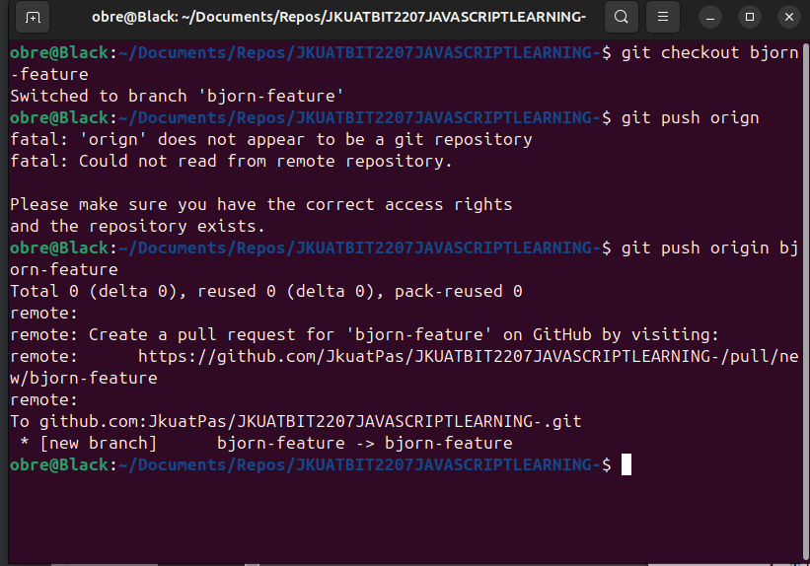

**2. Section 2: HTML and CSS (10 marks)**

On The homepage I have 3 links both have a hover effect upon passing a cursor over them and the alignment of the containers is set to center

**HOME PAGE**

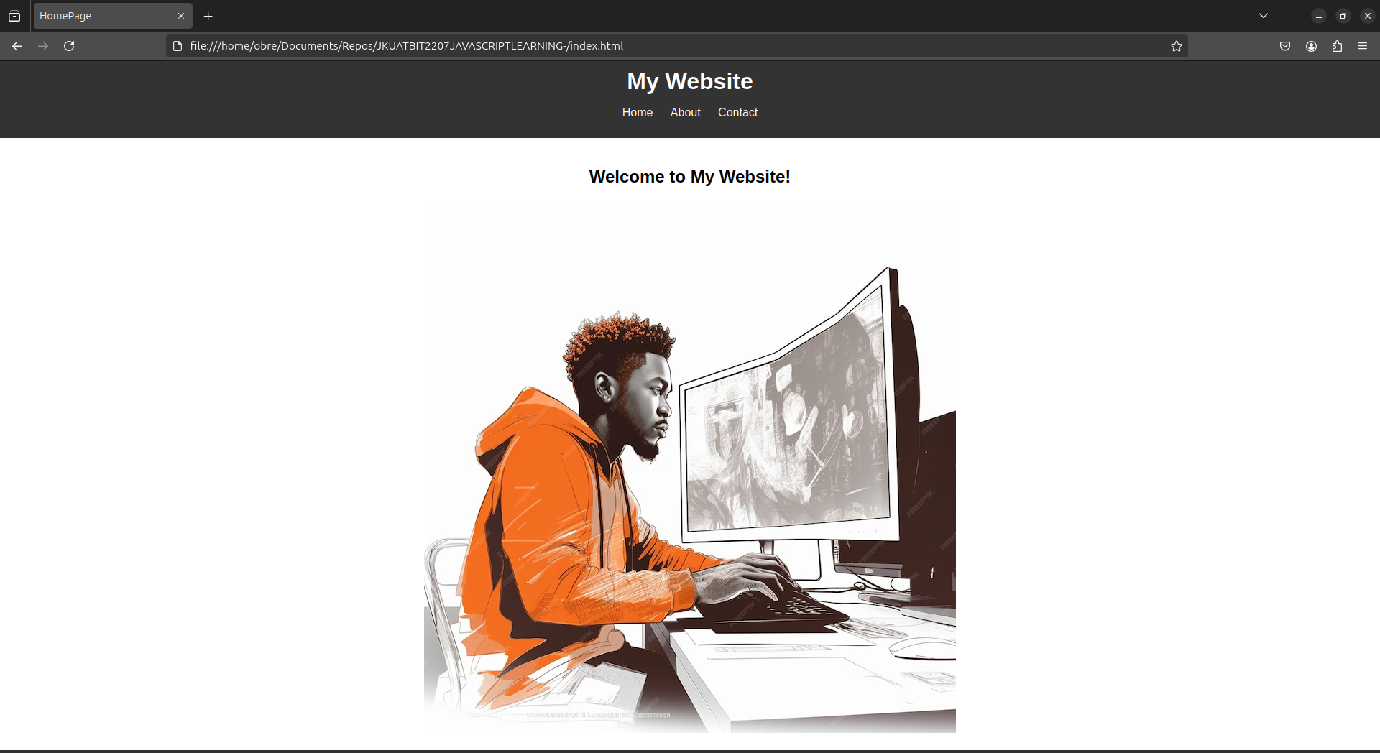

**ABOUT US PAGE**

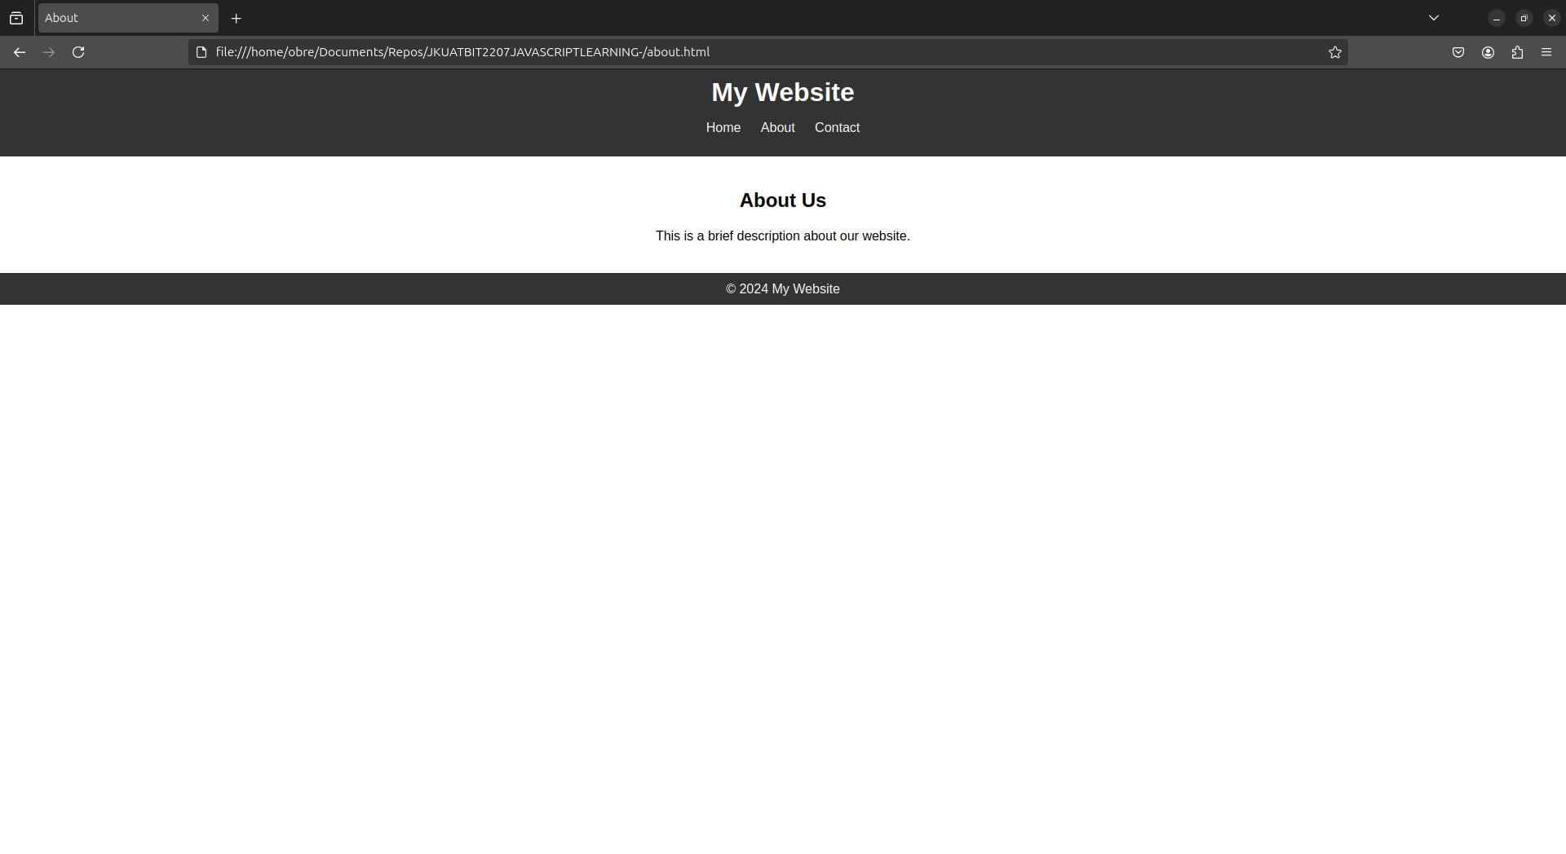

This is the screenshot of the contact page that has a form with 3 text inputs and ;lastly a submit button input to submit the form. So when the form is submitted an alert appears on the browser and

to thank the user for filling the form, which is basically done by javascript by adding an event listener upon submission of the form and run the alert function

**CONTACT PAGE**

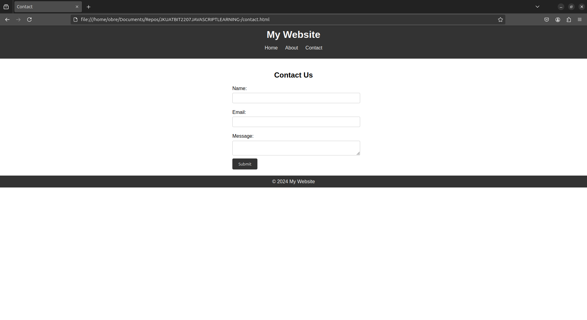

**Section 3: JavaScript Interactivity (10 marks)**

As you can see in the screenshot below there is a confetti feature whereby it pops up in every 3 seconds interval and colorful paper-like cuttings appear on the screen as a welcome animation

