**NAME: COSMAS NGENYA**

**ADM.NO: SCT221-C004-0028/2022**

1. **Section 1 Git and github**

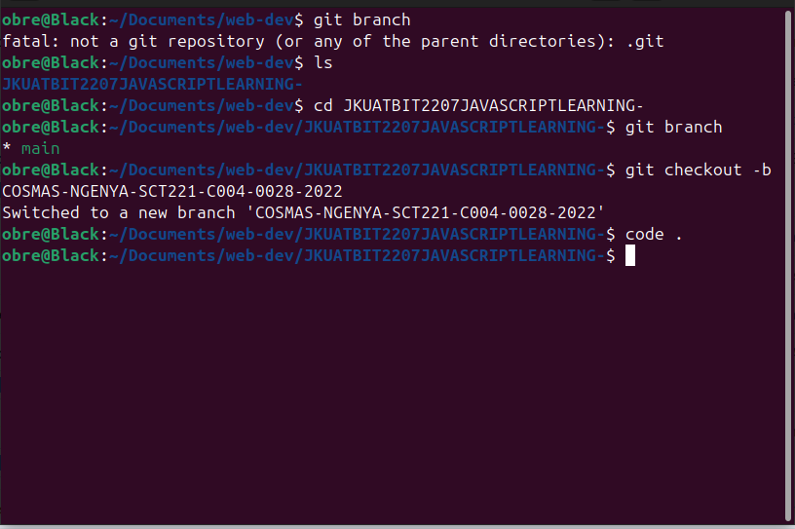

2. **Section 2: HTML and CSS (10 marks)**

**Homepage**

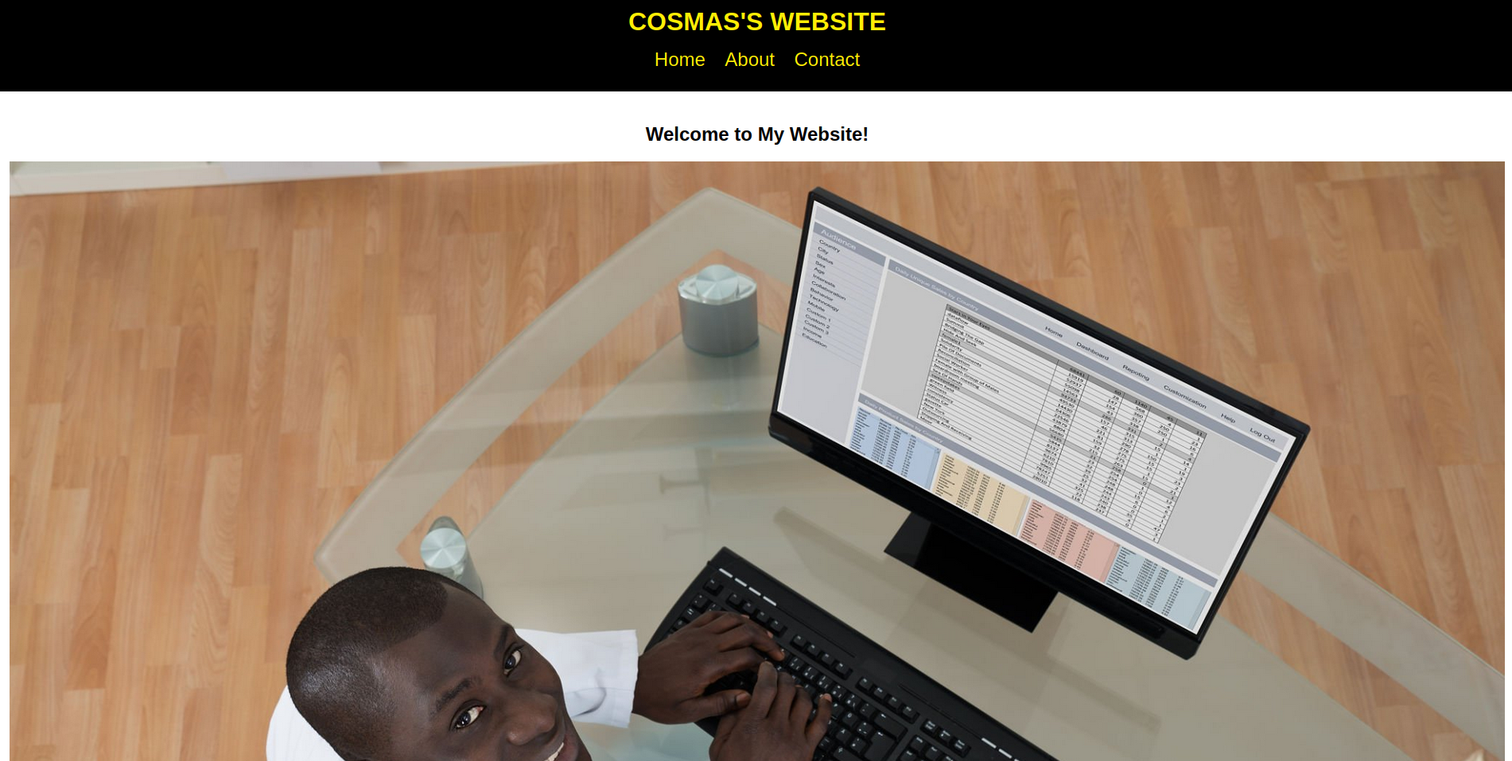

**About Page**

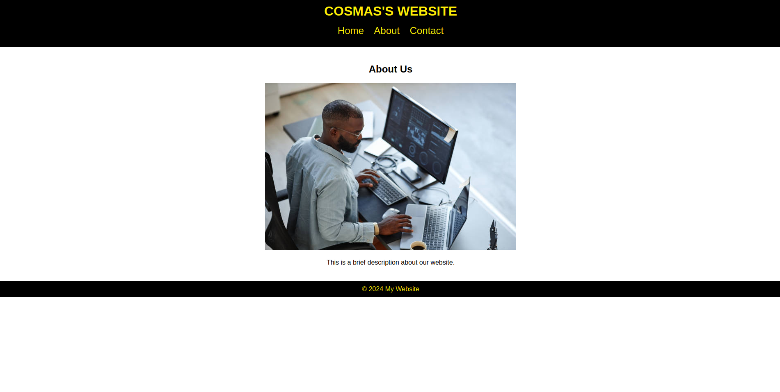**C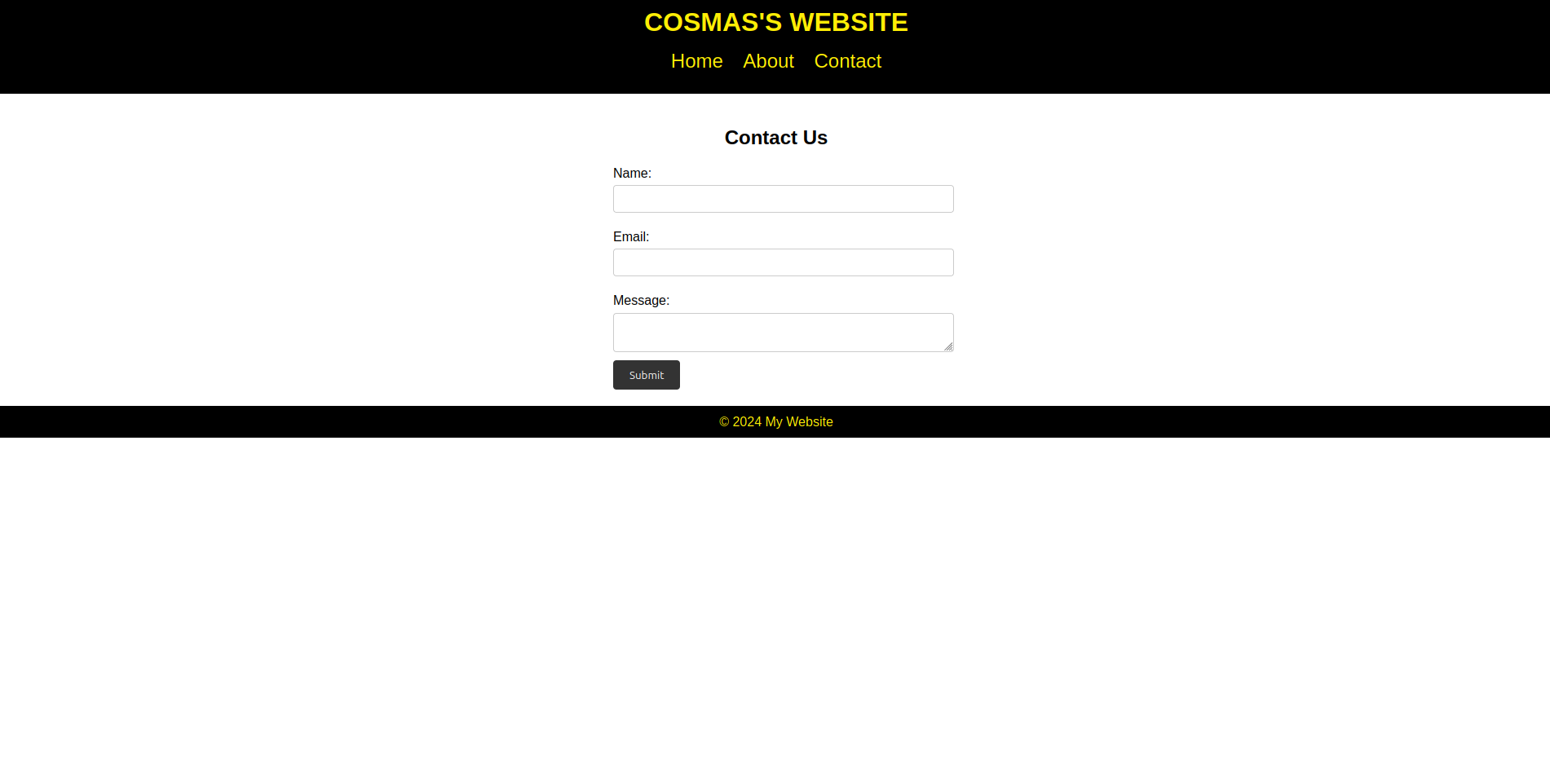ontact Page**

**3. SECTION 3: Javascript interactivity**

