Assignment -1 (PHY 125)

- The density of silver is 10.5X10³ Kg/m³. The atomic weight of silver is 107.9. Assuming that each silver atom provides one conduction electron. Calculate the density of electrons. The conductivity of silver at 20 ºC is 6.8X10⁷ ohm⁻¹m⁻¹. Calculate the mobility of electron in silver.
- The resistivity of Aluminum (Al) at room temperature is 2.62 x 10⁻⁸ ohm meter. Calculate the Drift velocity and the mobility of the electrons in a field of 50 Volt/ meter on the basis of classical free electron theory. Density of Al = 2700 kg/m³. N_{A} = 6.02 x 10²⁶ atoms/kmol, atomic weight of Al is 27. Assume that each Al atom contributes 3 electrons in the electron gas. (check solutions of 1 and 2 for atomic wt in kg or avagadro in per kmole)
- A copper wire of cross-sectional area 5 m² and in which there is a current of 200 amperes is considered. If the free electron density of copper is 8.5 x10²⁵/m³, compute the drift velocity.
- At room temperature, cooper has free electron density of 8.4X10²⁸ per m³. Find electron drift velocity in a cooper conductor having a cross section of 10⁻⁶ m² and carrying a current of 5.4 Ampere.
- Calculate the probability that a state in the conduction band is occupied by an electron and also calculate the thermal equilibrium electron concentration in silicon at T=300 K. Assume the Fermi energy is 0.25 eV below the conduction band. The value of Nc at T=300K is Nc =2.8X10¹⁹ cm⁻³. Ans: 6.43X10⁻⁵ and 1.8X10¹⁵ cm⁻³.
- Calculate the thermal equilibrium hole concentration in silicon at T=400K. Assume that the Fermi energy is 0.27 eV above the valence band energy. The value of Nv for silicon at T=300 K is Nv=1.04X10¹⁹ cm⁻³ . Ans: 6.43X10¹⁵ cm⁻³
- Calculate the intrinsic conductivity of silicon at room temperature if n=1.41X 10¹⁶ m⁻³, µ_{e}=0.145 m² /V-sec, µ_{h}=0.05m² /V-sec. What are the individual contributions made by electrons and holes? Ans: 0.439X10⁻³ S/m, 0 .327X10⁻³ S/m, 0.112X10⁻³ S/m.
- Silicon has a resistivity of 1500 Ω-m at a certain temperature. Compute the electron-hole concentration given that, µ_{e}= 0.14 m² /V-sec, µ_{h}= 0.05 m² /V-sec. Ans: 2.19X10¹⁶m⁻³
- Hall voltage of 20 mV is found to be developed with a sample carrying a current of 15 mA is placed in a transverse magnetic field of 0.4 Tesla. Calculate the Hall co-efficient, concentration of charge carriers and the mobility in the sample. The thickness of the sample along the magnetic field direction is 0.4 mm, thickness along the Hall field is 1 mm and conductivity are given as 0.36 m² /V-sec.
- A p-type semiconductor has a Hall coefficient equal to 0.0125 volt-m³ /amp-weber. Find out the density of charge carrier in it.
- Find current flowing (if any) (D1 and D2 are Si normal p-n junction diode) (Ans: 1.9 A)
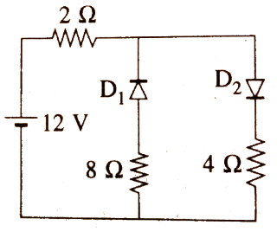
- Determine whether the ideal Zener diodes shown below are properly biased. If yes, find diode current.
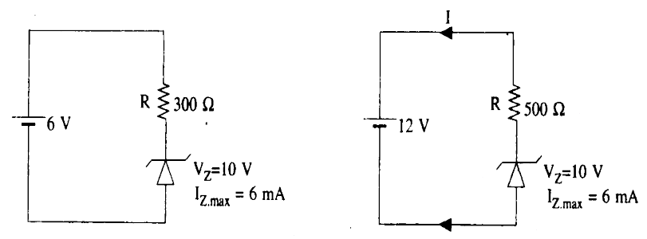
- Determine if the Zener diode is biased properly. If so, find I_{Z} and the power dissipated by the diode.
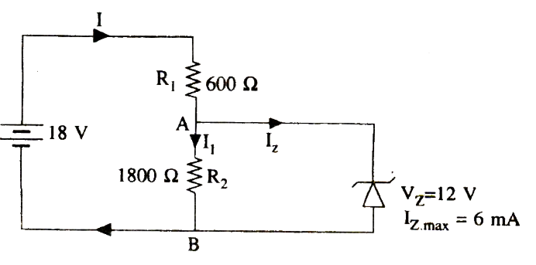
- The reverse saturation current at 300K of a p-n junction Ge diode is 5 micro–A. Find the voltage to be applied across the junction to obtain a forward current of 50 mA.
- Calculate the ratio of the current for a forward bias of 0.06 V to the current for the same value of reverse bias applied to a Ge p-n diode at 27⁰C.
- Find the value of the applied forward voltage for a Si p-n junction diode if I_{s}=30 micro ampere, I= 2 mA and e/KT = 39 volt⁻¹. (Ans: 0.11 volt)
- The reverse saturation current at 300 K of a p-n junction Ge diode is 5 µA. Find the voltage to be applied across the junction to obtained the forward current of 50 mA. (Ans: 0.238 V)
- Design and draw a zener regulator circuit to meet the following specifications. Load voltage = 8 V, Source voltage = 30 V, load current = 50 mA, I_{z} max = 5 mA and P_{zmax} = 1 Watt

