Name:
Year and Section:
Subject:

- Source Mac Address

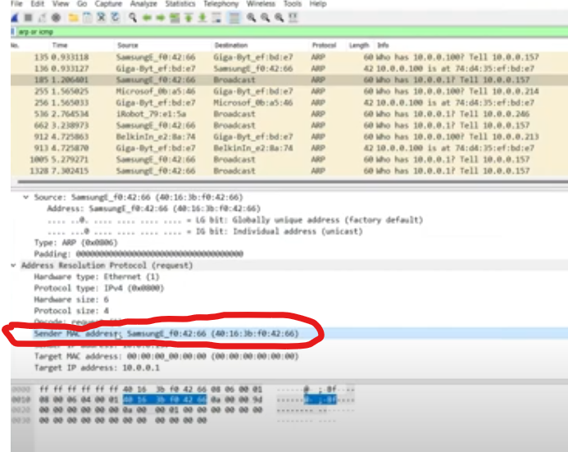

- Destination Mac Address

- Type

- Data

- FCS

