Name: Jhunde Kyle Taghoy
Year and Section: BSIT-3A
Subject: Networks and Internet Technology

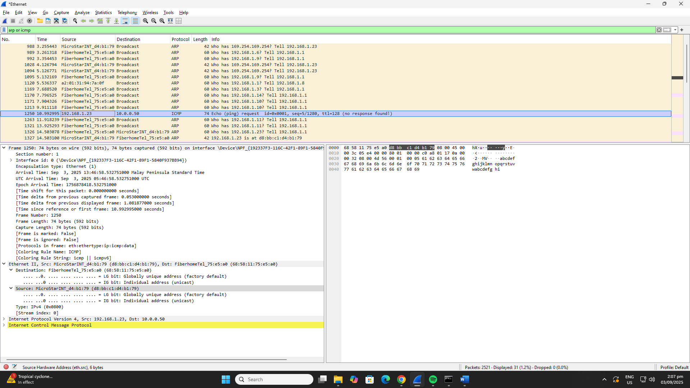

- Source Mac Address
Source: MicroStarINT_d4:b1:79 (d8:bb:c1:d4:b1:79)

- Destination Mac Address
Destination: FiberhomeTel_75:e5:a0 (68:58:11:75:e5:a0)

- Type
Type: IPv4 (0x0800)

- Data
0000 68 58 11 75 e5 a0 d8 bb c1 d4 b1 79 08 00 45 00 hX.u.......y..E.
0010 00 3c 05 e4 00 00 80 01 00 00 c0 a8 01 17 0a 00 .<..............
0020 00 32 08 00 4d 56 00 01 00 05 61 62 63 64 65 66 .2..MV....abcdef
0030 67 68 69 6a 6b 6c 6d 6e 6f 70 71 72 73 74 75 76 ghijklmnopqrstuv
0040 77 61 62 63 64 65 66 67 68 69 wabcdefghi

- FCS
Usually not visible. If present, it's the last 4 bytes in the bottom hex dump pane.

