USER GUIDE
ProTask System User Manual (Organization Admin Side)
- INTRODUCTION
DocuDB is a web-based document management system designed for Lapu-Lapu City College to securely store, organize, and manage institutional files.
This manual provides step-by-step instructions for administrators to upload, manage, share, and monitor documents efficiently.
- ACCESSING THE SYSTEM
2.1System Requirements
- A device with a web browser (Chrome, Firefox, Edge, etc.)
- Local Network or Internet connection
- URL: http://localhost:5173 (Differs on Deployment)
2.2 Log in
- Open your web browser and go to the DocuDB login page.
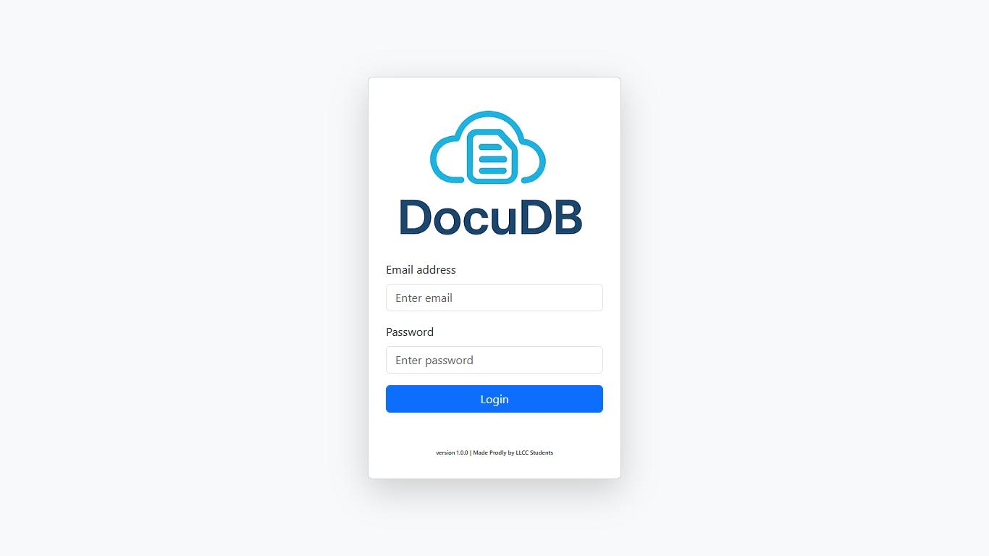
- Enter your Lapu-Lapu City College administrator email and password.
- Click “Login” to access the admin dashboard.
- DASHBOARD OVERVIEW
Once logged in, the Admin Dashboard displays all uploaded files, users, and activities in the system. The dashboard provides direct access to file management, user monitoring, and activity logs.
  - Navigation Menu
- Nav1: Manage Users – View, add, edit, or remove users.
- Nav2: System Logs – Display a list of all system activities, such as uploads, deletions, and sharing.
- Nav3: Documents – View, preview, or delete uploaded files and folders.
- Nav4: Others – View other features such as settings, filters, and admin configurations.
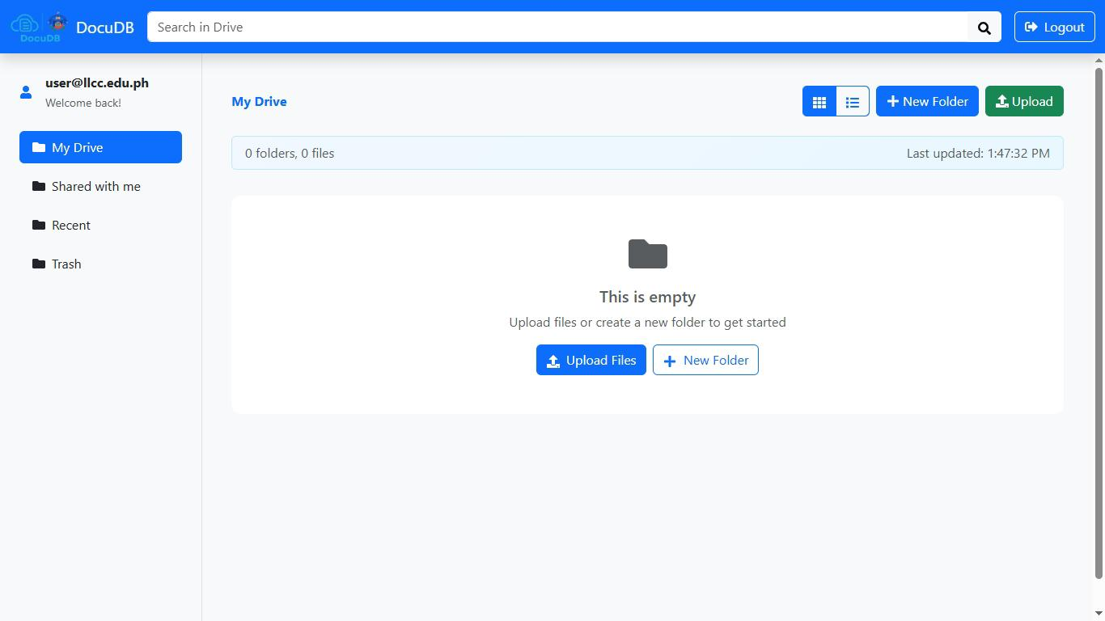

- MANAGING FILES AND FOLDERS
  - View and Manage Files
- Click on the Documents navigation tab.
- The list of uploaded files and folders will appear.
- Each document shows its name, owner, size, and control options (View, Download, Delete).
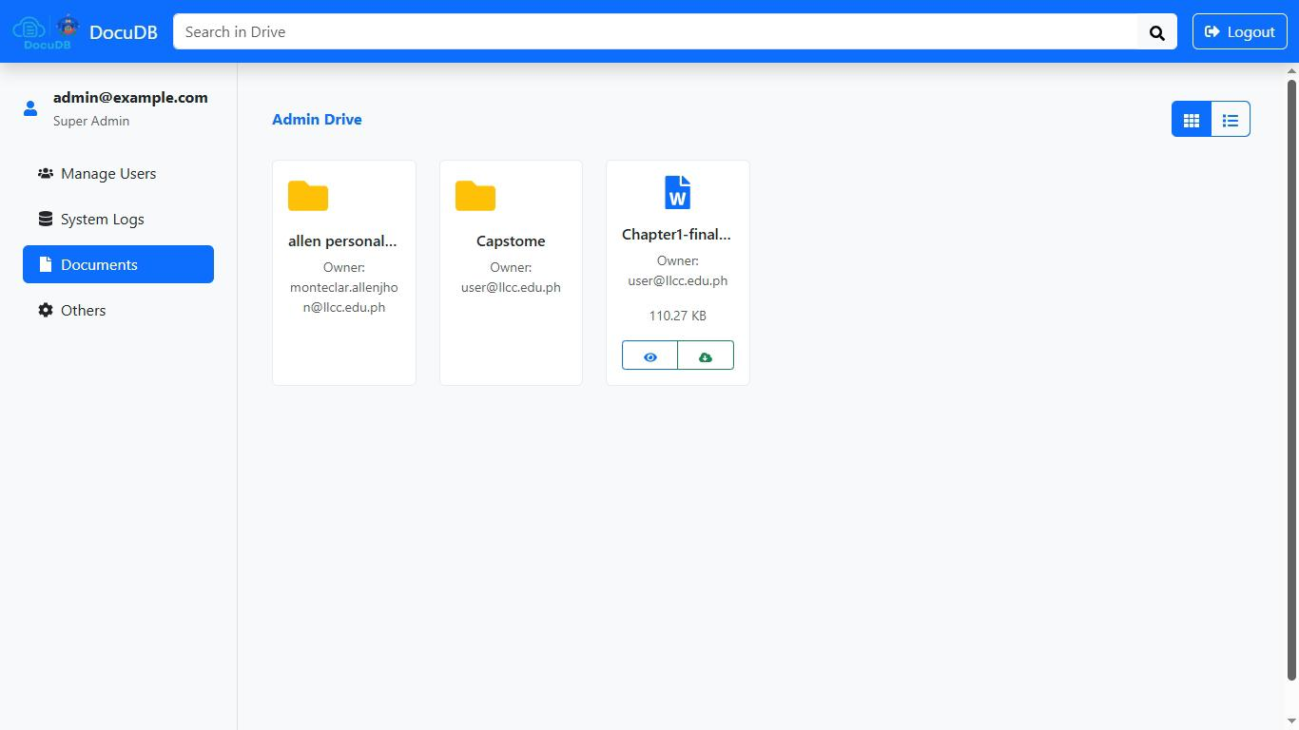

- MANAGING Users
  - View and Manage Status of Users
- From the Manage Users list, click the icon to modify a user’s status (Active or Inactive).
- All actions are recorded in the System Logs for transparency.
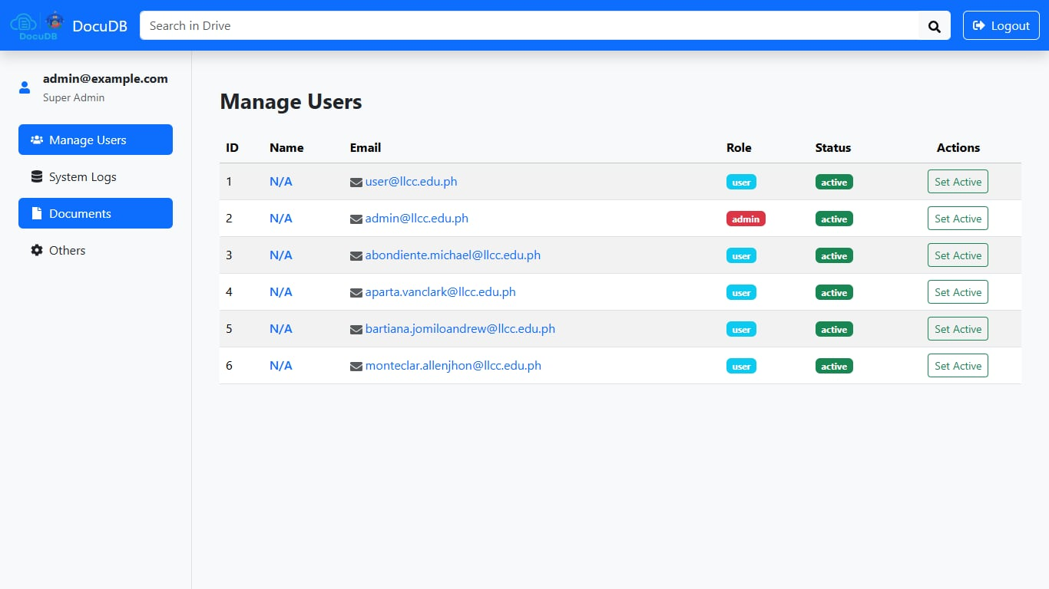

- SYSTEM MONITORING
  - View Logs
- Click the System Logs tab from the navigation menu.
- The log table displays:
- File Uploads
- File Deletions
- Shares and Permissions
- User Additions and Removals
- Login and Logout Activities
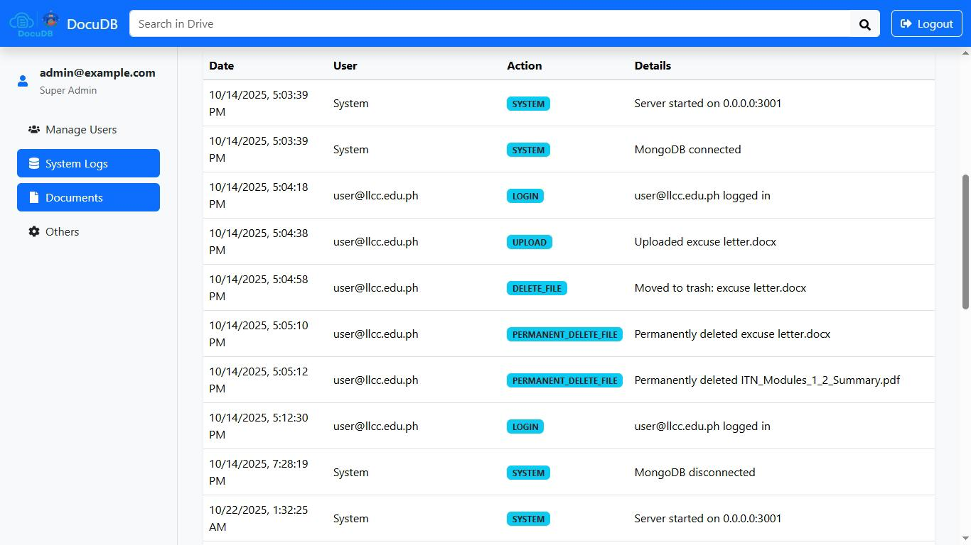

- LOGOUT
Click the Logout button on the top-right corner to securely exit the system.

DocuDB System User Manual (Member/User Side
1. INTRODUCTION
DocuDB is a web-based document management system developed for Lapu-Lapu City College students and staff to securely upload, organize, and share files within a centralized digital workspace.
This manual guides users on how to upload, manage, and share documents efficiently.
2. ACCESSING THE SYSTEM
2.1System Requirements
- A device with a web browser (Chrome, Firefox, Edge, etc.)
- Local Network or Internet connection
- URL: http://localhost:5173 (Differs on Deployment)
2.1System Requirements
- Go to the DocuDB login page.
- Enter your Lapu-Lapu City College email and password.

- Click Login to access your User Dashboard.

2. DASHBOARD OVERVIEW
After logging in, the User Dashboard displays your personal file storage area, called My Drive, along with other sections for collaboration and management.
3.1Navigation Menu
- Nav1: My Drive – Displays all your uploaded files and folders.
- Nav2: Shared with Me – Lists documents shared with you by other users.
- Nav3: Recent – Shows recently opened or uploaded files.
- Nav4: Trash – Temporarily stores deleted files for recovery.
- Nav5: Logout – Ends the session securely.
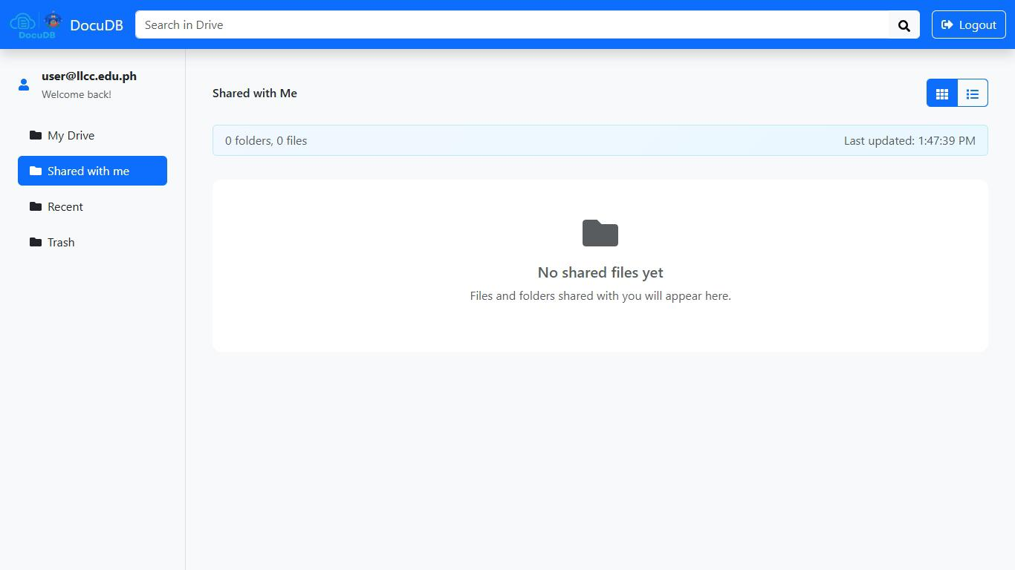

4. MANAGING YOUR FILES

4.1 Uploading Files
- Click the Upload button.
- Select files from your computer.
- Uploaded files will appear in My Drive.
Supported Formats: PDF, Word, Excel, PowerPoint, Images, and Text files.
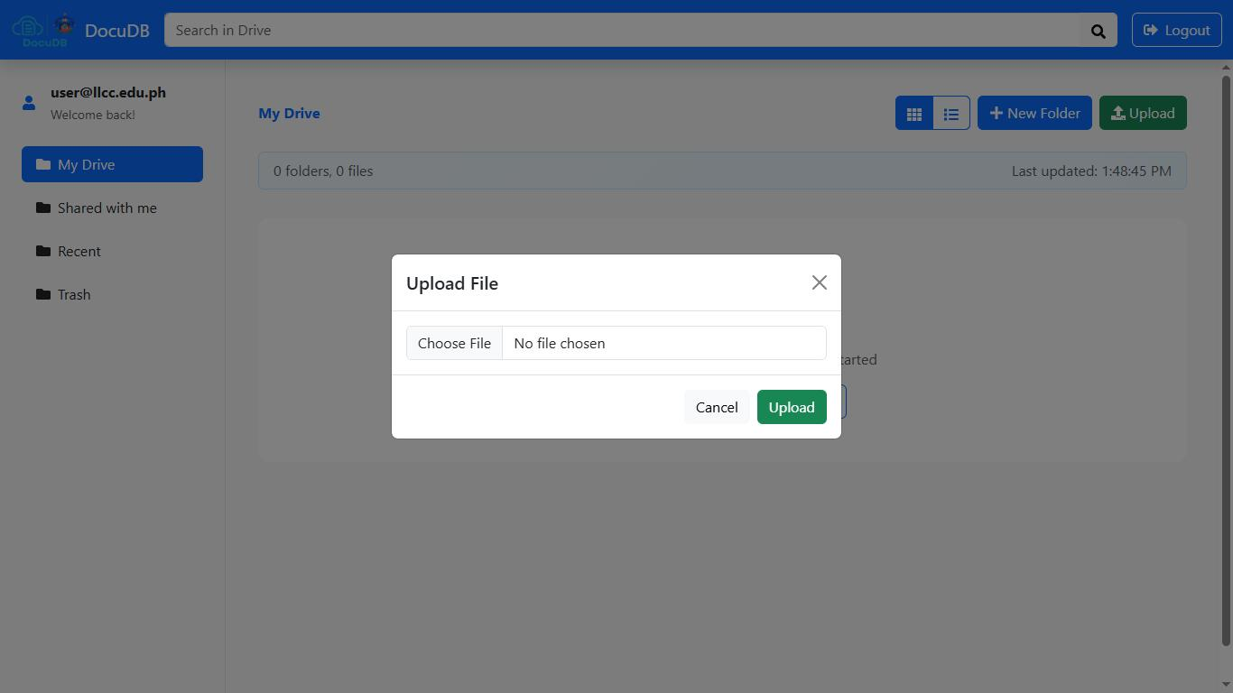

4.2 Creating a Folder
- Click the New Folder button.
- Enter the folder name and confirm.
- Use folders to organize documents by topic or department.
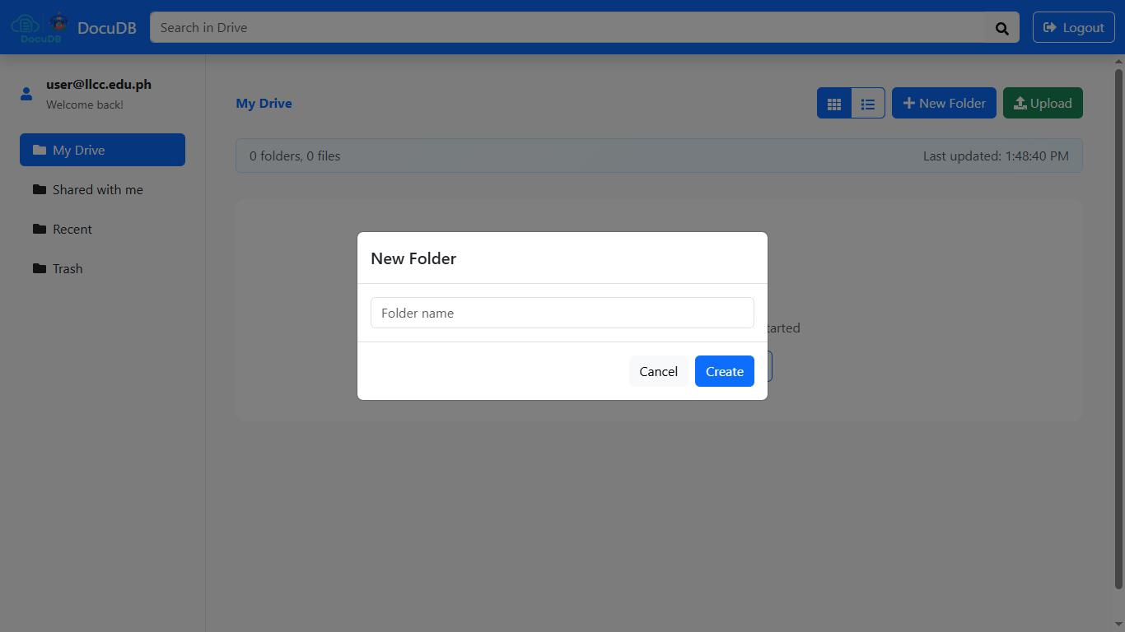

4.3 Moving, Renaming, or Deleting Files
- Hover over a file to see action buttons.
- You can:
- Rename a file/folder.
- Move it to another folder.
- Delete it (moves to Trash).
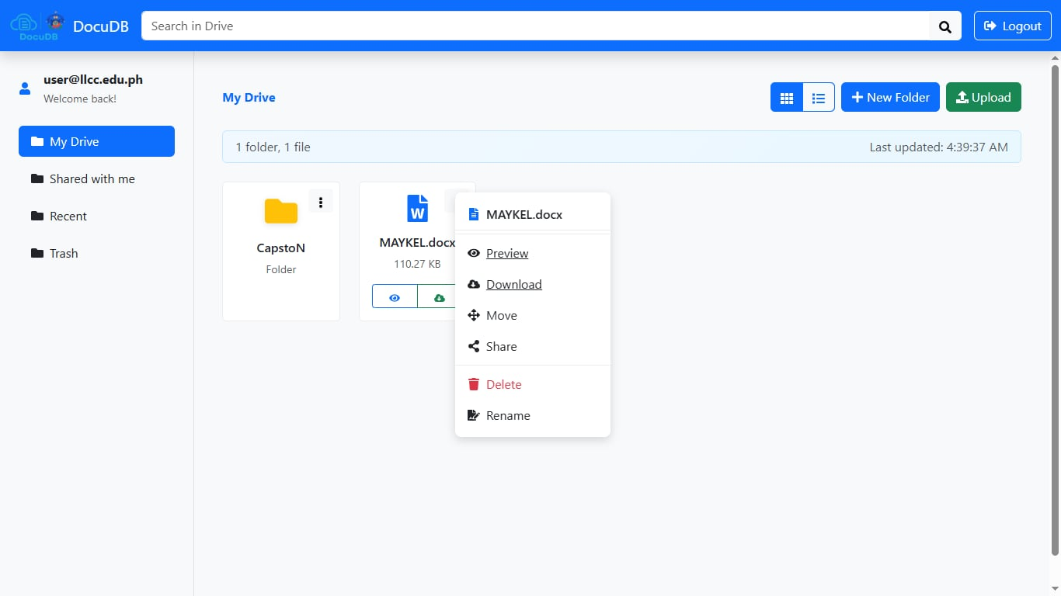

4.4 Restoring or Permanently Deleting Files
- Go to Trash from the sidebar.
- You can Restore files to their original location or Permanently Delete them.
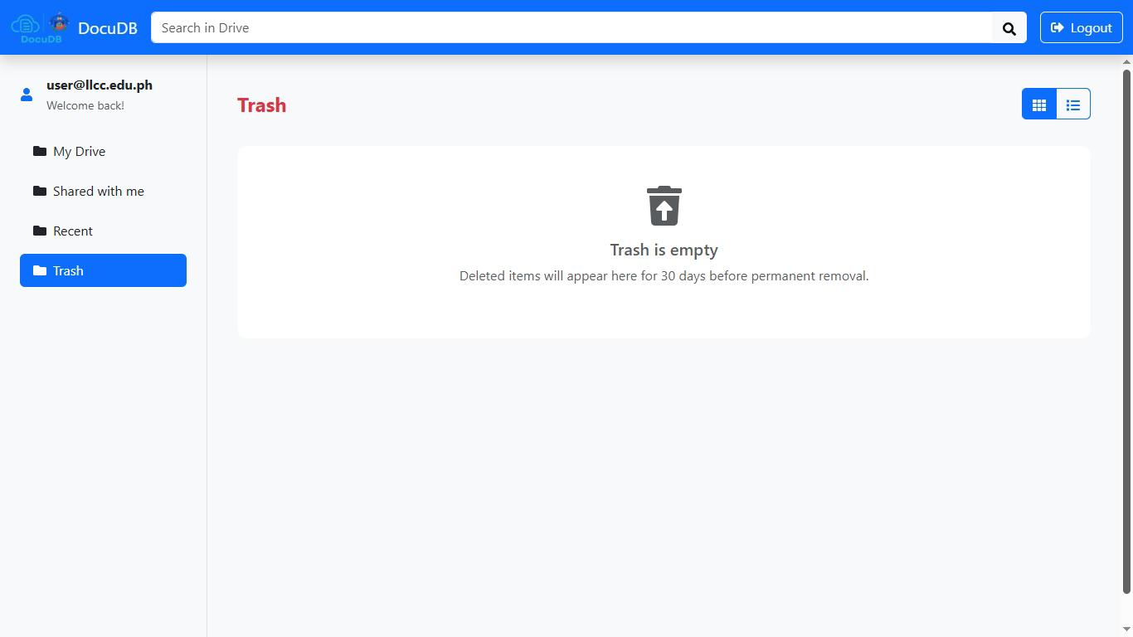

5. SHARING AND COLLABORATION

5.1 Sharing a File
- Select a file or folder.
- Click the Share icon.
- Enter the recipient’s Lapu-Lapu City College email.
- Choose permission:
  - View Only
  - Edit Access
- Click Share to confirm.
- All shared files will appear in the recipients’ Shared with Me section.
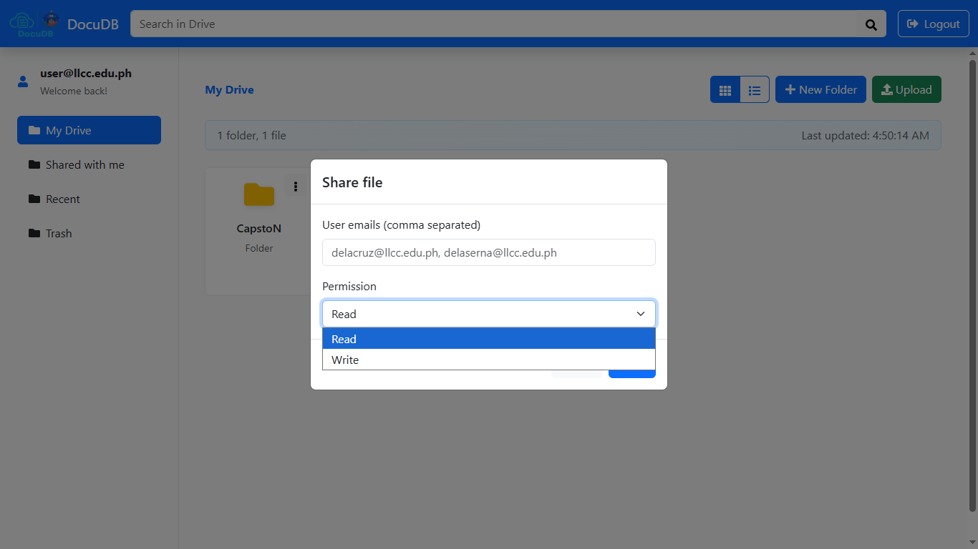

6. SEARCHING DOCUMENTS

6.1 File Search
- Type a keyword in the Search in Navigation bar.
- Search results update in real time as you type.
- You can search by File Name
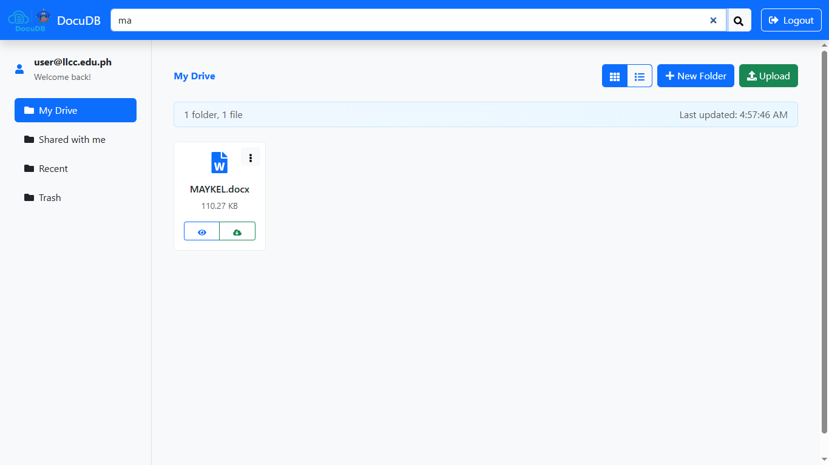

7. LOGOUT
Click the Logout button on the upper-right corner of the page to safely exit the DocuDB system.

