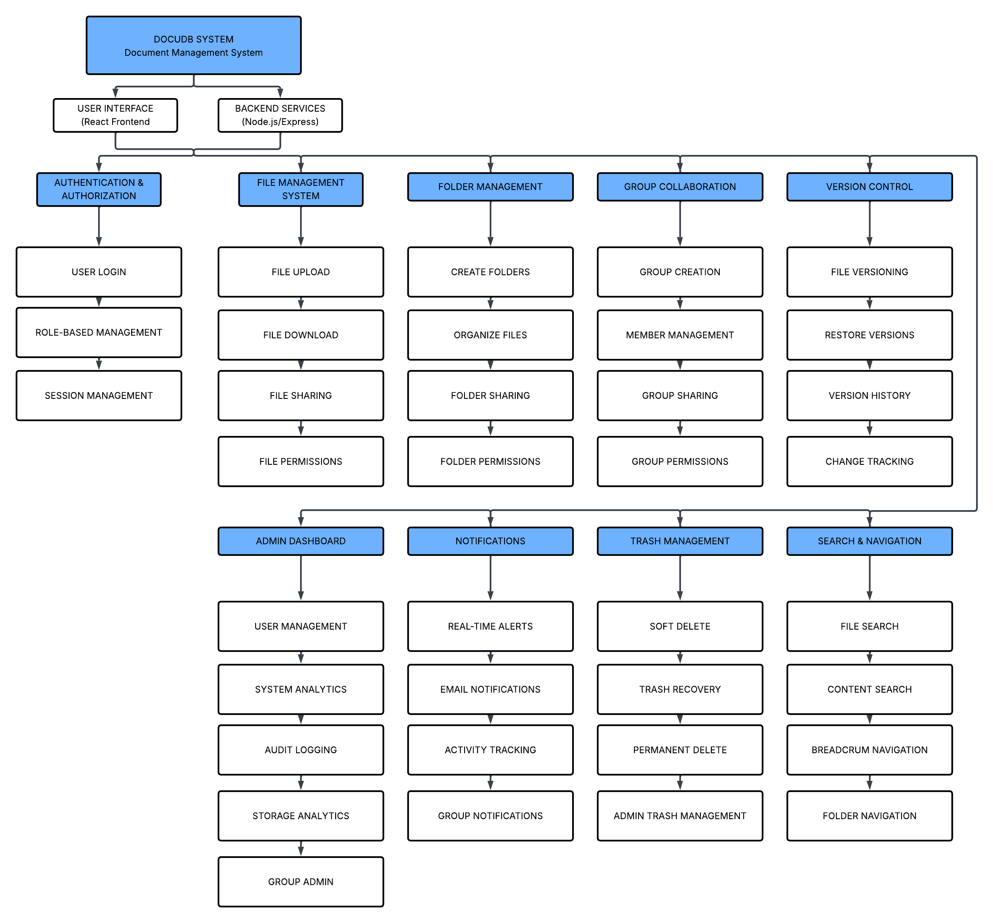

Submitted By: Group 7
Jhunde Kyle Taghoy Jomilo Andrew Bartiana
Michael Emmanual Abondiente Allen Jhon Monteclar
Van Clark Aparata

